Description:  
This circuit is sensitive to low frequency electromagnetic radiation and will detect for example hidden wiring or the field that encompasses a transformer. Pickup is by a radial type inductor, used as a probe which responds well to low frequency changing magnetic and electric fields. Ordinary headphones are used to for detection. The field that surrounds a transformer is heard as a 50 or 60Hz buzz. The circuit is below:-

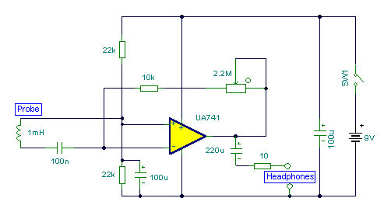

Notes  
I threaded a length of screened cable through an old pen tube and soldered the ends to a radial type can inductor. I used 1mH. The inductor fitted snugly into the pen tube. The opposite end of the cable connects to the input of the op-amp. Any op-amp should work here, possibly better results may be achieved with a low noise FET type such as the LF351. The 2M2 potentiometer acts as a gain control and the output is a pair of headphones. Stereo types can be used if they are wired as mono. I used an 8 ohm type, but the circuit should work equally well with higher impedance types. The probe (shown below) may be connected via screened cable and a 3.5mm stereo plug and socket.

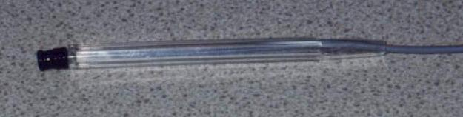

Detection  
The sensitivity of this circuit is good. Mains wiring buried an inch in plaster can be detected with precision. A small load on the electric supply is all that is needed; a 20 watt desk lamp or similar will suffice. The hum field surrounding a transformer can be detected oat over 7 inches. Domestic appliances such as videos and alarm clocks all produce interference which can be heard with the probe. The electric field surrounding a loudspeaker or earpiece can also be heard. Try lifting a telephone and place the probe near the earpiece. A telephone pickup coil can be used in place of the inductor if desired. I will make an improved version of this circuit with a meter output later.