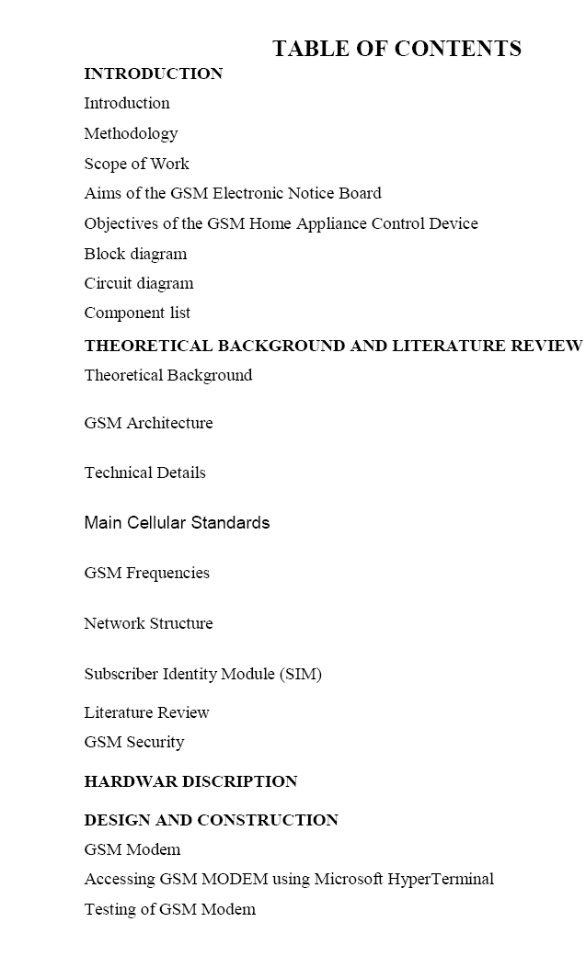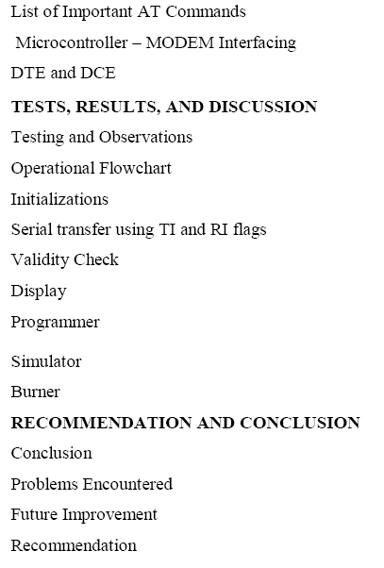

**Working**

You can see the notice boards being used specially at offices and public places to display important news and notices. To make the notice boards easy to use and more technically advance, I have used this prototype of**wireless notice board** where we can display the message by simply sending the message through your cell phone. These display systems are very accurate and easy to control and cheaply available and the most important thing is that they can be operated on low Voltage (Up to 12 Voltage).

A GSM module is used here for the wireless notice board to send the information or message to display. The main aim of this project is to save time and provide information urgently on display for the customers.  It can be used for multiple purposes like we can share live share market news, we can send trains time table to display, we can show lectures time table and important information for students and for teacher in school and collegel

In this circuit GSM module and a 16x2 LCD display is used for receiving message and display message respectively. When any urgent information is to share with more people this system works perfectly. When anyone wants to show any information or message, then sender sends a SMS to GSM Module. Then [Arduino](http://www.engineersgarage.com/microcontroller/arduino-projects)reads the GSM module and send it to the LCD. This project can be improved by using a larger display module. Here are few images showing the working of this project.

The advantage of this board is that it comes in very small in size; any kind of connectors can be soldered on its periphery according to our requirements. It is very breadboard friendly and occupies very less space of a typical breadboard.

**Component Explanation**

|  |  |
| --- | --- |
| * 269,219-Reads | [**LCD**](http://www.engineersgarage.com/electronic-components/16x2-lcd-module-datasheet)    **LCD (Liquid Crystal Display) screen is an electronic display module and find a wide range of applications. A 16x2 LCD display is very basic module and is very commonly used in various devices and circuits. These modules are...** |
| * 32,829-Reads | [**LED**](http://www.engineersgarage.com/electronic-components/leds-light-emitting-diode)    **Light emitting diodes.** |
| * 25,957-Reads | [**Resistor**](http://www.engineersgarage.com/electronic-components/resistors)  **Resistor is a passive component used to control current in a circuit. Its resistance is given by the ratio of voltage applied across its terminals to the current passing through it. Thus a particular value of resistor, for fixed voltage, limits the current through it. They are omnipresent in...** |
| * 17,284-Reads | [**Capacitor**](http://www.engineersgarage.com/electronic-components/capacitors)  **Capacitor is a passive component used to store charge. The charge (q) stored in a capacitor is the product of its capacitance (C) value and the voltage (V) applied to it. Capacitors offer infinite reactance to zero frequency so they are used for blocking DC components or bypassing the AC signals. The capacitor...** |

SIM 900 a GSM Module which we are going to use to receive the text message. This module needs 9V DC power supply so we are using adapter for that. Here we are using only two pins of this module to connect with Arduino or our ATmega 328/168/8 board.   
Those are GND to common all grounds and make path complete for data   
TX (TTL Transmitter pin) to receive signal to Microcontroller from GSM Module  
  
  
  
  
  
  
3) Atmega 328 Microcontroller with own breakout board or Arduino  
  
Here we are using Arduino UNO R3 but guys u have an option of making your own breakout board using Atmega 328, 168, 8 According to your application but don't forgot to burn bootloader without that u never gona burn any code from Arduino board (To burn bootloader in blank chip please follow our link HOW TO BURN BOOTLOADER IN ATMEGA 328) next for connections refer circuit diagram. If you are using Atmega 328/168/8 with own made board then follow this pin mapping and compare it with standard Arduino

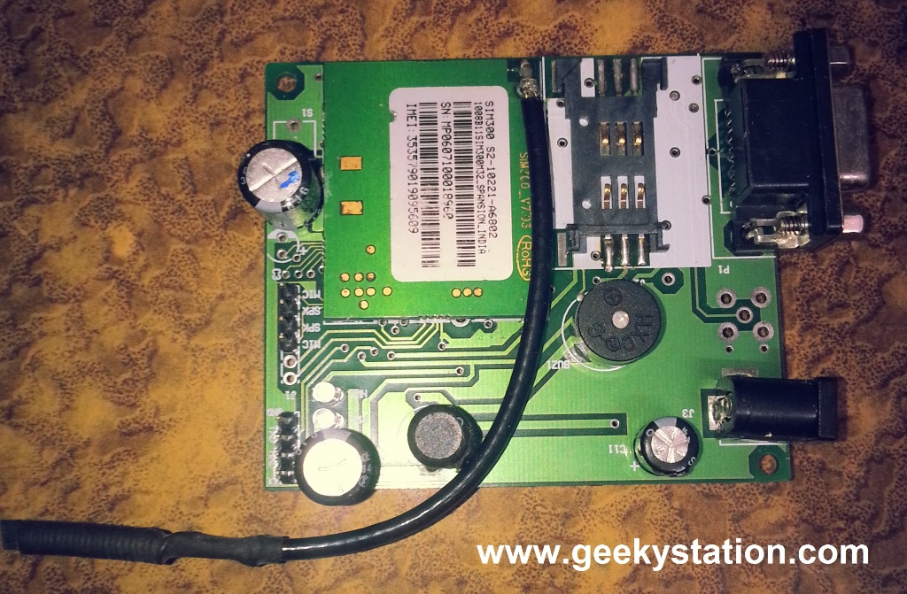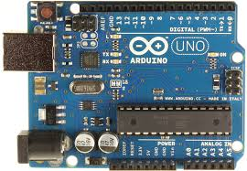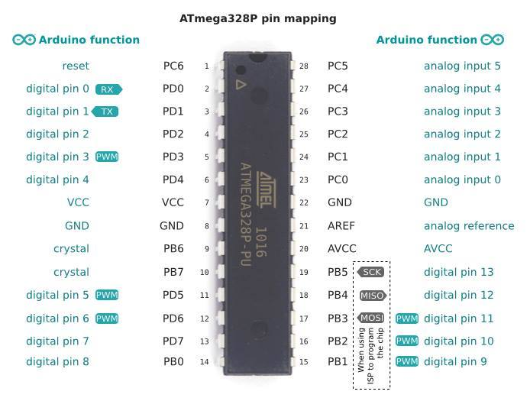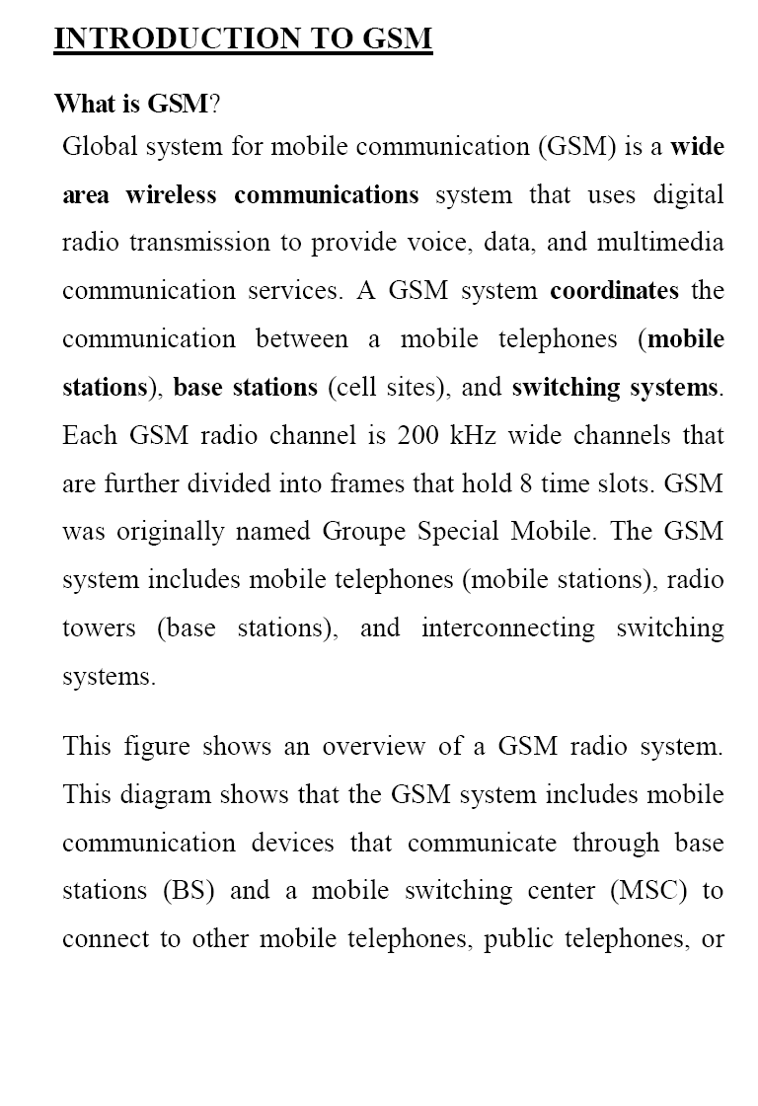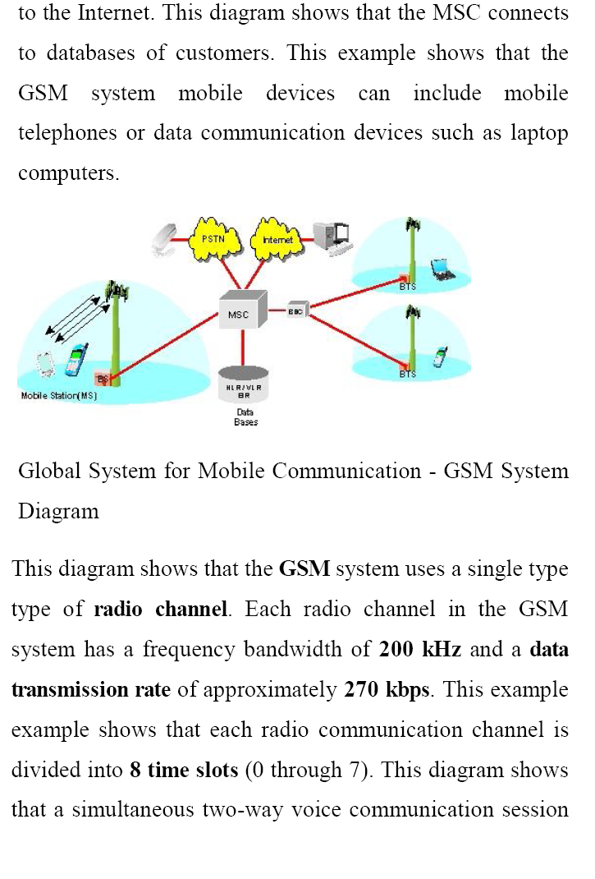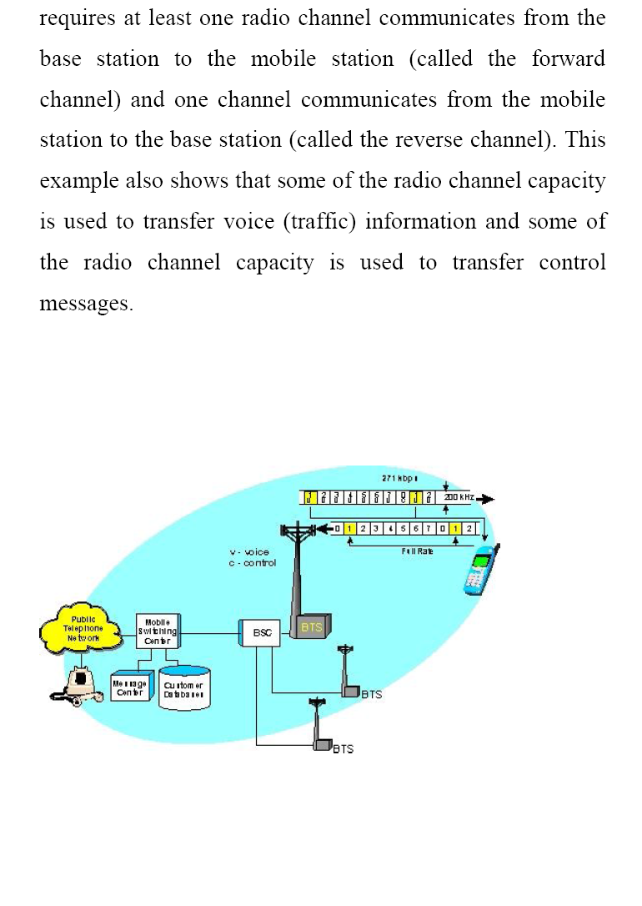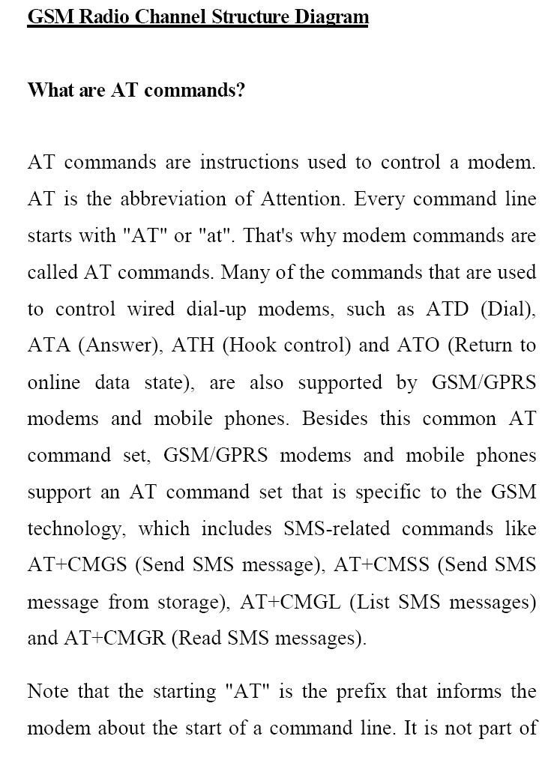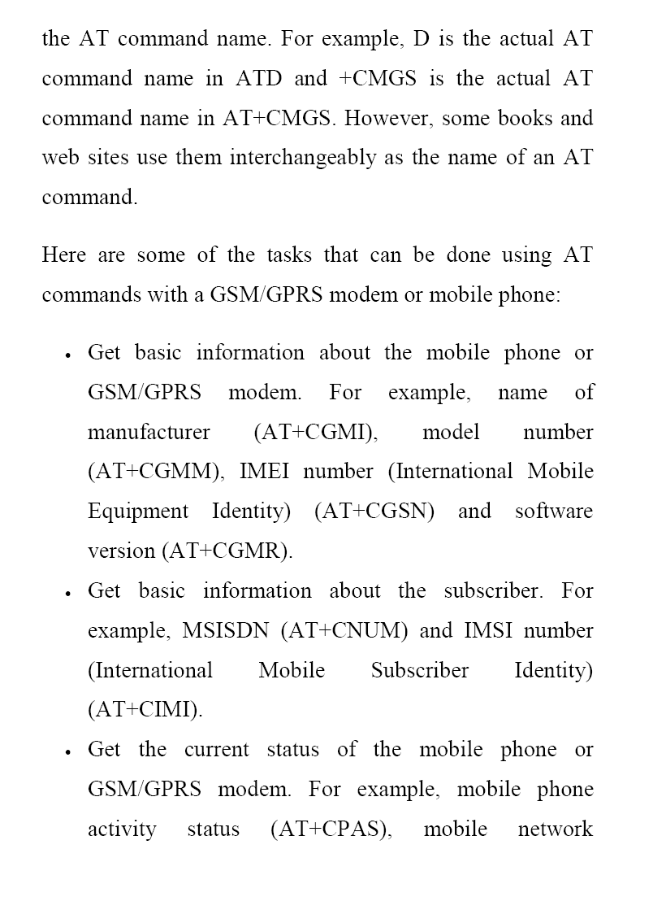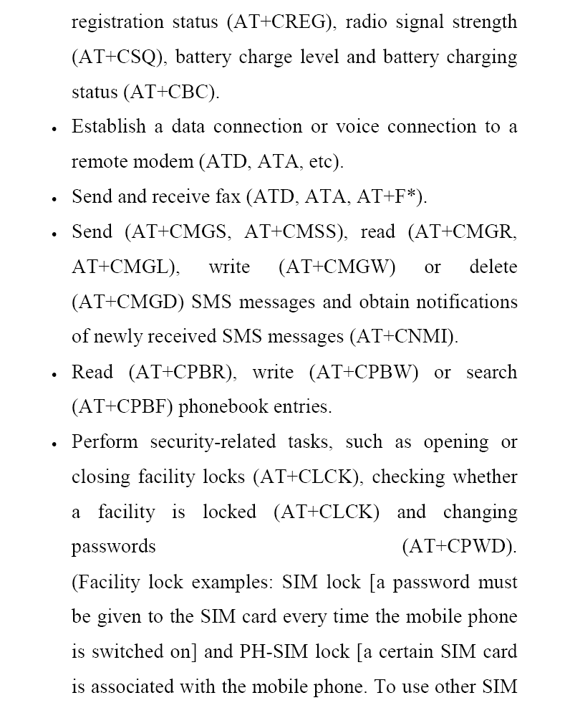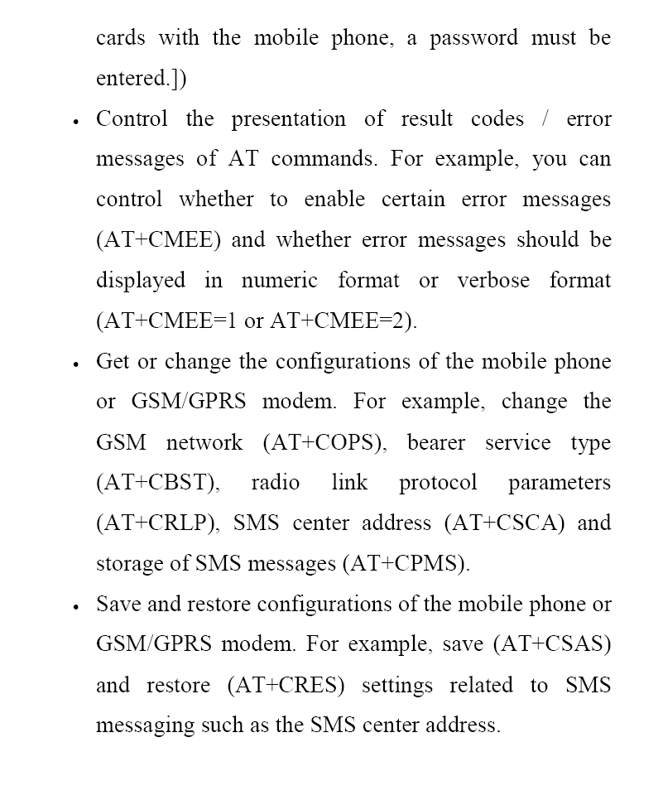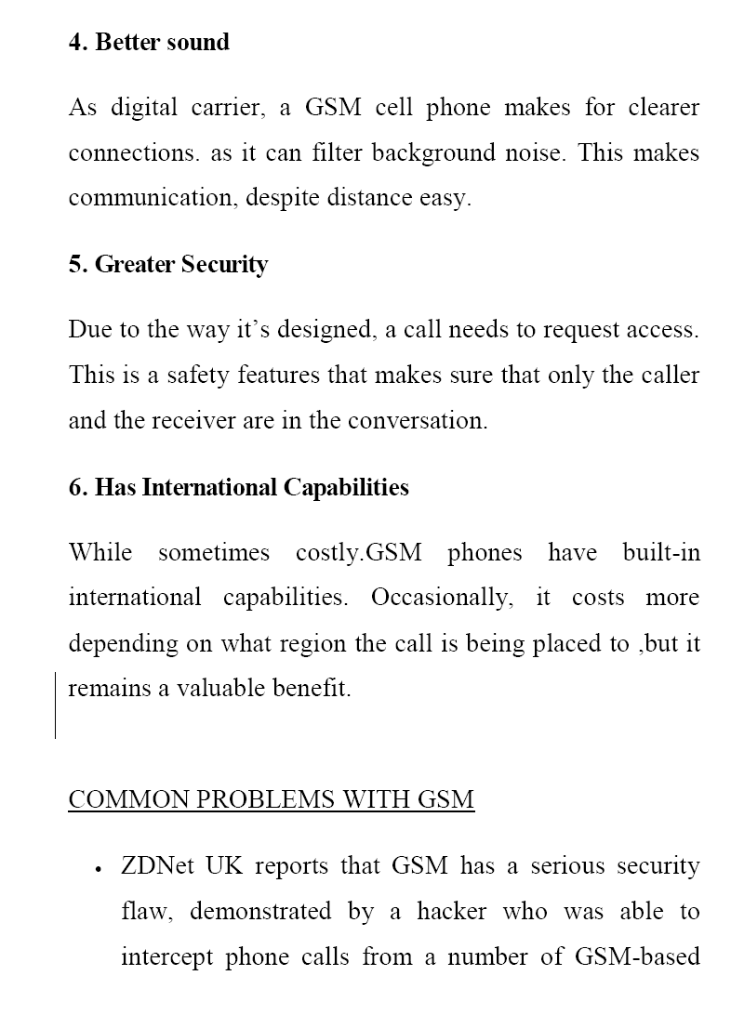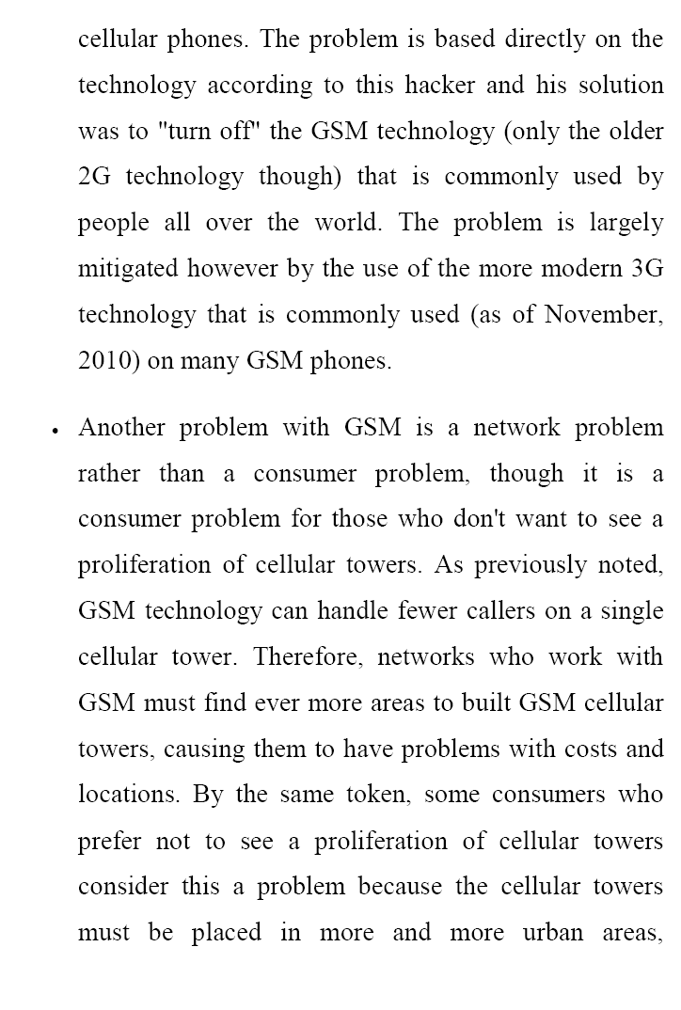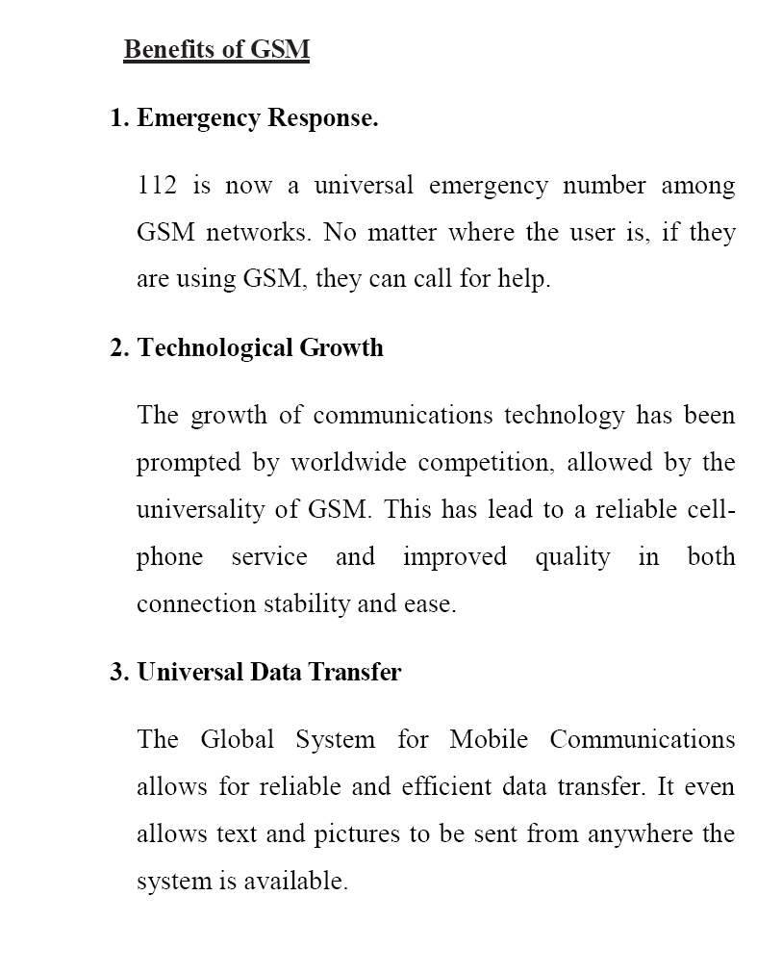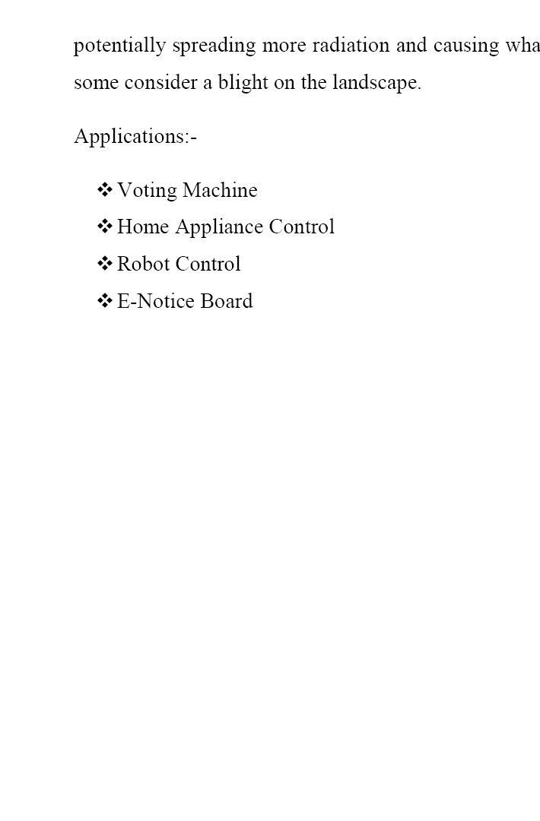

**BLOCK DIAGRAM**

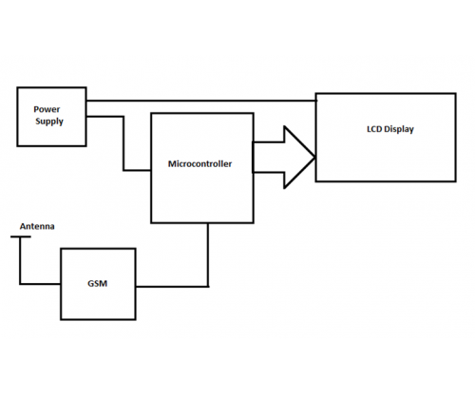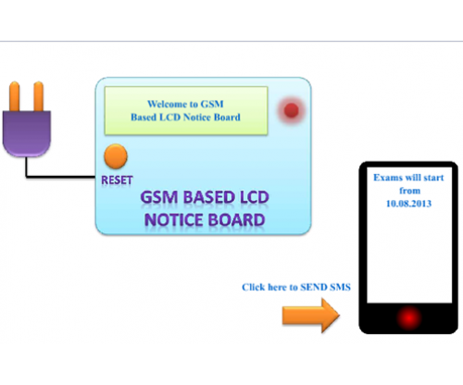

**Circuit Diagram**

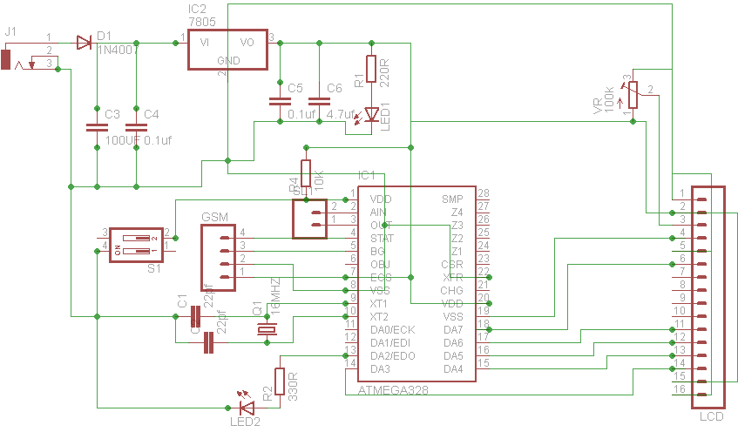

**Component List**

Part Value Quantity

C1 22pf 2

C2 100uF 1

C3 0.1uf 2

C4 4.7uf 1

D1 1N4007 1

GSM sim900 1

IC1 ATMEGA328 1

IC2 7805 1

LCD 16*2 1

LED1 3MM 2

CRYSTAL 16MHZ 1

R1 220R 1

R2 330R 1

R3 10K 1

S1 push switch 1

VR 20k 1

**Source Code**

#include <SoftwareSerial.h>

#include<LiquidCrystal.h>

LiquidCrystal lcd(13, 12, 11, 10, 9, 8);

SoftwareSerial SIM900(2,3); //tx-2 rx-3

int lenth,lenth1,i=0,temp;

char str[200];

char name[80];

int got=0;

void setup()

{

lcd.begin(16,2);

Serial.begin(9600);

SIM900.println("AT");

delay(100);

SIM900.begin(9600);

SIM900.println("AT+CNMI=2,2,0,0,0");

delay(100);

}

void loop()

{

if(got == 1)

{

lcd.setCursor(0, 0);

lcd.print(name);

}

else

{

lcd.setCursor(0, 0);

lcd.print("no notice to display");

}

lcd.scrollDisplayLeft();

serialEvent();

delay(1);

for(int j=0;j<600;j++)

{

serialEvent();

delay(1);

}

Serial.println(str);

if(temp==1)

{

i=0;

lenth1=0;

while(i<lenth)

{

{

lcd.clear();

got=1;

i++;

while(str[i]!='#')

{

name[lenth1]=str[i];

Serial.print(name[lenth1]);

lenth1++;

i++;

}

name[lenth1]='\0';

break;

}

i++;

}// end of while 1

lcd.clear();

lcd.setCursor(0,0);

delay(10);

lcd.print(name);

temp=0;

lenth=0;

lenth1=0;

}

}

void serialEvent()

{

while (SIM900.available())

{

char inChar = (char)SIM900.read();

str[lenth]=inChar;

lenth++;

if (inChar == '\n')

{

temp=1;

}

}

}