**Chapter1**

**INTRODUCTION**

**1.A PIR Sensor**

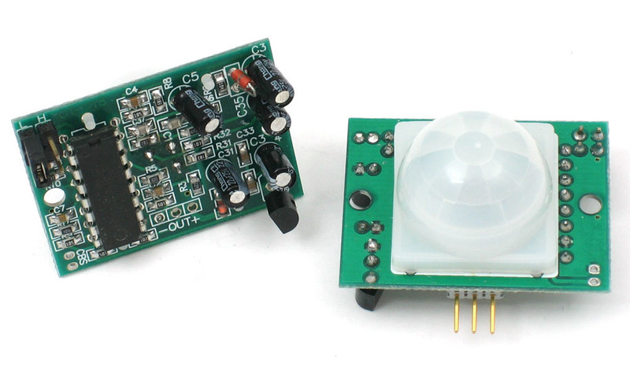

PIR sensors are more complicated than many of the other sensors explained in these tutorials (like photocells, FSRs and tilt switches) because there are multiple variables that affect the sensors input and output. To begin explaining how a basic sensor works, we'll use this rather nice diagram (if anyone knows where it originates plz let me know).

The PIR sensor itself has two slots in it, each slot is made of a special material that is sensitive to IR. The lens used here is not really doing much and so we see that the two slots can 'see' out past some distance (basically the sensitivity of the sensor). When the sensor is idle, both slots detect the same amount of IR, the ambient amount radiated from the room or walls or outdoors. When a warm body like a human or animal passes by, it first intercepts one half of the PIR sensor, which causes a positive differential change between the two halves. When the warm body leaves the sensing area, the reverse happens, whereby the sensor generates a negative differential change. These change pulses are what is detected.

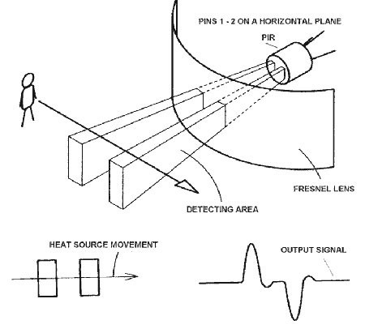

**THE PIR SENSOR**

The IR sensor itself is housed in a hermetically sealed metal can to improve noise/temperature/humidity immunity. There is a window made of IR-transmissive material (typically coated silicon since that is very easy to come by) that protects the sensing element. Behind the window are the two balanced sensors

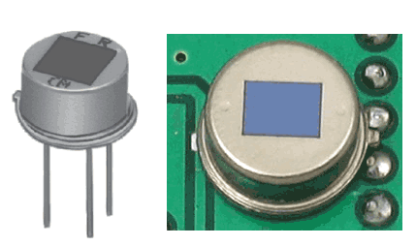

The IR sensor itself is housed in a hermetically sealed metal can to improve noise/temperature/humidity immunity. There is a window made of IR-transmissive material (typically coated silicon since that is very easy to come by) that protects the sensing element. Behind the window are the two balanced sensors.

**Left Image**

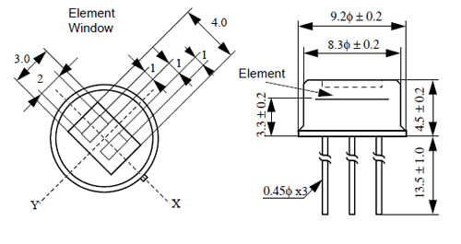

You can see above the diagram showing the element window, the two pieces of sensing material

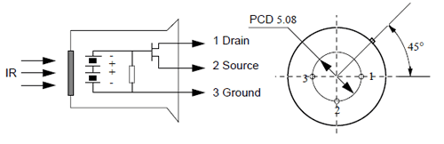

This image shows the internal schematic. There is actually a JFET inside (a type of transistor) which is very low-noise and buffers the extremely high impedence of the sensors into something a low-cost chip (like the BIS0001) can sense.

**Lences**

PIR sensors are rather generic and for the most part vary only in price and sensitivity. Most of the real magic happens with the optics. This is a pretty good idea for manufacturing: the PIR sensor and circuitry is fixed and costs a few dollars. The lens costs only a few cents and can change the breadth, range, sensing pattern, very easily.

In the diagram up top, the lens is just a piece of plastic, but that means that the detection area is just two rectangles. Usually we'd like to have a detection area that is much larger. To do that, we use [a simple lens](http://en.wikipedia.org/wiki/Lens_%28optics%29) such as those found in a camera: they condenses a large area (such as a landscape) into a small one (on film or a CCD sensor). For reasons that will be apparent soon, we would like to make the PIR lenses small and thin and moldable from cheap plastic, even though it may add distortion. For this reason the sensors are actually [Fresnel lenses](http://en.wikipedia.org/wiki/Fresnel_lens):

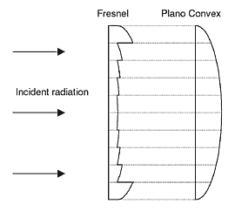

**Image from sensor margin**

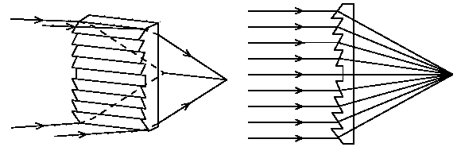

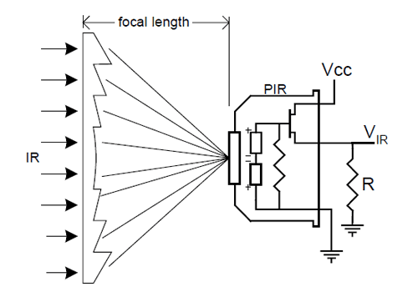

OK, so now we have a much larger range. However, remember that we actually have two sensors, and more importantly we dont want two really big sensing-area rectangles, but rather a scattering of multiple small areas. So what we do is split up the lens into multiple section, each section of which is a Fresnel

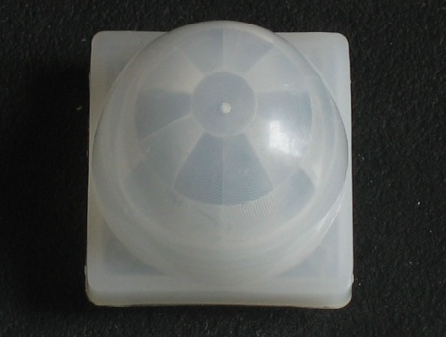

This macro shot shows the different Frenel len

The different faceting and sub-lenses create a range of detection areas, interleaved with each other. Thats why the lens centers in the facets above are 'inconsistant' - every other one points to a different half of the PIR sensing element

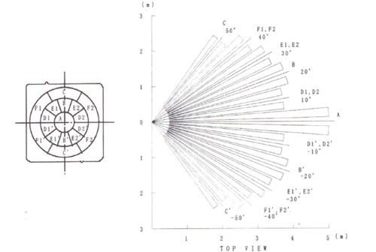

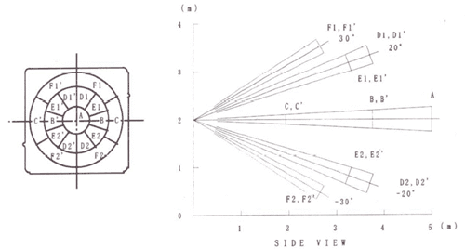

Here is another image, more qualitative but not as quantitative. (Note that the sensor in the Adafruit shop is 110° not 90°)

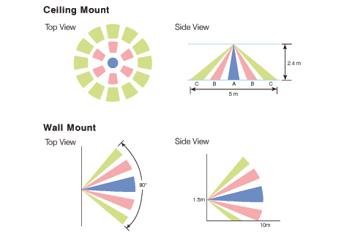

**1.B TYPES OF PIR MOTION SENSOR**

There are many different types of sensor that can be used in the home. Some of these are very simple, and others can be very complex and expensive.  
  
This is the second of a series of pages about motion sensors. If you have not seen the [first page](http://www.shed.com/tutor/sensors.html), you might want to visit it before this one.  
  
Here are some of the 'keywords' that you will discover as you browse this subject:

|  |  |  |
| --- | --- | --- |
| **Area Sensors**  Passive InfraRed Proximity (rf field) Microwave/Radar Ultrasonic Vibration Video |  | **Local Sensors**  Active InfraRed (light beam) Visible Light beam Laser Beam [Contact](http://www.shed.com/articles/TN.switches.html) [Tilt](http://www.shed.com/articles/TN.switches.html) [Proximity](http://www.shed.com/articles/TN.proximity.html) Strain/Stress |

http://www.shed.com/images/redball.gif **Important qualities of all sensors**   
  
We want all motion sensors to indicate the same thing : that some condition has changed.  
  
All sensors have some 'normal' state. 

* A door is closed.
* Motion has not been detected in some period.
* No one is standing on the floor mat at the door.
* Or maybe the laser beam across the driveway is 'clear'.

Some sensors only report when the 'normal' status is disturbed, others also report when the condition reverts to 'normal'.  
  
Other considerations will be things like the sensitivity of the sensor, the range of the sensor, whether the sensor requires a special power supply, whether the sensor can directly or indirectly send X-10 signals, and whether you must download or create a special function which will monitor some special device.   
  
http://www.shed.com/images/redball.gif **Signalling method ( how do we know ? )**   
  
There are several different models of motion sensor which are available that**directly** send X-10 signals to the powerlines, and others which send **wireless**signals to a **'transceiver'** which then re-transmit the command to the powerlines.  
  
http://www.shed.com/images/redball.gif **Addressing (Which sensor is talking ?)**   
  
If we have multiple sensors in the home, then it is very important to be able to identify which sensor is talking.  
  
In the X-10 system, each sensor is 'named' with a unique address. This must always be the case, regardless of the technology. It is also just the information that XTension needs to be able to recognize the exact unit, and locate it in your database.  
  
http://www.shed.com/images/redball.gif **Free Dusk Sensors**   
  
All of the motion sensors produced by X-10 provide a free 'dusk' sensor. This is quite nice, but always involves another X-10 house/unit address. When you have a lot of these motion sensors, it's not necessary to have each of the dusk sensors enabled.  
  
However, you can use this sensor as a verification of a light having turned on. Just make sure that you experiment with the placement, so that you know that the light sensor will not trigger for any reason other than the light turning on.  
  
The 'light' or 'dark' sensor status is often integrated into the 'logic' of the motion sensor, which sometimes produces aggravating functionality for the home automator. But all of the X-10 devices can be [easily modified](http://www.shed.com/tutor/images/ms12hack.gif) so that they always behave as motion sensors, and never report whether it is 'dark' or 'light'.  
  
Since we just don't need that many light sensors, we might make good use of that extra ability of the PIR sensors. If we clip the 'light sensor' inside the Hawkeye, and replace it with any kind of [switch](http://www.shed.com/articles/TN.switches.html), it can become even more useful.

http://www.shed.com/images/redball.gif **Special sensors and 'hacks'**   
  
Some really neat sensors must be handled differently, and may require that you be clever at programming, or that some good samaritan has already offered a free plug-in that will handle the 'odd' device.   
  
Some common devices can be 'hacked' easily to make it behave differently, or to add some useful function.  
  
Many of these 'hacks' have been discovered and described on other pages and websites. For a beginning, we will limit this article to things which only require a screwdriver ( and maybe wire cutter/strippers)

**Basic types of 'motion' sensors**  
**Passive InfraRed ( PIR )**  
  
The most frequent use of the **PIR** sensor is as an **'area'** sensor. Whether it is to detect 'someone moving in the front yard', or 'someone moving in the bathroom', or 'someone moving through a doorway', or even 'someone opened the beer cooler', it is all technically the same sensor and logic.   
  
There is a simple electronic device which is sensitive to **'heat'**, or rather the infrared light that is emitted by warm or hot objects (like humans).

The 'logic' of the PIR sensor is that it must detect 'significant change' of the normal level of heat within the 'field' of its view. The circuits that control it must be able to determine what 'normal' is, and then close a switch when the normal field changes, as when a human walks in front of it.

It must also be able to 'tolerate' slow changes within the field, and remember that as the new 'normal'. This is so that gradual changes like the sunlight changes

throughout the day, don't cause a false alarm. This is a standard behavior of 'PIR' type sensors. (There's a lot more electronics there than just the black window...)

The most common (PIR) type of X-10 motion sensor is the **"Hawkeye"** model line from X-10. It is quite small, and although can be quite a pain, it is cheap (often a freebie), it can be very useful.

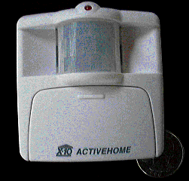

Currently, there have been 3 different 'upgrades' to this device. But the last two are functionally identical. The latest is simply more rugged for outdoor use.

**1C. GSM Module**

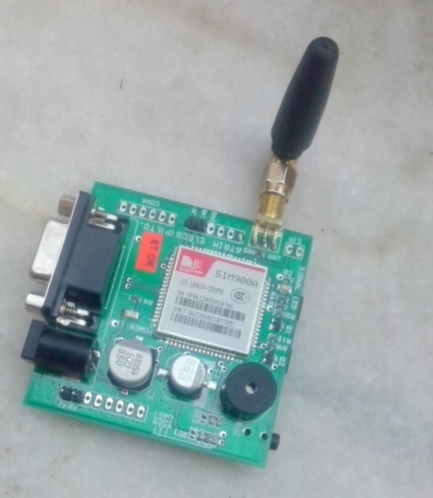

GSM (Global System for Mobile) / GPRS (General Packet Radio Service) TTL –Modem is

SIM900 Quad-band GSM / GPRS device, works on frequencies 850 MHZ, 900 MHZ, 1800

MHZ and 1900 MHZ. It is very compact in size and easy to use as plug in GSM Modem.

The Modem is designed with 3V3 and 5V DC TTL interfacing circuitry, which allows User to directly interface with 5V Microcontrollers (PIC, AVR, Arduino, 8051, etc.) as well as 3V3 Microcontrollers (ARM, ARM Cortex XX, etc.).

The baud rate can be configurable from 9600-115200 bps through AT (Attention) commands. This GSM/GPRS TTL Modem has internal TCP/IP stack to enable User to connect with internet through GPRS feature. It is suitable for SMS as well as DATA transfer application in mobile phone to mobile phone interface. The modem can be interfaced with a Microcontroller using USART (Universal Synchronous Asynchronous Receiver and Transmitter) feature (serial communication

**1.D Circuit Diagram**

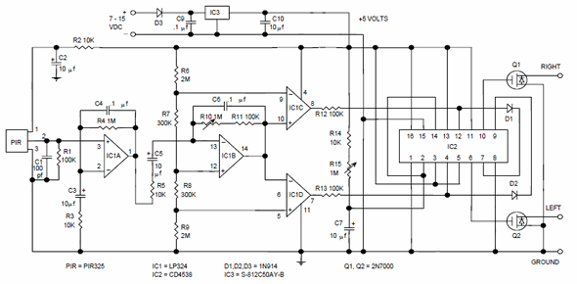

**PIR motion detector, General purpose motion detector**

This motion detector circuit uses a low cost LM324 quad operational amplifier as both a two stage amplifier and a window comparator. Amplifiers IC1A and IC1B have a gain of 100 each for a total of about 10,000. IC1C and IC1D form a window comparator that responds to signals about 200 millivolts above and 200 millivolts below Vcc/2. This window is set by the low current voltage drops across D1 and D2. Comparator

**Chapter 1**

**Components used in Project**

|  |  |  |  |
| --- | --- | --- | --- |
| S.No. | **Component** | Value | Qualtity |
|  | | | |
| 1 | **Micro Controller** | AT89C51 | 1 |
| 2 | **GSM Module** | SIM900A | 1 |
| 3 | **LCD** | 16x2 | 1 |
| 4 | **CD Case** |  | 1 |
| 5 | **Motor Driver** | L293D | 1 |
| 6 | **Voltage Regulator** | LM7812 | 1 |
| 7 | **Voltage Regulator** | LM7805 | 1 |
| 8 | **Comparator** | LM358 | 1 |
| 9 | **Resistors** | 1K | 5 |
| 10 | **Resistors** | 4.7K | 5 |
| 11 | **Resistors** | 10K | 5 |
| 12 | **Resistors** | 10K Pullup SIL | 2 |
| 13 | **Resistors** | 10K POT | 3 |
| 14 | **Capacitor** | 470uf | 1 |
| 15 | **Capacitor** | 100uf | 2 |
| 16 | **Capacitor** | 10uf | 2 |
| 17 | **Capacitor** | 33pf | 2 |
| 18 | **Capacitor** | 104pf | 2 |
| 19 | **LED** |  | 5 |
| 20 | **Crystal Oscillator** | 11.0592MHz | 2 |
| 21 | **IC Base** | 8-Pin | 1 |
| 22 | **IC Base** | 40-Pin | 1 |
| 23 | **IC Base** | 16-Pin | 1 |
| 24 | **Buzzer** |  | 1 |
| 25 | **Transistor** | BC547 | 2 |
| 26 | **Switch** | 2-Pin | 15 |
| 27 | **Transformer** | 9-0-9 (750mA) | 1 |
| 28 | **Diode** | 1N4007 | 4 |
| 29 | **Cable** | Power | 1 |
| 30 | **Connector** | Male Strip | 3 |
| 31 | **Connector** | Female Strip | 1 |
| 32 | **Connector – Female** | Double Sided 2-Pin | 5 |
| 33 | **Connector – Female** | Double Sided 3-Pin | 2 |
| 34 | **Connector – Female** | Double Sided 5-Pin | 1 |
| 35 | **Zero PCB** | Copper Clad | 2 |
| 36 | **Connecing Wire** |  | 1 |
| 37 | **Soldering Wire** |  | 1 |

**Chapter 2**

**Components used in Project**

**2.A Resistors**

Resistance is a passive component. It is defined as opposition to flow of current and is defined by Ohms law, which states that current in circuit is directly proportional to electromagnetic force and inversely to resistance. It is measured in ohms .Material shows a great variability in there resistively & in fact it is one of the most widely used physical quantities. Material such as silver & copper have very low resistance, steal & nickel offer such a high resistance that it can be considered to be virtually infinite & in fact they are regarding as insulator.

To match various requirement of there many applications, resistor vary wide in size & composition. Although in general , resistor are cylindrical in shape with a lead at either ends, there physical size ranges from larger than a pin head to over all the dimension of several cm material used in there construction vary.

**Resistors are two types :-**

(1) Fixed resistors

(2) Variable resistors.

**2.B Resistivity and Continuity**

The electrical resistance of a wire would be expected to be greater for a longer wire, less for a wire of larger cross section area, and would be expected to depend upon the material out of which the wire is made. Experimentally, the dependence upon these properties is a straightforward one for a wide range of conditions, and the resistance of a wire can be expressed as

**R = ρL / A**

ρ = resistivity

L = length

A = cross sectional area

The factor in the resistance which takes into account the nature of the material is the resistivity. Although it is temperature dependent, it can be used at a given temperature to calculate the resistance of a wire given geometry.

The inverse of resistivity is called conductivity. There are contexts where the use of conductivity is more convenient.

Electrical Conductivity = ơ = 1/ρ

**2.C Types of Resistors**

(1) Fixed Resistors :-

The most common fixed resistor is the composition type. The resistance element is made of graphite, or some other form of carbon, and alloy materials. These resistors generally have resistance values that range from 0.1Ω to 22MΩ.

Another kind of fixed resistor is the wire wound type. The resistance element is usually made of nickel-chromium wire wound on a ceramic rod. These resistors generally have resistance values that range from 1Ω-100kΩ.

(2) Variable Resistors :-

Variable resistors are used to adjust the amount of resistance in a circuit. A variable resistor consists of a sliding contact arm that makes contact with a satisfactory resistance element. As the sliding arm moves across the element, its point of contact on the element changes, effectively changing the length of the element. The rating of a variable resistor is its resistance at its highest setting.

Variable resistors are also called rheostats or potentiometers. Potentiometers generally have composition elements. They are used as control devices in radios, amplifiers, televisions, and electrical instruments.

**Rating Tolerances**

The actual resistance of a resistor may be greater o less than its indicated rating. The possible range of variance from the indicated rating is called its tolerance. Common tolerances for composition resistors are ±5, ±10, and ±20 percent. Wire wound resistors usually have a tolerance of ±5 percent.

The resistor is the simplest, most basic electronic component. In an electronic circuit, the resistor opposes the flow of electrical current through itself. It accomplishes this by absorbing some of the electrical energy applied to it, and then dissipating that energy as heat. By doing this, the resistor provides a means of limiting or controlling the amount of electrical current that can pass through a given circuit.

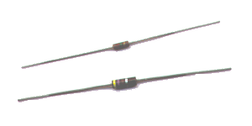

The design of PCB is the first step in manufacturing of PCBs. The reproducibility of PCB and its serviceability depend on design of PCB. PCB designing for “CALLED-ID Unit Using Micro-Controller “ is shown.

**PCB designing and fabrication**

**The various process is involved in PCB designing** **are** : -

(a) Schematic Diagram

(b) Layout

(c) Artwork

(d) Photo lithography

(e) Etching

(f) Plating

(g) Drilling

(h) Tinning

(i) Finishing

(j) Protective Coating

**1. Schematic Diagram :-**

A schematic diagram consists of a system of graphic symbols that represent electronic, electrical and electrochemical components PCB designer will transform schematic diagram into layout & artwork. Schematic Diagram can be drawn from :-

**(a) Drawing Schematic from elementary circuit diagram.**

The process of laying out schematic diagram based on the engineering sketch consists of :-

(i) Collecting data about components that are depicted on the diagram.

(ii) Organising the general layout of the diagram based on circuit functions or equipment subdivision.

(iii) Identifying the components by reference designations and other data.

(iv) Adding adequate notes to drawing.

**(b) Schematic Diagram from Prototype Instruments :-**

Drawing schematic from an actual circuit is skill which can be quickly sharpened by practice. It can be frustrating for first few times. Practice on simple circuits first. The various steps involved in drawing a schematic are:-

(i) Sketch the component layout of the board.

(ii) A sign arbitrary circuit symbols if not already outputs.

(iii) Identify probably Vcc , ground, inputs and outputs.

(iv) Start tracing with probably signal input.

(v) Complete intermediate drawing.

(vi) Reduce, redraw straighten drawing in stages.

(vii) Draw final schematic with inputs on left and so forth in a schematic diagram.

(viii) Schematic diagrams are generally drawn to show the components in stages, with each stage centered around a major components (transistor, IC etc.)

(ix) Normal signal flow on schematic diagram is from left to right and from top to bottom.

(x) There should be proper routing of interconnection to avoid confusion.

(xi) Reference designations should be used for the components used in schematic diagram.

**2. Layout :-**

The printed circuit layout is defined as being a sketch that shows the printed wiring substrate, the physical size of all electronics and mechanical components, and the routing of conductors that serve to interconnect the electronic parts. The layout is usually prepared in sufficient detail to permit the generation of documentation and artwork.

(a) A separate terminal pad should be provided with its centre on grid for each component lead to be the conductor pattern. In cases where large conductor area are to be used instead of individual conductor pads each components lead must still be provided with its own access hole.

(b) Whenever possible, conductor paths should be along the vertical and horizontal lines of the grid system. However irregular paths are acceptable only if they simplify the conductor pattern.

(c) The attention should be focussed on conductor width and spacing. The cross section area of the conductor paths is determined by the amount of current it is expected to handle for optimum ckt reliability, the component should be positioned rules that conductor width and spacing are not less than the specified throughout the centre conductor pattern.

**3. Artwork Generation Methods:-**

(a) Ink drawing

(b) Black tape on transparent sheet.

(c) Cut and strip method

(d) Red/Blue tapes on transparent sheet

(e) Preprocessing : This consist of initial preparation of a copper clad laminate ready for subsequent processing. Copper clad laminates are available in a fixed range of sizes. Thus oversized copper clad laminates are cut to the required PCB size. Once a piece of copper clad laminate is selected, and is cut to size, the next state is to drill tooling holes.

The copper surface of copper clad laminate need to be thoroughly cleaned before actual processing. The cleaning is required in order to remove all contaminants such as grease or copper oxide film which readily forms and exposed copper unless these contaminants are removed, they adversely affect the adhesion of the resist with copper surface. The copper is first chemically cleaned in a 5 to 10% by volume of bath of Hcl and water. This bath removes copper oxide and grease film or resist material copper surface.

**4. Photolithography :-**

Copper tracks and land patterns are defined on copper clad boards by means of Photo Lithography process. This process for PCBs involves the exposure of photo resist material to light through a mask. Both positive and negative photo resist materials can be used depend upon actual process. A preprocessed board is laminated with a photo resist materials can be used depend upon actual process. A preprocessed board is laminated with a photo sensitive resist material. The photo resist can be applied either in liquid form or as a dry film. Liquid resists are applied by spraying dipping, roller coating, low speed whirling or flow coating. The use of a negative photo resist, which becomes insoluble on exposure, is almost universal. The exposure uses UV light through a mask.

The exposure part of photo lithography involves exposure of the film coated copper clad board to UV light through an artwork mask. The mask can take the form of either a photographic positive image or a photographic image of the required track layout. The image should be correctly aligned with the board’s geometry in case of double sided & multiplier board.

After exposure the image needs to be developed. The development stage involves removal of resist material. In case of dry film resist, the developing agent is usually either a solvent such as trichloroethane or sodium carbonate solution.

**5. Etching:-**

This process is used for removal of a PCBs copper surface which is not protected by an etch resist material. The etching is performed by exposing the surface of the board to an etchant solution which dissolves away the exposed copper areas, there by leaving the desired conductor pattern on the board. The different types of etchant solution used are:-

(a) Ferric chloride

(b) Cupric chloride

(c) Chromic acid

(d) Alkaline ammonia

Etching of PCB is done by spray type etching machines. In spray etching, the etchant is pumped under pressure from the sump via a pipe network to the nozzles and from there gets splashed on to the boards. Spray etching machines offer high etching uniformity and last etching rate.

The high etching uniformity is achieved by spraying through a full number of equally distributed nozzles in ring supply. High etching rate results from fresh flow of the etchant over the boards. Inefficient etching will result in excess copper being present on the board and can cause short-circuiting between the tracks. Over-etching will result in etchant undercutting the track area defined by the etch resist layer and can result into broken track or thin track.

After completion of the etching, the board is rinsed under water for approximately 30 seconds and patted dry. This process will not remove the photo resist, which is allowed to remain on the PCB to protect the copper during drilling and punching.

**6. Drilling:-**

Drilling of component mounting holes into PCB is important mechanical operation in PCB production processes. The drilling is used to create the component lead holes and through holes in a PCB. Holes may also be required for heat sink assembly or connectors connection to the board. The drilling is always performed from copper side of the processed board for the following reasons:-

(a) To use the small etched centre hole in terminal pad, which aid in bit alignment.

(b) To minimize the possibility of pulling the copper foil away from the board base.

The drilling machines for PCB application are available in wide ranges of design and principles and generally have high speed range which is required for economic and efficient drilling. The drilling process can be performed by using CNC drilling machine. Using suitable jig, board are stacked and mounted on drilling machine. The board to be drilled machine. The board to be drilled are sandwiched between two sheets of material in order to reduce drill burrs on actual board by passing through abrasive rollers.

**7. Protective Coating:-**

PCB are stocked before being taken for final assemble. The PCB should retain its solder ability for long time so that reliable solder joint can be produced during assembly. The coating is done for following reasons:-

(a) It ensure protection of the copper track.

(b) To establish connection between different layers of double-sided PCB.

(c) It increases wear resistance and decreases contact resistance.

The coating can be of three types:-

(a) Immersion coating

(b) Electroless coating

(c) Electroplating

**8. Testing:-**

Each board needs to ensure that the required connections exist, that there are not short-circuit and that drill holes are properly placed. The testing usually consist of visual inspection and continuity testing.

**PCB SOLDERING**

With the component properly assembled, the final process necessary to complete the construction of PCB board is to produce sound electrical connection between component lead and foil pattern these connection are done by soldering. The soldering process consist of application of molten solder and a flux. There are two major soldering processes in use: hand soldering and mass solderin.

**SOLDER:**

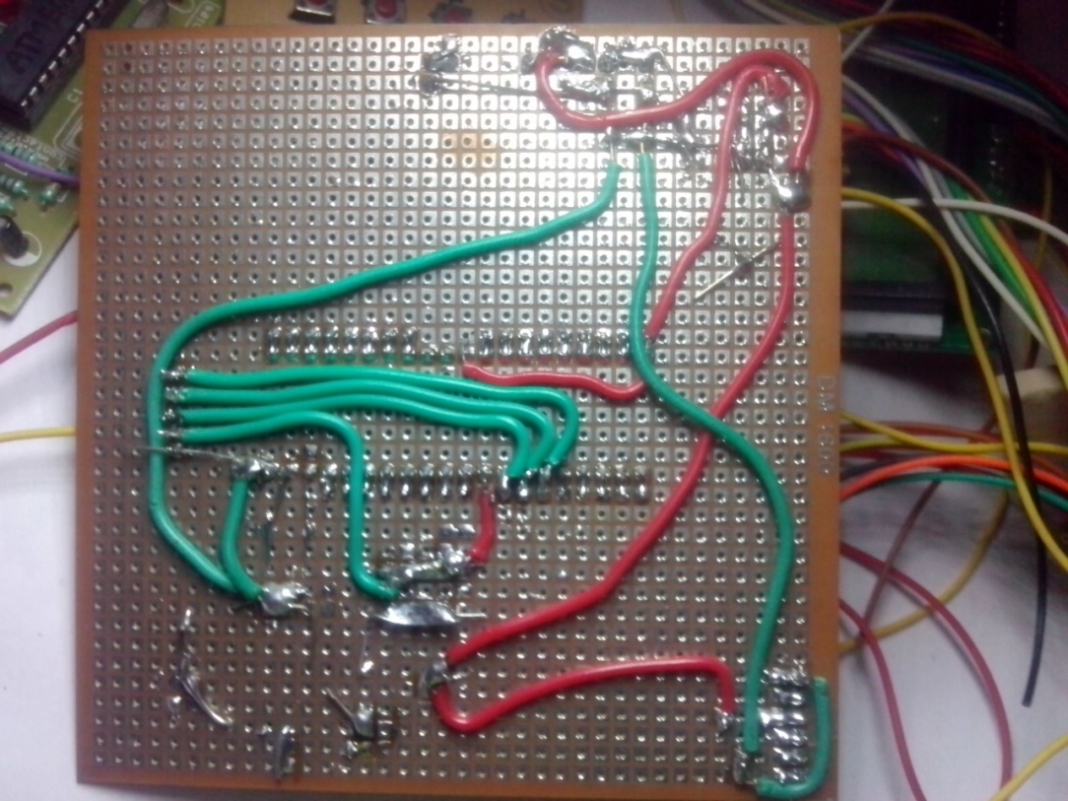

Most of the soldering is done by using tin lead alloy. Pure tin melts at 188°C and pure lead melts at 327°C and their mixture melts at 188°C when ration of tin and lead is approximately 60/40. As tin is more expensive than lead, solder with a higher tin content is more costly. Commercial available solder contains different amount of antimony, bismuth, cadmium, silver etc. Solder with a tin lead ration of 60/40 is used, because of its excellent wetting action. Wetting describes the ability of solder to readily spared and uniformly over the entire metal surface. For general soldering 18 gauge wire solder is used.

**Fluxes:**

The solder process requires that the surface should be totally clear so that metal to metal contact can be established. Most of metals in air forms an oxide film which prevents wetting. To maintain a clean surface ‘ flux ’ is used. A flux should have following properly:-

(a) It should be sufficiently active at room temp.

(b) It must be mobile enough to allow the solder to flow at this temp.

(c) It must remove fingerprint, dirt, grease etc.

Traditionally fluxes can be grouped as :-

(a) Rosin based fluxes

(b) Water soluble fluxes

(c) Solvent removable synthetic fluxes.

**Soldering Irons:-**

Soldering iron is used during soldering process to supply sufficing heat solder by transfer of heat from the soldering iron tip. These are generally three types of soldering irons.

(a) Resistive soldering iron

(b) Soldering gun

(c) Temperature controlled soldering iron.

The temperature controlled soldering iron are most suited to maintenance purposes when dealing with semiconductors component which are likely to damaged by over heating. This iron operates much slowly. These irons use thermocouple to sense the temperature of the tip & heating rate is controlled by means of thyristors. In temperature controlled type irons operator can set the desired temperature. The power is automatically turned off & on to maintain the tip at desired temperature.

**Chapter 3**

**MICROCONTROLLER BASED DOOR OPENER**

**3.A Introduction**

Due to the need to increase the security of life and properties in our environment,security systems are used as selective systems to decide who has access to a given location based on a personal distinctive trait of the user. It also serves the function of sensing or detecting false intrusion (using input sensory devices and gives early warning using audio warning devices alarm – light indicators and remotely controlled computer systems etc). The term false intrusion here is used to mean any form of attempt to gain entry without following the proper pre-designed protocol/protocols. From time past until present, security locks usually includes mechanical devices made of forged metal i.e simple lock and bolt, the door chain, pin tumbler lock, the jam lock and padlock etc. Other recently developed security devices are gadgets like laser beam detectors, motion detectors and magnetic card readers. Most recent of these devices are offshoots of biometric engineering. They include voice recognition systems, finger print readers, retina eye scanners etc. The major characteristic of security devices is to prevent an intruder from gaining access to a location. Most of these devices however have lapses which give an unauthorized person access to where they are barred i.e the simple jam lock and pad lock can be forced open or the keys duplicated by unauthorized persons and under certain conditions, i.e. physical changes of the individual concerned, the biometric devices sometimes fail in recognizing the authentic individual concerned. Hence they cannot be totally relied on. Furthermore, these devices are very expensive; its use is restricted to only a few individuals or organizations that can afford it. Devices such as motion detectors, light detectors among others are susceptible to be triggered by false signals such as noise impulses, whenever its sensitivity is increased.

They are not suitable for most outdoor security protection due to the fact that they don’t posses high discriminative capability during operation and they are fairly expensive. It is hence imperative to provide a locking device, one which is also efficient and reliable; with high discriminative capability, non reliance on the physical quality of the individual concerned, which when forced open triggers an alarm and which is by far less expensive than their counterparts. This has led to the design and construction of a microcontroller based electronic lock system. It includes using correct personal identification numbers to operate the locking device, by conditioning the access based on the configuration of the security device thereby granting access to the user with correct pin number. The microcontroller based electronic lock finds application in homes, banks in the field of military applications i.e. ammunition ware house, industries, ministries and government parastatals etc.

**3.B Objectives:-**

The major objectives are:

i) To provide a security lock that is efficient and reliable, at cheaper price in comparison with traditional devices.

ii) To design and implement a security system which gives authorized users the privilege to change their personal identification numbers any time.

iii) To provide opportunity of textual displays as compared to conventional ones which only show digits.

iv) To reduce the bulkiness characterized with other security locks of its type by the use of a microcontroller, the AT89S52.

**Methodology**

The approach is by experimental modular design where each is analyzed extensively and tested for functionality so as to prove satisfactory before joining the blocks to form the overall circuit. The modules considered in this project are:

i) The power supply module

ii) The keypad unit

iii) The display unit (16*2 LCD)

iv) The buzzer alarm

v) The control unit (AT89S52)

vi) The output e.g. LED

Textbooks, journals as well as various materials from the internet formed the major sources of information for this report. A detailed study of the data sheets and instruction set of the microcontroller unit used undertaken.

**3.C Brief Description**

This project entails the use of a microcontroller AT89S52 as the basis for a security lock. The keypad accepts digits from the user, based on the code written inside the AT89S52 microcontroller, the digits are simultaneously shown on the 16*2 LCD screen. The microcontroller compares the digits with the right pin number in its EEPROM memory (internal) e.g. if it is correct, it activates the port to which the LED is connected, (the LED represents the load door latch). Else, it prompts the user to try again with a textual display on the 16*2 LCD, and also accompanies it with a buzzer sound. The Authentic user can change the pin to another one, which is stored in the memory by first inputting the right code. The crystal oscillator used is 20MHz speed. The system is peculiar because of the use of the microcontroller and the 16*2 LCD. The 16*2 LCD has 16 pins and uses a serial protocol which is compatible with the microcontroller AT89S52 with 4 pins use for communication. It is powered with 2.75V, while the microcontroller is powered with 5V using LM 7812 variable voltage regulator.

**Literature Review**

When we think of locks, we think of a bolt containing a notch known as a talon, which is operated by moving the bolt backwards or forward by engaging a key in the talon. But there is more to locks than just a bolt or latch. A lock is a mechanical device that can be use for securing doors, cabinets, lid of brief cases or other luggage. It consists essentially of a bolt guarded by a mechanism which can be released by a mechanical, hydraulic or electrical/electronic actuator. The oldest known mechanical functioning lock was an Egyptian door lock used about 2000BC, made of wood and fastened vertically on the door post, the wooden block contained moveable pins or “pin tumblers” that dropped by gravity into openings in the cross piece of “bolts” and locked the door. It was operated by a wooden key with pegs that raised the number of tumblers sufficiently to clear the bolt so that it could be pulled back. The major disadvantage with it is that it was wholly made of wood. The Romans made an improvement on this by fabricating the first metal locks which was later improved by Robert Barson, an English man in 1778 and Linus Yale Jnr an American in 1861. The Yale lock consists of essentially a cylindrical plug placed in an outer barrel. The plug is rotated and in turn moves the bolt of the lock by means of a cam. The inserted key raises five pins of different sizes into corresponding holes in the plug. The most common form of cylindrical lock used in homes is the so-called night latch, operated from a key from outside and a knob from inside. In the 20th century, as machine tools and manufacturing methods became more sophisticated, locks were produced, which are either key operated (opened) or keyless. In the late 20th century, electromechanical locks were developed to trip electrical circuit as seen in automobile ignitions. Other keyless locks include remote controlled lock, “security card” operated and electronic code lock.

This report is about the electronic code lock, which is designed to respond to an electronic logic signal mechanism, with a digit sequence counter performing the function of a key. They are operated by inputting the correct code by external means through a keypad into a microcontroller which already have a pin number in its EEPROM memory (internal) to compare with, so that if it is correct (that is the pin number inputted by the user), It activates the port to which the LED is connected (the load that represents the door). Else it activates an audio alarm to alert security men or authorized user whenever there is an intrusion from unauthorized users.

**Theoretical Background of Microcontrollers**

A microcontroller often abbreviated MCU is a single computer chip integrated circuit that executes a user program normally for the purpose of controlling some device hence the name microcontroller. Microcontroller includes several thousands of transistors stored into one chip, with addition of external peripherals such as memory input-output lines, timers built into it.

**Microcontroller AT89S52 and Features**

AT89S52 belongs to a class of 8-bit microcontrollers of RISC architecture. It has the following features as shown in the table below and an internal structure.

**Flash program memory**:

This is used for storing a written program, it is an 8K x 14 words memory which can be programmed and cleared more than once, it makes the AT89S52 suitable for device development.

**EEPROM**:

It is a memory used for storing important data that must not be lost if power supply suddenly fails. The AT89S52 is made up of up to 256 x 8 bytes of EEPROM data memory. For instance the EEPROM stores the personal identification number which is compared with the user input so as to activate the port to which the door relay is connected.

**RAM:**

It contains data used by a program during its execution. The AT89S52 consists of up to 368 x 8 bytes of data memory (RAM).

**Pin Description**

VCC - supply voltage

GND – ground

P0.0 – P0.7 Port 0 is an 8 bit open drain bi-directional I/O port for external memory accessing. Port 0 is used to access lower order address bus.

P1.0 – P1.7 Port 1 is an 8 bit bi-directional I/O port with internal pull-ups. Port 1 also receives the low-order address bytes during flash programming and verification.

P2.0 – P2.7 Port 2 is an 8 bit bi-directional I/O port with internal pull-ups.

P3.0 – P3.7 Port 3 is an 8 bit bi-directional I/O ports with internal pull-ups.

RST – Reset input. A high on this pin for two machine cycles resets the 8051 microcontroller.

ALE – Address Latch Enable is used for latching the low address byte during external code memory access. AD0-AD7 are multiplexed lines.

PSEN – Program Store Enable is an active low output signal. PSEN is activated twice each machine cycle.

EA/VPP – External Access pin.

XTAL1 & XTAL2- The MCS-51 has on chip oscillator but requires an external clock to run it. A quartz crystal oscillator is connected to inputs XTAL1 & XTAL2.

**APPLICATION OF AT89S52**

Its applications include the design and implementation of electronic lock with display controlling home appliances, remote sensors and several safety devices. It is also used in systems where permanent storage of various parameters is needed due to its EEPROM memory; this system includes codes for transmitters, motor speed, receiver frequency etc

**Design**

In the construction of this project, the modular design is employed, the project is divided into two parts namely hardware and software with each of the section analyzed extensively. The block diagram of the microcontroller based Electronic door lock is shown below:

KEY PAD INPUT AND ENCODER

POWER SUPPLY

OUTPUT LED

DISPLAY UNIT

ALARM UNIT

AT89S52

MICROCONTROLLER BASED CONTROL UNIT

Block Diagram of a Microcontroller Based Electronic Door Lock.

The construction of this project employs majorly the AT89S52 microcontroller for several reasons.

Firstly, it is operated on a +5V DC supply and draws very little current. Further more, it has a very low power dissipation and high speed of operation and still maintains its data in case of power loss. Finally it has a large storage memory.

**Power Supply Unit**

This project utilizes DC voltages at two specified levels viz; +5V to supply the microcontroller and 2.75V to power the 16*2 LCD display. The power supply unit consist of a step down transformer, a rectifier circuit (bridge), a filter and three voltage regulators as shown in the block diagram below.

LM3 17 REGULATOR

15V REGULATOR

15V REGULATOR

FILTER CAPACITOR

RECTIFIER

TRANSFORMER

**The Transformer**

A transformer is an electrical A.C. component or equipment which consists of two or more coils that are linked together by mutual inductance. The centre tapped step down transformer, with the ratings 240V/24Vrms, 500mA is employed. This is required to suit the circuit fed by the DC supplied, it also the mains circuit from the power line.

For an ideal transformer,

VpIp = VsIs

Where Vs - is the voltage at the secondary coil

Vp - is the voltage at the primary coil

Is - is the current at the secondary coil

Ip - is the current at the primary coil

**The Rectifier**

This circuit converts the transformer AC output to DC power supply. This design uses four diodes; this arrangement is known as bridge rectification, as shown in the diagram below: C1 **+20V** When point A is positive with respect to point B (positive half cycle), current flows through the forward biased diodes D1 and D3 while D1 and D2 are reverse biased, giving the output wave form in (b). Conversely, when point B is positive with respect to point A (positive half cycle), current flows through the forward biased D1 and D2 giving an output wave form in (c). The result of the two wave form is an output voltage whose ripple frequency is twice the supply frequency.

For a bridge rectifier with four diodes

Vrms = 12V

Vpeak = Vrms 2 = 12 2 = 16.9V

The average DC voltage is given by

Vdc = Vpeak – diode drop imposed by rectifier circuit

Vdc = 16.9V – 1.5V

Vdc ≈ 15V

**The filter circuit**

The output of the rectifier circuit above is pulsating; it has a DC value and very significant AC component called RIPPLES. The filter circuit consists of capacitors (reservoir condenser) and is necessary to minimize the ripple content in the rectifier output. The capacitor charges up during the diode conduction period, to peak secondary voltage and discharges through the load when the rectifier voltage falls. If the output voltage has a ripple voltage of 50V, the filter Where I = 500mA (max transformer secondary current)

*dv* = ripple content = 50V

*dt* = time during which the capacitor discharges

= 2

1 the period of the 50Hz supply input

= 2

1 × 50

1 = 100

1 = 10mscan be chosen as follows;

Hence,

C ==500×10-3×10×10-3 ∕ 50=100μF

Thus, the filter capacitor is chosen as 100μf.

**The Regulator**

The microcontroller IC requires a +5V DC supply. The 7805 fixed voltage regulator thus functions to provide a stable 5V, DC voltage at its output. The 7805 is a three-pin integrated circuit with external connections. Its input voltage is from the 7815 Regulator output and has a capacitor C2 =100μF, connected across the output to remove transient response. Apart from the supply to the microcontroller the 7805 regulator supply the input of the LM 317 regulator which gives a voltage output of 2.75V for powering the 16*2 LCD.

**Hardware Design**

The functional Operation of the control Circuitry of the project is described in the Subsection.

**The Control Unit**

The microcontroller AT89S52 is the main control unit it processes and verifies the keypad inputs (Entered pin), and generate control signals to power the lock mechanism. Thus, this is done by comparing the digits with the right PIN number in the EEPROM memory (internal), if it is correct, it activates the port RD1, which has the LED (this represents the load), and also send an output text display on the 16*2 LCD, indicating “ACCESS GRANTED”. Else, it prompts the user with a text display that “ACCESS DENIED” and also with a buzzer sound. The speed of execution of each task is enhanced using higher frequency of 20Hz. The instruction cycle of the microcontroller divide this frequency by four.

**Clock Generator (Oscillator)**

The clock oscillator is a clock pulse generator required to operate the microcontroller, it increases the speed of execution of each task. Based on the microcontroller AT89S52, a 20MHz is suitable for the operation hence; it is used in this project.

**The keypad unit**

The keypad is employed as an external interface to the system through a user can communicate with the microcontroller to perform already programmed function. In this project a 4 x 4 matrix keypad was employed as shown in fig. The keypad perform two separate functions, they can serve as numeric keys and function keys. The numeric keys are design to input numeric values into the system, they include “0 – 9”. While the function keys “A – D” and “#”, “*” are used to process the inputs. In the design of the keypad, there is a need for mandatory processing unit to decipher an authentic key pressed from an unwanted noise pulse.This is known as key debouncing, to prevent against multiple single inputs a debounced delay of 150ms was chosen as a start value in the program written, this provided an advantage of reduced hardware and flexible debouncing period.



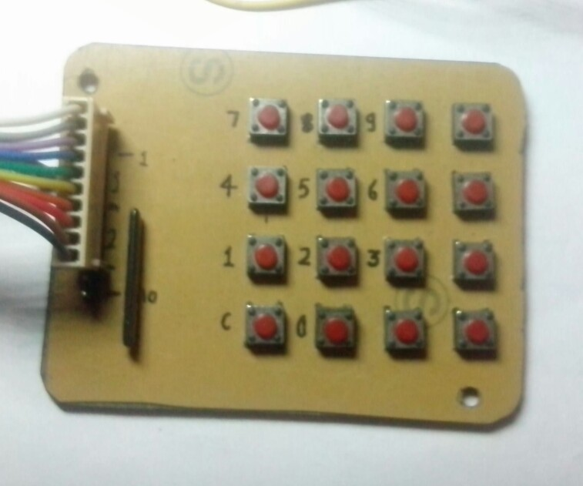

The output of the button pressed on the keypad is displayed on the 16*2 LCD, this help to makes correction if a mistake is made during the typing of the codes. When the input pin is correct it causes the microcontroller to generate the control signal to drive the lock mechanism else it setoff the buzzer alarm.

**The Display Panel Unit**

The display used is the Nokia 3310 liquid crystal display so as to give the user the opportunity of textual display as compared to conventional ones which shows digits. The 16*2 LCD uses a serial protocol having 8pins with 4pins used for communication with the microcontroller and the rest four pins used for other various function such as Reset, Ground, Vout and Vdd of 2.75V to run the LCD. During the operation the following text will be displayed. When an input is to be made,”1” is selected so that “Enter Pin” shows on the screen to tell the user to input the three digits pin, if the digits is not 1 to 3, “Invalid option” is displayed with a prompt telling the user “1 – 3 pins then # ”. If correct pin is entered, it displayed “ACCESS GRANTED” else “ACCESS DENIED”. The modified option is used to change the PIN to ensure security of the user’s code, the user is asked for the Old pin “Enter Old Pin” when done it displays a prompt “Enter Old Pin Again”. If the former is the same with the latter it prompt the user “Enter New Pin”, it ask once again for the new pin else it prompt with “PIN MISMATCH OLD PIN RETAIN”. The setting option is used if the pin is to be displayed in hidden mode or to appear as typed. The user is prompt with “HIDE OR DISPLAY AS TYPED”. If the Hide is picked, then the pin appears with “+”, else it displayed as typed.



The LM7812 output is used in powering the display. From the fig 3.4., 5V is supplied to the input of LM7812; two resistors R1and R2 of 10KΩ and 11KΩ are respectively used to limit the load. This is within the range of voltages that can power the LCD.

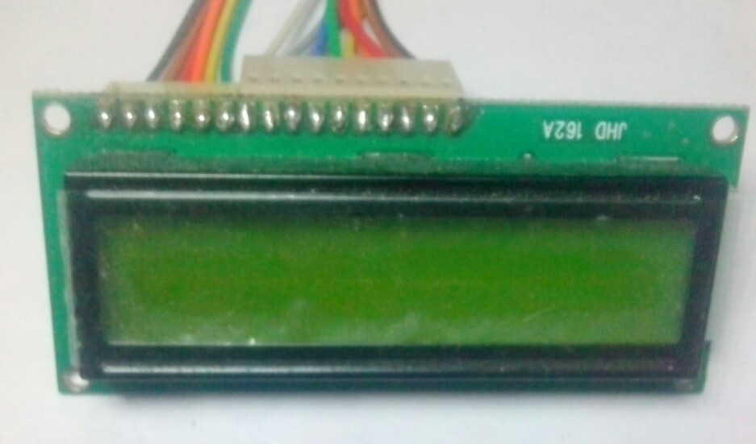

16x2 LCD used for display

**3.E Control Unit, Description and Result**

**The AT89S52 Programmer Unit**

Programming the microcontroller requires a special hardware called 89S52 programmer. It is a device that connects to the PC via either serial, parallel or USB port. With the microcontroller chip placed into the socket on the device, a special software known as mickrobasic helps transfer the program from PC to the 89S52 programmer which in turn “Burns” the program into the chip. Once done the chip is removed and inserted into the circuit, to perform its functions.

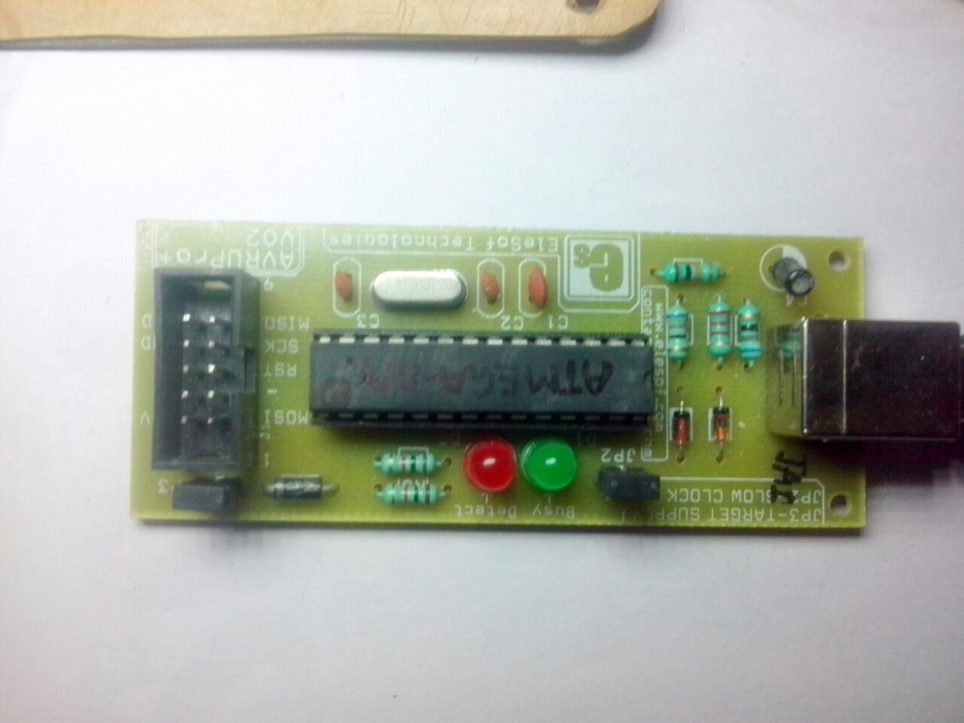

**Alarm unit**

The buzzer alarm is included in the circuit to come on when a wrong pin is inputed, so as to alert against intruders. When a wrong pin is entered the microcontroller activates the port to which the Buzzer is connected to.

**SOFTWARE DESIGN**

The software is designed in order to support the effectiveness of the hardware device. The complex and intricate operating routine of the software is achieved by writing the program in modules starting with the program algorithm, followed by the program flowchart as shown. The software was written in Mikrobasic language, and was written in sections for easy debugging and troubleshooting. Each section is tailored to meet the duty that will be imposed on the corresponding hardware unit

**Display program**

The display panel unit display upto twelve different statutes based on the operating state of the device, these statutes are “OPEN”,”ENTER PIN”,”ACCESS GRANTED”,”ACCESS DENIED”,”ENTER OLD PIN”,”ENTER NEW PIN”,”PIN MISMATCHED”,”PIN CHANGED”,”ENTER NEW PIN AGAIN”,”HIDE OR Serial EEPROM Microcontroller chip Programmer unit Host computer (PC) DISPLAY NUMBER”,”PRESS ANY KEY”,”CLOSE DEVICE”. The design of the font

was done using the LCD font designer in the mikrobasic crack.

**Keypad program**

Apart from the programming of the key pad to coordinating the activities of the microcontroller, another major programming done here is preventing jumping of the input key (bouncing). The program scans each key to detect a depressed key, and then a debouncing routine which is about 150ms delay is then executed. The routine is important so as to decipher authentic key pressed from Electrical noise which can lead to multiple input. The program decodes an authentic key pressed and stores the numeric values in a given register, it repeats this until the required numbers of key inputs are collected are collected. The “#” function key then enters the values to be processed.

**Algorithm for the Electronic Lock**

1. Default pin is stored in EEPROM.

2. Menu Showing Options

If digit is not 1-3, prompt with “invalid option” next message 1-3 pls, then # is the default enter key, pin should be 5 digits (use a function to alert user about this).

MENU

4. OPEN

5. MODIFY

6. SETTINGS

Select option

i) Code entered with Keypad command, analyzed for screen.

ii) Compare pin code with correct code.

iii) If wrong, increase counter by one – display wrong code, and beep

i) If right, activates LED and display, ”access granted”

ii) Display Reset Option for activated LED.

i) Prompt for user to type former code.

ii) Code entered with the keypad command, analyzed for Screen.

iii) Compare pin code with correct code.

iv) If wrong, increases counter by one – display wrong code, and beep.

v) If right, prompt user to type new pin, followed by #.

vi) prompt the user to type new pin again, followed by # to confirm if new code is not repetitive, retain original code and go back to menu, else replace with new code and store in EEPROM Memory then go back to Menu.

i) Prompt the user to hide or Display the pin.

ii) If the Hide is picked, then the Code/pin is shown with “+” sign.

**Discussion of Result**

From the above stated test results, it shows that the LED flashes when the right code is entered, when the port to which it is connected is activated. Also the alarm is triggered ON when the wrong code is inputted. But this whole process is without some limitations, which includes majorly the strange behavior of the buttons of the keypad 34 unit. The cause of the problem was because of the need for more debounce time for the buttons. This was promptly adjusted making the output of the keypad to be better.

**CHAPTER 4**

**THE PIR SENSOR**

A passive infrared sensor (PIR sensor) is an electronic [sensor](http://en.wikipedia.org/wiki/Sensor) that measures [infrared](http://en.wikipedia.org/wiki/Infrared) (IR) light radiating from objects in its field of view. They are most often used in [PIR-based motion detectors](http://en.wikipedia.org/wiki/Passive_infrared_sensor#MOTION).

**4.A Operating principal**

All objects with a temperature above [absolute zero](http://en.wikipedia.org/wiki/Absolute_zero) emit [heat](http://en.wikipedia.org/wiki/Heat) energy in the form of radiation. Usually this radiation is invisible to the [human eye](http://en.wikipedia.org/wiki/Human_eye) because it radiates at infrared wavelengths, but it can be detected by electronic devices designed for such a purpose.

The term *passive* in this instance refers to the fact that PIR devices do not generate or radiate any energy for detection purposes. They work entirely by detecting the energy given off by other objects. PIR sensors don't detect or measure "heat"; instead they detect the infrared radiation emitted or reflected from an object

**4.B Construction**

Infrared radiation enters through the front of the sensor, known as the 'sensor face'. At the core of a PIR sensor is a [solid state](http://en.wikipedia.org/wiki/Solid_state_(electronics)) sensor or set of sensors, made from [pyroelectric](http://en.wikipedia.org/wiki/Pyroelectricity)materials—materials which generate energy when exposed to heat. Typically, the sensors are approximately 1/4 inch square (40 mm2), and take the form of a [thin film](http://en.wikipedia.org/wiki/Thin_film). Materials commonly used in PIR sensors include [gallium nitride](http://en.wikipedia.org/wiki/Gallium_nitride) (GaN), [caesium nitrate](http://en.wikipedia.org/wiki/Caesium_nitrate) (CsNO3), [polyvinyl fluorides](http://en.wikipedia.org/wiki/Polyvinyl_fluoride), derivatives of [phenylpyridine](http://en.wikipedia.org/wiki/Phenylpyridine), and [cobalt](http://en.wikipedia.org/wiki/Cobalt) [phthalocyanine](http://en.wikipedia.org/wiki/Phthalocyanine). The sensor is often manufactured as part of an [integrated circuit](http://en.wikipedia.org/wiki/Integrated_circuit).

**4.C PIR based motion Detector**

[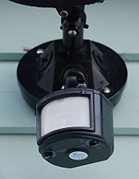](http://en.wikipedia.org/wiki/File:Motion_detector.jpg)

A PIR motion detector used to control an outdoor, automatic light.

[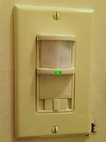](http://en.wikipedia.org/wiki/File:Light_switch_with_passive_infrared_sensor.jpg)

An indoor light switch equipped with PIR-based[occupancy sensor](http://en.wikipedia.org/wiki/Occupancy_sensor)

A PIR-based [motion detector](http://en.wikipedia.org/wiki/Motion_detector) is used to sense movement of people, animals, or other objects. They are commonly used in [burglar alarms](http://en.wikipedia.org/wiki/Burglar_alarm) and automatically-activated [lighting](http://en.wikipedia.org/wiki/Lighting) systems. They are commonly called simply "PIR", or sometimes "PID", for "passive infrared detector"

### 4.D Operation

An individual PIR sensor detects changes in the amount of infrared radiation impinging upon it, which varies depending on the temperature and surface characteristics of the objects in front of the sensor.[[2]](http://en.wikipedia.org/wiki/Passive_infrared_sensor#cite_note-Glolab_Corporation-2) When an object, such as a [human](http://en.wikipedia.org/wiki/Human), passes in front of the background, such as a [wall](http://en.wikipedia.org/wiki/Wall), the temperature at that point in the sensor's field of view will rise from [room temperature](http://en.wikipedia.org/wiki/Room_temperature) to [body temperature](http://en.wikipedia.org/wiki/Body_temperature), and then back again. The sensor converts the resulting change in the incoming infrared radiation into a change in the output voltage, and this triggers the detection. Moving objects of similar temperature to the background but different surface characteristics may also have a different infrared emission pattern, and thus sometimes trigger the detector.[[4]](http://en.wikipedia.org/wiki/Passive_infrared_sensor#cite_note-4)

PIRs come in many configurations for a wide variety of applications. The most common models have numerous [Fresnel lenses](http://en.wikipedia.org/wiki/Fresnel_lens) or mirror segments, an effective range of about ten meters (thirty feet), and a field of view less than 180 degrees. Models with wider fields of view, including 360 degrees, are available—typically designed to mount on a ceiling. Some larger PIRs are made with single segment mirrors and can sense changes in infrared energy over one hundred feet away from the PIR. There are also PIRs designed with reversible orientation mirrors which allow either broad coverage (110° wide) or very narrow "curtain" coverage, or with individually selectable segments to "shape" the coverage.

### 4.E Differential detection

Pairs of sensor elements may be wired as opposite inputs to a [differential amplifier](http://en.wikipedia.org/wiki/Differential_amplifier). In such a configuration, the PIR measurements cancel each other so that the average temperature of the field of view is removed from the electrical signal; an increase of IR energy across the entire sensor is self-cancelling and will not trigger the device. This allows the device to resist false indications of change in the event of being exposed to brief flashes of light or field-wide illumination. (Continuous high energy exposure may still be able to saturate the sensor materials and render the sensor unable to register further information.) At the same time, this differential arrangement minimizes [common-mode interference](http://en.wikipedia.org/wiki/Common-mode_interference), allowing the device to resist triggering due to nearby electric fields. However, a differential pair of sensors cannot measure temperature in this configuration, and therefore is only useful for motion detection.

### Product design

The PIR sensor is typically mounted on a [printed circuit board](http://en.wikipedia.org/wiki/Printed_circuit_board) containing the necessary electronics required to interpret the signals from the sensor itself. The complete assembly is usually contained within a housing, mounted in a location where the sensor can cover area to be monitored.

The housing will usually have a plastic "window" through which the infrared energy can enter. Despite often being only [translucent](http://en.wikipedia.org/wiki/Translucent) to visible light, infrared energy is able to reach the sensor through the window because the plastic used is [transparent](http://en.wikipedia.org/wiki/Transparent_materials) to infrared radiation. The plastic window reduces the chance of foreign objects (dust, insects, etc.) from obscuring the sensor's field of view, damaging the mechanism, and/or causing [false alarms](http://en.wikipedia.org/wiki/False_positive). The window may be used as a filter, to limit the wavelengths to 8-14 micrometres, which is closest to the infrared radiation emitted by humans. It may also serve as a focusing mechanism; see below.

### Focusing

Different mechanisms can be used to focus the distant infrared energy onto the sensor surface.

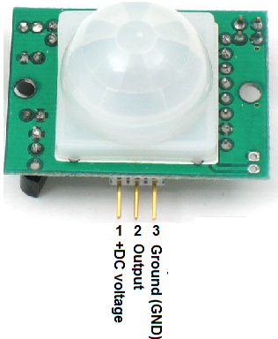

**Component in side PIR motion detector**

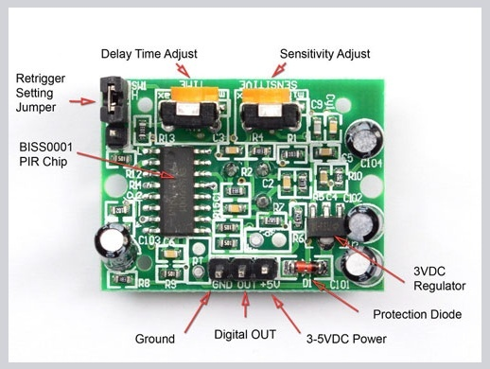

**Circuit Board of PIR Sensor**

**4.F Circuit diagram**

# PIR MOTION DETECTOR CONTROL CIRCUIT PIR-325

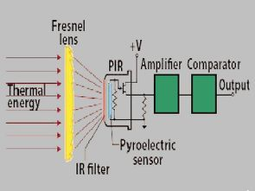

**PIR Sensor control circuit** has three different application circuits LM324, CD4538 used integrated. PR control circuit output control, opto Kubli, relays, MOSFET (right, left) can be used detailed description (in English) and PIR sensor works about the logic diagrams’s circuits RE200B, PIR325 PIR sensors used



**PIR motion detector, General purpose motion detector**

This motion detector circuit uses a low cost LM324 quad operational amplifier as both a two stage amplifier and a window comparator. Amplifiers IC1A and IC1B have a gain of 100 each for a total of about 10,000. IC1C and IC1D form a window comparator that responds to signals about 200 millivolts above and 200 millivolts below Vcc/2. This window is set by the low current voltage drops across D1 and D2. Comparator outputs feed through D3 and D4 that pass only the positive transitions into CD4538 CMOS single shot IC2 which feeds into Q1 that drives relay RY1.

**Direction sensing motion detector** This motion detector circuit will both detect motion and indicate the direction that an infrared emitting body is moving. The amplifier and comparator circuits This type of motion detector can be used to indicate people entering or leaving a building or in some robotic applications.

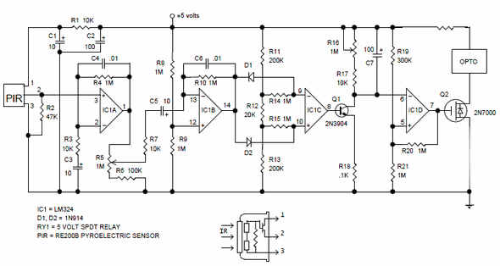

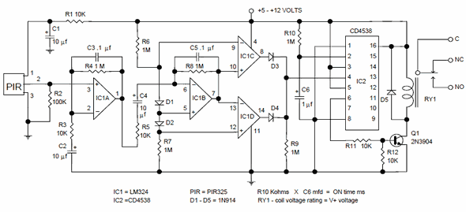

CHAPTER 5

**5.A GSM Module**



GSM (Global System for Mobile) / GPRS (General Packet Radio Service) TTL –Modem is

SIM900 Quad-band GSM / GPRS device, works on frequencies 850 MHZ, 900 MHZ, 1800

MHZ and 1900 MHZ. It is very compact in size and easy to use as plug in GSM Modem.

The Modem is designed with 3V3 and 5V DC TTL interfacing circuitry, which allows User to directly interface with 5V Microcontrollers (PIC, AVR, Arduino, 8051, etc.) as well as 3V3 Microcontrollers (ARM, ARM Cortex XX, etc.). The baud rate can be configurable from 9600-115200 bps through AT (Attention) commands. This GSM/GPRS TTL Modem has internal TCP/IP stack to enable User to connect with internet through GPRS feature. It is suitable for SMS as well as DATA transfer application in mobile phone to mobile phone interface. The modem can be interfaced with a Microcontroller using USART (Universal Synchronous Asynchronous Receiver and Transmitter) feature (serial communication).

**5.B Features**

• Quad Band GSM/GPRS : 850 / 900 / 1800 / 1900 MHz

• Built in RS232 to TTL or vice versa Logic Converter (MAX232)

• Configurable Baud Rate

• SMA (Sub Miniature version A) connector with GSM L Type Antenna

• Built in SIM (Subscriber Identity Module) Card holder

• Built in Network Status LED

• Inbuilt Powerful TCP / IP (Transfer Control Protocol / Internet Protocol) stack for

• internet data transfer through GPRS (General Packet Radio Service)

• Audio Interface Connectors (Audio in and Audio out)

• Most Status and Controlling pins are available

• Normal Operation Temperature : -20 °C to +55 °C

• Input Voltage : 5V to 12V DC

**Hardware Description**

**SIMCOM SIM900A GSM Module**

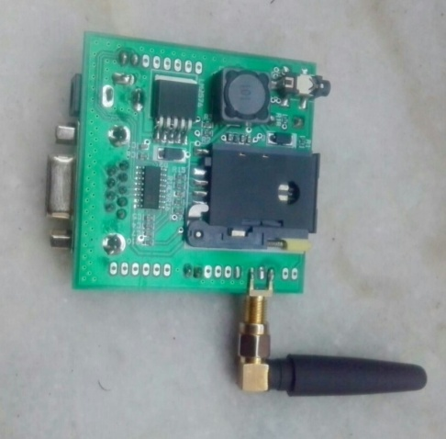

SIMCOM SIM900A GSM Module

This is actual SIM900 GSM module which is manufactured by SIMCOM. Designed for

global market, SIM900 is a quad-band GSM/GPRS engine that works on frequencies GSM

850MHz, EGSM 900MHz, DCS 1800MHz and PCS 1900MHz. SIM900 features GPRS

multi slot class 10/ class 8 (optional) and supports the GPRS coding schemes CS-1, CS-2,

CS-3 and CS-4. With a tiny configuration of 24mm x 24mm x 3mm, SIM900 can meet

31 almost all the space requirements in User‟s applications, such as M2M, smart phone, PDA

and other mobile devices.

**5.C MAX232 IC**

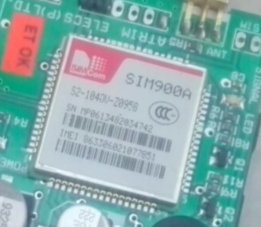

The MAX232 is an integrated circuit that converts signals from an RS-232 serial port to

signals suitable for use in TTL compatible digital logic circuits, so that devices works on TTL

logic can share the data with devices connected through Serial port (DB9 Connector).

Figure-3.8.2 MAX232 IC

**Serial port / DB9 connector:**

User just needs to attach RS232 cable here so that it can be connected to devices which have

Serial port / DB9 Connector.

32

**5.D GSM Antenna**

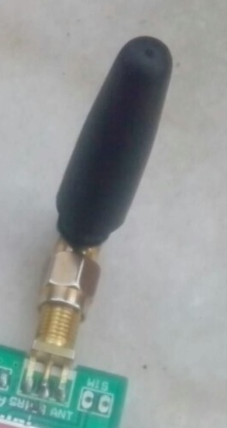

Using a suitable antenna can greatly improve your chances of success when trying to detect

weak radio signals. Unfortunately the range of suitable antennas for the GSM bands is very

limited and/or very expensive. Having previously experimented with building

homemade/DIY wireless (Wi-Fi) antennas, I felt doing the same for a GSM antenna shouldn't

be a problem.

**5.E Frequency Range**

The antenna needs to cover the full Standard and Extended GSM-900 bands, (880 MHz To

960 MHz). The GSM-1800 bands would be nice but it's optional, I can design another antenna for those bands.

**Size**

The antenna needs to be small and compact; the goal would be to have something that could

easily fit inside a laptop bag.

**Gain**

The antenna should have a reasonable amount of gain; I was hoping for something about 8

dB

**Build**

The antenna should be easy to build and require tools and materials that are easy and cheap to

acquire. A little bit of math‟s- An important measurement in radio is the distance between the

same points on two consecutive wave cycles, this distance is known as the wavelength and is

denoted with the symbol λ (lambda).

To calculate the wave length of a radio signal we take the Speed of Light in a Vacuum and

divide it by the frequency in Hertz (the number of full wave cycles per second).Wavelength

(λ) = Speed of Light / Frequency The center frequency for my antenna design is 920 MHz so

the wavelength is: Wavelength (λ) = 299792458 / 920000000 = ~0.325861367 = ~0.326

meters.

**5.F SIM (Subscriber Identity Module) Card Slot:**

This onboard SIM card slot provide User functionality of insert a SIM (GSM only) card of

any service provider. Process of inserting and locking SIM card into SIM card slot is given in

this manual. While inserting in and removing out SIM card from SIM card slot, User needs to

take precaution that power supply should be OFF so that after making Power supply ON it

will be easy to reinitialize with SIM for this module.

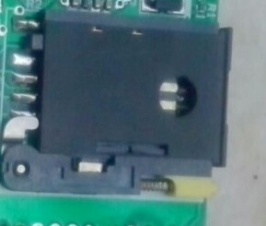

SIM Slot

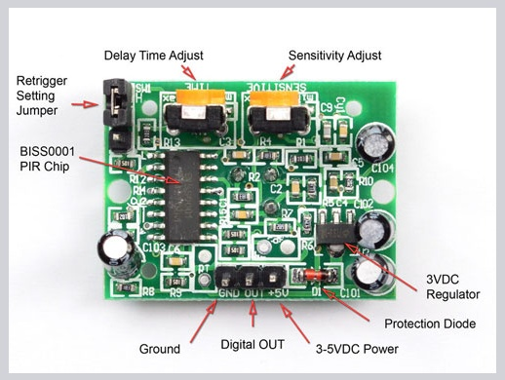

PIR Circuit Board With Components

**Chapter 6**

**PASSWORD BASED HOME SECURITY SYSTEM**

**6.A SOFTWARE SIMULATION**

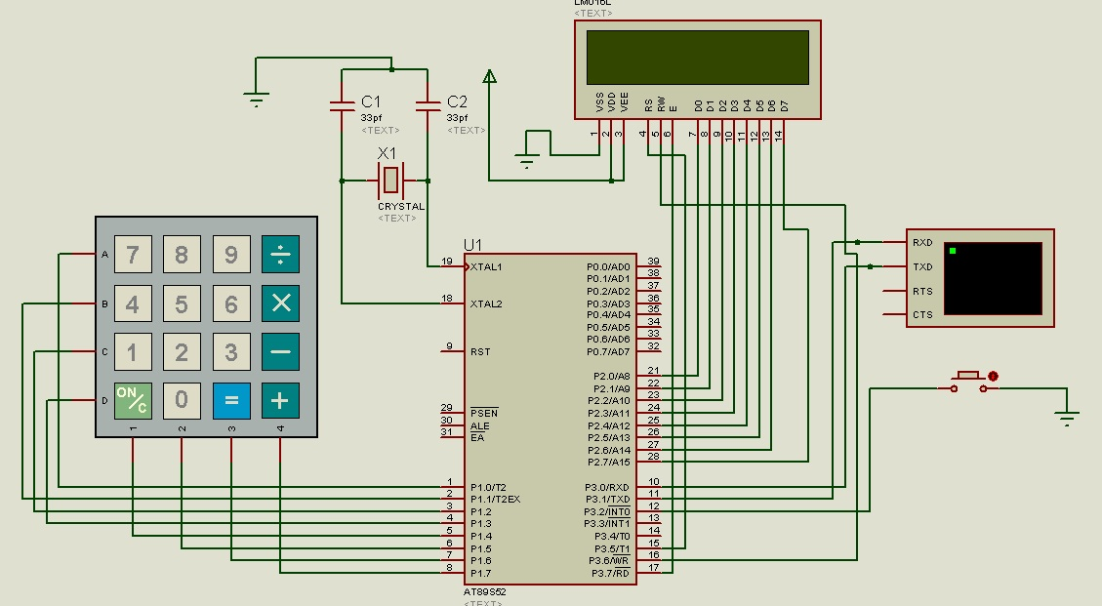

**6.B PROGRAMMING**

#include"INCFILES.h"

void Delay(unsigned int a) //delay function

{

int j;

int i;

for(i=0;i<a;i++)

{

for(j=0;j<150;j++)

{

}

}

}

void serial_init(void);

unsigned int j;

//Setup the serial port for 9600 baud at 11.0592MHz.

//-------------------------------------------------

void serial_init(void)

{

SCON = 0x50; /* SCON: mode 1, 8-bit UART, enable rcvr */

TMOD |= 0x20; /* TMOD: timer 1, mode 2, 8-bit reload */

TH1 = 0xFD; /* TH1: reload value for 9600 baud @ 11.0592MHz*/

TR1 = 1; /* TR1: timer 1 run*/

TI = 1; /* TI: set TI to send first char of UART*/

}

//Delay Routine start here

void delay1(int n)

{

int i;

for(i=0;i<n;i++);

}

void delay2(int n)

{

int i;

for(i=0;i<n;i++)

delay1(1000);

}

void main()

{

unsigned int i;

unsigned char passkey[5];

IE=0x81;

lcd_ini(1,1);

lcd_str("WELCOME TO");

lcd_position(2,1);

lcd_str("MY HOME ");

delay_sec(1);

serial_init();

while(1)

{

lcd_ini(1,1);

lcd_str("ENTER PASSWORD");

lcd_position(2,1);

for(i=0;i<5;i++)

{

passkey[i]=keypad_4x4();

lcd_display('*');

delay_msec(250);

}

if(strncmp(passkey,"12345",5)==0)

{

lcd_ini(1,1);

lcd_str("WELCOME MR.JAI ");

lcd_position(2,1);

lcd_str("JAI PRAKASH ");

motor_ccw(5);

delay_sec(2);

lcd_ini(1,1);

lcd_str("THANK YOU ");

lcd_position(2,1);

lcd_str("HAVE A NICE DAY ");

motor_cw(5);

delay_sec(2);

}

else

{

lcd_ini(1,1);

lcd_str("UNAUTHORIZED");

BZR=0;

delay_msec(100);

BZR=1;

}

}

}

void alcohol_sens() interrupt 0

{

lcd_ini(1,1);

lcd_str("THREAT DETECTED ");

delay_sec(1);

lcd_ini(1,1);

lcd_str("DOOR CLOSING ");

motor_ccw(5);

delay_sec(1);

lcd_position(2,1);

lcd_str("EMERGENCY ");

delay_sec(1);

lcd_ini(1,1);

lcd_str(" SENDING SMS ");

printf("AT+CMGF=1%c",13);

delay2(20);

printf("AT+CMGS=\"9990763547\"%c",13);//Text Mode| hex value of 13 is 0x0D (CR )

delay2(20); //Type your mobile number Eg : "9884467058"

printf("HIGH SECURITY ALERT SOME ONE ENTERED IN YOUR ROOM"); //Type text as u want

delay2(20);

printf("%c",0x1A); //line feed command

delay2(20);

lcd_position(2,1);

lcd_str("SYSTEM RESTART ");

delay_sec(1);

lcd_ini(1,1);

lcd_str("LOADING.........");

lcd_position(2,1);

lcd_str("SYSTEM RESTART ");

delay_sec(30);

while(sensor==0);

lcd_ini(1,1);

lcd_str("ENTER PASSWORD ");

lcd_position(2,1);

}

**HEADER FILE**

**<INCFILE.H>**

#include<REG51.H>

#include<string.h>

#include"delay.h"

#define LCD P2

sbit RS=P3^5;

sbit RW=P3^6;

sbit EN=P3^7;

#define keypad P1

sbit ROW1=keypad^0;

sbit ROW2=keypad^1;

sbit ROW3=keypad^2;

sbit ROW4=keypad^3;

sbit COL1=keypad^4;

sbit COL2=keypad^5;

sbit COL3=keypad^6;

sbit COL4=keypad^7;

sbit sensor=P3^2;

sbit motor2_1=P3^3;

sbit motor2_2=P3^4;

#include"lcd.h"

#include"keypad.h"

#include"motor.h"

#include<stdio.h>

#include<conio.h>

**6.C WORKING**

**When the system turn on it always require a password to access the security**

**When the password entered if the password is correct then the system open the door other wise it will send the msg on the mob no.(9990763547 ) Which is Used for the SMS alert**

**A message appear “SOME ONE WANTS TO ACCESS YOUR SECURITY” if password is correct and some one access your security. If any motion detected in the Security area then the doors automatically the doors are close and alarm on and a msg send to the mob.no. (9990763547) which is used in the programming on AT89S52 MICROCONTROLLER.**

**After 30sec the system restart and The Doors are already closed some one open the Door and get the threat**

**Chapter 7**

**Future Scope**

**7.A Bank Security System**

Banking is one of the sectors where technology and advancements in technologies have not been utilized to the fullest potential. Be in security system or access systems or even in material handling in banks. For example in the security systems even today very old practices are followed that can be made lot better using technologies like GSM which is easily usable and also easy to implement at a consumer level.  
In this project we take up one such segment of the banking industry, which is the safety locker system and propose a fault proof system for enhancing the security in banks. In the existing system in banks, for the access of a locker all a individual requires is a key, the locker number and a signature. All of these are relatively easy to either access or duplicate. If any individual has these then they can easily access the locker because there is no other verification or authentication involved.  
In this project we propose a GSM based secure access which combines many details of the individual in a very easy to use system at the customer level. In this project each locker is provided with a simple and low cost digital system that controls the lock to the locker instead of key. This digital system comprises of a small display also mounted on the locker itself. The digital system is connected to a computer in the bank that in turn has the database of the customers, with various details of the customers.  
The digital system using various personal details of the customer like the date of birth and their ATM pin and the date of the particular day generates a random number that is unique to the customer. This random number is display on the display on the locker. when a individual wants to access the locker they have to see the random number and send this number from their registered mobile number to a certain bank number as a SMS, along with their ATM pin.  
A GSM receiver connected to the bank computer receives this SMS sent from the user number and verifies all the details like weather or not the information was sent from the registers mobile number, whether or not the random number is accurate and finally weather or not the ATM pin was correct. After verifying all these details the computer sends a signal to the digital system in the locker to open the locker using a electronic lock.  
If any unauthorized access is detected the system can raise alarm to alert the bank staff of any attempt of unauthorized access. Thus this project can enhance the security of the bank lockers to a very high level, using a complex system that is hard to temper with and at the same time easy for the users to use. This also reduces the manual work involved in the whole locker access process.

**7.B Home Security System**

Home security or [home automation](https://www.elprocus.com/home-automation-systems-applications/) can be achieved by adopting central controllers to control home devices or appliances that sense different variables using appropriate sensors. The main aspect of such a system is a [sensory system](https://www.elprocus.com/sensors-types-applications/) that collects the parameter information like temperature, fire, human presence, gas, etc., and sends the corresponding data to the microcontroller or any other processor. This controller is programmed such that when these parameters cross their prescribed limits, it sends the command signals to various final controlling devices like relays, motors and buzzer devices.

**References**

**1.** [www.google.com](http://www.google.com)

**2.** [www.ieee.com](http://www.ieee.com)

**3.** [www.electronics4u.com](http://www.electronics4u.com)

**4.** Concept of Microcontrollers and Embedded systems from **Md. Ali Mazidi.**

**5.** Concept of GSM module control from **ELECTRONICSLABS.**