**CHAPTER-1**

**1.1 INTRODUCTION**

The world population is increasing day by day and the demand for energy is increasing accordingly. Oil and coal as the main source of energy nowadays, is expected to end up from the world during the recent century which explores a serious problem in providing the humanity with an affordable and reliable source of energy. The need of the hour is renewable energy resources with cheap running costs. Solar energy is considered as one of the main energy resources in warm countries.

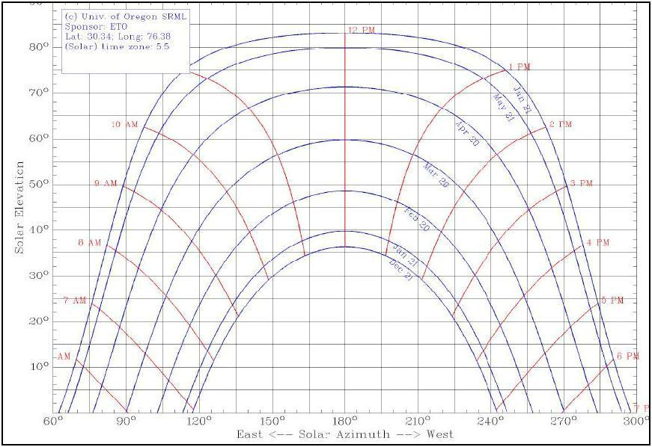

**Figure 1.1 Sun path at latitude of 310**

In general, India has a relatively long sunny day for more than ten months and partly cloudy sky for most of the days of the rest two months. This makes our country, especially the desert sides in the west, which include Rajasthan, Gujarat, Madhya Pradesh etc. very rich is solar energy. Many projects have been done on using photovoltaic cells in collecting solar radiation and Converting it into electrical energy but Most of these projects did not take into account the difference of the sun angle of Incidence by installing the panels in a fixed orientation which influences very highly the solar energy collected by the panel. As we know that the angle of inclination ranges between -90o after sun rise and +90o before sun set passing with 0o at noon. This makes the collected solar radiation to be 0% at sun rise and sun set and 100% at noon. This variation of solar radiations collection leads the photovoltaic panel to lose more than 40% of the collected energy. Fig. 1.1 shows the yearly sun path at the latitude of 30o. From the figure 1.1, one can estimate the exact position of sun in every.

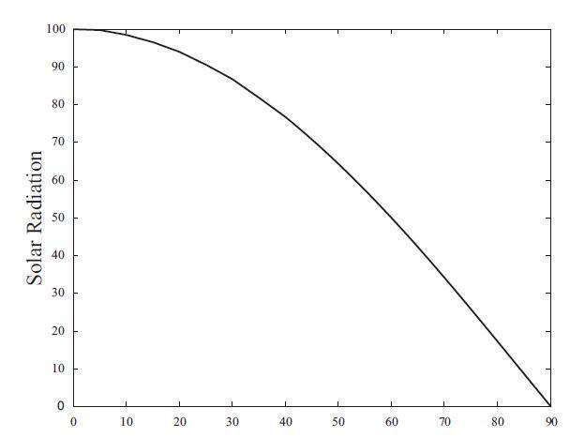

Solar angle of incidence

**Figure 1.2 Relationships between the solar radiation and the solar angle of incidence.**

Month and at any time during the day. The position is decided by two angles in spherical

coordinates; the Altitude angle which is the angle of the sun in the vertical plane in which the sun lies, and the Azimuth angle which represents the angle of the projected position of the sun in the horizontal plane. These two angles will be discussed deeply later in this document. Fig. 1.2 shows a curve for the relationship between the solar radiation and the solar angle of incidence. This figure shows that solar radiations falling on the solar array will be maximum when the angle of incidence on the panel is 00 this means that the panel is perpendicular to the sun.

In July 2009, India unveiled a US$19 billion plan to produce 20 GW (20,000MW) of solar power by 2020. Under the plan, the use of solar-powered Equipment and applications would be made compulsory in all government buildings, as well as hospitals and hotels. On November 18, 2009, it was reported that India was ready to launch its National Solar Mission under the National Action Plan on Climate Change, with plans to generate 1,000 MW of power by 2013.

**India's largest photovoltaic (PV) power plants**

1. Reliance Power Pokaran Solar PV Plant, Rajasthan, 40MW 02011-06 June 2011 Commissioning in March 2012
2. AdaniBitta Solar Plant, Gujarat, 40MW 02011-06 June 2011 To be Completed December 2011
3. Moser Baer - Patan, Gujarat,30MW 02011-06 June 2011 Commissioned July 2011
4. Azure Power - Sabarkantha, Gujarat, 10MW 02011-06 June 2011 Commissioned June 2011
5. Green Infra Solar Energy Limited - Rajkot, Gujarat, 10M W 02011-11-29 November 29, 2 011 Commissioned November 2011

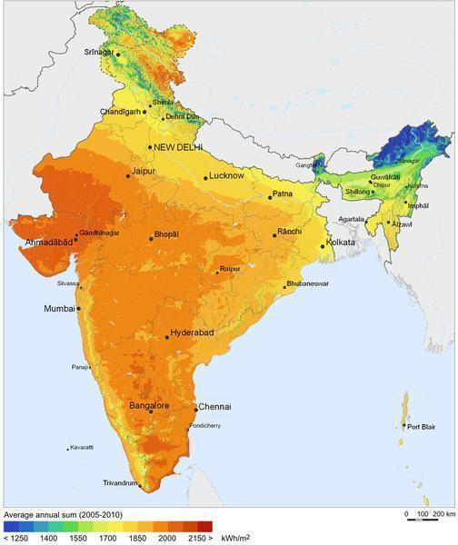

**Figure 1.3 The average solar radiations receiver by different regions in India.**

The daily average solar energy incident over India varies from 4 to7 kWh/m2 with about 1500–2000 sunshine hours per year (depending upon location), which is far more than current total energy consumption. For example, assuming the efficiency of Photo voltaic  thousand times greater than the domestic electricity demand projected for 2015. Fig 1.3 shows the average solar radiations receiver by different regions in India. Gujarat government has signed a MoU with Clinton Foundation to build the world’s largest solar-power plant in the region. The 3,000-megawatt plant near the border between India and Pakistan would be one of four planned by the initiative, a William J. Clinton Foundation program to promote renewable energy. The other proposed sites are in California, South Africa, and Australia.

Solar Tracker is a Device which follows the movement of the sun as it rotates from the east to the west every day. The main function of all tracking systems is to provide one or two degrees of freedom in movement. Trackers are used to keep solar collectors/solar panels oriented directly towards the sun as it moves through the sky every day. Using solar trackers increases the amount of solar energy which is received by the solar energy collector and improves the energy output of the heat/electricity which is generated. Solar trackers can increase the output of solar panels by 20-30% which improves the economics of the solar panel project.

**1.1.1 Concept of solar radiation**

Before talking about the solar tracking systems, we will review some basic concepts concerning solar radiation and mention some important values to better understand the results of this work. The sun, at an estimated temperature of 5800 K, emits high amounts of energy in the form of radiation, which reaches the planets of the solar system. Sunlight has two components, the direct beam and diffuse beam. Direct radiation (also called beam radiation) is the solar radiation of the sun that has not been scattered (causes shadow). Direct beam carries about 90% of the solar energy, and the "diffuse sunlight" that carries the remainder. The diffuse portion is the blue sky on a clear day and increases as a proportion on cloudy days. The diffuse radiation is the sun radiation that has been scattered (complete radiation on cloudy days). Reflected radiation is the incident radiation (beam and diffuse) that has been reflected by the earth. The sum of beams, diffuse and reflected radiation is considered as the global radiation on a surface. As the majority of the energy is in the direct beam, maximizing collection requires the sun to be visible to the Panels as long as possible.

Sunlight takes about 8.3 minutes to reach the Earth from the surface of the Sun. A photon starting at the centre of the sun and changing direction every time it encounters a charged particle would take between 10,000 and 170,000 years to get to the surface.

The total amount of energy received at ground level from the sun at the zenith depends on the distance to the sun and thus on the time of year. It is about 3.3% higher than average in January and 3.3% lower in July. If the extraterrestrial solar radiation is 1367 watts per square meter (the value when the earth-sun distance is 1  astronomical unit), then the direct sunlight at the earth's surface when the sun is at the zenith is about 1050 W/m2, but the total amount (direct and indirect from the atmosphere) hitting the ground is around 1120 W/m2. In terms of energy, sunlight at the earth's surface is around 52 to 55 percent infrared (above 700 nm), 42 to 43 percent visible (400 to 700 nm), and 3 to 5 percent ultraviolet (below 400 nm). At the top of the atmosphere, sunlight is about 30% more intense, having about 8% ultraviolet (UV), with most of the extra UV consisting of biologically damaging short-wave ultraviolet

Direct sunlight has a luminous efficiency of about 93 lumens per watt of radiant flux, higher than most artificial lighting, including fluorescent. Multiplying the figure of 1050 watts per square meter by 93 lumens per watt indicates that bright sunlight provides an illuminnce of approximately 98000 Lux (lumens per square meter) on a perpendicular surface at sea level. The illumination of a horizontal surface will be considerably less than this if the sun is not very high in the sky. Averaged over a day, the highest amount of sunlight on a horizontal surface occurs in January at the South Pole.

Sun light is the key factor in the photosynthesis the process used by plants and other autotrophic organisms to convert light energy, normally from the sun, into chemical energy that can be used to fuel the organisms' activities.

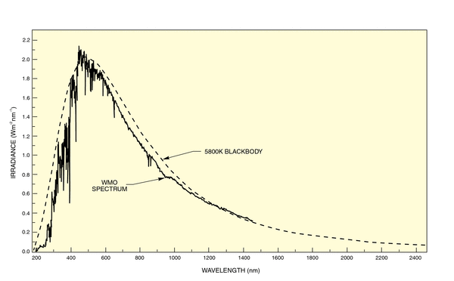

**Fig 1.4 Relation between wavelength and irradiation**

**1.1.1.1 Extraterrestrial and Terrestrial Spectra**

**Extraterrestrial Spectra**

Figure shows the spectrum of the solar radiation outside the earth's atmosphere. The range shown, 200 - 2500 nm, includes 96.3% of the total irradiance with most of the remaining 3.7% at longer wavelengths. Many applications involve only a selected region of the entire spectrum. In such a case, a "3 sun unit" has three times the actual solar irradiance in the spectral range of interest and a reasonable spectral match in this range.

**Terrestrial Spectra**

The spectrum of the solar radiation at the earth's surface has several components Direct radiation comes straight from the sun, diffuse radiation is scattered from the sky and from the surroundings. Additional radiation reflected from the surroundings (ground or sea) depends on the local "albedo." The total ground radiation is called the global radiation. The direction of the target surface must be defined for global irradiance. All the radiation that reaches the ground passes through the atmosphere, which modifies the spectrum by absorption and scattering. Atomic and molecular oxygen and nitrogen absorb very short wave radiation, effectively blocking radiation with wavelengths <190 nm. When molecular oxygen in the atmosphere absorbs short wave ultraviolet radiation, it photo dissociates. This leads to the production of ozone. Ozone strongly absorbs longer wavelength ultraviolet in the Hartley band from 200 - 300 nm and weakly absorbs visible radiation. The widely distributed stratospheric ozone produced by the sun's radiation corresponds to approximately a 3 mm layer of ozone at STP. The "thin ozone layer" absorbs UV up to 280 nm. Wavelength dependent Rayleigh scattering and scattering from aerosols and other particulates, including water droplets, also change the spectrum of the radiation that reaches the ground (and make the sky blue). For a typical cloudless atmosphere in summer and for zero zenith angle, the 1367 W m-2 reaching the outer atmosphere is reduced to ca. 1050 W m-2 direct beam radiation, and ca. 1120 W m-2 global radiation on a horizontal surface at ground level.

**The Changing Terrestrial Solar Spectrum**

Absorption and scattering levels change as the constituents of the atmosphere change. Clouds are the most familiar example of the ground level spectrum also depends on how far the sun's radiation must pass through the atmosphere. Elevation is one factor. Denver has a mile (1.6 km) less atmosphere above it than does Washington, and the impact of the time of year on solar angle is important, but the most significant changes are due to the earth's rotation .At any location, the length of the path the radiation must take to reach ground level changes as the day progresses. So not only are there the obvious intensity changes in ground solar radiation level during the day, going to zero at night, but the spectrum of the radiation changes through each day because of the changing absorption and scattering path length. With the sun overhead, direct radiation that reaches the ground passes straight through the entire atmosphere, all of the air mass, overhead. We call this radiation "Air Mass 1 Direct" (AM 1D) radiation, and for standardization purposes we use a sea level reference site. The global radiation with the sun overhead is similarly called "Air Mass 1 Global" (AM 1G) radiation. Because it passes through no air mass, the extraterrestrial spectrum is called the "Air Mass 0" spectrum.  
The atmospheric path for any zenith angle is simply described relative to the overhead air mass. The actual path length can correspond to air masses of less than 1 (high altitude sites) to very high air mass values just before sunset. Our Oriel Solar Simulators use filters to duplicate spectra corresponding to air masses of 0, 1, 1.5 and 2, the values on which most comparative test work is based.

**1.1.1.2 Declination angle**

The declination of the sun is the angle between the equator and a line drawn from the centre of the Earth to the center of the sun. The declination is maximum (23.450) on the summer/winter (in India 21 June and 22 December) The declination angle, denoted by δ, varies seasonally due to the tilt of the Earth on its axis of rotation and the rotation of the Earth around the sun. If the Earth were not tilted on its axis of rotation, the declination would always be 0°. However, the Earth is tilted by 23.45° and the declination angle varies plus or minus this amount. Only at the spring and fall equinoxes is the declination angle equal to 0°.

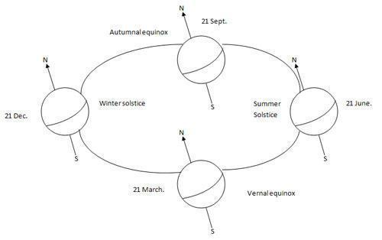

**Figure 1.5 the Declination Angles**

**1.1.1.3 Hour angle**

The Hour Angle is the angular distance that the earth has rotated in a day. It is equal 15 degrees multiplied by the number of hours from local solar noon. This is based on the nominal Time, 24 hours, required for the earth to rotate once i.e. 360 degrees.

Solar hour angle is zero when sun is straight over head, negative before noon, and positive after noon. (Here noon means 12.00 hour)

**1.1.1.4 Solar altitude (**θ**z)**

The solar altitude is the vertical angle between the horizontal and the line connecting to the sun. At sunset/sunrise altitude is 0 and is 90 degrees when the sun is at the zenith. The altitude relates to the latitude of the site, the declination angle and the hour angle.

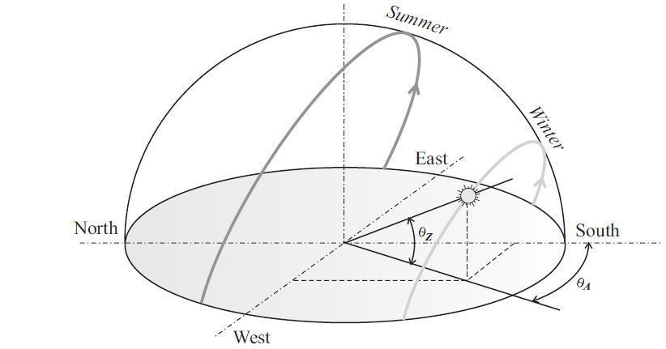

**Figure 1.6 Solar altitudes and azimuths typical behavior of sun path**

**1.1.1.5 Solar azimuth (**θ*A*)

The azimuth angle is the angle within the horizontal plane measured from true South or North. The azimuth angle is measured clockwise from the zero azimuths. For example, if you're in the Northern Hemisphere and the zero azimuths are set to South, the azimuth angle value will be negative before solar noon and positive after solar noon.

**1.1.2 Insolation**

Insolation is a measure of solar radiation energy received on a given surface area and recorded during a given time. It is also called solar irradiation and expressed as hourly irradiation if recorded during an hour, daily irradiation if recorded during a day, for example. The unit recommended by the World Meteorological Organization is MJ/m2 (mega joules per square meter) or J/cm2 (joules per square centimeter).Practitioners in the business of solar energy may use the unit Wh/m2 (watt-hours per square meter). If this energy is divided by the recording time in hours, it is then a density of power called irradiance, expressed in W/m2 (watts per square meter). Over the course of a year the average solar radiation arriving at the top of the Earth's atmosphere at any point in time is roughly 1366 watts per square meter. The Sun's rays are attenuated as they pass through the atmosphere, thus reducing the irradiance at the Earth's surface to approximately 1000 W m−2 for a surface perpendicular to the Sun's rays at sea level on a clear day. The isolation of the sun can also be expressed in Suns, where one Sun equals 1000 W/m2.

**1.2 OBJECTIVE**

The aim of the project is to keep the solar photovoltaic panel perpendicular to the sun throughout the year in order to make it more efficient. The single axis solar photovoltaic panel takes astronomical data as reference and the tracking system has the capability to always point the solar array toward the sun and can be installed in various regions with minor modifications. The horizontal motion of the panel is obtained by taking azimuth angle as reference. The fuzzy controller has been used to control the position of DC motors. .

Solar Tracker is a Device which follows the movement of the sun as it rotates from the east to the west every day. The main function of all tracking systems is to provide one or two degrees of freedom in movement.

**1.2.1 Types of solar tracker**

**1.2.1.1 Passive tracking system**

The passive tracking system is stationary system. These cannot be movable it’s fixed on proper direction. When the sun light is inclined on the plate its semiconductors materials produced the electricity.

**1.2.1.2 Active tracking system**

The active tracking system is movable in the direction of the sun .When sun is move east to west the tracker also move toward the direction of the sun. Due to moving of these panel is called active tracker system.

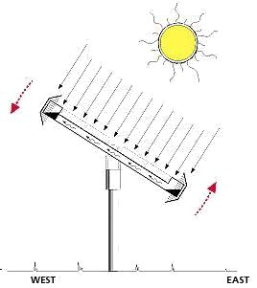

**Figure 1.7 Active tracker solar**

The single axis tracking systems realizes the movement of either elevation or azimuth for a solar power system. Which one of these movements is desired, depends on the technology used on the tracker as well as the space that it is mounted on. For example the parabolic through systems utilize the azimuth ally tracking whereas the many rooftop PV-systems utilize elevation tracking Because of the lack of space. A single-axis tracker can only pivot in one plane either horizontally or vertically. This makes it less complicated and generally cheaper than a two-axis tracker, but also less effective at harvesting the total solar energy available at a site. Trackers use motors and gear trains to direct the tracker as commanded by a controller responding to the solar direction. Since the motors consume energy, one wants to use them only as necessary. Single axis trackers have one degree of freedom that acts as an axis of rotation. There are several common implementations of single axis trackers. These include horizontal single axis trackers (HSAT) and vertical single axis trackers (VSAT).

A horizontal-axis tracker consists of a long horizontal tube to which solar modules are attached. The tube is aligned in a north-south direction, is supported on bearings mounted o n pylons or frames, and rotates slowly on its axis to follow the sun's motion across the sky. This kind of tracker is most effective at equatorial latitudes where the sun is more or less overhead at noon. In general, it is effective wherever the solar path is high in the sky for substantial parts of the year, but for this very reason, does not perform well at higher latitudes. For higher latitude, a vertical-axis tracker is better suited. This works well wherever t he sun is typically lower in the sky and, at least in the summer months, the days are long.

**1.3 MOTIVATION**

The energy contributed by the direct beam drops off with the cosine of the angle between the incoming light and the panel. The table no. 1.1 shows the Direct power lost (%) due to misalignment (angle *i*).

|  |  |
| --- | --- |
| Misalignment (angle *i* ) | Direct power lost (%)=1-cos(i) |
|  |  |
| 00 | 0 |
|  |  |
| 10 | .015 |
|  |  |
| 30 | .14 |
|  |  |
| 80 | 1 |
|  |  |
| 23.40 | 8.3 |
|  |  |
| 300 | 13.4 |
|  |  |
| 450 | 30 |
|  |  |
| 750 | >75 |

**Table 1.1 Direct power lost (%) due to misalignment (angle *i*)**

The sun travels through 360 degrees east-west a day, but from the perspective of any fixed location the visible portion is 180 degrees during a 1/2 day period. Local horizon effects reduce this somewhat, making the effective motion about 150 degrees. A solar panel in a fixed orientation between the dawn and sunset extremes will see a motion of 75 degrees on either side, and thus, according to the table above, will lose 75% of the energy in the morning and evening. Rotating the panels to the east and west can help recapture these losses. A tracker rotating in the

East-west direction is known as a single-axis tracker.

**1.4 PROBLEM FORMULATION AND PROPOSED WORK**

As we know that the solar tracker is a device which track the direction of the sun .it’s a unique device which can flow the direction of the sun and move east to west direction in the starting age of the solar panel it’s a stationary panel which work as a transducer and convert the inclined sun light on the panel into the electricity. It’s a very useful device to which produced an electricity without generate any pollution hence this project is Eco friendly.

Due to the stationary of panel, the efficiency of the stationary panel is less than 20% so increases efficiency of the panel we used a tracker which flow the direction of the sun. Hence the rotation of the panel increased the efficiency of the solar panel 20% to 35%. So this device is known as the single axial solar tracker.

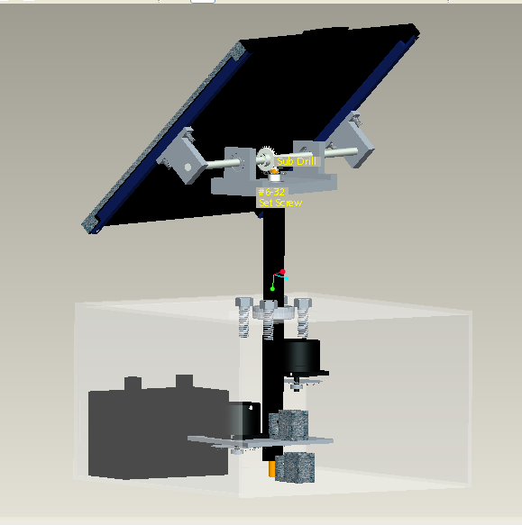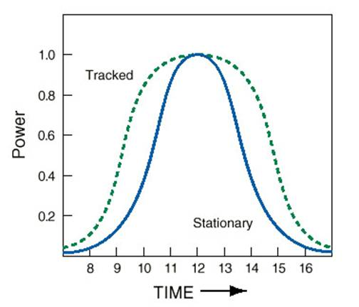

**Figure1.8 Single axial tracker and its effienicey graph**

**1.5 METHOLOGY / PLANNING OF WORK**

To preparing of the project there are a lot of steps. With the help of this small steps we can makes this project completely

**1**Fabricated the ATMEGA 328 on the pcb

**2** Interfacing motor IC L293D with the ATMEGA 328

**3** Fabricated both IC on the Aurdino-uno

**CHAPTER-2**

**2.1 BLOCK DAIGRAM**

The 2 LDR modules read the light intensity from the Sun Rays and provide feedback to the Arduino Controller unit. The C program running inside the Arduino will get the values from the LDR modules and calculate the angle to turn in the Left or Right direction.

LDR Module 1

Arduino-Uno

(Microcontroller Unit)

Stepper Motor Driver Module

Solar Panel

Stepper Motor

LDR Module 2



**Figure 2.1 The block diagram of the sun tracker**

The direction will be decided based on the intensity of light falling on the two LDR modules. Once the Direction to turn is decided the Arduino will give command to Stepper motor driver module to turn the stepper motor in particular direction in calculated angle. The Solar Panel is mounted on the Stepper motor which will turn towards the direction of sun, when the stepper motor rotates. When the Solar panel is facing directly in direction of the sun the system will stop unless there is further change in the Sun’s position.

**2.2 CIRCUIT DIAGRAM**

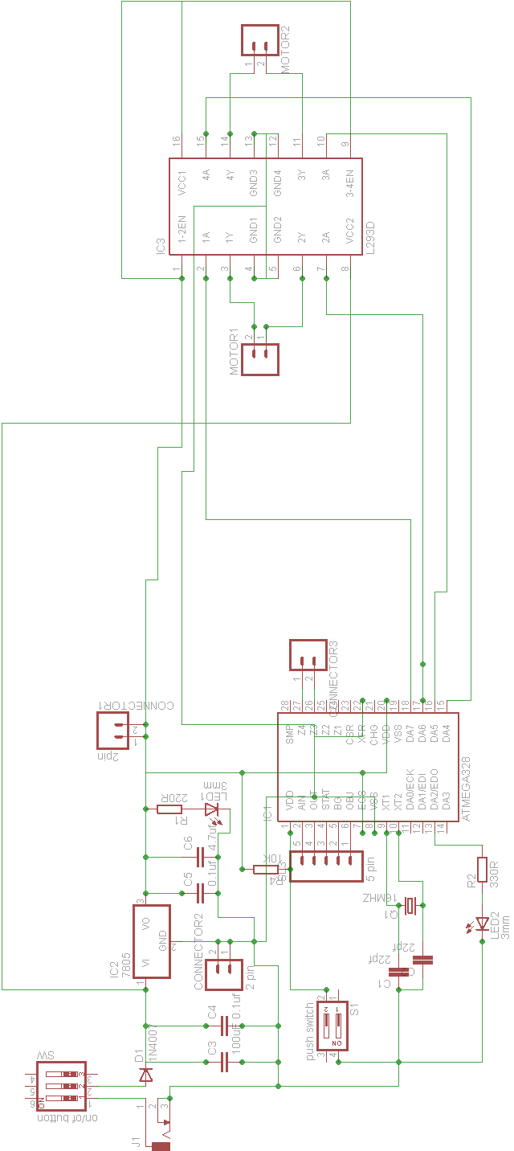

**Figure 2.2 Circuit diagram of solar tracker**

**2.3 CIRCUIT DIAGRAM EXPLANATION**

**2.3.1 LDR (Light dependent resistor)**

We are using two Light Dependent Resistor’s as a sensor. They sense the higher density area of sun light. The solar panel moves to the high light density area through servo motors. Each LDR is connected to power supply forming a potential divider. Thus any change in light density is proportional to the change in voltage across the LDR’s.

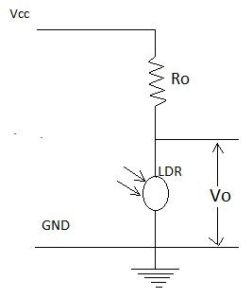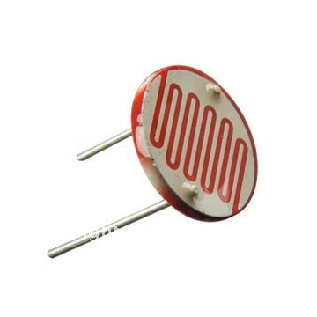

**Figure 2.3 LDR**

LDR is a passive transducer hence we will use potential divider circuit to obtain corresponding voltage value from the resistance of LDR.LDRs resistance is inversely proportional to the intensity of light falling on it i.e. Higher the intensity or brightness of light the Lower the resistance and vice-versa. LDRs or Light Dependent Resistors are very useful especially in light/dark sensor circuits. Normally the resistance of an LDR is very high, sometimes as high as 1000 000 ohms, but when they are Illuminated with light resistance drops dramatically. As its name implies, the Light Dependent Resistor (LDR) is made from a piece of exposed semiconductor material such as cadmium sulphide that changes its electrical resistance from several thousand Ohms in the dark to only a few hundred Ohms when light falls upon it by creating hole-electron pairs in the material.

The net effect is an improvement in its conductivity with a decrease in resistance for an increase in illumination. Also, photo resistive cells have a long response time requiring many seconds to respond to a change in the light intensity. Materials used as the semiconductor substrate include, lead sulphide (PbS), lead selenide (PbSe), indium antimonide (InSb) which detect light in the infra-red range with the most commonly used of all photo resistive light sensors being Cadmium Sulphide (Cds).Cadmium sulphide is used in the manufacture of photoconductive cells because its spectral response curve closely matches that of the human eye and can even be controlled using a simple torch as a light source. Typically then, it has a peak sensitivity wavelength (λp) of about 560nm to 600nm in the visible spectral range.

**Input (ADC):**

Arduino has an in built 10-bit Analog to Digital converter (ADC), hence it Can provide Digital values from 0-1023.(since 2^10=1024). We can also set the ADC reference voltage in arduino, but here we will let it use default value. LDR’s has two pins, and to get voltage value from it we use potential divider circuit. In potential divider we get Vout corresponding to resistance of LDR which in turn is a function of light Falling on LDR.

LDR resistance and hence lower the Output voltage (Vout) and lower the light intensity, higher the LDR resistance and hence higher the Vout.

**Output (PWM):**

Arduino has a 8-bit PWM generator, so we can get up to 256 distinct PWM signal. To drive a servo we need to get a PWM signal from the board, this is usually accomplished using timer function of the microcontroller but arduino makes it very easy. Arduino provides a servo library in which we have to only assign servo angle (0-1800) and the servo rotate by that angle, All the PWM calculations are handled by the servo library and we get a neat PWM.

**2.3.2 Arduino-uno**

The ATMEGA-328 is a  [modified Harvard architecture](http://en.wikipedia.org/wiki/Modified_Harvard_architecture) [8-bit](http://en.wikipedia.org/wiki/8-bit) [RISC](http://en.wikipedia.org/wiki/Reduced_instruction_set_computer) single chip [microcontroller](http://en.wikipedia.org/wiki/Microcontroller) which was developed by  [Atmel.](http://en.wikipedia.org/wiki/Atmel) It uses on-chip  [flash memory](http://en.wikipedia.org/wiki/Flash_memory) for program storage, as opposed to  [one-time programmable ROM,](http://en.wikipedia.org/wiki/Programmable_read-only_memory) [EPROM](http://en.wikipedia.org/wiki/EPROM), or [EEPROM](http://en.wikipedia.org/wiki/EEPROM) used by other micro controllers at the time.

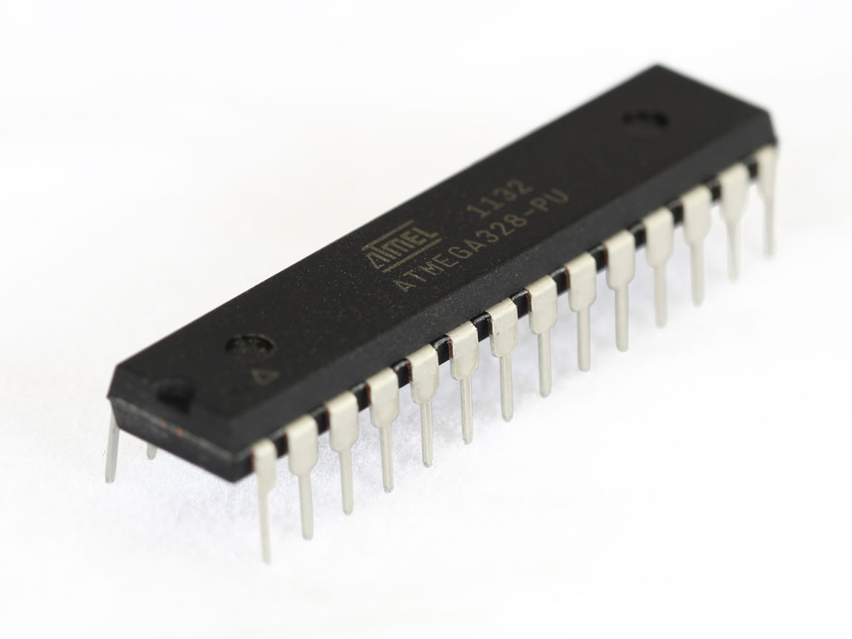

**Figure2.4 ATMEGA328**

**Features: -**

|  |  |  |  |
| --- | --- | --- | --- |
| Flash | | : | 16KB |
| EEPROM | | : | 1024B |
| SRAM | | : | 512B |
| Clock freq. | | : | up to 20MHz |
| Supply voltage | | : | 2.8-5.5v |
|  | Ext. Interrupt | : | 24 |
|  | PWM | : | 6 |
| Ext. Interrupt | | : | 24 |

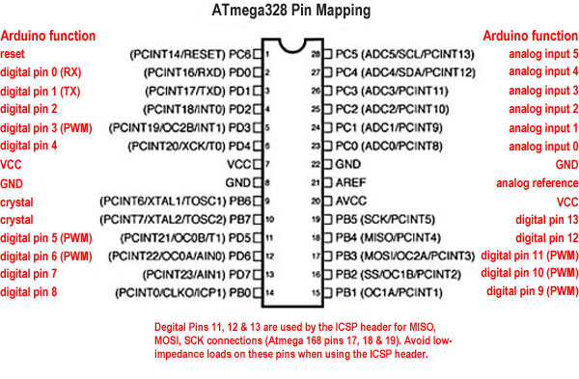

**Figure2.5 Pin diagram of ATMEGA328**

**2.3.3 Pin description**

**Port B (PB7:0) XTAL1/XTAL2/TOSC1/TOSC2**

Port B is an 8-bit bi-directional I/O port with internal pull-up resistors (selected for each bit). The Port B output buffers have symmetrical drive characteristics with both high sink and source capability. As inputs, Port B pins that are externally pulled low will source current if the pull-up resistors are activated. The Port B pins are tri-stated when a reset condition becomes active, even if the clock is not running. Depending on the clock selection fuse settings, PB6 can be used as input to the inverting Oscillator amplifier and input to the internal clock operating circuit. Depending on the clock selection fuse settings, PB7 can be used as output from the inverting.

Oscillator amplifier if the Internal Calibrated RC Oscillator is used as chip clock source, PB7.6 is used as TOSC2.1 input for the Asynchronous Timer/Counter2 if the AS2 bit in ASSR is set.

**Port C (PC5:0)**

Port C is a 7-bit bi-directional I/O port with internal pull-up resistors (selected for each bit). The

PC5. 0 output buffers have symmetrical drive characteristics with both high sink and source capability. As inputs, Port C pins that are externally pulled low will source current if the pull-up resistors are activated. The Port C pins are tri-stated when a reset condition becomes active, even if the clock is not running.

**PC6/RESET**

If the RSTDISBL Fuse is programmed, PC6 is used as an I/O pin. Note that the electrical characteristics of PC6 differ from those of the other pins of Port C. If the RSTDISBL Fuse is un programmed, PC6 is used as a Reset input. A low level on this pin for longer than the minimum pulse length will generate a Reset, even if the clock is not running.

**Port D (PD7:0)**

Port D is an 8-bit bi-directional I/O port with internal pull-up resistors (selected for each bit). The Port D output buffers have symmetrical drive characteristics with both high sink and source capability. As inputs, Port D Pins that are externally pulled low will source current if the pull-upresistors are activated. The Port D pins are tri-stated when a reset condition becomes active, even if the clock is not running.

**AVCC**

AVCC is the supply voltage pin for the A/D Converter, PC3:0, and ADC7:6. It should be externally connected to VCC, even if the ADC is not used. If the ADC is used, it should be connected to VCC through a low-pass filter. Note that PC6.4 use digital supply voltage, VCC.

**AREF**

AREF is the analog reference pin for the A/D Converter.

**ADC7:6 (TQFP and QFN/MLF package only)**

In the TQFP and QFN/MLF package, ADC7.6 serves as analog inputs to the A/D converter. These pins are powered from the analog supply and serve as 10 channels.

**2.3.4 Motor driver IC**

Motor Driver ICs are primarily used in autonomous projects only. Also most microprocessors operate at low voltages and require a small amount of current to operate while the motors require a relatively higher voltages and current. Thus current cannot be supplied to the motors from the microprocessor. This is the primary need for the motor driver IC.

The L293D is a 16 pin IC, with eight pins, on each side, dedicated to the controlling of a motor. There are 2 INPUT pins, 2 OUTPUT pins and 1 ENABLE pin for each motor. L293D consist of two H-bridge. H-bridge is the simplest circuit for controlling a low.

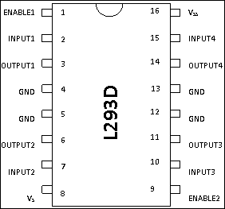

**Figure 2.6 Motor driver circuit**

|  |  |  |
| --- | --- | --- |
| **Pin No** | **Function** | **Name** |
| 1 | Enable pin for Motor 1; active high | Enable 1,2 |
| 2 | Input 1 for Motor 1 | Input 1 |
| 3 | Output 1 for Motor 1 | Output 1 |
| 4 | Ground (0V) | Ground |
| 5 | Ground (0V) | Ground |
| 6 | Output 2 for Motor 1 | Output |
| 7 | Input 2 for Motor 1 | Input 2 |
| 8 | Supply voltage for Motors; 9-12V (up to 36V) | Vcc 2 |
| 9 | Enable pin for Motor 2; active high | Enable 3,4 |
| 10 | Input 1 for Motor 1 | Input 3 |
| 11 | Output 1 for Motor 1 | Output 3 |
| 12 | Ground (0V) | Ground |
| 13 | Ground (0V) | Ground |
| 14 | Output 2 for Motor 1 | Output 4 |
| 15 | Input2 for Motor 1 | Input 4 |
| 16 | Supply voltage; 5V (up to 36V) | Vcc 1 |

**Table 2.1 Functions of pins of motor driver IC**

**2.3.5 Maximum ratings over operating over air condition absolute**

|  |
| --- |
|  |
| 1 Output supply voltages (Vcc1) 36V |
| 2 Input voltages 7V |
| 3 Peak output voltages -3V to Vcc1 |
| 4 Peak output current, IO (non repetitive, t ≤ 100 µs) ±1.2 A |
| 5 Storage temperature ranges -65°C to 150°C |
| 6 Maximum allowing temperature +150°C |

**Table 2.2 Maximum rating of driver ICs**

**2.3.6 STEPPER MOTOR**

A stepper motor (or step motor) is a brushless dc electric motor that divides a full rotation into a number of equal steps. The motor's position can then be commanded to move and hold at one of these steps without any feedback sensor, as long as the motor is carefully sized to the application. Switched reluctance motors are very large stepping motors with a reduced pole count, and generally are closed-loop commutated.

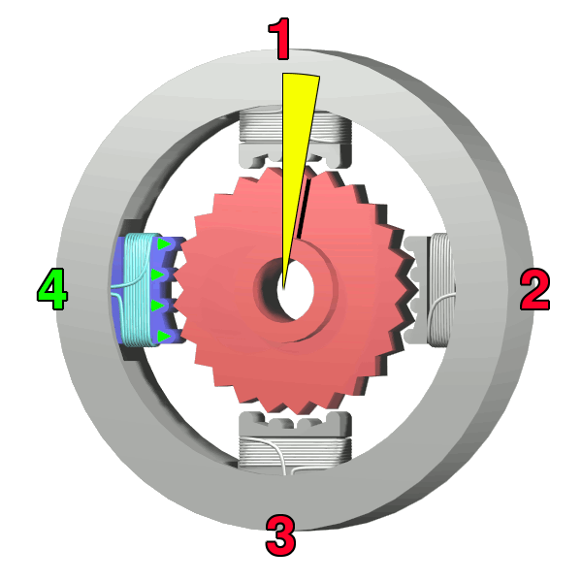

**Figure 2.7 Stepper motor**

**2.3.6.1 Fundamental of operation**

DC brushed motors rotate continuously when DC voltage is applied to their terminals. The stepper motor is known by its important property to convert a train of input pulses (typically square wave pulses) into a precisely defined increment in the shaft position. Each pulse moves the shaft through a fixed angle. Stepper motors effectively have multiple "toothed" electromagnets arranged around a central gear-shaped piece of iron. The electromagnets are energized by an external control circuit, such as a microcontroller. To make the motor shaft turn, first, one electromagnet is given power, which magnetically attracts the gear's teeth. When the gear's teeth are aligned to the first electromagnet, they are slightly offset from the next electromagnet. This means that when the next electromagnet is turned on and the first is turned off, the gear rotates slightly to align with the next one. From there the process is repeated. Each of those rotations is called a "step", with an integer number of steps making a full rotation. In that way, the motor can be turned by a precise angle.

**2.3.6.2 Types**

1 Permanent magnet stepper

2 Hybrid synchronous stepper

3 Variable reluctance stepper

4 Lavet type stepper motor

**2.3.6.3 Two phase stepper motor**

**Unipolar motors**

A unipolar stepper motor has one winding with centre tap per phase. Each section of windings is switched on for each direction of magnetic field. Since in this arrangement a magnetic pole can be reversed without switching the direction of current, the commutation circuit can be made very simple (e.g., a single transistor) for each winding. Typically, given a phase, the center tap of each winding is made common: giving three leads per phase and six leads for a typical two phase motor. Often, these two phase commons are internally joined, so the motor has only five leads.

A unipolar stepper motor has one winding with centre tap per phase. Each section of windings is switched on for each direction of magnetic field. Since in this arrangement a magnetic pole can be reversed without switching the direction of current, the commutation circuit can be made very simple (e.g., a single transistor) for each winding. Typically, given a phase, the center tap of each winding is made common: giving three leads per phase and six leads for a typical two phase motor. Often, these two phase commons are internally joined, so the motor has only five leads.

**Bipolar motors**

Bipolar motors have a single winding per phase. The current in a winding needs to be reversed in order to reverse a magnetic pole, so the driving circuit must be more complicated, typically with an H-bridge arrangement (however there are several off-the-shelf driver chips available to make this a simple affair). There are two leads per phase, none are common.

Static friction effects using an H-bridge have been observed with certain drive topologies

Dithering the stepper signal at a higher frequency than the motor can respond to will reduce this "static friction" effect.

Because windings are better utilized, they are more powerful than a unipolar motor of the same weight. This is due to the physical space occupied by the windings. A unipolar motor has twice the amount of wire in the same space, but only half used at any point in time, hence is 50% efficient (or approximately 70% of the torque output available). Though a bipolar stepper motor is more complicated to drive, the abundance of driver chips means this is much less difficult to achieve.

An 8-lead stepper is wound like a unipolar stepper, but the leads are not joined to common internally to the motor. This kind of motor can be wired in several configurations:

1 Unipolar

2 Bipolar with series windings

3 Bipolar with parallel winding

4 Bipolar with a single winding per phase

**2.3.6.4 Stepper motor system**

A stepper motor system consists of three basic elements, often combined with some type of user interface.

**Indexers** - The indexer (or controller) is a microprocessor capable of generating step pulses and direction signals for the driver. In addition, the indexer is typically required to perform many other sophisticated command functions.

**Drivers** - The driver (or amplifier) converts the indexer command signals into the power necessary to energize the motor windings. There are numerous types of drivers, with different voltage and current ratings and construction technology. Not all drivers are suitable to run all motors, so when designing a motion control system the driver selection process is critical.

**Stepper motors** - The stepper motor is an electromagnetic device that converts digital pulses into mechanical shaft rotation. Advantages of step motors are low cost, high reliability, high torque at low speeds and a simple, rugged construction that operates in almost any environment. The main disadvantages in using a stepper motor is the resonance effect often exhibited at low speeds and decreasing torque with increasing speed.

**2.3.7 Solar panl**

Solar panel refers either to a [photovoltaic](http://en.wikipedia.org/wiki/Photovoltaic) module, a [solar thermal energy](http://en.wikipedia.org/wiki/Solar_thermal_energy) panel, or to a set of solar [photovoltaic](http://en.wikipedia.org/wiki/Photovoltaic) (PV) modules electrically connected and mounted on a supporting structure. A PV [module](http://en.wikipedia.org/wiki/Module) is a packaged, connected assembly of [solar cells](http://en.wikipedia.org/wiki/Solar_cell). Solar panels can be used as a component of a larger [photovoltaic system](http://en.wikipedia.org/wiki/Photovoltaic_system) to generate and supply [electricity](http://en.wikipedia.org/wiki/Solar_power) in commercial and residential applications. Each module is rated by its [DC](http://en.wikipedia.org/wiki/Direct_current) output power under standard test conditions, and typically ranges from 1W to 320 watts. The [efficiency](http://en.wikipedia.org/wiki/Solar_cell_efficiency) of a module determines

The area of a module given the same rated output an 8% efficient 230 watt module will have twice the area of a 16% efficient 230 watt module. There are a few solar panels available that are exceeding 19% efficiency. A single solar module can produce only a limited amount of power; most installations contain multiple modules. A photovoltaic system typically includes a panel or an array of solar modules, an inverter, and sometimes [battery](http://en.wikipedia.org/wiki/Battery_(electricity)) and/or [solar tracker](http://en.wikipedia.org/wiki/Solar_tracker) and

Interconnection wiring.

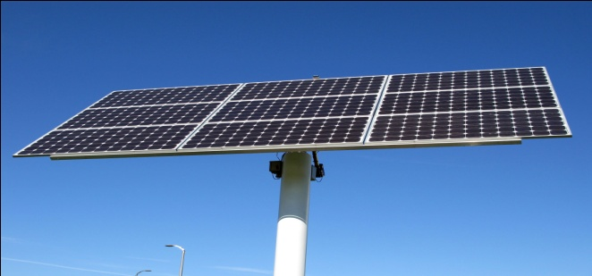

**Figure2.8 Solar Panel**

Photovoltaic’s are the direct conversion of light into electricity at the atomic level. Some materials exhibit a property known as the photoelectric effect that causes them to absorb photons of light and release electrons. When these free electrons are captured, electric current results that can be used as electricity.

A solar cell (also called photovoltaic cell or photoelectric cell) is a solid state electrical device that converts the energy of light directly into electricity by the photovoltaic effect. Crystalline silicon PV cells are the most common photovoltaic cells in use today. A number of solar cells electrically connected to each other and mounted in a support structure or frame are called a photovoltaic module. Modules are designed to supply electricity at a certain voltage, such as a common 12 volts system. The current produced is directly dependent on how much light strikes

The module. Multiple modules can be wired together to form an array. In general, the larger the area of a module or array, the more electricity will be produced. Photovoltaic modules and arrays produce direct-current (DC) electricity. They can be connected in both series and parallel electrical arrangements to produce any required voltage and current combination.

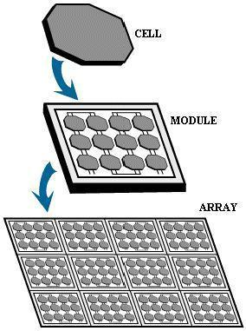

**Figure 2.9 Photovoltaic panel or array**

**2.3.8 Construction of solar cell**

Solar modules use light energy (photons) from the sun to generate electricity through the photovoltaic effect. The majority of modules use wafer-based crystalline silicon cells or thin-film cells based on cadmium telluride or silicon. The structural (load carrying) member of a module can either be the top layer or the back layer. Cells must also be protected from mechanical damage and moisture. Most solar modules are rigid, but semi-flexible ones are available, based on thin-film cells. These early solar modules were first used in space in 1958

Electrical connections are made in series to achieve a desired output voltage and/or in parallel to provide a desired current capability. The conducting wires that take the current off the modules may contain silver, copper or other non-magnetic conductive transition metals. The cells must be connected electrically to one another and to the rest of the system. Externally, popular terrestrial usage photovoltaic modules use MC3 (older) or MC4 connectors to facilitate easy weatherproof connections to the rest of the system.

Bypass diodes may be incorporated or used externally, in case of partial module shading, to maximize the output of module sections still illuminated.

Some recent solar module designs include concentrators in which light is focused by lenses or mirrors onto an array of smaller cells. This enables the use of cells with a high cost per unit area (such as gallium arsenide) in a cost-effective way. Depending on construction, photovoltaic modules can produce electricity from a range of frequencies of light, but usually cannot cover the entire solar range (specifically, ultraviolet, infrared and low or diffused light

**2.3.9 Efficiencies**

Depending on construction, photovoltaic modules can produce electricity from a range of frequencies of light, but usually cannot cover the entire solar range (specifically, ultraviolet, infrared and low or diffused light. Hence much of the incident sunlight energy is wasted by solar modules, and they can give far higher efficiencies if illuminated with monochromatic light. Therefore, another design concept is to split the light into different wavelength ranges and direct the beams onto different cells tuned to those ranges. This has been projected to be capable of raising efficiency by 50%. Scientists from Spectro lab, a subsidiary of Boeing, have reported development of multi junction solar cells with an efficiency of more than 40%, a new world record for solar photovoltaic cells. The Spectrolab scientists also predict that concentrator solar cells could achieve efficiencies of more than 45% or even 50% in the future, with theoretical efficiencies being about 58% in cells with more than three junctions.

Currently the best achieved sunlight conversion rate (solar module efficiency) is around 21.5% in new commercial products typically lower than the efficiencies of their cells in isolation. The most efficient mass-produced solar modules. Have power density values of up to 175 W/m2 (16.22 W/ft2). Research by Imperial College,London has shown that the efficiency of a solar panel can be improved by studding the light-receiving semiconductor surface with aluminum nano cylinders similar to the ridges on Lego blocks. The scattered light then travels along a longer path in the semiconductor which means that more photons can be absorbed and converted into current. Although these nano cylinders have been used previously (aluminum was preceded by gold and silver), the light scattering occurred in the near infrared region and visible light was absorbed strongly. Aluminum was found to have absorbed the ultraviolet part of the spectrum, while the visible and near infrared parts of the spectrum was found to be scattered by the aluminum surface. This, the research argued, could bring down the cost significantly and improve the efficiency as aluminum is more abundant and less costly than gold and silver. The research also noted that the increase in current makes thinner film solar panels technically feasible without "compromising power conversion efficiencies, thus reducing material consumption. Efficiencies of solar panel can be calculated by MPP (Maximum power point) value of solar panels.

Solar inverters convert the DC power to AC power by performing MPPT process: solar inverter samples the output Power (I-V curve) from the solar cell and applies the proper resistance (load) to solar cells to obtain maximum power.

Micro-inverted solar panels are wired in parallel which produces more output than normal panels which are wired in series with the output of the series determined by the lowest performing panel (this is known as the "Christmas light effect"). Micro-inverters work independently so each panel contributes its maximum possible output given the available sunlight.

**CHAPTER-3**

**3.1 RESULT ANALYSIS**

This paper presents the performance analysis of dual axis solar tracking system using Arduino. The ultimate objective of this project is to investigate whether static solar panel is better than solar tracker, or the opposite. This project is divided into two stages namely, hardware and software development. In hardware development, two light dependent resistors (LDR) were utilized to capture the maximum light source from the sun. One servo motors also were employed to move the solar panel to maximum light source location sensed by the LDRs. As for the software part, the code was constructed by using C programming language and was targeted to the Arduino UNO controller. The performance of the solar tracker was analyzed and compared with the static solar panel and the result showed that the solar tracker is better than the static solar panel in terms of voltage, current and power. Therefore, the solar tracker is proven more effective for capturing the maximum sunlight source for solar harvesting applications.

**3.2 CONCLUSION**

The panel is mounted on a single axis system. It is called a single-axis tracker as the mechanism rotates in only one plane around a single axis. The axis can be oriented such that the panels stand up at a tilt (called a polar axis) or lie flat (called a horizontal axis). Horizontal axis is more suitable for small latitudes (locations in the tropics and closer to the equator, i.e., southern India), whilst polar axis is more suitable for larger latitudes (locations far from the equator, i.e., northern India). This system tracks the sun from east to west during the day. The project described is a polar-type single-axis tracking system as shown in Fig 3.1.

Due to rotation of the panel the efficiency of the panel is increased 20% to 30%. Hence the single-axis is providing the better output compare then the stationary panel.

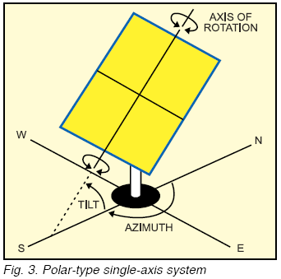

**3.3 FUTURE SCOPE**

As the proposed prototype is a miniature of main system, it has some limitations which can be mitigated through future developments. A small cardboard is rotated in the system and 12v solar panel is used for analysis. As a miniature system, it works out well. Larger Solar panel must be integrated with the system to prepare better result and cost analysis. It has been proven through our research and statistical analysis that solar tracking system with single-axis freedom can increase energy output by approximately 20%.Further mechanical enhancement can be done to the prototype, to implement dual-axis tracking. With the help of the dual-axis the efficiency of the solar panel can be increased. Hence due to the dual-axial tracker increased the output from 30% to 50%.

Once the hardware upgrades have been fulfilled, new measurement activities could take

place. Measurements in other seasons of the year would help validate the simulations with other weather conditions. During April and May, some perfect sunny days with mild temperatures offer the best conditions for radiation analysis. Also, warm days in summer should be included in the new measurements to analyze the temperature influence of the solar modules in the performance of the power plant. Longer measurement periods, like a month or a complete year, would be useful to validate simulations with more accuracy. It would also allow getting the real energy gain using a solar tracker over a year. Finally the analysis of days with changing weather conditions will remain as a little challenge, since most of the measurement and simulation problems converge on those days, making it extremely difficult getting precise results.

In the future the study of solar tracking systems could be extended to other methods used to capture the sun’s radiation like multijunction PV cells, solar thermal systems and photovoltaic concentrators. More than studying the tracking systems itself, like it was done at this work, an efficiency comparison could be made between different technologies under optimized conditions, to determine the most efficient solar power systems. An example could be a PV tracker with multijunction PV cells compared to a photovoltaic collector systems.

**3.3.1 Dual solar tracker**

Dual axis trackers as shown in the figure 3.3.1 have two degrees of freedom that act as axes of rotation. Double-axis solar trackers, as the same suggest, can rotate simultaneously in horizontal and vertical directions, and s o are able to point exactly at the sun at all times in any location.

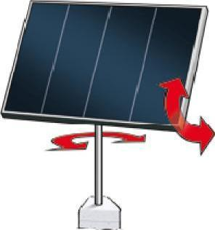

**Figure3.2 Dual axis solar tracker**

Dual axis tracking systems realize movement both along the elevation- and azimuthally axes. These tracking systems naturally provide the best performance, given that the components have high enough accuracy as well.

**REFRENCES**