2015

Prepared by:

Computronics Lab

3/3/2015

CELAB Electronics Work Shop

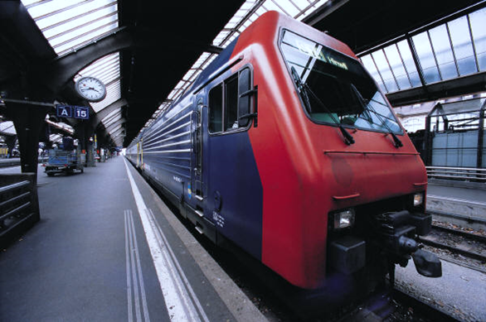

Contents

1 BASIC ELECTRONICS 3

1.1 IntroductiontoElectronicComponents 3

1.2 Using Bread Board (With List of Items) 3

1.3 Internal Connection of Bread Board 3

1.4 Mini Projects on Bread Board (Any 2) 4

1.5 Introduction to Soldering (Items Used For Soldering) 4

1.5.1 During Soldering 4

1.6 Mini Projects with Soldering (Any 2) 5

2 PCB DESIGNING 7

2.1 Working on Eagle Win 7

2.2 Creating PCB Layout 7

2.3 Make Mini Projects on Eagle Win (Any 2) 7

2.4 Toner Transfer Method 8

**2.4.1** Items Used In 8

2.4.2 PCB Etching Process 8

2.5 Make Mini Projects or Modules with PCB Etching (Any Two) 8

3 8051 PROGRAMMING 9

3.1 Introduction To 8051 9

3.2 Pin Diagram and Ports Of 8051 9

3.3 Pin Description 10

3.4 General Basic Circuit 12

3.5 Introduction to Keil Compiler 12

3.5.1 Installation and Setup 12

3.5.2 Steps of Making a New Project in Keil 12

3.5.3 Sample Program of Led Blinking 12

3.5.4 Software Description 12

3.5.5 Variation in Led Blinking (by Student) 12

3.6 AVR Programmer for 8051 Program Uploading 12

3.6.1 Software Installation 12

3.6.2 Pin Description 12

3.6.3 Commands Used For Uploading the Hex File 13

3.7 Interfacing Modules with 8051 (Any 5) 13

3.8 Interfacing Motor Driver With 8051 13

3.9 Interfacing DTMF Module With 8051 13

3.10 8051 Interfacing With LCD 13

3.11 8051 Interfacing With IR Module 14

3.12 8051 Interfacing With Keypad 15

3.13 Projects based on 8051. 15

4 ARDUINO PROGRAMMING 15

4.1 Pin Diagram 15

4.2 Ports of Atmega328 15

4.3 Installing Arduino Ide 15

4.4 Uploading Programs to Arduino 15

4.5 Interfacing Modules with Arduino (Any 5) 15

4.6 Arduino Interfacing with Motor Driver 16

4.7 Arduino Interfacing with LCD 17

4.8 Projects based on Arduino 17

5 ROBOTICS 18

5.1 Introduction to 10 Components Used To Make a Simple Robot 18

5.2 Making Different Chassis Basis 18

5.3 Using Basis Modules Require For Robotics 18

5.4 Make Robots Using Arduino Uno Board (Any 3) 18

6 DEMO PROJECTS TO DISPLAY 18

6.1 Remote Control Motor On Off 18

6.2 Wireless Power Transmission 18

# BASIC ELECTRONICS

## Introduction to Electronic Components

* Led
* Diode
* Resistor
* Capacitor
* Transistor
* Dc Motor
* Transformer
* Switch
* Connectors
* PCB
* IC’s/ IC Base
* Variable Resistor
* LDR
* Condenser Mic
* Speaker/Buzzer
* 7 Segment Display
* Relay
* MOSFET (IRF 540)
* IR LED (Tx And Rx)
* Bridge Rectifier IC

## Using Bread Board (With List of Items)

* Both Side Male Connector
* Battery Connector
* 9 Volt Dc Battery
* Few Bread Board Wires

## Internal Connection of Bread Board

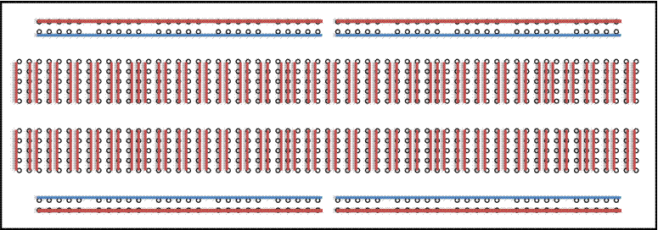

## Mini Projects on Bread Board (Any 2)

|  |  |
| --- | --- |
| **NAME OF MINI PROJECT** | **PATH** |
| AUTOMATIC STREET LIGHT | embedded-projects\pcb_designs\mini_projects |
| CLAP SWITCH | embedded-projects\pcb_designs\mini_projects |
| OBJECT COUNTER | embedded-projects\pcb_designs\mini_projects |
| MELODY GENERATOR USING LM 66 | embedded-projects\pcb_designs\mini_projects |

## Introduction to Soldering (Items Used For Soldering)

* Soldering Paste
* Soldering Iron
* Soldering Wire
* Zero PCB

### During Soldering

**DO’S**

* Always Unplug the Soldering Iron When It Is Unattended
* Be Careful To Keep Clothes, Hair, Power Cables and Skin etc. Away From the Soldering Iron Tip and the Metal Shaft
* Always Handle the Iron By the Plastic Handle

**DON’T’S**

* Always Plug the Soldering Iron When It Is Unattended
* To Keep Clothes, Hair, Power Cables And Skin etc. Near The Soldering Iron Tip And The Metal Shaft
* Handle The Iron By The Metal Shaft

<Don’t are just reverse sentence to Do’s Please make new points here>

## Mini Projects with Soldering (Any 2)

|  |  |
| --- | --- |
| **NAME OF MINI PROJECT** | **PATH** |
| AUTOMATIC STREET LIGHT | embedded-projects\pcb_designs\mini_projects |
| CLAP SWITCH | embedded-projects\pcb_designs\mini_projects |
| OBJECT COUNTER | embedded-projects\pcb_designs\mini_projects |
| MELODY GENERATOR USING LM 66 | embedded-projects\pcb_designs\mini_projects |

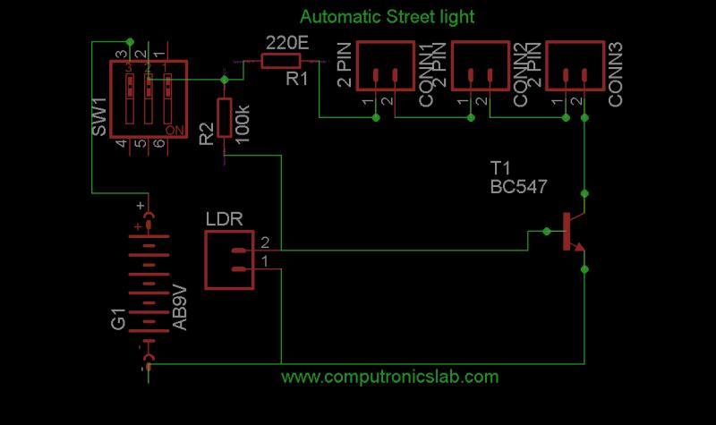

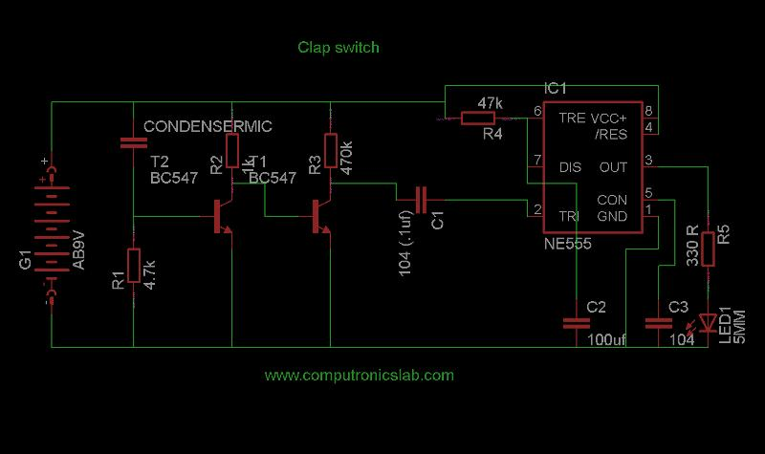

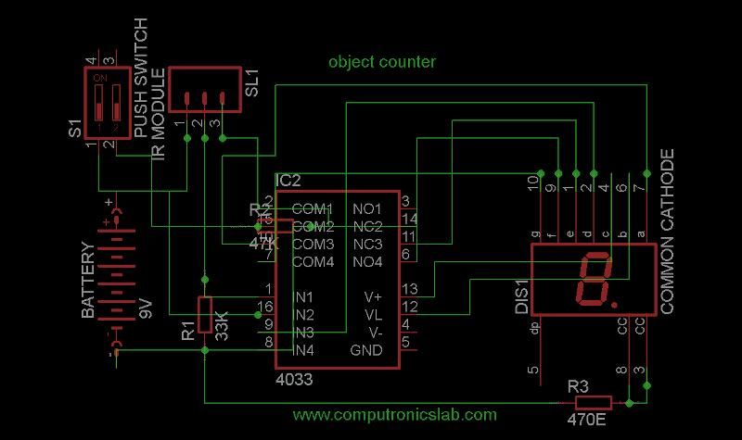

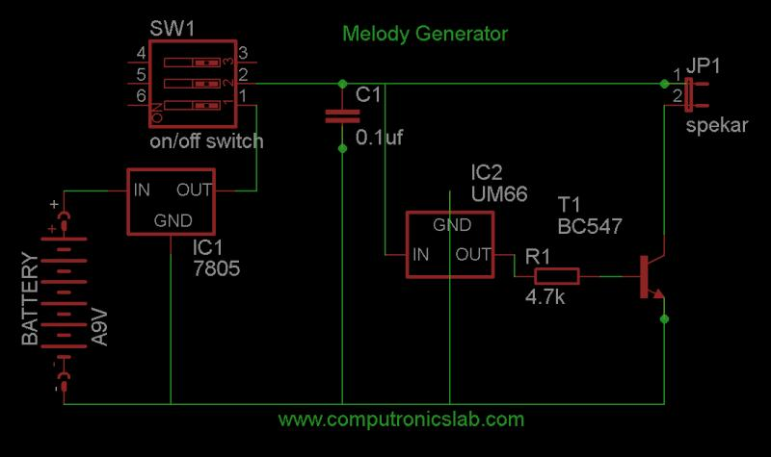

# PCB DESIGNING

## Working on Eagle Win

<Steps>

## Creating PCB Layout

<Steps>

## Make Mini Projects on Eagle Win (Any 2)

|  |  |  |  |  |  |
| --- | --- | --- | --- | --- | --- |
| **NAME OF THE PROJECTS** | | | **PATH** | | |
| CLAP SWITCH | | | embedded-projects\pcb_designs\mini_projects | | |
| OBJECT COUNTER | | | embedded-projects\pcb_designs\mini_projects | | |
| AUTOMATIC STREET LIGHT | | | embedded-projects\pcb_designs\mini_projects | | |
| MELODY GENERATOR USING UM66 | | | embedded-projects\pcb_designs\mini_projects | | |
| **5 ITEMS USED IN PCB ETCHING PROCESS(TONER TRANSFER METHOD)** | | | | | |
| **IRON(PRESS)** | **GLOSSY PAPER** | **Fecl3 SOLUTION** | | **LASER PRINTER** | **BRD FILE** |
| **COPPER CLAD BOARD** | **PCB DRILL MACHINE** |  | |  |  |

## Toner Transfer Method

### Items Used In

* IRON(PRESS)
* GLOSSY PAPER
* Fecl3 SOLUTION
* LASER PRINTER
* BRD FILE
* COPPER CLAD BOARD
* PCB DRILL MACHINE

### PCB Etching Process

* Print The Design Board File Pattern Using The Darkest Laser Printer Setting.
* Cut the Pattern out Using Scissors Leaving at least 1/8 Inch to ¼ Inch of Extra Paper.
* Cut The Copper Clad Board Of Size Same As Pattern.
* Scrub The Copper Clade Board Using Sand Paper.
* Lay The Copper Clad Board On A Rigid, Flat, Heat Resistant Surface.
* Lay The Paper Pattern Face Down On The Copper.
* Place the Clothes Iron on the Back of the Pattern Hold the Iron On The Whole Pattern For 1/3 Minutes or More Pressing Firmly.
* After The Board Is Well-Heated Place The Rear Of The Iron Along An Edge Of The Board (With The Rest Of The Iron On The Board), And Press Hard Near The Rear Of The Iron's Handle.
* Pick Up The Board And Drop It Into Hot Water.
* Peel Off The Paper If The Paper Underneath Is Still A Little Dries, Put The Board Back Into The Water, For Another Ten Minutes Or More.
* Rub The Remaining Paper Off, With Thumb Pressure Usually; Almost The Entire Paper Residue Comes Off.
* Rinse The Board And Wipe The Board Dry With A Clean Paper Towel Make Any Necessary Corrections, Using A Sharpie Or Other Etch-Resistant Permanent Black Marker Pen.
* Use Ferric Chloride, In A Tupperware-Style Plastic Food Container, In A Sink Of Hot Water.  Hold It Flat and Push It Up And Down Vertically. Don't Get the Etchant on Anything Else, Especially A Good Stainless-Steel Sink or Your Clothing.
* Wipe And Flush Any Accidental Spills With Lots Of Water, Immediately. The Ferric Chloride Will Also Stain Your Skin. Wash It Off Immediately, If Possible.

## Make Mini Projects or Modules with PCB Etching (Any Two)

|  |  |
| --- | --- |
| **NAME OF THE PROJECTS/MODULES** | **PATH** |
| CLAP SWITCH | embedded-projects\pcb_designs\mini_projects |
| OBJECT COUNTER | embedded-projects\pcb_designs\mini_projects |
| AUTOMATIC STREET LIGHT | embedded-projects\pcb_designs\mini_projects |
| MELODY GENERATOR USING UM66 | embedded-projects\pcb_designs\mini_projects |
| RELAY DRIVER | embedded-projects\pcb_designs\modules |

# 8051 PROGRAMMING

## Introduction To 8051

* A Highly Integrated 40 Pin Single Chip With All The Peripherals Like Ram, ROM,I/O Ports, Timers Etc.
* 8 Bit Microcontrollers (Perform 8 Bit Arithmetic And Logical Operation) Design By Intel.
* 32 General Purposes Register Each Of 8 Bits.
* Four Parallel Ports Each Of 8 Bits (Port0, Port1, Port2, And Port3).
* One Full Duplex Serial Communication Port
* 128 Bytes One Chip Data Memory (Ram).
* Kb One Chip Program Memories (Rom).
* 8 Bit Data Bus.
* 16 Bit Address Bus.
* 2 16 Bit Timers.
* Five Interrupts (3 Internal And Two Externals).

## Pin Diagram and Ports Of 8051

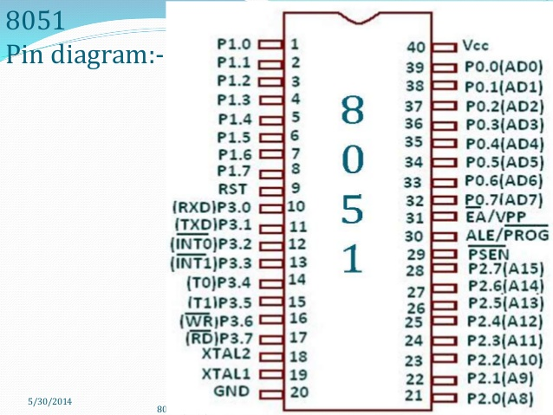

## Pin Description

|  |  |
| --- | --- |
| **PIN** | **DESCRIPTION** |
| **9** | Pin 9 Is The Reset Pin Which Is Used To Reset The Microcontroller’s Internal Registers And Ports Upon Starting Up. (Pin Should Be Held High For 2 Machine Cycles.) |
| **18 AND19** | The 8051 Has A Built-In Oscillator Amplifier Hence We Need To Only Connect A Crystal At These Pins To Provide Clock Pulses To The Circuit |
| **PIN 40 AND 20** | Pins 40 And 20 Are Vcc And Ground Respectively. The 8051 Chip Needs +5v 500ma To Function Properly. |
| **PINS 29, 30 & 31** | Pin 29 Is Called PSEN. This Is "Program Store Enable". In Order To Use The External Memory It Is Required To Provide The Low Voltage (0) On Both PSEN And EA Pins  Pin 30 Is Called Ale (Address Latch Enable), Which Is Used When Multiple Memory Chips Are Connected To The Controller And Only One Of Them Needs To Be Selected. We Will Deal With This In Depth In The Later Chapters.  As Described In The Features Of The 8051, This Chip Contains A Built-In Flash Memory. In Order To Program This We Need To Supply A Voltage Of +12v At Pin 31. If External Memory Is Connected Then Pin 31, Also Called EA/VPP, And Should Be Connected To Ground To Indicate The Presence Of External Memory. |
| **PORT P1 (Pins 1 to 8)** | The Port P1 Is A General Purpose Input / Output Port Which Can Be Used For A Variety Of Interfacing Tasks. The Other Ports P0, P2 And P3 Have Dual Roles Or Additional Functions Associated With Them Based Upon The Context Of Their Usage. The Port 1 Output Buffers Can Sink/Source Four TTL Inputs. When 1s Are Written To Portn1 Pins Are Pulled High By The Internal Pull-Ups And Can Be Used As Inputs. |
| **PORT P3 (Pins 10 to 17)** | Port P3 Acts As A Normal Io Port, But Port P3 Has Additional Functions Such As, Serial Transmit And Receive Pins, 2 External Interrupt Pins, 2 External Counter Inputs, Read And Write Pins For Memory Access. |
| **PORT P2 (pins 21 to 28)** | Port P2 Can Also Be Used As A General Purpose 8 Bit Port When No External Memory Is Present, But If External Memory Access Is Required Then Port P2 Will Act As An Address Bus In Conjunction With Port P0 To Access External Memory |
| **PORT P0 (pins 32 to 39)** | Port P0 Can Be Used As A General Purpose 8 Bit Port When No External Memory Is Present, But If External Memory Access Is Required Then Port P0 Acts As A Multiplexed Address And Data Bus That Can Be Used To Access External Memory In Conjunction With Port P2. |

## General Basic Circuit

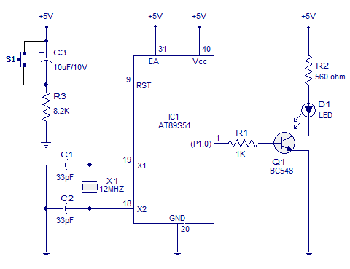

## Introduction to Keil Compiler

### Installation and Setup

### Steps of Making a New Project in Keil

### Sample Program of Led Blinking

### Software Description

### Variation in Led Blinking (by Student)

## AVR Programmer for 8051 Program Uploading

### Software Installation

### Pin Description

8051 AVR

MOSI 🡪 MOSI

MISO 🡪 MISO

SCK 🡪 SCK

RST 🡪 RST

GND 🡪 GND

### Commands Used For Uploading the Hex File

## Interfacing Modules with 8051 (Any 5)

|  |  |
| --- | --- |
| **NAME OF THE MODULES** | **PATH** |
| MOTOR DRIVER | embedded-projects\pcb_designs\modules |
| DTMF | embedded-projects\pcb_designs\modules |
| LCD MODULE | Use original |
| RELAY DRIVER | embedded-projects\pcb_designs\modules |
| IR MODULE | embedded-projects\pcb_designs\modules |
| KEYPAD | embedded-projects\pcb_designs\modules |
| 7 SEGMENT DISPLAY | embedded-projects\pcb_designs\modules |
| PIR MOTION SENSOR | Use original(connect VCC, GND, Out pin to 8051) |

## Interfacing Motor Driver With 8051

## Interfacing DTMF Module With 8051

## 8051 Interfacing With LCD

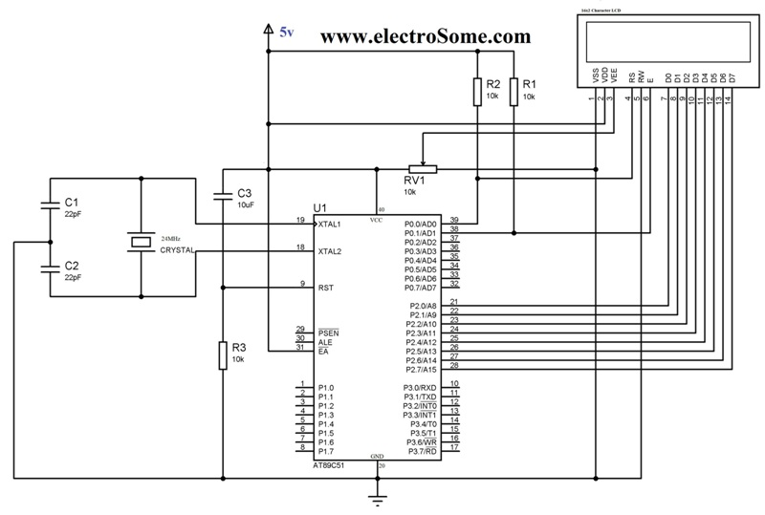

## 8051 Interfacing With IR Module



|  |
| --- |
| **VCC GND OP**  **IR MODULE** |

## 8051 Interfacing With Keypad

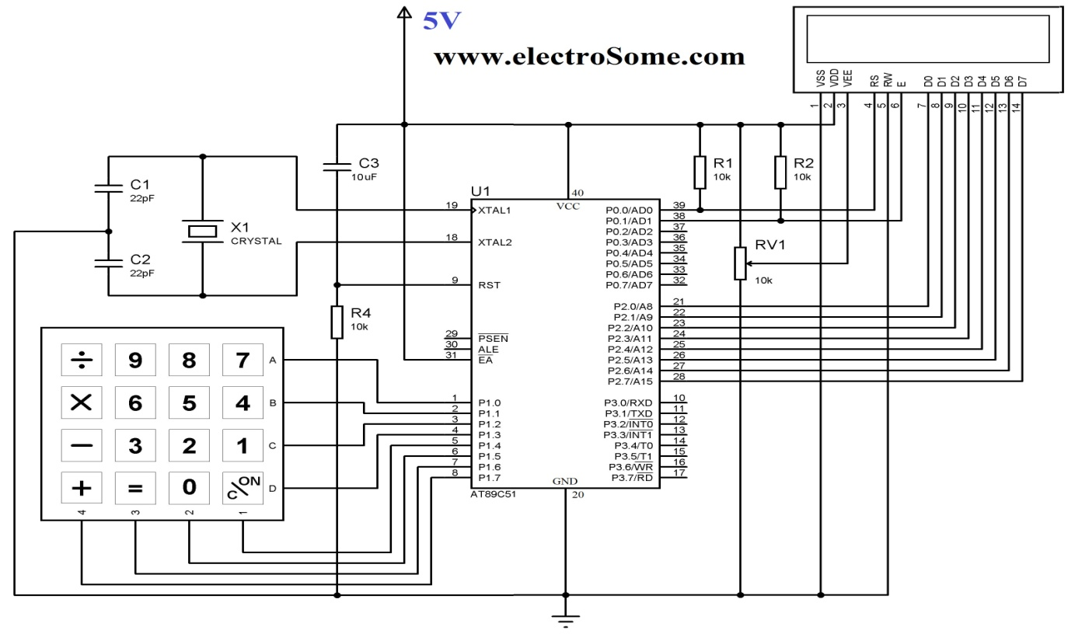

## Projects based on 8051.

|  |  |
| --- | --- |
| **NAME OF THE PROJECT** | **PATH** |
| Bidirectional Visitor Counter | embedded-projects\project_codes\8051\Projects |
| PWM Motor Speed Control | embedded-projects\pcb_designs\major_projects |
| Electronic Lock | embedded-projects\pcb_designs\major_projects |
| RS 232 Based Data Transfer | embedded-projects\pcb_designs\major_projects |

# ARDUINO PROGRAMMING

## Pin Diagram

## Ports of Atmega328

## Installing Arduino Ide

## Uploading Programs to Arduino

## Interfacing Modules with Arduino (Any 5)

* Motor Driver
* LCD Module
* IR Module
* 7 Segment Display
* DTMF Module
* Relay Driver
* Keypad
* PIR Motion Sensor

## Arduino Interfacing with Motor Driver

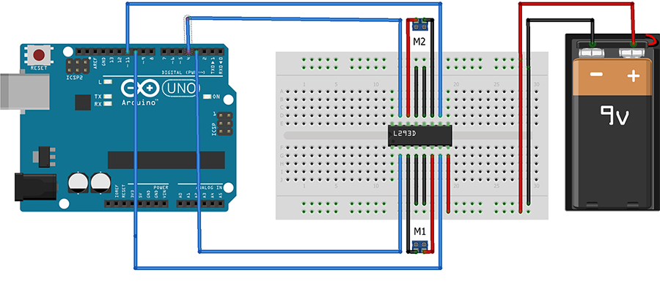

|  |  |
| --- | --- |
| **SOURCE CODE** | **PATH** |
| **ARDUINO INTERFACING WITH MOTOR DRIVER** |  |

|  |
| --- |
| **VCC O/P GND**  **IR MODULE** |

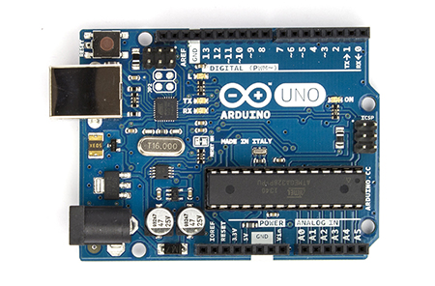

|  |  |
| --- | --- |
| **SOURCE CODE** | **PATH** |
| **ARDUINO INTERFACING WITH IR ODULE** |  |

## Arduino Interfacing with LCD

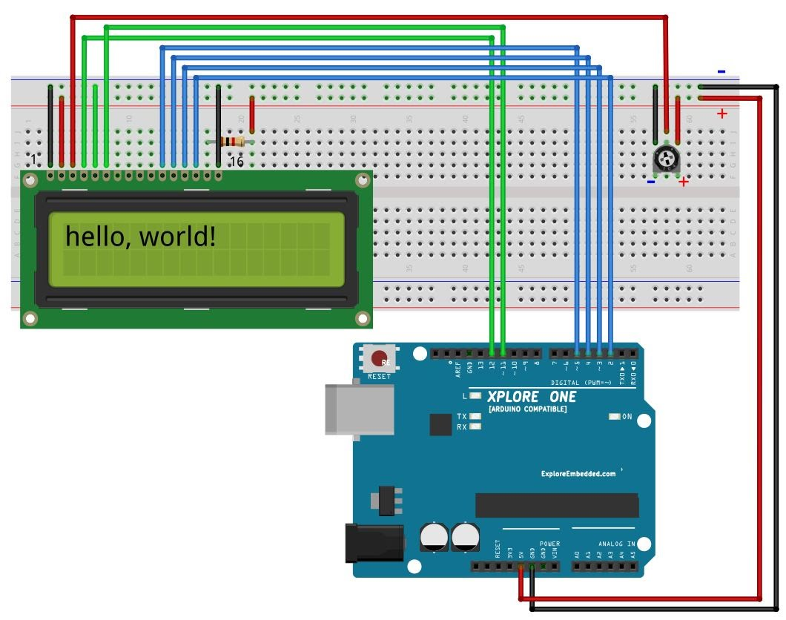

**9VOLT**

**GND**

|  |  |
| --- | --- |
| **SOURCE CODE** | **PATH** |
| **ARDUINO INTERFACING WITH LCD** |  |

|  |
| --- |
| **ARDUINO INTERFACING WITH KEYPAD** |

## Projects based on Arduino

|  |  |
| --- | --- |
| **NAME OF THE PROJECT** | **PATH** |
| **DTMF ROBOT** | **embedded-projects\project_codes\arduino\Projects** |
| **TEMPERATURE SENSOR USING LM 35** | **embedded-projects\project_codes\arduino\Projects** |

# ROBOTICS

## Introduction to 10 Components Used To Make a Simple Robot

|  |  |  |  |  |
| --- | --- | --- | --- | --- |
| **L293D IC** | **FRONT WHEEL** | **WHEELS** | **CHACHIS** | **BATTERY** |
| **CONNECTORS** | **GEAR MOTOR** |  |  |  |

## Making Different Chassis Basis

## Using Basis Modules Require For Robotics

* MOTOR DRIVER
* IR MODULE
* LDR MODULE

## Make Robots Using Arduino Uno Board (Any 3)

|  |  |
| --- | --- |
| **NAME OF THE PROJECTS** | **PATH** |
| **DTMF ROBOT** | **embedded-projects\project_codes\arduino\Projects** |
| **EDGE AVOIDING ROBOT** | **embedded-projects\project_codes\8051\Projects** |
| **LINE FOLLOWING ROBOT** | **embedded-projects\project_codes\8051\Projects** |

# DEMO PROJECTS TO DISPLAY

## Remote Control Motor On Off

## Wireless Power Transmission