Smart Home

http://www.smarthome.com/insteon.html

WHAT IS HOME AUTOMATION?

****Home automation is “The Internet of Things"…The way that all of our devices and appliances will be networked together to provide us with a seamless control over all aspects of our home and more. Home automation has been around from many decades in terms of lighting and simple appliance control, and only recently has technology caught up for the idea of the interconnected world, allowing full control of your home from anywhere, to become a reality. With home automation, you dictate how a device should react, when it should react, and why it should react. You set the schedule and the rest is automated and based off of your personal preferences thus providing convenience, control, money savings, and an overall smarter home. Home automation can also alert you to events that you might want to know about right-away while you are gone like water leaks and unexpected access to your home, or any part of it. At any time, you can grab your iPhone, Android device or other remote control and change the settings in your house as desired.

*Over the past few decades many companies have entered the home automation sector...*



CONVENIENCE

Control and automate just about every device and appliance within your home whether you are at home or far away. We've all gotten used to controlling our TV from the couch; just wait until you are able to dim the lights as well.

Imagine adjusting the temperature from your bed or controlling the volume of your whole-house audio system from any room. Or imagine the wall/ceiling heater in your bathroom coming on automatically on chilly mornings 5 minutes before your alarm clock goes off so that it is warm when you enter. Many Smarthome products also save energy -- we'll all agree that's a nice convenience.

SAFETY

**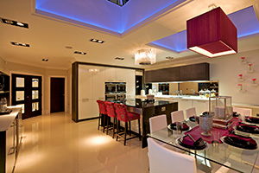**Always on guard and at the ready, home automation provides security, safeguarding your home. From a security camera’s peering eye to a water sensor that will alert you of a possible costly leak, an automated home keeps your property under surveillance so you can react at a moment’s notice.

We're all used to opening the garage door from the car, but you'll be surprised how much safer you'll feel coming home to a lit home and even turning on more lights from your keyfob remote upon your arrival. With a couple of basic products you can have your whole house light up like Fort Knox when there is motion detected at any corner of your house. Imagine your house sending you an email if there is motion where there shouldn't be any. Or you can have your security system call you if there is an alarm, which might include your typical security alarm or even a low or high temperature or water in the laundry room or basement.

ENERGY SAVINGS

Home automation works efficiently for you, saving money on your utilities and providing overall convenience.

FUN

Home automation gets you involved. Set your personal preferences and actions, then sit back and enjoy using the latest in home automation technology. Though such technology is quite complex, it remains completely flexible and user friendly making for a fun experience.High-tech products for the home are fun to use and share with others. Whether viewing visitors at your front door on your TV or tuning your stereo by using voice recognition, you'll find home automation surprisingly enjoyable. And when it comes to impressing the friends, you'll be happy to show off your newfound applications.

With the broad selection of home automation products offered by Smarthome, you can control just about anything you wish in your home. If you have questions about a particular product please [contact our expert technical support team](http://www.smarthome.com/contacts) - they're happy to help you find exactly what you are looking for.

# WHAT IS INSTEON?

INSTEON is the best-selling, most-reliable home control and automation technology. Using both the existing wires (power line) in the home and radio-frequency communication, INSTEON adds remote control and automation to lighting, appliance and home control applications of all types. From lighting control to integrated security systems, the gold-standard in home automation allows you to manage your home the way you want. Easy to install and setup, INSTEON offers the flexibility and dependability to make your life more convenient, safe and fun.

## RELIABLE

INSTEON is the most reliable and best-selling wireless home-control networking technology. With every INSTEON-enabled device being a repeater, the signal gets stronger with every added device. In addition, each INSTEON message contains error detection, so lights turning on accidentally will virtually never happen.

## SIMPLE

No other technology allows you to install new products without a complicated network enrollment and management procedures, so you won’t need to be (or hire) an IT expert. To link one INSTEON product to another you simply press and hold their set buttons – one at a time. INSTEON is the least complex of the network infrastructures. And, in networking, complexity leads to cost and risk.

## FULLY COMPATIBLE

INSTEON products are fully compatible with one-another. Other technologies/products may be labeled as such, but incompatibilities exist nonetheless.

INSTEON products are fully backward, and forward compatible. When other technologies create new commands, all older products become obsolete.

## FAST

Other home automation networks have a noticeable delay when turning on a light or activating an appliance. Other networking technologies have even longer delays and “popcorn” effects when launching multi-device scenes. INSTEON messages get through in less than 0.05 seconds - faster than the human eye can detect, so there are no visible delays. Activate an INSTEON-enabled switch and the lights turn on instantaneously.

## AFFORDABLE

While other home automation systems extend into the thousands of dollars to install and implement, a complete INSTEON-enabled system costs a fraction of its competitors. INSTEON can be integrated into any number of products easily and at a very low cost, so it will impact your life a whole lot more that it will impact your wallet.

## AWARD-WINNING

Perhaps the most award-winning home networking technology, INSTEON technology and products lead the world when it comes to innovation. For a list of awards, [click here](http://www.smarthome.com/insteon-awards).

## CONSUMER PRAISE

Consumers, in addition to the industry gurus, love INSTEON. For a selection of testimonials, [click here](http://www.smarthome.com/sc-insteon-testimonials).

## WHY IS INSTEON BETTER?

### **DUAL-BAND**

INSTEON is the only home networking technology that makes use of two separate physical layers (RF plus Powerline). INSTEON signals automatically jump from one layer to the other, and back. Each layer works around road-blocks in the other. It is estimated that the error rate for a dual band technology might be 100 times smaller than that of a single-band technology.

### **SIMULCAST**

Like other mesh networks, INSTEON signals are repeated by devices in the network. However, INSTEON messages are repeated (if and as required) simultaneously by every node in the network. Each repeat of the INSTEON signal is referred to as a hop. Each message is designed to stop hopping when it reaches the responder.

Other networks repeat along a pre-determined network “route”. Creating this route and maintaining this route (called “healing”) is complicated and expensive in terms of silicon and memory. Furthermore, the simulcast network scales naturally, while the routed network runs into challenges at a geometrically growing rate.

### **STATELINKTM**

INSTEON responders need not understand specific commands to join a scene (virtually everything in home automation is/can be considered a scene), it only need remember the state it was in when the scene was created. Just like your car radio only need remember the station it was on when you held one of your favorites’ buttons. Other technologies use specific commands. Every time a new command is created, products already in customers’ homes become obsolete with respect to that function. Furthermore, Statelink allows a single command to be broadcast to an entire home/building network and simultaneously (and elegantly) cause the scene to enact. Image that versus other technologies where the dozens of lighting circuits (or bulbs) come on one at a time (called the popcorn effect).

### **THE OTHER STUFF**

Like all other modern networking technologies, INSTEON has automatic error detection and correction. Every message is confirmed as it is received, and if any errors are detected, the message is automatically resent.

INSTEON has only one class of devices, versus two, three or more with Zwave, Zigbee and the other technologies.

Every INSTEON DEVICE acts as a repeater -- receiving and sending every message to all other devices on the network. So instead of stressing the network by adding more INSTEON devices, you actually strengthen it.

With no central controller or networking setup required, setting up your INSTEON network is a simple plug and tap to link one INSTEON product to another. Best of all, every INSTEON device has its own unique ID, so neighbors and would-be hackers can't control your home.

# WHAT CAN I CONTROL?

## LIGHTING

Obtain the ability to manage your home lighting from where ever you are in the world. Control individual lights located in different parts of your home all from your own bed, kitchen, car, of even if you are poolside at a resort on the other side of the planet. Home automation gives you full authority over your home’s lighting from where ever, whenever.

## CAMERAS

Cameras have been a staple of home and business security for some time now and advancements in technology have allowed for improved optics, sensors, and many other special features including the ability to remotely view your property. Log into your camera and visually see, in real-time, specific areas of your home or business while you are away. Rotate, reposition, record, zoom, and snap photos all from the palm of your hand. Go a step further, and automate your camera to record at a specified time. Even allow it to automatically snap a picture when it senses movement. Cameras add a vast amount of unique features and capabilities to anyone’s property. Security Systems & Access Control

## SECURITY SYSTEMS & ACCESS CONTROL

Remotely open a garage door or unlock/lock a specific door within your home all from your fingertips. With a home automated security system, your house can directly contact you, sending an alert about a specific security related event that has occurred on your property. Be it a trespasser, water leak, or a sudden rise in temperature, home automation remains on guard for you.

## HOME THEATER & ENTERTAINMENT

Your Home Theater system has many components, from Blu-Ray Players and external D/A converters to digital cable boxes and HTPCs. Every part of your Home Theater system performs very specific roles to envelop you in audio-visual nirvana. Home automation can power on specific components and select which inputs and outputs to switch to all from one remote and all from one button. No longer do you have to manually perform several different steps to achieve a single outcome. Home automation performs for you and brings easy management to your ever growing Home Theater system.

## PHONE SYSTEMS

A home automated phone system can provide many benefits, such as increased security, privacy, and even home monitoring. Caller screening assures that only specific numbers trigger your phone to ring, silencing those callers best avoided. Call into a distant vacation home and receive live information about the current status of your property be it current weather in the area, security breaches, and even if there are any water leaks. With such a system in place, you can rest assured that you’ll receive no surprises upon arriving at your favorite vacation home.

## THERMOSTATS

A remote controlled thermostat provides you with complete control over your home’s temperature. Operate your home’s heater or air conditioning while from the cozy confines of your bed, in your car while driving from work, at an airport as you wait for your flight to leave, or when your flight touches down in another country. Receive alerts when temperatures get too low or too high, keeping your pets and plants happy while you’re away. Maintain a comfortable living environment within your home all from your fingers tips.

## IRRIGATION

Home automation doesn’t only apply to the insides of your home, but even to the lush plant life that surrounds it. Automate your properties home irrigation system and set your own preferences and automation do the rest. Conserve water and save money with sensors that sense rain, shutting off your sprinkler system so you don’t waste precious water. Your sprinkler system can even trigger if it senses movement on your lawn turning your irrigation into a home deterrent against animals and trespassers.

## CABLE & STRUCTURED WIRING

Home automation can be accomplished using various types of connectivity. What's great is that many of today's home automation products need no new wires - so they are perfect to retrofit into an existing home. If you are building new or doing a major remodel, please consider adding networking, audio, video and control wiring while it is easy and relatively inexpensive. Later on you'll be happy you did.

WHAT TECHNOLOGY?

There are many different methods which allow you to remotely control your home’s lighting, appliances, security system, and other consumer electronics. The table below shows the most popular remote technologies along with their advantages and disadvantages.

THE MAIN PLAYERS

|  |  |  |  |  |  |
| --- | --- | --- | --- | --- | --- |
| **Brand** | **INSTEON** | **Z-Wave** | **Wi-Fi** | **Bluetooth** | **802.15.4/Zigbee** |
| **Maximum Theoretical Network Size** | Unlimited | 232 | 256 | 9 | 256 |
| **Maximum Practical Network Size** | 1000's | 30-35 | Dozens | 9 | Dozens |
| **Physical Layer 1** | RF | RF | RF | RF | RF |
| **Physical Layer 1 Frequency** | 915MHz | 915MHz | 2.4GHz | 2.4GHz | 915MHz or 2.4GHz |
| **Physical Layer 2** | Powerline | - | - | - | - |
| **Physical Layer 2 Frequenc** | 132KHz | - | - | - | - |
| **Mesh Enrollment** | Automatic | Procedural | Procedural | Procedural | Procedural |
| **Operate without Hub** | Yes | - | - | - | - |
| **Cost** | $ | $$ | $$$ | $ | $$ |
| **Compatibility Classes (Less is More)** | 1 | >1 | Many | 3 | >9 |
| **Forward & Backward Compatible** | Yes | - | - | - | - |
| **Scenes without Delay** | Yes | - | - | - | - |
| **Message Propagation** | Simulcast | Routed | Routed | Theoretical | Routed |
| **Network Configuration** | Full Mesh | Partial Mesh | Star | Star | Star + Mesh |
| **Controller Failure** | Remote Access Failure | Complete Network Failure | Complete Network Failure | Complete Network Failure | Complete Network Failure |
| **Mobile Devices** | Automatic | Breakdown | Automatic | Automatic | Breakdown |
| **Initial Products** | Fully Supported | Obsolete | Just launched | Just launched | Obsolete |
| **Physical Interoperability** | Yes | Yes | Yes | Yes | Not Assured |
| **Brand Interoperability** | Yes | Not Assured | With Software/SDK | With Software/SDK | Limited |
| **Messages Acknowledged** | Yes | Yes | Yes | Yes | Yes |
| **Unique Addressing** | Yes | - | - | - | Not Enforced |
| **Error Detection** | Yes | Yes | Yes | Yes | Yes |
| **Error Correction** | Yes | Yes | Yes | Yes | Yes |
| **Collision Avoidance** | Yes | Yes | Yes | Yes | Yes |

# NINE PRODUCTS THAT COULD SAVE YOU THOUSANDS

## 1. ALARM CLOCK WITH BED SHAKER DOUBLES AS A SECURITY MONITORING DEVICE

[[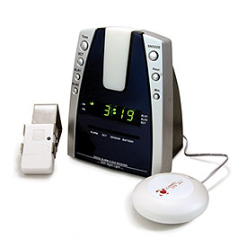](http://www.smarthome.com/52312.html)](http://www.smarthome.com/52312.html)Heavy sleepers beware! Research shows that an alarming number of adults are not woken by standard smoke detector alarms during a fire, a number that climbs drastically for heavy-sleepers and the hearing impaired. A bed shaker is a proven way to ensure you are woken during a fire in your house.

The Krown Dual Alarm Clock with Wireless Alarm Monitoring Receiver is among the most advanced alarm clocks in the world. Able to sync up with your fire protection and security systems, you can make sure that you will never sleep through a disaster. Along with the proven bed-shaker, this alarm clock can also trigger a bedside lamp and produce a 95db buzzer.

[#52312 Krown Manufacturing KA1000 Dual Alarm Clock with Wireless Alarm Monitoring Receiver](http://www.smarthome.com/52312.html)

## 2. PROTECT YOURSELF FROM IDENTITY THEFT AND PICKPOCKETS

[[](http://www.smarthome.com/94203BK.html)](http://www.smarthome.com/94203BK.html)Pickpockets have a new advantage in the ways they can steal your money. Banking and credit card companies are issuing cards with embedded RFID chips. These chips have a built in security flaw which allows tech-savvy credit thieves to 'scan' and obtain information on your credit card without ever touching your wallet.

The Rouge Wallet has advanced RFID scanning protection, keeping the information in your wallet, in your wallet. The Rouge wallet also has a patented shape that allows it to conform to your front pocket, making traditional pick pocketing nearly impossible.

[#94203BK Rogue WALRFIDBLKNT Made in Maine Wallet with RFID Protection, Black](http://www.smarthome.com/94203BK.html)

## 3. BUILD A SAFETY NETWORK OF INTERCONNECTED ALARMS IN YOUR HOME WITHOUT THE COST AND HASSLE OF WIRING

[[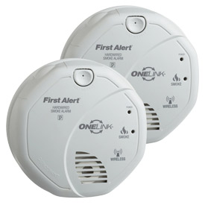](http://www.smarthome.com/79860.html)](http://www.smarthome.com/79860.html)Reports from the National Fire Protection Association show that people have nearly a 50 percent better chance of surviving a fire if their home has the recommended number of smoke alarms. Reports also show that direct property losses due to fire reach almost $11 billion a year.

The First Alert Onelink Wireless Battery Powered Smoke Alarm - 2 Pack lets you know the instant there is fire danger. A single smoke Alarm is only acceptable for very small homes or apartments; typically most home applications will require multiple alarms (depending on local law). This 2-pack gets you started with the ability to cover two locations within your home; more are recommended. The First Alert Onelink Wireless Battery Powered Smoke Alarm was designed for wireless smoke alarm integration - easily link your alarms together with the press of a button. When one of the alarms sound, they all sound for maximum whole home protection.

The First Alert ONELINK Smoke Alarm can even be linked to the INSTEON Smoke Bridge to create email and text message alerts in case of smoke or fire using an INSTEON Hub or other central controller.

[#79860 First Alert Onelink Wireless Battery Powered Smoke Alarm - 2 Pack](http://www.smarthome.com/79860.html)

## 4. MONITOR YOUR TEENAGER'S DRIVING HABITS, TEST FOR EMISSIONS, TRACK MILEAGE, AND MORE

[[](http://www.smarthome.com/19111.html)](http://www.smarthome.com/19111.html)While driving, your right foot is your worst enemy when it comes to the amount of money you spend on gas each week. Your car may be rated for 35 MPG, but since this is based on an ideal scenario, you are most likely not reaching this level of savings.

The Car Chip Pro Data Logger allows you to download and analyze your driving habits by providing raw data from your car's OBDII (onboard diagnostics). See graphs and summary reports, records of extreme acceleration & braking, gas mileage reports, engine parameters and more. All data is time-stamped as well so this information is great for contesting traffic tickets and accidents.

[#19111 Davis Instruments 8226 Car Chip Pro Data Logger](http://www.smarthome.com/19111.html)

## 5. PROTECT THE EQUIPMENT IN YOUR HOME FROM ELECTRICAL SURGES

[[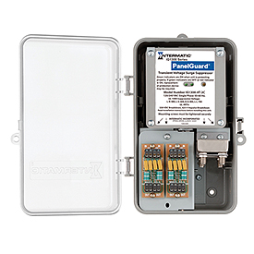](http://www.smarthome.com/25195.html)](http://www.smarthome.com/25195.html)A common misconception is that power surges are primarily cause by lighting or some other external source. The fact is that many power surges originate from inside the house. Any high-power electrical device (such as a refrigerator or washing machine) can cause power to surge in your home circuit which can damage other devices in your home.

The Intermatic Whole House Hardwired Surge Suppressor provides SE (service entrance) and sub-panel protection against power surges. Offering a higher capacity to handle surge energy over standard plug-in strips, the Whole House Surge Suppressor keeps all electronic equipment safe from surges and spikes. Also backed by a $10k Connected Equipment Manufacturer Warranty, you can't beat that.

[#25195 Intermatic Whole House Hardwired Surge Suppressor](http://www.smarthome.com/25195.html)

## 6. PREVENT DRYER FIRES WITH A LINT-REMOVAL VENT CLEANING SYSTEM FOR ANY SIZE VENT

[[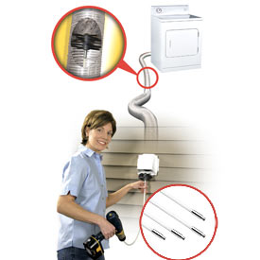](http://www.smarthome.com/92308.html)](http://www.smarthome.com/92308.html)Want something that costs you money every month and could light your home on fire? No? Well, you may already have it.

Lint fires are no joke. Clothing dryers are associated with over 15,600 fires, 20 deaths and 370 injuries each year mostly caused by lint deposits in the dryer exhaust vents. The best way to prevent these types of fires is to periodically clean your dryer vents. The best way to do that is with the LintEater System. The rotating lint trap brush will clean your vents (up to 24' long) with ease and also provides the added bonus of increased dryer efficiency, saving you money every time you dry your clothes.

[#92308 LintEater System And Extension Kit](http://www.smarthome.com/92308.html)

## 7. AN INNOVATIVE STOVE CLEANING SYSTEM WITH EXTENSION RODS

[[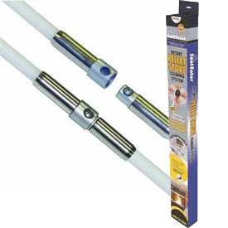](http://www.smarthome.com/92310C.html)](http://www.smarthome.com/92310C.html)Regularly cleaning your stove is a necessity for preventing flue fires and the standard DIY option of cleaning with brushes can be a daunting and time consuming task!

The Sooteater Stove Cleaning and Extension Rods Combo Kit stove and fireplace flues with a spinning chimney whip that removes dangerous soot and ash buildup better than a brush. Cleaning from the bottom up the Stove Cleaning Combo Kit fits any drill for fast and efficient cleaning.

[#92310C Sooteater Stove Cleaning and Extension Rods Combo Kit](http://www.smarthome.com/92310C.html)

## 8. ULTRAVIOLET AIR TREATMENT SYSTEM PROVIDES A HEALTHIER BREATHING ENVIRONMENT

[[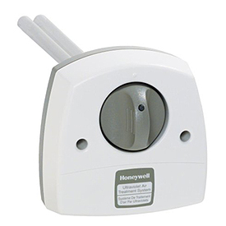](http://www.smarthome.com/20494.html)](http://www.smarthome.com/20494.html)They're in the air ducts! Airborne bacteria travels throughout your home using the very system that keeps you and your family warm and cozy at night. With healthcare costs rising, the cost of getting sick is getting to be a bigger hit on family budgets each year.

Honeywell's UV Lamp Airborne Bacteria Treatment System is an innovative solution to killing airborne bacteria that travels through your home's ductwork. The UV is easy to install, simply drill a hole using the included template into your central air duct, plug in and begin zapping bacteria. Utilizes UV technology similar to the ones used in hospitals, laboratories and commercial kitchens and is easy to add to your existing heating and cooling system. The unique Honeywell solution kills up to 70% of bacteria passing through the system.

[#20494 Honeywell UV Lamp Airborne Bacteria Treatment System](http://www.smarthome.com/20494.html)

## 9. INSTANT WATER LEAK DETECTION AND ALERTS

[[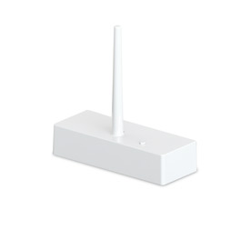](http://www.smarthome.com/2852-222.html)](http://www.smarthome.com/2852-222.html)The risk of water damage in a home is high. In fact, it is one of the most common home insurance claims. Every year millions of homeowners suffer billions of dollars in losses. But these losses can be reduced or even avoided altogether with the INSTEON Leak Sensor.

The INSTEON Leak Sensor alerts you so you can stop the leak before damage to your home occurs. Other leak sensors on the market require running wires or drilling holes, the INSTEON Leak Sensor is an all-in-one design. This makes it super simple to install and ideal for placing in tight areas. Simply add as many sensors as you'd like to the INSTEON Hub (sold separately) and get instant alerts delivered via text/email to your smartphone.

[#2852-222 INSTEON Water Leak Sensor](http://www.smarthome.com/2852-222.html)

# REMOTE LIGHTING CONTROL

The most common home automation projects begin with wanting to control a light from across the room. At Smarthome there are so many ways to do this that we thought it might do us all some good to write out the most popular choices according to our customers.

BASIC

### **PLUG-IN LIGHT CONTROL**

This kit will get you up and controlling 2 plug-in lights in less than 10 minutes. It consists of a handheld remote (INSTEON Mini Remote) and 2 lamp controllers (LampLinc Dual-Band dimmers).

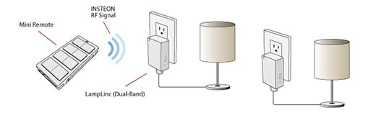

#### **DESCRIPTION**

INSTEON Mini Remote sends RF commands (On, Off, Dim, Bright) to the LampLinc dual-band modules allowing you to control lamps up to 150' away. The remote is capable of controlling a total of eight devices or can be setup to control eight scenes of any large number of INSTEON devices (movie time, dinner party, goodnight, welcome home, away, vacation, etc).

# REMOTELY CONTROLLING AND MONITORING YOUR GARAGE DOOR

Everyone with a garage has, at one point, left the garage door open unintentionally. Whether it's left open for an hour or over night, the point is all your tools, bicycles and other stuff is open for anyone to see. With our solution below, you can quickly and easily monitor and control your garage door from inside your home.

## GARAGE DOOR STATUS AND CONTROL FROM INSIDE THE HOUSE

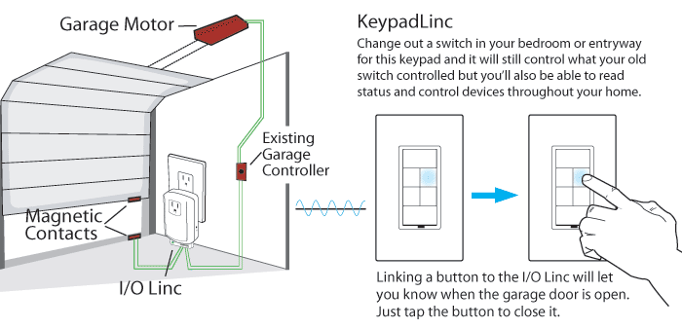

### **DESCRIPTION**

Replace an existing wall switch with the KeypadLinc, set up your I/O Linc Garage Door Control & Status Kit and wirelessly link one button on the KeypadLinc to the I/O Linc. Now when the garage door opens, the LED on that button will light up. Press the button to close the garage. It's that simple. Easily expand the other unused buttons on the KeypadLinc to control the garage lights or any other light in the house. Just add additional INSTEON-compatible wall switches or plug-in modules to the lights you want to control.

### **IMPORTANT**

You should only remotely close a garage door when you can be sure it is safe, either by watching it directly or through a camera. Use of safety beam devices can further increase the safety of remote garage door control and are usually required by law.

### **PARTS LIST**

* [I/O Linc - INSTEON Garage Door Control & Status Kit](http://www.smarthome.com/74551.html)
* [Keypad Dimmer Switch](http://www.smarthome.com/insteon-2334-232-keypad-dimmer-switch-dual-band-6-button-white.html)

#### 

# REMOTE IR CONTROL

While there are plenty of products that offer to [extend your IR remote signals](http://www.smarthome.com/_/Remotes_IR_Repeaters/IR_Repeaters/IR_to_RF_to_IR_Systems/_/5/1Rj/2nv/nav.aspx) from one room to another, using INSTEON allows you to easily combine lighting control with IR control. Now you can not only turn your favorite station on from another room but also dim the lights down - all from a single remote.

BASIC

### **REMOTE CONTROL FOR YOUR A/V EQUIPMENT**

Use a remote to set a romantic mood by turning on your stereo, setting the radio station and dimming down the lights.

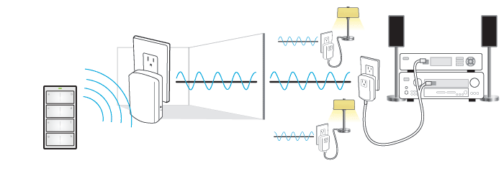

#### **DESCRIPTION**

INSTEON Mini Remote sends a wireless RF signal to Access Points or dual-band products which send signals over your existing electrical wires to the IRLinc Transmitter. IRLinc then converts the signals to IR commands to control your A/V equipment. You can also link INSTEON switches, plug-in modules, outlets and more to respond to the same command; creating elegant movie-time scenes.

#### **NOTE**

The RF signals from the Mini Remote can be converted and transmitted to the IRLinc by way of any [dual-band device](http://www.smarthome.com/insteon.html?features=1804). Choose [LampLinc Dual-Band](http://www.smarthome.com/2457D2.html) modules for lamp control and you won't need an Access Point.

#### **PARTS LIST**

•  [INSTEON Mini Remote, White](http://www.smarthome.com/2342-222.html)  
•  [INSTEON Range Extender](http://www.smarthome.com/insteon-range-extender.html)  
•  [IRLinc Transmitter - INSTEON to IR Converter](http://www.smarthome.com/2411t.html)  
•  [INSTEON LampLinc Lamp Dimmer Modules](http://www.smarthome.com/2457d2.html)  
  
[ORDER THIS BUNDLE](http://www.smarthome.com/remote-ir-control-bundle-basic.html)

# REMOTE TEMPERATURE CONTROL

Why go through the hassle of having to get out of bed when the temperature can be adjusted wirelessly? Here are a few ways to adjust a home's thermostat from a remote control.

## ACCESS A HOME'S THERMOSTAT FROM A SMARTPHONE OR TABLET DEVICE

Use a smartphone to access a home's thermostat and set it to a preferred temperature setting. This allows a home to be at the perfect temperature upon arrival.

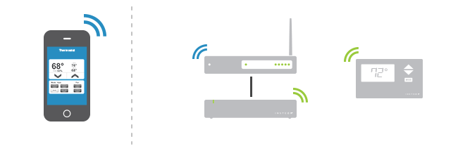

### **DESCRIPTION**

Use any web-enabled device such as a smartphone or tablet device to communicate with the INSTEON Hub, which sends signals over your homes existing power wires, and then to the INSTEON Thermostat. Easily expand the INSTEON network to control lighting with [plug-in lamp dimmers](http://www.smarthome.com/_/Dimmers_Lighting_Appliance_Control/INSTEON/Plug_in_Screw_In_Modules/Plug_In_Dimmers/_/z/23b/1Qd/2MV/nav.aspx), [wall switches](http://www.smarthome.com/_/Dimmers_Lighting_Appliance_Control/Decora_Paddle/Dimmers_Wall_Switches_Keypads_Touchscreens/Dimming/INSTEON/Wall_Switches_Dimmers/_/z/2N3/1QV/22B/23b/2MD/nav.aspx?Ns=Price), and [more](http://www.smarthome.com/_/INSTEON/_/23b/land.aspx).

### **PARTS LIST**

1. [INSTEON Hub](http://www.smarthome.com/2242-222.html)
2. [INSTEON Thermostat](http://www.smarthome.com/2441TH.html)

## INSTANT TEMPERATURE CONTROL FROM ANYWHERE WITHIN A HOME

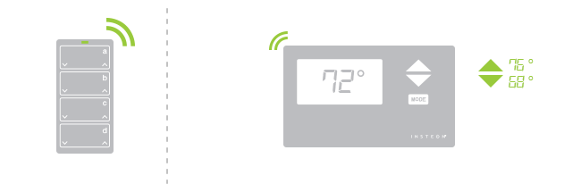

### **DESCRIPTION**

Replace a home's thermostat with an INSTEON Thermostat and use an INSTEON Mini Remote to operate a home's heating or air conditioning system and recall a favorite temperature preset with the touch of a button from anywhere within a home.

### **PARTS LIST**

1. [INSTEON Mini Remote](http://www.smarthome.com/2342-232.html)
2. [INSTEON Thermostat](http://www.smarthome.com/2441TH.html)

# MOTION-ACTIVATED LIGHTING CONTROL

Use two equally simple motion-activated devices: Open/Close Sensor which mounts to any door or window or Motion Sensor which mounts on a wall. Either one can be set to turn on a light when activated and turn it off when the door or window closes or motion has stopped being sensed.

## LET MOTION CONTROL THE LIGHTS

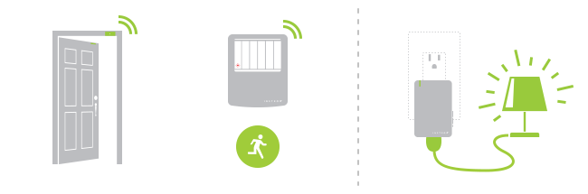

### **DESCRIPTION**

Would you like to turn on a light every time a closet door is opened and then have the light turn off when the door is closed? Maybe you just need a light turned on without having to feel around for the switch in the dark. Either way, this solution is for you. In the above illustration we show an Open/Close Sensor and a Motion Sensor. Both can turn on a light when activated. The Open/Close Sensor turns the light off when the door or window is closed and the Motion Sensor turns it off after a period of time of no motion. Both communicate wirelessly to a LampLinc which plugs into a standard outlet (shown above) or a SwitchLinc Dimmer Switch (also included with this bundle) which is hardwired and replaces an existing wall switch.

### **PARTS LIST**

* [Motion Sensor](http://www.smarthome.com/2842-222/INSTEON-Wireless-Motion-Sensor/p.aspx) (for detecting motion)
* [Open/Close Sensor](http://www.smarthome.com/2843-222/INSTEON-Wireless-Open-Close-Sensor/p.aspx) (for detecting a door or window opening)
* [SwitchLinc Dimmer Switch](http://www.smarthome.com/2477D/SwitchLinc-INSTEON-Remote-Control-Dimmer-Dual-Band-White/p.aspx)
* [LampLinc Plug-In Dimmer](http://www.smarthome.com/2457D2/LampLinc-INSTEON-Plug-In-Lamp-Dimmer-Module-Dual-Band-2-Pin/p.aspx)

[ORDER THIS BUNDLE](http://www.smarthome.com/motion-activated-lighting-control-bundle.html)

# WHAT TO DO IF YOU DON'T HAVE A NEUTRAL WIRE

For all incandescent applications use the [SwitchLinc 2-Wire Dimmer](http://www.smarthome.com/2474DWH.html). This switch does not require a neutral connection but note that it is for use with incandescent lighting:

|  |  |
| --- | --- |
| [[SwitchLinc 2-Wire Dimmer](http://www.smarthome.com/2474DWH.html) SwitchLinc 2-Wire Dimmer](http://www.smarthome.com/2474DWH.html) | SwitchLinc 2-Wire Wiring Illustration |

[[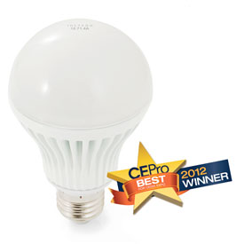](http://www.smarthome.com/2672-222.html)](http://www.smarthome.com/2672-222.html)If you don't want to replace a switch, you can now simply replace your light bulbs with the [INSTEON LED Bulb](http://www.smarthome.com/2672-222.html). Now you don't have to worry about re-wiring if you don't have to. Simply leave your wall switch in the On position and control the INSTEON bulb from any INSTEON controller.

## GET AN EXPERT

When in doubt, hire a pro to find out if you have neutral wires in your switch box. If necessary they can "pull" neutral wires wherever you need them.

## WHAT ABOUT USING THE GROUND WIRE IF YOU DON'T HAVE NEUTRALS?

While it is true that the ground wire and the neutral wires connect to the same place in your circuit panel, it is NOT acceptable by building and electrical codes to use the ground wire in this manner.

DOUBLE-TAP AN INSTEON SWITCH TO TURN THE LIGHTS OFF THROUGHOUT THE HOUSE

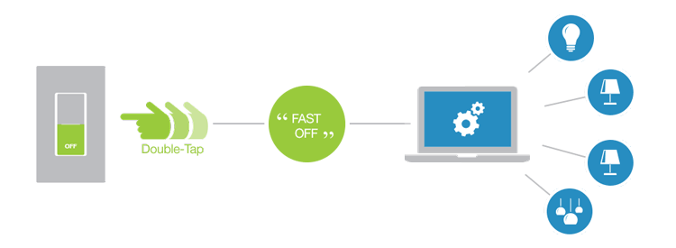

A convenient yet often unused feature of [INSTEON switches](http://www.smarthome.com/_/ProductResults.aspx?Ntt=insteon%20switches) is the double-tap (on/off). Normally used for bypassing a slow fade-on or fade-off, the double-tap of a switch can transmit a unique command that can be used to trigger an event using software such as[HouseLinc](http://www.smarthome.com/_/Dual_Band/_/36n/nav.aspx?Ntt=houselinc). This tip will cover how to program an “All Off” for your lights as you leave for work each day.

To program this feature in [HouseLinc](http://www.smarthome.com/_/Dual_Band/_/36n/nav.aspx?Ntt=houselinc) you will want to set up an Event that will send an All INSTEON Off command whenever a particular switch is double-tapped. It is usually a good idea to select the switch closest to your exit door.

SETUP

1. The first step in the software is to set up a scene that would turn all the lights off. Click on the ‘Scenes’ tab in the top left corner of the software and right-click in the left hand field to Add New Scene. Name the scene and check the boxes to include all of the lights you would like to shut off when you’re on your way out of the house. Once your devices have been included, you will want to click the ‘Save’ button towards the top of the right-hand section of the screen.
2. Next you will want to click on the ‘Events’ tab towards the top right hand section of the HouseLinc window and click the ‘Add Event’ button. To edit the event you would simply drag and drop from the left hand side of the screen to the right hand side of the screen. Drag your newly created scene into the ‘Action(s)’ section of the Event. Next you will want to click Edit in the same section and change the description to Turn Off.
3. The final step is setting your trigger. In the top left hand corner of the screen, click the Devices tab and drag your desired switch into the ‘Trigger(s)’ section of the event. Here you will also want to edit the description to read ‘Off Double-Tapped’. When you have your trigger in place, you will want to click OK and HouseLinc will save the event.

Now whenever you are leaving the house, double-tapping off at the switch will shut off all the lights (A single tap on or off will still operate the switch normally).

NOTES

Before installing INSTEON wall switches and keypads be sure to check that you have neutral wires available behind your existing switches. These are commonly a group of white wires that are capped off in the back of the junction box.

# CONTROL YOUR PERSONAL STEAM BATH WITH INSTEON

Have a long day at the office or an extra grueling workout? How nice would it be to be able to relax and calm your nerves in your own personal steam bath? Our project is based on the Mr. Steam steam bath generator system available at Smarthome.com.

Note that this is a fairly advanced setup and you should be familiar with home plumbing, electricity and carefully examine your existing layout and plumbing before moving forward. To safely install a steam generator in your home you should have a fully-enclosed shower or sealed, weatherproof room with a drain. Please consult the Mr. Steam installation guide for more information.

## GETTING STARTED

Here is the diagram we are working from:

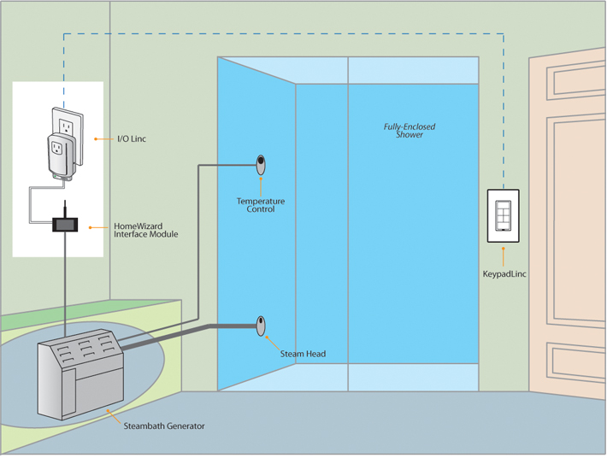

## EQUIPMENT LIST

* 1x - [6-Button KeypadLinc](http://www.smarthome.com/2487S/p.aspx)
* 1x - [I/O Linc INSTEON Low Voltage Interface](http://www.smarthome.com/2450/p.aspx)
* 1x - [Mr. Steam Residential Steambath Generator](http://www.smarthome.com/55106/p.aspx)
* 1x - [Mr. Steam eTEMPO Control Kit](http://www.smarthome.com/55101PN/p.aspx)
* 1x - [Mr. Stream HomeWizard Wireless Control](http://www.smarthome.com/55103/p.aspx)

Note that each setup will be unique and you may require additional equipment.

### **STEP 1**

Install the Steambath generator, steam head, eTEMPO temperature controller and the HomeWizard controller. Please follow the Mr. Steam guidelines and installation instructions carefully.

### **STEP 2**

Configure the HomeWizard interface for Home Automation mode. You can test that the system is configured properly by connecting the on/off home automation connectors with a jumper wire. This should start the steam generator.

### **STEP 3**

Plug the I/O Linc to an outlet and connect the I/O Linc to the HomeWizard using the following diagram as a reference:

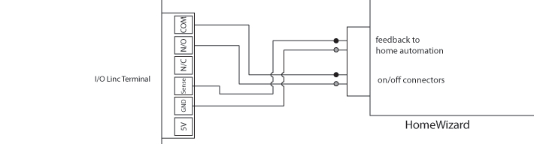

### **STEP 4**

Replace your bathroom light switch with the KeypadLinc. The KeypadLinc has a built-in switch that allows you to continue controlling what the old light switch controlled and gives you four additional buttons that can be linked to other INSTEON devices in the home.

### **STEP 5**

Select any of the small buttons on the KeypadLinc and link it to the I/O Linc by following the instructions in the quick-start guide.

### **STEP 6**

Test to ensure that all of your INSTEON devices have been setup properly. At this point you should be able to control your personal steam bath from the KeypadLinc...Pretty cool huh? You're Done! Next time you have a rough day at the office, take comfort in the fact that you can relax and sooth your muscles in your own personal steam bath.

With INSTEON Hub you would be able to control your steam bath from any smart phone, letting you turn on your steam bath from your car! We hope this helps some of you get off the ground with some of the more advanced features INSTEON has to offer.

# CONTROLLING AND AUTOMATING POOL ATTACHMENTS WITH INSTEON

Have you ever wanted to control your pool's pump, lighting, and/or heater from within the comfort of your home? How about from your Smartphone or Tablet? The versatility of INSTEON allows you to modernize your home, including its amenities, with automation beyond what was previously possible. This solution will provide you with the essential steps needed to automate and remotely access your pool's pump, heater, and lighting using the latest INSTEON dual-band technology. Let's get started!

## EQUIPMENT LIST

* 1x - [INSTEON SwitchLinc](http://www.smarthome.com/2477S.html)
* 1x - [INSTEON 220V/240V 30 Amp Load Controller](http://www.smarthome.com/2477SA1.html)
* 1x - [INSTEON Hub](http://www.smarthome.com/2242-222.html)

## NOTE

* This solution is considered to be an advanced setup and it is important to carefully examine the layout of your pool's wiring setup before continuing.
* One is required for each heavy duty pool related appliance. For example: one for the pool cleaner, one for the pool heater, etc...

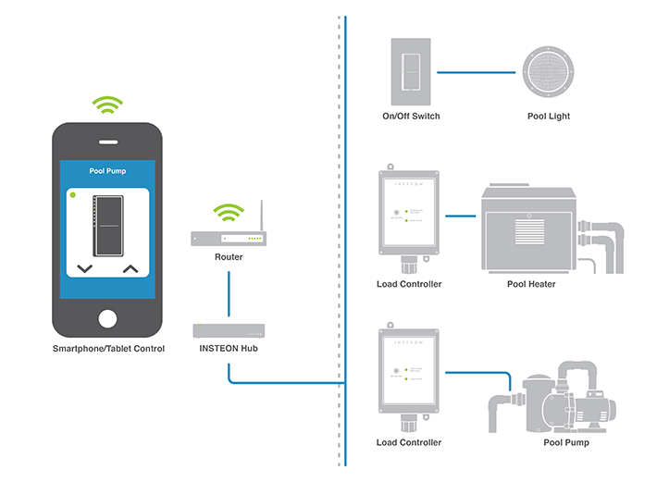

### **STEP 1: REPLACE THE EXISTING POOL LIGHTING SWITCH**

Replace your pool lighting switch with the INSTEON SwitchLinc.

### **STEP 2: CONNECTING THE INSTEON 220V/240V 30 AMP LOAD CONTROLLER**

a

Connect the INSTEON Load Controller to your pool's pump or heater. Depending on your pool's configuration, this step may require a different configuration than what is outlined here. It is important to note that multiple INSTEON Load Controllers will be needed when connecting a pool cleaner and pool heater. One INSTEON Load Controller will be needed for each heavy duty pool related appliance being connected.

### **STEP 3: INTEGRATING THE INSTEON HUB**

Setup and configure the INSTEON Hub. After setting up the Hub, follow the onscreen instructions to link your SwitchLinc and 220V Load Controller. Your pool equipment should now be controllable from your smartphone or tablet.

### **STEP 4: RELAX AND ENJOY**

Now, you will be able to not only control your pool's pump, lights, and/or heater from a comfortable and convenient location from within your home, but also schedule, automate, and access all connected pool related INSTEON devices from the palm of your hand with a smartphone or tablet. Once you've setup remote access you can even log into your home before you leave the office and get the pool ready for your arrival.

### **STEP 5: HAVE FUN EXPANDING**

The INSTEON Hub can be expanded to control your entire house. Check out the video below for some ideas

https://www.youtube.com/watch?v=EFqV8Uq4rzU

## REFERENCES

* INSTEON SwitchLinc: [Manual](http://www.smarthome.com/manuals/2477s.pdf) | [Quick Start Guide](http://www.smarthome.com/manuals/2477sqs.pdf)
* INSTEON Load Controller: [Manual](http://www.smarthome.com/manuals/2477SA.pdf) | [Quick Start Guide](http://www.smarthome.com/manuals/2477saqs.pdf)
* INSTEON Hub: [Manual](http://www.smarthome.com/manuals/2242-x22.pdf) | [Quick Start Guide](http://www.smarthome.com/manuals/2242-x22qs.pdf)

# HOW TO OUTSMART A BURGLAR - HOW TO AUTOMATICALLY TURN ON AN INSIDE LIGHT WITH OUTSIDE MOTION

Imagine that you are a burglar... You are casing a house that you are looking to rob. You walk around the side yard and a motion sensor light goes off - big deal, those things get as much attention as a random car alarm. You find a window you can get through and you're in.

Now, imagine that instead of a typical motion sensor light going off, an actual interior light in the house turned on! Unless you really feel like going to jail, you will probably move on to an unoccupied residence.

Our project is a simple system that will turn on an interior light when an outdoor motion sensor is tripped. You can set this up in a variety of ways to fit your preference and though this project uses INSTEON, you don't need an existing system to accomplish it.

## GETTING STARTED

Here is the diagram we are working from. This project should take around 30 minutes to complete.

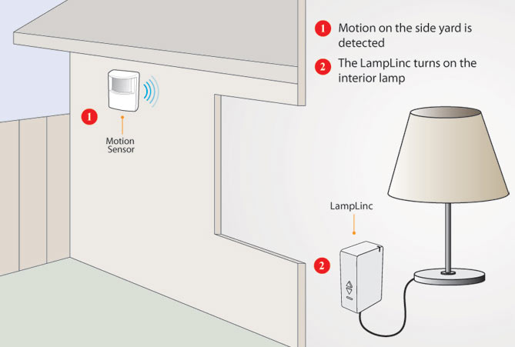

## EQUIPMENT LIST

For this project we are using the following products:

* 1x - [INSTEON Wireless Motion Sensor](http://www.smarthome.com/2842-222.html)
* 1x - [INSTEON LampLinc Dimmer (Dual-Band)](http://www.smarthome.com/2457D2.html)

### **STEP 1**

Mount your motion sensor in the desired location outside your home. Follow the instructions included with the sensor for installation instructions and locating tips.

### **STEP 2**

Chose the lamp you want to turn on when the motion sensor is triggered. Unplug the lamp and plug in the LampLinc dimmer into the outlet, then the lamp into the LampLinc.

### **STEP 3**

Press and hold the "Set" button on the motion sensor for 5 seconds (until red LED on the back begins to blink). You now have 4 minutes to set the responding device (the LampLinc in this example).

### **STEP 4**

With the Motion Sensor in linking mode (see previous step), press and hold the "Set" button on the LampLinc for 3 seconds or until it beeps.

You now have a clever and effective burglar deterrent! Whenever someone trips the outdoor motion sensor, your interior lamp will turn on. You can expand on this setup so that other lights turn on, cameras are activated and more. With [HouseLinc](http://www.smarthome.com/houselinc.html) software you can even receive an email notification!

# CONTROL ALL THE LIGHTS IN THE HOUSE FROM ONE SWITCH OR REMOTE

Because most people unknowingly leave lights on as they leave the house, we recommend installing the controller next to your front door. And since most homes have a switch located there anyway and our keypad can replace an existing light switch, it works out easiest.

## PARTS LIST

* 1x - KeypadLinc (available with a built-in [dimmer](http://www.smarthome.com/2334-232.html) or [switch](http://www.smarthome.com/2487S.html) which makes for a hassle-free swapping out your existing wall switch)
* 1x - (or more) [Dimmer](http://www.smarthome.com/2477D.html) or [switch](http://www.smarthome.com/2477S.html) for each light you want to control
* 1x - (or more) [Lamp module](http://www.smarthome.com/2457D2.html) for each lamp you want to control

## SETUP

1. Replace the switches you want to control with dimmers or relay switches.
2. Plug each lamp into a lamp module.
3. Replace the front door switch with the KeypadLinc.The keypad features a built-in load controller so you don't lose control over the light switch.
4. Choose a button on the KeypadLinc that you want to use as your whole house light controller.
5. Press and hold the selected button on the KeypadLinc for 10 seconds and release, the button should start blinking, then tap the set button again (this puts the button into multi-link mode and it will stay in this mode for approximately 4 minutes).
6. Go to the first switch and hold the set button for approximately three seconds, repeating this for each switch in the house.
7. Next go to the first lamp module and tap the set button, repeat this for each additional lamp module.
8. When you're finished linking all your switches and lamp modules, return to the KeypadLinc and press the blinking button (this exits the KeypadLinc from programming mode).
9. Now each time you press the button all lights controlled by INSTEON dimmers and plug-in modules will be controlled by that single button.

## TIPS

* You can also program the KeypadLinc button to only send off commands when pressed. To do this press and hold the button on the KeypadLinc for 10 seconds. Release and the button should be blinking. Press and hold the button again for 5 seconds. When you release, the button's LED should flutter and return to blinking. Press and hold again for 5 seconds and it will exit out of programming mode. Now whenever you press the button it will only send off command to all devices linked to the button.
* For rooms that have 2 or more lamps, save money by plugging the lamps into a power strip or splitter then plugging the splitter into the lamp module. Just be sure the combined wattage of all lamps is under the maximum rating of the lamp module

## NOTES

Before installing INSTEON wall switches and keypads be sure to check that you have neutral wires available behind your existing switches. These are commonly a group of white wires that are capped off in the back of the junction box.

# VIEW A CAMERA AT YOUR FRONT DOOR AND CONTROL YOUR PORCH LIGHT FROM YOUR IPHONE

## PARTS LIST

* 1x - [INSTEON Hub](http://www.smarthome.com/2242-222.html)
* 1x - [Wireless IP Camera](http://www.smarthome.com/75790.html)
* 1x - [Dimmer](http://www.smarthome.com/2477D.html) (for incandescent lighting) or [Switch](http://www.smarthome.com/2477S.html) (for CFL or other non-dimmable lighting)

## SETUP

1. Replace the porch light switch with the INSTEON switch (dimmer or relay).
2. Plug the INSTEON Hub directly into an outlet near your router (avoid plugging INSTEON Hub into surge-protected power strips or outlets as this may impede signals).
3. Connect the INSTEON Hub into an available port on your router with the included network cable.
4. With your iPhone, connect to INSTEON Hub following the instructions in the manual.
5. Now using your iPhone create a "front door" room within INSTEON Hub and link your porch light.
6. Install and setup your IP camera following the camera instructions.
7. Once you have confirmed your camera is viewable online, go to the front door room in INSTEON Hub and
8. Now you can view and control the camera and light from a single page on your iPhone or web-enabled device.

## NOTES

Before installing INSTEON wall switches and keypads be sure to check that you have neutral wires available behind your existing switches. These are commonly a group of white wires that are capped off in the back of the junction box.

# KNOW WHEN YOUR KIDS TURN THEIR BEDROOM LIGHTS ON OR OFF FROM A KEYPAD IN YOUR BEDROOM

## PARTS LIST

* 1 [KeypadLinc](http://www.smarthome.com/2334-232.html)
* 1 [Dimmer](http://www.smarthome.com/2477D.html) (for incandescent lighting) or [Relay](http://www.smarthome.com/2477S.html) (for CFL or non-dimmable lighting)

## SETUP

1. Replace the master bedroom switch with the KeypadLinc - the large buttons will control the local load and you'll have four buttons available for controlling remote lighting.
2. Replace your child's wall switch with the dimmer or relay switch.
3. Select a button on the KeypadLinc that you want to use as your indicator/controller for the kids room light and press and hold for 10 seconds. The keypad button will start blinking - you are now in programming mode.
4. Go to the kids room and using a fingernail or small screwdriver and press and hold the set button for 5 seconds - the light should flash indicate successfull linking.
5. Now when your child's room light is turned on, the corresponding button on the keypad will be illuminated. If you want to turn it off just press the button.

## NOTES

Before installing INSTEON wall switches and keypads be sure to check that you have neutral wires available behind your existing switches. These are commonly a group of white wires that are capped off in the back of the junction box.

# GET A TEXT MESSAGE OR E-MAIL TO YOUR CELL PHONE IF A DOOR OR WINDOW OPENS

## PARTS LIST

* 1x - [ISY-99i w/PLM](http://www.smarthome.com/12236DB.html)
* 1x - [INSTEON Open/Close Sensor](http://www.smarthome.com/2843-222.html)
* 1x - [INSTEON Access Point](http://www.smarthome.com/2443.html)

## SETUP

1. Plug the INSTEON PLM into an outlet next to your router our network jack. Install a cat 5 from the PLM into the ISY-99i Port "A" jack. Install a second cat 5 cable from the ISY-99i "network" jack to a open port on your router.
2. Install the INSTEON Open/Close Sensor in the location you want to monitor (example: if a door, then attach the Open/Close Sensor magnet to the door and the TrigglerLinc itself to the door frame).
3. Plug in the INSTEON Access Point into an AC outlet (this is a wireless RF receiver for the Open/Close Sensor).
4. Log into the ISY-99i by going to you Network Neighborhood on your computer and clicking on "My Lighting". When the program starts, click on Administrative Console then go to Link Management and click on Start Linking.
5. Go to the Open/Close Sensor and press the set button. The Device should now show up in the ISY-99i as the device ID labeled on the Open/Close Sensor. At this point you may want to rename it to some other name.
6. With in the ISY-99 menu there is a Configuration tab that will take you to a screen to enter your email address or cell phone information. Once that is done you will need to write a simple rule in the ISY-99i program menu that will look something like this: If - Status of Open/Close Sensor is On   
   Then - Notify (Notify is the name that the ISY-99i gives to its email and text message function).

## TIPS

Be sure to name the Open/Close Sensor something descriptive like "Front Door Open" or "Living Room Window Open". This way when the ISY sends you an email it will read like this: "Living Room Window has changed state" If you do not give it a specific name the message you will receive will say "Open/Close Sensor has changed state".

# AUTOMATICALLY TURN OFF LIGHTS WHEN YOU ARM YOUR SECURITY SYSTEM

Add the ability to have your security system automatically turn lights off when you arm your security system. This reduces energy costs and keeps you from having to walk around the house making sure lights have been turned off before you leave the house. This project assumes you currently own a security panel that provides a relay output from the main board. We recommend that you be familiar with your security system or have a professional complete this project.

## PARTS LIST

* 1x - [INSTEON I/O Linc](http://www.smarthome.com/2450.html)
* 1x - [INSTEON Dimmer](http://www.smarthome.com/2477D.html) or [INSTEON ON/OFF Switch](http://www.smarthome.com/2477S.html) wall switch for each light you want to control
* 1x - [INSTEON Lamp module](http://www.smarthome.com/2457D2.html) for each lamp you want to control
* 1x - Pair of [INSTEON Access Points](http://www.smarthome.com/2443.html)

## SETUP

1. Install your Access Points on opposite phases in the house. (explained in the setup guide for Access Point).
2. Install the wall switch or lamp module to control your desired light. For the new wall switch you will install it in place of your existing switch. For a lamp module you will plug your lamp into the bottom outlet and plug the lamp module into a wall outlet.
3. Now plug the I/O Linc next to your alarm panel.
4. Typically most alarm panels will have at least a set of contacts that are part of the system that will allow you to trigger an external device. This part of the process may require someone who is very familiar with the system.
5. There may be an option to pick either a normally open or a normally closed set of contacts. These are usually shown as N/O or N/C on the security panel circuit board. The most practical would be to pick the N/C set of contacts and run wires from there to the N/C set of contacts on the I/O Linc.
6. Now press the set button in on the I/O Linc for 5 seconds and the led should be flashing, now go to the switch or lamp module and hold the set button in for 5 seconds. This will link each light to the I/O Linc.
7. You should now be able to test that the links work by by tapping the set button on the I/O Linc once to turn on the light and again to turn it off. If this doesn't work then follow the instructions that came with the I/O Linc on how to link it to another device.
8. The alarm system will need to be programmed to tell the contacts to open when the system is armed and close when the system is disarmed. This may happen without any programming needed but you will need to verify operation first.
9. Once all of this is done the alarm should turn on your lights when you disarm the system and turn them off when it is armed.

## TIPS

* Using a continuity meter to check the contacts on the alarm system ahead of time will verity if you need any additional programming. Connecting the meter to the normally closed contacts when the system is disarmed will show continuity but when the system is armed it will not show continuity. If this set of contacts does not change state you may need some outside help from an alarm company familiar with the system. Sometimes an add on component can be purchases by your alarm provider to provide these contacts.
* By following the instructions with these devices you can have the device come on a dim level or have the I/O Linc send only off commands.

## NOTES

This project can take up to two hours if the alarm contacts are present and no programming needs to be done by an outside contractor.

# CONTROL INSTEON DEVICES WITH HOMELINK

The HomeLink® Wireless Control System is a great feature included with hundreds of models of cars, providing a convenient way to replace up to three handheld radio frequency (RF) transmitters used for controlling garage doors, security systems, and home lighting. However, most users of HomeLink® rarely use it for more than just controlling the garage door.

HomeLink® learns commands sent from RF remotes, which are then repeated whenever you push a HomeLink® button. This system works with RF remotes that are within a 288-433MHz range, like many garage door remotes that commonly operate within this frequency. However, the INSTEON RF signal operates at 915MHz. Since INSTEON signals operate in a higher range than many RF remotes, a few preliminary steps are necessary to connect your HomeLink® system to your INSTEON controlled devices.

## REQUIRED PARTS

* 1x - [X10 Compatible Controller](http://www.smarthome.com/_/Handheld_Tabletop_Remotes/X10_Compatible/_/1QT/23X/nav.aspx)
* 1x - [EZX10RF X10 RF to INSTEON Power Line Converter](http://www.smarthome.com/31276.html)
* X10 compatible controllers operate at 310MHz and will communicate with the EZX10RF X10 RF to INSTEON Power Line Converter, a device that translates X10 signals into a language that INSTEON devices can understand.
* In addition, an INSTEON device or groups of devices are **required**.
* [View all INSTEON devices](http://www.smarthome.com/_/INSTEON/_/23b/land.aspx) available at Smarthome.

### **STEP 1: EZX10RF PLACEMENT**

After installing an INSTEON device(s), plug the EZX10RF into an available outlet. It is highly recommended to place the EZX10RF as close as possible to where activation of the HomeLink® system will occur. For most people, it will be activated from the driveway, so place the EZX10RF into a room closest to that specific location.

### **STEP 2: PROGRAM THE X10 KEYCHAIN REMOTE FOR TWO DEVICES INTO THE EZX10RF**

1. Program the same "ON" command from the X10 remote to the EZX10RF converter.
2. Plug the EZX10RF into the selected outlet and observe its LED flash a number of times and then glow steadily after a few seconds.
3. The EZX10RF is now ready to program.
4. For convenience, a pass-through outlet is provided. Ensure that any device plugged into this outlet is not a RF emitter that would interfere with the EZX10RF.

### **STEP 3: HOW TO SETUP INSTEON CONTROL, PROGRAMMING AN X10 CODE, AND LINKING INSTEON DEVICES**

Controlling INSTEON devices involves teaching the EZX10RF the X10 RF based command that will be used as the trigger and linking the INSTEON device(s) that will respond.

**The following steps are used to link one or several INSTEON devices on a single command from the X10 remote:**

1. Press and hold the pushbutton on the side of the EZX10RF for four seconds, then release it. The LED on the EZX10RF should be flashing about once per second. The flashing LED means the EZX10RF is now listening for an X10 signal.
2. Using the wireless X10 transmitter, press the "ON" button that you will want to control this specific scene with. The LED on the EZX10RF will begin to flash more rapidly upon "hearing" the X10 signal. The rapid flashing of the LED signifies that the EZX10RF is now listening for INSTEON devices to be linked.
3. Press and hold the "SET" button on the INSTEON device to be controlled until the load flashes. The LED should flash once and then turn on to solid. The LED on the EZX10RF may flash briefly, but will continue to blink about twice per second indicating readiness to link additional INSTEON devices to this group.
4. If any additional INSTEON devices need to be linked, then repeat step 3. Otherwise, press and hold the pushbutton on the EZX10RF for four seconds, then release it. At this point the LED on the EZX10RF will turn off.
5. A timer (from .5 to 15.5 minutes) can now be added to delay the "OFF" command regardless of the duration of the incoming wireless signal. If no timer is needed, end the linking process by pressing and holding the pushbutton on the EZX10RF for four seconds. The EZX10RF LED will glow steadily again. If a timer is needed, tap the pushbutton on the EZX10RF 1-31 times (each tap adds 1/2 minute to the timer), then press and hold its pushbutton for four seconds to end the linking session. **Note:** If you notice that the LED continues to blink, press the pushbutton once to finish.

### **STEP 4: PROGRAM THE KEYCHAIN REMOTE INTO YOUR HOMELINK® SYSTEM**

Program one of the "ON" buttons from the Wireless X10 Keychain Remote into an available HomeLink button. Programming steps will differ between make and models, so it is best to refer to your vehicles HomeLink manual or visit the [HomeLink programming page.](http://www.homelink.com/home" \t "_blank)

# NEVER WALK TO BED IN THE DARK AGAIN

**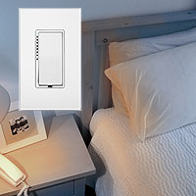**The dishes are done, the kids are asleep, and you've finally finished reading the paper. But before you hop into bed, you'll have to go downstairs and turn off the lamp in the family room, as well as the front porch light. By the time you've stumbled through the dark house on the way back upstairs, you're wide awake again. Sound familiar?

Relief is closer and easier than you think. With just a few smart lighting control products, you can turn off any light in the house from your nightstand.

## THE SOLUTION

Although every home is set up differently, we've found that the most common lights that Smarthome customers want to control remotely are:

* An overhead light fixture in the family room
* A plug-in lamp in the family room
* The front porch light
* The overhead kitchen lights

All of these devices can be managed from your bedside table, even turning every one of them off with the single press of a button!

## THE SHOPPING LIST

|  |  |  |
| --- | --- | --- |
| [[INSTEON Mini Remote](http://www.smarthome.com/2342-232.html) INSTEON Mini Remote, White](http://www.smarthome.com/2342-232.html) | [[INSTEON Switches and Dimmers](http://www.smarthome.com/_/Dimmers_Lighting_Appliance_Control/Dimmers_Wall_Switches_Keypads_Touchscreens/INSTEON/Wall_Switches_Dimmers/_/z/1QV/23b/2MD/nav.aspx) INSTEON Wall Switches and Dimmers](http://www.smarthome.com/_/Dimmers_Lighting_Appliance_Control/Dimmers_Wall_Switches_Keypads_Touchscreens/INSTEON/Wall_Switches_Dimmers/_/z/1QV/23b/2MD/nav.aspx) | [[Plug-in Modules](http://www.smarthome.com/_/Dimmers_Lighting_Appliance_Control/INSTEON/Plug_in_Screw_In_Modules/_/z/23b/1Qd/nav.aspx) INSTEON Plug-in modules](http://www.smarthome.com/_/Dimmers_Lighting_Appliance_Control/INSTEON/Plug_in_Screw_In_Modules/_/z/23b/1Qd/nav.aspx) |

The most popular and easiest solution to set up would be to purchase a [INSTEON Mini Remote](http://www.smarthome.com/2342-232.html) and two [LampLinc Plug-In Modules](http://www.smarthome.com/2457D2.html). From here you'll want to choose expansion options for controlling other lights (or appliances) throughout the home. To control the overhead light fixtures in the family room and kitchen, as well as the porch light, you'll need a [wall switch](http://www.smarthome.com/_/Dimmers_Lighting_Appliance_Control/Appliance/Dimmers_Wall_Switches_Keypads_Touchscreens/INSTEON/Wall_Switches_Dimmers/_/z/2O5/1QV/23b/2MD/nav.aspx) or [wall dimmer](http://www.smarthome.com/_/Dimmers_Lighting_Appliance_Control/Dimmers_Wall_Switches_Keypads_Touchscreens/Dimming/INSTEON/Wall_Switches_Dimmers/_/z/1QV/22B/23b/2MD/nav.aspx) (switch for on/off only and dimmer for dimmable incandescent, CFL, or LED bulbs); to control the family room lamp or any plug-in light, you would choose a [plug-in dimmer module](http://www.smarthome.com/_/Dimmers_Lighting_Appliance_Control/INSTEON/Plug_in_Screw_In_Modules/Plug_In_Dimmers/_/z/23b/1Qd/2MV/nav.aspx) (for dimmable lighting) or [plug-in appliance module](http://www.smarthome.com/_/Dimmers_Lighting_Appliance_Control/INSTEON/Plug_in_Screw_In_Modules/Plug_in_ON_OFF_Modules/_/z/23b/1Qd/2MX/nav.aspx) (for non-dimmable lighting such as CFL or LED bulbs).

## THE SETUP: GETTING STARTED

INSTEON Mini Remote sends On/Off/Dim/Bright commands via RF signal up to 150' to the LampLinc dual-band modules. Simply plug your lamp into one of the included LampLinc modules and plug the LampLinc into the outlet. Press and hold one of the control buttons on the INSTEON Mini Remote for 10 seconds to put it into programming mode and finally press and hold the set button on the LampLinc. Repeat for the second LampLinc and you're done.

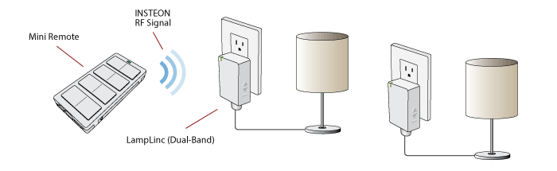

This system is expandable for control of up to 4 unique devices or scenes. Just add more lamp or appliance controllers or remote control wall switches and dimmers.

# SET THE PERFECT MOOD FOR VALENTINES DAY

Set the mood for Valentine's Day or any other special event with INSTEON-compatible lighting control. Using your home's existing wiring, these products connect in seconds for whole-house mood lighting at the press of a button.

## BASIC ONE-BUTTON MOOD LIGHTING



[[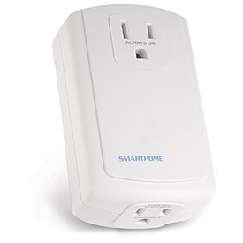](http://www.smarthome.com/_/Dimmers_Lighting_Appliance_Control/INSTEON/Plug_in_Screw_In_Modules/_/z/23b/1Qd/nav.aspx)](http://www.smarthome.com/_/Dimmers_Lighting_Appliance_Control/INSTEON/Plug_in_Screw_In_Modules/_/z/23b/1Qd/nav.aspx)Whether you're automating your dining room, your bedroom, or your entire house, an easy way to get started is to purchase two [plug-in lamp modules](http://www.smarthome.com/2457D2.html) that turn lamps into instant dimmers and also a [mini remote](http://www.smarthome.com/2342-232/INSTEON-Mini-Remote-4-Scene/p.aspx) to control the lamps from the comfort of the couch or bed. Just press a couple of buttons to link each LampLinc module to the included controller. The INSTEON Mini Remote will turn on and dim lamps individually or turn on multiple lamps in scenes that can include every light in your home. Each connected lamp can fade on at a different rate, and each can come on to a specific brightness level to help you to set the perfect mood for your evening. You can include more [INSTEON Lamp Dimmers](http://www.smarthome.com/_/Dimmers_Lighting_Appliance_Control/INSTEON/Plug_in_Screw_In_Modules/Plug_In_Dimmers/_/z/23b/1Qd/2MV/nav.aspx) to meet your needs. You can also connect fans, fountains, or other appropriate appliances to each scene by plugging them into [INSTEON Appliance](http://www.smarthome.com/_/Dimmers_Lighting_Appliance_Control/INSTEON/Plug_in_Screw_In_Modules/Plug_in_ON_OFF_Modules/_/z/23b/1Qd/2MX/nav.aspx)modules, which should be used for non-dimmable lights. You can even control [switched lights](http://www.smarthome.com/_/Dimmers_Lighting_Appliance_Control/Dimmers_Wall_Switches_Keypads_Touchscreens/INSTEON/Wall_Switches_Dimmers/_/z/1QV/23b/2MD/nav.aspx) with your INSTEON Mini Remote.

## EXPAND YOUR INSTEON LIGHTING CONTROL

[[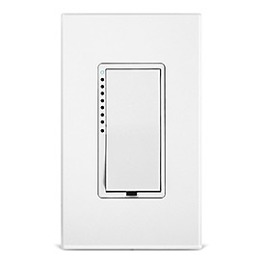](http://www.smarthome.com/_/Dimmers_Lighting_Appliance_Control/Dimmers_Wall_Switches_Keypads_Touchscreens/INSTEON/Wall_Switches_Dimmers/_/z/1QV/23b/2MD/nav.aspx)](http://www.smarthome.com/_/Dimmers_Lighting_Appliance_Control/Dimmers_Wall_Switches_Keypads_Touchscreens/INSTEON/Wall_Switches_Dimmers/_/z/1QV/23b/2MD/nav.aspx)Once you've set up your INSTEON kit, you can expand to include wall switches in any room.The [INSTEON SwitchLinc Dimmer](http://www.smarthome.com/2477D.html) wires in like a standard switch with an additional connection to the neutral wire (found in most homes). This attractive dimmer controls loads up to 600 watts (a [1000-watt version](http://www.smarthome.com/2477DH.html) is also available), and it can also be controlled remotely using your INSTEON Mini Remote, so you can add lights into scenes or turn them off from your bed. For non-dimmable lights (such as fluorescent) or ceiling fans, connect a [INSTEON SwitchLinc Relay (Non-dimming)](http://www.smarthome.com/2477S.html) instead. Switches and wall plates are also available in almond, black, brown and gray, and the LED colored light bars can be changed as well. See the full [SwitchLinc family](http://www.smarthome.com/_/Lighting_Accessories/_/Tv/nav.aspx) and find the right switch for your home.

## ADVANCED LIGHTING CONTROL OPTIONS

The INSTEON Mini Remote isn't your only option for controlling and dimming lamps and switches remotely. By wiring in an [INSTEON KeypadLinc Dimmer](http://www.smarthome.com/2334-232.html), you'll not only have direct control of the connected load, but you'll also be able to program the keypad to control multiple additional lights or scenes with the press of a button. Of course, each connected light can be dimmed or brightened and programmed to come on at a different rate. You can also manage your lighting with your computer: Try our FREE [HouseLinc Desktop Software](http://www.smarthome.com/houselinc.html).

## OTHER ROMANTIC OPTIONS

[[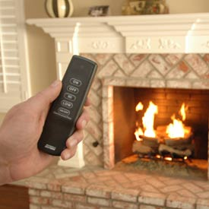](http://www.smarthome.com/_/Fireplace_Control/_/VD/nav.aspx)](http://www.smarthome.com/_/Fireplace_Control/_/VD/nav.aspx)Valentine's Day is a time to surprise your significant other with romantic gestures, so get creative! Smarthome can help with a wide variety of products, such as [fireplace adapters](http://www.smarthome.com/_/Fireplace_Control/_/VD/nav.aspx)that allow for remote control from the comfort of your couch, or [electric and battery-operated candles](http://www.smarthome.com/_/Candles/_/UV/nav.aspx?pp=12), which can help to set the mood without any danger of burning down the house. However you choose to celebrate, have a happy Valentine's Day!

# NEVER COME HOME TO A DARK HOUSE

Hate coming home in the dark? There's no need to stumble across your walkway or bump into scattered items left in your home's entryway. With just a few simple products, you can use INSTEON technology to turn your lights on automatically at sunset, so you'll never again need to fumble for your house keys in the dark.



## TURN YOUR PORCH LIGHT ON AT SUNSET AUTOMATICALLY

### **EQUIPMENT LIST**

* 1x - [INSTEON Hub](http://www.smarthome.com/2242-222.html)
* 1x - [INSTEON SwitchLinc Dimmer](http://www.smarthome.com/2477D.html)

Setting your porch light to turn on automatically at sunset is easy to do. Follow the included instructions to install the [INSTEON SwitchLinc Dimmer](http://www.smarthome.com/2477D.html), which wires in like a standard wall switch, with an additional connection to a neutral wire. Plug the [INSTEON Hub](http://www.smarthome.com/2242-222.html) into a wall outlet and connect it to your router using the included ethernet cable. You will need an Internet connection in order to set up the hub and schedule the lights to turn on and off. The setup wizard will walk you through the initial set up. Once you tell the software in what city and time zone you live, you'll be able to set up the system to turn the light on automatically at sunset, as designated by your location. The software adjusts automatically for Daylight Saving Time.

You don't need to leave your computer on in order to run the program: The INSTEON Hub saves information to the Cloud, so timers are stored there as well as locally in the device, and run when scheduled.



## COME HOME TO A WELL-LIT HOUSE WITHOUT WASTING ELECTRICITY

### **EQUIPMENT LIST**

* 1x - [INSTEON Hub](http://www.smarthome.com/2242-222.html)
* 1x - [INSTEON SwitchLinc Dimmer](http://www.smarthome.com/2477D.html)
* 1x - [INSTEON LampLinc Dimmer](http://www.smarthome.com/2457D2.html)

The Smarthome Manager Essential Software can trigger more than a porch light to turn on. Use this ultra-flexible software to create a lighting scene for your homecoming each evening with the porch light, entry hall light, and a lamp in your living room each turning on at a specific time or at sunset. You'll need a [SwitchLinc](http://www.smarthome.com/2477D.html) for every switched light or an[INSTEON LampLinc Dimmer](http://www.smarthome.com/2457D2.html) for every plug-in lamp to be controlled.

Once the switches and lamp modules are installed, just use the Smarthome Manager Essential Software's setup wizard to create the scene. Again, you don't need to leave your computer on in order to run the program. You'll enjoy increased energy savings by turning the lights on only as it gets dark, and you can set your porch light to turn off automatically at your normal bed time, so you won't be wasting electricity by leaving the light on all night long.

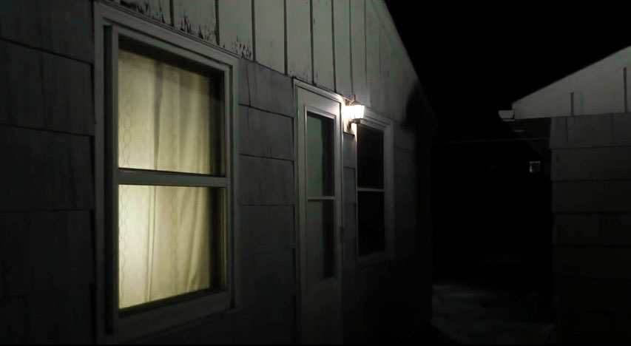

## USE THE SECURITY FEATURE FOR A LIVED-IN LOOK

### **EQUIPMENT LIST**

* 1x - [INSTEON Hub](http://www.smarthome.com/2242-222.html)
* 1x - [INSTEON SwitchLinc Dimmer](http://www.smarthome.com/2477D.html)
* 1x - [INSTEON LampLinc Dimmer](http://www.smarthome.com/2457D2.html)
* 1x - [INSTEON On/Off Module](http://www.smarthome.com/insteon-2635-222-on-off-module.html)

If would-be thieves are watching your home, they might notice if the lights turn on automatically at the same time every day. But the Smarthome Manager Essential Software can easily turn your lights on at random times around a time you set. The software's randomizing feature turns on the lights you designate within 15 minutes before or after any specified time. Again, you'll need a [SwitchLinc](http://www.smarthome.com/2477D.html) for every switched light or a [LampLinc](http://www.smarthome.com/2457D2.html) for every plug-in lamp to be controlled.

Get creative with the software: Even if you're away on vacation, you can still turn your bedroom lights on at approximately 8:00 and off at 10:00 each night, making your house look occupied and adding a level of security. You can even plug a radio or television into an [INSTEON On/Off Module](http://www.smarthome.com/insteon-2635-222-on-off-module.html) for audio that can be heard outside your home, helping to make it seem occupied when you're away.

# FUN, EASY KEYPADLINC SCENE IDEAS

An [INSTEON Keypad Dimmer Switch](http://www.smarthome.com/insteon-2334-232-keypad-dimmer-switch-dual-band-6-button-white.html) can do more than provide an attractive option for turning on a couple of lights from one location. You can use your keypad controller to create scenes that can make coming home and leaving quick and easy. Here are a few simple ideas that can be integrated into your KeypadLinc to maximize its capabilities. You can link hundreds of lights to each KeypadLinc button if you wish, but each dimmable light will need to be connected to an INSTEON-compatible [INSTEON SwitchLinc Dimmer](http://www.smarthome.com/2477D.html) or a [INSTEON LampLinc Dimmer](http://www.smarthome.com/2456D3.html) (non-dimmable lights should connect to [INSTEON SwitchLinc Relays](http://www.smarthome.com/2477S.html) or [IINSTEON On/Off Modules](http://www.smarthome.com/insteon-2635-222-on-off-module.html)).

Follow these instructions for one-button lighting scenes accessible from your entryway.

HOME SCENE

### **HOME SCENE**

Use this scene when you arrive home after dark. With the press of a button, you'll turn on your porch light, entryway light, and a light in your kitchen or living room to light your path through the house.

#### **ARRIVING HOME AFTER DARK**

You don't need to stumble through your house when you get home after sunset. By linking one of your small KeypadLinc buttons to a few lights, you'll have a clear pathway through your house accessible with a single button press.

#### **HOW TO SET IT UP**

1. Decide which lights you want to include in the scene. For a Home scene, we suggest your porch light, an entryway light, and perhaps a hall light and a bedroom or kitchen light.
2. Set your KeypadLinc into scene setup mode by pressing and holding your designated scene button for 10 seconds and then pressing the SET button at the bottom of the KeypadLinc.
3. If you're linking to a SwitchLinc Dimmer, press and hold the paddle top for 10 seconds. Most products will link in a similar manner, either by pressing and holding ON or by holding the SET button for 10 seconds.
4. Press any button on your KeypadLinc to exit scene setup mode.

# MAKE ANY BUILT-IN LIGHT AN INSTEON LIGHT

Have you ever thought about automating a built-in light or appliance fixture, like a ceiling fan? You don't have to change the switch in order to do so.

Control any built-in incandescent light with INSTEON commands using the [INSTEON In-LineLinc Dimmer](http://www.smarthome.com/2475D.html), which wires in discreetly and permanently to any light. Use the[INSTEON In-LineLinc Relay](http://www.smarthome.com/2475S2.html) to control any wired-in appliance or compact fluorescent lights.

These in-line fixture switches can mount in a standard J-box or in a more compact area, such as a ceiling fan fixture box. The In-LineLincs attach directly to your wiring, making it possible to control the unit via INSTEON commands using a [ControLinc tabletop controller](http://www.smarthome.com/2430.html), an [INSTEON SwitchLinc Dimmer](http://www.smarthome.com/2477D.html), an [INSTEON RemoteLinc](http://www.smarthome.com/mini-remote.html) or a wall-mounted [INSTEON Keypad Dimmer Switch](http://www.smarthome.com/insteon-2334-232-keypad-dimmer-switch-dual-band-6-button-white.html) to communicate with the module from anywhere in the house. Manage your INSTEON devices easily with [HouseLinc Desktop software](http://www.smarthome.com/2413uh.html), which lets you use your computer to link and unlink any INSTEON-compatible components.

## STEP 1: INSTALLING THE IN-LINELINC MODULE

[[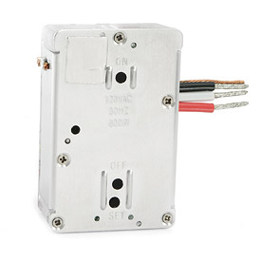](http://www.smarthome.com/2475D.html)](http://www.smarthome.com/2475D.html)As with any installation involving electrical wires, make all connections with the power OFF in order to avoid possible injury or damage to the device.

To install the In-LineLinc, strip 3/4" of insulation from the ends of the conductors and make connections as shown in the installation manual wiring diagram. Mount the module using the included screws.

## STEP 2: LINKING THE IN-LINELINC MODULE TO AN INSTEON-COMPATIBLE CONTROLLER

Prior to closing up the junction box or reinstalling the fixture, write down the In-LineLinc's INSTEON ID for future reference and link the In-LineLinc to the INSTEON controller or controllers you'll be using to manage the light or appliance remotely.

To link the devices, hold down the controller's ON button for 10 seconds and then press the In-LineLinc's SET button for 3 seconds. Once linked, you'll be able to turn the light or appliance on and dim the light remotely. You can even assign the In-LineLinc an X10 address to control it with any [X10 transmitter](http://www.smarthome.com/_/Dimmers_Lighting_Appliance_Control/X10_Compatible/_/z/23X/nav.aspx).

## STEP 3: CONFIRMING THE SIGNALS

Using any linked INSTEON transmitter, turn the In-LineLinc's light or appliance on and off to ensure the module controls the load in response to remote control.

THE DIFFERENT TYPES OF WALL TIMERS

One of the easiest ways to better manage home lighting, ceiling fans, heaters and other amenities is with a Wall Timer. Using a Wall Timer is great way to getting started with home automation as it will allow a particular device to operate for a specified amount of time. There are many Wall Timer solutions available at Smarthome and this guide will help you find one that fits your specific needs.

INTELLIGENT WALL TIMERS

An Intelligent Wall Timer is one that uses a technology (such as [INSTEON](http://www.smarthome.com/_/INSTEON/_/23b/land.aspx)) to schedule on/off times to control one or more devices on the same network. Additionally these timers can often be remotely programmed from another controller on that same network.

PROGRAMMABLE WALL TIMERS

A Programmable Wall Timer can typically manage multiple events per day for a device's operating time - extending up to 24 hours a day and up to seven days a week. There are also solar based functionality built into many of these timers that will automatically turn lights on or off based on the sunrise and sunset. These Wall Timers offer many options and are designed to handle complicated schedules as well as to better management of a home's appliances, pumps, motors, and other devices.

|  |  |
| --- | --- |
| [http://cache-m2.smarthome.com/images/25645wh.jpg](http://www.smarthome.com/_/Tork/_/3DH/nav.aspx?Ntt=programmable+wall+timer) | [http://cache-m2.smarthome.com/images/42536big.jpg](http://www.smarthome.com/_/Dimmers_Lighting_Appliance_Control/Dimmers_Wall_Switches_Keypads_Touchscreens/Honeywell/_/z/1QV/1yh/nav.aspx) |
| [Tork Programmable Timers](http://www.smarthome.com/_/Tork/_/3DH/nav.aspx?Ntt=programmable+wall+timer) | [Honeywell Programmable Timers](http://www.smarthome.com/_/Dimmers_Lighting_Appliance_Control/Dimmers_Wall_Switches_Keypads_Touchscreens/Honeywell/_/z/1QV/1yh/nav.aspx) |

PUSH BUTTON TIMER SWITCHES

Easy to install and affordable with basic controls, Push Button Timer Switches have multiple physical buttons that can be pushed to give you a specific amount of time that a device will operate for. These switches have timings that range from 5 minutes up to 12 hours and can be used to automatically shut off lights, spas, heaters, ceiling fans, bathroom vans, and many other devices.

|  |  |
| --- | --- |
| [http://cache-m2.smarthome.com/images/4253iv.jpg](http://www.smarthome.com/_/Timers_Automation/Automatic_Timers/Basic_Lighting_Appliance_Timers/Timers_PC_Advanced_Automation/_/r/2HR/1T7/1QZ/nav.aspx?Ntt=leviton) | [http://cache-m2.smarthome.com/images/25092big.jpg](http://www.smarthome.com/_/Dimmers_Lighting_Appliance_Control/Auto_Shut_Off/Dimmers_Wall_Switches_Keypads_Touchscreens/Heath_Zenith/_/z/21l/1QV/2hT/nav.aspx) |
| [Leviton Push Button Timers](http://www.smarthome.com/_/Timers_Automation/Automatic_Timers/Basic_Lighting_Appliance_Timers/Timers_PC_Advanced_Automation/_/r/2HR/1T7/1QZ/nav.aspx?Ntt=leviton) | [Intermatic Push Button Timers](http://www.smarthome.com/_/Timers_Automation/1_Button/1_Event/Auto_Shut_Off/Basic_Lighting_Appliance_Timers/Intermatic/Wall_Mounted_Timers/_/r/2Pj/2eL/21l/1T7/1gz/2Mj/nav.aspx) |

WALL TIMERS WITH OCCUPANCY SENSORS

These unique timers feature an integrated sensor that utilizes passive infrared (PIR) technology. It senses movement and turns on the attached lights, heater, fan, or other devices when someone enters the room. When the sensor no longer detects movement the attached device shuts off. The onboard timer can delay shutting off a device from 15 seconds to 15 minutes. An added feature of timers is that an ambient-light override (typically a photocell sensor) prevents lights from being turned on when there is sufficient daylight available. This feature helps to save money making these timers even more efficient than other types of wall timers. Occupancy sensors are available in different colors, some able to control multiple loads, and work in three way applications.

|  |  |
| --- | --- |
| [http://cache-m2.smarthome.com/images/2522ibig.jpg](http://www.smarthome.com/_/Dimmers_Lighting_Appliance_Control/Dimmers_Wall_Switches_Keypads_Touchscreens/Leviton/Motion_Occupancy_Sensors/Timing/Wall_Switches_Dimmers/_/z/1QV/1j1/2HL/21F/2MD/nav.aspx) | [http://cache-m2.smarthome.com/images/25025wh.jpg](http://www.smarthome.com/_/Dimmers_Lighting_Appliance_Control/Auto_Shut_Off/Dimmers_Wall_Switches_Keypads_Touchscreens/Heath_Zenith/_/z/21l/1QV/2hT/nav.aspx) |
| [Leviton Sensor Timers](http://www.smarthome.com/_/Dimmers_Lighting_Appliance_Control/Dimmers_Wall_Switches_Keypads_Touchscreens/Leviton/Motion_Occupancy_Sensors/Timing/Wall_Switches_Dimmers/_/z/1QV/1j1/2HL/21F/2MD/nav.aspx) | [Heath/Zenith Sensor Timers](http://www.smarthome.com/_/Dimmers_Lighting_Appliance_Control/Auto_Shut_Off/Dimmers_Wall_Switches_Keypads_Touchscreens/Heath_Zenith/_/z/21l/1QV/2hT/nav.aspx) |

SPRING WOUND TIMERS

A Spring Wound Timer is a low cost and simple solution with easy installation and basic control. The timer's knob is twisted to a desired run time allowing the mechanical design to break the circuit at the end of the timing cycle specified, which then turns off the attached device. There are many different Spring Wound Timer solutions available with different time increments ranging from 15 minutes up to 24 hours. The main advantage of these switches is that they are typically easy to wire and do not need to be programmed.

|  |  |
| --- | --- |
| [http://cache-m2.smarthome.com/images/119297big.jpg](http://www.smarthome.com/_/Timers_Automation/Basic_Lighting_Appliance_Timers/Intermatic/Spring_Wound/_/r/1T7/1gz/22F/nav.aspx) | [http://cache-m2.smarthome.com/images/55990big.jpg](http://www.smarthome.com/_/Dimmers_Lighting_Appliance_Control/Spring_Wound/Timers_PC_Advanced_Automation/Woods/_/z/22F/1QZ/3BJ/nav.aspx) |
| [Intermatic Spring Wound Timers](http://www.smarthome.com/_/Timers_Automation/Basic_Lighting_Appliance_Timers/Intermatic/Spring_Wound/_/r/1T7/1gz/22F/nav.aspx) | [Woods Spring Wound Timers](http://www.smarthome.com/_/Dimmers_Lighting_Appliance_Control/Spring_Wound/Timers_PC_Advanced_Automation/Woods/_/z/22F/1QZ/3BJ/nav.aspx) |

# ENERGY EFFICIENT SUBSTITUTES FOR INCANDESCENT BULBS

## ENERGY SAVING LIGHT BULBS: CFL VS. LED

Homeowners today are shifting towards more cost efficient and eco-friendly solutions for managing energy consumption in their homes.  Proper lighting improves the appearance and safety of a home both inside and out, yet it can also account for nearly 25% of a home's electricity.   Most people don’t realize that the standard incandescent bulbs they’ve been using for years are only 10% efficient; meaning only 10% of the electricity they use is transferred into light and the rest into heat!  Fortunately, the push for a greener way of life has brought rise to two major alternative options for standard incandescent light bulbs: the compact fluorescent light bulb (CFL) and a light emitting diode light bulb (LED).  Knowing what to look for and the difference between the two will help the average consumer save energy dollars each month.

## CFL LIGHTING

As a replacement for your average screw in light bulb, [CFL bulbs](http://www.smarthome.com/_/Dimmers_Lighting_Appliance_Control/Bulbs/Fluorescent/Light_Bulbs_Light_Fixtures_etc/_/z/2o1/2Gt/1Qf/nav.aspx) are an excellent option.  In simplest terms, CFLs are a miniature version of the common fluorescent light, using an electrical current to make phosphor gas glow.  Older CFLs use magnetic ballasts which usually cause a delay and/or flicker when they are turned on, however most new CFLs use electronic ballasts that eliminate this.  When compared to incandescent bulbs, CFLs are approximately four times as efficient; a 25 Watt CFL will have the same light output as a 100 Watt incandescent.  They also last up to 10 times longer, meaning that over the life of a standard CFL, you would expect to have used 10 incandescent bulbs.  Unlike a regular fluorescent light, a CFL gives off light that looks just like a standard incandescent. Choosing the bulb design that best suits the application is also a factor; available form factors include spiral, triple tube, standard, globe, flood and candelabra style bulbs to name a few.  While the purchase price of a CFL is typically 3 to 10 times greater than that of an equivalent incandescent bulb, over the lifespan of the bulb you can expect a large return on energy savings (see comparison chart below).  Continuously turning a CFL bulb on and off, or exposure to outdoor elements, can reduce the expected life span, so consider where you will be using them.  While dimmable CFLs and CFLs that can be used with timers are available, they may not always work with dimmer switches, dimmer modules, or timers. Lastly, CFL bulbs contain trace amounts of mercury which is a toxic metal, and although they can be disposed of in your regular trash, caution should be taken if a bulb is broken in your home.

## LED LIGHTING

Recently, advances in technology have given rise to [LED lighting](http://www.smarthome.com/_/Dimmers_Lighting_Appliance_Control/Bulbs/LED/Light_Bulbs_Light_Fixtures_etc/_/z/2o1/2Gv/1Qf/nav.aspx) as a replacement for the traditional incandescent bulb.  LEDS are small, solid light bulbs which drive their light in one direction or in cones of varying width depending on the bulb design.  Traditionally this type of directional lighting has been used for task lighting, flashlights and headlamps.  However, grouping these light in clusters and applying new designs have led to the LED as an extremely energy efficient replacement for the standard incandescent bulb.  An LED style bulb will generally last approximately 100 times as long as an incandescent; meaning that over the life of a standard LED style bulb, you would expect to have used 100 incandescent bulbs!  When compared to incandescent bulbs, LEDs are approximately six times as efficient; in simplest terms a 16 Watt LED style bulb will have the same light output as a 100 Watt incandescent.  An LED style bulb can be upward of 50 to 100 times the cost of standard incandescent bulb (although costs continue to drop), but you can expect a large return on your investment do to the lifespan and energy savings when compared to an incandescent bulb (see comparison chart below).  Another great feature of LED style bulbs are their durability; because they don’t have a filament they can withstand jarring and bumping making them less likely to be damaged under circumstances when a regular incandescent bulb would be broken.  When used with a dimmer, LED bulbs can brighten and dim fairly consistently from 30% brightness up.  They will also work well with most timers.  On the low end, instead of going completely off, LEDs tend to exhibit a slight glow due to the small amount of current that LEDs require to illuminate. Because this type of alternative lighting is still at the beginning stages, you can expect the capabilities of LED style bulbs to grow.

## UNDERSTANDING LUMENS

When replacing a standard incandescent bulb with a CFL or an LED as an alternative, one of the most important factors to understand is lumens.  A lumen is a measurement of how many foot-candles of light a bulb puts out in a square foot of area…or in laymen’s terms, how bright a bulb is.   Many CFL and LED bulbs are misleading, whether intentional or unintentional, when describing the bulbs they replace.  If you want a CFL or and LED bulb to replace your existing incandescent, make sure that the lumens match up.

## COMPARISON CHART

|  |  |  |  |  |  |  |
| --- | --- | --- | --- | --- | --- | --- |
| **Bulb Type** | **Lumens** | **Watts** | **Investment** | **Consumption** | **Energy Cost** | **Total Cost** |
| Incandescent | 1600 | 100 | $100.00 | 10000 kWh | $1,000.00 | $1,100.00 |
| CFL | 1600 | 25 | $100.00 | 2500 kWh | $250.00 | $350.00 |
| LED | 1600 | 15 | $100.00 | 1500 kWh | $150.00 | $250.00 |

### **INVESTMENT BASED ON:**

* Incandescent: $1.00 per bulb x 100 bulbs to equal the lifespan of one LED style bulb
* CFL: $10.00 per bulb x 10 bulbs to equal the lifespan of one LED style bulb
* LED: $100.00 per bulb equal to 100,000 hour lifespan

### **CONSUMPTION BASED ON:**

* Kilowatt hours (kWh) of energy used over the course of 100,000 hours

### **ENERGY COST BASED ON:**

* 10 cents per kWh average fee from utility company

## SYNOPSIS

Incandescent bulbs still make up a majority of the light bulbs in homes today, but as more people become energy and environmentally conscious, both the CFL and the LED bulbs are well suited alternatives.  Over the long term an LED style bulb will save you the most money although the initial cost may seem high.  The good news is that LED bulbs last for 10 years or more.  The CFL bulb will save you nearly as much as an LED style Bulb with a fraction of the investment.  Consider the placement and how you will be using each of your bulbs and a combination of the two alternatives will be rewarding over the long haul, not just in your pocket book but also for the planet.

## FACT

If every home in America replaced just one incandescent light bulb with an ENERGY STAR qualified CFL, in one year it would save enough energy to light more than 3 million homes. That would prevent the release of greenhouse gas emissions equal to that of about 800,000 cars.  Saving electricity reduces CO2 emissions, sulfur oxide and high-level nuclear waste.

# TIMER-ACTIVATED HOLIDAY LIGHTS

## THE PROBLEM

You've worked hard at setting up your holiday lighting display. You want your friends and neighbors to enjoy your handiwork. But then the inevitable happens: You forget to turn them on. Or worse, you forget to turn them off and end up wasting electricity during late-night hours or during the day.

But you can eliminate those headaches by automating your holiday lights. With a few simple products, you can have lights turn on and off at preset times or even automatically when the sun goes down (with an automatic turn-off after any amount of time you choose). Best of all, you can have your holiday lights up and running in just half an hour or less!

## TURN LIGHTS ON AUTOMATICALLY AT SPECIFIC TIMES

[[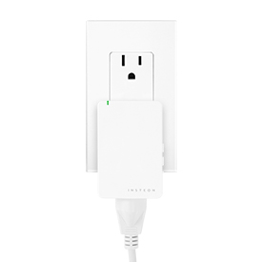](http://www.smarthome.com/insteon-2635-222-on-off-module.html)](http://www.smarthome.com/insteon-2635-222-on-off-module.html)If you're not going to be home at dusk, your neighbors can still enjoy your holiday display. Plug your holiday lights into an [INSTEON On/Off Modules](http://www.smarthome.com/insteon-2635-222-on-off-module.html) (you'll need one ApplianceLinc module for every major grouping of lights up to 480 Watts - make sure you don't exceed the number of connected strings recommended by the holiday light manufacturer). Or you can plug them into an [ApplianceLinc - INSTEON Outdoor Plug-In On / Off Appliance Module](http://www.smarthome.com/2634-222.html) which is outdoor rated and handles loads up to 1500 Watts. Then, using[HouseLinc - INSTEON Desktop Software with USB Interface](http://www.smarthome.com/2413uh.html) you can program on and off times for your ApplianceLinc modules, giving you complete automated control of your holiday lighting.

## SET UP AN INSTEON PLUG-IN TIMER

[[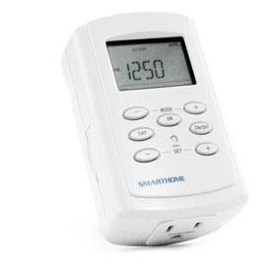](http://www.smarthome.com/2456S3T/TimerLinc-INSTEON-Plug-In-Timer/p.aspx)](http://www.smarthome.com/2456S3T/TimerLinc-INSTEON-Plug-In-Timer/p.aspx)You can also set up a timed lighting system without a PC on the premises. The first thing you'll need is an [TimerLinc - INSTEON Plug-In Timer](http://www.smarthome.com/2456S3T.html). It can signal any INSTEON receiver to turn your holiday lights on or off. Simply plug in your holiday lights into an ApplianceLinc (as described above). Then just link the ApplianceLinc modules to the TimerLinc and program the on time and off time for each group of lights you have programmed. This step takes just a few minutes and is no more difficult than setting an alarm clock.

# HOLIDAY LIGHTING MADE EASY WITH INSTEON

The holiday season gives you a chance to show off your creative spirit with custom lighting displays inside and outside your home. By using INSTEON lighting and appliance automation devices, you can easily control your lights andanimated decorations. There are three basic ways to automate your lighting displays: from a timer, via remote control or from any web enabled device.

## FROM A TIMER

**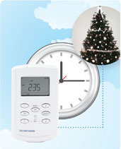**Using a simple timer such as [TimerLinc](http://www.smarthome.com/2456S3T.html), you can set on and off times for each day of the week, to control a single or group INSTEON controlled lights or devices. Once programmed, you won't have to lift a finger; your lights and decorations will turn on and off at the time you have specified, and by doing this you can limit the amount of energy your using, which will save you money on the holiday electric bill.

## VIA REMOTE CONTROL

**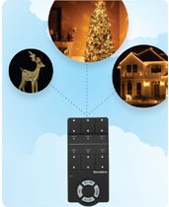**Most lighting enthusiasts have more than one or two strands of lights and powered decorations operating throughout the holiday season. If you are one of these people, you know what a pain it can be to run around the house every night and turn everything on, only to run around again before you go to sleep to turn everything off. Not only is this tedious but who's to say you won't accidentally leave something on. You can eliminate all of this by connecting everything via INSTEON, and using a [RemoteLinc](http://www.smarthome.com/mini-remote.html) to turn up to six individual or groups of lights and powered decorations on or off, from anywhere inside you home. Turn everything on at the start of the night, leave only a couple things on later in the night, or simply use the 'All Off ' button to shut everything down, all from the comfort of your couch or bed.

## FROM ANY WEB-ENABLED DEVICE

**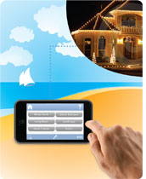**Managing your holiday lighting displays doesn't have to be limited to using timers or remotes. You can use a [SmartLinc - INSTEON Central Controller](http://www.smarthome.com/2412N.html)to operate your entire INSTEON network and holiday lighting from anywhere in the world. It works with any web-enabled iPhone, cell phone or PDA to give you remote access of all your INSTEON devices. So whether you are working late, celebrating the holidays with family or friends, or halfway around the world on vacation, you can still turn lights on and off to illuminate your home with holiday spirit or to give it that "lived-in" look while you are away.

## WHAT YOU NEED

To build your INSTEON network, the most important thing you need is a pair of [Access Points](http://www.smarthome.com/2443.html) or a [dual-band INSTEON product](http://www.smarthome.com/insteon.html?features=1804), these allow for communication between devices throughout you home. For most holiday lighting you'll simply need on and off control; the [ICON Remote Control Appliance Module (3-Pin)](http://www.smarthome.com/2856S3B.html)will handle up to 400 Watts. If you want to dim lamps or other dimmable holiday lighting, the [ICON Lamp Dimmer (2-Pin)](http://www.smarthome.com/2856D2B.html) can handle loads up to 150 Watts. If you are looking for a clean installation that won't compromise your decor, simply replace any existing wall receptacle with an[OutletLinc - INSTEON Remote Control Outlet](http://www.smarthome.com/2473SWH.html). All you have to do is plug your lights or decorations into one of these modules and you can control them in one of the aforementioned ways or via any INSTEON [Controller](http://www.smarthome.com/_/Dimmers_Lighting_Appliance_Control/Dimmers_Wall_Switches_Keypads_Touchscreens/Electronic_Low_Voltage/_/z/1QV/2OB/nav.aspx). Numerous other [INSTEON](http://www.smarthome.com/_/INSTEON/_/23b/land.aspx)products are also available.

## FOR THE ADVANCED USER

**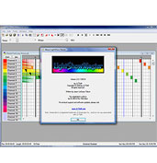**If you are looking for the ultimate in holiday lighting control,[Light Show Master 2.0 Holiday Lighting Control Software](http://www.smarthome.com/14251.html) will give you the ability to orchestrate a custom lighting display set to music. Using an [INSTEON PowerLinc Modem](http://www.smarthome.com/2413S.html), sold separately, you can create animated lighting displays, via control of INSTEON modules, and synch it with your favorite holiday sounds. The software allows for programming of custom lighting sequences that will turn your lights on and off and fade them up and down for an unlimited number of show "events" that can span minutes, hours, days, or even years.

# CONTROLLING AUDIO AND VIDEO COMPONENTS THROUGH WALLS

"I have placed my cable box and DVD player inside a cabinet/closet and I would like to be able to control my equipment. What do I need to achieve this?"

It seems that as more people toss out their old huge TV and cabinets in favor of that sexy wall-mounted flat panel TV, the more they realize just how much room the A/V gear takes up. They now want to move the gear to a nearby closet or maybe just completely hidden behind closed cabinet doors. These are both great ideas, but how can you control them once they are out of sight? Since most components are controlled by infrared (IR), the question is how to get those signals through an opaque wall, door or cabinet?

BASIC

### **BASIC SOLUTION**

The most basic solution we have is the [IR to RF to IR Remote Control Range Extender Kit](http://www.smarthome.com/80430.html) which will allow you to change out a battery in your remote (AA or AAA) and replace it with a special battery. This battery detects and converts signals from your remote into RF (radio frequency) which will then communicate to a base station to control your components.

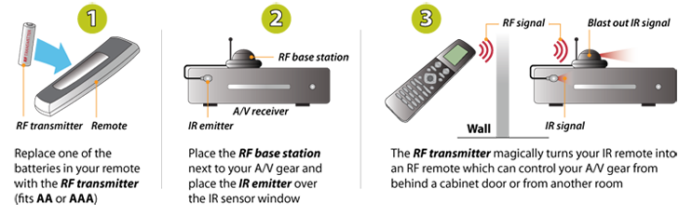

#### **KIT**

•  [IR to RF to IR Remote Control Range Extender Kit](http://www.smarthome.com/nextgen-ir-to-rf-to-ir-remote-control-extender-kit-418-mhz.html)  
  
[ORDER NOW](http://www.smarthome.com/nextgen-ir-to-rf-to-ir-remote-control-extender-kit-418-mhz.html)

# WIRELESSLY TRANSMIT ALL OF YOUR A/V SIGNALS

## THE FUTURE IS NOW

Wiring your flat screen TV to a cable/satellite receiver can be a daunting task, especially if you have wall mounted your TV and need to run wires through your walls. Or how about the eyesore of using a cord concealer to hide the wires running up and down your walls. With the number of devices we have connected to our TVs today, such as cable/satellite receivers, gaming systems, DVD/Blu-ray players, phone/tablet interfaces, and computers (just to name a few), you will have cords going all over the place.

The same as can be said for speakers. To get the most out of your surround sound, you will need to configure your speaker setup around your home theater. Without access to the walls or ceiling, or if you simply don't want speaker cables everywhere, wireless is the way to go.

Fortunately, Smarthome offers some great options for eliminating the cables and wirelessly transmitting all of your Audio/Video (A/V) signals.



## AFFORDABLE AND RELIABLE AV

The [RF LINK Wireless A/V Sender](http://www.smarthome.com/76540.html) is a tried and true system that does exactly what its name implies. This system is a simple, yet cost effective way to take a standard definition video and stereo audio signal (via composite RCA connections), and send it wirelessly (stream it) up to 400 feet away. The kit uses a high 5.8GHz radio frequency (RF) signal, so you'll avoid interference with other crowded low frequency devices. An infrared (IR) extender is also built in so you will still be able to use your existing remote to control your components.

## HIGH-DEFINITION AND EXPANDABLE HD CONTENT

For streaming High-Definition (HD) signals, the [SECO-LARM Wireless HDMI Distribution System](http://www.smarthome.com/77730.html) is the latest and greatest option. The system seamlessly distributes an HD video and audio signal (via HDMI connections), up to 30 meters (approximately 100 feet). The kit uses a 5.1~5.9 GHz RF signal along for transmitting HD 1080p video and digital audio, ideal for most short range residential and commercial applications. Also included is an (IR) extender, so you will still be able to use your existing remote to control your components.

## SURROUND SOUND AUDIO

For a simple 2 channel (right and left) sound system, you can use a Channel Vision [1-to-1 Wireless Audio Transmitter](http://www.smarthome.com/83684.html) and [1-to-1 Wireless Audio Amplifier and Receiver](http://www.smarthome.com/83595.html). The Wireless Transmitter will stream two speaker outputs to the Wireless Receiver which has a 100-Watt built-in amplifier and 2 speaker outputs. This will allow you to keep your home theater amplifier/receiver out of sight with the ability to put your speakers almost anywhere you want, up to 300 feet apart, with limited use of wires from the Wireless Receiver to the speakers.

However, nowadays most home theaters use multi-channel audio – a 7.2 channel system as an example, would use 7 speakers and 2 subwoofers for a completely immersive surround sound experience. For this type of application (or other similar surround sound systems, such as 5.1, 5.2, 7.1, 9.1, 9.2, etc.), use a combination of Channel Vision [1-to-Unlimited Wireless Audio Transmitters](http://www.smarthome.com/83616.html) and [1-to-Unlimited Wireless Audio Amplifier and Receivers](http://www.smarthome.com/83702.html) for the speakers (and passive, non-powered subwoofers, and use [1-to-Unlimited Wireless Audio Transmitters](http://www.smarthome.com/83616.html) and [1-to-Unlimited Wireless Audio Receivers](http://www.smarthome.com/83617.html) for dual powered subwoofer systems, or a [1-to-1 Wireless Audio Transmitter](http://www.smarthome.com/83684.html)and [1-to-1 Wireless Audio Receiver](http://www.smarthome.com/83685.html) for single powered subwoofer systems.

# ATTACHING A SUBWOOFER TO A HOME THEATER

Having a subwoofer integrated within your home theater is essential for experiencing full and accurate sound. The Subwoofer is responsible for reproducing and projecting low-end frequencies well below the capabilities of most speakers. The subwoofer can range in sizes from as small as 6 1/2 inches or less to a massive 18 inches or more. They deliver that room-shaking bass that can be found in most movies and are also versatile enough to deliver warm, smooth bass found in most musical tracks. Subwoofers allow you to literally feel the audio, like a thump to your chest and a shake in your leg. This simple guide assumes that you already have an Audio/Video Receiver, including home theater speakers, and discusses how to determine the type of subwoofer you own, how to connect it, and where it should be placed within a room.

## STEP 1: TYPES OF SUBWOOFERS

### **POWERED**

A powered subwoofer (also known as an Active Subwoofer) does not require any kind of external amplifier because the amplifier is already built-in.

|  |  |
| --- | --- |
| [[http://cache-m2.smarthome.com/images/67610.jpg](http://www.smarthome.com/67610.html) The Niles Audio SW8 8-Inch Powered Compact Subwoofer](http://www.smarthome.com/67610.html) | [[http://cache-m2.smarthome.com/images/8205s08_main.jpg](http://www.smarthome.com/8205S08.html) The BIC 8in 100-Watt Powered Subwoofer](http://www.smarthome.com/8205S08.html) |

### **PASSIVE**

A passive subwoofer does not contain an internal amplifier and is usually designed to install into a wall. In order to function properly, it requires an external amplifier such as a power amp or one that is specifically made for subwoofers. Amplifiers designed for subwoofers will usually have the necessary adjustments to help tweak a subwoofer's signal for optimum low-end production. It is important to choose an amplifier that does not exceed the advertised wattage of the subwoofer. An amplifier that provides more wattage than what a subwoofer can handle may result in audio distortion, amplifier clipping, and overall damage.

|  |  |
| --- | --- |
| [[http://cache-m2.smarthome.com/images/67002.jpg](http://www.smarthome.com/67002.html) The Niles Audio SW8 8-Inch Powered Compact Subwoofer](http://www.smarthome.com/67002.html) | [[http://cache-m2.smarthome.com/images/67279.jpg](http://www.smarthome.com/67279.html) The BIC 8in 100-Watt Powered Subwoofer](http://www.smarthome.com/67279.html) |

[View all powered and passive subwoofers available at Smarthome](http://www.smarthome.com/_/Speakers_A_V_Home_Theater/Speakers/Subwoofers/_/R/1SV/2qv/nav.aspx)

## STEP 2: CONNECTING THE CABLES

Most modern Audio/Video Receivers (AVRs) have a dedicated subwoofer connection located on the rear input/output panel. Usually the subwoofer connection is labeled as "Subwoofer Out" or something similar. The subwoofer output connector often utilizes an RCA connection, a type of cable designed to pass audio and video signals. On some older AVRs, a direct wire connection where the subwoofer's speaker wire connects directly to the AVR's "subwoofer out" speaker terminal is utilized. Regardless of what type of connection is available, be it RCA or direct wired, it is highly recommended to use shielded, heavy gauge cabling specifically designed for subwoofers. Such cables provide a cleaner, more noise-free audio signal.

The image below shows two subwoofer outputs. Today's AVRs feature 7.2, 9.2, and even 11.2 capabilities. The ".2" means that there are two subwoofer outputs available so that two subwoofers can be used at the same time. If the AVR had only a 5.1 capability, then the ".1" would mean that it only has one subwoofer output and thus only one subwoofer can be used.

|  |  |
| --- | --- |
| http://cache-m2.smarthome.com/images/subout_SLC04.jpg | http://cache-m2.smarthome.com/images/48935_SLC04.jpg |

[View all subwoofer RCA cables available at Smarthome](http://www.smarthome.com/_/Cable_Structured_Wiring/Audio_Solutions/Cables_Wire/Composite_RCA_Cable/RCA_Connectors/_/v/3gP/1PB/2CJ/2Td/nav.aspx)

If your AVR does not have an RCA "subwoofer output" connector, then a different approach is needed. Some self-powered subwoofers are able to take the speaker-level signals from the amp and extract the low-end sounds. Connect speaker cable from the front-left and front-right terminal outputs located on the rear panel of your AVR. Now, connect the other end of the speaker wire to the speaker wire terminals on the subwoofer. The amplification circuitry will combine both channels to mono, extract the bass frequencies, and amplify the sound for the subwoofer speaker.

|  |  |
| --- | --- |
| http://cache-m2.smarthome.com/images/speaker_sub.jpg | http://cache-m2.smarthome.com/images/84918.jpg |

[View all speaker wire available at Smarthome](http://www.smarthome.com/_/Cable_Structured_Wiring/Cables_Wire/Speaker_Wiring/_/v/1PB/2ST/nav.aspx)

## STEP 3: SUBWOOFER PLACEMENT

1. Subwoofers are omnidirectional, meaning that the subwoofer can project sound in all directions, unlike speakers that mostly project sound in the direction they are facing.
2. Start by placing your subwoofer near the front of your home theater system. A few feet to the left or right of the screen is a good starting point. Keep in mind that you will need to run electricity, audio cables, or speaker wires to the subwoofer.
3. Listen to some music or load up your favorite movie and give your home theater a listen while observing how the subwoofer integrates into the entirety of the system. Ideally, the subwoofer should be producing smooth, punchy, deep, and rounded low-end bass with a clear sound. If the subwoofer's placement is producing more of a boom rather than a punch, try adjusting its position.
4. Most modern AVRs come with their own version of an auto calibration feature which can get your entire home theater system, including the subwoofer, sounding optimum regardless of the subwoofer's placement. The auto calibration features of modern AVRs help to take out most of the difficult and often tricky work of getting the best sound from your home theater. Reference your AVR's manual for more information on its auto calibration feature.

## SOMETHING DIFFERENT

In addition to a subwoofer, there is also the Tactile Transducer. As mentioned in the above summary, bass is something that can be felt and these devices assure exactly that. The Tactile Transducer produces only the vibrations that come from low-end reproduction. Usually, these devices will attach to the underside of a chair or a sofa and will vibrate in-sync with the bass that is being reproduced from your home theater's subwoofer. The combination of a subwoofer and Tactile Transducer allows you to feel an explosion from a scene in a movie and feel the bass drum of a song more accurately. The Tactile Transducer takes audio listening and turns it into a sensory experience.

[View all Tactile Transducers available at Smarthome](http://www.smarthome.com/_/Speakers_A_V_Home_Theater/Speakers/Transducers/_/R/1SV/2qx/nav.aspx)

ENJOY THE BIG GAME THE SMARTHOME WAY

Are you ready for some championship football? While the teams take on each other, you're taking on your buddies' appetites and thirst at your Super Bowl party. Smarthome can help you with your menu preparation, with our barbecue thermometers, beer taps and wine openers. We'll even make sure you see and hear every exciting touchdown and every memorable commercial thanks to our high-definition projectors, HDTV antennas and expandable speaker systems. Enjoy the game the Smarthome way!

|  |  |  |  |  |
| --- | --- | --- | --- | --- |
| [[http://cache-m2.smarthome.com/images/5941-e.jpg](http://www.smarthome.com/5941.html) GE Find-It Large Backlit Button Home Theater Universal Remote Control Remote](http://www.smarthome.com/5941.html) | [[http://cache-m2.smarthome.com/images/7744hi-e.jpg](http://www.smarthome.com/7744HI.html) HDTV UHF/VHF Indoor Antenna](http://www.smarthome.com/7744HI.html) | [[http://cache-m2.smarthome.com/images/8177-e.jpg](http://www.smarthome.com/8177.html) The Big Remote](http://www.smarthome.com/8177.html) | [[http://cache-m2.smarthome.com/images/7744ho-e.jpg](http://www.smarthome.com/7744HO.html) Amplified HDTV Outdoor Antenna](http://www.smarthome.com/7744HO.html) | [[http://cache-m2.smarthome.com/images/8045ir-e.jpg](http://www.smarthome.com/8045IR.html) Internal RF Adapter for Any Remote](http://www.smarthome.com/8045IR.html) |

Whether you're tuning in to ABC for the pre-game show or one of several channels offering alternate halftime shows, you'll want to have a cool [remote control](http://www.smarthome.com/_/Home_Theater_Remotes/_/Rp/nav.aspx) in your hand. From [The Big Remote](http://www.smarthome.com/8177.html) to the ultra-flexible [GE Find-It Large Backlit Button Home Theater Universal Remote Control](http://www.smarthome.com/5941.html), Smarthome's remotes will access what you want to watch. You can even add an [RF adapter](http://www.smarthome.com/8045I.html) to control your components behind cabinet doors.

|  |  |  |  |
| --- | --- | --- | --- |
| [[http://cache-m2.smarthome.com/images/82001-e.jpg](http://www.smarthome.com/82001.html) Smarthome Select 6-Inch In-ceiling Speakers (Pair)](http://www.smarthome.com/82001.html) | [[http://cache-m2.smarthome.com/images/82002-e.jpg](http://www.smarthome.com/82002.html) Smarthome Select 6" In-wall Speakers (Pair)](http://www.smarthome.com/82002.html) | [[http://cache-m2.smarthome.com/images/972410s-e.jpg](http://www.smarthome.com/972410S.html) Bose Acoustimass 10-III System, Silver](http://www.smarthome.com/972410S.html) | [[http://cache-m2.smarthome.com/images/9724m2-e.jpg](http://www.smarthome.com/9724M2.html) Bose Companion 2 Speakers](http://www.smarthome.com/9724M2.html) |

Often, the sounds of the game are as important as the sights. Make sure you don't miss a call, a sack or a funny commercial by installing [speakers](http://www.smarthome.com/_/Speakers_AV/_/R/land.aspx) throughout your living room. Thanks to [in-wall](http://www.smarthome.com/_/Speakers_AV_Home_Theater/In_Wall/Speakers/_/R/2qp/1SV/nav.aspx) and [in-ceiling](http://www.smarthome.com/_/Speakers_AV_Home_Theater/In_Ceiling/Speakers/_/R/2qr/1SV/nav.aspx) speakers and [speaker sets](http://www.smarthome.com/_/Speakers_Accessories/_/T/nav.aspx) that can be set up around the room for surround sound effects, you won't miss a moment of the biggest game of the year.

|  |  |  |  |
| --- | --- | --- | --- |
| [[http://cache-m2.smarthome.com/images/3216-e.jpg](http://www.smarthome.com/3216.html) Smart BBQ Fork](http://www.smarthome.com/3216.html) | [[http://cache-m2.smarthome.com/images/32150-e.jpg](http://www.smarthome.com/32150.html) LED Grill Light](http://www.smarthome.com/32150.html) | [[http://cache-m2.smarthome.com/images/9135-e.jpg](http://www.smarthome.com/9135.html) CO²-Powered Beer Tap System](http://www.smarthome.com/9135.html) | [[http://cache-m2.smarthome.com/images/9171-e.jpg](http://www.smarthome.com/9171.html) Portable Rechargeable Battery Operated Blender](http://www.smarthome.com/9171.html) |

Grill those burgers to your exact taste with a [Smart BBQ Fork or thermometer](http://www.smarthome.com/3216.html), and then be sure to give your guests something to wash them down with. From beer taps to blenders to coolers, Smarthome's [BBQ accessories](http://www.smarthome.com/_/BBQ_Products/_/UL/nav.aspx) can help to make your Super Bowl party great. You can even pick up a new [Caller ID box](http://www.smarthome.com/_/Intercoms_Phones/Caller_ID_Products/Home_Phones_Accessories/_/9/2n5/1Qz/nav.aspx), to make sure you're not interrupted!

# WHOLE-HOME DVD VIDEO DISTRIBUTION

High-definition television provides crisp, clear images not available with standard cable or satellite imaging. But installing HDTV tuners in every room of your home that has a television set can become expensive; even more costly and difficult would be running component video and digital audio cabling from room to room. Luckily, a couple of simple options are available that will allow you to access your high-definition media without breaking your budget. Please keep in mind that you'll need an [off-air antenna](http://www.smarthome.com/_/Speakers_AV_Home_Theater/AV_Home_Theater_Accessories/Antennas_Mounts/_/R/1Sb/2lz/nav.aspx) to receive the HD signals.

## DISTRIBUTE HIGH-DEFINITION SIGNALS OVER CAT. 5 WIRING

[[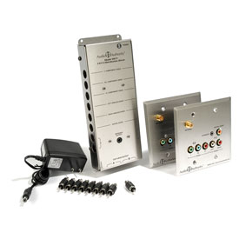](http://www.smarthome.com/77707K.html)](http://www.smarthome.com/77707K.html)Expensive coax cable isn't necessary if your home is pre-wired with cat. 5 wiring. Create a whole-house high-def distribution system with the [HDTV Signal Distribution Kit](http://www.smarthome.com/77707K.html), which sends component video, digital audio, and stereo analog audio up to 1000 feet.

This kit includes a cat. 5 driver, which distributes audio, video, and power to the two included wall plates; video and audio can also be accessed locally. The wall plates install in a standard dual-gang electrical box. Add more [drivers](http://www.smarthome.com/77707D.html) and[wall plates](http://www.smarthome.com/77707WP.html) to expand to every room in the house: Each driver will support up to two wall plates.

Connect an [IR signal distribution](http://www.smarthome.com/_/IR_Distribution/_/Rr/nav.aspx) kit, and you'll even be able to control source equipment from other rooms in the house.

## SHARE HIGH-DEFINITION SIGNALS AMONG MULTIPLE DEVICES

[[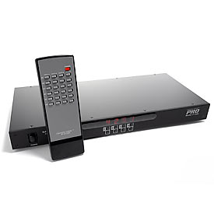](http://www.smarthome.com/83587.html)](http://www.smarthome.com/83587.html)Want to watch HD cable or satellite programming or a DVD in a room other than the one with connected components? Connect A/V devices to the [Rack-Mount 6 x 4 Component Video Matrix](http://www.smarthome.com/83587.html), and you'll be able to view any of six different devices on four different screens in your home. You can even watch a satellite feed in your bedroom while your kids watch a DVD in the living room simultaneously. Best of all, since the Rack-Mount 6 x 4 Component Video Matrix accepts multiple high-definition component inputs, you won't be limited to the single device that can connect to a standard television. The Rack-Mount 6 x 4 Component Video Matrix accepts component video and analog audio inputs from all six connected devices.

# WHAT KIND OF CABLE IS RIGHT FOR MY HOME?

It's important to make the right choices when cabling your home to take advantage of all of the advanced services that are available now. Until recently, homes were only wired for electricity. Later came cable for telephone (usually installed by the local phone company after the house was built.) After the homeowner moved in, he would install himself an antenna on the roof and some 300-Ohm twin lead to his one and only TV.

Today, when people are building homes and electricians are wiring them, there are many more types of [cable](http://www.smarthome.com/_/Cable_Structured_Wiring/Cables_Wire/_/v/1PB/nav.aspx) that need to be used. The electrical contractor will still be installing pretty much the same type of wire for electricity service that was used decades ago, but other decisions need to be made.

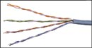For telephone service, homes are now being built with Cat. 3 or Cat. 5 cable. Originally developed for computer networks, installers now use this cable for telephone service, as its electrical properties lead to better signals and less cross-talk between telephone lines. The prices on these cables have come down dramatically in recent years so that the cost differential between ordinary telephone cable and Cat. 5 is negligible. It's a big selling point in many newly built tract houses.

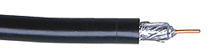Since the late '70s, most homes have access to cable TV service. During this time and succeeding years, the cable company would wire your house for cable service. More commonly they would wrap the outside of the home with cable since they would not run cables between walls. A few years into this period, we saw the phasing out of 300-Ohm twin lead cable in favor of coax cable. Unfortunately, many people installed the wrong type of coax in their homes. Today, we recommend only installing RG-6 coax cable. It comes in two varieties: double-shield and quad-shied. Quad is the better one to invest in, as it resists interference from the outside world. We recommend running two lines of RG-6 coax to each jack and the central distribution point.

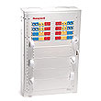The other hot topic right now is an in-home network. A wired network is faster and more reliable than a wireless. If you are building or remodeling a home, run a second [Cat. 5 cable](http://www.smarthome.com/_/Cable_Structured_Wiring/Cables_Wire/Data_Cat_5E_Cable/_/v/1PB/2Sp/nav.aspx) to each location where each telephone jack will be installed. Ethernet, the most popular networking technology, can send data up to 100 megabits per second over Cat. 5 cable. Wireless solutions only offer a fraction of that speed. It's possible to take new DSL and cable modem technologies and share it with more than one PC. At each telephone jack, install a Cat. 5-rated RJ-45 connector.

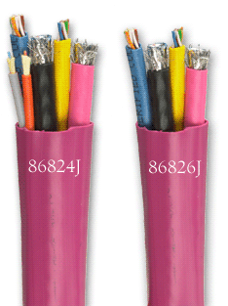Our fastest-growing cable products are the [All-In-One-Cables](http://www.smarthome.com/_/Cable_Structured_Wiring/Bundled_Wire/Cables_Wire/_/v/2Sj/1PB/nav.aspx). These cables combine multiple conductors all under one sheath. It comes in several different configurations, but they all have two RG-6 coax cables and two Cat. 5 (or better) communication cables. We also have bundles that include fiber optic or speaker cables in addition to the Coax and Cat. 5 cables. Using this cable can save money and time during the installation process. It's far easier and quicker to run one cable between a room and a distribution point than is it to run four individual cables between the same.

# PROTECTING ELECTRONIC EQUIPMENT

There are many different ways to protect home or office electronics. Surge Protectors guard against electrical spikes, Isolation Transformers keep electrical impurities from components and Battery Backups help during power outages. These unique and often overlooked components help assure that expensive electronic equipment remain safe and functional during electronically unstable situations, protecting against potential power related damage and providing added peace of mind.

## TYPES OF PROTECTION

### **SURGE PROTECTORS**

Not to be confused with Power Strips, which offer no protection against electrical surges, Surge Protectors are the essential last line of defense against unstable electricity that finds its way into your home. Also known as Power Conditioners, Surge Protectors are always on guard ensuring that valuable components remain functional. Surge Protectors safeguard electronics from power surges and spikes often associated with dirty and unstable electricity, as well as lightning strikes from severe storms. In addition, Surge Protectors are typically rated to handle a specific number of joules (the measurement of energy a surge or spike causes) - the higher the joule rating the better the protection. Some Surge Protectors have built-in filters that can lower the level of dirty electronic noise introduced into components. This is beneficial for home theaters as electronic noise can degrade audio-video quality. Advanced Surge Protectors also offer protection for RJ11 (phone), RJ45 (Ethernet), Coaxial (Cable and Satellite) and occasionally for other proprietary inputs and outputs. Surge Protectors range from simple applications ideal for a few home theater components, to large heavy duty rack-mountable units for equipment cabinets or closets, and Whole Home Surge Protectors which install on or near a breaker panel. Depending on needs and available budget, there is a specific Surge Protector available for nearly any application.

Video of [Panamax Surge Protection Technology](http://www.smarthome.com/_/Panamax/_/1nt/nav.aspx)

[Additional Surge Protectors available at Smarthome](http://www.smarthome.com/_/Speakers_A_V_Home_Theater/A_V_Home_Theater_Accessories/Power_Supplies_Surge_Protectors/_/R/1Sb/2m9/nav.aspx?Ns=Best)

### **ISOLATION TRANSFORMERS**

Considered to be a beyond-premium solution for surge protection. These types of units provide a vast array of features geared towards offering pure, untainted, noise free electricity for audio-video components and other applications where heavy duty components are used. Isolation Transformers are robust units built around a massive, often physically heavy, toroidal transformer which isolates electronic noise, ground loops, and other negative electronic interferences from components. Normally they plug directly into a standard power outlet and provide voltage stabilization, giving components a near perfect stream of electricity while also protecting them for harmful electrical impurities and surges. For simple, effective surge protection, an Isolation Transformer is as good as it gets.

Video of [Torus Power, Toroidal Transformer Power Conditioners](http://www.smarthome.com/_/Speakers_A_V_Home_Theater/A_V_Home_Theater_Accessories/Torus/_/R/1Sb/41N/nav.aspx)

[Additional Isolation Transformers available at Smarthome](http://www.smarthome.com/_/Cable_Structured_Wiring/Advanced_Installs_60_minutes/Middle_Atlantic/Power_Supplies_Batteries/Up_to_25/_/v/23P/1lH/1PH/5i/nav.aspx?Ns=PriceHigh)

### **BATTERY BACKUPS**

Though not considered to be a form of surge protection, a Battery Backup (also known as an Uninterruptible Power Supply or UPS) allows a component to continue functioning for a limited amount of time during a blackout or brownout (a partial blackout). Another advantage is that a Battery Backup will allow a component to power down properly instead of instantly shutting down. This is particularly valuable because when power suddenly shuts off and instantly turns back on, it causes an extreme fluctuation of electricity, which can damage a component's internal circuitry. Common applications are for desktop computers providing additional time to finish and save work as well as for audio-video equipment that requires proper shut down.

Video of [Middle Atlantic Uninterruptible Power Supplies:](http://www.smarthome.com/_/Middle_Atlantic/_/1lH/nav.aspx?Ntt=Battery+Backups)

[Additional Battery Backups at Smarthome](http://www.smarthome.com/_/Cable_Structured_Wiring/Power_Supplies_Batteries/Xantrex/_/v/1PH/3Lj/nav.aspx)

# DISTRIBUTING MUSIC FROM A SMARTPHONE OR TABLET

There are many ways to stream and distribute music from a Smartphone or Tablet. From using a simple cable connection with a receiver to installing an advanced audio distribution system, music can span the entirety of a home for all to enjoy. Utilizing a home's [Audio/Video Receiver](http://www.smarthome.com/_/Component/Sony/_/2pn/1tB/nav.aspx) (AVR), music can easily be distributed from one room to multiple rooms and on to an outside patio, yard, or pool area. The solutions provided below offer various methods for you to enjoy musical entertainment throughout a home.

GOOD

### **LISTENING TO MUSIC THROUGH A HOME THEATER**

The simplest way of distributing music to an AVR is to use a cable. The [3.5mm Plug to RCA Stereo Y-adapter](http://www.smarthome.com/849847.html) connects to one of the auxiliary inputs on an AVR via the RCA connectors while the 3.5mm end of the cable plugs directly into the headphone output jack found on most Smartphones or Tablets. After all connections have been made, select the correct auxiliary input on the AVR, choose some music on the Smartphone or Tablet, and enjoy!

The [Steren CL-265-436 3.5mm to RCA Stereo Y Adapter Cable  
[](http://www.smarthome.com/849848.html)](http://www.smarthome.com/849848.html)

Another method of distributing music from a Smartphone or Tablet is to utilize Bluetooth. Most new Smartphones and Tablets have built-in Bluetooth functionality. By connecting a [Bluetooth Stereo Receiver](http://www.smarthome.com/_/Speakers_A_V_Home_Theater/1_8_3_5mm_Mini_Jack/A_V_Home_Theater_Accessories/Bluetooth/_/R/2z9/1Sb/23d/nav.aspx) to an AVR, a Smartphone or Tablet can wirelessly stream music to that AVR. This method provides wireless freedom of up to approximately 30-35 feet (between the AVR and a Smartphone or Tablet) allowing comfortable music control from a distance.

Wiring Diagram of the [Calrad 40-BT2 Portable Bluetooth Stereo Receiver  
[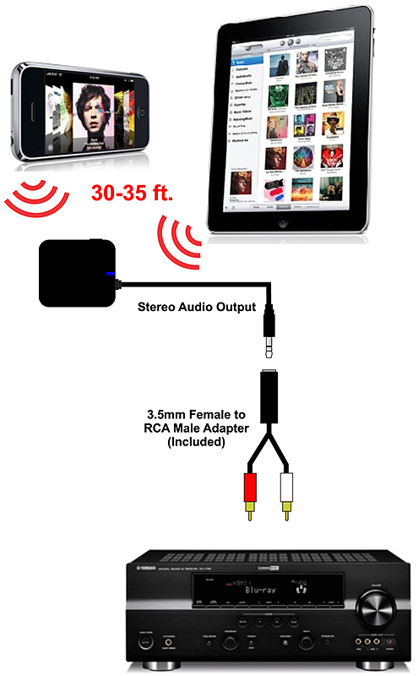](http://www.smarthome.com/79116.html)](http://www.smarthome.com/79116.html)

# DISTRIBUTE HDMI HIGH DEFINITION VIDEO OVER LONG DISTANCES

How do you extend HDMI cables from one area in the home to another without spending a fortune or compromising signal loss? The answer is with HDMI baluns. The balun allows you to extend HDMI far beyond that of regular HDMI cables using standard Ethernet networking cables. We'll cover the basics and the options when deciding on which balun is right for HDMI distribution.

## WHAT IS A BALUN?

Direct from Wikipedia: A***balun***is a type of electrical transformer that can convert electrical signals that are balanced about ground (differential) to signals that are unbalanced (single-ended) and vice versa. They are also often used to connect lines of differing impedance. The origin of the word balun is***bal***(ance) +***un***(balance)

Well that clears it up doesn't it? The important thing to understand here is that for running HDMI over long distances you'll need a a balun on the transmitting end (to unbalance the signal) and one on the receiving end (to balance the signal back).

## WHAT YOU'LL NEED WHEN EXTENDING HDMI SIGNALS

* A balun kit made up of a transmitter and receiver. Some are sold only as kits but others are sold separately so be sure you're getting a transmitter and its corresponding receiver.
* Two HDMI cables to connect both ends to their respective balun. These can be short, inexpensive cables.
* A bundle or pre-terminated Cat-5 (or Cat-6) networking cable. No matter which one you go with you'll need to run two cables:
  + Bundle spools save you money if you're doing long runs but require terminating of the ends with RJ-45 connectors using a crimp tool.
  + Pre-terminated Ethernet networking cables - These are the easiest to use since they already have the connectors attached. The downside is that they may not have the length you require.

## IMPORTANT NOTE

The HDMI specification allows "handshaking" between devices that are connected to one another. This initial communication provides details about resolution, copy protection and other bits of information that are established between the devices (such as a Blu-ray player to A/V receiver to TV). Adding an HDMI extender may interfere with this handshaking process. An important factor in whether or not the HDMI extender will work depends mostly on your A/V receiver. There are two types of HDMI switching found in A/V receivers: "straight switching" and "switching with repeating". If your A/V receiver features the repeating type of switching you have a less chance of handshake failure.

## FEATURES

Let's briefly go over some of the key features found among HDMI extenders

### **FORM FACTOR**

Before going too far into the decision making process you first need to determine the form factor of your balun. There are basically two types: free-standing or in-wall:

|  |  |
| --- | --- |
| Free Standing http://cache-m2.smarthome.com/images/77820.jpg | In-Wall http://cache-m2.smarthome.com/images/6786.jpg |

In-wall baluns look clean and professional while free standing baluns are quick to setup and use. Choose the one that's right for your application.

### **1080I OR 1080P SUPPORT**

You'll want to choose an HDMI extender that supports the resolution you plan on using. Most support both resolutions but the distance that is possible for 1080p will be less. Consult your A/V system specs to find out which one you'll be using.

### **3D COMPATIBLE**

If you plan on watching 3D content make sure you pick a balun that can process the 3D signal.

### **IR PASS-THROUGH SUPPORT**

IR pass-through is a convenient feature that allows you to send IR remote control signals from the TV location back to your gear location.

|  |  |  |  |  |
| --- | --- | --- | --- | --- |
|  | [[http://cache-m2.smarthome.com/images/97547-e.jpg](http://www.smarthome.com/97547.html) HDMI Over 2X Category 5e Cables Wall Plate Extender with IR Repeater](http://www.smarthome.com/97547.html) | [[http://cache-m2.smarthome.com/images/97546-e.jpg](http://www.smarthome.com/76543.html) HDMI Extender Kit for Category 5e/6 Cables](http://www.smarthome.com/76543.html) | [[http://cache-m2.smarthome.com/images/7832-e.jpg](http://www.smarthome.com/7656L.html) HDMI Video and Audio Balun, 1080i (Pair)](http://www.smarthome.com/7656L.html) | [[http://cache-m2.smarthome.com/images/97629-e.jpg](http://www.smarthome.com/97629.html) HDMI Over 2x Cat5e Cables Wall Plate Extender](http://www.smarthome.com/97629.html) |
| **Form Factor** | In-Wall | Free Standing | Free Standing | In-Wall |
| **Display Resolution** | Up to 1080p | Up to 1080p | Up to 1080i | Up to 1080p |
| **3D Compatible** | No | No | No | Yes |
| **IR Pass-through** | Yes | No | No | No |
| **Advertised Distance** | 100ft (1080p) 200ft (up to 1080i) | 100ft (1080p) 200ft (up to 1080i) | 150ft | 100ft (1080p) |

## NEW! WIRELESS HDMI EXTENDER

[[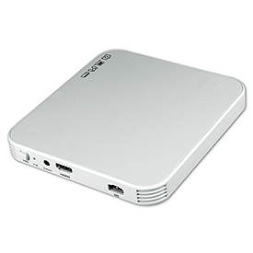](http://www.smarthome.com/97558.html)](http://www.smarthome.com/97558.html)

* Wirelessly extend an HDMI signal up to 100 feet
* Transmits through walls - no line of sight required
* Auto tracking smart antenna
* Real time, visually lossless HD compression

Need to extend an HDMI signal over a distance but can't run a cable? The Vanco International 280511 transmits HDMI audio/video signals up to 100 feet wirelessly. This unit transmits through walls - no line of sight necessary. This device is comprised of a transmitter and auto-tracking smart antenna that communicate realtime, visually lossless HD audio and video. Best of all, this extender is easy to install and simple to use.

## RELATED PRODUCTS

|  |  |  |
| --- | --- | --- |
| [[Wireless Speakers](http://www.smarthome.com/_/Cable_Structured_Wiring/Cables_Wire/HDMI_Cable/_/v/1PB/2CP/nav.aspx) HDMI Cables](http://www.smarthome.com/_/Cable_Structured_Wiring/Cables_Wire/HDMI_Cable/_/v/1PB/2CP/nav.aspx) | [[Remote Control Lighting Kits](http://www.smarthome.com/_/Speakers_A_V_Home_Theater/A_V_Distribution_Wired/High_Definition_HD/_/R/1SZ/22f/nav.aspx) HDMI Distribution](http://www.smarthome.com/_/Speakers_A_V_Home_Theater/A_V_Distribution_Wired/High_Definition_HD/_/R/1SZ/22f/nav.aspx) | [[Outlets and Other Hardwired Devices](http://www.smarthome.com/_/Cable_Structured_Wiring/Connectors_Jacks_Trim_Plates/HDMI/Media_Wallplates/_/v/1P5/2ob/1OT/nav.aspx) HDMI Media Wallplates](http://www.smarthome.com/_/Cable_Structured_Wiring/Connectors_Jacks_Trim_Plates/HDMI/Media_Wallplates/_/v/1P5/2ob/1OT/nav.aspx) |

# MONITOR YOUR HOME FROM ANYWHERE

The safety of your home and your loved ones ranks tops in life's priorities. Keep an eye on your home with [home alert systems](http://www.smarthome.com/_/Sensors/Alert_Systems_Other_Sensors/_/L/1S7/nav.aspx) that remotely monitor and control your home, vacation property or small business. Homeowners can monitor a remote location for a plethora of environmental conditions -- including flooding, freezing, and carbon monoxide -- to curb any potential disasters, such as pipes bursting or the complete flooding of your home.

Without spending thousands of dollars to set up a hardwired security alarm system, these product solutions will protect your family and home without breaking the bank.

## SENSAPHONE

[[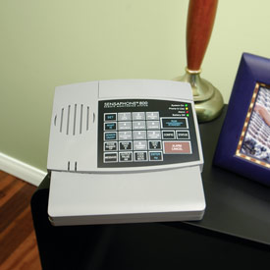](http://www.smarthome.com/70051/Sensaphone-800-Remote-Monitoring-and-Control-System/p.aspx)](http://www.smarthome.com/70051/Sensaphone-800-Remote-Monitoring-and-Control-System/p.aspx)A fully programmable environmental monitoring system, the [Sensaphone 800](http://www.smarthome.com/70051.html) allows both local and remote monitoring and control of your home or small business. Easy to install and operate, the Sensaphone requires no rewiring of your home and only needs standard telephone service to work.

With built-in sensors to monitor temperature, sound and AC power failure, the system simply connects to your telephone jack and calls up to eight phone numbers to report the conditions if temperatures go above or below certain levels, if a smoke alarm or security system siren goes off, or if there's a power failure. You can also call your vacation home at any time to obtain a status report or to listen in to on-site sounds for total peace of mind.

The system can also be expanded with up to seven additional status sensors to detect other conditions of your choice, so long as the sensors use normally open or normally closed contacts. These can include:

* [Water Sensors](http://www.smarthome.com/7160.html) - Offer early warning to minimize flooding damage
* [Freeze Sensors](http://www.smarthome.com/7193.html) - Prevent bursting pipes due to water freezing
* [Temperature Sensors](http://www.smarthome.com/7020.html) - Monitor other areas
* [Smoke Detectors](http://www.smarthome.com/7026.html) - Get an instant alert in the event of a fire
* [Motion Sensors](http://www.smarthome.com/7025.html) - Protect your home against potential intruders
* [Humidity Sensors](http://www.smarthome.com/7030.html) - Safeguard the climate-sensitive parts of your home

## SKYLINK AAA

[[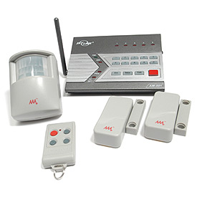](http://www.smarthome.com/73102.html)](http://www.smarthome.com/73102.html)A complete wireless system, the [Skylink Home Smart Center](http://www.smarthome.com/73102.html) not only functions as a security system, but also allows you to control household appliances and lights remotely by dialing into the system from any touch-tone phone. The center of this powerful and flexible system is its control panel, where you will program passwords, sensors and more.

Setup is a breeze. Plug the system's AC power adapter into a wall outlet, pop in the 4 AAA batteries (sold separately) and connect the system to your phone jack and you're ready to go.

The Home Smart Center operates in two modes: alert mode or alarm mode. In alert mode (used when you are in the house), whenever a sensor is triggered, you will be notified by voice and flashing LED lights to indicate in which zone the sensor was triggered. In alarm mode (used when you leave the house), the system alarm will sound and then call up to five preprogrammed phone numbers to deliver an emergency message. Disarm the alarm by entering your pass code into the control panel or by using the included keychain remote. For larger homes or for remote sensors, adding a[wireless signal booster/repeater](http://www.smarthome.com/73102R.html) is a good way to add reliability to the system, so you'll be sure to receive an alert the moment your home is breached.

|  |  |  |
| --- | --- | --- |
| [[http://cache-m2.smarthome.com/images/73102fs-e.jpg](http://www.smarthome.com/73102FS.html) Water Leak Sensors](http://www.smarthome.com/73102FS.html) | [[http://cache-m2.smarthome.com/images/73102gs-e.jpg](http://www.smarthome.com/73102GS.html) Garage Sensors](http://www.smarthome.com/73102GS.html) | [[http://cache-m2.smarthome.com/images/73102aa-e.jpg](http://www.smarthome.com/73102AA.html) Audio Sensors](http://www.smarthome.com/73102AA.html) |

Supporting up to a total of 10 sensors in up to 5 zones, the Home Smart Center supports a myriad of sensors. In addition to the included motion and window sensors, the system supports [water leak sensors](http://www.smarthome.com/73102fs.html), [garage sensors](http://www.smarthome.com/73102gs.html) and [audio sensors](http://www.smarthome.com/73102aa.html).

## HOUSEHOLD ALERT COMBINATION SET

[[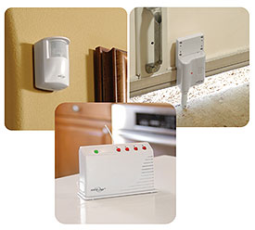](http://www.smarthome.com/7311C.html)](http://www.smarthome.com/7311C.html)For those on a budget, the [Household Alert System](http://www.smarthome.com/7311C.html)offers an economical and completely wireless way to monitor and protect your home. Strictly a local alert system, it does not dial out to any emergency phone number but provides both a visual and audio alarm whenever sensors are triggered to warn anyone in the home.

Easy to use and install, the system is comprised of the Houselink receiver and the sensor(s) that suits your needs. Setup is as easy as plugging the receiver's power adapter into a wall outlet and then placing the sensors where you need them. Fully expandable, the receiver can control up to four different sensors, including[door/window sensors](http://www.smarthome.com/7311ds.html), [motion sensors](http://www.smarthome.com/7311ms.html), and [water sensors](http://www.smarthome.com/7311wa.html), so you can be alerted when the garage door is left open, an intruder triggers the motion sensor in the back yard, or a water leak is detected in the basement.

|  |  |  |
| --- | --- | --- |
| [[http://cache-m2.smarthome.com/images/7311DS-e.jpg](http://www.smarthome.com/7311DS.html) Household Door/Window Alert Sensor](http://www.smarthome.com/7311DS.html) | [[http://cache-m2.smarthome.com/images/7311wa-e.jpg](http://www.smarthome.com/7311wa.html) Household Water Alert Sensor](http://www.smarthome.com/7311wa.html) | [[http://cache-m2.smarthome.com/images/7311ms-e.jpg](http://www.smarthome.com/7311ms.html) Household Motion Alert Sensor](http://www.smarthome.com/7311ms.html) |

## COMPARISON CHART

|  |  |  |  |
| --- | --- | --- | --- |
| **Wireless Security System Features** | [Sensaphone 800](http://www.smarthome.com/70051.html) | [AAA Home Smart Center](http://www.smarthome.com/73102.html) | [Household Alert](http://www.smarthome.com/7311C.html) |
| **Primary Controller Type** | Standalone tabletop unit | Standalone tabletop unit | Standalone tabletop unit |
| **Remote Control Options** | Touch-tone phone | Keychain remotes, touch-tone phone | None |
| **Supported Sensors** | Water, temperature, smoke, motion, humidity, freeze, any sensor using open/close contact closure | Door/window, motion detector, water leak, garage door, audio smoke alarm | Door/window, motion detector, water leak, garage door |
| **Notifications** | Calls emergency phone numbers | Alarm: calls emergency phone numbers, siren blast alert: voice announcement, flashing LEDs, beeping | Siren blast alert: flashing LEDs |

# HOME SECURITY SOLUTIONS

### **CHOOSE THE RIGHT SOLUTION TO SECURE YOUR HOME**

No two homes are identical because of the people who live in them. So there is not a one size fits all security solution. Below are some different levels of devices that can help identify your home security needs.

BASIC

### **SINGLE SENSOR ALERT**

Hear an alarm when a door or window is opened with this simple Techko Ultra Slim Safety Entry Alarm. A 110 decibel alarm is emitted when this simple sensor is triggered from the magnetic field. This is an ideal product to alert your loved ones that are home, or to frighten off unwanted visitors.

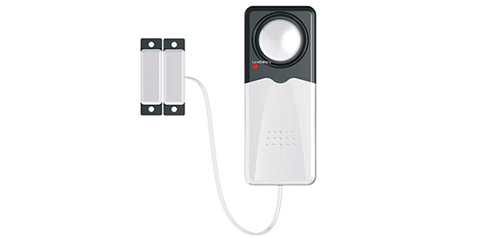

#### **SETUP**

Setup is as simple as attaching the magnet on the door or window, the sensor on the frame adjacent to the magnet, and the alarm close by. Once the magnetic field is broken the alarm will sound for 60 seconds and reset itself. There is a switch on the alarm to arm and disarm when needed.

#### **PARTS LIST**

•  [Techko Ultra Slim Safety Entry Alarm](http://www.smarthome.com/32450.html)  
  
[ORDER NOW](http://www.smarthome.com/techko-s183-ultra-slim-safety-entry-alarm.html)

# OUTDOOR SECURITY LIGHTING

### **MOTION ACTIVATED SECURITY LIGHTING FOR YOUR HOME**

Adding motion activated security lights outside of your home can help you see when taking out the trash and more importantly they can ward off unwelcomed visitors. Seeing a light come on can be the first step to being aware of what is going on outside your home at night. With these great solution ideas, you can easily place light where you need it the most, save energy, or record video.

BASIC

### **SIMPLE & AFFORDABLE**

LED lights are not only bright, they are extremely energy efficient. In the Fulcrum Outdoor Wireless Floodlight, they can last up to 100,000 hours. This weatherproof battery powered floodlight has 6 ultra-bright LEDs that are activated by its integrated motion sensor. With a maximum 25 foot detection range, this security light can be mounted high enough so that is will not be easily tampered with and still sense a wide array. When the motion stops the lights will turn off in 30 seconds. The floodlight also has a photocell sensor so that it will not turn on in the daylight. This affordable DIY solution can be added to any home.

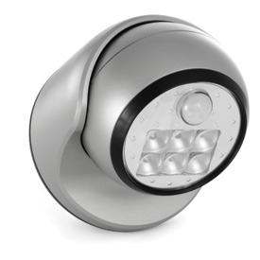

#### **SETUP**

Install four C batteries into the sealed compartment. When choosing the placement of the light, keep in mind detection distance and spotlight placement. Use the provided mounting hardware and attach the floodlight to any wall, post, or ceiling.

#### **PARTS LIST**

•  [Fulcrum Outdoor Wireless Floodlight](http://www.smarthome.com/fulcrum-20031-101-outdoor-wireless-motion-activated-led-floodlight.html)  
•  [C Batteries (2-Pack)](http://www.smarthome.com/sony-platinum-alkaline-batteries-2-pack.html)  
  
[ORDER NOW](http://www.smarthome.com/outdoor-security-lighting-bundle-basic.html)

# MONITOR YOUR HOME FROM ANYWHERE

The safety of your home and your loved ones ranks tops in life's priorities. Keep an eye on your home with [home alert systems](http://www.smarthome.com/_/Sensors/Alert_Systems_Other_Sensors/_/L/1S7/nav.aspx) that remotely monitor and control your home, vacation property or small business. Homeowners can monitor a remote location for a plethora of environmental conditions -- including flooding, freezing, and carbon monoxide -- to curb any potential disasters, such as pipes bursting or the complete flooding of your home.

Without spending thousands of dollars to set up a hardwired security alarm system, these product solutions will protect your family and home without breaking the bank.

## SENSAPHONE

[[](http://www.smarthome.com/70051/Sensaphone-800-Remote-Monitoring-and-Control-System/p.aspx)](http://www.smarthome.com/70051/Sensaphone-800-Remote-Monitoring-and-Control-System/p.aspx)A fully programmable environmental monitoring system, the [Sensaphone 800](http://www.smarthome.com/70051.html) allows both local and remote monitoring and control of your home or small business. Easy to install and operate, the Sensaphone requires no rewiring of your home and only needs standard telephone service to work.

With built-in sensors to monitor temperature, sound and AC power failure, the system simply connects to your telephone jack and calls up to eight phone numbers to report the conditions if temperatures go above or below certain levels, if a smoke alarm or security system siren goes off, or if there's a power failure. You can also call your vacation home at any time to obtain a status report or to listen in to on-site sounds for total peace of mind.

The system can also be expanded with up to seven additional status sensors to detect other conditions of your choice, so long as the sensors use normally open or normally closed contacts. These can include:

* [Water Sensors](http://www.smarthome.com/7160.html) - Offer early warning to minimize flooding damage
* [Freeze Sensors](http://www.smarthome.com/7193.html) - Prevent bursting pipes due to water freezing
* [Temperature Sensors](http://www.smarthome.com/7020.html) - Monitor other areas
* [Smoke Detectors](http://www.smarthome.com/7026.html) - Get an instant alert in the event of a fire
* [Motion Sensors](http://www.smarthome.com/7025.html) - Protect your home against potential intruders
* [Humidity Sensors](http://www.smarthome.com/7030.html) - Safeguard the climate-sensitive parts of your home

## SKYLINK AAA

[[](http://www.smarthome.com/73102.html)](http://www.smarthome.com/73102.html)A complete wireless system, the [Skylink Home Smart Center](http://www.smarthome.com/73102.html) not only functions as a security system, but also allows you to control household appliances and lights remotely by dialing into the system from any touch-tone phone. The center of this powerful and flexible system is its control panel, where you will program passwords, sensors and more.

Setup is a breeze. Plug the system's AC power adapter into a wall outlet, pop in the 4 AAA batteries (sold separately) and connect the system to your phone jack and you're ready to go.

The Home Smart Center operates in two modes: alert mode or alarm mode. In alert mode (used when you are in the house), whenever a sensor is triggered, you will be notified by voice and flashing LED lights to indicate in which zone the sensor was triggered. In alarm mode (used when you leave the house), the system alarm will sound and then call up to five preprogrammed phone numbers to deliver an emergency message. Disarm the alarm by entering your pass code into the control panel or by using the included keychain remote. For larger homes or for remote sensors, adding a[wireless signal booster/repeater](http://www.smarthome.com/73102R.html) is a good way to add reliability to the system, so you'll be sure to receive an alert the moment your home is breached.

|  |  |  |
| --- | --- | --- |
| [[http://cache-m2.smarthome.com/images/73102fs-e.jpg](http://www.smarthome.com/73102FS.html) Water Leak Sensors](http://www.smarthome.com/73102FS.html) | [[http://cache-m2.smarthome.com/images/73102gs-e.jpg](http://www.smarthome.com/73102GS.html) Garage Sensors](http://www.smarthome.com/73102GS.html) | [[http://cache-m2.smarthome.com/images/73102aa-e.jpg](http://www.smarthome.com/73102AA.html) Audio Sensors](http://www.smarthome.com/73102AA.html) |

Supporting up to a total of 10 sensors in up to 5 zones, the Home Smart Center supports a myriad of sensors. In addition to the included motion and window sensors, the system supports [water leak sensors](http://www.smarthome.com/73102fs.html), [garage sensors](http://www.smarthome.com/73102gs.html) and [audio sensors](http://www.smarthome.com/73102aa.html).

## HOUSEHOLD ALERT COMBINATION SET

[[](http://www.smarthome.com/7311C.html)](http://www.smarthome.com/7311C.html)For those on a budget, the [Household Alert System](http://www.smarthome.com/7311C.html)offers an economical and completely wireless way to monitor and protect your home. Strictly a local alert system, it does not dial out to any emergency phone number but provides both a visual and audio alarm whenever sensors are triggered to warn anyone in the home.

Easy to use and install, the system is comprised of the Houselink receiver and the sensor(s) that suits your needs. Setup is as easy as plugging the receiver's power adapter into a wall outlet and then placing the sensors where you need them. Fully expandable, the receiver can control up to four different sensors, including[door/window sensors](http://www.smarthome.com/7311ds.html), [motion sensors](http://www.smarthome.com/7311ms.html), and [water sensors](http://www.smarthome.com/7311wa.html), so you can be alerted when the garage door is left open, an intruder triggers the motion sensor in the back yard, or a water leak is detected in the basement.

|  |  |  |
| --- | --- | --- |
| [[http://cache-m2.smarthome.com/images/7311DS-e.jpg](http://www.smarthome.com/7311DS.html) Household Door/Window Alert Sensor](http://www.smarthome.com/7311DS.html) | [[http://cache-m2.smarthome.com/images/7311wa-e.jpg](http://www.smarthome.com/7311wa.html) Household Water Alert Sensor](http://www.smarthome.com/7311wa.html) | [[http://cache-m2.smarthome.com/images/7311ms-e.jpg](http://www.smarthome.com/7311ms.html) Household Motion Alert Sensor](http://www.smarthome.com/7311ms.html) |

## COMPARISON CHART

|  |  |  |  |
| --- | --- | --- | --- |
| **Wireless Security System Features** | [Sensaphone 800](http://www.smarthome.com/70051.html) | [AAA Home Smart Center](http://www.smarthome.com/73102.html) | [Household Alert](http://www.smarthome.com/7311C.html) |
| **Primary Controller Type** | Standalone tabletop unit | Standalone tabletop unit | Standalone tabletop unit |
| **Remote Control Options** | Touch-tone phone | Keychain remotes, touch-tone phone | None |
| **Supported Sensors** | Water, temperature, smoke, motion, humidity, freeze, any sensor using open/close contact closure | Door/window, motion detector, water leak, garage door, audio smoke alarm | Door/window, motion detector, water leak, garage door |
| **Notifications** | Calls emergency phone numbers | Alarm: calls emergency phone numbers, siren blast alert: voice announcement, flashing LEDs, beeping | Siren blast alert: flashing LEDs |

# USING MOTION SENSORS OUTDOORS

## HISTORY OF MOTION SENSORS

[Motion sensors](http://www.smarthome.com/_/Sensors/Motion_PIR_Occupancy/Occupancy_Motion_Sensors/_/L/25l/1S3/nav.aspx) have been used with alarm systems since the 1970s. Back then, motion sensors were based on ultrasonic technology. Sound waves were emitted from a sensor, and the resulting reflected sounds were analyzed to detect changes. When a change was detected, the motion sensor notified the alarm system's control panel (or whatever it was connected to). These ultrasonic sensors were frequently blamed for triggering false alarms. A phone ringing, an alarm clock sounding, or the heating system coming on could cause a false alarm. A better solution was needed.

The best solution found and used today is based upon infrared technology (abbreviated "IR"). Other technologies based on microwave and radar were tried, but they never gained the popularity of infrared technology. Infrared sensors began to appear on the market in the 1980s. When they first came out, they were somewhat expensive, but as production ramped up and more manufacturers found ways to use them for different applications, the price dropped quickly. The most popular consumer uses of IR sensors are for motion-sensing floodlights.

## HOW MOTION SENSORS WORK

[[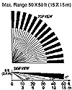](http://www.smarthome.com/images/7481cov.gif)](http://www.smarthome.com/images/7481cov.gif)IR sensors look for the presence of human heat moving across their field of view. The sensors are passive, which means that they are looking for the movement. Unlike radar and ultrasonic systems that emit a signal and look for a reflection, IR sensors just receive.

All IR sensors have some common ratings and specifications. The first is the detection pattern or the field of view. This defines how wide or narrow the IR sensor can detect. Typically, they look like the image on the right.

## THE PROBLEM USING IR SENSORS OUTDOORS

If motion sensors are so much better now than the early ultrasonic models, why can't they be used outdoors with an alarm system? Strangely, it still comes down to the issue of reliability. With motion-detecting floodlights, if the sensor false alarms, the only consequences are the lights' coming on for a few minutes. If an IR sensor connected to an alarm system falses, the sirens are set off and in some cases, the police may be dispatched to investigate. The noise of the sounding alarm sirens will surely irritate your neighbors. You don't want a mob burning down your home because the alarm system is going off constantly!

[[](http://www.smarthome.com/4082/Leviton-X10-Motion-Detector-6417/p.aspx)](http://www.smarthome.com/4082/Leviton-X10-Motion-Detector-6417/p.aspx)When IR motion sensors are used outdoors, they are more likely to cause false alarms. The most common cause of a false trip is rapidly changing weather conditions. For example, when a warm winds blows across the[X10 Motion Sensing Floodlights](http://www.smarthome.com/4080XT/X10-PR511-or-PHS01-X10-Motion-Detector-Floodlights/p.aspx), it's not uncommon for them to trip on. Not only do the floodlights come on, but so do the X10 devices inside the house that are set to X10 addresses controlled by those floodlights. This is acceptable since no noise is being produced.

[[](http://www.smarthome.com/images/Laddie10a-1big.jpg)](http://www.smarthome.com/images/Laddie10a-1big.jpg)There are some alternatives to IR sensors that can be used outdoors that will decrease the likelihood of false alarms. The IR beam system sends an invisible beam between two points. If the beam is broken, it trips the alarm system. The [Weatherproof Infrared Beam Motion Detectors](http://www.smarthome.com/7460/Weatherproof-Infrared-Beam-Motion-Detector/p.aspx) are not affected by weather unless you have tumbleweeds or small compact cars blowing across your property during high winds. The transmitter and receiver can be placed outdoors up to 130 feet apart.

[[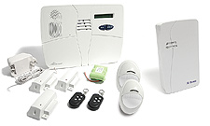](http://www.smarthome.com/73903P/Smarthome-SELECT-SecureLinc-2-Wireless-Home-Security-System/p.aspx)](http://www.smarthome.com/73903P/Smarthome-SELECT-SecureLinc-2-Wireless-Home-Security-System/p.aspx)Some alarm systems have a feature called "Cross-Zoning", which will reduce false alarms. Cross-zoning requires that two zones be activated at nearly the same time in order to trigger the alarm system. Basically you place two sensors looking at the same area that needs to be protected. When someone enters that zone, the two sensors will have to detect the intrusion within a few seconds for the alarm panel to consider it a valid detection. The [Web-Enabled SecureLinc Family Kit](http://www.smarthome.com/73903P/Smarthome-SELECT-SecureLinc-2-Wireless-Home-Security-System/p.aspx) has this feature built into it.

Finally, if you do choose to use a motion detector outdoors, be sure to choose one that is rated for outdoor usage. The regular indoor models don't have the protection to keep the effects of moisture from damaging the electronics on the circuit board. If an indoor-rated model is placed outside, even if it is protected from the rain, it will soon malfunction within a year or so. Here are a few models that are rated for outdoor use:

|  |  |
| --- | --- |
| [[http://cache-m2.smarthome.com/images/740126.jpg](http://www.smarthome.com/740126.html) Motion-Activated LED Light](http://www.smarthome.com/740126.html) | [[http://cache-m2.smarthome.com/images/7460.jpg](http://www.smarthome.com/7460.html) Infrared Beam Motion Detector](http://www.smarthome.com/7460.html) |

# KNOW WHEN SOMEONE ENTERS YOUR DRIVEWAY

Looking for a way to monitor traffic in and out of your driveway? Smarthome offers a wide variety of wireless systems that will alert you the moment an expected or unexpected visitor arrives at your home.

## WIRELESS PROBE DRIVEWAY ALERT

[[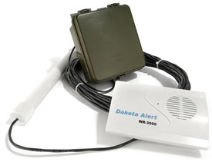](http://www.smarthome.com/7313.html)](http://www.smarthome.com/7313.html)

If you live in an area that might be prone to wildlife, you'll want to be sure that your driveway alert system won't be triggered by deer or other large animals. The [Wireless Probe Driveway Alert](http://www.smarthome.com/7313.html)system includes a probe that's buried at the base of your driveway and sends a signal to the transmitter only when a car is detected. The battery-operated weatherproof transmitter mounts easily on a tree or post near the driveway and sends a radio signal back to the receiver, which can be plugged into an outlet in your home up to 3000 feet away.

Up to four different zones can be monitored by adding additional [transmitters](http://www.smarthome.com/7313T.html) (sold separately). The transmitters can be programmed so they will each sound a different tone at the receiver. Extra [receivers](http://www.smarthome.com/7312R.html) are also available to be purchased separately - put them in several rooms in your house, so you'll always know the instant someone drives onto your property.

## WIRELESS MOTION DETECTOR

[[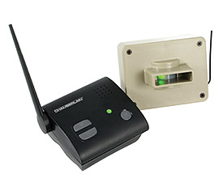](http://www.smarthome.com/7317.html)](http://www.smarthome.com/7317.html)Use the [Wireless Motion Alert](http://www.smarthome.com/7202.html) to detect motion at your driveway or at any other key entrance to your property. This system is expandable to up to four transmitters. Additional [transmitters](http://www.smarthome.com/7203.html) are sold separately. The sensor can detect motion and sends a signal up to 1/2 mile. The receiver plugs into an outlet in your home and sounds an adjustable tone for each sensor in the system.

Other motion detector systems are also available. Try the [Reporter w/Voice alert system](http://www.smarthome.com/7316.html), which combines a wireless motion sensor with a built-in speaker that lets you talk with the person on the sensor's end, up to 1000 feet away, through a digitally clear and secure connection. When movement is detected, an alert is sounded at the base station, which will allow you to listen through the sensor's wireless microphone for 10 seconds. Additional [sensors](http://www.smarthome.com/7316R.html) are available. Up to eight sensors can be installed.

[[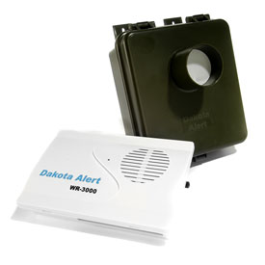](http://www.smarthome.com/7312.html)](http://www.smarthome.com/7312.html)One of our most popular systems, the [Wireless Motion Alert](http://www.smarthome.com/7312.html) will send an instant signal from the foot of your driveway to your home when a person or car enters your property. The weatherproof transmitter is easily mounted on a tree or post near the driveway. The transmitter uses a passive infrared (PIR) beam to detect people or vehicles to a distance of up to 80 feet, then sends a radio signal back to the receiver, which can be placed in your home up to 3000 feet away. When the receiver gets a signal from the transmitter, one of four user-specified tones will sound for a few seconds. Up to four different zones can be monitored by adding additional [transmitters](http://www.smarthome.com/7312T.html)(sold separately). The transmitters can be programmed so they will each sound a different tone at the receiver. Extra [receivers](http://www.smarthome.com/7312R.html) are also available to be purchased separately. Put them in several rooms in your house, so you'll always know the instant someone steps onto your property. Check out more selections on other [indoor or outdoor alert sensors](http://www.smarthome.com/_/Sensors/Alert_Systems_Other_Sensors/_/L/1S7/nav.aspx).

## VOICE ALERT SYSTEM WITH ONE SENSOR

[[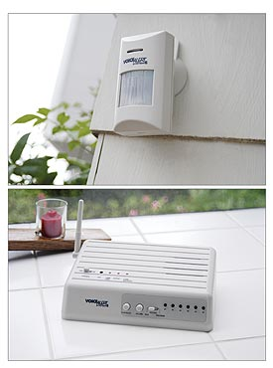](http://www.smarthome.com/7138.html)](http://www.smarthome.com/7138.html)The [Voice Alert System with One Sensor](http://www.smarthome.com/7138.html), which includes one receiver and one sensor, announces in your own words that motion has been detected in a particular area. You can connect up to 6 sensors total, each with its own customized voice announcements. The sensors offer adjustments for the length of time between transmissions (to extend battery life) as well as an optional pet-immune lens for ignoring small animals. The motion sensors take it one step further by offering a way to connect an external triggering device to the sensor. This means that if you don't have a need to detect motion but you would like to know if someone opens a door or gate, you can connect a pair of magnetic contacts to the sensor and simply use the sensor as a transmitter.

If that's not enough, the receiver offers 4 relay outputs that are adjustable to the following settings:

* No output
* 1-second output
* 5-second output
* 30-second output
* 60-second output
* Continuous output

See the Voice Alert Operating Instructions for more information.

NEVER GET LOCKED OUT OF YOUR HOUSE

With the hustle and bustle of everyday life, we all have our moments where we forget things: birthdays, appointments, paying our bills, and even our car and house keys. Here are a few nifty gadgets and devices that will make sure you never get left out in the cold.

|  |  |
| --- | --- |
| [[Fingerprint Keypad Locks](http://www.smarthome.com/_/Door_Locks_Access_Control/Biometric/Door_and_Gate_Access/_/7/1zz/1Qn/nav.aspx) Fingerprint Door Locks](http://www.smarthome.com/_/Door_Locks_Access_Control/Biometric/Door_and_Gate_Access/_/7/1zz/1Qn/nav.aspx) | [[RF Remote Door Knobs](http://www.smarthome.com/_/Door_Locks_Access_Control/Door_and_Gate_Access/Wireless/_/7/1Qn/1z5/nav.aspx) RF Remote Door Knobs](http://www.smarthome.com/_/Door_Locks_Access_Control/Door_and_Gate_Access/Wireless/_/7/1Qn/1z5/nav.aspx) |

Whether you don't like carrying your keys on a jog or just plain left the keys in the house, you will never have to worry about getting locked out of the house again with a[fingerprint door lock](http://www.smarthome.com/_/Door_Locks_Access_Control/Biometric/Door_and_Gate_Access/_/7/1zz/1Qn/nav.aspx). Simply swipe your finger over the sensor and the door will unlock whenever it reads a registered fingerprint. You can also bypass the lock by punching in a PIN code. Don't want to program or remember codes to get into your house? Use an[RF Remote Door Knob](http://www.smarthome.com/_/Door_Locks_Access_Control/Door_and_Gate_Access/Wireless/_/7/1Qn/1z5/nav.aspx) to open your door with the press of a button.

|  |  |  |
| --- | --- | --- |
| [[Wall-Mounted Key Safe](http://www.smarthome.com/81000.html) Wall-Mounted Key Safe](http://www.smarthome.com/81000.html) | [[Locking Stor-A-Key](http://www.smarthome.com/81001L.html) Locking Stor-A-Key](http://www.smarthome.com/81001L.html) | [[Magnetic Stor-A-Key](http://www.smarthome.com/81001.html) Magnetic Stor-A-Key](http://www.smarthome.com/81001.html) |

You can also keep a spare key stored in a [wall-mounted combination safe](http://www.smarthome.com/81000.html) on the outside of your home. The heavy-duty key holder makes it virtually impossible to pry open, requiring your user-programmed access code to get to the key. If you prefer a hide-a-key style of key storage device, the [Locking Stor-A-Key](http://www.smarthome.com/81001l.html) is secured by a numerical code lock that can be hidden outside your home. By storing your spare car key in a [magnetic Stor-A-Key](http://www.smarthome.com/81001.html) and attaching it under your car, you never have to call the Auto Club to let you back into your locked car.

# HOME SURVEILLANCE AND RECORDING THAT IS RIGHT FOR YOU

There are many options when it comes to adding surveillance around your home. Smarthome offers a variety of solutions, from wireless IP Cameras that can be remotely accessed and controlled from your smartphone or tablet, to covert cameras that capture video and images from a hidden location, to complete DVR kits that can handle and record video from several different camera locations.

4 CAMERAS + DVR

### **TRADITIONAL CAMERA AND DVR SYSTEM**

If you are looking for a surveillance system that is a little more traditional, this kit from DEFENDER is the perfect choice. It is a professional quality security monitoring system for a home or office that can be installed by any do-it-yourselfer. It includes 4 high resolution bullet cameras each with 48 IR LEDS for capturing images in the dark up to 150 feet away. The DVR has a whopping 2TB of built in storage to capture all the video and images you need. All the necessary cables and wire are also included to setup and maintain your system - you shouldn't have to purchase anything else.

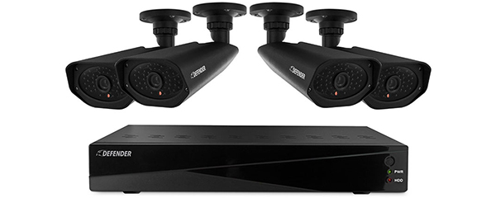

Using the DEFENDER's remote viewing software you can network the DVR to the internet so that you'll be able to view live camera feeds, watch recorded footage and receive motion activated email alerts from a smart device or computer. The DVR can be connected directly to a monitor or TV for viewing with the ability to custom name channels, view picture-in-picture, full screen, quad screen, zoom or set sequence switching.

If you need more than 4 cameras, or think you might in the fututre, the DVR features 8-Channels, so you can up to 4 more cameras to this system.

### **PARTS LIST**

  • 1x - [DEFENDER 21159 Sentinel Pro 8CH 2TB DVR with 4 IR LED Cameras, 800TVL](http://www.smarthome.com/defender-21159-sentinel-pro-8ch-2tb-dvr-with-4-ir-led-cameras-800tvl.html)

[ORDER NOW](http://www.smarthome.com/defender-21159-sentinel-pro-8ch-2tb-dvr-with-4-ir-led-cameras-800tvl.html)