**DECLARATION**

We hereby declare that this submission is our own work and that, to the best of my knowledge and belief, it contains no material previously published or written by another person nor material which to a substantial extent has been accepted for the award of any other degree of the university or other institute of higher learning, except where due acknowledgment has been in the text.

Signature-

Name-: Kuldeep Kumar

Roll No. - (1213220803)

Date-

**CERTIFICATE**

This is to certify that the project entitled **“Water Level Indicator”** submitted by **Kuldeep Kumar WITH ROLL NO** – 1213220803 in the partial fulfillment of the requirements for award of **Bachelor of Technology** in **Electrical Engineering** from **Uttar Pradesh Technical University, Lucknow** under my supervision. The project embodies result of original work and studies carried out by the student’s them selves and the contents of the project do not form the basis for the award of any other degree to the candidate or to anybody else from this or any other University/Institution.

Prof: Mr. Sanjeev Ojha Project Cordinator

H.O.D (EE) Asst. Prof

GNIOT (Guide)

**ABSTRACT**

Water Level Indicator is rapidly gaining notoriety as an important means of expanding electronics circuitry . As such, it is vital that those in engineering fields understand the technologies associated with this area. Our project will include the design and construction of a transistor-based Water level Indicator, allows more energy saving by automatically indicating the water level in the tank . This system builds upon topics learned in this course. A working system is ultimately be demonstrate to validate the design. Problems and possible improvements are also be presented.

# ACKNOWLEDGEMENT

In the absence of mother the birth of a child is not possible and in the absence of teacher the right path of knowledge is impossible. This project is by far the most significant accomplishment in our life and it would be impossible without people who supported us and believed us.

We would like to extend my gratitude and my sincere thanks to my honorable, esteemed guide Professor ***Mr. Sanjeev Ojha***, Department of Electrical Engineering,GNIOT, Greater Noida for their immeasurable guidance and valuable time that he devoted for project. We sincerely thank for their exemplary guidance and encouragement. His trust and support inspired me in the most important moments of making right decisions and we are glad to work with him.

Also we would also like to give thanks to our project co-coordinator **Mr. Pradeep Bhardawaz** (Assistant Professor (EE)) and all the faculty of EE department for their support, help and encouragement during this work.

We would like to thank all my friends for all the thoughtful and mind stimulating discussions we had, which prompted us to think beyond the obvious.

We have enjoyed their companionship so much during my stay at GNIOT, Greater Noida. We would like to thank all those who made my stay in GNIOT, Greater Noida an unforgettable and rewarding experience.

A boat held to its moorings will see the floods pass by; but detached of its moorings, may not survive the flood. The support of all the members of our family (specially our Parents, and

Grand-parents, our elder sisters and our loving younger brother and sister) motivated us to work even while facing the Blues. We dedicate this work to them.

# Chapter-1

# INTRODUCTION

The water level indicator employs a simple mechanism to detect and indicate the water level in an overhead tank or any other water container. The sensing is done by a set of nine probes which are placed at nine different places in increasing order of height; common probe is placed at the base of the tank. The level nine represent the tank full condition while level 1 represents the tank empty condition. The purpose of the water level indicator is to caution a person that a water tank has been filled up to a particular level. This circuit exploits the simple fact that water is a good conductor of electricity. The system is capable of indicating the water level in two ways- visual (by the means of an LED) and audible (by the means of a sound generated by a piezoelectric buzzer). The placement of two probes (with connections from the circuit) inside the water tank determines the minimum detectable level (MDL). When the water reaches this height in the tank (or any other fluid container); the buzzer is activated and the LED is turned on.

Basically the unit is made up of various sensorsacting *as a* switch. Let me explain in a simple way. What happens is when you turn on your water pump, the water starts to get pumped from your underground reservoir or from your underground water supply from the pipes to your water tank? In the tank there is a *set of* sensors *(to be precise there are 7 sensors),*in the water tank. Just think them as a switch, as the work of the sensor will be to connect a circuit. I will explain in details in my intractable. So the water starts to get filled in the tank and when the water level in the tank starts to rise up, what happens is that the sensors that is installed in the tank starts to get activated one by one indicating the water level in the tank. And finally when it reaches to its top most sensor, there will be a visual display as well as a sound from the unit indicating that the water has filled in the tank and one can be alerted that the tank has been filled up and the water pump has to be switched off saving the electricity bill as well as over flow of water from the tank.

**Chapter-2**

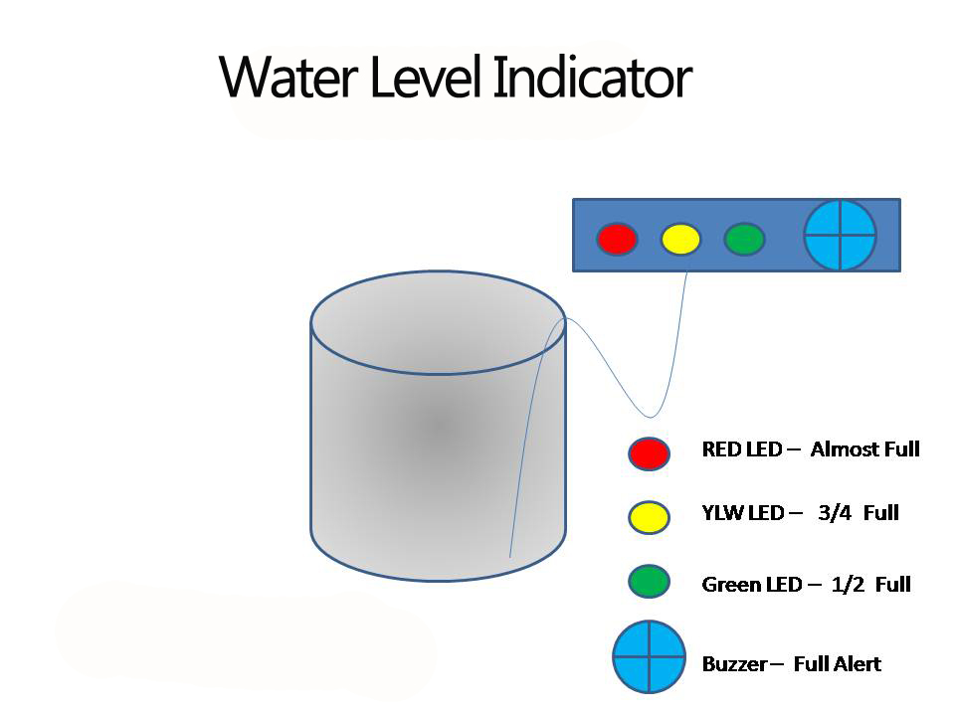

Fig 1.0

# 2.1 CIRCUIT DIAGRAM

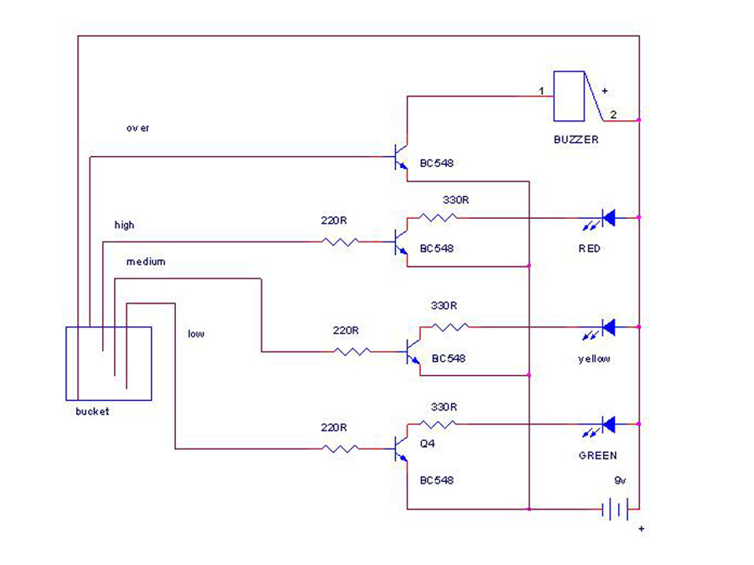

Fig 1.1

# 2.2 WORKING PRINCIPLE

The water level indicator employs a simple mechanism to detect and indicate the water level in a tank or any other container. The level sensing is done by a pair of probes, the resistance between which depends upon the water level in the tank. These probes can be placed in two ways on the walls of the tank or container:1. Both the probes can be placed at different points on the wall lying at the same level/height from the bottom. This height determines the minimum detectable water level, or 2. The probes can be placed at different points lying at two different heights from the tank bottom. In this case, the probe which is placed higher than the other determines the minimum detectable water-level. When the water-level is below the minimum detectable level (MDL), there is infinite impedance between the two probes. Hence, transistor T2 remains in the cut-off mode and does not conduct. However when water-level reaches MDL or is above it, the connection between the probes gets completed (through the conducting medium o water) and the base voltage of T2 increases. This causes the base-emitter junction of T2 to get forward biased and the piezoelectric buzzer is turned “on” to generate an alarm sound. The path from the emitter of T2 through resistance R3 is responsible for forward biasing the base of transistor T1. This switches T1 from cut-off to conduction mode, thereby driving the red LED to glow. Hence at each instance when water reaches the MDL, both the buzzer and LED indicate this simultaneously.

# 2.3 USED COMPONENT

* BC 548 **TRANSISTOR**
* RED AND GREEN LED’S
* RESISTOR 220 OHM
* BUZZER
* BATTERY 9 VOLT
* WATER TANK
* BATTERY CONNECTOR
* DRILL PCB
* CONNECTING WIRES
* SOLDERING WIRES
* WATER MOTOR

# Chapter-3

# COMPONENT DESCRIPTION

**3.1 BC 548 NPN TRANSISTOR**

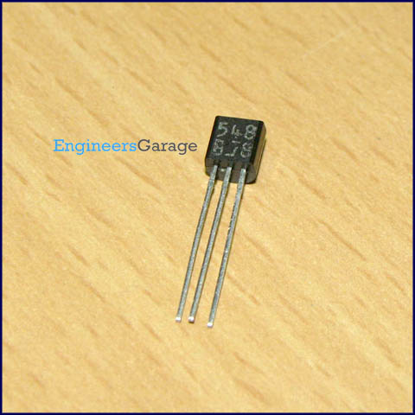

Fig 1.2

**BC548** is general purpose silicon, NPN, bipolar junction transistor. It is used for amplification and switching purposes. The current gain may vary between 110 and 800. The maximum DC current gain is 800.  Its equivalent transistors are 2N3904 and 2SC1815. These equivalent transistors however have different lead assignments. The variants of BC548 are 548A, 548B and 548C which vary in range of current gain and other characteristics. The transistor terminals require a fixed DC voltage to operate in the desired region of its characteristic curves. This is known as the biasing. For amplification applications, the transistor is biased such that it is partly on for all input conditions. The input signal at base is amplified and taken at the emitter. **BC548** is used in common emitter configuration for amplifiers. The voltage divider is the commonly used biasing mode. For switching applications, transistor is biased so that it remains fully on if there is a signal at its base. In the absence of base signal, it gets completely off.

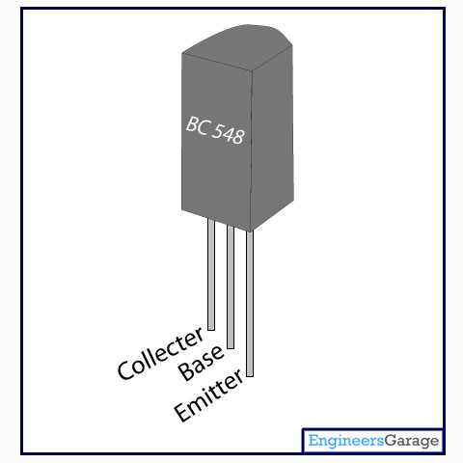

Pin diagram fig 1.3

# 3.2 RESISTOR

# 

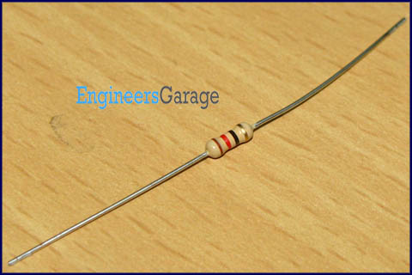

fig 1.4

Resistor is a passive component used to control current in a circuit. Its resistance is given by the ratio of voltage applied across its terminals to the current passing through it. Thus a particular value of resistor, for fixed voltage, limits the current through it. They are omnipresent in electronic circuits.

The different value of resistances are used to limit the currents or get the desired voltage drop according to the current-voltage rating of the device to be connected in the circuit. For example, if an LED of rating 2.3V and 6mA is to be connected with a supply of 5V, a voltage drop of 2.7V (5V-2.3V) and limiting current of 6mA is required. This can be achieved by providing a resistor of 450Description: http://www.engineersgarage.com/sites/default/files/Ohm%20grey%203_0.jpg connected in series with the LED.

Resistors can be either fixed or variable. The low power resistors are comparatively smaller in size than high power resistors. The resistance of a resistor can be estimated by their color codes or can be measured by a millimeter. There are some non linear resistors also whose resistance changes with temperature or light. Negative temperature coefficient (NTC), positive temperature coefficient (PTC) and light dependent resistor ([LDR](http://engineersgarage.com/content/ldr)) are some such resistors. These special resistors are commonly used as sensors. Read and learn about internal structure and working of a [resistor](http://www.engineersgarage.com/insight/how-resistor-works).

Pin Diagram:

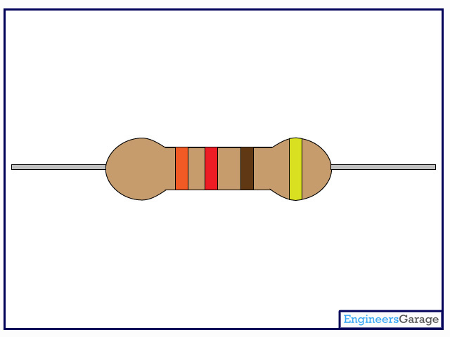

fig 1.5

**Carbon Film Resistor**

Resistors are one of the most crucial parts of any circuit. They vary from micro-ohms to mega-ohms in terms of their value. Also, they come in various forms like embedded as a chip in an IC, can be a bare metal or can be in form of a conductive plastic. This Insight will give a detailed exploration of carbon film resistor which has a ceramic core.

**Outer Structure**

Resistor looks like a solid capsule with leads at both ends which are used to connect it to the circuit.

On the capsule body, there are colored bands, typically four to six in number which tells the value of the resistance.

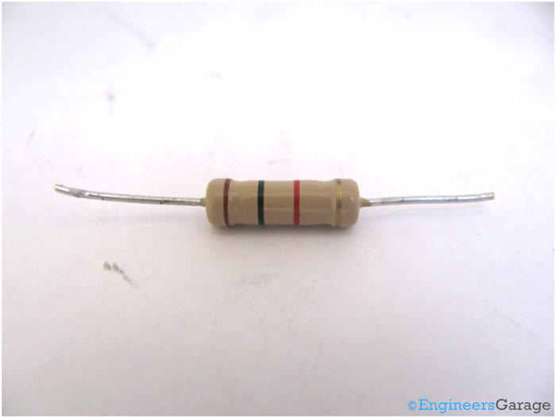

The resistance of the given resistor is 1000 ohm +/-5% tolerance. It is interesting to know that the temperature coefficient is in ppm instead of being in °C. This can be explained using a simple example. Consider a resistor with a rating 30 ppm for its temperature coefficient. This means that for every 1°C rise in temperature, the resistance would not change more than 30/10000000 or 0.000030 ohms.

## Outer Coating

The outer coating and color bands are composed of silicone conformal coating. This coating protects the resistor from high temperatures, moistures and thermal shocks, hence keeping the resistor intact and increasing working tendency at various ambient conditions.

The coating is very firmly adhered to the surface and cannot be easily removed using mechanical forces. Under the coating is the heat conducting ceramic covered with a carbon film that has a metallic alloy wiring engraved over it. This alloy wiring is the one that functions as per the specifications of the resistance.

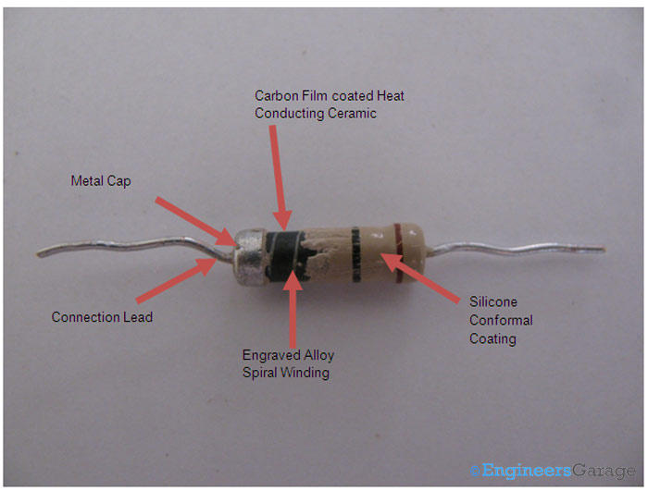

## Metal Cap Terminals

When the coating is scrapped off from the terminals, two metal caps are seen fixed over the ceramic element at its ends. These metal caps form the electrical connections of the resistor with the circuit and vice versa.

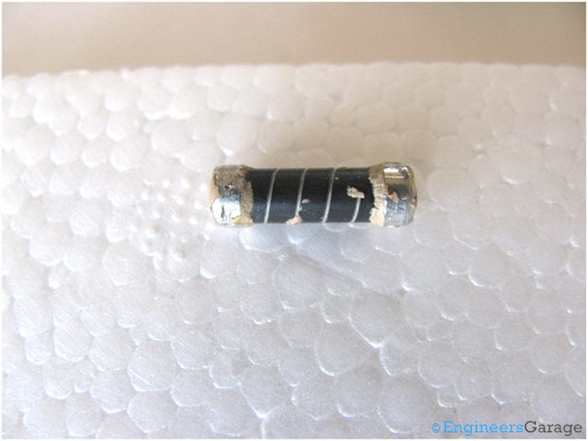

The metal caps are tightly attached to the capsule and the silicone coating tightens the bond even more. The leads are welded to the caps and hence both of them aid in sustaining electrical connections with the circuit.

## Ceramic Capsule

After the caps are removed, carbon film covering a ceramic cylinder can be seen as a solid cylinder that has metal alloy wire embedded on it. The carbon film is closely adhered to the ceramic cylinder, making the wires strongly positioned. At the ends, where the caps were attached, there are no wires, indicating that they connect to the metal caps which through the lead connections complete the electric circuit.

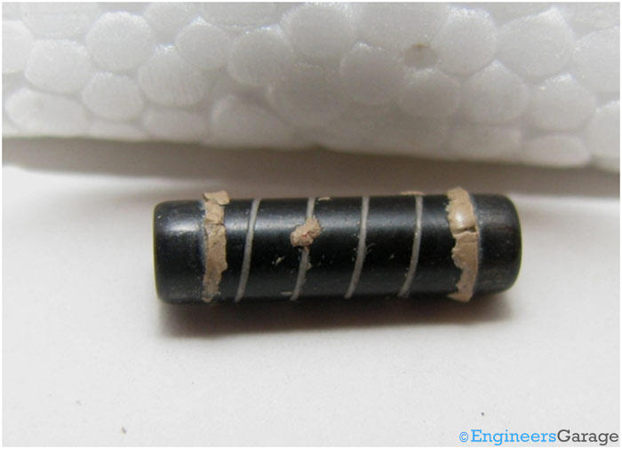

When the capsule is opened further, a solid internal structure of white ceramic is found as can be seen in the next image.

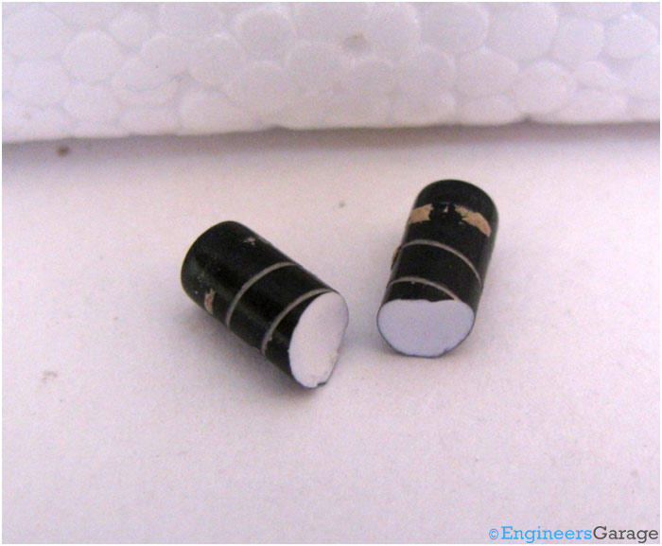

The ceramic works as a heat conductor and can handle thermal stress very well so that the desired resistance levels can be obtained and maintained across the resistor.  Heat dissipation capacity of the resistor will increase with the thickness of the ceramic capsule. Resistance is dependent on the length of the metal alloy wire.

**3.3 Resistor Color Code Chart**

Below are two current color band codes for resistors: four- and five-band resistor color-codes.

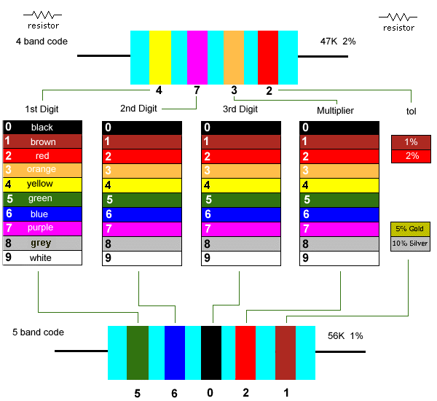

Ordinary 5% general-purpose types will use the four-band resistor code. The five-band resistor color code is more likely to be associated with the more precise 1% and 2% types. However, there is another five-band code and a six-band code that can also be used.

Resistors come in a range of values but the two most common are the E12 and E24 series. The E12 series comes in twelve values for every decade, and the E24 series comes in twenty-four values per decade as seen below.

E12 series - 10, 12, 15, 18, 22, 27, 33, 39, 47, 56, 68, 82

E24 series - 10, 11, 12, 13, 15, 16, 18, 20, 22, 24, 27, 30, 33, 36, 39, 43, 47, 51, 56, 62, 68, 72, 82, 91

You will notice with the E12 values that each succeeding value falls within ±10% of the previous/following values. This came from earlier days when resistances were within 20% tolerance (accuracy). Later values of ±5% tolerance led to the E24 range of resistance. Quite common today are 2% tolerance metal films types but for general-purpose use we tend to stick to E12 values of resistance in 1%, 2% or 5% tolerance.

# 3.4 LED

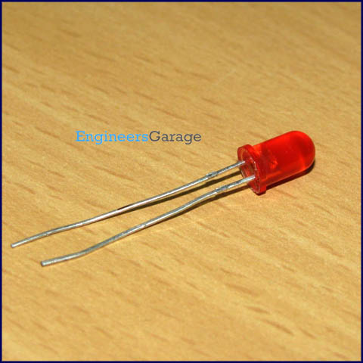

**Light emitting diodes** (**LEDs**) are semiconductor light sources. The light emitted from **LED**s varies from visible to infrared and ultraviolet regions. They operate on low voltage and power. LEDs are one of the most common electronic components and are mostly used as indicators in circuits. They are also used for luminance and optoelectronic applications.

Based on semiconductor diode, **LED**s emit photons when electrons recombine with holes on forward biasing. The two terminals of LEDs are anode (+) and cathode (-) and can be identified by their size. The longer leg is the positive terminal or anode and shorter one is negative terminal.

The forward voltage of **LED** (1.7V-2.2V) is lower than the voltage supplied (5V) to drive it in a circuit. Using an LED as such would burn it because a high current would destroy its p-n gate. Therefore a current limiting resistor is used in series with LED. Without this resistor, either low input voltage (equal to forward voltage) or PWM (pulse width modulation) is used to drive the LED. Get details about internal structure of a LED.

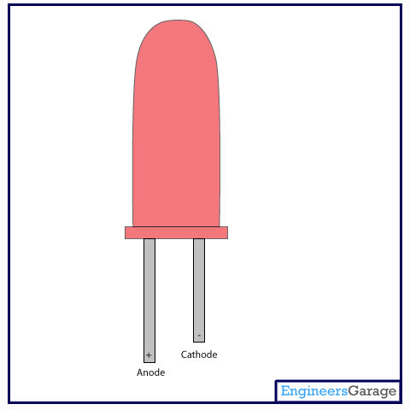

LED (Light Emitting Diode) is a special diode that emits light when an electric voltage is applied to it. It is common electronic component that is being used in devices like TV, computer, etc. generally for indicating purpose. They are available in various colors like red, yellow, green etc.

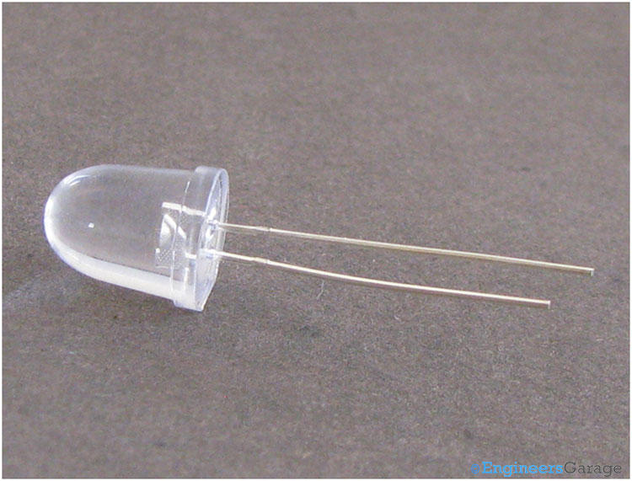

There are two leads of an LED that are used to supply input voltage. The longer lead is positive and known as ‘Post’, and the smaller is negative known as ‘Anvil’ as shown in the image above.

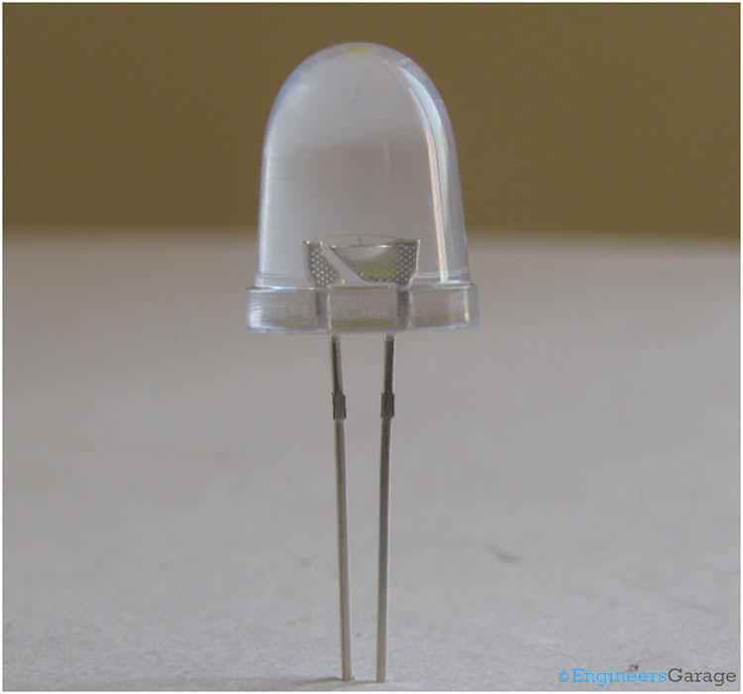

The above image shows the structure of an LED. A metal cup is placed on the negative lead (Anvil) which holds a semiconductor die. The semiconductor die is a combination of two semiconductor materials – N type and P type and an active region (known as P-N junction) between them. The outer body is formed of an epoxy glass that provides directionality to the light as well as protection to the die and leads.

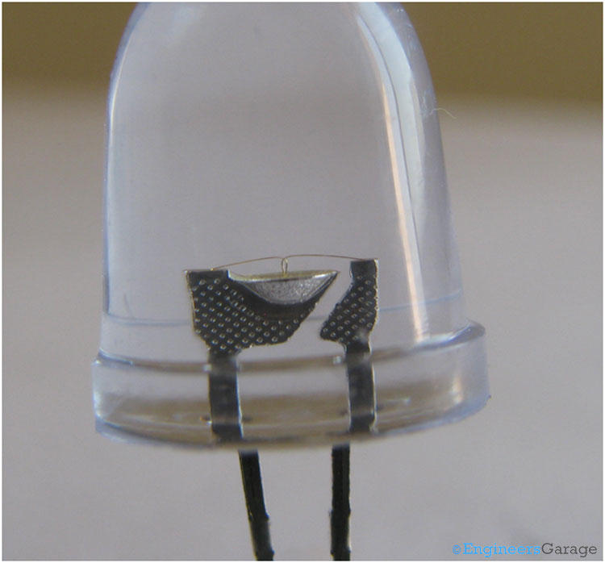

A closer look shows the structure of various components clearly. A cone shape cup, which holds the semiconductor die. The conical shape plays an important role to reflect the light emitted from the semiconductor die. Both leads are connected with the die by a wire bond.

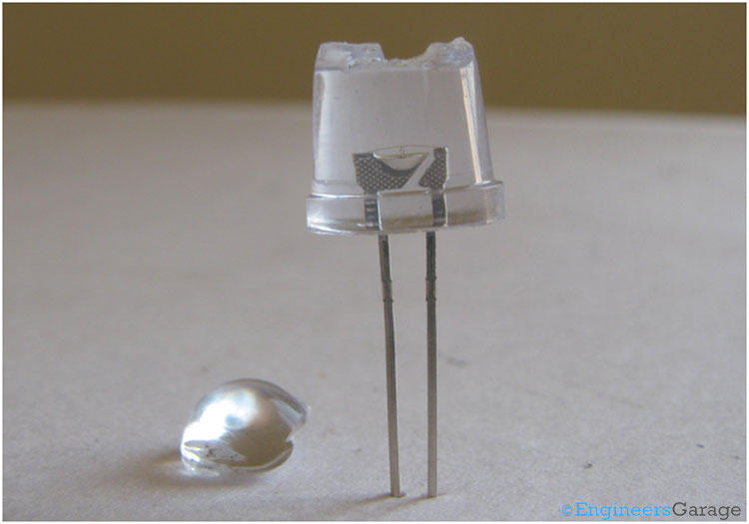

The entire assembly is encapsulated in a epoxy glass case. The shape of the glass gives directionality to the light emitted from semiconductor die.

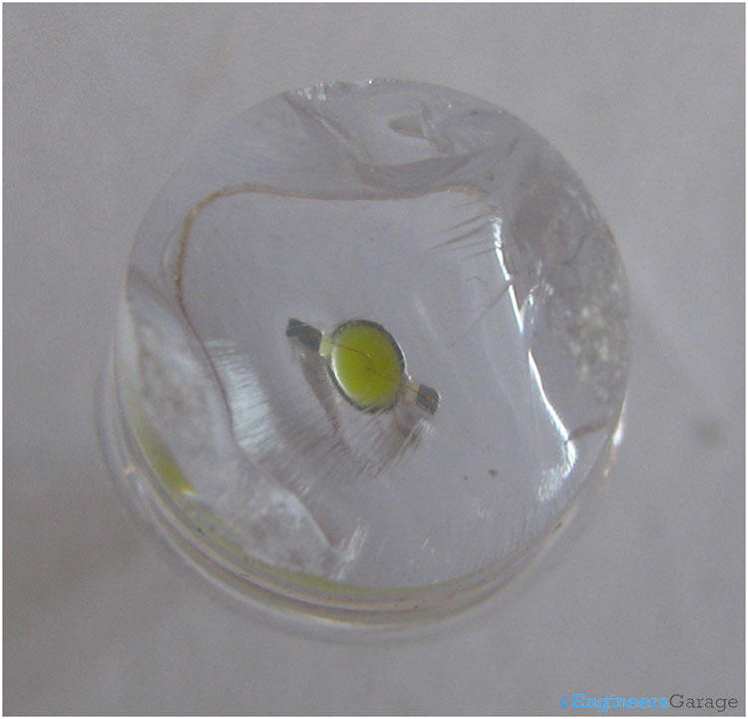

This image is the top view of the LED after removing some section of the epoxy glass case. You can see how the semiconductor die is placed in the cone. The wires are also visible on a closer look.

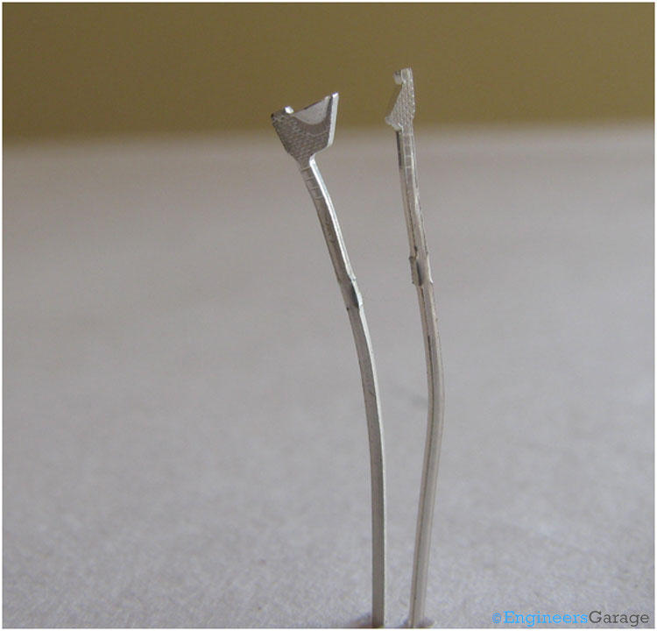

After removing the glass completely, the above image shows the front view of the leads. It showcases the structure of both the leads – Anvil and Post, which are connected to the N layer and P layer of the semiconductor die respectively by wire bond.

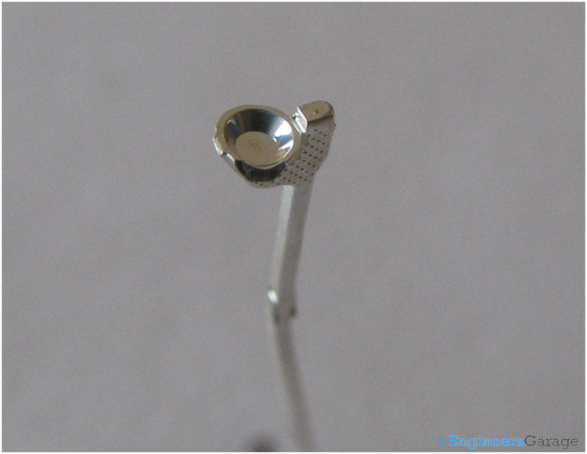

The negative terminal (Anvil) has a cavity where the semiconductor die is placed. This cavity is shaped so as to reflect the produced light into upward direction.

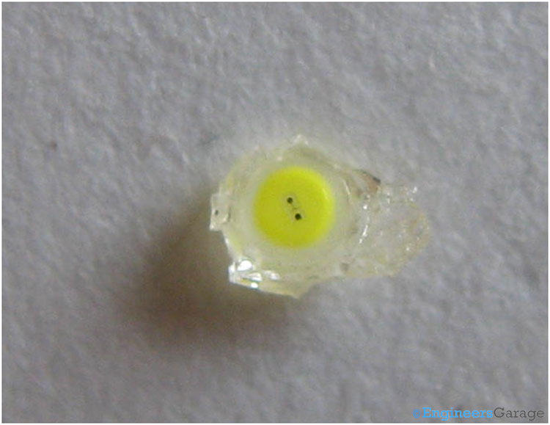

The semiconductor die which is the heart of the LED, placed on the cavity located on negative terminal (Anvil).

## Working:

The P type semiconductor is connected with the positive end of battery and N type with the negative end of the battery. When a current is passed through the LED, free electrons from the N layer moves to the P layer in the active region (P-N Junction). This involves a drop from the conduction band to the lower orbit and electrons release some energy in the form of photons. The frequency and wavelength of the light produced photons is dependent on the material and doping level of the semiconductor. In case of LED, the material used and doping levels are set so as to produce photons with wavelength in the range of desired color of light in the visible spectrum.

# 3.5 BUZZER

A **buzzer** or **beeper** is a signaling device, the word "buzzer" comes from the rasping noise that buzzers made when they were electromechanical devices, operated from stepped-down AC line voltage at 50 or 60 cycles. Other sounds commonly used to indicate that a button has been pressed are a ring or a beep

A buzzer or beeper is a signaling device, usually electronic, typically used in automobiles, household appliances such as a microwave oven, or game shows.

It most commonly consists of a number of switches or sensors connected to a control unit that determines if and which button was pushed or a preset time has lapsed, and usually illuminates a light on the appropriate button or control panel, and sounds a warning in the form of a continuous or intermittent buzzing or beeping sound. Initially this device was based on an electromechanical system which was identical to an electric BELL[http://cdncache-a.akamaihd.net/items/it/img/arrow-10x10.png](http://www.buzzer-speaker.com/faq/what%20is%20buzzer.htm#61774515) without the metal gong (which makes the ringing noise). Often these units were anchored to a wall or ceiling and used the ceiling or wall as a sounding board. Another implementation with some AC-connected devices was to implement a circuit to make the AC current into a noise loud enough to drive a loudspeaker and hook this circuit up to a cheap 8-ohm speaker. Nowadays, it is more popular to use a ceramic-based piezoelectric sounder like a Son alert which makes a high-pitched tone. Usually these were hooked up to "driver" circuits which varied the pitch of the sound or pulsed the sound on and off.

In game shows it is also known as a "lockout system," because when one person signals ("buzzes in"), all others are locked out from signaling. Several game shows have large buzzer buttons which are identified as "plungers".

The word "buzzer" comes from the rasping noise that buzzers made when they were electromechanical devices, operated from stepped-down AC line voltage at 50 or 60 cycles. Other sounds commonly used to indicate that a button has been pressed are a ring or a beep. Some systems, such as the one used on Jeopardy!, make no noise at all, instead using light.

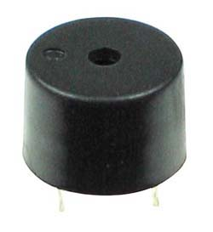

# 3.6 9VOLT BATTERY



**Conclusion**

Water level Indicator is a very simple electronic circuits that is used for water saving and are highly economical. Water level Indicator consists of a buzzer that beeps when the water level goes above the threshold level. This type of simple but highly economical circuitry should be employed in every water tank for minimizing the water wastages.

As we know that only 3% of the water present in this earth is drinking water and if the world war 3 will be fought then surely this time it will be fought for water.

Hence we should save water as much as we can.