**BASIC ELECTRONICS**

Introduction to 20 Electronics Component

|  |  |  |  |
| --- | --- | --- | --- |
| **LED** | **Diode** | **Transistor** | **DC Motor** |
| **Resistor** | **Capacitor** | **Transformer** | **Switch** |
| **Connectors** | **PCB** | **IC’s/ IC Base** | **Variable Resistor** |
| **LDR** | **Condenser Mic** | **Speaker/Buzzer** | **7 Segment Display** |
| **Relay** | **MOSFET IRF540** | **IR Tx AND Rx LED** | **BRIDGE RECTIFIER IC** |

|  |  |  |  |
| --- | --- | --- | --- |
| **USING BREAD BOARD(WITH LIST OF ITEMS)** | | | |
| **BOTH SIDE MALE CONNECTOR** | **BATTER CONNECTOR** | **9 VOLT DC BATTERY** | **FEW BREAD BOARD WIRES** |

|  |
| --- |
| **INTERNAL CONNECTION OF BREAD BOARD** |

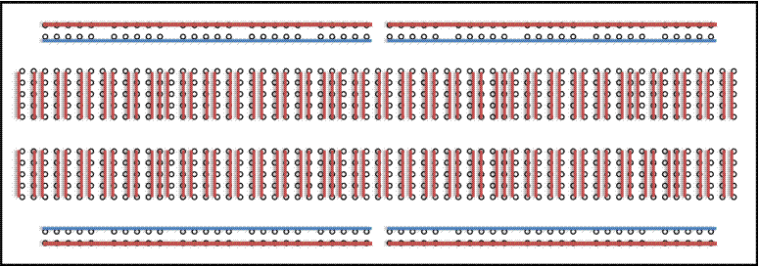

|  |  |
| --- | --- |
| **ANY TWO MINI PROJECTS ON BREAD BOARD** | |
| NAME OF MINI PROJECT | PATH |
| **AUTOMATIC STREET LIGHT** | **embedded-projects\pcb_designs\mini_projects** |
| **CLAP SWITCH** | **embedded-projects\pcb_designs\mini_projects** |
| **OBJECT COUNTER** | **embedded-projects\pcb_designs\mini_projects** |
| **MELODY GENERATOR USING LM 66** | **embedded-projects\pcb_designs\mini_projects** |

|  |  |  |  |  |
| --- | --- | --- | --- | --- |
| **INTRODUCTION TO SOLDERING(ITEMS USED FOR SOLDERING)** | | | | |
| **SOLDERING PASTE** | **SOLDERING IRON** | | **SOLDERING WIRE** | **HOLE PCB** |
| **DURING SOLDERING** | | | | |
| **DO’S** | | **DON’T’S** | | |
| **ALWAYS UNPLUGTHE SOLDERING IRON WHEN IT IS UNATTENDED** | | **ALWAYS PLUG THE SOLDERING IRON WHEN IT IS UNATTENDED** | | |
| **BE CAREFUL TO KEEP CLOTHES, HAIR, POWER CABLES AND SKIN ETC AWAY FROM THE SOLDERING IRON TIP AND THE METAL SHAFT**. | | **TO KEEP CLOTHES, HAIR, POWER CABLES AND SKIN ETC NEAR THE SOLDERING IRON TIP AND THE METAL SHAFT**. | | |
| **ALWAYS HANDLE THE IRON BY THE PLASTIC HANDLE.** | | **HANDLE THE IRON BY THE METAL SHAFT.** | | |

|  |  |
| --- | --- |
| **MAKE ANY TWO MINI PROJECTS WITH SOLDERING** | |
| NAME OF MINI PROJECT | PATH |
| **AUTOMATIC STREET LIGHT** | **embedded-projects\pcb_designs\mini_projects** |
| **CLAP SWITCH** | **embedded-projects\pcb_designs\mini_projects** |
| **OBJECT COUNTER** | **embedded-projects\pcb_designs\mini_projects** |
| **MELODY GENERATOR USING LM 66** | **embedded-projects\pcb_designs\mini_projects** |

|  |
| --- |
| **AUTOMATIC STREET LIGHT** |

|  |
| --- |
| **CLAP SWITCH** |

|  |
| --- |
| **OBJECT COUNTER** |

|  |
| --- |
| **MELODY GENERATOR USING UM66** |

**PCB DESIGNING**

|  |
| --- |
| **WORKING ON EAGLE WIN** |
| **CREATING PCB LAYOUT** |

|  |  |  |  |  |  |
| --- | --- | --- | --- | --- | --- |
| **MAKE MINI PROJECTS ON EAGLE WIN(ANY TWO)** | | | | | |
| **NAME OF THE PROJECTS** | | | **PATH** | | |
| **CLAP SWITCH** | | | **embedded-projects\pcb_designs\mini_projects** | | |
| **OBJECT COUNTER** | | | **embedded-projects\pcb_designs\mini_projects** | | |
| **AUTOMATIC STREET LIGHT** | | | **embedded-projects\pcb_designs\mini_projects** | | |
| **MELODY GENERATOR USING UM66** | | | **embedded-projects\pcb_designs\mini_projects** | | |
| **5 ITEMS USED IN PCB ETCHING PROCESS(TONER TRANSFER METHOD)** | | | | | |
| **IRON(PRESS)** | **GLOSSY PAPER** | **Fecl3 SOLUTION** | | **LASER PRINTER** | **BRD FILE** |

|  |  |
| --- | --- |
| **MAKE MINI PROJECTS OR MODULES WITH PCB ETCHING(ANY TWO)** | |
| **NAME OF THE PROJECTS/MODULES** | **PATH** |
| **CLAP SWITCH** | **embedded-projects\pcb_designs\mini_projects** |
| **OBJECT COUNTER** | **embedded-projects\pcb_designs\mini_projects** |
| **AUTOMATIC STREET LIGHT** | **embedded-projects\pcb_designs\mini_projects** |
| **MELODY GENERATOR USING UM66** | **embedded-projects\pcb_designs\mini_projects** |
| **RELAY DRIVER** | **embedded-projects\pcb_designs\modules** |

**8051 PROGRAMMING**

|  |  |  |  |
| --- | --- | --- | --- |
| **PIN DIAGRAM AND PORTS OF 8051** | | | |
| **INTRODUCTION TO 8051** | **NO OF PORTS IN 8051** | **PIN DESCRIPTION** | **GENERAL BASIC CIRCUIT** |

|  |
| --- |
| **AVR PROGRAMMER FOR 8051 PROGRAM UPLOADING** |
| **AVR SOFTEWARE INSTALLATION ON SYSTEM** |
| **AVR PIN DESCRIPTION AND NO OF COMMANDS USED FOR UPLOADING THE HEX FILE** |

|  |
| --- |
| **8051** |
| **MOSI** |
| **MISO** |
| **SCK** |
| **RST** |
| **GND** |

|  |
| --- |
| **AVR** |
| **MOSI** |
| **MISO** |
| **SCK** |
| **RST** |
| **GND** |

|  |  |  |  |  |
| --- | --- | --- | --- | --- |
| **INTRODUCTION TO KEIL COMPILER** | | | | |
| **INSTALLATION** | **STEPS OF MAKING A NEW PROJECT IN KEIL** | **SAMPEL PROGRAM OF LED BLINKING** | **SOFTWARE DESCRIPTION** | **VARITION IN LED BLINKING BY STUDENT** |

|  |  |
| --- | --- |
| **INTERFACING MODULES WITH 8051(ANY 5)** | |
| **NAME OF THE MODULES** | **PATH** |
| **MOTOR DRIVER** | **embedded-projects\pcb_designs\modules** |
| **DTMF** | **embedded-projects\pcb_designs\modules** |
| **LCD MODULE** | **Use original** |
| **RELAY DRIVER** | **embedded-projects\pcb_designs\modules** |
| **IR MODULE** | **embedded-projects\pcb_designs\modules** |
| **KEYPAD** | **embedded-projects\pcb_designs\modules** |
| **7 SEGMENT DISPLAY** | **embedded-projects\pcb_designs\modules** |
| **PIR MOTION SENSOR** | **Use original(connect Vcc, Gnd, Out pin to 8051)** |

|  |
| --- |
| **INTERFACING MOTOR DRIVER WITH 8051** |

|  |
| --- |
| 8051  **P2.0**  **P2.1**  **P2.2**  **P2.3** |

|  |
| --- |
| **MOTOR DRIVER**  **L293D**  **2 3**  **7 6**  **10 11**  **15 14** |

|  |
| --- |
| **INTERFACING DTMF MODULE WITH 8051** |

|  |
| --- |
| **8051**  **P30**  **P31**  **P32**  **P33**    **P20 P21 P22 P23** |

|  |
| --- |
| **DTMF DECODER**  **10**  **11**  **12**  **13** |

|  |
| --- |
| **2 7 10 15**  **L293D MOTOR DRIVER**  **3 6 11 14** |

|  |
| --- |
| **MOTOR DRIVER**  **L293D**  **2 3**  **7 6**  **10 11**  **15 14** |

|  |
| --- |
| **8051 INTERFACING WITH LCD** |

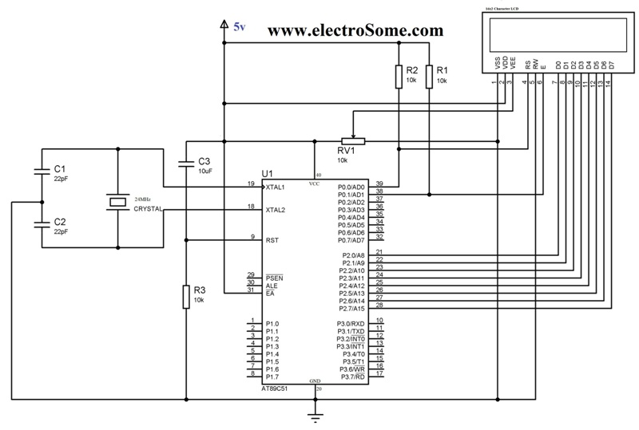

|  |
| --- |
| **8051 INTERFACING WITH IR MODULE** |



|  |
| --- |
| **VCC GND OP**  **IR MODULE** |

|  |
| --- |
| **8051 INTERFACING WITH KEYPAD** |

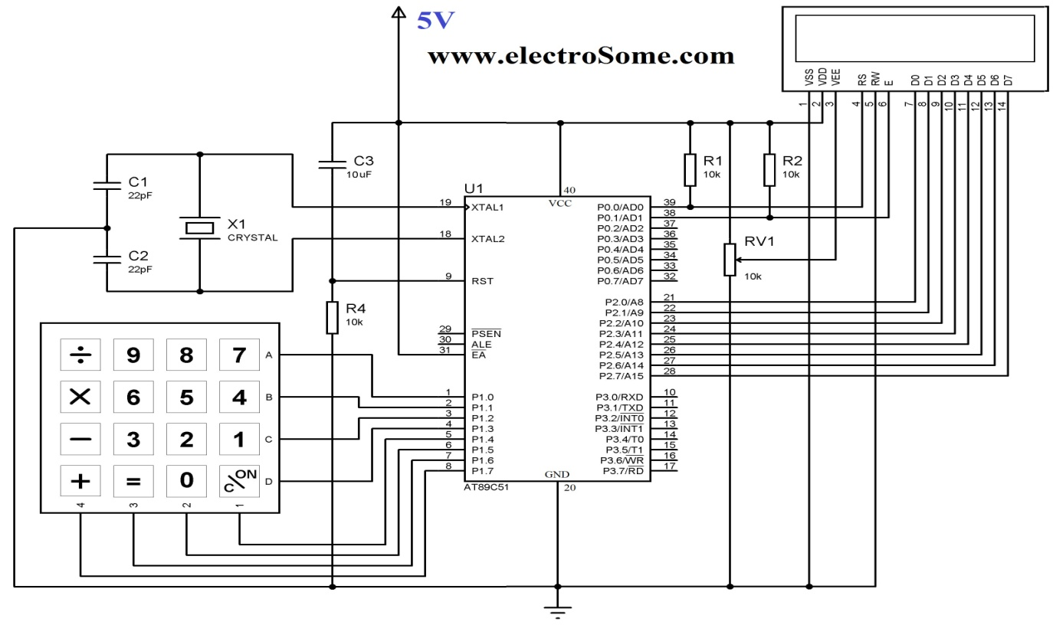

|  |
| --- |
| **2 projects based on 8051.** |

|  |  |
| --- | --- |
| **NAME OF THE PROJECT** | **PATH** |
| **BIDIRECTIONAL VISITOR COUNTER** | **embedded-projects\project_codes\8051\Projects** |
| **PWM MOTOR SPEED CONTROL** | **embedded-projects\pcb_designs\major_projects** |
| **ELECTRONIC LOCK** | **embedded-projects\pcb_designs\major_projects** |
| **RS 232 BASED DATA TRANSFER** | **embedded-projects\pcb_designs\major_projects** |

**ARDUINO PROGRAMMING**

|  |
| --- |
| **PIN DIAGRAM AND PORTS OF ATMEGA328/ARDUINO** |
| **USING ARDUINO IDE FOR UPLOADING PROGRAMS TO ARDUINO** |

|  |  |  |  |
| --- | --- | --- | --- |
| **INTERFACING MODULES WITH ARDUINO (ANY 5)** | | | |
| **MOTOR DRIVER** | **LCD MODULES** | **IR MODULES** | **7 SEGMENT DISPLAY** |
| **DTMF MODULES** | **RELAY DRIVER** | **KEYPAD** | **PIR MOTION SENSOR** |

|  |
| --- |
| **ARDUINO INTERFACING WITH MOTOR DRIVER** |

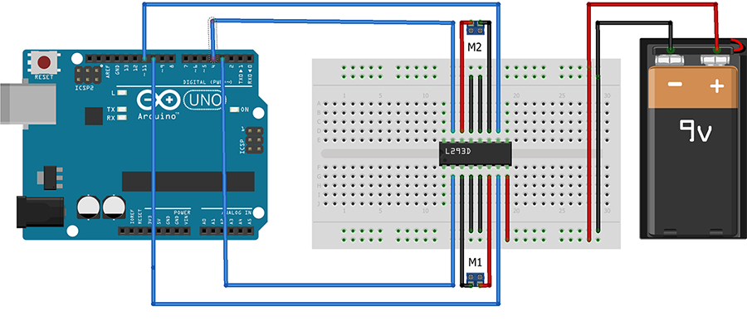

|  |  |
| --- | --- |
| **SOURCE CODE** | **PATH** |
| **ARDUINO INTERFACING WITH MOTOR DRIVER** |  |

|  |
| --- |
| **VCC O/P GND**  **IR MODULE** |

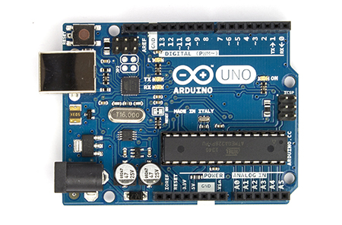

|  |  |
| --- | --- |
| **SOURCE CODE** | **PATH** |
| **ARDUINO INTERFACING WITH IR ODULE** |  |

|  |
| --- |
| **ARDUINO INTERFACING WITH LCD** |

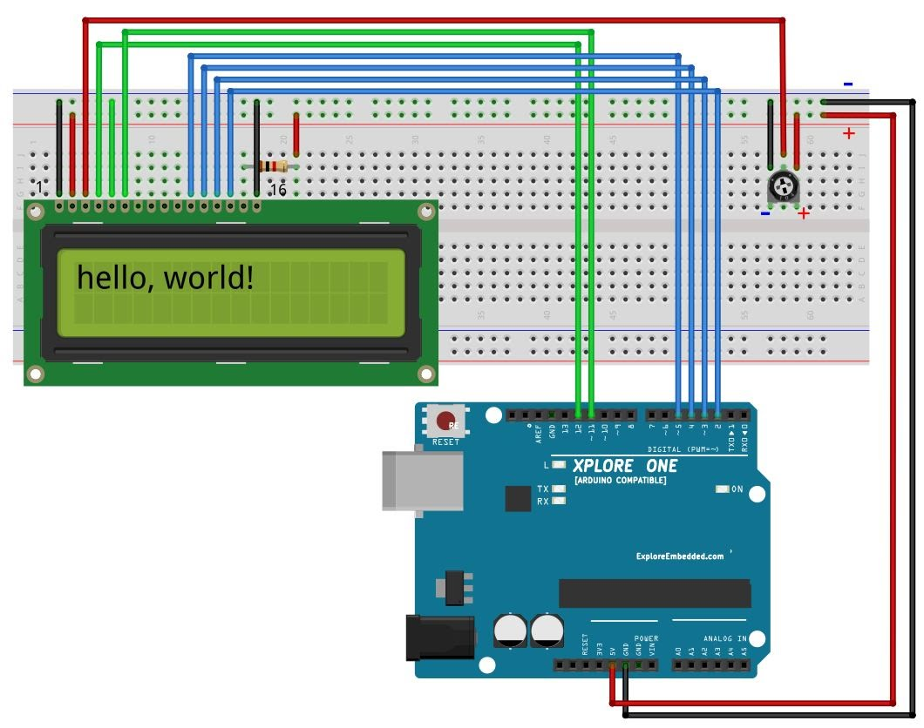

**9VOLT**

**GND**

|  |  |
| --- | --- |
| **SOURCE CODE** | **PATH** |
| **ARDUINO INTERFACING WITH LCD** |  |

|  |
| --- |
| **ARDUINO INTERFACING WITH KEYPAD** |

|  |
| --- |
| **2 projects based on Arduino.** |

|  |  |
| --- | --- |
| **NAME OF THE PROJECT** | **PATH** |
| **DTMF ROBOT** | **embedded-projects\project_codes\arduino\Projects** |
| **TEMPERATURE SENSOR USING LM 35** | **embedded-projects\project_codes\arduino\Projects** |

**ROBOTICS**

|  |  |  |  |  |
| --- | --- | --- | --- | --- |
| **INTRODUCTION TO 10 COMPONENT USED TO MAKE A SIMPLE ROBOT** | | | | |
| **L293D IC** | **FRONT WHEEL** | **WHEELS** | **CHACHIS** | **BATTERY** |
| **CONNECTORS** | **GEAR MOTOR** |  |  |  |

|  |  |  |
| --- | --- | --- |
| **MAKING DIFFERENT CHACHIS BASIS** | | |
| **USING 3 BASIS MODULES REQUIRE FOR ROBOTICS** | | |
| **MOTOR DRIVER** | **IR MODULE** | **LDR MODULE** |

|  |  |
| --- | --- |
| **MAKE 3 ROBOT USING ARDUINO UNO BOARD** | |
| **NAME OF THE PROJECTS** | **PATH** |
| **DTMF ROBOT** | **embedded-projects\project_codes\arduino\Projects** |
| **EDGE AVOIDING ROBOT** | **embedded-projects\project_codes\8051\Projects** |
| **LINE FOLLOWING ROBOT** | **embedded-projects\project_codes\8051\Projects** |

**DEMO PROJECTS TO DISPLAY**

|  |
| --- |
| **2 Demo Project to Display** |

|  |
| --- |
| **REMOTE CONTROLE MOTOR ON OFF** |
| **WIRELESS POWER TRANSMISSION** |