The menu
- Sectors
- Clinical Operations
- Solutions
- Delivery Models
- Expertise
- Education
- About us
- Contact us

Sectors
Navigating Medical Device & Diagnostic Development to Market Success
Clinical trials investigate is a leading full-service CRO with a notable focus on the medical device and diagnostics sector. Our globally located medical, regulatory, and operational experts can assist you during all phases of your product development, from initial market access to post-marketing requirements and life cycle management. You can rely on our medical device and diagnostics expertise from simple pilot studies to large, complex trials across multiple countries and for your pre- and post-market needs.
Clinical Trials Investigate is a leading full-service Contract Research Organization (CRO) with a specialized focus on the medical device and diagnostics sector. We combine global reach with deep expertise to support clients at every stage of their product development journey.
Comprehensive Global Expertise
Our team of internationally located medical, regulatory, and operational specialists brings extensive experience in navigating complex clinical and regulatory landscapes. This ensures your product development process—from concept to commercialization—is efficient, compliant, and strategically guided.
End-to-End Product Development Support
We provide tailored assistance throughout all phases of your product’s life cycle:
- Early Development & Market Access: Guidance on feasibility studies, pilot trials, and regulatory strategy to facilitate smooth entry into target markets.
- Clinical Trials: Management of simple pilot studies as well as large, multicenter, and multinational trials. Our expertise encompasses both pre-market approval trials and post-market surveillance studies.
- Post-Market & Life Cycle Management: Support with ongoing safety monitoring, regulatory reporting, and evidence generation to ensure continued market compliance and product optimization.
Specialized Medical Device & Diagnostics Capabilities
We understand the unique challenges associated with medical devices and diagnostics, including device-specific endpoints, regulatory requirements, and operational logistics. Clients benefit from our experience in:
- Designing and implementing complex clinical trials across multiple countries
- Managing pre-market submissions and approvals
- Conducting post-market studies, including registries and observational trials
- Ensuring compliance with international standards and local regulations
Why Choose Us
By partnering with Clinical Trials Investigate, you gain a reliable, experienced ally who can seamlessly integrate scientific, operational, and regulatory expertise to help bring your device or diagnostic solution from concept to commercial success.

Clinical Operations
Clinical trials investigate ensures the efficient and effective conduct of clinical trials by proactive planning, communicating, monitoring performance, managing resources, and ensuring adherence to timelines and contractual obligations. Clinical operations project management is supported by well-developed processes and experienced team members; involving:
Concept of project management as presented in the PMBOK® Guide and its specialized application to clinical research for delivering new therapeutic drugs, biologics, medical devices, and in-vitro diagnostic (IVD) products.

📘 1. Core Concept of Project Management
1.1. Value-Driven, Practitioner-Informed Framework
The PMBOK® Guide – Eighth Edition establishes a modern, adaptable foundation for project management by integrating evidence from thousands of practitioners and emphasizing value delivery over rote procedure. Projects are defined as temporary, unique initiatives undertaken to create value in context. Project Management Institute
1.2. Six Core Principles
These principles guide behavior and decision-making across all types of projects:
- Adopt a holistic view – understand the project in its whole organizational and environmental context.
- Focus on value – prioritize measurable benefits, not just output metrics.
- Embed quality – quality is integrated throughout, not inspected at the end.
- Lead accountably – assume responsibility for outcomes ethically and transparently.
- Integrate sustainability – consider long-term and systemic impacts.
- Build empowered teams – foster collaboration and autonomy. projectmanagementpmo.com
1.3. Seven Performance Domains
The guide organizes practice around critical areas of focus such as Governance, Scope, Schedule, Finance, Stakeholders, Resources, and Risk. These domains replace older „knowledge areas“ and reflect what matters most in real-world delivery. Bookmag
1.4. Practical Guidance and Processes
PMBOK 8 reintroduces ~40 practical processes, tools, and techniques that are aligned with performance domains and usable in predictive, adaptive (e.g., agile), and hybrid project contexts, making the methodology both principled and actionable. LinkedIn

🧪 2. Why Project Management Matters for Clinical Research
Clinical research programs — including trials of new therapeutic drugs, biologics, medical devices, and in-vitro diagnostics (IVDs) — are complex, regulated, multi-disciplinary projects that demand structured coordination, risk management, quality assurance, and stakeholder alignment. These industries are among the most regulated and resource-intensive sectors, where poor planning can compromise safety, data integrity, and regulatory approval timelines. The Pharmaceutical Journal
Project management brings clarity, traceability, and controlled execution to these efforts, helping teams deliver safe, effective treatments and technologies in a way that aligns with both scientific rigor and regulatory requirements.

📈 3. Applying PMBOK 8 to Clinical Development Programs
Below is how PMBOK concepts map to the lifecycle of therapeutic drug, biologic, device, and IVD development:

🧩 3.1. Project Initiation & Defining Strategic Scope
Before scientific work begins, the project must be formally initiated with clear strategic objectives, stakeholder needs, and boundaries:
- Define intended value — e.g., patient outcomes, regulatory approvals, market entry.
- Identify stakeholders — sponsors, regulators (FDA, EMA, NMPA), investigators, CROs, patients.
- Establish governance structures — steering committees, sponsor oversight, compliance roles.
This mirrors the PMBOK focus on holistic value orientation, stakeholder engagement, and governance. Bookmag
In clinical research, this includes creating documents such as the protocol, investigator’s brochure, and initial regulatory strategy plan. Wikipedia

📌 3.2. Planning Phase (Comprehensive & Regulatory-Driven)
Clinical research planning is among the most multifaceted of all project planning activities:
3.2.1. Technical & Scientific Planning
- Study design — phase I–IV clinical study structures.
- Eligibility criteria and endpoints — scientific and ethical targets.
- Data standards — e.g., CDISC compliance for regulatory submissions. Wikipedia
3.2.2. Regulatory and Quality Planning
- Align with Good Clinical Practice (GCP), ICH guidelines, and local regulations.
- Integrate quality planning and compliance checkpoints into the project management plan.
3.2.3. Integrated Risk & Resource Planning
- Risk registers and mitigation plans for enrollment delays, safety events, supply shortages.
- Resource allocation across clinical operations, biostatistics, data management, and monitoring. Project Management Institute
Conceptually, this aligns with PMBOK’s performance domains for scope, schedule, risk, and resources, but must explicitly incorporate regulatory and scientific risk unique to clinical research.

🚀 3.3. Execution & Monitoring in Clinical Context
3.3.1. Execution
- Activation of sites, patient recruitment, therapy administration, device usage or sample collection.
- Cross-functional coordination among teams and external partners.
3.3.2. Monitoring & Controlling
- Real-time measurement of enrollment rates, safety signals, data quality.
- Integrated quality management (CQMS) to track compliance with GCP norms. Wikipedia
- Adaptive responses to interim findings or regulatory feedback.
This phase exemplifies PMBOK’s emphasis on continuous governance, stakeholder management, and performance measurement across domains. Bookmag
👉 Example: Clinical trial master protocols and adaptive designs use iterative decision points that require robust project governance and risk responsiveness.

🧾 3.4. Close-Out, Submission & Benefits Realization
After data collection and analysis:
- Complete clinical reports, safety analyses, and statistical summaries.
- Regulatory submissions (e.g., Common Technical Document for new drugs).Wikipedia
- Lessons learned and archival of documents.
- Post-market projects (Phase IV) feed into lifecycle management.
This aligns with the closing focus area in PMBOK, but in clinical research it also triggers product approval milestones, market launch planning, and potential ongoing surveillance projects.

🧬 4. Special Considerations Across Product Types
4.1. Therapeutic Drugs & Biologics
- Long timelines with multiple regulatory checkpoints (Phase I–III).
- Complex risk profiles (safety, efficacy) requiring extensive monitoring.
- Integration of pharmacovigilance and real-world evidence planning as part of the project plan.
These complexities benefit from PMBOK-oriented risk domain focus and quality integration throughout. Epicflow

4.2. Medical Devices & IVDs
- Medical devices and IVD projects face stricter design control and quality system regulations (ISO 13485, FDA QSR).
- Requirements include verification/validation activities, traceability matrices, and robust configuration management — these become formal deliverables supported by structured project planning and governance. Medical Device HQ

🧠 5. Benefits of Applying Project Management in Clinical Research
✔ Improved Predictability
Structured planning and risk management reduce surprises in timelines and costs. The Pharmaceutical Journal
✔ Quality & Compliance Alignment
Embedding quality across phases enhances data integrity, supports regulatory compliance, and improves audit readiness. cromospharma.com
✔ Cross-Functional Leadership
Project managers bridge scientific, operational, and regulatory domains — aligning multidisciplinary teams toward shared outcomes.
✔ Adaptive Oversight
Real-time monitoring, continuous stakeholder engagement, and iterative adjustments increase the likelihood of successful trial outcomes.

Solutions
Approach your next product development program with the right scientific and strategic consultancy support to consistently achieve goals and meet the highest quality and compliance standards.
Solutions for Comprehensive Product Development
At Clinical Trials Investigate, we provide tailored scientific and strategic consultancy to guide your product development programs from concept through post-market activities. Our solutions are designed to consistently achieve your project goals while maintaining the highest quality, regulatory, and compliance standards.

Clinical Development
We design and implement clinical programs that ensure robust evidence generation for regulatory submissions, market access, and patient safety. Our services include:
- Study design and protocol development
- Feasibility assessments and site selection
- Risk-based monitoring and trial management
Clinical Operations
Our operational teams manage trials efficiently across local and global sites, ensuring timely delivery and adherence to regulatory requirements:
- Site management and monitoring
- Patient recruitment and retention strategies
- Clinical trial logistics and vendor management
Biometrics & Data Science
We provide comprehensive statistical and analytical support to ensure accurate, reliable data interpretation:
- Biostatistics and statistical programming
- Data management and validation
- Advanced analytics and AI-driven insights
Medical Monitoring & Safety
We maintain patient safety and data integrity across all studies through proactive monitoring:
- Adverse event tracking and reporting
- Risk assessment and mitigation strategies
- Safety data analysis and interpretation
Regulatory Affairs
Our experts guide your product through complex regulatory pathways:
- Regulatory strategy and submissions (pre- and post-market)
- Interactions with global health authorities
- Compliance with international standards (FDA, EMA, ISO, etc.)
Medical & Technical Writing
We deliver high-quality documentation to support regulatory submissions and scientific communication:
- Clinical study reports (CSRs)
- Investigator brochures and protocols
- Technical documents, manuscripts, and regulatory dossiers
Project Management
Our project managers ensure your programs remain on track, within scope, and on budget:
- Integrated project planning and resource management
- Risk assessment and mitigation
- Cross-functional coordination and reporting
Quality & Compliance
We embed quality assurance across every phase of your product development:
- Audits and inspections support
- SOP development and compliance oversight
- Continuous improvement initiatives
Technology & Data Solutions
We leverage technology to streamline operations, enhance data integrity, and support decision-making:
- Electronic data capture (EDC) systems
- Clinical trial management systems (CTMS)
- Advanced analytics platforms
Product Vigilance & Post-Marketing
We support your products throughout their life cycle with robust post-market strategies:
- Real-world evidence generation
- Post-marketing surveillance studies
- Pharmacovigilance and safety monitoring
Medical Affairs & Toxicology
Our medical experts provide scientific guidance to support regulatory submissions, clinical strategies, and product safety:
- Toxicology assessment and risk evaluation
- Advisory support for clinical and regulatory decisions
- Evidence-based medical strategy development
Consulting
We provide tailored consulting to optimize your development strategy and operational efficiency:
- Strategic planning and go-to-market guidance
- Gap analysis and process optimization
- Regulatory readiness and compliance audits

This comprehensive approach ensures your product development programs are scientifically rigorous, operationally efficient, and fully compliant with global regulatory standards, from early development to post-market activities.

Delivery Models
Ensure quality, efficiency, and reliability with customized Clinical trials investigate delivery model that fits your unique business needs.
Delivery Models for Optimized Product Development
At Clinical Trials Investigate, we provide flexible and tailored delivery models to meet the unique needs of your organization. Our models are designed to maximize efficiency, maintain the highest quality standards, and ensure reliability throughout your product development lifecycle.

Full-Service Solutions
Our full-service model offers end-to-end management of your clinical and regulatory programs. From initial strategy through post-market activities, we serve as your single point of accountability:
- Integrated Program Management: Seamless coordination of all functional areas, including clinical development, regulatory affairs, medical writing, and pharmacovigilance.
- Global Clinical Trial Execution: Planning, implementation, and oversight of multi-country trials, ensuring compliance with local and international regulations.
- Regulatory and Compliance Assurance: Support for pre- and post-market submissions, inspections, and audits.
- Medical and Scientific Expertise: Access to therapeutic, diagnostic, and device-specific expertise to inform study design and product strategy.
- Data-Driven Insights: Real-time analytics, biometrics, and reporting for informed decision-making and risk management.
This model is ideal for organizations seeking a trusted partner to manage the full spectrum of their clinical programs, reducing operational burden and accelerating time-to-market.

Functional Service Provider (FSP) Solutions
Our FSP model allows you to augment your internal capabilities with specialized expertise and resources on-demand:
- Scalable Resource Deployment: Flexible allocation of experienced professionals across clinical operations, data management, biostatistics, regulatory affairs, medical writing, and safety.
- Targeted Expertise: Access to specialized skill sets for specific projects or phases without long-term commitments.
- Process Integration: Seamless collaboration with your internal teams, aligned with your SOPs and quality standards.
- Cost Efficiency: Optimized resource utilization to manage budgets while maintaining high-quality outcomes.
- Rapid Response: Agile deployment to support urgent project needs or unexpected operational demands.
The FSP model is ideal for organizations looking for flexibility, cost control, and the ability to scale expertise up or down depending on project requirements.

Why Choose Our Delivery Models
- Customized to match your operational structure and strategic goals
- Ensures consistent quality, compliance, and risk mitigation
- Provides both end-to-end management and targeted, flexible support
- Leverages global expertise and technology for efficiency and reliability

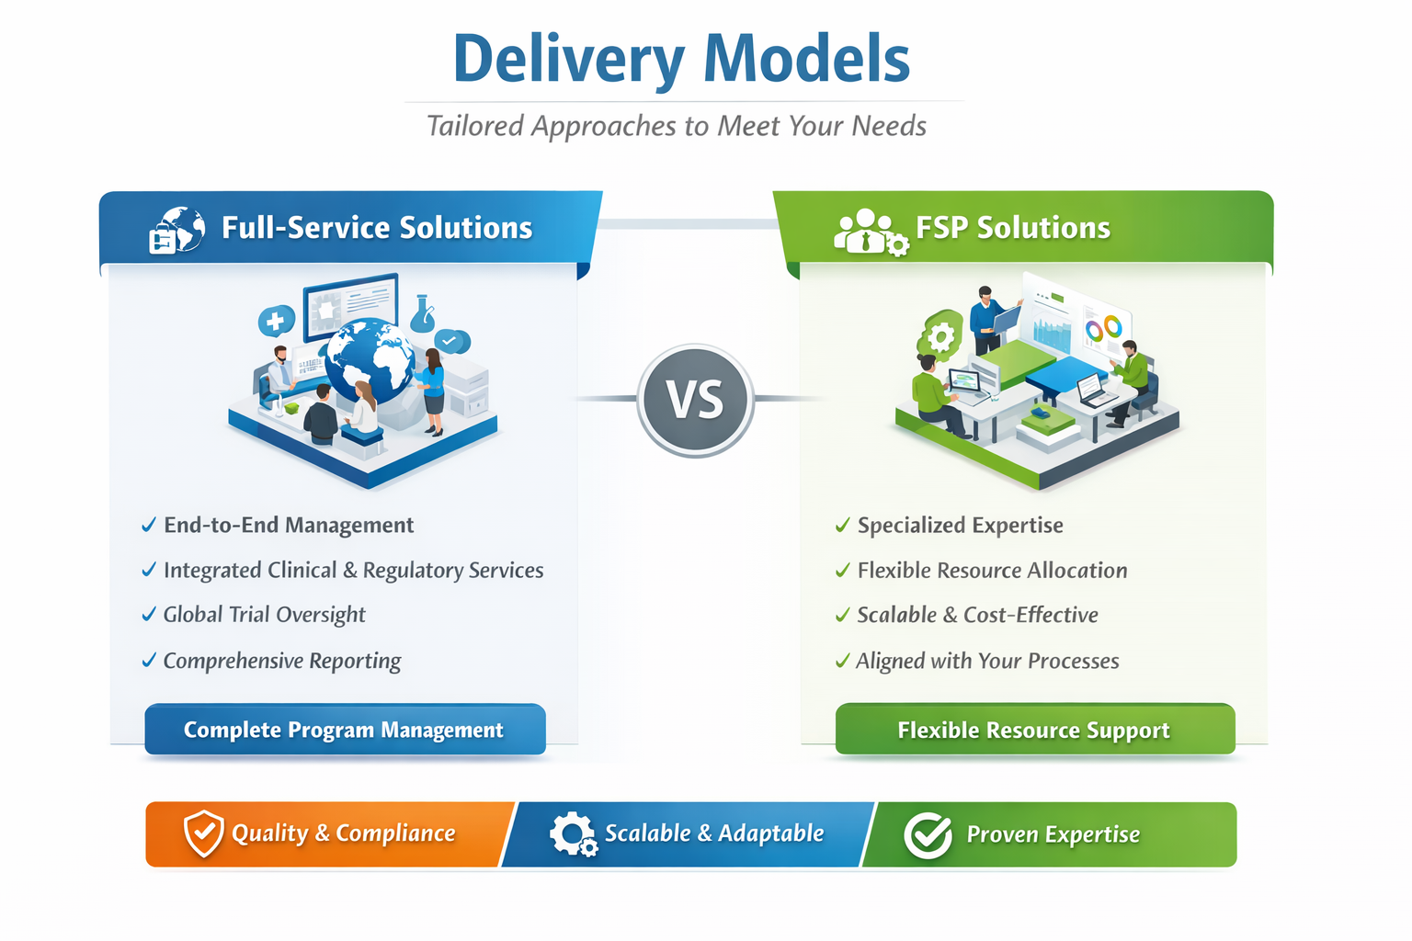
Expertise
Explore our strengths. Discover our wide range of therapeutic expertise and specialized experience that expedites the development and commercialization of innovative drugs, devices, and diagnostics.
Expertise: Driving Innovation in Healthcare
At Clinical Trials Investigate, we leverage deep therapeutic knowledge and specialized experience to accelerate the development, regulatory approval, and commercialization of innovative drugs, medical devices, and diagnostics. Our global teams combine scientific rigor with operational excellence to deliver high-quality, compliant results across diverse therapeutic areas.

Therapeutic Areas
We offer expertise across a broad spectrum of therapeutic domains, enabling targeted strategies for clinical development:
Therapeutic Area | Key Capabilities
Cardiovascular | Clinical trial design, device integration, post-market surveillance
Oncology | Biomarker-driven trials, safety monitoring, regulatory submissions
Neurology | Patient recruitment strategies, multi-center trials, medical monitoring
Infectious Diseases | Epidemiology studies, vaccine trials, real-world evidence collection
Endocrinology & Metabolism | Outcome assessments, biometrics, pharmacovigilance
Rare & Orphan Diseases | Adaptive trial design, small population strategies, global regulatory navigation
Diagram Concept: A circular or network diagram showing each therapeutic area as a node connected to the central “Expertise” hub, highlighting comprehensive coverage.

Specialties
Our specialized capabilities support complex, high-value projects and unique regulatory needs:
Specialty | Description / Benefit
Medical Devices & Diagnostics | Regulatory strategy, trial execution, post-market studies
Real-World Evidence & Post-Marketing | Observational studies, registries, pharmacovigilance
Regulatory Affairs | Global submission support, compliance audits, strategy planning
Biometrics & Data Science | Advanced analytics, AI-driven insights, statistical programming
Medical & Technical Writing | Protocols, clinical study reports, regulatory documentation
Medical Affairs & Toxicology | Risk assessment, clinical guidance, safety strategy
Project Management | Integrated planning, resource optimization, milestone tracking
Diagram Concept: A layered pyramid or segmented wheel illustrating “Core Expertise” at the center, with each specialty radiating outward to show integrated capabilities.

Why Our Expertise Matters
- Accelerates development timelines with domain-specific knowledge
- Ensures regulatory compliance across global markets
- Provides integrated, cross-functional solutions for drugs, devices, and diagnostics
- Supports both pre-market and post-market needs with proven results

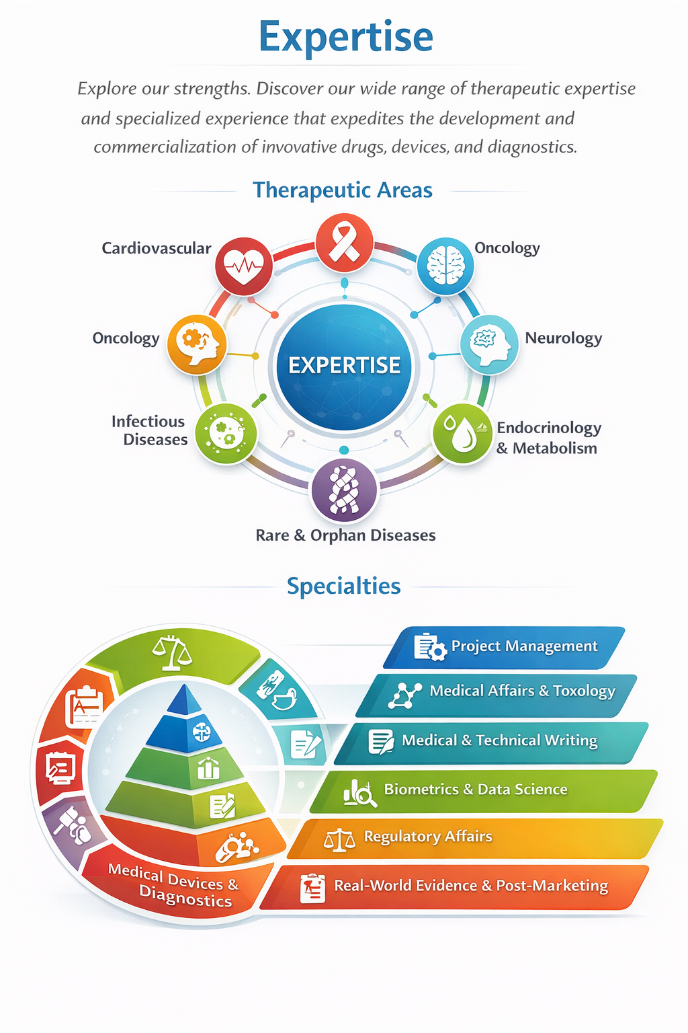
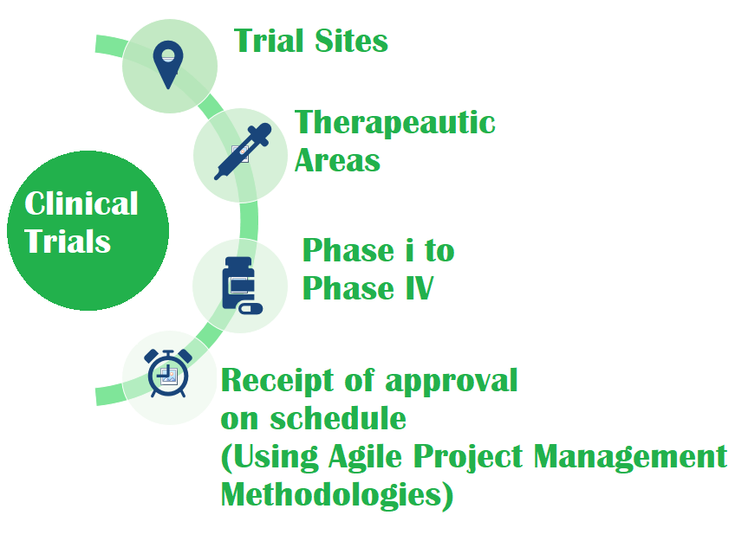

Education
1. Overview of Clinical Trials
- Explanation: Understanding the basics of clinical trials, including phases, types, and processes involved.
- URL: [NIH Clinical Trials Overview](https://www.nih.gov/health-information/clinical-trials)
2. Informed Consent Process
- Explanation: Education about the importance of informed consent, how it is obtained, and ethical considerations.
- URL: [FDA Informed Consent](https://www.fda.gov/science-research/science-and-research-special-topics/informed-consent)
3. Regulatory Requirements
- Explanation: Knowledge of the regulatory framework governing clinical trials, including FDA and ICH guidelines.
- URL: [FDA Regulations](https://www.fda.gov/science-research/science-and-research-special-topics/clinical-trials)
4. Data Management and Analysis
- Explanation: Understanding data collection, management, and statistical analysis in clinical trials.
- URL: [Clinical Trial Data Management](https://www.ncbi.nlm.nih.gov/pmc/articles/PMC5506173/)
5. Patient Recruitment and Retention
- Explanation: Strategies for effectively recruiting and retaining participants in clinical trials.
- URL: [NIH Patient Recruitment](https://www.nih.gov/research-training/clinical-research/clinical-trial-recruitment)
6. Ethical Considerations
- Explanation: Education on the ethical principles guiding clinical trials, including respect for persons, beneficence, and justice.
- URL: [Nuremberg Code](https://www.hhs.gov/ohrp/regulations-and-policy/belmont-report/read-the-belmont-report/index.html)
7. Understanding Trial Results
- Explanation: How to interpret and understand the results of clinical trials, including efficacy and safety data.
- URL: [Clinical Trial Results](https://www.who.int/clinical-trials-registry-platform)
8. Role of Clinical Research Coordinators
- Explanation: The responsibilities and skills required for those managing clinical trials.
- URL: [Clinical Research Coordinator Role](https://www.aacr.org)
9. Adverse Event Reporting
- Explanation: Understanding how to report and manage adverse events during clinical trials.
- URL: [FDA Adverse Event Reporting](https://www.fda.gov/safety/reporting-serious-problems-fda)
10. Emerging Trends in Clinical Trials
- Explanation: Insights into new methodologies, technologies, and practices in clinical trials.
- URL: [Clinical Trials Innovation](https://www.clinicaltrials.gov)

About us
About us:
CLINICAL Trials INVESTIGATE (CTI) Mission and Vision
Vision
Clinical Trials Investigate (CTI) is an affiliate of both International Information Technology & Application and International Institute of Technology & Application. Clinical Trials Investigate (CTI) seeks to become a great center of clinical research, and a catalyst for development in the entire world. In the words of its Founder, it sees its role as a "Development center". Thus, the Center will honor the traditional Center roles of clinical repository and transmitter of clinical knowledge, and center for the creation of new knowledge. As a "Development Center", it will focus on the practical role that a great Center must play in clinical development of the world.
Mission Statement
The Center’s mission is to ensure quality clinical development and as leaders, equip the personnel with the skills needed for clinical development trials/research in the world, and give them the knowledge needed to create solutions that will benefit the world.
To this end, Clinical trials Investigate (CTI) fosters the creation of leaders committed to sustaining a culture of Good clinical practice in which diverse people share in the rights and responsibilities of safety, rights and well beings of subjects, proficient in creating and applying technology to wise purpose, and dedicated to delivering biologic devices and medications that leads to a healthy and prosperous world.
Clinical trials Investigate (CTI) is a home
To realize this vision and fulfill our mission, we focus our efforts on the following strategic goals:
- Clinical Trails Investigate (CTI) is a Clinical research Center of great repute.
- Retaining, retraining and recruiting personnel with the highest standards and academic excellence who are devoted to research and mentoring new personnel in clinical research.
- Fostering and building an environment that develops staff who are problem solvers, and whose lives are transformed for service and leadership in clinical development and research.
- Developing and encouraging the effective use of technology to support prompt delivery in clinical research.
- Developing the physical environment to support the goals of a Clinical research Center.
- Accelerating and sustaining financial growth to achieve financial stability.
- Helping create and sustain a social and political environment supportive of these goals
Values Statement
Our values statement defines what we hold in common as members of the Clinical Trials Investigate (CTI) community, and informs our vision and mission statements.
- We believe strict adherence requirements of Protocols, Standard Operating Procedures and Regulatory and Quality assurances.
- We believe that respect, tolerance and understanding among national, ethnic, and religious groups are essential to the success the center’s goals. The Center will actively work to instill these values in its staff and will itself reflect them in its policies.
- We believe that the Center, in all of its activities, shall demonstrate the highest standards of integrity, transparency, and honesty.
- We believe that freedom of expression is fundamental to any research and development community and affirm that all members of the Clinical trials Investigate (CTI) community will have to express any opinion without fear of reprisals of any kind and ensuring full compliance with all regulatory requirements and conducts.
Dedication and Experience:
Clinical Trials Investigate (CTI) is dedicated and will always deliver your study successfully and provide the highest quality service. Clinical trials Investigate (CTI) engages documented, time-proven and time-driven processes to manage your project activities, timelines, resources and budget. Our services strictly are performed in accordance with our SOPs and in compliance with ICH / GCP guidelines and 21 CFR Part 11. Our dedicated and experienced staff will always work closely with your team to understand the requirements and scope of your development program and will ensure that the right team is put in place to accomplish all activities at hand from the commencement of project discussions. Clinical trials Investigate (CTI) regularly draws upon the expertise of industry opinion leaders and subject matter experts with the necessary therapeutic experiences to provide consultation and input into the design of all studies.
Our trials experiences include:
- Oncology
- Alzheimer's Disease
- ALS
- Anxiety Disorders
- Parkinson's Disease
- Chronic Pain
- Dementia (including MID & DAT)
- Depression
- Diabetic Neuropathy
- Epilepsy
- Fibromyalgia
- First clinical episode multiple sclerosis
- Head Injury
- Insomnia
- Migraine/Headache
- Multiple Sclerosis (with/without Spasticity)
- Muscle Disease
- Neuromuscular Disorders
- Obesity
- Peripheral Neuropathy
- Sleep Disorders
- Stroke
- Vascular Dementia
- Other Neurological Disorders
We collaborate with an Internal Medicine/Endocrinology practice that has conducted trials in:
- Hypertension
- Anti-Infectives
- Hyperlipidemia
- Neuropathic Pain Control
- Diabetes

Capabilities
Technology
Clinical Trials Investigate (CTI)’s experienced and certified professionals provide the most current and commonly applied technologies, including:
Clinical data management systems (CDMS)
• Safety systems
• SAS programming
• Electronic data capture systems (EDC)
• Regulatory submission systems (eCTD)
• Electronic Trial Master File (eTMF)

Clinical trials Investigate (CTI) Services
- Clinical research education
- Patient education
- Regulatory/Quality Assurance
- Drug Safety
- Clinical Development
- Site Recruitment and Human Resources Management
- Data Management
- Medical Writing
- Project Management
Clinical research education:
Clinical trials Investigate (CTI) believes the Workforce Quality Accreditation will help to minimize vendor oversight costs related to compliance checks and new and changing project staff. Training has been identified by Clinical trials Investigate (CTI) as the key bolster of confidence and tremendously enhances productivity and consequently timely delivery of all our Phases 1 – IV trails. Training and competence programs provide reassurance that the achieving organization has better quality staff, which in turn improves trial efficiency and lowers costs.
Clinical trials Investigate (CTI) encourages all professional team members to obtain industry standard certifications and offer effective trainings to enhance their duties.
The Clinical trials Investigate (CTI) training programs for CRA, CRC, and PI include among others SOP, Protocol, ICH/GCP, Investigators meeting etc.
Training leading to certifications is offered for clinical research associate, clinical research coordinator and principal investigator, to enhance their proficiency in five (5) core knowledge areas:
1. Investigational Product Management
2. Protocol
3. Safety
4. Trial Management
5. Trial Oversight

Regulatory/Quality Assurance
Regulatory
• Planning, Preparation and Organization of Pre-IND meetings and submission
• FDA meetings, especially End of Phase II meetings and Special Protocol Assessments
• Assembly of IND and NDA, submission and management
• Submission of agency compliance for electronic or paper-based to US regulatory environments (FDA)
• Constant regulatory agency liaison

Quality Assurance:
• Preparation of SOP and procedure compliance
• Pre-Approval inspection audits
• Sponsor/CRO general auditing
• Compliance evaluation of manufacturing and packaging sites – Current Good Manufacturing Practice (cGMP)

Drug Safety
Pharmacovigilance (is the practice of monitoring the effects of medical drugs after they have been licensed for use, especially in order to identify and evaluate previously unreported adverse reactions.
"Clinical trials Investigate (CTI) hopes to develop diagnostic tools to improve pharmacovigilance”) for investigational and marketed products
• Safety database management, reconciliation and database lock
• Literature screening and review
• Individual Case Study Report (ICSR) is an adverse event report for an individual patient - ICSR processing and expedited reporting
• Unblinding – Unblinding is only for serious and unexpected adverse experiences that are associated with the use of the drug (i.e., there is a reasonable possibility that the experience may have been caused by the drug) (see 21 CFR 312.32(c)(1)(i)
• Medical assessment and monitoring:
Ascertainment of Adverse Events: • spontaneously reported/observed symptoms and signs • Symptoms/Signs reported as a result of a probe – Checklist – Questionnaire • Both
Other Safety Assessments/Monitoring: • Vital signs • Laboratory evaluations – CBC – LFTs – CPK – Renal Function Tests – Pancreatic enzymes • Special safety assessments, for example: – Visual, Hearing – Neurological exam – ECG

• Aggregate reporting
At Clinical trials Investigate (CTI), we help you to meet regulatory requirements for aggregate reporting with the help of our closely aligned scientific writing and pharmacovigilance teams, to support aggregate reporting and safety writing for all stages of the product life cycle, including summary of product characteristics, Reference safety information, Safety Update Report, Periodic Benefit-Risk Evaluation Reports among others. We have also helped customers by having our aggregate reporting team harmonize with their case processing partner to provide quality aggregate reports.

We provide complete support on aggregate reports -like SPC, ASR, RSI, PSUR, PADER and PBRER- from maintaining your global reporting calendar, to collating information from all your pertinent departments, authoring safety reports and medical review of the prepared reports, to submitting the finalized document to the regulator. Our aggregate reporting team comprises healthcare professionals and physicians who are well trained and extensively experienced across therapeutic areas to understand the global regulatory requirements.
• Signal detection and evaluation
Signal detection One commonly cited definition is from the Council for International Organizations of Medical Sciences (CIOMS), which defines a safety signal as “information that arises from one or multiple sources (including observations or experiments), which suggests a new, potentially causal association, or a new aspect of a known association between an intervention. Example of New Information on an Already Identified Safety Signal: 1. an oncology drug is associated with a characteristic form of cardiomyopathy (a weakening of the heart muscle sometimes seen with certain types of chemotherapy). > This was initially identified on the basis of a small number of spontaneous reports. 2. Ongoing surveillance is initiated to gather more information about the association. 3. The new/additional information obtained through surveillance suggests that the risk for this adverse effect may be especially high in: > Pediatric patients. > Patients previously treated with radiation to the chest region. > Patients receiving a cumulative dose above a certain threshold.

Clinical Development
• Preparation of Clinical Development Plan
• Protocol development especially: Bioequivalency and Bioavailability studies
• Sample size and power computations
• Evaluation of bio / surrogate markers for timely demonstration of efficacy and safety
• Informed consent in accordance with FDA guidelines
• Clinical strategy consultation in accordance with FDA guidelines

Our experiences include Quality of Life, Bioequivalence, Bioavailability and Meta-analyses.
Site Recruitment and Human Resources Management
• Interviews to determine interest, availability & expertise
• Preparation of letters of confidentiality and non-disclosure agreements
• Site qualification visits and preparation of formal evaluation reports
• Investigator Meetings’ planning and execution
• Interim monitoring visits, including source data verification, IRB/SAE document review and CRF corrections, noting to file both protocol and regulatory deviations
•Trial site management
• Site Initiation visits, Motivational Visits to enhance recruitment, Risk based monitoring especially in oncology
• Close-out visits: final study binder review, final drug accountability and return, and review of study documentations

Data Management
• CRF/eCRF design, printing and shipment
• Database Development, maintenance and security
• Electronic data validation , edit and checks
• Double data entry for all paper-based studies
• Data Management Plan preparation
• Electronic and manual data review and quality assurance
• Query management and prompt reviews
• MedDRA and Who Drug coding: MedDRA is a rich and highly specific standardized medical terminology developed by ICH to facilitate sharing of regulatory information internationally for medical products used by humans. It is used for registration, documentation and safety monitoring of medical products both before and after a product has been authorized for sale. Products covered by the scope of MedDRA include pharmaceuticals, vaccines and drug-device combination products.
• SAE Reconciliation with source document verification and between clinical and safety databases
• External data import and integration

Medical Writing
IND documentations
• Investigator Brochures
• Protocols, Charters, and Informed Consents
• Clinical Trial Reports
• Scientific posters and papers
• Clinical manuscripts to support marketing and journal publications
• All NDA section summaries

Project Management
Clinical trials Investigate (CTI) assigns a Project Manager to each project and, each project manager is responsible for every detail of the project from initiation to completion. Communication and interaction with our Clients are considered the highest priorities and are routinely conducted through both formal methods such as, project team meetings, and/or informal discussions and ad hoc teleconferences. Attention to projects is not determined by either Client or project size but rather by successfully completing a project to a Client’s satisfaction. Some of the basic elements of project management responsibilities are listed below:
- Provide project management leadership to plan, prepare and execute clinical projects.
- Lead clinical project team members toward timely completion of project deliverables.
- Interface with cross functional team (clinical, divisional, and external) and acts as liaison with site investigators and study coordinators.
- Contribute to Core Teams by providing clinical/therapeutic expertise, assess risk, review and approve Pharmaceutical Product Development (PPD) required documents.
- Develop project plans for clinical projects.
- Execute a project plan including management of schedule, cost, resources and deliverables.
- Lead and direct project teams.
- Prepare and manage clinical trial budget.
- Develop and maintain positive relationships both internal and external to project, including site personnel.
- Identify and manage risks that could derail the project.
- Provide direction and support to team members and promote teamwork. · Participate in site selection process.
- Work closely with Therapeutic Lead (Clinical Program Manager) to identify therapeutic area related issues.
- Contribute to departmental initiatives as directed.
- Support the Quality Policy by building quality into all aspects of the incumbent's work.
- Maintain compliance to all quality requirements
Career
- Career Opportunities
- Jobs Listing

Career Opportunities
Clinical trials Investigate (CTI) is an equal opportunity employer. In addition to offering a dynamic work environment, Clinical trials Investigate (CTI) offers a competitive compensation package. If you are interested in exploring career opportunities at our office located in Marietta, Georgia please check our Open Positions or mail, fax, or email your resume, including salary history, to:

jobs@clinicaltrialsinvestigate.com
Human Resources
Clinical trials Investigate (CTI)
2470 Windy Hill Rd, Suite 310
Marietta, GA 30067
Call: (404) 207-2431

Contact US

How Can We Help?
Explore the possibilities of collaboration with Clinical trials investigate. Whether you have inquiries, project requests, or a desire to learn more about our services, we’re here to assist you. Let’s join forces on the path to a healthier and safer world!
If you are interested in a career with Clinical trials investigate, please visit the dedicated www.iitaedu.org . Any CV sent via Contact Us page will be NOT processed and will be cancelled.
Top of Form
First Name*
Last Name*
Title
Company*
City*
State / Province (US Only)
Postal Code*
Country*
Company Email*
Phone*
Message
Yes, I want to receive news and resources from Clinical trials investigate
Submit button

