Test Restaurant

Business Report
Test Restaurant
▁▁▁▁▁▁▁▁▁▁▁▁

Food & Beverage / Restaurant
Prepared: 23 July 2026

Prepared in accordance with professional Chartered Accountancy standards
1. Executive Financial Snapshot
The headline numbers and their five-year trajectory
₹2.76 Cr | ₹1.07 Cr | ₹75.76 L | 5.65×
Revenue · Year 5 | EBITDA · Year 5 | PAT · Year 5 | Average DSCR

2. Financial Summary
Five-year projection — figures taken directly from the Excel model
Projected Financial Performance (₹)
Particulars | Year 1 | Year 2 | Year 3 | Year 4 | Year 5
Net Sales / Revenue | ₹1.62 Cr | ₹1.87 Cr | ₹2.14 Cr | ₹2.44 Cr | ₹2.76 Cr
EBITDA | ₹51.84 L | ₹63.93 L | ₹77.12 L | ₹91.49 L | ₹1.07 Cr
EBIT (Operating Profit) | ₹46.59 L | ₹58.68 L | ₹71.87 L | ₹86.24 L | ₹1.02 Cr
Profit Before Tax | ₹40.39 L | ₹53.82 L | ₹68.35 L | ₹84.05 L | ₹1.01 Cr
Profit After Tax | ₹30.29 L | ₹40.37 L | ₹51.26 L | ₹63.04 L | ₹75.76 L
Cash Accrual | ₹35.54 L | ₹45.62 L | ₹56.51 L | ₹68.29 L | ₹81.01 L

3. Key Financial Ratios
Viability and Coverage Ratios
Ratio | Year 1 | Year 2 | Year 3 | Year 4 | Year 5
DSCR | 2.43× | 3.19× | 4.14× | 5.36× | 13.13×
Current Ratio | 18.21× | 25.28× | 33.57× | 42.82× | 53.88×
Debt–Equity Ratio | 0.67× | 0.29× | 0.12× | 0.03× | 0.00×
EBITDA Margin | 32.0% | 34.2% | 36.0% | 37.5% | 38.9%
Net Profit Margin | 18.7% | 21.6% | 23.9% | 25.9% | 27.5%

4. Executive Summary
Refer to the accompanying Excel financial model for detailed figures.
5. Business Overview
Refer to the accompanying Excel financial model for detailed figures.
6. Market Analysis
Refer to the accompanying Excel financial model for detailed figures.
7. Financial Overview
Refer to the accompanying Excel financial model for detailed figures.
8. Risk Assessment
Refer to the accompanying Excel financial model for detailed figures.
9. Conclusion & Recommendations
Refer to the accompanying Excel financial model for detailed figures.
10. Basis of Preparation — Key Assumptions
Every projection in this report is computed from these inputs
Assumption | Value
A. COMPANY & LOAN PARTICULARS
Name of the Unit | Test Restaurant
Constitution (Proprietor / Partnership / Pvt Ltd) | Pvt Ltd
Line of Activity / Product | Dine-in & Takeaway Restaurant
Term Loan applied for | 5,000,000
Promoters' Capital / Equity brought in | 3,000,000
Interest rate on Term Loan | 12.00%
Term Loan tenure (in MONTHS, e.g. 60 for 5 years) | 60
Moratorium / holiday period (in MONTHS) | 6
Interest rate on Working Capital | 14.00%
Income Tax rate | 25.00%
B. SALES VOLUME
Covers served (Year 1) | 36,000
Sales Growth | Yr 1
→ growth index Year 1…5 (Year 1 = 1.00) | 100.00%
Relative weight per month (M1…M12) | M1
→ weights (e.g. 1.0 each, or seasonal) | 0.95
Average order value (Year 1) | 450
annual price / value growth | 5.00%
Gross margin on sales (%) → Food & beverage cost = Sales × (1 − margin) | 65.00%
(cost of sales is margin-based, not per-unit) | 35.00%
(not used in this industry) | 0
annual power cost escalation | 5.00%
Other cost per unit of activity (packaging / fulfilment) | 25
annual other-variable escalation | 4.00%
Direct wages & salaries / month (Year 1) | 180,000
annual wages escalation | 6.00%
Operating / facility overheads / month (Year 1) | 85,000
annual factory-OH escalation | 5.00%
Repairs & maintenance / month (Year 1) | 15,000
annual R&M escalation | 4.00%
Administrative expenses / month (Year 1) | 50,000
annual admin escalation | 5.00%
Selling & distribution | 3.00%
Land (no depreciation) | 0
Building — cost | 0
Building — depreciation rate | 0.00%
Plant & Machinery — cost | 2,500,000
Plant & Machinery — depreciation rate | 15.00%
Furniture / other — cost | 1,500,000
Furniture / other — depreciation rate | 10.00%
G. WORKING CAPITAL CYCLE
Raw material holding | 7
Finished goods holding | 2
Receivables / debtors | 3
Creditors / payables | 15
Minimum cash & bank balance | 200,000
Bank's WC margin (borrower's stake) | 25.00%
H. TARGET MARKET SEGMENTS (who the revenue actually comes from) | Segment name
Segment 1 | Dine-in customers
Segment 2 | Takeaway / delivery orders
Segment 3 | Catering & events

11. Graphs & Charts
Visual summary of the projections set out in the statements above
Revenue, EBITDA and Profit After Tax — five-year projection
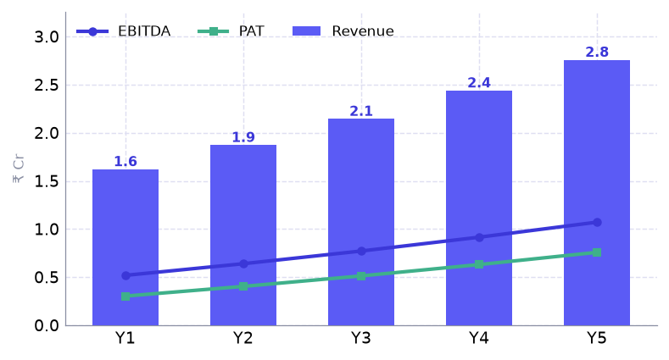

Debt Service Coverage Ratio by year
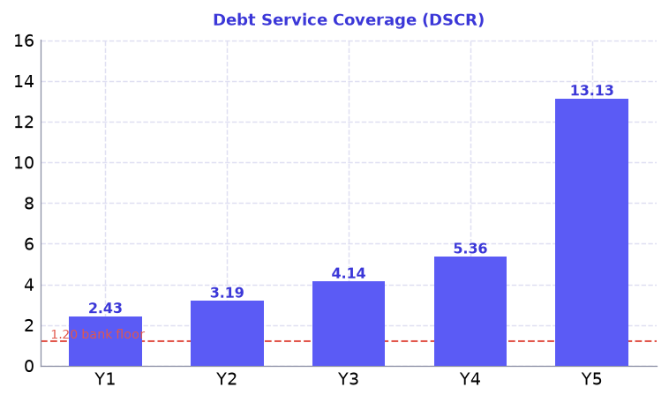

EBITDA and net profit margins by year
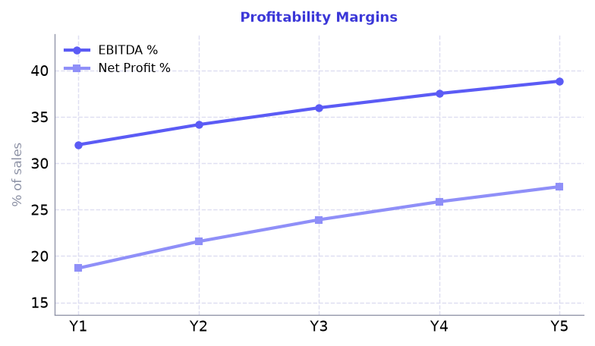

Where each rupee of Year-1 revenue goes
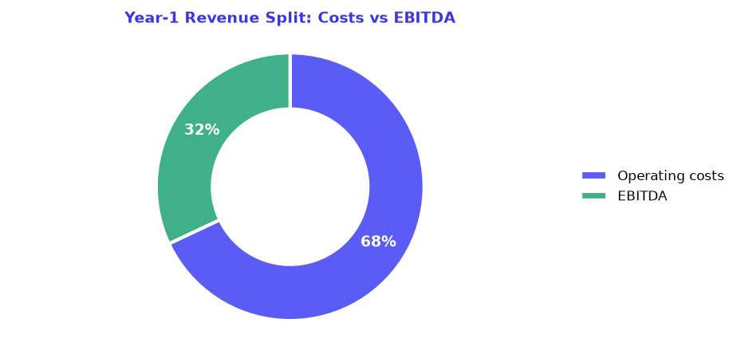

What the charts show
Revenue rises from ₹1.62 Cr in Year 1 to ₹2.76 Cr in Year 5, a +70% movement over the projection, with EBITDA and profit after tax widening alongside it.
Debt service coverage averages 5.65 times and stays above the 1.20 benchmark throughout.
Margins improve as fixed costs are spread over a larger turnover — net profit margin moves from 18.7% to 27.5% of sales.
In Year 1, 68% of every rupee of revenue is absorbed by operating costs and 32% remains as EBITDA.
Detailed month-by-month projections, the dashboard, ratios and statutory formats are provided in the accompanying Excel workbook. All figures in this report are drawn from that model.

