*User Manual*

This portion will cover vendor registration and vendor management which includes product management, vendor basic info, and order management for vendor and payment details.

***Register as vendor:***

For registration follow these steps.

Go to URL[*https://test.desiclothingonline.com/*](https://test.desiclothingonline.com/)

Navigate to the bottom of the page and click the link Register as vendor.

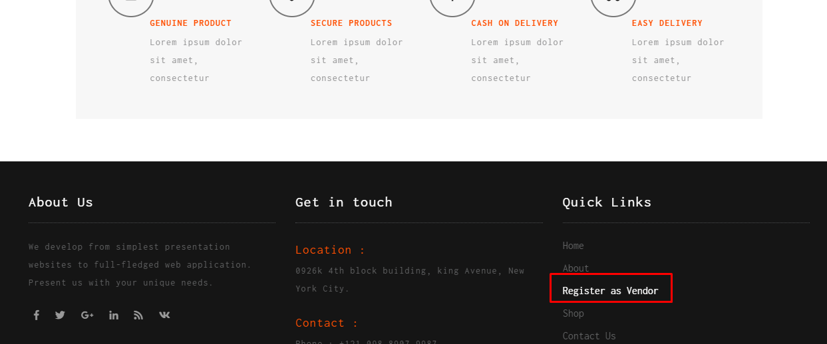

On registration page fill out the details and press submit. You will get the confirmation message.

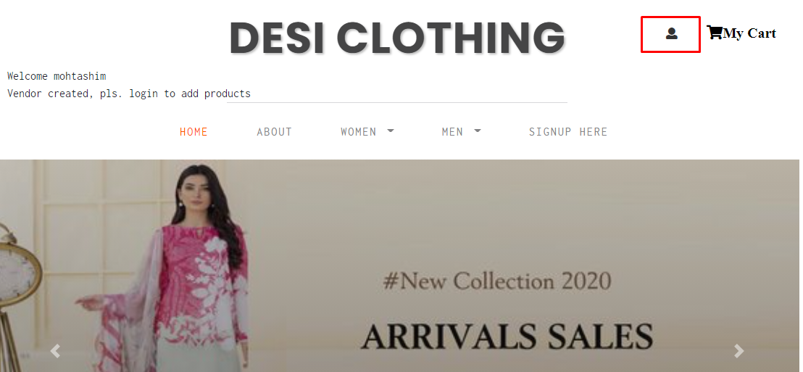

Press the login button to login to vendor area. Remember to check login as vendor checkbox.

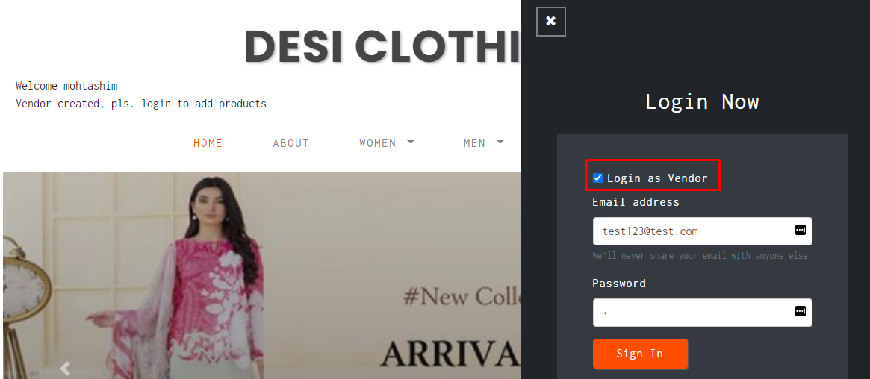

After successful login you will get the screen for vendor management.

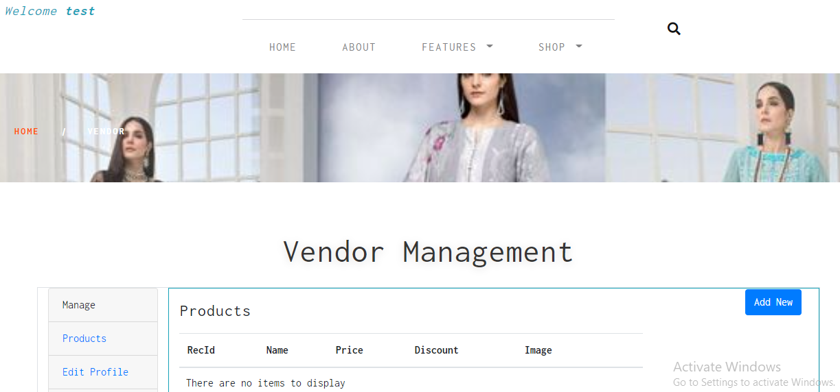

Press Add New button to add new product.

On success you will get confirmation message.

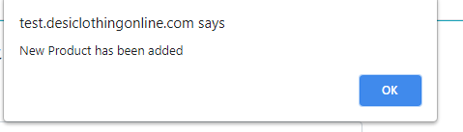

On the bottom you can add pictures for newly added product.

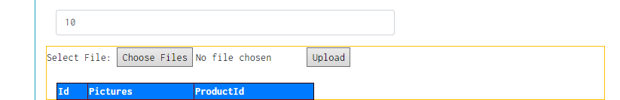

You will get confirmation of image upload. You can add more than one image.

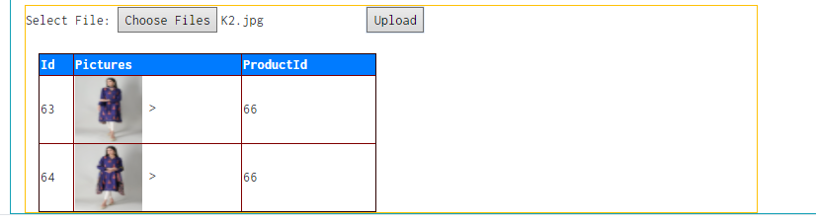

You can press cancel and go to the main product page.

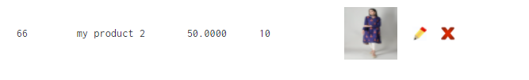

New added product will be there and new product will also be on the main page of the website.

***Order Management***

After someone purchased your product it will come to you in Orders area. Click orders in the left hand menu.

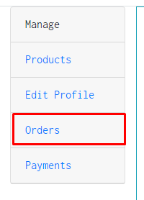

You will get all orders on the screen.

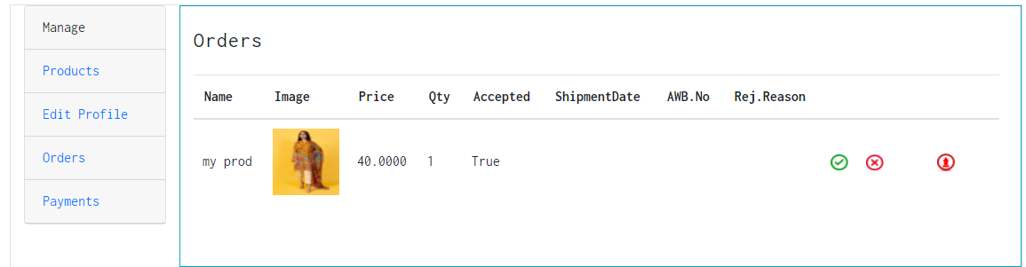

Now you can accept or reject orders and also can upload shipment prove for accepted order

To accept order press right button and enter ETA in the popup window.

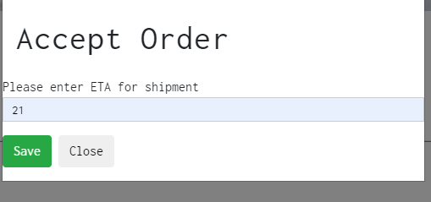

Whenever you accept the order customer will get email that they will get the product in how many days.

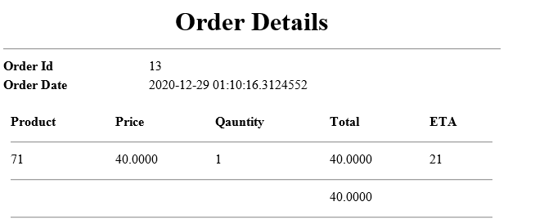

You can upload shipment product by pressing upload button and enter details regarding shipment.

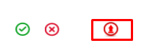

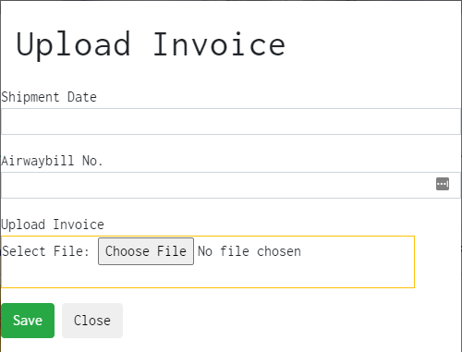

Or you can reject order by press cancel button.

