Running Token Status
Overview
The User/Patient can request the HIP for the current ongoing token number in the specific counter and the HIP can respond back with the current ongoing token number along with the average time taken to service a token number, measured in minutes by using the HIECM APIs.

Sequence Diagram
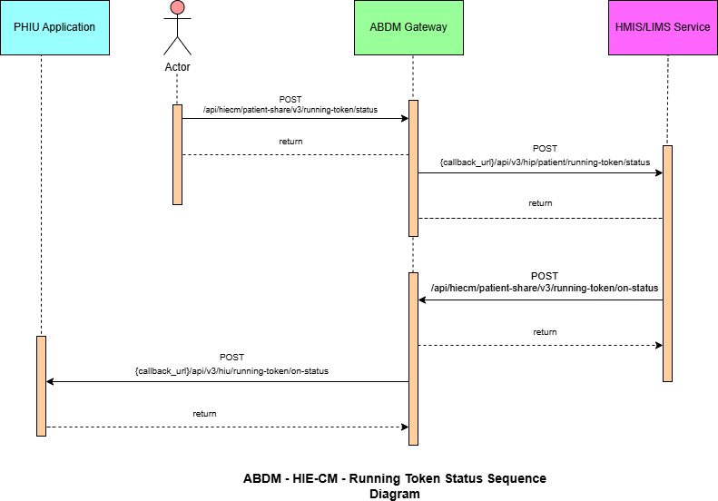

List of APIs
Running Token Status
This API will be invoked from the integrator application (any PHR application, just like ABHA) to request the HMIS/LIMS for the current running token number in the specific counter.
A patient cannot request the current running token number from the HIP if they already don’t have a token number generated for the specified counter.

URL: /api/hiecm/patient-share/v3/running-token/status
Method: POST
Request Headers:

Property Name | Example Value | Required | Description
REQUEST-ID | 18235d89-cb13-479d-ad71-  7a57d5f669a8 | Yes | Unique UUID for track the end-to- end request  transaction
TIMESTAMP | 2022-10-06T10:10:00.587Z | Yes | Actual time when request was initiated, ISO Date time format represents date and  time
Authorization | eyJhbGciOiJSUzUxMiJ9. eyJzdWIiOiJ2YXNhbnRoYWt1bWFyLmtlc2 F2  YW5Ac2J4IiwiY2xpZW50SWQiOiJz YngiLCJzeXN0ZW0iOiJBQkhBLUEiLCJy ZXF1ZXN0ZXJJZCI6IlBIUi1XRUIiL  CJwaHJNb2JpbGUiOm51bGwsImV4c CI6MTY2NzI5ODExNSwia  WF0IjoxNjY3MjkwOTE1LCJwaHJBZ GRyZXNzIjoidmFzYW50aGFrdW1hci5rZX NhdmFuQHNieCIsInR4bklkIjoi  YjEwMGM4ZDMtNTE1ZC00YWFiLTg1O | Yes | JWT Access token which was issued by ABDM session API after successful validation of client id and secret

 | WQtYzNlMTUwOTE3ZGY1In0
X-HIU-ID | IN2810014366 | Yes | Identifier of the health information user to which the request was  intended
X-CM-ID | SBX | Yes | Suffix of the consent manager to which the request was  intended
X-AUTH-TOKEN | eyJhbGciOiJSUzUxMiJ9.eyJzdWIiOiJnaXJ pamFAc2J4IiwiY2xpZW50SWQiOiJQSFItV 0VCIiwicmVxdWVzdGVySWQiOiJrX2hpc CIsInN5c3RlbSI6IkFCRE0iLCJtb2JpbGUiOi I4MjgxMTQ3MDgwIiwiZXhwIjoxNjc3NjY5N DU1LCJpYXQiOjE2Nzc2NjIyNTUsInRyYW5z YWN0aW9uSWQiOiJkMmY5OTNkNi1kOD g4LTQyMTMtOTc3My0wYmJjMzMwMjVh NGYiLCJhYmhhQWRkcmVzcyI6Imdpcml qYUBzYngifQ.Ad_jGrduH6_krBBnlRO912 mQabxMOiB0GN6FjdZjoiCQY4AkUD3Mc Gq2NR-X-GAjHVpkRtKx69m4_44h- FqTCbZlo09hq0SEM1KBMkPDl163JcFNMJ GnXBa5E-mu6DpBSPA-  VirSvBVj6CEpZLbTa2nBBSJJi_leszwHNrk  do- pe6rSc2G3SJfCW_DzFmzd_fxdvbFC- N1yyhN3Rw5r8A1GnSrVSBhRjm4qy5O_g utl1XW9CaBaZSah7GOxGRr4gpSIJJvILW ovwG58DyNzEhrHtAfIje_pegqRsNMOFI- xPYJd2x6CcDKSoAXvXO0jbuoOvlPl5khpl  OKU-WcFeWA | Yes | JWT Access token which was issued by IDP service after successfully user authentication

Body Parameters:

Property  Name | Example Value | Require  d | Description
hipId | "TEST_HIP" | Yes | The identifier of the health information  provider
context | 2 | Yes | The counter in the HMIS/LIMS for which  we request running token

Request Body:

Request Body:
{
"hipId" : "Mohan_HIP",
"context": "1"
}
Response:
Code: 202 ACCEPTED
Response:

Running Token Status – Callback
This is a callback for running token number request API call. This needs to be implemented by HMIS/LIMS at their end.

URL: {callback_url}/api/v3/hip/patient/running-token/status
Method: POST
Request Headers:

Property  Name | Example Value |  | Required |  | Description
REQUEST-ID | 18235d89-cb13- 479d-ad71-  7a57d5f669a8 |  | Yes |  | Unique UUID for track the end-to-end request transaction
TIMESTAMP | 2022-10-  06T10:10:00.587Z |  | Yes |  | Actual time when request was initiated, ISO 8601 represents date and time by starting with the year, followed by the month, the day, the hour, the minutes, seconds and  milliseconds
X-HIP-ID | IN2810014366 |  | Yes |  | Identifier of the health information provider to  which the request was intended
Authorization | eyJhbGciOiJSUzUxMi J9.  eyJzdWIiOiJ2YXNhbn RoYWt1bWFyLmtlc2F 2  YW5Ac2J4IiwiY2xpZ  W50SWQiOiJz | Yes |  | JWT Access token which was issued by ABDM session API after successful validation of client id and secret

YngiLCJzeXN0ZW0iOi JBQkhBLUEiLCJy ZXF1ZXN0ZXJJZCI6IlBI Ui1XRUIiL
CJwaHJNb2JpbGUiO m51bGwsImV4c CI6MTY2NzI5ODExNS
wia WF0IjoxNjY3MjkwOTE1 LCJwaHJBZ
GRyZXNzIjoidmFzYW 50aGFrdW1hci5rZX NhdmFuQHNieCIsInR 4bklkIjoi YjEwMGM4ZDMtNTE1Z C00YWFiLTg1O WQtYzNlMTUwOTE3Z
GY1In0

Body Parameters:

Property  Name | Example Value | Require  d | Description
hipId | "TEST_HIP" | Yes | The identifier of the health information  provider
context | 2 | Yes | The counter in the HMIS/LIMS for which  we request running token

Request Body:

Request Body:
{
"hipId" : "Mohan_HIP",
"context": "1"
}

Response:
Code: 202 Accepted
Response:

Running Token On-Status
This API will be used by the HIP to respond to the token number request by providing the current ongoing token number at the specified counter.
Additionally, the HIP can also share the average time taken to service a token number, measured in minutes.

URL: /api/hiecm/patient-share/v3/running-token/on-status
Method: POST
Request Headers:

Property Name | Example Value | Required | Description
REQUEST-ID | 18235d89-cb13-479d-ad71-  7a57d5f669a8 | Yes | Unique UUID for track the end to end  request transaction
TIMESTAMP | 2022-10-06T10:10:00.587Z | Yes | Actual time when request was initiated, ISO 8601 represents date and time by starting with the year, followed by the month, the day, the hour, the minutes, seconds  and milliseconds
Authorization | eyJhbGciOiJSUzUxMiJ9. eyJzdWIiOiJ2YXNhbnRoYWt1bWFyLmtlc2 F2  YW5Ac2J4IiwiY2xpZW50SWQiOiJz YngiLCJzeXN0ZW0iOiJBQkhBLUEiLCJy ZXF1ZXN0ZXJJZCI6IlBIUi1XRUIiL  CJwaHJNb2JpbGUiOm51bGwsImV4c CI6MTY2NzI5ODExNSwia  WF0IjoxNjY3MjkwOTE1LCJwaHJBZ GRyZXNzIjoidmFzYW50aGFrdW1hci5rZX NhdmFuQHNieCIsInR4bklkIjoi YjEwMGM4ZDMtNTE1ZC00YWFiLTg1O  WQtYzNlMTUwOTE3ZGY1In0 | Yes | JWT Access token which was issued by ABDM session API after successful validation of client id and secret

X-CM-ID | SBX | Yes | Suffix of the consent manager to which the request was  intended

Body Parameters

Property Name | Example Value | Required | Description
hipId | TEST_HIP | Yes | The identifier of the health information provider.
context | 43 | Yes | HMIS/LMIS Counter ID
runningTokenNumber | 3 | Yes | The ongoing token number  in the counter
averageTokenServiceTimeInMinutes | 5 | No | The average time taken to service a token number,  measured in minutes.
Error | "error": {  "code": "ABDM- 1234",  "message": "Failure reason"  } | No | This property should be passed if any error occurred while processing with proper error code and message.
requestId | f29f0e59-8388- 4698-9fe6-  05db67aeac46 | Yes | The request-id from the running token number  request API call.

Request Body

"token": {
"hipId": "Mohan_HIP", "context": "1",
"runningTokenNumber": "51",
"averageTokenServiceTimeInMinutes": 2
},
"response": {
{
Request Body: Success

"requestId": "86bdcfec-f335-4eb7-ad26-4c69ee608817"
}
}
}
"error": {
"code": "ABDM-1234",
"message": "Failure reason"
},
"response": {
"requestId": "86bdcfec-f335-4eb7-ad26-4c69ee608817"
}
{
Request Body: Error

Response

Code : 202 Accepted
Response:

Running Token On-Status - Callback
This is a callback for running token number request API call.

URL: {callback_url}/api/v3/hiu/running-token/on-status
Method: POST
Request Headers:

Property Name | Example Value | Required | Description
REQUEST-ID | 18235d89-cb13-479d-ad71-  7a57d5f669a8 | Yes | Unique UUID for track the end-to- end request  transaction
TIMESTAMP | 2022-10-06T10:10:00.587Z | Yes | Actual time when request was initiated, ISO 8601  represents date and

time by starting with the year, followed by the month, the day, the hour, the minutes, seconds
and milliseconds
Authorization | eyJhbGciOiJSUzUxMiJ9. eyJzdWIiOiJ2YXNhbnRoYWt1bWFyLmtlc2 F2  YW5Ac2J4IiwiY2xpZW50SWQiOiJz YngiLCJzeXN0ZW0iOiJBQkhBLUEiLCJy ZXF1ZXN0ZXJJZCI6IlBIUi1XRUIiL  CJwaHJNb2JpbGUiOm51bGwsImV4c CI6MTY2NzI5ODExNSwia  WF0IjoxNjY3MjkwOTE1LCJwaHJBZ GRyZXNzIjoidmFzYW50aGFrdW1hci5rZX NhdmFuQHNieCIsInR4bklkIjoi YjEwMGM4ZDMtNTE1ZC00YWFiLTg1O  WQtYzNlMTUwOTE3ZGY1In0 | Yes | JWT Access token which was issued by ABDM session API after successful validation of client id and secret
X-CM-ID | SBX | Yes | Suffix of the consent manager to which the request was  intended
X-HIU-ID | IN2810014366 | Yes | Identifier of the health information users to which the request was  intended

Body Parameters

Property Name | Example Value | Required | Description
hipId | TEST_HIP | Yes | The identifier of the health information provider.
context | 43 | Yes | HMIS/LMIS Counter ID
runningTokenNumber | 3 | Yes | The ongoing token number  in the counter
averageTokenServiceTimeInMinutes | 5 | No | The average time taken to service a token number,  measured in minutes.
Error | "error": { | No | This property should be  passed if any error occurred

 | "code": "ABDM- 1234",  "message": "Failure reason"  } |  | while processing with proper error code and message.
requestId | f29f0e59-8388- 4698-9fe6-  05db67aeac46 | Yes | The request-id from the running token number  request API call.

Request Body

}
"token": {
"hipId": "Mohan_HIP", "context": "1",
"runningTokenNumber": "51",
"averageTokenServiceTimeInMinutes": 2
},
"response": {
"requestId": "86bdcfec-f335-4eb7-ad26-4c69ee608817"
}
{
Request Body: Success
}
"error": {
"code": "ABDM-1234",
"message": "Failure reason"
},
"response": {
"requestId": "86bdcfec-f335-4eb7-ad26-4c69ee608817"
}
{
Request Body: Error

Response:
Code : 202 Accepted
Response:

Error Codes Listing

Code | Message
ABDM-1065 | Invalid X Auth token
ABDM-1031 | No tokens found for the abha address today
ABDM-1040 | Invalid HIU ID
ABDM-1015 | Request Timed out

