SANDBOX DOCUMENTATION
(ABDM_SCAN & SHARE)
Version 1.0
regCreated on 03.03.2025

- Base URL and X-CM-ID 3
- Terminology Definition 3
- Gateway 3
  - Overview 3
  - List of APIs 3
    - Auth token API 3
    - OpenID Configuration API 5
    - Keycloak Certificate API 6
    - Update bridge URL API 9
    - Registration of Facility & Software Linkage 10
    - Find bridge by service id 12
    - Find services by bridge id 14
- Scan and Profile Share 16
  - Overview 16
  - Sequence Diagram 17
  - List of APIs 17
    - Profile share 17
    - Profile share – Callback 21
    - Profile on-share 25
    - Profile on share – Callback 27
  - Scan and Record Share 29
    - Overview 29
    - Sequence Diagram 30
    - Record share 30
    - Record share - Callback 33
    - Record on-share 36
    - Record on-share – Callback 38
  - Scan and Pay 41
    - Overview 41
    - Sequence Diagram 41
    - List of APIs 41
- Error Codes Listing 53

Base URL and X-CM-ID
Environment | Base URL | X-CM-ID
Sandbox | https://dev.abdm.gov.in | Sbx
Production | https://apis.abdm.gov.in | Abdm

Terminology Definition:
Bridge ID: Is client ID which provided by NHA to HIP (Its alphanumerical eg: SBX_00XXXX)
Service ID: Is Facility ID which is generated from NHPR application (Its alphanumeric eg: IN02100000XX)

Gateway

Overview
This is the key ABDM building block that manages ABHA addresses, maintains links to health data for each ABHA address and manages consents provided by the user for sharing of their health data. It also supports exchange of interoperable health data between HIPs and HIUs. The HIE-CM enables exchange of personal health data with consent as per the Health Data Management Policy issued by NHA.

List of APIs

Auth token API
This API will be invoked to generate auth token.

URL: /api/hiecm/gateway/v3/sessions
Request: POST

Header Parameters:
Property Name | Example Value | Required | Description
REQUEST-ID | 18235d89-cb13-479d-ad71-  7a57d5f669a8 | Yes | Unique UUID for tracking the end-toend request transaction
TIMESTAMP | 2022-10-06T10:10:00.587Z | Yes | The actual time when the request was initiated, ISO Date time format represents the date and time

X-CM-ID | Sbx | Yes | Suffix of the consent manager to which the request was intended.

Body Parameters:
Property Name | Example Value | Required | Description
clientId | SBX_XXXXXX | Yes | Client id for authentication
clientSecret | “XXXXXXXXXXXXX” | Yes | Client secret for authentication
grantType | client_credentials | Yes | Grant type for authentication

Request Body:
Request Body
{
"clientId": "SBX_XXXXX",
"clientSecret": "XXXX-XXX-XXXX-XXXX-XXXXXXX",
"grantType": "client_credentials"
}

Response:

Response
Code : 202 Accepted

{

"accessToken":
"eyJhbGciOiJSUzI1NiIsInR5cCIgOiAiSldUIiwia2lkIiA6ICJBbFJiNVdDbThUbTlFSl9JZk85ejA2ajlvQ3Y1MXBLS
0ZrbkdiX1RCdkswIn0.eyJleHAiOjE3MjMyMjU3MTEsImlhdCI6MTcyMzIyNDUxMSwianRpIjoiMzE3MjVkN2Qt NmM1Mi00OWE0LTk0M2MtZmY2ZjhkNjNhYmRlIiwiaXNzIjoiaHR0cHM6Ly9kZXYubmRobS5nb3YuaW4vYX V0aC9yZWFsbXMvY2VudHJhbC1yZWdpc3RyeSIsImF1ZCI6ImFjY291bnQiLCJzdWIiOiJjN2NhMjk3Yi0yZTVh LTRkN2UtOGY5YS0xYWU2NDAxYWQ0Y2YiLCJ0eXAiOiJCZWFyZXIiLCJhenAiOiJTQlhfMDAwMTM1Iiwic2Vzc
2lvbl9zdGF0ZSI6IjhiYjQ4ZGM5LTJmMDUtNDA0OC05MGUxLWRjYjgxNWRmOGU5MyIsImFjciI6IjEiLCJhbGx vd2VkLW9yaWdpbnMiOlsiaHR0cDovL2xvY2FsaG9zdDo5MDA3Il0sInJlYWxtX2FjY2VzcyI6eyJyb2xlcyI6W yJIaWRJbnRlZ3JhdGVkUHJvZ3JhbSIsIkhJVV9QQVlFUiIsImhmciIsImhpdSIsIm9mZmxpbmVfYWNjZXNzIi wiaGVhbHRoSWQiLCJwaHIiLCJPSURDIiwiaGVhbHRoX2xvY2tlciIsImhpcCIsImhwX2lkIl19LCJyZXNvdXJjZV 9hY2Nlc3MiOnsiU0JYXzAwMDEzNSI6eyJyb2xlcyI6WyJ1bWFfcHJvdGVjdGlvbiJdfSwiYWNjb3VudCI6eyJy
b2xlcyI6WyJtYW5hZ2UtYWNjb3VudCIsIm1hbmFnZS1hY2NvdW50LWxpbmtzIiwidmlldy1wcm9maWxlIl19f Swic2NvcGUiOiJvcGVuaWQgZW1haWwgcHJvZmlsZSIsImNsaWVudEhvc3QiOiIxMDAuNjUuMTYwLjIxNCI
sImNsaWVudElkIjoiU0JYXzAwMDEzNSIsImVtYWlsX3ZlcmlmaWVkIjpmYWxzZSwicHJlZmVycmVkX3VzZXJ uYW1lIjoic2VydmljZS1hY2NvdW50LXNieF8wMDAxMzUiLCJjbGllbnRBZGRyZXNzIjoiMTAwLjY1LjE2MC4yMTQi
fQ.L56AYZYfzFrO_gNedAbSwR9foEO661z2cMGEeOKsz2ZXsIpTb9oLd9fmRiixIS7ToGoW2VzzXC14qrXnwZIqknBZchTRJrmyGk6iRJ NQYR4k12hrn4tbdW- h5e9m4NWFAvPtGbBUyKA8gotrne9fn7T0MOC7N_J8TS3JLr2gothJSgc9P3VDKm8c6zpAObQPmwEpH qJH6j2Q07nGsoaBygxovoIeFn6G6zwIa-_mKw_a86L_CYxr8Gxw5-
5PXkh2XwYp_xLIiJ3t7vLM97UFThwSn_TmRF6W1LH145m_6NxY4hQclHi1elK3OP4LvR1SLDwtAQZSCm4Jpihd0uMw", "expiresIn": 1200,
"refreshExpiresIn": 1800,

"refreshToken":
"eyJhbGciOiJIUzI1NiIsInR5cCIgOiAiSldUIiwia2lkIiA6ICIyMWU5NzA4OS00ZTcxLTQyNGEtOTAzYS1jOTAyMW M1NmFlNWYifQ.eyJleHAiOjE3MjMyMjYzMTEsImlhdCI6MTcyMzIyNDUxMSwianRpIjoiZGY5ODdmYzQtYzdk Ni00OGNmLTliM2EtNzRmNWVkMTljMmNmIiwiaXNzIjoiaHR0cHM6Ly9kZXYubmRobS5nb3YuaW4vYXV0a C9yZWFsbXMvY2VudHJhbC1yZWdpc3RyeSIsImF1ZCI6Imh0dHBzOi8vZGV2Lm5kaG0uZ292LmluL2F1dGg vcmVhbG1zL2NlbnRyYWwtcmVnaXN0cnkiLCJzdWIiOiJjN2NhMjk3Yi0yZTVhLTRkN2UtOGY5YS0xYWU2ND AxYWQ0Y2YiLCJ0eXAiOiJSZWZyZXNoIiwiYXpwIjoiU0JYXzAwMDEzNSIsInNlc3Npb25fc3RhdGUiOiI4YmI0O GRjOS0yZjA1LTQwNDgtOTBlMS1kY2I4MTVkZjhlOTMiLCJzY29wZSI6Im9wZW5pZCBlbWFpbCBwcm9maWx lIn0._cOnTXMf2bObS1nySL-AjvM5PQxgCHJRm2oO66nrx1M",

"tokenType": "bearer"

}

OpenID Configuration API
Openid-configuration API, defined within OpenID Connect which provides configuration information about the Identity Provider (IDP).
URL: /api/hiecm/gateway/v3/.well-known/openid-configuration
Request: GET

Header Parameters:

Property Name | Example Value | Required | Description
REQUEST-ID | 18235d89-cb13-479d-ad71-  7a57d5f669a8 | Yes | Unique UUID for tracking the end-toend request transaction
TIMESTAMP | 2022-10-06T10:10:00.587Z | Yes | The actual time when the request was initiated, ISO Date time format represents the date and time
X-CM-ID | Sbx | Yes | Suffix of the consent manager to which the request was intended.

Response

Response
Code : 202 OK
{

"jwks_uri": "https://dev.abdm.gov.in/api/hiecm/gateway/v3/certs"

}

Keycloak Certificate API
In response to open ID configuration API, Keycloak, the open-source identity provider, provides an OAuth certificate that can be used with open source authentication requests for certificates.
URL: /api/hiecm/gateway/v3/certs
Request: GET

Header Parameters:
Property Name | Example Value | Required | Description
REQUEST-ID | 18235d89-cb13-479d-ad71-  7a57d5f669a8 | Yes | Unique UUID for tracking the end-toend request transaction
TIMESTAMP | 2022-10-06T10:10:00.587Z | Yes | The actual time when the request was initiated, ISO Date time format represents the date and time
X-CM-ID | Sbx | Yes | Suffix of the consent manager to which the request was intended.

Response

Response
Code : 202 OK
{

"keys": [

{

"e": "AQAB",

"kid": "AlRb5WCm8Tm9EJ_IfO9z06j9oCv51pKKFknGb_TBvK0", "kty": "RSA",
"n": "mgmW7W5ZGF_G5cJevwYi8HiPcI-6qS_psnZxa4v3bkwAkyOoOd8-6ketrOI-
ZA2PbRbGnxFfZHiI94rdFXJ4Q9ampscsz9NocTIPMPmWydJ8A50pZaYWyikYDSJiDltq7i3WspPKSOuQHrC 5h9dMcCVveX5oeg0tO68Z79gwDlpcxiqDbFaphsqDvx-
5XkfwiqvOBaybK6_BCBPuTqWMUEuUklLYXu2X7ESHdVNFMFAjxCcCXUtP7LFdvT3nnFekRmG82QbSQSVe
4N5tPH8q0MCxSWWn2c15bDnzOF-dvfRCVPRabCzw0M-utHR9diTrWtq6Koi5buxgwM1rbk0p8Q", "use": "sig",
"x5c": [

"MIICrzCCAZcCBgFy/3WZBjANBgkqhkiG9w0BAQsFADAbMRkwFwYDVQQDDBBjZW50cmFsLXJlZ2lzdHJ5 MB4XDTIwMDYyOTA5NDEzNloXDTMwMDYyOTA5NDMxNlowGzEZMBcGA1UEAwwQY2VudHJhbC1yZWdpc
3RyeTCCASIwDQYJKoZIhvcNAQEBBQADggEPADCCAQoCggEBAJoJlu1uWRhfxuXCXr8GIvB4j3CPuqkv6b
J2cWuL925MAJMjqDnfPupHraziPmQNj20Wxp8RX2R4iPeK3RVyeEPWpqbHLM/TaHEyDzD5lsnSfAOdKWW mFsopGA0iYg5bau4t1rKTykjrkB6wuYfXTHAlb3l+aHoNLTuvGe/YMA5aXMYqg2xWqYbKg78fuV5H8Iqrzg WsmyuvwQgT7k6ljFBLlJJS2F7tl+xEh3VTRTBQI8QnAl1LT+yxXb0955xXpEZhvNkG0kElXuDebTx/KtDAsUllp9

nNeWw58zhfnb30QlT0Wmws8NDPrrR0fXYk61rauiqIuW7sYMDNa25NKfECAwEAATANBgkqhkiG9w0BAQs FAAOCAQEACkC3TijrXIgi4vn+l1uL1nfdK6vOIL5UZ6yCjSOq7zYW6b3Qe8j7NrPb9RJC+pbIERyNbB+t9hsa5 g1L7lkjCNlUuxfJprsJ9LJKlM5g7dYEA6XPCJ7C6AVlarj72vlWXQvwjnQMO2/CM9/Jp5Hnv2Qwjn7NME2OW M0iblc/TD+DEZK5L5mlWMyuBSQo2o/AcOmfG4MoE5Gm/CaOJ47rSrf+lq83e5+dyKh7uLVAa+5WK8Im 5nEs6BLSGyo2KlaV0mW9yCkoRLLbipjH8+rJwkUU6iu7QVjz0peGZzYldya5n35gMWH7Bu4HqFneKNRww
D6w8rGNC+uWtgWejDZ3yQ=="

],

"x5t": "EaMhYGUIvMkp8tvSM3QoaqaF8xM",

"x5t2": "vGer6Pt8AhZn8RlbHhAFksOCcGf3u1UWU7Qq-Doy7ro", "alg": "RS256"
},

{

"e": "AQAB",

"kid": "oc-l6O1yJ7wJKYEeyeUafsz3Aecq7YnCIqbzbIfkJk8", "kty": "RSA",
"n":
"jDOehgMzurNQT0WJCTWN6a34639uIKOLO1LnXZes_kTakWh6iRxmkExLLCD7MJjz9aijTHwIuKAtOCSbFO pwbqSfF6dMBS2c8cv0AU3pE8kSMpGJKDZ9diA-BuUriwr9BUYSUW8SM68QH_HCaz2mmN_Z8ynTQ4kWw_Idj-enVpkHYtq00DriG98l6RXF1Ao9Kd16ctoNbthuQYH0RSRIXnt0Qtm4GSAY7abPCNa64mir0auldU72DJHXwDo6g5OGz6E Mm86ZAV_pvh_5YzFpfkUA8TK2LFVAmC3Up- IMxv0yMMKFZjkFGA0QKYMkMTC5ruLaE7cec-njA7dJQnQ",

"use": "sig", "x5c": [

"MIICrzCCAZcCBgGHxvQVmDANBgkqhkiG9w0BAQsFADAbMRkwFwYDVQQDDBBjZW50cmFsLXJlZ2lzdHJ 5MB4XDTIzMDQyODA4MTk1N1oXDTMzMDQyODA4MjEzN1owGzEZMBcGA1UEAwwQY2VudHJhbC1yZWdpc
3RyeTCCASIwDQYJKoZIhvcNAQEBBQADggEPADCCAQoCggEBAIwznoYDM7qzUE9FiQk1jemt+Ot/biCjiztS 512XrP5E2pFoeokcZpBMSywg+zCY8/Woo0x8CLigLTgkmxTqcG6knxenTAUtnPHL9AFN6RPJEjKRiSg2fXYg PgblK4sK/QVGElFvPkjOvEB/xwms9ppjf2fMp00OJFsPyHY/np1aZB2LatNA64hvfJekVxdQKPSndenLaDW7Y bkGB9EUkSF57dELZuBkgGO2mzwjWuuJoq9PmrpXVPu9gyR18A6OoOThs+hDJvOmQFf6b4f+WMxaX5FA PEytixVQJgt1KfiDMb9MjDChWY5BRgNECmDJDEwua7i2hO3HnPp4wO3SUJ0CAwEAATANBgkqhkiG9w0B AQsFAAOCAQEABYAcXOSr+WgOxKVmygID9WjB4rDuAVDyU3GmjBvckdWhYJuBX8Vs04hNVNgf904gqy
+D5wZIQU985stK3PdogFGN2jVw2kO9G3hG4/7uwYKqciKApT/pSPMeHRltHGp/Mwr6e5poVwgQyrn+Be H373U1Q6eB1QUYnElP+16y7bbvQhfDAS2X9sqdfurB9YIL5xZMPddZaf7pPX8oWOVlB0XH1JEZfsX125qq0Xn K8z/Rd8KI8zTfJw6D2Kzrk1WvQSlM5KnTQmcSk3kwDlW5Dg657dT49Y68mI4azq34q17JgBhTx3IbTuf94QT w7QC5wmFtO+hc6zPVODX8JWu7sQ=="

],

"x5t": "-HZ-fkkNBhTsPHWrhATwlZflhdU",

"x5t2": "tjVDNCTx7Fn0TfM-6uHvbwjWlIxIaFtGxiZZ6uJFxr4", "alg": "RS512"
}

]

}

Update bridge URL API
This API will be called to update the bridge base URL.

URL: /api/hiecm/gateway/v3/bridge/url
Request: PATCH

Header Parameters:
Property Name | Example Value | Required | Description
Authorization | eyJhbGciOiJSUzUxMiJ9. eyJzdWIiOiJ2YXNhbnRoY Wt1bWFyLmtlc2F2YW5Ac 2J4IiwiY2xpZW50SWQiOi JzYngiLCJzeXN0ZW0iOiJ  BQkhBLUEiLCJyZXF1ZXN0Z XJJZCI6IlBIUi1XRUIiLCJwa  HJNb2JpbGUiOm51bGws | Yes | JWT Access token which was issued by ABDM session API after successful validation of client id and secret.
REQUEST-ID | 18235d89-cb13-479dad71-  7a57d5f669a8 | Yes | Unique UUID for tracking the end-to-end request transaction
TIMESTAMP | 2022-10-  06T10:10:00.587Z | Yes | The actual time when the request was initiated, ISO Date time format represents the date and time
X-CM-ID | sbx | Yes | Suffix of the consent manager to which the request was intended.

Body Parameters:
Property Name | Example Value | Required | Description
url | https://webhook.site/b7 99c0b8-4e75-4545- 8eb2-  d8c2d5f0c9f6 | Yes | Bridge base URL

Request Body:
Request Body
{
"url": "https://webhook.site/b799c0b8-4e75-4545-8eb2-d8c2d5f0c9f6"
}

Response:

Response
Code : 202 Accepted

Registration of Facility & Software Linkage
Overview: The software being used by the provider must integrate with the digital building blocks of ABDM and comply with the guidelines outlined NHA. NHA maintains the national directory of all healthcare facilities. Any participating facility needs to sign up in the health facility registry at (nhpr.abdm.gov.in) This ensures that they are a valid facility which is authorized to issue health records in the ecosystem. HFR consists of information for each healthcare facility in the country – hospitals, clinics, diagnostic centers, pharmacies etc., across all systems of medicine and covering both public and private health facilities. HFR offers APIs that can be used by various stakeholders in the ecosystem. Healthcare information service provider application or healthcare repository provider application must be upgraded to become ABDM compliant.

Registration of facility:

Through website: https://hspsbx.abdm.gov.in/home (sandbox) , https://nhpr.abdm.gov.in/home (production) Step-by-step user manual document access:
Goto: https://hspsbx.abdm.gov.in/home (sandbox) , https://nhpr.abdm.gov.in/home (production)
>>Resource center >> User Manual
>> Select “For Health Fecility” >>Download “User Manual” >>Refer Content

“A” (Health Professional ID (HPID) creation), “B” (Facility Registration) Registration of bridge services (HIP/HIU) on facility:

Option 1: Linking through website: https://hspsbx.abdm.gov.in/home (sandbox) , https://nhpr.abdm.gov.in/home (production) Step-by-step user manual document access:
Goto: https://hspsbx.abdm.gov.in/home (sandbox) , https://nhpr.abdm.gov.in/home (production) >>Resource center >> User Manual >> Select “For Health Facility”
>>Download “User Manual” >>Refer Content “C” (Software Linkage).

Option 2: Through API This API ( https://facilitysbx.abdm.gov.in/v1/bridges/MutipleHRPAddUpdateServi ces ) will be used to link multiple bridges against a facility. It will accept the facility id , facility name and list of HRP i.e. bridges.
Please note:
- You must pass in all the required parameters to create the API.
- The data needs to be passed in the required format as mentioned for each field. API can refer swagger link :
https://facilitysbx.abdm.gov.in/swaggerui.html#/Multiple_HRP_API >>>Go to Multi HRP API >>>and Select
“/v1/bridges/MutipleHRPAddUpdateServices v1MutipleHRPAddUpdateServices”

Parameters:
Params | Required | Description | Data type | Format if any
facilityId | Yes | Will be validated if present in HFR or not | String | Starting with IN and of 12  characters
facilityName | Yes | Name of the facility to be linked | String | Alphanumeric
bridgeId | Yes | Valid Bridge Id to be linked. | String | Alphanumeric and validity to be checked by HIECM

hipName | Yes | - To provide uniqueness against each bridges that is linked . HIP  name is the | String | - HIP name can be the Hospital name added
bridgeName |  | name of the hospital which will reflect |  | with suffix of bridge name. example
 |  | on ABHA/PHR app when the patent will search for the respective hospital. |  | Hospital  name=XYZ and bridge name  =BRIDGE TEST, so  the HIP name = XYZ BRIDGE.  - HIP name can not be more than 15  characters., No special  character is allowed  (%$*#@(~&!), and it should be unique for every  bridge for a facility
type | Yes | HIP / HIU etc | String | Validated by HIECM
Active | Yes | True/false | boolean | Accept Boolean value

Find bridge by service id
This API will fetch the bridge details for the given service id.

URL: /api/hiecm/gateway/v3/bridge-service/serviceId/{serviceId}
Request: GET

Header Parameters:
Property Name | Example Value | Required | Description
Authorization | eyJhbGciOiJSUzUxMiJ9. eyJzdWIiOiJ2YXNhbnRoY Wt1bWFyLmtlc2F2YW5Ac 2J4IiwiY2xpZW50SWQiOi JzYngiLCJzeXN0ZW0iOiJ  BQkhBLUEiLCJyZXF1ZXN0Z XJJZCI6IlBIUi1XRUIiLCJwa  HJNb2JpbGUiOm51bGws ImV4cCI6MTY2NzI5ODEx  NSwiaWF0IjoxNjY3MjkwO  TE1LCJwaHJBZGRyZXNzIjo  idmFzYW50aGFrdW1hci5 rZXNhdmFuQHNieCIsInR 4bklkIjoiYjEwMGM4ZDMt NTE1ZC00YWFiLTg1OWQtY zNlMTUwOTE3ZGY1In0 | Yes | JWT Access token which was issued by ABDM session API after successful validation of client id and secret.
REQUEST-ID | 18235d89-cb13-479dad71-  7a57d5f669a8 | Yes | Unique UUID for tracking the end-to-end request transaction
TIMESTAMP | 2022-10-  06T10:10:00.587Z | Yes | The actual time when the request was initiated, ISO Date time format represents the date and time
X-CM-ID | sbx | Yes | Suffix of the consent manager to which the request was intended.

Response:

Response
Code : 200 Ok
{
"id": 1561,
"bridgeId": "SBX_XXXX", "serviceId": "TestClinicHIP", "name": "TestClinicHIP",
"isHip": true,
"isHiu": true, "isPhr": false,
"endpoints": {}, "active": true,
"registerTime": "2021-03-01 11:17:35.1735",
"dateCreated": "2021-03-01 11:17:35.1735",

"dateModified": "2024-04-22 11:04:46.446"
}

Find services by bridge id
This API will fetch all the service ID details linked with the respective bridge id.

URL: /api/hiecm/gateway/v3/bridge-services
Request: GET

Header Parameters:
Property Name | Example Value | Required | Description
Authorization | eyJhbGciOiJSUzUxMiJ9. eyJzdWIiOiJ2YXNhbnRoY Wt1bWFyLmtlc2F2YW5Ac 2J4IiwiY2xpZW50SWQiOi JzYngiLCJzeXN0ZW0iOiJ  BQkhBLUEiLCJyZXF1ZXN0Z XJJZCI6IlBIUi1XRUIiLCJwa  HJNb2JpbGUiOm | Yes | JWT Access token which was issued by ABDM session API after successful validation of client id and secret.
REQUEST-ID | 18235d89-cb13-479dad71-  7a57d5f669a8 | Yes | Unique UUID for tracking the end-to-end request transaction
TIMESTAMP | 2022-10-  06T10:10:00.587Z | Yes | The actual time when the request was initiated, ISO Date time format represents the date and time
X-CM-ID | sbx | Yes | Suffix of the consent manager to which the request was intended.

Response:

Response
Code : 200 Ok
{
"bridge": {
"id": "SBX_XXXX",
"name": "Testing",
"url": "https://abdcb.doctor9.com", "active": true,
"blocklisted": false
},
"services": [

{
"id": "@#$%^&*(",
"name": "hello", "types": [
"HIP", "HIU"
],
"endpoints": { "hipEndpoints": [
{
"use": "registration",
"connectionType": "HTTPS", "address":
"https://events.hookdeck.com/e/src_3gsnEgI941mh/registration"

},
{
"use": "data-upload",
"connectionType": "HTTPS", "address":
"https://events.hookdeck.com/e/src_3gsnEgI941mh/data-upload"
}
],
"hiuEndpoints": [
{
"use": "registration",
"connectionType": "HTTPS", "address":
"https://events.hookdeck.com/e/src_3gsnEgI941mh/registration"
},
{
"use": "data-upload",
"connectionType": "HTTPS", "address":
"https://events.hookdeck.com/e/src_3gsnEgI941mh/data-upload"
}
],
"healthLockerEndpoints": [
{
"use": "registration",
"connectionType": "HTTPS", "address":
"https://events.hookdeck.com/e/src_3gsnEgI941mh/registration"
},
{
"use": "data-upload",
"connectionType": "HTTPS", "address":
"https://events.hookdeck.com/e/src_3gsnEgI941mh/data-upload"
}
]
},
"active": true
}

]
}

Scan and Profile Share

Overview
The User/Patient can share his/her basic KYC information with the
HMIS/LIMS by scanning the QR Code using the integrator application (Example: ABHA App), which enables them to complete the seamless profile share during their visit.
The authenticity of the profile information is verified by the HIE-CM internally before sharing with the HMIS/LIMS.

The content of the QR code is a URL (sample for reference: https://phrsbx.abdm.gov.in/share-
profile?hipid=IN3410000260&counterid=12345) that contains 2 parameters:
- The HIP ID
- Facility defined context (for example: counter code)

Sequence Diagram
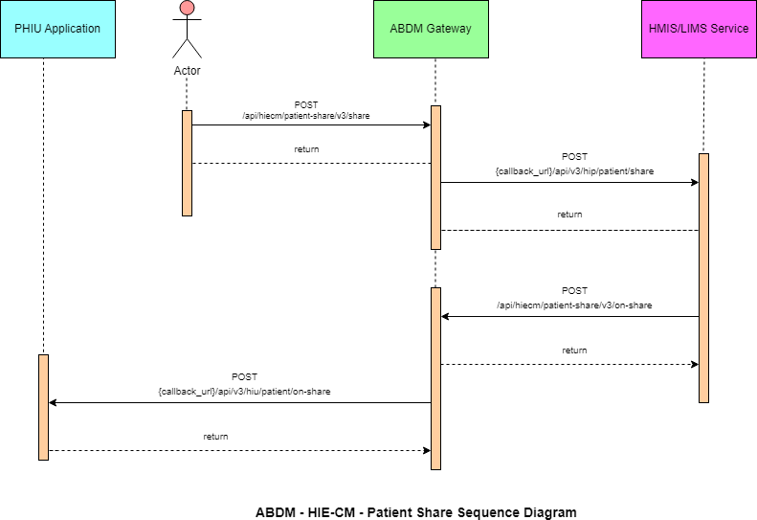

List of APIs

Profile share
This API will be invoked from the integrator application (any PHR application, just like ABHA) to share the user/patient profile with HMIS/LIMS.

URL: /api/hiecm/patient-share/v3/share
Method: POST

Request Headers:

Property Name | Example Value | Required | Description
REQUEST-ID | 18235d89-cb13-479d-ad71-  7a57d5f669a8 | Yes | Unique UUID for track the end to end request  transaction

TIMESTAMP | 2022-10-06T10:10:00.587Z | Yes | Actual time when request was initiated, ISO Date time format represents date and time
Authorizatio n | eyJhbGciOiJSUzUxMiJ9. eyJzdWIiOiJ2YXNhbnRoYWt1bWFyLmtlc 2F2 YW5Ac2J4IiwiY2xpZW50SWQiOiJz  YngiLCJzeXN0ZW0iOiJBQkhBLUEiLCJy ZXF1ZXN0ZXJJZCI6IlBIUi1XRUIiL  CJwaHJNb2JpbGUiOm51bGwsImV4c CI6MTY2NzI5ODExNSwia  WF0IjoxNjY3MjkwOTE1LCJwaHJBZ  GRyZXNzIjoidmFzYW50aGFrdW1hci5rZX NhdmFuQHNieCIsInR4bklkIjoi  YjEwMGM4ZDMtNTE1ZC00YWFiLTg1O WQtYzNlMTUwOTE3ZGY1In0 | Yes | JWT Access token which was issued  by ABDM session API after successful  validation of client id and secret
X-HIU-ID | IN2810014366 | Yes | Identifier of the health information user to which the request was intended
X-CM-ID | sbx | Yes | Suffix of the consent manager to which the request was intended
X-AUTH-TOKEN | eyJhbGciOiJSUzUxMiJ9.eyJzdWIiOiJna XJpamFAc2J4IiwiY2xpZW50SWQiOiJQS FItV0VCIiwicmVxdWVzdGVySWQiOiJrX 2hpcCIsInN5c3RlbSI6IkFCRE0iLCJtb2Jp bGUiOiI4MjgxMTQ3MDgwIiwiZXhwIjoxNj  c3NjY5NDU1LCJpYXQiOjE2Nzc2NjIyNTUs  InRyYW5zYWN0aW9uSWQiOiJkMmY5O TNkNi1kODg4LTQyMTMtOTc3My0wYmJj MzMwMjVhNGYiLCJhYmhhQWRkcmVzc yI6ImdpcmlqYUBzYngifQ.Ad_jGrduH6  _krBBnlRO912mQabxMOiB0GN6FjdZjoi  CQY4AkUD3McGq2NR-X- GAjHVpkRtKx69m4_44h- | Yes | JWT Access token which was issued by IDP service after successfully user authenticatio n

FqTCbZlo09hq0SEM1KBMkPDl163JcFNM JGnXBa5E-mu6DpBSPA-
VirSvBVj6CEpZLbTa2nBBSJJi_leszwHNr
kdope6rSc2G3SJfCW_DzFmzd_fxdvbFCN1yyhN3Rw5r8A1GnSrVSBhRjm4qy5O
_ gutl1XW9CaBaZSah7GOxGRr4gpSIJJvIL WovwG58DyNzEhrHtAfIje_pegqRsNMO FI-
xPYJd2x6CcDKSoAXvXO0jbuoOvlPl5kh plOKU-WcFeWA

Body Parameters:

Property Name | Example Value | Require d | Description
intent | "PROFILE_SHARE" | Yes | This is a key value pair which contains the purpose with following possible values.  Profile_share Payment  Health_record_sharing
metaData | {  "hipId": "Test_HIP", "context": "ABC123", "hprId":  "abdulkalam@abdm", "latitude": "-38.679",  "longitude": "58.498" } | Yes | This is a key value pair which contains the location longitude and latitude.  hipId:- healthInformationProviderId context:- counterCode  hprId:- healthprofessionalregisterId

profile | {  "patient": {  "abhaNumber": 18443810806111,  "abhaAddress": "1844381@abdm",  "name": "User 1",  "gender": "M",  "dayOfBirth": "20",  "monthOfBirth": "1",  "yearOfBirth": "1999", "address": { "line":  "C/O  Sandipan Kshirsagar Ambejogai Road Renuka Nagar Latur",  "district": null, "state": null, "pincode": null ,  }  "phoneNumber": "9876543210"  }  } | Yes | This is key value pair which contains patient details

Request Body

Request Body:

{
"intent": "PROFILE_SHARE",
"metaData": {
"hipId": "MAYUR_HIP",
"context": "ABC123",
"hprId": "abdulkalam@abdm", "latitude": "-38.679",
"longitude": "58.498"
},
"profile": {
"patient": {
"abhaNumber": 91178386101251, "abhaAddress": "9117838@sbx", "name": "User 1",
"gender": "M",
"dayOfBirth": "10",
"monthOfBirth": "10",
"yearOfBirth": "1994", "address": {
"line": "C/O Sandipan Kshirsagar Ambejogai Road Renuka Nagar", "district": null,
"state": null, "pincode": null
},
"phoneNumber": "9876543210"
}
}
}

Response

Response:
Code: 202 ACCEPTED

Profile share – Callback
This is a callback API for patient share API.

URL: {callback_url}/api/v3/hip/patient/share
Method: Post

Request Headers:

Property Name | Example Value | Required | Description

REQUEST-ID | 18235d89-cb13-  479d-ad717a57d5f669a8 | Yes | Unique UUID for track the end to end request transaction
TIMESTAMP | 2022-10-  06T10:10:00.587Z | Yes | Actual time when request was initiated, ISO 8601 represents date and time by starting with the year, followed by the month, the day, the hour, the minutes, seconds and milliseconds
X-HIP-ID | IN2810014366 | Yes | Identifier of the health information provider to which the request was intended

Body parameters

Property Name | Example Value | Required | Description
intent | PROFILE_SHARE | Yes | This is a key value pair which contains the purpose with following possible values.  Profile_share Payment  Health_record_sharing
metaData | "metaData": {  "hipId": "MAYUR_HIP",  "context": "ABC123", "hprId": "abdulkalam@abdm",  "latitude": "-38.679",  "longitude": "58.498"  } | Yes | This is a key value pair which contains the location longitude and latitude. hipId:- healthInformationProviderId context:- counterCode  hprId:- healthprofessionalregisterId
profile | "profile": {  "patient": {  "abhaNumber": 91178386176531, | Yes | This is key value pair which contains all the patient details

"abhaAddress": "91178386@sbx",
"name": "User 1",
"gender": "M",
"dayOfBirth": "10",
"monthOfBirth": "10",
"yearOfBirth": "1994", "address": {
"line": "C/O Sandipan Kshirsagar Ambejogai Road",
"district": null, "state": null, "pincode": null
},
"phoneNumber": "9876543210"
}

Request Body

Request Body:

{
"intent": "PROFILE_SHARE",
"metaData": {
"hipId": "MAYUR_HIP",
"context": "ABC123",
"hprId": "abdulkalam@abdm", "latitude": "-38.679",
"longitude": "58.498"
},
"profile": {
"patient": {
"abhaNumber": 9117838615XXXX, "abhaAddress": "91178XXXX@sbx", "name": "User 1",
"gender": "M",
"dayOfBirth": "XX", "monthOfBirth": "XX", "yearOfBirth": "XXXX", "address": {
"line": "C/O Sandipan Kshirsagar Ambejogai Road Renuka Nagar", "district": null,
"state": null, "pincode": null
},
"phoneNumber": "987654XXXX"
}
} }

Response

Response:
Response: In call back url below details should be displayed as per the Xauth token

{"intent":"PROFILE_SHARE","metaData":{"hipId":"MAYUR_HIP","context":"6","hprId":"abdulkal am@hpr.abdm","latitude":"-
38.670","longitude":"58.498"},"profile":{"patient":{"abhaNumber":"91178386156891","abhaAddr ess":"911783XX@sbx","name":"User 1",
"gender":"M","dayOfBirth":"XX","monthOfBirth":"XX","yearOfBirth":"XXXX","address":{"line":null
,"district":null,"state":null,"pincode":null},"phoneNumber":"987654XXXX"}}}
Code: 200 OK

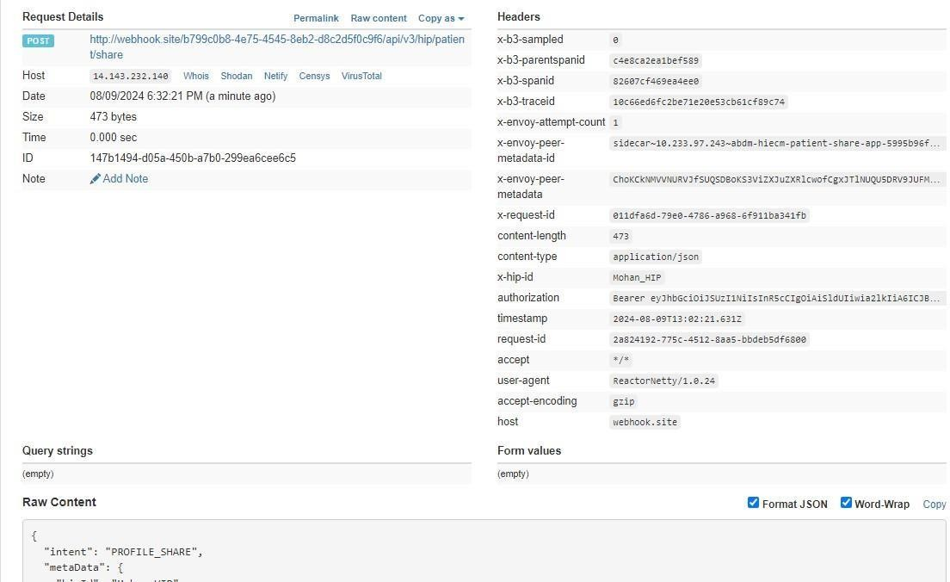

Profile on-share
This API will be invoked by HIP to acknowledge the request by the user/patient to share the profile details.

URL: /api/hiecm/patient-share/v3/on-share
Method: Post

Request Headers:

Property Name | Example Value | Required | Description
REQUEST-ID | 18235d89-cb13-479d-ad71-  7a57d5f669a8 | Yes | Unique UUID for track the end to end request transaction
TIMESTAMP | 2022-10-06T10:10:00.587Z | Yes | Actual time when request was  initiated, ISO 8601 represents date and time by starting with the year, followed by the month, the day, the hour, the minutes, seconds and milliseconds

Authorization | eyJhbGciOiJSUzUxMiJ9.  eyJzdWIiOiJ2YXNhbnRoYWt1bWFyLmtlc 2F2  YW5Ac2J4IiwiY2xpZW50SWQiOiJz YngiLCJzeXN0ZW0iOiJBQkhBLUEiLCJy ZXF1ZXN0ZXJJZCI6IlBIUi1XRUIiL  CJwaHJNb2JpbGUiOm51bGwsImV4c CI6MTY2NzI5ODExNSwia  WF0IjoxNjY3MjkwOTE1LCJwaHJBZ  GRyZXNzIjoidmFzYW50aGFrdW1hci5rZX NhdmFuQHNieCIsInR4bklkIjoi  YjEwMGM4ZDMtNTE1ZC00YWFiLTg1O WQtYzNlMTUwOTE3ZGY1In0 | Yes | JWT Access token which was issued by ABDM session API after successful validation of client id and secret
X-CM-ID | sbx | Yes | Suffix of the consent manager to which the request was intended

Body Parameters

Property Name | Example Value | Required | Description
abhaAddress | ABHA address | Yes | Patient ABHA address against which the health records needs to be linked
status | “SUCCESS” | Yes | Transaction status from HIP to HIE-CM,  “success” “failed”
context | 43 | Yes | HMIS/LMIS Counter ID
tokenNumber | 3 | Yes | Token number at HMIS/LMIS to be provided to the patient
expiry | 180 | Yes | Patient year of birth
requestId | f29f0e59-8388-  46989fe605db67aeac46 | Yes | This is a key value pair which contains the purpose

Request Body

Request Body:
{
"acknowledgement": {
"abhaAddress": "abc@abdm", "status": "success",
"profile": {
"context": "43",
"tokenNumber": "3",
"expiry": "180"
}
},
"response": {
"requestId": "f29f0e59-8388-4698-9fe6-05db67aeac46"
}
}

Response

Response:
Code : 200 OK

Request Body : ERROR
-> Use this in case of error response (Ex: This is the one example for error payload and the code will be same. But, message will be change each error).

Request Body:
{
"error": {
"code": "ABDM-9999: ",
"message": "string"
},
"response": {
"requestId": "6f0b4665-a915-4c92-aa36-65afb4a2cd71"
}
}

Profile on share – Callback
This is a callback API for patient on-share API.

URL: {callback_url}/api/v3/hiu/patient/on-share

Method: Post

Request Headers:

Property Name | Example Value | Required | Description
REQUEST-ID | 18235d89-cb13-  479d-ad717a57d5f669a8 | Yes | Unique UUID for track the end to end request transaction
TIMESTAMP | 2022-10-  06T10:10:00.587Z | Yes | Actual time when request was initiated, ISO 8601 represents date and time by starting with the year, followed by the month, the day, the hour, the minutes, seconds and milliseconds
X-HIU-ID | ABDM_sbx | Yes | Suffix of the HIU to which the request was intended

Body Parameters:

Property Name | Example Value | Required | Description
abhaAddress | ABHA address | Yes | Patient ABHA address against which the health records needs to be linked
Status | “success” | Yes | Trasaction status from HIP to HIE-CM,  “success” “failed”
Context | 43 | Yes | HMIS/LMIS Counter ID
tokenNumber | 3 | Yes | Token number at HMIS/LMIS to be provided to the patient
Expiry | 180 | Yes | Patient year of birth
requestId | f29f0e59-8388-  46989fe605db67aeac46 | Yes | This is a key value pair which contains the purpose

Request Body
Request Body:

"acknowledgement": {
"abhaAddress": "abc@abdm", "status": "success",
"context": "43",
"tokenNumber": "3",
"expiry": 180
},
"response": {
"requestId": "f29f0e59-8388-4698-9fe6-05db67aeac46"
}
}

Response

Response:
Code: 200 OK
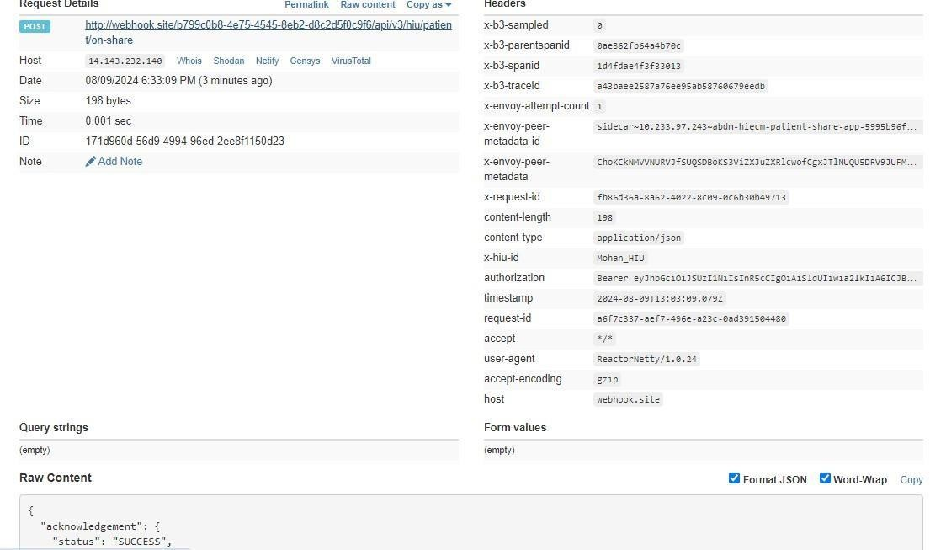

Scan and Record Share

Overview

- The User/Patient can share his/her basic KYC information with the HMIS/LIMS by scanning the QR Code using the integrator application (Example: ABHA App), which enables them to complete the seamless profile share during their visit.
- The authenticity of the profile information is verified by the HIE-CM internally before sharing with the HMIS/LIMS.

Sequence Diagram



Record share

This API will be invoked from the integrator application (any PHR application, just like ABHA) to share the user/patient record with HMIS/LIMS.

URL: /api/hiecm/patient-share/v3/share Method:
Post Request Headers:

Property Name | Example Value | Required | Description
REQUEST-ID | 18235d89-cb13-479d-ad71-  7a57d5f669a8 | Yes | Unique UUID for track the end to end request transaction
TIMESTAMP | 2022-10-06T10:10:00.587Z | Yes | Actual time when request was initiated, ISO 8601 represents date and

 |  |  | time by starting with the year, followed by the month, the day, the hour, the minutes, seconds and milliseconds
Authorization | eyJhbGciOiJSUzUxMiJ9.  eyJzdWIiOiJ2YXNhbnRoYWt1bWFyLmtlc 2F2  YW5Ac2J4IiwiY2xpZW50SWQiOiJz NhdmFuQHNieCIsInR4bklkIjoi  YjEwMGM4ZDMtNTE1ZC00YWFiLTg1O WQtYzNlMTUwOTE3ZGY1In0 | Yes | JWT Access token which was issued by ABDM session API after successful validation of client id and secret
X-CM-ID | sbx | Yes | Suffix of the consent manager to which the request was intended
X-Auth-TOKEN | eyJhbGciOiJSUzUxMiJ9.  _gutl1XW9CaBaZSah7GOxGRr4gpSIJJv  ILWovwG58DyNzEhrHtAfIje_pegqRsNM OFI-xPYJd2x6CcDKSoAXvXO0jbuoOvlPl5kh plOKU-WcFeWA | Yes | JWT Access token which was issued by IDP service after successfully user authentication
X-HIU-ID | HIU_ID | Yes | Identifier of the health information user to which the request was intended

Body Parameters

Property Name | Example Value | Required | Description
Intent | RECORD_SHARE | Yes | This is a key value pair which contains the purpose with following possible values.  Profile_share Payment  Health_record_sharing

metadata | {  "hipId": "Test_HIP",  "context": "ABC123", "hprId":  "XXXXXX@abdm",  "latitude": "-38.679",  "longitude": "58.498" } | Yes | This is a key value pair which contains the location longitude and latitude.  hipId:- healthInformationProviderId context:- counterCode  hprId:- healthprofessionalregisterId
healthInfo Bundle | {  "content":  "eyJhbGciOiJSUzUxMiJ 9-KCAiC5GZd3aPROr  5WtlyQ-Csz2N0taGCOMNjrd5J TbbayA",  "media": "Json", "checkSum": "abcdefg12",  "careContextReferenc e": "Blood test"  } | Yes | Patient health record to be shared.

Request Body
Request Body

{
"intent" : "RECORD_SHARE" ,
"metaData" : { "hipId" : "HIP_ID" ,
"context" : "ABC123" ,
"hprId" : "abdulkalam@abdm" , "latitude" : "-37.519 ",
"longitude" : "58.498"
},
"profile": {
"patient": {
"abhaNumber": 9117838615XXXX, "abhaAddress": "91178XXX@sbx", "name": "User 1",
"gender": "M",
"dayOfBirth": "XX", "monthOfBirth": "XX", "yearOfBirth": "XXXX", "address": {
"line": "C/O Sandipan Kshirsagar Ambejogai Road Renuka Nagar", "district": null ,
"state": null , "pincode": null
},
"phoneNumber": "987654XXXX"
}
},
"healthInfoBundle" : {
"content" : “eyJhbGciOiJSUzUxMiJ9.eyJzdWIiOiIxODQ0MzgxMDgwNjQ0MEBh0EtAAibtzTS2yF - Bq0_6fbIymHjv4_IpIcyU9aSFEC2VYgHxuoGEFC5FEje8 -FAua8
FMrWAsTwioxbGujqjvcM9OC1BUrRakmAVxk7GGfmF7jQC8wBxH
Csz2N0taGCOMNjrd5JTbbayA”,
-KCAiC5GZd3aPROr
5WtlyQ -

"media" : "Json" ,
"checkSum" : "abcdefg12" ,
"careContextReference" : "Blood test"
}
}

Response

Response:
Code : 202 Accepted

Record share - Callback
This is a callback API for patient share API.

URL: {callback_url}/api/v3/hip/patient/share
Method: Post

Request Headers:

Property Name | Example Value | Required | Description
REQUEST-ID | 18235d89-cb13-479d-ad71-  7a57d5f669a8 | Yes | Unique UUID for track the end to end request transaction
TIMESTAMP | 2022-10-06T10:10:00.587Z | Yes | Actual time when request was  initiated, ISO 8601 represents date and time by starting with the year, followed by the month, the day, the hour, the minutes, seconds and milliseconds
Authorization | eyJhbGciOiJSUzUxMiJ9.  eyJzdWIiOiJ2YXNhbnRoYWt1bWFyLmtlc 2F2  CJwaHJNb2JpbGUiOm51bGwsImV4c CI6MTY2NzI5ODExNSwia  WF0IjoxNjY3MjkwOTE1LCJwaHJBZ | Yes | JWT Access token which was issued by ABDM session API after successful validation of client id and secret
X-CM-ID | sbx | Yes | Suffix of the consent manager to which the request was intended
X-HIP-ID | HIU_ID | Yes | Identifier of the health information provider to which the request was intended

Body Parameters

Proper ty  Name | Example Value | Required | Description

Intent | RECORD_SHARE | Yes | This is a key value pair which contains the purpose with following possible values.  Profile_share Payment  Health_record_sharing
metada ta | {  "hipId": "Test_HIP", "counterId": "ABC123", "hprId": "abdulkalam@abdm  ",  "latitude": "-38.679",  "longitude": "58.498" } | Yes | This is a key value pair which contains the location longitude and latitude
healthIn Bundle | {  "content":  "eyJhbGciOiJSUzUxMi J9.eyJzdWIiOiIxODQ0 MzgxMDgwNjQ0MEB hYmRtIiwiY -FAua8  5WtlyQ-Csz2N0taGCOMNjrd 5JTbbayA",  "media": "Json", "checkSum": "abcdefg12",  "careContextReferen ce": "Blood test"  } | Yes | Consists of the health information that must be shared with the HIP with encrypted care context content

Request Body

Request Body:
{
"intent": "RECORD_SHARE",
"metaData": { "hipId": "HIP_ID",
"counterId": "ABC123", "hprId": "XXXXXXX@abdm",

"latitude": "-37.519",
"longitude": "58.498"
},
"healthInfoBundle": {
"content": “eyJhbGciOiJSUzUxMiJ9.eyJzdWIiOiIxODQ0MzgxMDgwNjQ0MEBhYmRFAua8 FMrWAsTwioxbGujqjvcM9OC1BUrRakmAVxk7GGfmF7jQC8wBxH-KCAiC5GZd3aPROr
5WtlyQCsz2N0taGCOMNjrd5JTbbayA”, "media": "Json",
"checkSum": "abcdefg12",
"careContextReference": "Blood test"
}
}

Response

Response:
Code: 202 Accepted
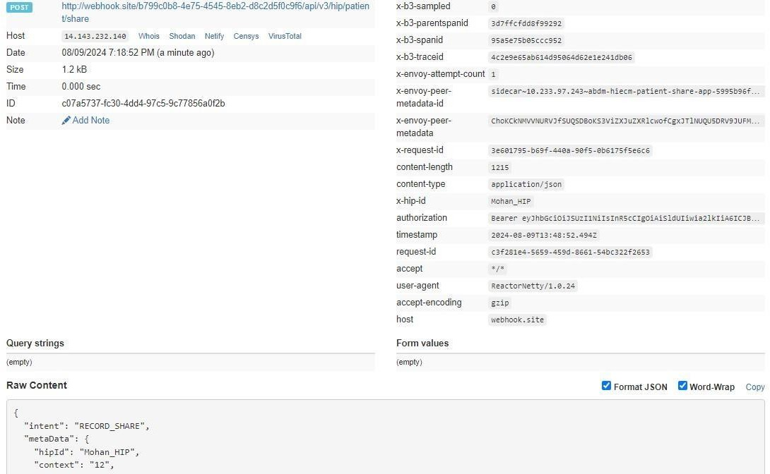

Record on-share

This API will be invoked by HIP to acknowledge the request by the integrator application (any PHR application, just like ABHA) to share record.

URL: /api/hiecm/patient-share/v3/on-share
Method: POST

Request Headers:

Property Name | Example Value | Required | Description
REQUEST-ID | 18235d89-cb13-479d-ad71-  7a57d5f669a8 | Yes | Unique UUID for track the end to end request transaction
TIMESTAMP | 2022-10-06T10:10:00.587Z | Yes | Actual time when request was initiated, ISO Date time format represents date and time
Authorization | eyJhbGciOiJSUzUxMiJ9.  eyJzdWIiOiJ2YXNhbnRoYWt1bWFyLmtlc 2F2  YW5Ac2J4IiwiY2xpZW50SWQiOiJz YngiLCJzeXN0ZW0iOiJBQkhBLUEiLCJy ZXF1ZXN0ZXJJZCI6IlBIUi1XRUIiL  CJwaHJNb2JpbGUiOm51bGwsImV4c CI6MTY2NzI5ODExNSwia  WF0IjoxNjY3MjkwOTE1LCJwaHJBZ  GRyZXNzIjoidmFzYW50aGFrdW1hci5rZX NhdmFuQHNieCIsInR4bklkIjoi  YjEwMGM4ZDMtNTE1ZC00YWFiLTg1O WQtYzNlMTUwOTE3ZGY1In0 | Yes | JWT Access token which was issued by ABDM session API after successful validation of client id and secret
X-CM-ID | sbx | Yes | Suffix of the consent manager to which the request was intended

Body Parameters

Property Name | Example Value | Required | Description
abhaAddress | ABHA address | abhaAddress | ABHA address
Status | “success” | Status | “success”

healthInformation | {  "healthInformationReference": "123456"  } | payment | {  "paymentReference": "abc"  }
requestId | f29f0e59-8388-  46989fe605db67aeac46 | Yes | This is a key value pair which contains the purpose

Request Body

Request Body
{
"acknowledgement": { "status": "SUCCESS",
"abhaAddress": "XXXXXX@abdm", "healthInformation": {
"healthInformationReference": "123456"
}
},
"response": {
"requestId": "ecf0cb2d-5178-40d3-85fa-14d25f6bdc0d"
}

Response

Response:
Code: 202 ACCEPTED

Record on-share – Callback

This is a callback API for patient on-share.

URL: {callback_url}/api/v3/hiu/patient/on-share
Method: POST

Request Headers:

Property Name | Example Value | Required | Description
REQUEST-ID | 18235d89-cb13-479d-ad71-  7a57d5f669a8 | Yes | Unique UUID for track the end to end request transaction
TIMESTAMP | 2022-10-06T10:10:00.587Z | Yes | Actual time when request was initiated, ISO 8601 represents date and time by starting with the year, followed by the month, the day, the hour, the minutes, seconds and milliseconds
X-HIU-ID | ABDM_sbx | Yes | Suffix of the HIU to which the request was intended
Authorization | eyJhbGciOiJSUzUxMiJ9.  eyJzdWIiOiJ2YXNhbnRoYWt1bWFyLmtlc2F2 YW5Ac2J4IiwiY2xpZW50SWQiOiJz YngiLCJzeXN0ZW0iOiJBQkhBLUEiLCJy  ZXF1ZXN0ZXJJZCI6IlBIUi1XRUIiL  CJwaHJNb2JpbGUiOm51bGwsImV4c CI6MTY2NzI5ODExNSwia  WF0IjoxNjY3MjkwOTE1LCJwaHJBZ  GRyZXNzIjoidmFzYW50aGFrdW1hci5rZX NhdmFuQHNieCIsInR4bklkIjoi  YjEwMGM4ZDMtNTE1ZC00YWFiLTg1O WQtYzNlMTUwOTE3ZGY1In0 | Yes | JWT Access token which was issued by ABDM session API after successful validation of client id and secret

Body parameters

Property Name | Example Value | Required | Description
abhaAddress | ABHA address | Yes | Patient ABHA address against which the health records needs to be linked
Status | “success” | Yes | Trasaction status from HIP to HIE-CM,  “success” “failed”
healthInformationReference |  | Yes

requestId | f29f0e59-8388-  46989fe605db67aeac46 | Yes | This is a key value pair which contains the purpose

Request Body

Request Body:
{
"acknowledgement": { "status": "SUCCESS",
"abhaAddress": "XXXXXXXX@abdm", "healthInformation": {
"healthInformationReference": "123456"
}
},
"response": {
"requestId": "ecf0cb2d-5178-40d3-85fa-14d25f6bdc0d"
}
}

Response

Response:
Code: 200 OK
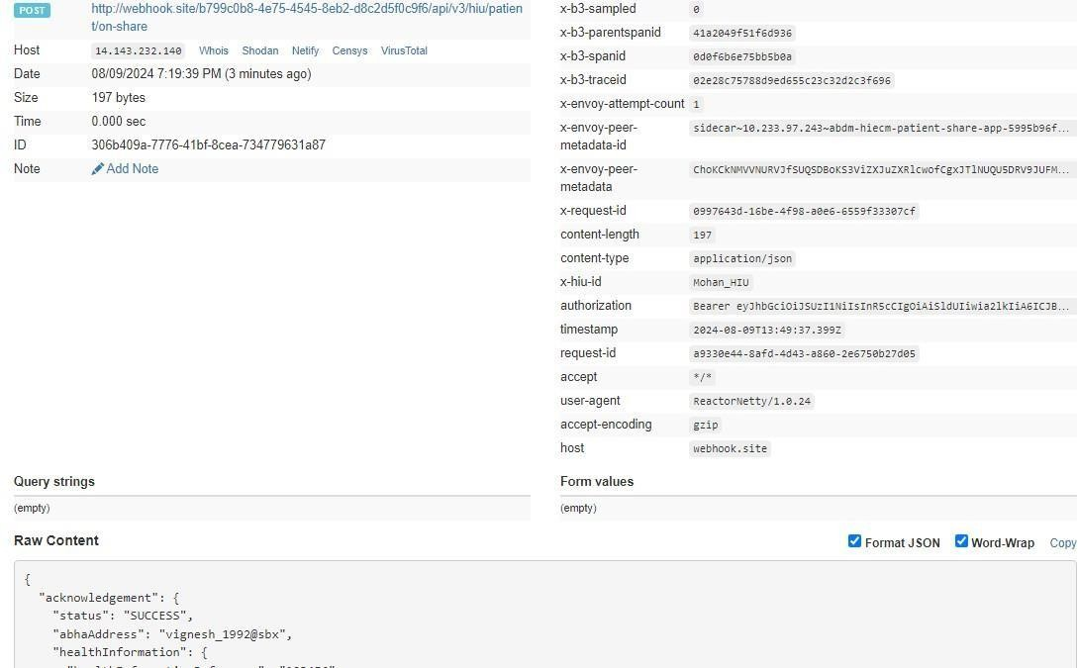

Scan and Pay

Overview
The User/Patient can share his/her basic KYC information with the
HMIS/LIMS by scanning the QR Code using the integrator application (Example: ABHA App), which enables them to complete the seamless profile share during their visit.
The authenticity of the profile information is verified by the HIE-CM internally before sharing with the HMIS/LIMS.

Sequence Diagram



List of APIs

      - Payment share

This API will be invoked from the integrator application (any PHR application, just like ABHA) to share the user/patient payment details with HMIS/LIMS.

URL: /api/hiecm/patient-share/v3/share

Method: Post

Request Headers:

Property Name | Example Value | Required | Description
REQUEST-ID | 18235d89-cb13-479d-ad71-  7a57d5f669a8 | Yes | Unique UUID for track the end to end request transaction
TIMESTAMP | 2022-10-06T10:10:00.587Z | Yes | Actual time when request was
 |  |  | initiated, ISO Date time format represents date and time
Authorization | eyJhbGciOiJSUzUxMiJ9.  eyJzdWIiOiJ2YXNhbnRoYWt1bWFyLmtlc 2F2  YW5Ac2J4IiwiY2xpZW50SWQiOiJz YngiLCJzeXN0ZW0iOiJBQkhBLUEiLCJy ZXF1ZXN0ZXJJZCI6IlBIUi1XRUIiL  CJwaHJNb2JpbGUiOm51bGwsImV4c CI6MTY2NzI5ODExNSwia  WF0IjoxNjY3MjkwOTE1LCJwaHJBZ  GRyZXNzIjoidmFzYW50aGFrdW1hci5rZX NhdmFuQHNieCIsInR4bklkIjoi  YjEwMGM4ZDMtNTE1ZC00YWFiLTg1O WQtYzNlMTUwOTE3ZGY1In0 | Yes | JWT Access token which was issued by ABDM session API after successful validation of client id and secret
X-HIU-ID | HIU_ID | Yes | Identifier of the health information user to which the request was intended
X-CM-ID | sbx | Yes | Suffix of the consent manager to which the request was intended
X-AUTH-TOKEN | eyJhbGciOiJSUzUxMiJ9.eyJzdWIiOiJna XJpamFAc2J4IiwiY2xpZW50SWQiOiJQS FItV0VCIiwicmVxdWVzdGVySWQiOiJrX 2hpcCIsInN5c3RlbSI6IkFCRE0iLCJtb2Jp bGUiOiI4MjgxMTQ3MDgwIiwiZXhwIjoxNj  c3NjY5NDU1LCJpYXQiOjE2Nzc2NjIyNT WcFeWA | Yes | JWT Access token which was issued by IDP service after successfully user authentication

Body Parameters

Property Name | Example Value | Required | Description
Intent | "PAYMENT_SHARE" | Yes | This is a key value pair which contains the purpose with following possible values.  Profile_share Payment  Health_record_sharing
metadata | {  "hipId": "Test_HIP", "counterId": "ABC123", "hprId":  "abdulkalam@abdm", "latitude": "-38.679", | Yes | This is a key value pair which contains the location longitude and latitude.  hipId:- healthInformationProviderId context:- counterCode  hprId:- healthprofessionalregisterId
"longitude": "58.498"
}
paymentBundle | {  "upiAddress": "upi@gmail.com",  "orderNo": "123",  "amount": 1100.123, "merchantId":  "LGKYL67895#567y",  "description": "Testt"  } | Yes | Consists of payment information such as the upi address, payment amount, order details and the merchant information

Request Body
Request Body:

{
"intent": "payment_share", "metaData": {
"hipId": "HIP_ID",
"counterId": "ABC123", "hprId": "XXXXX@abdm", "latitude": "-37.519",
"longitude": "58.494"
},
"profile": {
"patient": {
"abhaNumber": {{abha-number}},
"abhaAddress": "{{abha-address}}", "name": "User 1",
"gender": "M",
"dayOfBirth": "XX", "monthOfBirth": "XX", "yearOfBirth": "XXXX", "address": {
"line": "C/O Sandipan Kshirsagar Ambejogai Road Renuka Nagar", "district": null,
"state": null, "pincode": null
},
"phoneNumber": "9876543210"
}
},
"paymentBundle": {
"upiAddress": "upi@gmail.com", "orderNo": "123",
"amount": 1100.123,
"merchantId": "LGKYL67895#567y", "description": "Testt"
}
}

Response

Response:
Code: 202 ACCEPTED

Payment share – Callback

This is a callback API for payment share.

URL: {callback_url}/api/v3/hip/patient/share
Method: POST

Request Headers:

Property Name | Example Value | Required | Description
REQUEST-ID | 18235d89-cb13-479d-ad71-  7a57d5f669a8 | Yes | Unique UUID for track the end to end request transaction
TIMESTAMP | 2022-10-06T10:10:00.587Z | Yes | Actual time when request was initiated, ISO 8601 represents date and time by starting with the year, followed by the month, the day, the  hour, the minutes, seconds and milliseconds
X-HIP-ID | IN2810014366 | Yes | Identifier of the health information provider to which the request was intended
Authorization | eyJhbGciOiJSUzUxMiJ9.  eyJzdWIiOiJ2YXNhbnRoYWt1bWFyLmtlc2F2 YW5Ac2J4IiwiY2xpZW50SWQiOiJz YngiLCJzeXN0ZW0iOiJBQkhBLUEiLCJy  ZXF1ZXN0ZXJJZCI6IlBIUi1XRUIiL  CJwaHJNb2JpbGUiOm51bGwsImV4c CI6MTY2NzI5ODExNSwia  WF0IjoxNjY3MjkwOTE1LCJwaHJBZ  GRyZXNzIjoidmFzYW50aGFrdW1hci5rZX NhdmFuQHNieCIsInR4bklkIjoi  YjEwMGM4ZDMtNTE1ZC00YWFiLTg1O  WQtYzNlMTUwOTE3ZGY1In0 | Yes | JWT Access token which was issued by ABDM session API after successful validation of client id and secret

Body parameters

Property Name | Example Value | Required | Description
Intent | {  “purpose”: “profile_share”, “hip_id”: “ABDM_HIP”,  "context”: “43”  } | Yes | This is a key value pair which contains the purpose

metadata | { lat: 20.5937, long: 78.9629 } | Yes | This is a key value pair which contains the location longitude and latitude.  hipId:- healthInformationProviderId context:- counterCode  hprId:- healthprofessionalregisterId
paymentBundle | {  "upiAddress": "upi@gmail.com",  "orderNo": "123",  "amount": 1100.123, "merchantId":  "LGKYL67895#567y",  "description": "Testt"  } | Yes | Consists of payment information such as the upi address, payment amount, order details and the merchant information

Request Body

Request Body:
{
"intent": "payment_share", "metaData": {
"hipId": "HIP_ID",
"counterId": "ABC123",
"hprId": "XXXXXXXX@abdm", "latitude": "-37.519",
"longitude": "58.494"
},
"profile": {
"patient": {
"abhaNumber": {{abha-number}},
"abhaAddress": "{{abha-address}}", "name": "User 1",
"gender": "M",
"dayOfBirth": "XX",
"monthOfBirth": "XX", "yearOfBirth": "XXXX", "address": {
"line": "C/O Sandipan Kshirsagar Ambejogai Road XXXXXX",

"district": null, "state": null,
"pincode": null
},
"phoneNumber": "987654XXXX"
}
},
"paymentBundle": {
"upiAddress": "upi@gmail.com", "orderNo": "123",
"amount": 1100.123,
"merchantId": "LGKYL67895#567y", "description": "Testt"
}
}

Response

Response:
Code: 200 OK
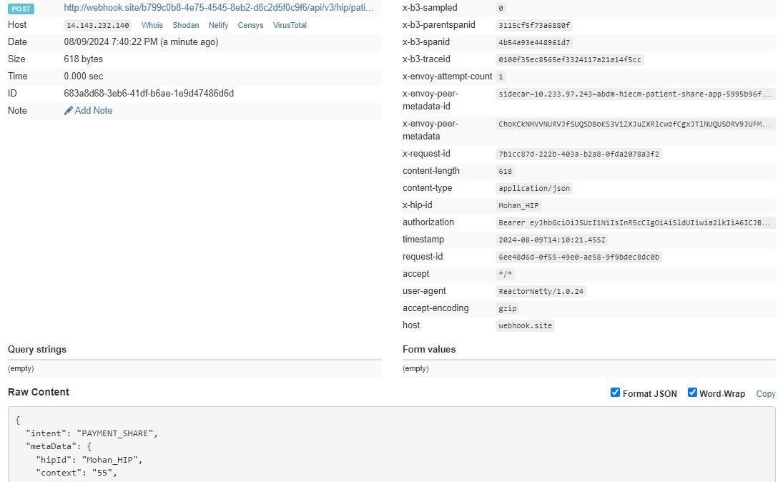

Payment on-share

This is an API called by HIP as a response to payment share API call.

URL: /api/hiecm/patient-share/v3/on-share
Method: POST

Request Headers:

Property Name | Example Value | Required | Description
REQUEST-ID | 18235d89-cb13-479d-ad71-  7a57d5f669a8 | Yes | Unique UUID for track the end to end request transaction
TIMESTAMP | 2022-10-06T10:10:00.587Z | Yes | Actual time when request was initiated, ISO Date time format represents date and time
Authorization | eyJhbGciOiJSUzUxMiJ9.  eyJzdWIiOiJ2YXNhbnRoYWt1bWFyLmtlc 2F2  YW5Ac2J4IiwiY2xpZW50SWQiOiJz YngiLCJzeXN0ZW0iOiJBQkhBLUEiLCJy ZXF1ZXN0ZXJJZCI6IlBIUi1XRUIiL  CJwaHJNb2JpbGUiOm51bGwsImV4c CI6MTY2NzI5ODExNSwia  WF0IjoxNjY3MjkwOTE1LCJwaHJBZ  GRyZXNzIjoidmFzYW50aGFrdW1hci5rZX NhdmFuQHNieCIsInR4bklkIjoi  YjEwMGM4ZDMtNTE1ZC00YWFiLTg1O WQtYzNlMTUwOTE3ZGY1In0 | Yes | JWT Access token which was issued by ABDM session  API after successful validation of client id and secret
X-CM-ID | sbx | Yes | Suffix of the consent manager to which the request was intended

Body Parameters

Property Name | Example Value | Required | Description
abhaAddress | ABHA address | Yes | Patient ABHA address against which the health records needs to be linked
status | “success” | Yes | Trasaction status from HIP to HIE-CM, “success”  “failed”
payment | {  "acknowledgement": {  "status": "SUCCESS", "abhaAddress":  "XXXXXXXXX@abdm",  "payment": {  "paymentReference": "1234567"  } | Yes | Success payment status
response | {  "requestId": "37ba8d92ef3c-4a2b-9d4ff25c9e50a23b"  } | Yes | Request Id from the Share api

Request Body

Request Body:
{
"acknowledgement": { "status": "SUCCESS",
"abhaAddress": "XXXXXX@abdm", "payment": {
"paymentReference": "abc"
}
},
"response": {
"requestId": "37ba8d92-ef3c-4a2b-9d4f-f25c9e50a23b"
}
}

Response

Response:
Code: 202 ACCEPTED

Payment on-share – Callback

This is a callback API for patient on-share.

URL: {callback_url}/api/v3/hiu/patient/on-share
Method: POST

Request Headers:

Property Name | Example Value | Required | Description
Authorization | eyJhbGciOiJSUzUxMiJ9.  eyJzdWIiOiJ2YXNhbnRoYWt1bWFyLmtlc2F2 YW5Ac2J4IiwiY2xpZW50SWQiOiJz YngiLCJzeXN0ZW0iOiJBQkhBLUEiLCJy  ZXF1ZXN0ZXJJZCI6IlBIUi1XRUIiL  CJwaHJNb2JpbGUiOm51bGwsImV4c CI6MTY2NzI5ODExNSwia  WF0IjoxNjY3MjkwOTE1LCJwaHJBZ  GRyZXNzIjoidmFzYW50aGFrdW1hci5rZX NhdmFuQHNieCIsInR4bklkIjoi  YjEwMGM4ZDMtNTE1ZC00YWFiLTg1O  WQtYzNlMTUwOTE3ZGY1In0 | Yes | JWT Access token which was issued by ABDM session API after successful validation of client id and secret
REQUEST-ID | 18235d89-cb13-479d-ad71-  7a57d5f669a8 | Yes | Unique UUID for track the end to end request transaction
TIMESTAMP | 2022-10-06T10:10:00.587Z | Yes | Actual time when request was initiated, ISO 8601 represents date and time by starting with the year, followed by the month, the day, the  hour, the minutes, seconds and milliseconds

X-HIU-ID | ABDM_sbx | Yes | Suffix of the HIU to which the request was intended

Body parameters

Property Name | Example Value | Required | Description
abhaAddress | ABHA address | Yes | Patient ABHA address against which the health records need to be linked
Status | “success” | Yes | Trasaction status from HIP to HIE-CM,  “success” “failed”
Payment | {  "acknowledgement": { "status": "SUCCESS",  "abhaAddress": "XXXXXXX@abdm",  "payment": {  "paymentReference": "1234567"  } | Yes | Payment status
Response | {  "requestId": "37ba8d92-ef3c-4a2b-9d4f-f25c9e50a23b"  } | Yes | Request Id from the share api

Request Body

Request Body:

{
"acknowledgement": { "status": "SUCCESS",
"abhaAddress": "XXXXXXX@abdm", "payment": {
"paymentReference": "abc"
}
},
"response": {
"requestId": "37ba8d92-ef3c-4a2b-9d4f-f25c9e50a23b"
}
}

Response

Response:
Code: 200 OK
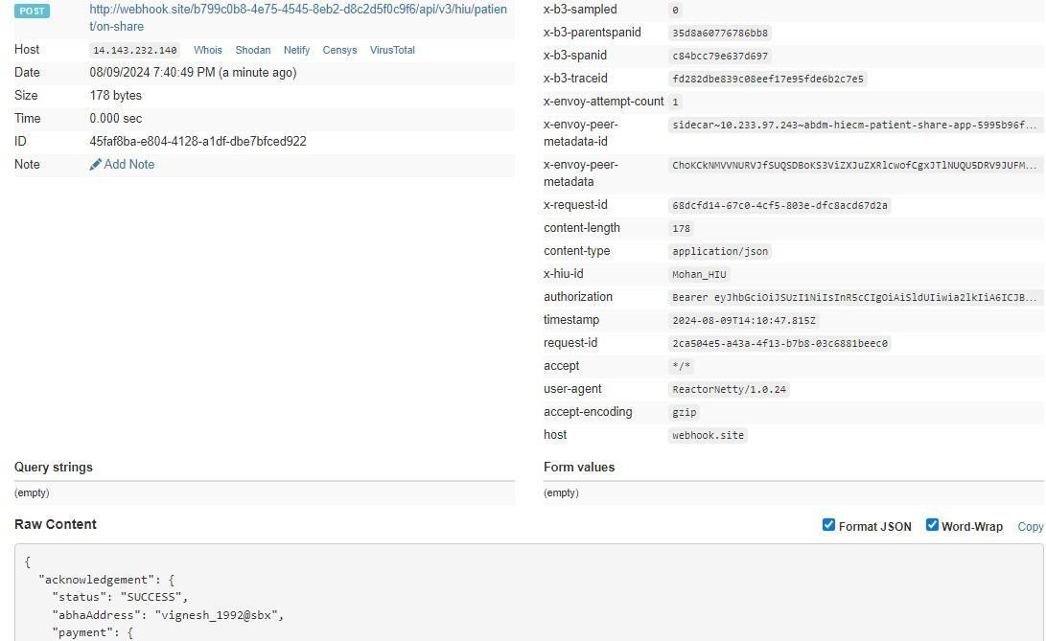

Error Codes Listing
Code | Error
ABDM-1000 | Unable to connect the database
ABDM-1001 | No data found
ABDM-1002 | Integrity violation
ABDM-1003 | Email Gateway is unavailable
ABDM-1004 | SMS Gateway is unavailable
ABDM-1005 | Invalid receiver
ABDM-1006 | Bad Request, invalid request Body
ABDM-1007 | Connection failed due to timeout
ABDM-1008 | SMS service currently disabled
ABDM-1009 | Email service currently disabled
ABDM-1010 | Validation failed
ABDM-1011 | Gateway database unavailable
ABDM-1012 | No records found against the ABHA Address
ABDM-1013 | Invalid ABHA Number
ABDM-1014 | Invalid Mobile Email
ABDM-1015 | Invalid Response
ABDM-1016 | Invalid TimeStamp
ABDM-1017 | Invalid TransactionId
ABDM-1018 | Share Profile database unavailable
ABDM-1019 | Dependent Service Unavailable
ABDM-1020 | Unknown database
ABDM-1021 | Lack of required priviledges
ABDM-1022 | Too many requests
ABDM-1023 | Invalid User
ABDM-1024 | Dependent service unavailable
ABDM-1025 | Invalid ServiceId
ABDM-1026 | Invalid Link Token
ABDM-1027 | You are blocked. Please try again after 24 hours.
ABDM-1028 | HIP is unavailable
ABDM-1029 | Redis server is unavailable
ABDM-1030 | Invalid request ID
ABDM-1031 | Invalid request
ABDM-1032 | Invalid header
ABDM-1033 | HIU is unavailable

ABDM-1034 | Notification service unavailable
ABDM-1035 | Invalid HIP ID
ABDM-1035 | OTP does not matched
ABDM-1036 | Data does not matched
ABDM-1037 | Counter and Care context count mismatch
ABDM-1038 | ABHA address and Link token mismatch
ABDM-1039 | Invalid Consent request id
ABDM-1040 | Invalid HIU ID
ABDM-1041 | Invalid Acknowledgement
ABDM-1042 | Provider Mandatory
ABDM-1043 | ABHA Address does not match with KYC details.
ABDM-1044 | Broadcast Failed
ABDM-1045 | Database Access is restricted
ABDM-1046 | Invalid Purpose
ABDM-1047 | Purpose does not exist
ABDM-1048 | Timeout
ABDM-1049 | Invalid Profile Share Intent Keys
ABDM-1050 | Invalid Profile Share Metadata Keys
ABDM-1051 | Invalid ABHA Number or ABHA Address
ABDM-1052 | Invalid TransactionId or response's requestId
ABDM-1053 | Data already exists
ABDM-1054 | Invalid Subscription Request Id
ABDM-1401 | HIP is not available
ABDM-1402 | Acknowledgement is not received from HIP
ABDM-9999 | Unknown exception
ABDM-1061 | Consent artefact expired
ABDM-1062 | Consent Not granted
ABDM-1063 | Date Range given is invalid
ABDM-1064 | request with this request id already exists
ABDM-1017 | Invalid TransactionId
ABDM-1109 | ABHA DB service unavailable
ABDM-1108 | Notification DB service unavailable
ABDM-1205 | Document DB Gateway is unavailable
ABDM-1034 | Notification service unavailable
ABDM-1029 | Redis server is unavailable
ABDM-1202 | Document Gateway is unavailable
ABDM-1200 | LGD Gateway is unavailable

ABDM-1201 | IDP Gateway is unavailable
ABDM-9999 | Unknown exception
ABDM-1101 | This ABHA Address already exists. Please create with unique ABHA Address
ABDM-1006 | Invalid combinations of scopes
ABDM-1100 | You have requested multiple OTPs Or Exceeded maximum number of attempts for OTP match in this transaction.  Please try again in 30 minutes.
ABDM-1006 | Bad Request, invalid request Body

