**Scheduling**

**Scheduling => Job Sheet Print**

When Scheduler filters the record based on the date of booking or department wise or order number than he can view the details where he can change the **Expected Due Date** and **Product Tests parameter.**

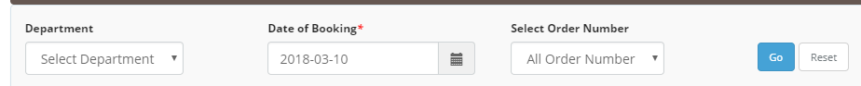

Can change the expected due date



Scheduler need to verify the test parameter after clicking on the product tests name

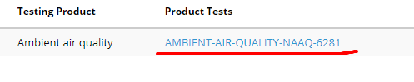

Than scheduler need to verify the test parameter, method, equipment from the list if any test parameter are missing than scheduler can add other parameter using add more button.

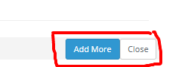

Scheduler can also take the print for the sample with the test parameter name, instrument and method

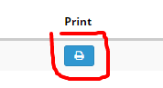

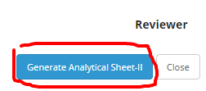

So scheduler can provide print of Analytical sheet to the Analyst so Analyst can verify the test parameter, instrument and method accordingly .

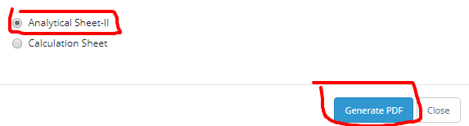

After booking the order from the order master next step will be scheduling section. On scheduling section scheduler need to assign analyst.

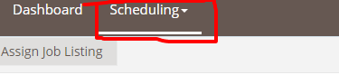

**Scheduling => Assign Job**

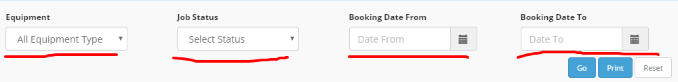

**After filtering the department, Analyst, equipment, job status and booking date from and to, you can filter the analyst and these are the optional parameter, you can directly click on go button than it will display the entire result list like booking date, sample name, report number ,parameter name, equipment name etc with the analyst name.**



**Now scheduler needs to assign the analyst according to the parameter and equipment.**

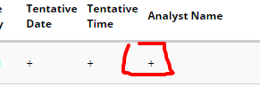

**Analysts are assigning according to the equipment, suppose if you are assign according to equipment than all similar equipment assign to the single analyst, Suppose if there is a equipment like chemically than all chemically equipment assign to the single analyst ,user need to click on the checkbox for this.**

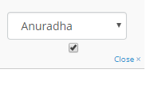

**Tentative date and tentative time also need to add**

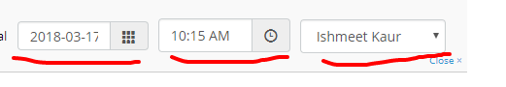

**And then update the detail**

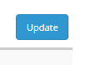

**Scheduling => Jobs**

* Scheduler can view the assign jobs of the sample name and analyst assign to for the sample and can change the status of the sample like pending or completed.
* Change status to pending with reason.

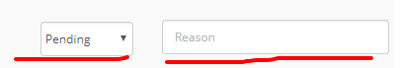

* Same for the completed

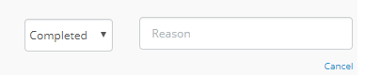

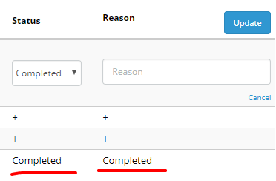

Filter the record according to job type, department wise, analyst, equipment, job status, booking date

Can search the record using the search box filter according to booking date, Sample name, Report code, Equipment name, Method name, Analyst name etc.

