**Testing (Role: Tester)**

Next step will be the testing phase

**Sales->Reports**

Tester can filter the record according to booking date and expected date**.**

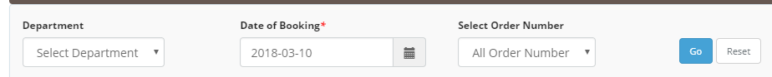

On the reports page status will change to testing.

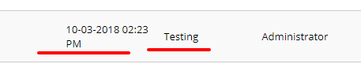

* Tester need to click on the (+) add sign to provide the test result.

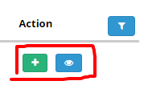

* After click on the add button , a popup will appear

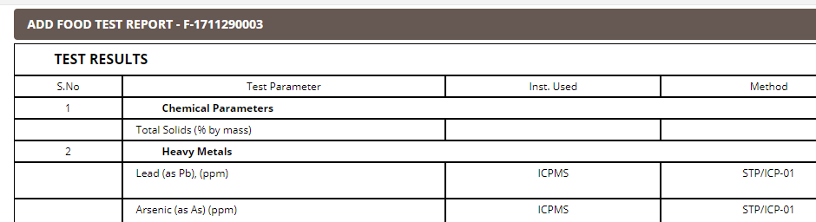

* Now tester needs to add the test result in the input box.

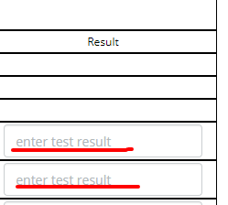

Then click on the save button to save the result.

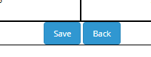

After adding the result in the window status of sample will be changed from testing to reviewing. And sample will move to the reviewer.