

Java Environment for CSCF Infofauna (JECI)
  - Documentation technique développeur

Version : 0.0.1
Auteur : HENRY Pierre
Date : 10.09.2014

Historique du document
Date | Version  Document | Version  Software | Auteur | Commentaires
15.09.2014 | 0.1 | 1.0 beta | Pierre Henry | Création du document

Table des matières
1 Introduction 5
1.1 JECI 5
1.2 Target audience 5
1.3 Source control 5
1.4 Versioning 5
2 Architecture overview 7
3 Technology overview 10
3.1 Java 10
3.2 Web 11
4 Maven 12
4.1 Modules 12
4.2 Build number plugin 14
4.3 Repositories 14
4.4 Profiles 14
4.5 How to build 15
5 Common domain model 17
5.1 Thesaurus 17
5.2 Systematics 17
5.3 Users, persons and institutions 18
6 Object2map 20
7 Spring contexts 22
7.1 Configuration placeholder 23
8 Persistence 24
8.1 Data Source 24
8.2 DAO layer 24
8.3 JPA Hibernate 24
8.4 Stored procedures 27
8.5 Oracle JDBC proprietary 28
9 Logging 29
10 Security with Apache Shiro 30
11 Common web architecture 31
11.1 Spring MVC 31
11.2 SSO 31
11.3 Bootstrap and Less 31
12 Unit tests 32
13 MIDAT 33
13.1 Domain model 33
13.2 Services 33
13.3 Webapp 33
13.4 Angular consultation module 33
14 InfoFauna 34
14.1 Users management 34
14.2 Persons and institutions management 34
14.3 Thesaurus browser 34
15 Config Tomcat 35
15.1 Data source 35
15.2 JSessionID 35

Introduction
This document is the technical developer’s documentation for the JECI project which includes InfoFauna and MIDAT.

JECI
The JECI project is a wrapper project for several CSCF apps that are based on a set of common technology and databases.
It includes a common technological base, on top of which the following applications are built :
- InfoFauna : the main database of the CSCF and the webapp to manage its content. It includes basic data that can be used by other apps, such as
  - a multilingual thesaurus
  - multilingual hierarchical systematics data
  - Persons and institutions info
- MIDAT : a database and a web application for the evaluation of biotic indexes of superficial water quality, using the IBCH, SPEAR and MAKROINDEX methods.

Target audience
This document is intended for developers who will have to work with the code of the project.
Developer should be familiar with the following technologies :
- Java
  - JEE webapps
  - JPA / Hibernate
  - Spring
  - Maven
- Web technologies
  - HTML5
  - CSS 3
  - JavaScript
  - JQuery
  - Angular JS

See the Technology overview section for more details about the tools used.

Source control
The source code of the project is available on our SVN server at the following URL :
https://svn.unine.ch:8443/svn/infofauna
It follows a normal trunk/tags/branches structure.

Versioning
For the sake of simplicity, all the modules inside the project share the same version number. The versioning follows loosely the Semantic Versioning 2.0.0 :
The version number is of the form MAJOR.MINOR.PATCH, e.g : 1.0.3.
Only the production releases have a full version numbers.
Development versions use the maven –SNAPSHOT modifier : 1.0-SNAPSHOT
The beta versions use a b plus an iteration number : 1.0b5
The Release Candidate versions use rc plus iteration number : 1.0rc1
The production version will use a full version number : 1.0.0
Beat and RC versioning is only used for major or minor version changes, not for patch increments.
The documentation is versioned independently from the source code. The document refers which version of the software it is relevant for.
Each numbered version matches a SVN revision number. This revision number is extracted during the build, see Build number plugin.

Architecture overview
Here is a very high level diagram of the application architecture :
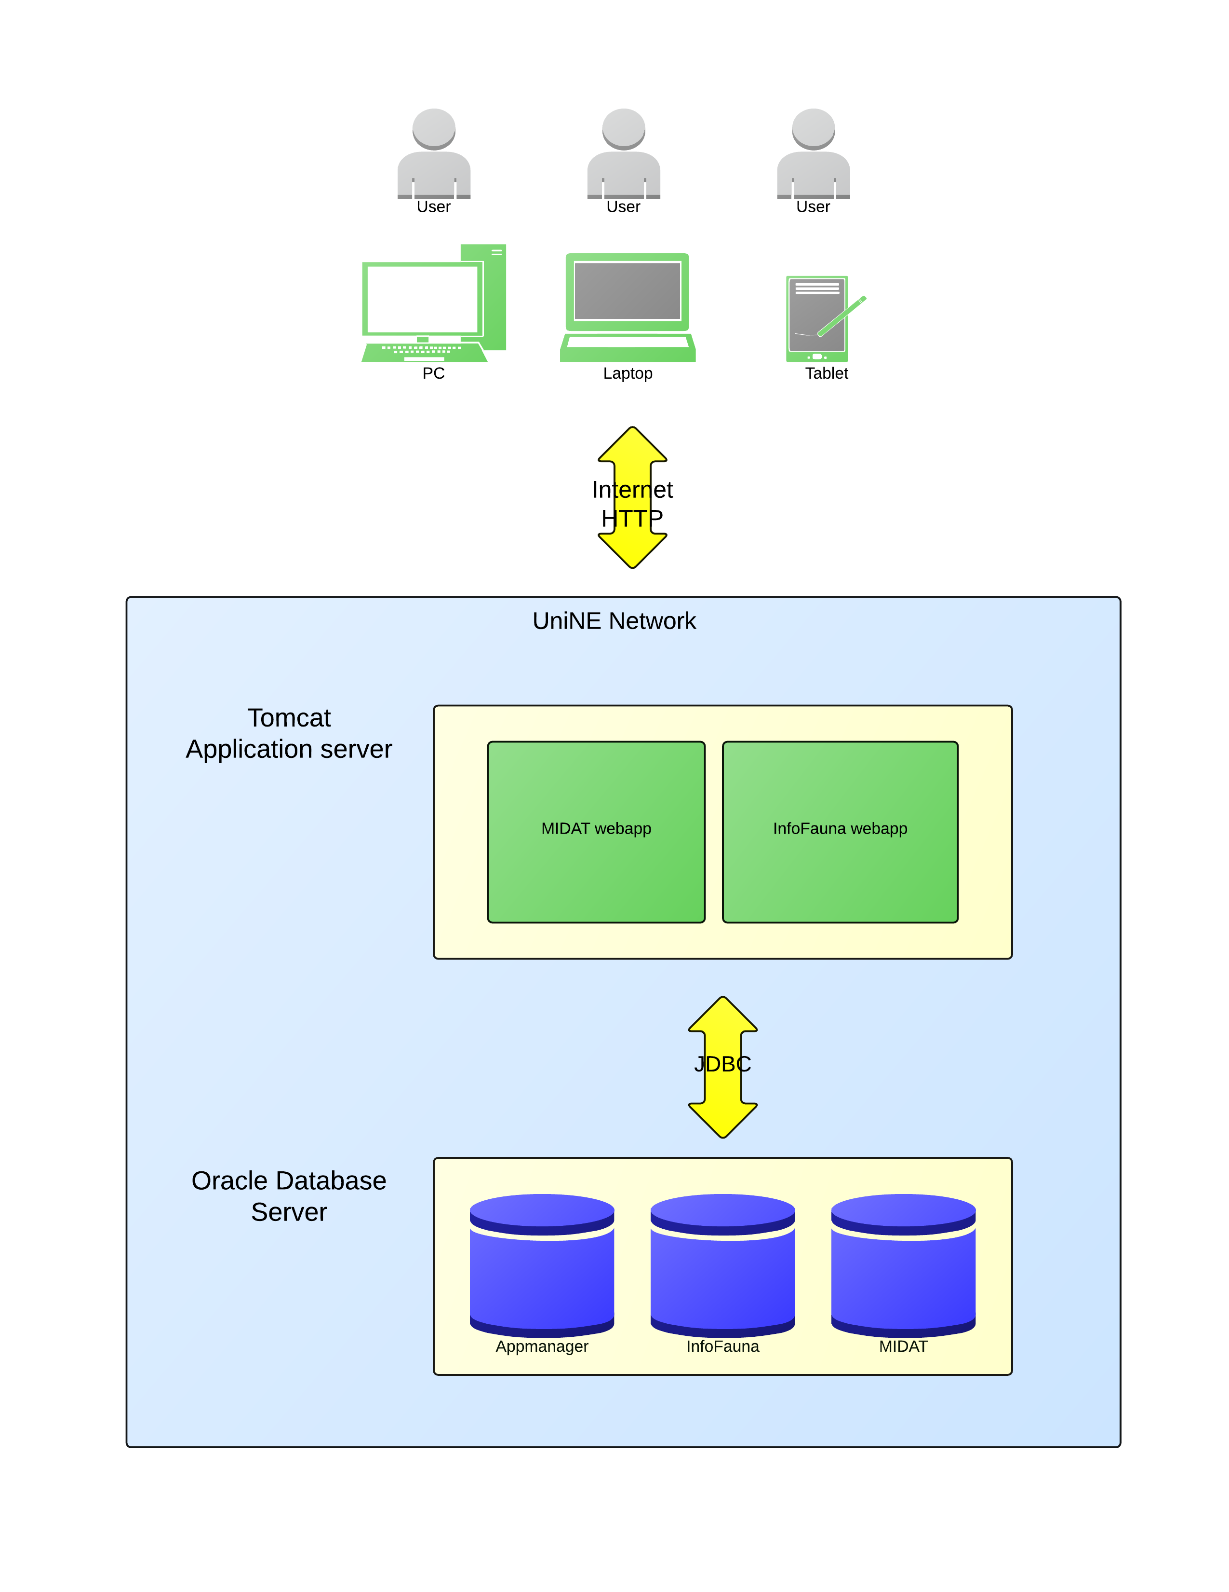
Figure 1 - High level architecture
The system consists of an Oracle database server containing several relevant schemas, and of one or more Tomcat servlet containers containing webapps (currently 2 webapps, but this number could increase in the future) which are accessed over the internet by the users.
The server infrastructure is hosted on the UniNE network. The applications will be accessible from anywhere on the internet.
The project is designed so that adding a new application (an example : in the future, WebFauna will have to be migrated to this new infrastructure) will be relatively easy, and avoid a lots of code duplication by reusing the existing code for functionalities that already exist in the other apps.
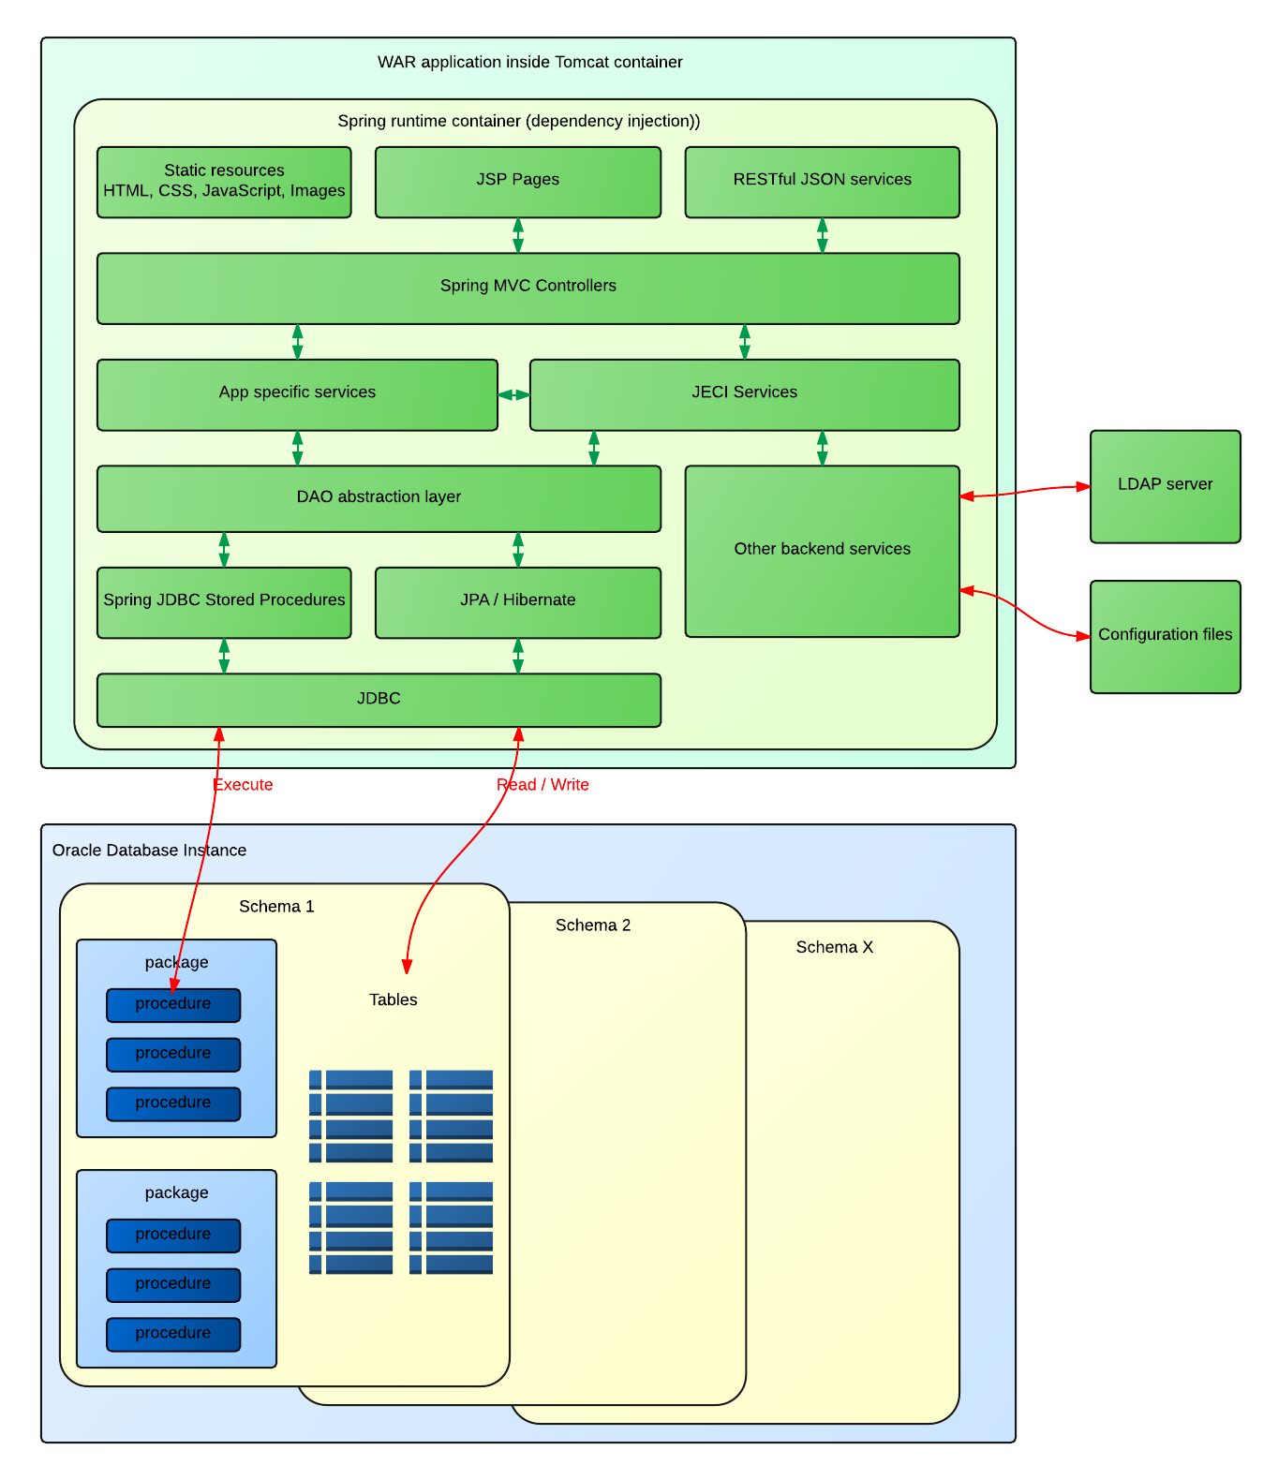
Figure 2 - Software architecture
The above figure shows the software architecture of a JECI application (at the time of writing, both existing applications share the exact same architecture).
As a JEE WAR web application, the webapp is hosted inside a Tomcat container.
The application’s objects are managed using the dependency injection mechanisms provided by the Spring core framework.
At the lowest level, database access is made through JDBC. However the application does not make JDBC calls directly. Instead there is a mix of JPA/Hibernate (Hibernate is mostly used as a JPA implementation), and stored procedures calls through the abstraction provided by Spring JDBC.
The apps access several different schemas in the underlying database.
The different methods are abstracted by a series of DAO interfaces facing upwards.
The persistence layer (DAO + SP + JPA + JDBC) is common for both webapps. I.E. the same source code is compiled and embedded in both applications.
On top of the persistence layer is the service layer. There is a common service module that is the same for all apps, and a set of specific services that are specific to each app. The app services an make calls to the common services but the opposite is not true.
The service layer implements all business logic above the simple CRUD and page navigation. In order to avoid the needless proliferation on the service layer of dumb methods doing simple proxying to the DAO layer, direct calls from controllers to DAOs are authorized, only for simple cases. Where chaining of calls and extra logic is needed, there will always be a service method to implement it.
Finally on top of the service layer is the MVC controller layers, implemented using the Spring VMC framework.
There are two types of MVC controllers :
- Classic MVC page request controllers that are used to navigate pages and submit data using HTML forms
- RESTful JSON controllers that provide access to the domain in a REST-like manner (currently it doesn’t implement a fully restful API but this could be improved in the future)

There also is a bunch of services that access external sources such as LDAP and configuration files using different backend technologies.
Currently the client can only be the web browser and client web application through JavaScript, but in the future the REST aspect could be improved to allow other types of clients such as mobile native apps.

Technology overview
This section presents an overview of the different technologies used, including platform, frameworks and libraries.

Java
The main programming language and platform for the server-side is Java. A number of libraries and frameworks are used :

JDK
The project is based on Java 8. So a JDK 8 or above is required.

Servlet API
For the web part it is based on the JavaEE Servlet Specification version 3.0.

Spring
Spring is heavily used throughout the project. It is primarily used as a runtime container providing dependency injection and some aspect oriented features (e.g. transaction management).
The version of Spring is 4.0.

JUnit
Junit is the framework used for unit testing.

Hibernate
Hibernate is the JPA implementation used in the project.

Hibernate Spatial
In order to allow spatial queries, we use Hibernate Spatial, an Hibernate plugin that dds these capabilities to Hibernate.

Hibernate validator
The Hibernate Validator is used as the JSR 303 Bean Validation implementation for validation of form type objects.

QueryDSL
QueryDSL is a library that provides a DSL (Domain Specific Language) for building complex queries in Java. We use it on top of JPA to build criteria for searching entities. It is easier to use than the JPA criteria API.

Apache Shiro
Apache Shiro is the Security framework that provides access and permissions control in the app.

SLF4J and Logback
SLF4J is a logging façade library that is widely used in the Java world, and Logback is the native implementation of SLF4J. We use both four our logging needs.

Guava
Guava is a general purpose Java library made by Google. We use some paets of it, notably the useful collections types such as MultiMap.

Jackson
Jackson is the JSON livrary used to serialize objects to JSON (and in the future to deserialize objects from JSON to Java).

Tiles
Tiles ia a web library that allows to define layouts without repeating HTML code in the JSP pages.

Web

Twitter Bootstrap
Twitter Bootstrap is the CSS framework used to build the layout of the webapps. It provides easy to use layout methods including responsive features. It allows us to build a clean and modern looking UI without wasting too much time on it.

Less CSS
Less CSS is a CSS tool that extends the CSS language and allows useful features such as variables and improves the syntax. Less files are then compiled to CSS files at build time.

Font Awesome
Font Awesome is a nice free scalable vector icons set thatr can be customized using CSS.

JQuery
Well, JQuery, you know…
We still use version 1.x in order to maintain broad compatibility of older browsers.

JQuery UI
We also use JQuery UI for some components such as date pickers.

jqGrid
jqGrid is a JQuery plugin to build dynamic AJAX-powered tables with features such as paging and sorting.

Noty
Noty is a jQuery plugin used to display notifications to the user.

Mustache JS
Mustache is a templating system that is used together with JQuery to do client-side rendering of data received via JSON.

Angular JS
Currently, a part of MIDAT is implemented using Angular JS. It is a very powerful JS MVC framework that simplifies the building of dynamic single page apps.
In the future, Angular JS must be favored over the classic JSP with JQuery approach.

Angular UI
Angular UI is a set of extensions to Angular. Currently we use the Angular UI Bootstrap module that simplifies the integration of Angular and bootstrap.

trNgGrid
This is an Angular directive that allows to build dynamic tables with paging, sorting etc.

Maven
The project is organized and built using Maven.
As it is a relatively big and complex project, it is divided into several modules, that each produce an artifact that can then be used by other modules.
All the modules have a common parent modules, named simply jeci, that defines common paramters and allow to build the project as a whole.

Modules
The following diagram shows the existing modules and their dependency relationships :
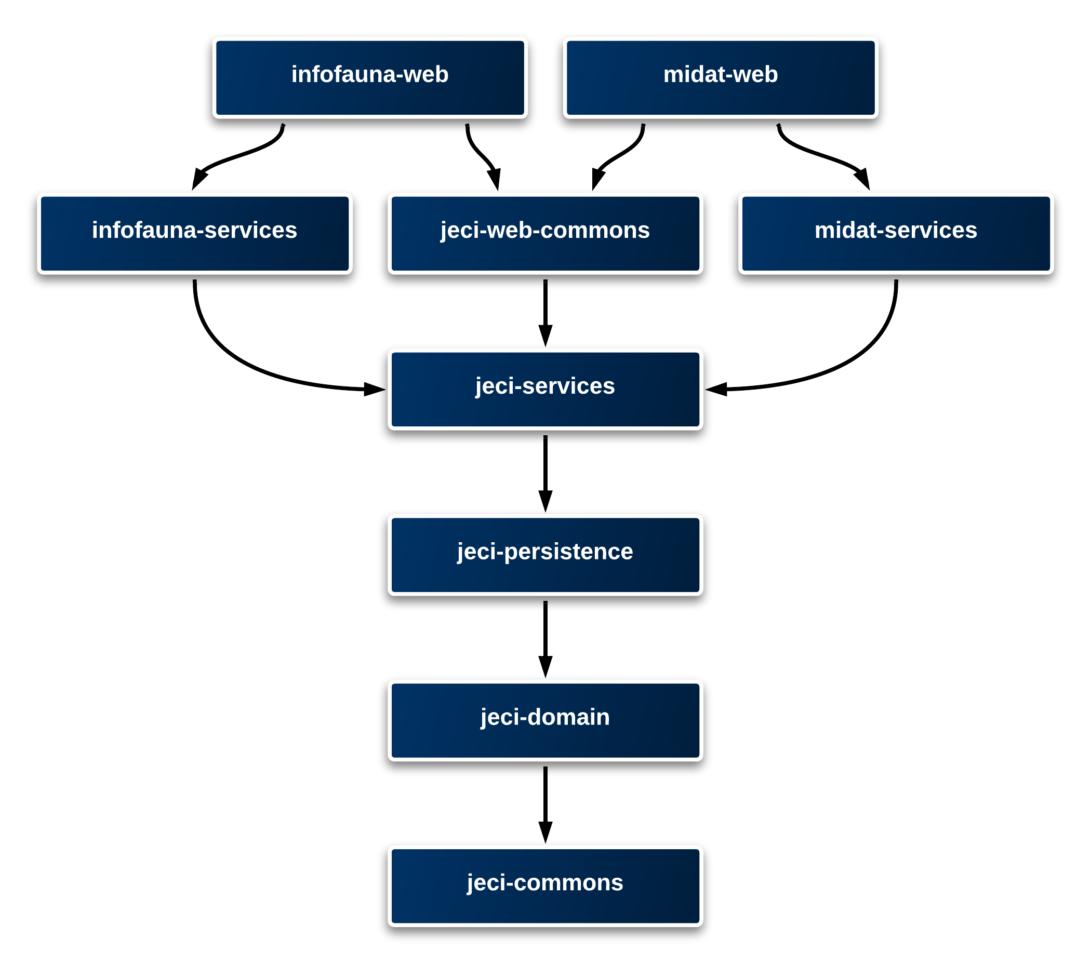
Figure 3 - Maven modules and dependencies
Here is in a few words what each module contains and/or does :

jeci-commons
It is a simple library module that contains utility classes that can be used by all the other modules.
It also contains the configuration for the profiles and the configuration files.

jeci-domain
It contains all the domain entity classes. Most are JPA entities annotated as such but there are also non-JPA entities. Most classes in this module are value objects and don’t contain much logic.

jeci-persistence
This module contains all the classes and configuration files that make the databse persistence work. There is a whole chapter about the persistence.

jeci-services
This module contains service classes that are common to all the apps. For example security services are common to all the apps.

jeci-web-commons
This module contains some generic controller and helper classes for the web functionalities.
It also contains all the static resources used for the web part. It also has the Less CSS files and its build includes the Less plugin to compile the less files into CSS :
<plugin>
<groupId>org.lesscss</groupId>
<artifactId>lesscss-maven-plugin</artifactId>
<version>1.7.0.1.1</version>
<configuration>
<outputDirectory>${project.build.directory}/${project.build.finalName}/resources/css</outputDirectory>
<compress>false</compress>
<force>true</force>
<includes>
<include>styles.less</include>
</includes>
</configuration>
<executions>
<execution>
<goals>
<goal>compile</goal>
</goals>
</execution>
</executions>
</plugin>
This module uses the war packaging. As such, it is not merely used as a dependency by the other web modules, but it is applied as an overlay, which copies all the static resources into the other project.
See : http://maven.apache.org/plugins/maven-war-plugin/overlays.html

infofauna-services
This module contains the service classes that are specific to the Infofauna app.

infofauna-web
This modules contains the actual Infofauna webapp. It is a war module. Since it depends on the common web module, most static files and some Java classes are inherited from it.

midat-services
This module contains the services that are specific to the MIDAT webapp.

midat-web
This modules contains the actual MIDAT webapp. It is a war module. Since it depends on the common web module, most static files and some Java classes are inherited from it.

Build number plugin
We use the buildnumber-maven-plugin in order to generate a build number variable, based on the SVN revision

Repositories
The following repositories are added to the parent POM file :
- Java.net for the JEE6 Artifacts
- SpringSource for the Spring atrifacts
- OSGEO GeoTools for the GeoTools library that is used with Hibernate Spatial
- Hibernatespatial.org for the Hibernate Spatial extension
- Version99 is a repository that contains “blank” artifacts. It is used with SLF4J, in order to exclude the commons-logging library and allow the SLF4J classes to be used instead. See http://www.slf4j.org/faq.html#excludingJCL

Profiles
In order to manage different configurations for different runtimes, we implemented Maven profiles.
The profiles are defined in the pom.xml at in the root project :
<profiles>
<profile>
<id>dev</id>
<properties>
<environment>dev</environment>
</properties>
</profile>
<profile>
<id>test</id>
<properties>
<environment>test</environment>
</properties>
</profile>
<profile>
<id>prod</id>
<properties>
<environment>prod</environment>
</properties>
</profile>
</profiles>
Each profile defines a value for the environment property.
This property is then used in the other POM files to copy various resources.
The content of the profiles is defined in the jeci-commons project :
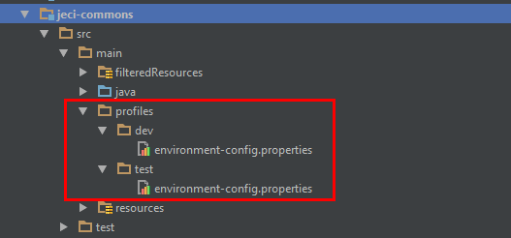
Figure 4 - Profiles content
There is a profiles directory, that contains a folder for each named profile.
Currently the profile-specific resources are only a single configuration file, named environment-config.properties. This config file contains configuration values that are specific to a given profile. There is also a common config file that is situated in jeci-commons/src/main/resources/config/default-config.properties.
The file for the selected profile is copied in the build process of the jeci-commons module :
<!-- Config file from active profile -->
<resource>
<directory>src/main/profiles/${environment}/</directory>
<targetPath>config/</targetPath>
<includes>
<include>environment-config.properties</include>
</includes>
</resource>
The environment variable is also used in the WAR modules’ build, to name the resulting war files accordingly to the selected profile:
<warName>${project.build.finalName}-${project.version}-${environment}</warName>

How to build

Prerequisites
You need Maven 3 installed on you machine. To check if it is available try running the command mvn from the command line.
The following artifacts must be installed in your local Maven repository or available in your own repository manager such as Artifactory :
The oracle JDBC classes :
<dependency>
<groupId>com.oracle</groupId>
<artifactId>ojdbc14_g</artifactId>
<version>10.2.0.5</version>
<scope>provided</scope>
</dependency>
Object2Map (see Object2map) :
<dependency>
<groupId>ch.unine.sitel.Object2Map</groupId>
<artifactId>Object2Map</artifactId>
<version>1.0-SNAPSHOT</version>
</dependency>

Build
If you are using and IDE to build the project, then use the IDE’s way of calling the Maven build file.
From the command line, go to the root of the project and run the following command (replace test with the desired profile :
> mvn –P test clean install
This should run the build for the whole project.
Some unit tests are dependent on the database being accessible, and containing some specific records. In order to run the build without the unit tests, add the skipTests switch :
> mvn –DskipTests=true –P test clean install
The final WAR files will be found in the distribution module :
distribution\target\distribution-${version}-distro\
For example :
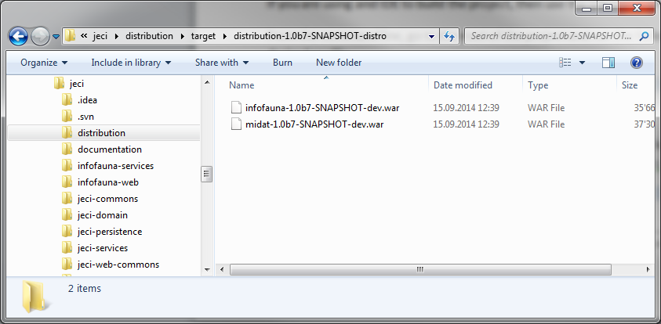
Figure 5 - Build result

Common domain model
This section describes the common domain model that contains entities that can be used by other modules.

Thesaurus
The thesaurus is a set of entities that provide storage of multilingual values, regrouped by realms.
For example you have a realm CANTON that contains values for each Swiss canton. Each value has a translation for all supported languages.
Realms and values are identified by a human readable code, in addition to a database generated ID.
Here is a simplified entity diagram of this important domain :
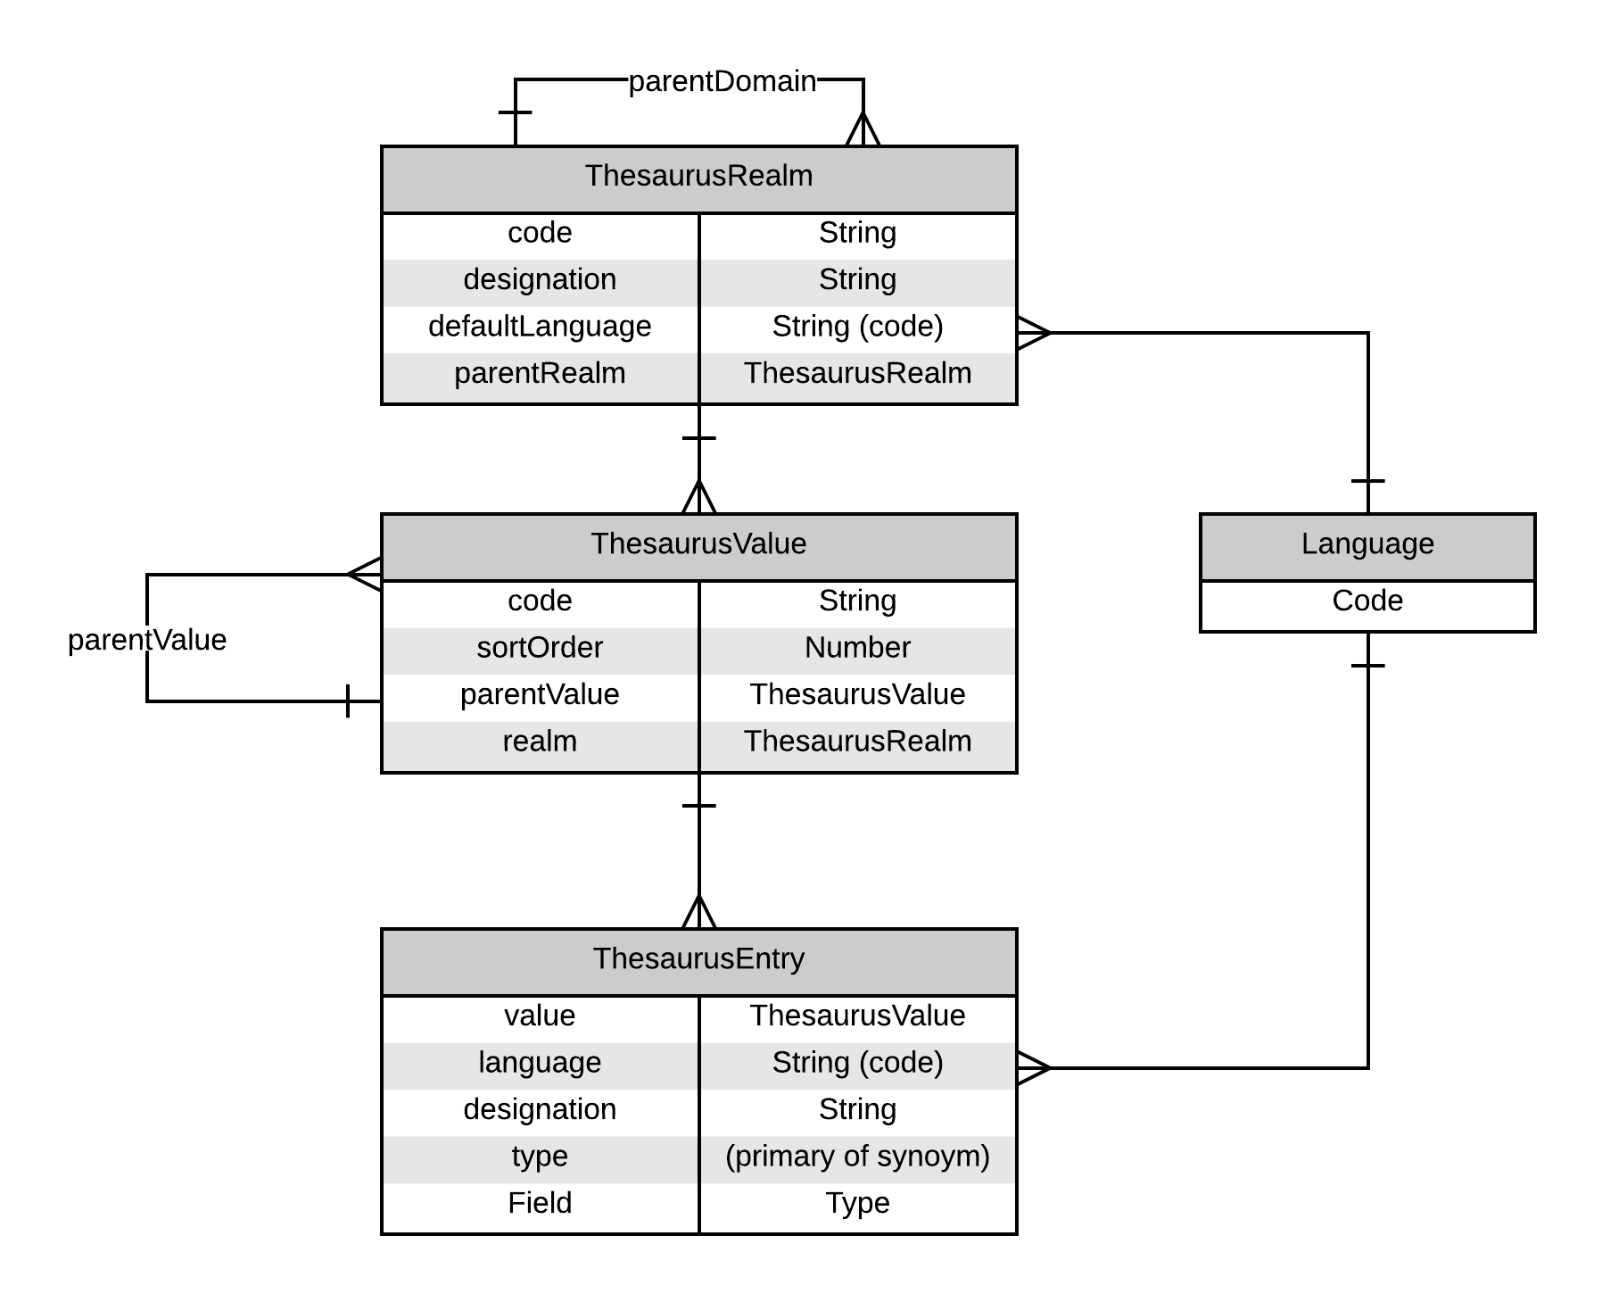
Figure 6 - Thesaurus entity diagram
Note the following points :
- A domain can define a parent domain
- A value can have a parent value, that must belong to the domain defined as the parent of the given domain. E.g: The PROVINCE domain could be the child of the COUNTRY domain. Each PROVINCE value would have a COUNTRY value as the parent.
- There can be several entries for the same value in the same language. One will be difned as primary and the other(s) as synonyms

Systematics
The systematics is another important part of the domain.
It is used to store information about the systematics, in the biology sense, also known as taxonomy : the hierarchic classification of living things, from the more general kingdom (Plants, Animals, Fungi etc.) to the most precise (species and sub-species).
The entities are quite similar to the thesaurus. First the taxonomic ranks define the hierarchy of ranks, from kindom to sub-species. There are about 20 levels, such as class, order, family etc. Each taxonomic rank has a parent, except the highest kingdom. It forms a chain so there can be no rank with 2 children.
Then, come the taxon. Each rank can contain several taxons. Taxons are linked to each other via a parent-child relationship. A taxon can refer as a parent only to another taxon belonging to a higher taxonomic rank. But it doesn’t always have to be the immediate next superior rank.
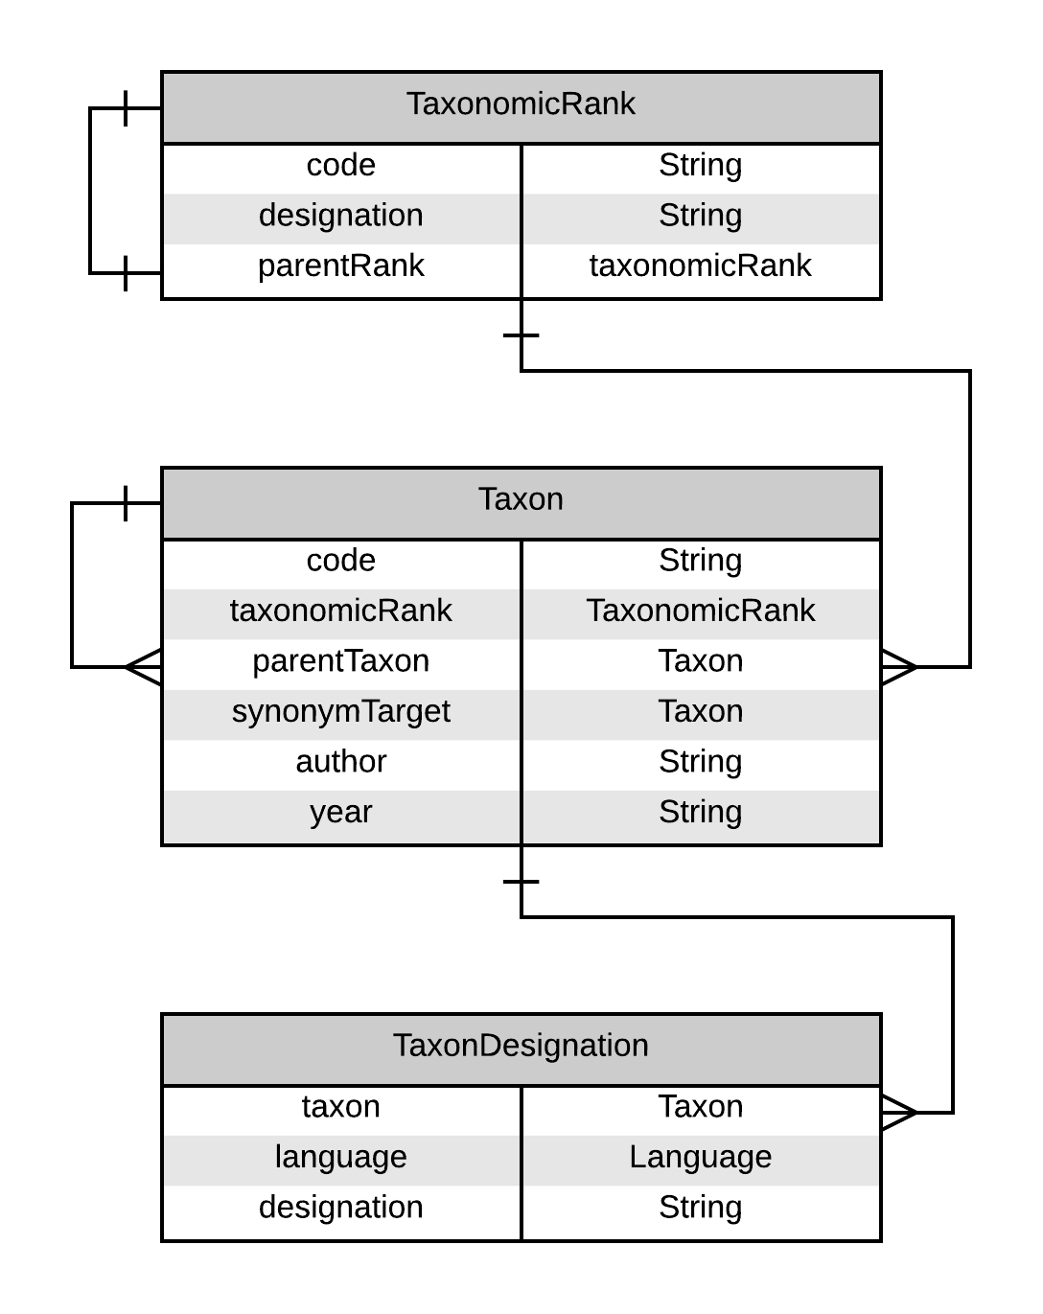
Figure 7 - Thesaurus entity diagram

Users, persons and institutions
The following diagram describes the part of the domain including the persons, entities and security-related entities :
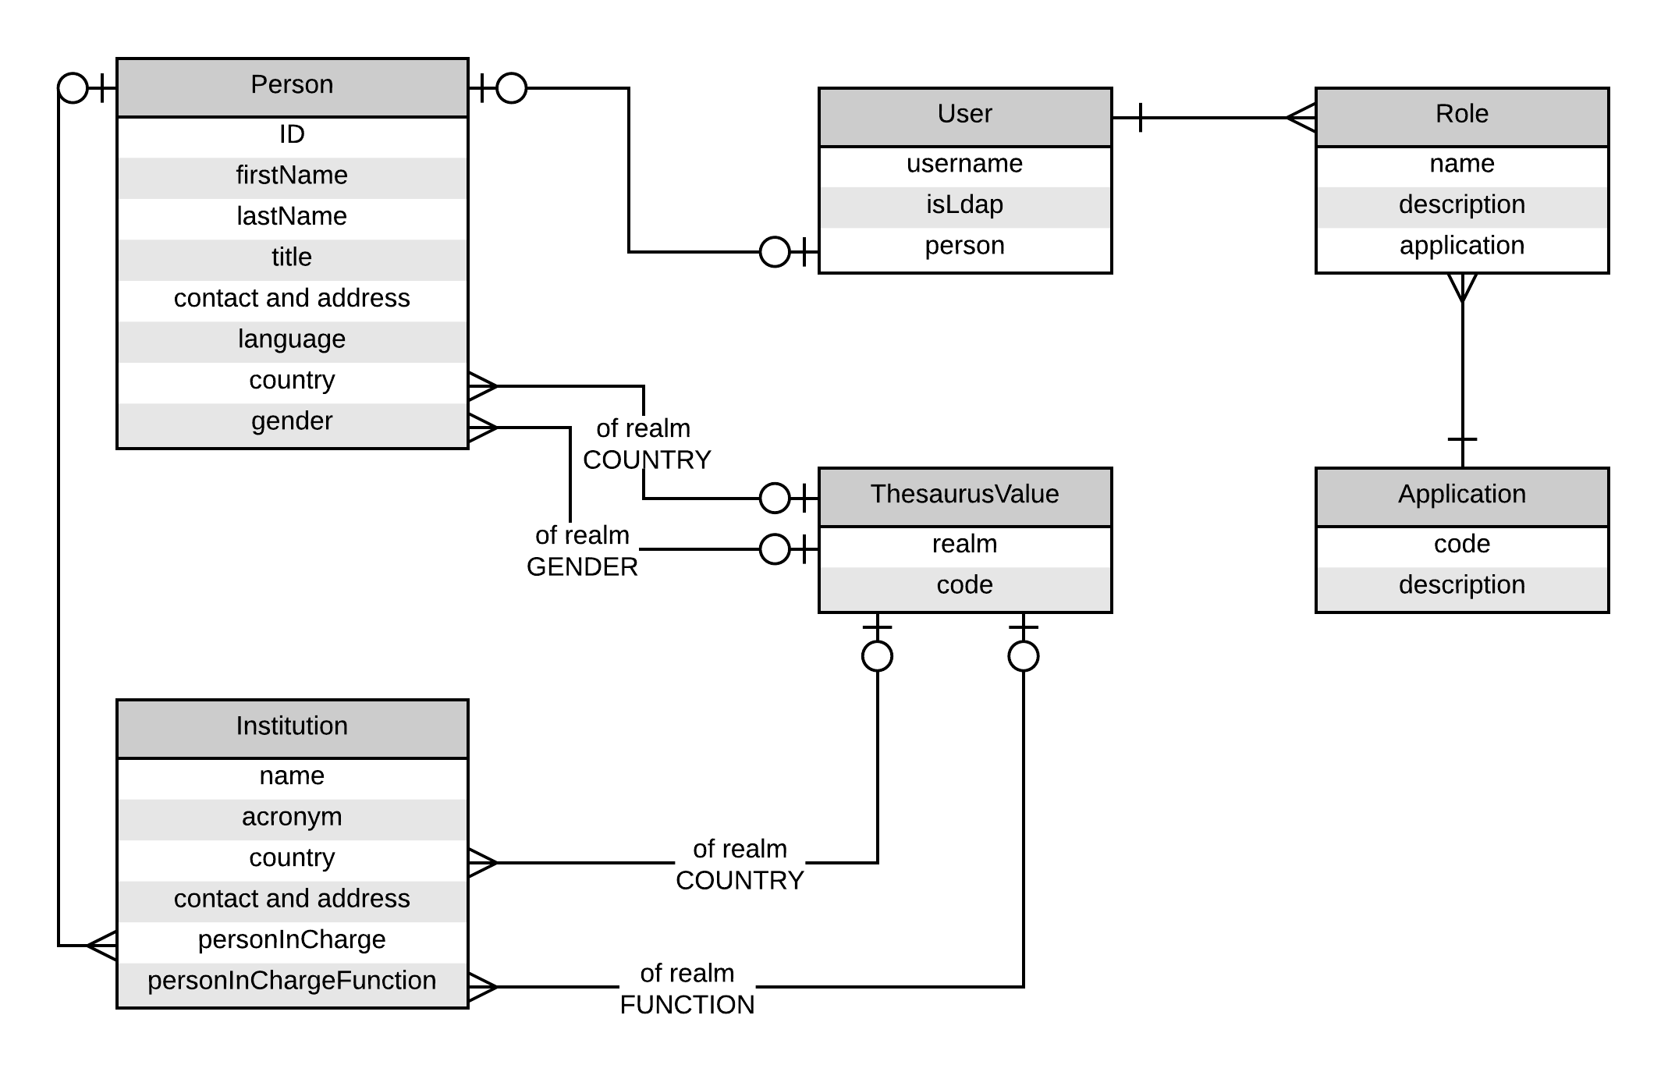
Figure 8 - Persons, institutions and security ERD
The meaning of these entities is quite straigfht-forward. Here are a few points to be aware of :
A user might or might not be related linked to a person. It is totally possible to create a user using just a username.
A user has one or more roles that define what he can do in the applications. Each role belongs to an application, so if we might have for example 2 roles named admin, one applying to the midat app and the other to the infofauna app.
Institution defines a person that is in charge of it. It also defines a thesaurus value for the exact function of this person inside the institution. For example “John Doe is responsible of the institution CSCF with the function Director”.

Object2map
Object2Map is a simple library that I wrote to simplify the generation of JSON representing a Java Object from a web service. (Actually it is used for JSON but could be used for other serialization techniques as well)
It allows to generate a map that represents an object in a tree-like structure. The root map contains String keys that are mapped to values that can be either a “primitive” or “atomic” data-type, or, in turn, a map.
The advantage of the library is that it allows the user to specify at runtime which properties have to be included in the resulting map, including nested properties.
Example use case : you have a Person class representing a person, with some simple attributes (ID, name, address etc.) and nested objects, such as Employer, and a Collection of Vehicles. The Employer itself has a list of Persons that are its employees.
Now the first problem is that if you just pass the Person object to a JSON library, e.g. Jackson, it will probably raise an exception because there will be a cycle in the object graph (personemployerperson…).
Also, for some requests you will need the whole object graph Person + Employer + Vehicles, just without the Employer’s Collection<Person> Sometimes, just the ID and name will be all that is needed (for a select menu for example). So you need a way to specifiy which fields will be included (or excluded).
One way is to add annotations to the model classes. It works well but is quite inflexible. You cannot change easily which fields are included on which occasion.
Another way is to use DTOs, with a reduced set of properties. And to do the mapping either manually or with a framework that automates the mapping such as Dozer. But it is either very verbose or adds quite some complexity.
Object2Map allows you to convert your Person object to a Map<String, Object> specifying the properties you want included. You can specify it using three methods :
- Default (Only maps simple and simple collection properties, depth of one, no nested objects.)
- Nested properties depth (you specify that the tree walking process will go X levels deep from the root object, including all properties it finds)
- Specify the exact properties (including nested ones)
  - Using a map of properties objects
  - Using a list of string property names
  - Using a descriptor in JSON-like format

Object2Map also supports nested collections. You can also specify if you wish to use only JavaBeans properties (getters/setters), or also include private fields.
The project can be found here on SVN: https://svn.unine.ch:8443/svn/SITEL/Object2Map
Currently it is still in version 1.0-SNAPSHOT. So it must be checked out and built using Maven to install the library on the local repository.
Eventually the goal is to have numbered releases that can be deployed to our Artifactory repository.

Spring contexts
The project being based on Spring, there are a number of Spring context defined throughout the Maven modules :
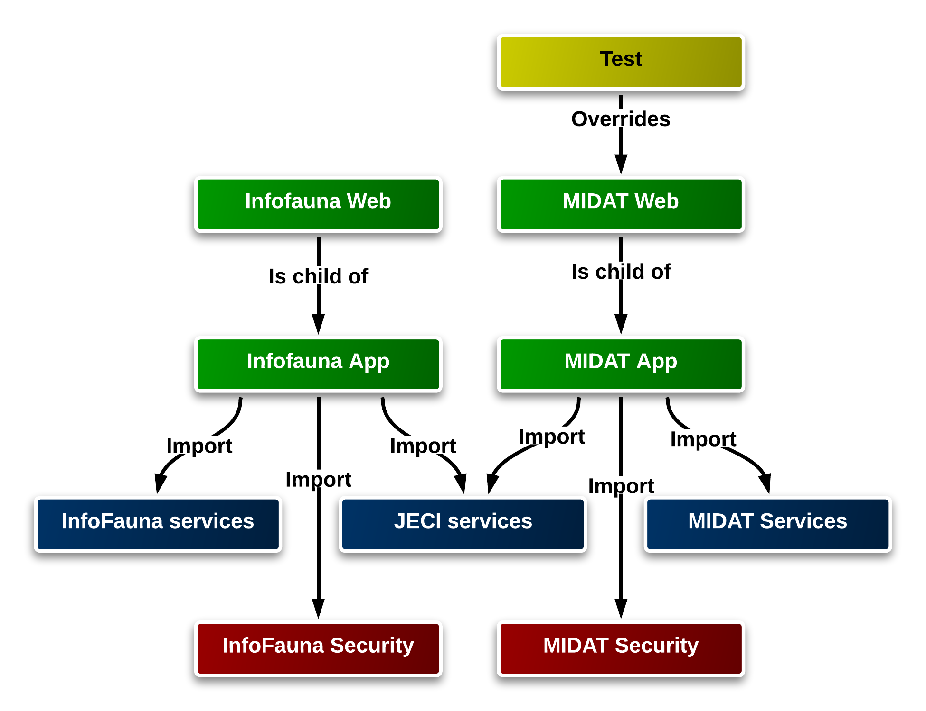
Figure 9 - Spring contexts
First are the Services modules, one the is common (JECI) and one for each app. These contexts contain all the services and persistence beans configurations.
Then the security contexts contain the configuration for the security-related Shiro beans (see Security with Apache Shiro) for each app.
In turn, the application contexts are just containers that import the services and security contexts, in order to avoid repetition of the beans defined in the common services context.
The app contexts are configured in the web.xml file of each application to act as the root context of the app :
<!-- Spring context -->
<context-param>
<param-name>contextConfigLocation</param-name>
<param-value>
classpath*:META-INF/midat-app-context.xml
</param-value>
</context-param>
Then the web contexts are the ones that contain all the web-related beans, MVC classes etc. They are specified to the Spring dispatcher servlet also in web.xml :
<!-- Spring dispatcher servlet - creates Spring web context -->
<servlet>
<servlet-name>SpringMVCDispatcher</servlet-name>
<servlet-class>org.springframework.web.servlet.DispatcherServlet</servlet-class>
<init-param>
<param-name>contextConfigLocation</param-name>
<param-value>WEB-INF/midat-web-context.xml</param-value>
</init-param>
<load-on-startup>1</load-on-startup>
</servlet>
This means that the beans defined in the web context will have access to all the beans defined in the application context, but not the opposite. It ensures a nice separation of layers.
Finally, the test context is used in the integration tests. It overrides some of the beans, such as the datasource of the app. See Unit tests.

Configuration placeholder
In the JECI services context, we define a property placeholder bean :
<!-- Load configuration files and allow '${}' style placeholders -->
<bean class="org.springframework.context.support.PropertySourcesPlaceholderConfigurer">
<property name="locations">
<list>
<value>classpath:config/default-config.properties</value>
<value>classpath:config/environment-config.properties</value>
</list>
</property>
<property name="ignoreUnresolvablePlaceholders" value="true"/>
<property name="ignoreResourceNotFound" value="true"/>
</bean>
This reads properties from the specified properties files, and allows to use the properties in the rest of the contexts, in the form ${property.name}, for example, se the configuration of the Entity Manage Factory in the next chapter.

Persistence
The persistence layer is common for all applications that work on top. There is only one artefact for the domain entities and one for the persistence layer (DAOs). These artefacts are used by both applications. But they are actually running twice. They are not shared at runtime. This is one of the limitations of the chosen architecture (only WAR files on Tomcat and no EJBs).
Due to the nature of the project and the fact that a good chunk of the business logic was implemented in the database as stored procedures, the persistence layer is a mix of JPA/Hibernate entites, and Stored Procedure calls that are not treated with JPA.
Hibernate is used for many operations, in general when read-only or CRUD operations are involved.
Stored procedures are used heavily in MIDAT for the data importation from Excel files to data tables.

Data Source
There is a common data source that is used for both stored procedure calls and JPA.
The datasource is defined in Tomcat’s context.xml file. The datasource is then referenced in the Spring context via JNDI :
<!-- JDBC data source : JNDI lookup, the connexion is configured in Tomcat's context.xml -->
<jee:jndi-lookup id="jeciDataSource"
jndi-name="jdbc/jeciDataSource" expected-type="javax.sql.DataSource" />

DAO layer
There is a DAO layer that is constituted of interfaxces and their implementation.
The interface layer does not differentiate between JPA and SP (Stored Procedure) DAOS. The differentiation is done in the implementation. So the client code doesn’t have to worry if the work of the DAO is done using JPA or SP.
The base package for the DAO interface is ch.cscf.jeci.persistence.daos.interfaces.
Then there is one base package for the JPA DAOs implementations and one for the SP DAOS implementations:
ch.cscf.jeci.persistence.daos.jpa
ch.cscf.jeci.persistence.daos.sp

JPA Hibernate
The JPA implementation used is Hibernate, version 4.x
As far as possible, only JPA classes and annotations are used. In some cases we used native Hibernate classes :
- Type definitions for enums, see ch.cscf.jeci.persistence.hibernate.PersistentEnumUserType
- Hibernate validator constraints
- Hibernate Spatial types

Configuration
The JPA EntityManager factory is configured in the JECI services context :
<!-- JPA EntityManager factory -->
<bean id="entityManagerFactory" class="org.springframework.orm.jpa.LocalContainerEntityManagerFactoryBean">
<property name="dataSource" ref="jeciDataSource"/>
<property name="persistenceUnitName" value="mainPersistenceUnit" />
<property name="jpaProperties">
<props>
<prop key="hibernate.dialect">${persistence.hibernate.dialect}</prop>
<prop key="hibernate.show_sql" >${persistence.hibernate.show_sql}</prop>
<prop key="hibernate.format_sql" >${persistence.hibernate.format_sql}</prop>
<!--<prop key="hibernate.spatial.connection_finder" >ch.cscf.jeci.persistence.hibernate.DBCPPooledConnectionFinder</prop>-->
<prop key="hibernate.spatial.ogc_strict" >false</prop>
</props>
</property>
</bean>
It uses the datasource defined above.
The corresponding persistence.xml file is :
jeci\jeci-persistence\src\main\resources\META-INF\persistence.xml
This is where the persistence unit is defined and the entity classes are linked.
There is also a TransactionManager that is used for Spring transactional support, based on the EntityManager factory:
<!-- Transaction manager based on JPA -->
<bean id="transactionManager" class="org.springframework.orm.jpa.JpaTransactionManager">
<property name="entityManagerFactory" ref="entityManagerFactory"/>
</bean>

Entities
The base package for the entities is ch.cscf.jeci.domain.entities in the jeci-domain project. Not however that this package and its sub-packages also contain model classes that are not JPA entites.
The Entities are annotated using JPA annotations.
There is an abstract base entity class that defines properties and mappings that are common to all entity classes :
ch.cscf.jeci.domain.entities.BaseEntity
This class contains the ID field, the status field (for soft delete), and the auditing fields.
However, as the names of these fields are unique on each DB table due to the prefix convention that is in use in the DB (i.e. Each table has a 3 letters prefix that is added in front of every column name, so for example ID becomes SPH_ID in the SAMPLEHEADER table, and , SST_ID in the SAMPLESTATION table), each class that extends the BaseEntity must override the mapping for these fields with the name. For example for the Person class :
@Entity
@Table(
name="PERSON", schema = "INFOFAUNA"
)
@AssociationOverrides( {
@AssociationOverride(name="creationUser", joinColumns=@JoinColumn(name="PER_USR_ID_CREATE")),
@AssociationOverride(name="updateUser", joinColumns=@JoinColumn(name="PER_USR_ID_MODIFY"))
})
@AttributeOverrides({
@AttributeOverride(name = "id", column = @Column(name = "PER_ID")),
@AttributeOverride(name = "status", column = @Column(name = "PER_STATUS")),
@AttributeOverride(name = "creationDate", column = @Column(name = "PER_USR_CREATE_DATE")),
@AttributeOverride(name = "updateDate", column = @Column(name = "PER_USR_MODIFY_DATE")),
@AttributeOverride(name = "dbCreationDate", column = @Column(name = "PER_CREDATE")),
@AttributeOverride(name = "dbUpdateDate", column = @Column(name = "PER_MODDATE")),
@AttributeOverride(name = "dbCreationUser", column = @Column(name = "PER_CREUSER")),
@AttributeOverride(name = "dbUpdateUser", column = @Column(name = "PER_MODUSER"))
})
@SequenceGenerator(name="idSeq", sequenceName="INFOFAUNA.SEQ_PERSON")
public class Person extends BaseEntity { … }

JPA DAO
The JPA DAOs are all located in the package ch.cscf.jeci.persistence.daos.jpa
They are based on an abstract generic DAO class that implements the basic methods suh as findById etc. in a generic way.
A concrete JPA DAO class only has to extend this class with the given generic type, and it already has all the basic functionality. Only specific methods must be implemented.
One of the functionalities offered by this generic DAO is a powerful set of list methods that provide listing with sorting by column, paging and restrictions. It simplifies the use of server-side paging and simple filtering of collections of entities.

Hibernate Spatial
Hibernate spatial is currently used in the MIDAT entity SampleStation. This class defined a place for water sampling. It has a field of type GeometricType :
@Type(type = "org.hibernate.spatial.GeometryType")
@Column(name = "SST_COORDINATES")
@QueryType(PropertyType.NONE)
private Point coordinates;
This allows to issue geolocalized queries on this entity, for example get all stations inside a given polygon. It is used for the geo-localized search in ch.cscf.jeci.persistence.daos.jpa.midat.SampleStationJPADAO#findStationsIdsInsideRectangle :
@Override
public List<Long> findStationsIdsInsideRectangle(Double west, Double east, Double north, Double south) {
Geometry rectangle = buildRectangle(west, east, north, south);

Query q = getEm().createQuery("select station.id from SampleStation station where within(station.coordinates, :rectangle ) = true", Long.class);

q.setParameter("rectangle", rectangle);
List<Long> result = q.getResultList();
return result;
}
The predicate within(station.coordinates, :rectangle ) = true is part of the org.hibernate.spatial.dialect.oracle.OracleSpatial10gDialect that includes geographical queries. The predicate is then translated into Oracle specific spatialized query.

Fix for bug in SDOPoint
There is a bug in Hibernate Spatial’s implementation of SDO_POINT (class org.hibernate.spatial.dialect.oracle.SDOPoint) : http://www.hibernatespatial.org/jira/browse/HIBSPA-117
It takes the Y value for the Z field when the Z field is present. In MIDAT, the sample stations use a SDO_POINT field with X,Y and Z coordinates where Z represents the altitude.
The fix in the code is very simple. The problem was to integrate the fix in our project until it is released in Hibernate Spatial.
The trick is to integrate the fixed source file in the commons web project. The file will be compiled, and the class file end up in the WEB-INF/classes directory of the webapp.
Since in webapps contained by Tomcat, the classloader priority of the classes directory is higher than the jar files contained in WEB-INF/lib, our own class will replace the original one.
See : http://tomcat.apache.org/tomcat-7.0-doc/class-loader-howto.html
It is obvious that this fix is a hack and as soon as the fixed JAR is released it should be used instead.

QueryDSL
The dynamic search for samples in ch.cscf.jeci.persistence.daos.jpa.midat.SampleJPADAO#search uses the QueryDSL library. This library greatly simplifies the dynamic manipulation of query predicates and is a welcome improvement over the JPA Criteria API.
See https://github.com/querydsl/querydsl/tree/master/querydsl-jpa

Auditing
TODO

Stored procedures
Stored procedures are called using an abstraction class provided by Spring JDBC :
org.springframework.jdbc.object.StoredProcedure
This class abstract calls to SP. We implemented our own abstract subclass to add general functionality :
ch.cscf.jeci.persistence.storedprocedures.StoredProcedure
This class provides some logic to handle the error codes that can be returned by the SPs.
Then each SP that needs to be called is implemented as a separate class. All the stored procedure are located in the package :
ch.cscf.jeci.persistence.storedprocedures
The implementation is really quite straightforward. It consists of defining the following elements :
Name of the procedure to be called, including schema and package name :
private static final String SQL = "midat.PKG_EXCELW.p_buildsheetlist";
Implement a constructor that declares the IN and OUT parameters of the SP and compile it :
public GetExcelSheetsSP(DataSource ds){
setDataSource(ds);
setSql(SQL);
declareParameter(new SqlParameter(ProtocolImportDAO.IN_EXCEL_FILE_BLOB, Types.BLOB));
declareParameter(new SqlOutParameter(ProtocolImportDAO.OUT_CURSOR, OracleTypes.CURSOR, new RowMapper() {
@Override
public Object mapRow(ResultSet rs, int rowNum) throws SQLException {
return rs.getString(2);
}
}));
declareParameter(new SqlOutParameter(ProtocolImportDAO.OUT_SHEET_COUNT, Types.BIGINT));
compile();
}
In case one of the out parameters is a CURSOR, we define a RowMapper that handles the cursor rows.
Define an execute method that takes any arbitrary arguments needed as inputs for the execution, sets the input parameters, executes, and handles the result :
public List<String> execute(UploadedFileInfo fileInfo){
Map<String, Object> inputs = new HashMap<>(1);

DefaultLobHandler handler;
OracleLobHandler lh = new OracleLobHandler();
lh.setNativeJdbcExtractor(new CommonsDbcpNativeJdbcExtractor());

inputs.put(ProtocolImportDAO.IN_EXCEL_FILE_BLOB, new SqlLobValue(fileInfo.getBytes(), lh));

Map<String, Object> result = execute(inputs);
return (List<String>)result.get(ProtocolImportDAO.OUT_CURSOR);
}
The results are obtained as a Map. In case we want the result of a CURSOR, it will be mapped using the RowMapper defined above and received as a List.

Oracle BLOB and files
As illustrated in the previous code extract, to pass the content of a file to SP that expects an input of type BLOB, you need to build an object of class org.springframework.jdbc.core.support.SqlLobValue. This is a class that is part of the Oracle JDBC driver. Unfortunately it is deprecated, but we couldn’t find a better way to achieve this.

Problem when Oracle packages are recompiled
In the current form, when the Oracle packages are recompiled while the application runs, there is a risk that it will stop working well and might need a restart. This is because the stored procedure objects are created at the start of the application and then re-used.

SP DAOs
The package
ch.cscf.jeci.persistence.daos.sp
Contains all the DAOS that are based on SP calls.
They contain one or more SP as private field. The SP are initialized in the constructor of the DAO. The constructor also received the data source via auto-wiring so it can pass it to the stored procedure instances.
It then has public methods that performs task by executing the stored procedure(s).
Actually, the only purpose of these DAOs is to hide the SP implementation from the layer above, so that the persistence is presented uniformly and without exposing implementation details.

Oracle JDBC proprietary
As mentioned above, the handling of cursors and BLOBs in stored procedures require the use of several proprietary Oracle JDBC class. This is why we need the Oracle JDBC driver to be included in the project, even though the creation of the connections is handled by the Tomcat Connection Pool.

Logging

SLF4J
SLF4J is a logging façade. In other words, it defines interfaces for a logging API. There are various implementations, or “bindongs” that can be used. Logback is the native implantation, i.e. it implements the SLF4J interfaces natively. Other implementations redirect the logging statements to another underlying library such as Log4J or Commons.
In our configuration, LogBack is the implementation that is used. We then use “bridges” to redirect the logs of external libraries that use legacy APIs (Log4J and commons-logging) to SLF4J and, as a final result, output everything through LogBack.
See : http://www.slf4j.org/legacy.html
That is why we have the following dependencies in the parent POM :
<!-- SLF4J bridge for log4j (redirects logging from log4j to slf4j -->
<dependency>
<groupId>org.slf4j</groupId>
<artifactId>log4j-over-slf4j</artifactId>
<version>1.7.5</version>
</dependency>

<!-- SLF4J bridge for commons-logging (redirects logging from java.commons.logging to slf4j -->
<dependency>
<groupId>org.slf4j</groupId>
<artifactId>jcl-over-slf4j</artifactId>
<version>1.7.5</version>
</dependency>

<!-- Exclude commons-logging from the build by overriding it with an empty JAR -->
<dependency>
<groupId>commons-logging</groupId>
<artifactId>commons-logging</artifactId>
<version>99-empty</version>
</dependency>

<!-- Exclude log4j from the build by overriding it with an empty JAR -->
<dependency>
<groupId>log4j</groupId>
<artifactId>log4j</artifactId>
<version>99-empty</version>
</dependency>
The bridges dependencies replace the original classes with classes that redirect output to SLF4J. The “empty JARs” dependencies are used to eliminate the original classes from the classpath. If we didn’t use this technique, we would have to exclude the dependency from each external library dependency that transitively or directly requires it. By replacing it with an empty JAR, the classes from the original library are not included in the classpath and are raplced by the classes from the “bridge” implementation.
See also Repositories

Logback
As mentioned above, Logback is the library through which the actual logging is done.
The application classes use SLF4J interfaces and classes, the implementations are provided by Logback.
The main interfaces used class are org.slf4j.Logger and org.slf4j.LoggerFactory.
The code to obtain a logger in a class is the following :
private Logger logger = LoggerFactory.getLogger(this.getClass());
Logback is configured through an XML file present in each application :
jeci\infofauna-web\src\main\resources\logback.xml
jeci\midat -web\src\main\resources\logback.xml
The logging is configured to use a rolling file appender that will create a file per day.
For more info about logback configuration see the official documentation : http://logback.qos.ch/manual/configuration.html

Security with Apache Shiro and SSO
The framework us d for the security aspect of JECI is Apache Shiro.
We implemented some custom components to add a simple SSO functionality.
The requirement for the SSO was simple :
Given 2 or more webapps (currently thatr would be MIDAT and Infofauna), if a user has logged in in one of the apps, and, from the same machine and the same web browser, goes to another one, he should be recognized and not have to login again.
The system only applies to the apps that are part of the project.
The implementation was done using the database as the common storage between the webapps. There are 2 columns added to the uer table :
- SSO token : this is a unique string that identifies a user. In order to simplify the implementation, we used the already existing jsession id cookie that is used to identify the session in JEE webapps.
- SSO counter : a counter that is incremented when the user initiates a session in one of the apps and decremented when the session times out. When the counter reaches 0, he is considered logged out completely again.

Here is a schema of the components that we implemented :
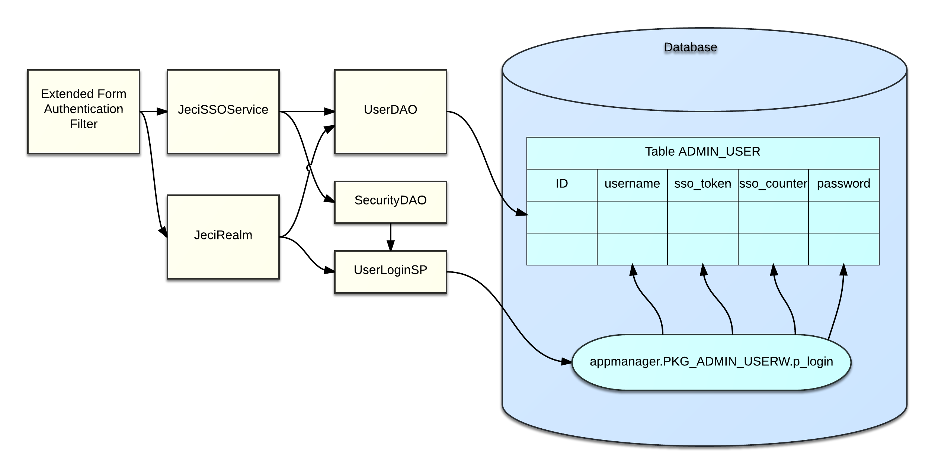
Figure 10 - Security components
The extended filter provides the higher level SSO logic while the service and the Realm provide the lower level logic of individual checks.
Here is the logic flow used to determine if a given request is considered authenticated or not :
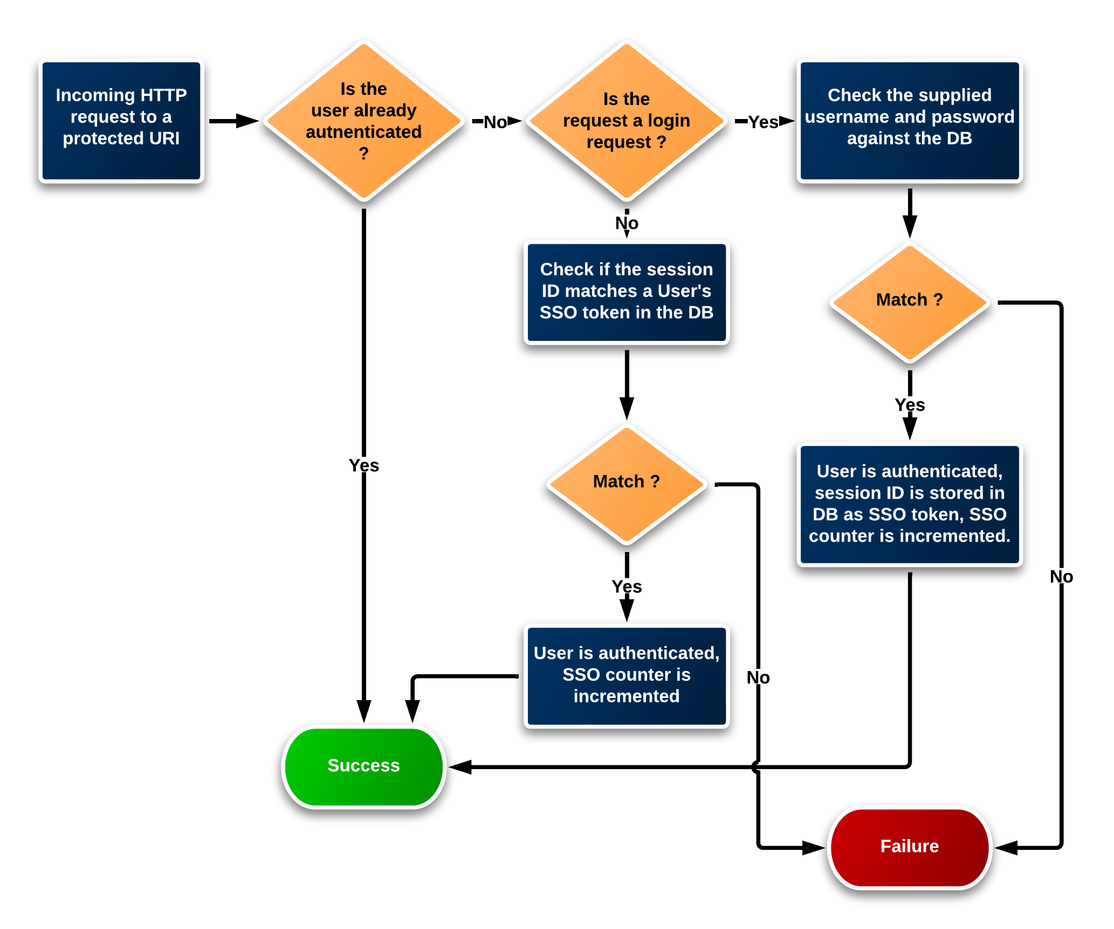
Figure 11 - Authentication workflow

Session timeout
In order to ensure that once a user was logged in, the SSO counter and timeout would eventually be reset, we implemented a session listener : ch.cscf.jeci.web.security.JeciSSOSessionListener
This listener executes when the session is destroyed. If the session is destroyed by a timeout, it decrements the SSO counter for the current user.
If the session is destroyed by an explicit log out action by the user, then the SSO token and timeout are reset.
This mechanism only works when the application keeps running until the session timeout occurs. If the application is stopped or restarted before, the timeout might never be executed. In order to ensure a clean state of the SSO system at startup, we implemented a ServletContextListener, ch.cscf.jeci.web.security.JeciSSOServletContextListener, that resets all SSO counters at startup.

Roles
Users are associated with roles. And roles are associated with an application. So during the login process, the Realm gets all the roles associated to the user AND the app for which the login is being made, and stores the role names into the AuthorizationInfo object that is then used by Shiro to check for authorizations.

Shiro filter configuration
The configuration of the Shiro filter for the web authorization is made in the bean definition in the security context :
<property name="filterChainDefinitions">
<value>
/resources/** = anon
/authentication/** = anon
/combined.css = anon
/combined.js = anon
/** = authc
</value>
</property>
Here we define URL patterns that are feely accessible (anon), (this includes static resources like images, css and JavaScript, the login page, etc.) and the rest needs authentication (authc).
URLs that are just marked with authc will be accessible to any logged in user whatever its roles in the app (but a user needs at least one role in this app to be able to log in).
For resources that needs to be restriced by role the syntax would be like this, for example to restrict a resource to the users with the role MANAGER :
/app/thesaurus/** = authc, roles[MANAGER]

Spring MVC

The jeci-web-commons project
The project jeci-web-commons defines a common layout for the web applications. It contains all the common static resources (JavaScript, images and icons, CSS, HTML templates…) and some base classes that are used in the apps. But jeci-web-commons is not a real WAR project. It cannot be built and run independently.
Instead, it is added as a dependency of the concrete WAR projects and they “inherit it” in for form of a WAR overlay. This means that all the files from the commons project are copied by Maven over the files of the final project. See more about this here : http://maven.apache.org/plugins/maven-war-plugin/overlays.html

General organisation
The web framework used is Spring WebMVC. The configuration of the different Spring modules is already described in the chapter Spring contexts.
The controllers are divided into two categories :
- the MVC application, that constitutes a “classic” MVC web application, with the Spring controllers and the View in the form of JSPs.
- The API, which constitutes a sort of REST-like web API that serves JSON data. I write REST-like because it does not respect all principles of REST, just some of them. The API is used by AJAX calls via jQuery from the JSP pages, and data access for the Angular modules.

The whole Spring MVC application is annotation-driven (all the controllers are marked with annotations).

MVC application
The MVC application controllers are based in the package ch.cscf.midat.web.controllers.app respectively ch.cscf.infofauna.web.controllers.app.
Their controller methods generally return a string value that denotes the ID of a Tile (se below).
Besides the authentication of the user, the use of the session is reduced to a strict minimum, but in some cases we used it because it was really the simplest solution.
The commons project contains a bunch of useful abstract controllers that provide common functionality for authentication, file upload, message notification, and lists with server-side pagination.

Tiles
Tiles is the library used for composing the web pages based on a common layout while avoiding code repetition. We use Tiles version 3.
There is a tiles configuration files that defines common layout in the commons project, and one for each application for app specific pages :
jeci\jeci-web-commons\src\main\webapp\WEB-INF\tiles-base.xml
jeci\midat-web\src\main\webapp\WEB-INF\tiles-midat.xml
jeci\infofauna-web\src\main\webapp\WEB-INF\tiles-infofauna.xml

Menu system
The navigation between the screens of the apps is made through a navigation menu situated at the top of the screen. In addition to this, a breadcrumb component displays the current location.
The structure of the menu is defined in a homemade XML file :
jeci\infofauna-web\src\main\resources\menu.xml
The menu is structured in groups and items, which allows an arbitrary number of sub-m,enus. The display part however limits the number of levels possible.
The class ch.cscf.jeci.web.menu.Menu is responsible for parsing this XML structure and translating into ch.cscf.jeci.web.menu.MenuElement that can be either ch.cscf.jeci.web.menu.MenuGroup or ch.cscf.jeci.web.menu.MenuItem. This class is a spring managed bean.
The bean is then exposed to the JSP through the ch.cscf.jeci.web.menu.MenuInterceptor. The JSP file menu.jsp and breadcrumb.jsp, with the help of the custom tag menuElement, render the menu as well as the current page. The id of the current menu item is set as an attribute of the tile definition.

Page numbering system
A requirement that was defined at the start of the project was that each application screen should have a distinct number or code that would allow to easily refer to a given screen or page when discussing bugs or improvements.
The page numbers are specified in the tiles definitions and displayed at the top right of the page content in the same component as the breadcrumb :
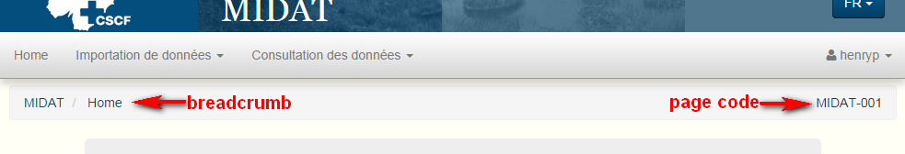
Figure 12 - Breadcrumb and page numbering

Messages notification
The abstract base controller also includes methods to add notification messages for the user. Messages can be of any of these categories :
- Success
- Error
- Notice
- Info
The messages are displayed at the top of the page. The JQuery plugin Noty is used to make the messages appear and fade out after a moment :
The messages are rendered in the JSP file messages.jsp that is included in the tiles layout. The custom JSP tag messages.tag does the actual rendering job.

Errors handling
TO DO

I18n

I18n for JavaScript

Rest API

Bootstrap and Less

JavaScript and JQuery

Unit testing

MIDAT

Domain model

Services

Webapp

Angular consultation module

InfoFauna

Users management

Persons and institutions management

Thesaurus browser

Config Tomcat

Data source
Datasource dans context.xml :
<Resource
name="jdbc/jeciDataSource"
auth="Container"
type="javax.sql.DataSource"
url="jdbc:oracle:thin:@mizar.unine.ch:1521:tfauna"
username="fauna_app"
password="fauna4onelogin"
driverClassName="oracle.jdbc.driver.OracleDriver"
maxActive="5"
initialSize="2"
poolPreparedStatements="true"
maxOpenPreparedStatements="100"
testWhileIdle="true"
removeAbandoned="true"
removeAbandonedTimeout="5000"
validationQuery="select sysdate from dual"
/>
Ne pas oublier de copier le JAR des drivers JDBC Oracle dans le répertoire lib

JSessionID
Dans conf/web.xml, ajouter l’attribut sessionCookiePath :
<Context sessionCookiePath="/" >

