Table S1- Descriptive statistics of reporting delay of SAARI notification for the 17 regional health departments of São Paulo state, Brazil, from 08/08/2021 to 06/10/2024.
drs | Q1 | Median | Q3 | Min | Max | n | mean | sd | iqr
ARARAQUARA | 1 | 1 | 2 | 0 | 106 | 4725 | 1,72 | 3,48 | 1
ARAÇATUBA | 0 | 1 | 1 | 0 | 53 | 4339 | 1,06 | 1,56 | 1
BAIXADA SANTISTA | 1 | 2 | 5 | 0 | 144 | 9967 | 4,92 | 9,69 | 4
BARRETOS | 0 | 1 | 2 | 0 | 43 | 2362 | 1,47 | 2,44 | 2
BAURU | 1 | 1 | 2 | 0 | 70 | 14153 | 1,83 | 2,81 | 1
CAMPINAS | 1 | 1 | 2 | 0 | 150 | 42876 | 1,73 | 4,01 | 1
FRANCA | 1 | 2 | 4 | 0 | 87 | 2766 | 5,73 | 11,72 | 3
GRANDE SÃO PAULO | 1 | 1 | 2 | 0 | 163 | 156154 | 2,28 | 4,63 | 1
MARÍLIA | 1 | 1 | 1 | 0 | 159 | 10861 | 1,49 | 4,76 | 0
PIRACICABA | 1 | 1 | 3 | 0 | 65 | 10711 | 2,91 | 5,31 | 2
PRESIDENTE PRUDENTE | 1 | 1 | 2 | 0 | 113 | 5555 | 1,99 | 4,64 | 1
REGISTRO | 0 | 1 | 1 | 0 | 91 | 2140 | 0,8 | 2,52 | 1
RIBEIRÃO PRETO | 1 | 1 | 1 | 0 | 107 | 12017 | 1,5 | 3,48 | 0
SOROCABA | 1 | 1 | 2 | 0 | 78 | 14487 | 1,88 | 2,86 | 1
SÃO JOSÉ DO RIO PRETO | 0 | 1 | 1 | 0 | 89 | 20760 | 0,92 | 2,53 | 1
SÃO JOÃO DA BOA VISTA | 1 | 1 | 2 | 0 | 93 | 4632 | 2,33 | 3,88 | 1
TAUBATÉ | 1 | 1 | 3 | 0 | 122 | 19884 | 3,24 | 7,35 | 2

Figure SM1- Performance of the nowcaster model in correcting reporting delay in the last four weeks of SARI hospitalization data using different window size parameters. (A) 95% and 50% prediction integral coverage (B), log of WIS, and the Dispersion component of WIS.
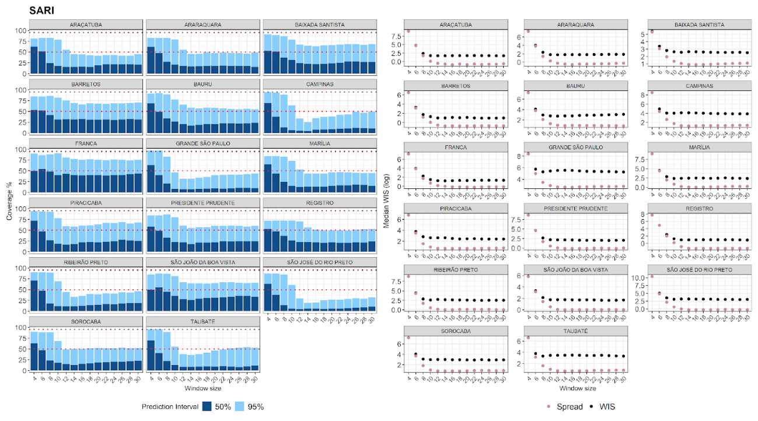

Figure SM2 – Weighted Interval Scores of SARI hospitalizations across different periods of the epidemic curve for the 14 health districts of São Paulo state, Brazil.

