**Procedure for Quality Control of ETD Metadata (from ProQuest)**

**Purpose:** Metadata has been received from ProQuest for new Masters Theses and Doctoral Dissertations (otherwise known as electronic theses & dissertations, or ETDs.) This metadata has been transformed for upload to the ISU Digital Repository. Because the metadata entry is generally done by users submitting documents without guidelines or oversight, it is fairly inconsistent. The goal of the work accomplished through these steps is to ensure accurate, uniform, and high-quality metadata for our thesis collection.

**Scope:** The dissertations in the batches this project will process typically cover a time span from 2012-present. This is because some dissertations were initially embargoed, or not made available for download.

**1.** Open your assigned spreadsheet of ETD metadata. Each row in the spreadsheet represents one ETD. The left-most column should include a URL hyperlinked to an online version of each ETD. Use this link to open one document at a time in your web browser.

**Note: If you have make a change to any cell in the spreadsheet, please highlight the cell**. A metadata librarian will be transferring your changes to the XML data, and we need to know which cells changed in order to update the data which will be uploaded into the DR.

**2. Just as you would do when copy-cataloging a book, use the title page of the ETD to confirm the accuracy of the metadata in the spreadsheet.** If any changes need to be made to a field, make them in the text of the spreadsheet, then highlight the cell you have changed. If you come across any weird character conversion errors (for example, “&#947;” instead of “γ”) you can just highlight the cell, and a metadata librarian will replace the code with the proper character.

Please check the accuracy and completeness of the following fields. You can see examples of where this data might come from on the last page of these instructions.

* **Title**

Double check that the entire title is in the metadata (especially if there is a subtitle.) Highlight any title with strange character conversion issues. If the first word of a subtitle (first word after the colon) is capitalized, please make it lower case to follow RDA conventions.

* **Author’s name (spread across the following five fields):** 
  + **First Name (author’s first name)**
  + **Middle Name (author’s middle name)**
  + **Last Name (author’s middle name)**
  + **Name Suffix (such as Jr. or III)**
  + **Rights holder (author’s full name)**

Prefer the fullest form of the author’s name, even if that comes from the metadata record and is not reflected on the title page of the ETD.

* **Document Type**

Will be one of two values: either “thesis” or “dissertation”.

* **Degree Name**

This field cannot have any abbreviations in it, so all degree names must be spelled out in their full form.

* **Major/Department and Keywords**

The department is not listed on the title page of the ETD, but the major should be. If the Department listed in the spreadsheet seems strange compared to the major or title, just highlight the cell and a metadata librarian will check it.

Add the **major** listed on the ETD title page to the beginning of the ‘**Keywords**’ field. If the major is one of the interdisciplinary majors, please also enter it in the ‘**Major**’ field.

**Interdisciplinary majors include:**

Bioinformatics and Computational Biology

Biorenewable Resources and Technology

Botany

Community Development

Ecology and Evolutionary Biology

Environmental Science

Genetics

Gerontology

Human Computer Interaction

Immunobiology

Information Assurance

Information Systems

Microbiology

Molecular, Cellular, and Developmental Biology

Neuroscience

Nutritional Sciences

Plant Biology

Seed Technology and Business

Sustainable Agriculture

Systems Engineering

Toxicology

Transportation

* **Advisor1, Advisor2, Advisor3**

Even though there may be several committee members’ names on the title page, only include as advisors names which are followed by terms such as “major professor” or “co-major professor.”

* **Institution**

Should always be “Iowa State University”, but if that’s not what’s on the title page it means ProQuest gave us someone else’s document!

* **Publication Date and Copyright Date**

The Publication Date has to be formatted 1/1/YYYY, and Copyright Date is just the four-digit YYYY year. The years on these dates should be the same. If only one is presented on the title page, accept the value for both fields.

* **Disciplines**

Briefly look at the disciplines that have been assigned to the ETD. This data came from a cross-walk, where one vocabulary was converted to another by a computer, so it could be inaccurate. Take a moment to 1) delete any duplicate disciplines and 2) check to see if the disciplines sound vaguely accurate. If you delete a duplicate or the disciplines assigned sound fishy, please highlight the cell.

You do not need to check anything with the Embargo Date or the Abstract.

**3.** Repeat this copy-cataloging process for each ETD on the spreadsheet. Notify Kelly when you have completed your work. Thank you!!

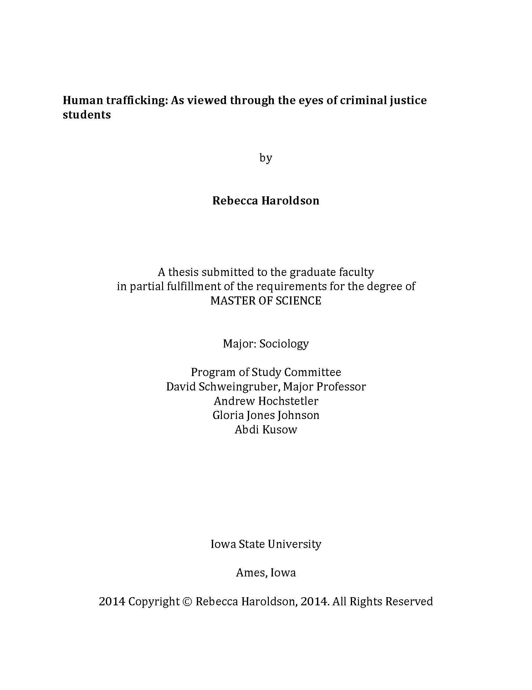

Copyright Date

Publication Date

Institution

Institution

Advisor1

If not in ‘Keywords’ field, add to ‘Keywords’ field. If interdisciplinary major, add to ‘Major’ field.

Document Type

Degree Name

First Name

Last Name

Title