**Login**

* url <http://103.94.16.226:8069/web/session/authenticate>
* header :

Accept application/json

Content-Type application/json

* Body :

{

"jsonrpc": "2.0",

"method": "call",

"params": {

"db": "plasmadb",

"login": "admin",

"password": "1@",

"context": {}

},

"id": "1"

}

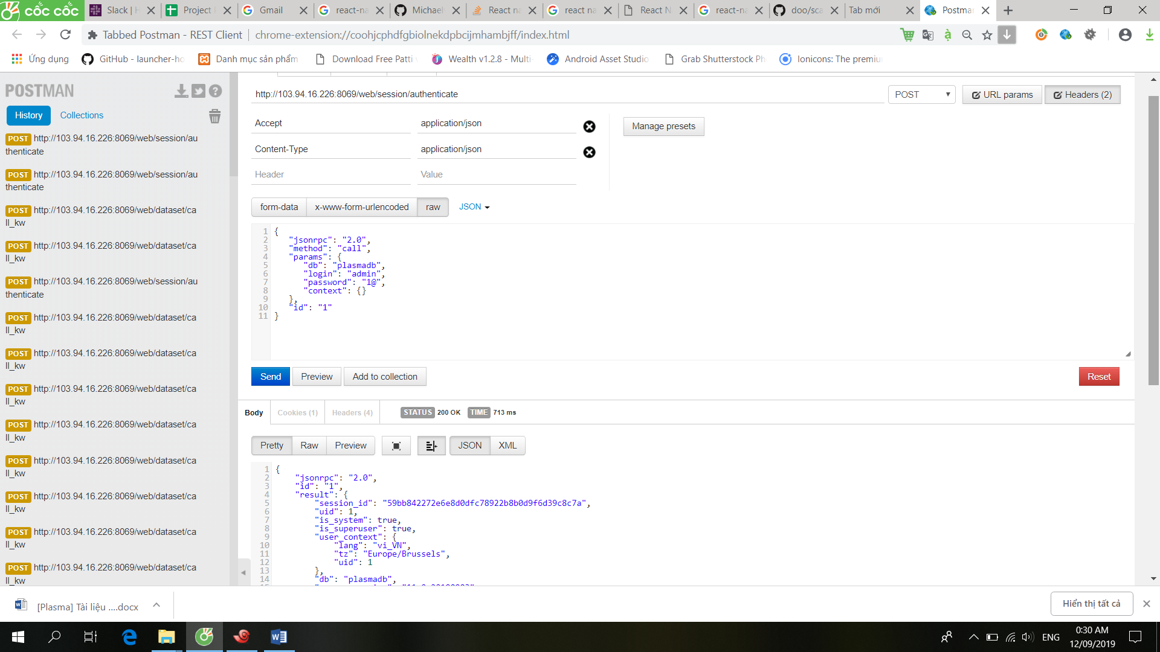

**Get list data from model**

[**http://103.94.16.226:8069/web/dataset/call_kw**](http://103.94.16.226:8069/web/dataset/call_kw)

* body

{

"jsonrpc": "2.0",

"method": "call",

"model": "res.partner",

"params": {

"kwargs": {

"context": {},

,"limit":5,"offset":0

},

"method": "search_read",

"model": "p.equipment",

"args": [

[]

],

"context": {}

},

"id": "1"

}

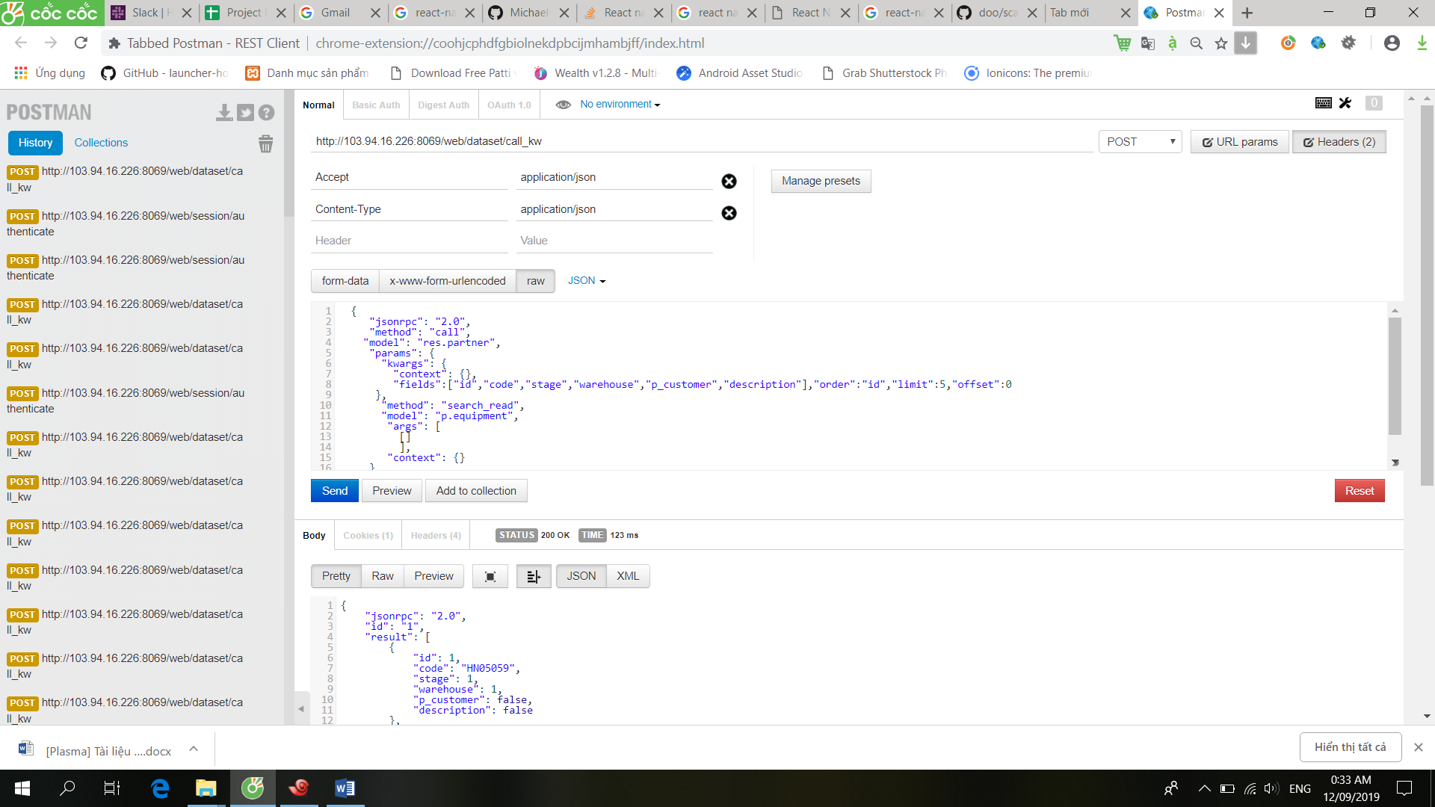

**Get data from id**

[**http://103.94.16.226:8069/web/dataset/call**](http://103.94.16.226:8069/web/dataset/call)

* header: như trên
* body :

{

"jsonrpc": "2.0",

"params": {

"method": "read",

"model": "res.partner",

"args": [<---dien id vao day ---- >]

},

"id": "1"

}

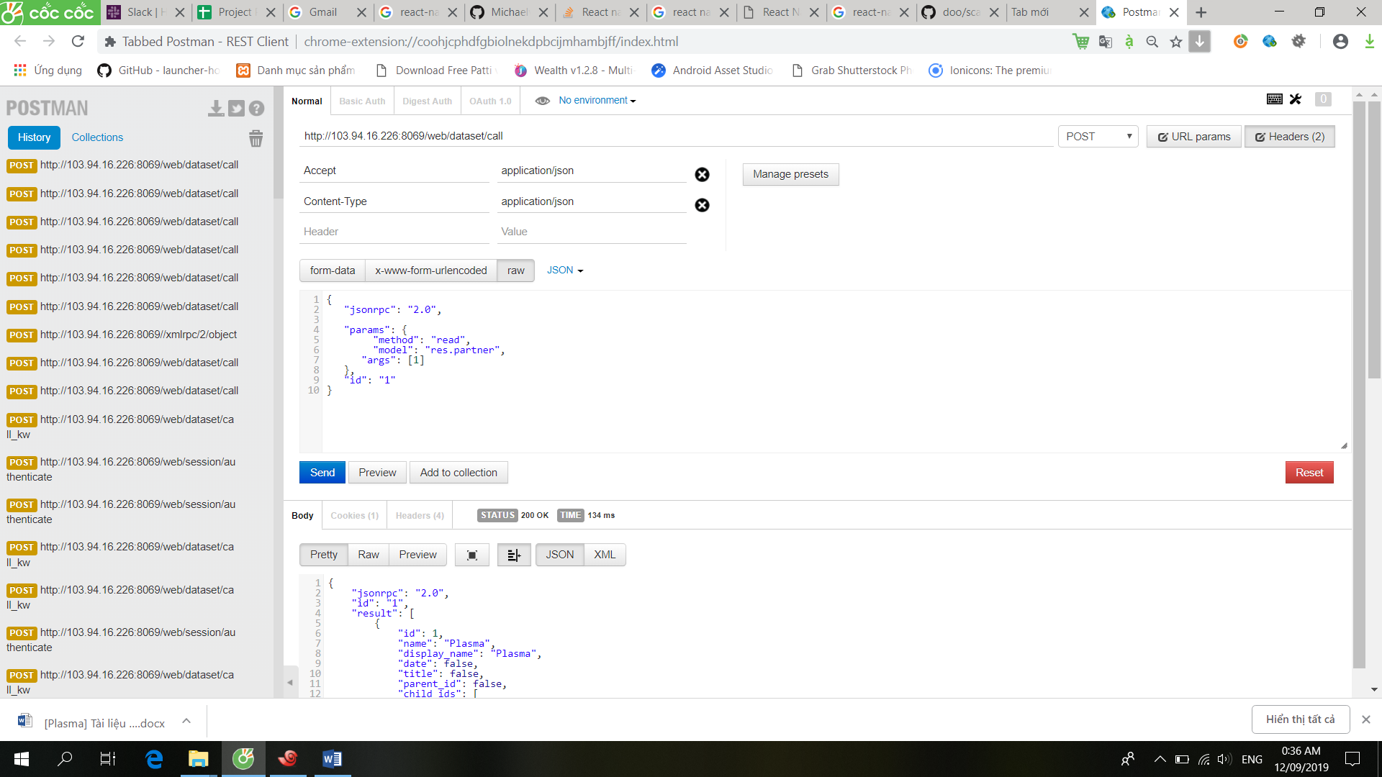

**Group by**

* Header như trên
* Body

{

"jsonrpc": "2.0",

"params": {

"kwargs": {

"context": {},

//"domain" : [["date_time", ">", "2019-09-01"], ["date_time", "<", "2019-09-30"]],

"fields": [ "p_customer" , "sequence"],

"groupby": ["p_customer"]

},

"method": "read_group",

"model": "p.order",

"args": [

[

]

],

"context": {}

},

"id": "1"

}

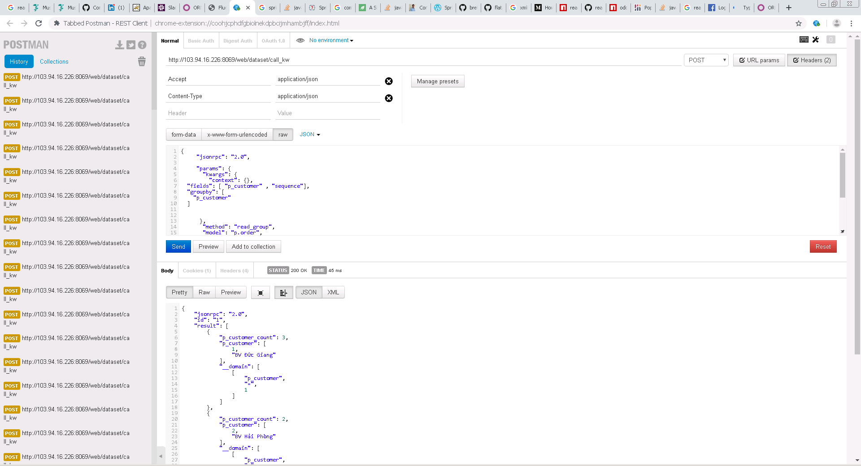

**Group thiết bị theo trạng thái**

* Header giữ nguyên
* Body

{

"jsonrpc": "2.0",

"params": {

"kwargs": {

"context": {},

"fields": [ "stage" , "sequence"],

"groupby": ["stage"]

},

"method": "read_group",

"model": "p.equipment",

"args": [[]],

"context": {}

},

"id": "1"

}

* Response

{

"jsonrpc": "2.0",

"id": "1",

"result": [

{

"stage_count": 1,

"stage": 2,

"__domain": [

[

"stage",

"=",

2

]

]

},

{

"stage_count": 3,

"stage": 4,

"__domain": [

[

"stage",

"=",

4

]

]

}

]

}

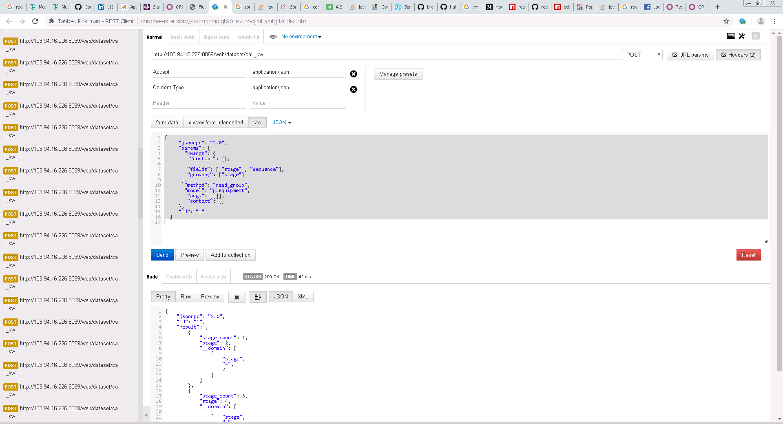

<https://www.npmjs.com/package/react-native-odoo-promise-based>