**Color -** [FFFFFF](https://convertingcolors.com/hex-color-FFFFFF.html) (back ground main colour),[D32D2F](https://convertingcolors.com/hex-color-D32D2F.html) (main button with text white) , [EFEFEF](https://convertingcolors.com/hex-color-EFEFEF.html) / [EFD7D7](https://convertingcolors.com/hex-color-EFD7D7.html) (2nd button with text black), [8E8E8E](https://convertingcolors.com/hex-color-8E8E8E.html) (icons , and can add white colour in the middle of the icons like camera icon have circle in the middle), , [EFEFEF](https://convertingcolors.com/hex-color-EFEFEF.html) (Text field background colour).

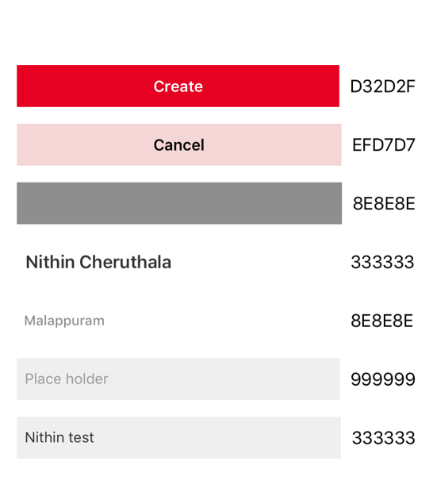

**Help me**

**Feeds with Layers** with filter (country, state, district) and **Sort** (type of create posts)

**Search** for people, districts , state and country, posts

**Create new post**

**Profile** (For user)

**Settings**(User profile, mute notification for different layers)

**Layer profile or page**

**Notifications** andNotification extension and branch io(share)

**Create Post**

**1**.**Normal post** (text. image, video, link, tags)

**2**.**Poll**

**3.Lost/Found** (people and things)

**4.Jobs**

**5.Protests**

**6.Events**

**7.Sale/Buy**

**8.Gov declaration**

**9.Obituary**

**10.Entertaiment**

Feed cards Content

**1.Help me(should be highlighted )**

1.Title

2.Message(Optional)

3.Location

**2.Normal post**

1. Only test (with link and without)
2. Image (with text and without text) and link
3. Video (with text and without) and link
4. Only Link

**3.Poll**

1.Question

2.Only Text

3.Text with Image

4.Only Image

**4.Lost/Found**

1.Type(Lost / Found)

2. Images (if its uploaded)

3. Title

4. Location

5. Contact (button should open call, if the creator did not give number we will give created user number)

**5.Events**

1.Main event image

2.Event name

3.Start date

4.End date

5.Location

**6.Jobs**

1.Title

2.Company name

3.Location

4.contact

**7.Sell/Buy**

1.Images

2.Type

3.Title

4.address

4.Category

4.Contact

**8.** **Obituary**

1.Image

2.Name

3.Place (Optional)

5.Contact number(Optional

**9.** **Gov declaration**

1.Images / Video

1.Title

2.Description

**10.Protest**

1.Title

2.Location

3.description

4.Leaders name

5.Time

6.Button for support

**11.Entertaiment**

1.Title

2.Description

3.Video

**Creation Field Content**

**PRIVACY FOR ALL THE TYPES**(Only user from the particular layer can see / all users in the world)

**1.Help me(Pop up)**

1. We have to fetch the current location
2. Message(optional)

**2.Normal post**

1. Images
2. Texts
3. URL Embedded view
4. Video
5. privacy

**3.Poll**

1. Question
2. Options Text boxes with image
3. privacy(Only user from the particular layer can see / all users in the world)

**4.Lost/Found**

1. Post type selection - Lost or Found
2. Category- People, Things, Documents
3. Name(Object name or People name).
4. Description
5. Location
6. Mobile number with check box(Use mobile number of this account)
7. images
8. If user selected people then have to change the design with age, etc

**5.Events**

1. Main event image
2. Photos
3. Event name
4. Description
5. Start date
6. .End date
7. Location
8. Category-

· Business & Professional

· Charity & Causes

· Community & Culture

· Education

· Fashion & Beauty

· Film, Media & Entertainment

· Government

· Politics

· Health & wellness

· Religion & Spirituality

· Science & Technology

· Sports & Fitness

· Travel & Outdoor

· Arts Festival / Sports meet – school or campus

**6.Jobs**

1. Type of job – Full time, part time, etc
2. Job title
3. Company name
4. Job location
5. Job Info / Job Description
6. Contact – mail/ mob number

**7.Sell/Buy**

1. Type – Sell, Buy, Rent
2. Image(Optional)
3. Name of the item
4. Description
5. Price
6. Address
7. Category –
   * 1. Cars & Scooters
     2. Crafts & Art
     3. Fashion
     4. Health & Beauty
     5. Home & Furniture
     6. Kitchen
     7. Mobile Phones
     8. Music, Movies & Books
     9. Pets
     10. Photography & cameras
     11. Computers & Tablets
     12. Property
     13. Sports & Outdoors
     14. Tools & DIY
     15. Toys
     16. TVs & Audio
     17. Everything else
8. Contact – Verified Mobile number

**8.** **Obituary**

1. Image
2. Name
3. Place (Optional)
4. Description(Optional)
5. Contact number(Optional)

**9.** **Gov declaration**

1. Images / Video
2. Title
3. Description

**10.Protest**

1. Title
2. Leader name(Optional)
3. Description
4. Location
5. Start time and end time

**11.Entertaiment**

1. Title
2. Description
3. Video