# Composition:

Each100mlContainsSesamumindicumCocosnucifera

ForimmediaterelieffromHead-ache,Back-ache, AloeVeraSinus.itis,Arthiritis,Chestpain,AdominalP,ain,Stiffneck,§lfrTITbandra

SOml20mllOmllOml

Forstrengtheningnerves,muscles

# Composition:

Each1oomlContains

Sesamumindicum 70ml

Cocosnucifera 30ml

Ecliptaprostrata 4ml

AloeVera 6ml

Citruslimon Bml

Swelling,Wond,Bru1ces,.Sprains,Scabies,Eczema,CelastruspaniculatusMuscledetenorat1onandStiffness Sanssurealappa

Kaempferiagalanga PipercucubaSantalumalbum

CasumbulbocastanumPapaversomniferum

# Composition:

CoconutOilMayilanchiKrishnathulasi KattarpolaKayyonni

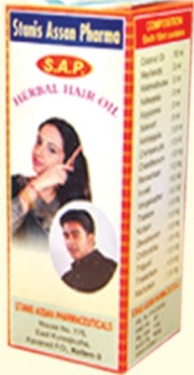

Nourisheshairfromroottotip Satavari

Arrestshairfallandprotectsthe Kariveppilascalpagai.nstskm'-rashes,0andruffetc. CChhaenmdphaarnuathmi

lOml

lOOmglOOmglOOmglOOmglOOmglOOmglOOmg

:lOml

:3ml

:3ml

:3ml

:3ml

:3ml

:1.5ml

:l.Sml

:l.Oml

andbonesbyusingdailyforbody Hibiscusrosasinensis 4mg

massageandbathingpurposes. Asparagus racemosus 6mgOcimum tenuiflorum 2mg

Preventsandcuresskindiseases Sanssurealappa 2.Smg

andrestoresthe naturalglossyness Cossiatora l.Smgofskinandgivesdaylongfreshness. Santalumalbum l.Smg

Vetiveria zizanioides 2mg

Papaver somniferum 2mg

Cedrusdeodara 2mg

Pipercucuba 2mgPterocarpusmarsupium2mgAcalyphaindica 7mg

Ecliptaprastrata 7mg

Azaderactaindica 70mg

Ricinuscommunis 30mg

# Composition:

100gChoornam



Forthepurificationofblood,forgiving CuminumCyminum lOgm

Excessivesneezing,runningnose,Headache,RamachamSunusitis,Skin-rashes.Eczema,Wrinklesetc.lruveli

:l.Oml

:1.0ml

strengthandVigourtotheNervoussystem,effectiveincontrollingrespiratory disorders,

ZingibarOfficinale lOgm

Piperlongum SgmElattariaCardamomum lgm

Kaempferiagalanga lgm

Provideeshealthygrowthandglossy Vengaikathalblacknesstothe . Tra

hair. Kottam

Devatharam ChittarathaThippali

:1.0ml

:1.5ml

:1.5ml

:1.5ml

:1.5ml

:1.5ml

Cholesterol,HighBloodpressure,Diabetes,

CHAITHANYAM-AV Piles,Gastritis,Constipation etc. PiperNigrum lgm

*.>L*

CHOORNAM Usage:OneTea-Spoonfulofowdermixedin Apiumgraveolens lgm

Attfflthl>rri. acupofdrinkingwaterormilortea-onceor Syzygiumaromaticum lgmtwicedaily Oryzasativa 20gm

Cucurmaangustifolia 30gm

ThakkolamKacholam

:1.5ml

:1.5ml

HordeumVulgare 20gm

Forimmediaterelieffromwounds,swelling,sprainsandstrains,inflammationandall

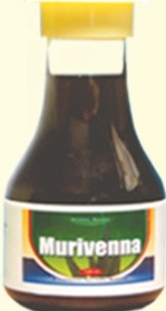

# Composition:

Each100mlContains Celastruspaniculatus Alpiniagalanga

Piperlongumlll1ciumverumKaempferiagalangaSanssurealappa

Carumbulbocastanum

1.5mg

1.5mg

1.5mg

1.5mg

1.5mg4mg

2mg

# Composition:

EachlOOgmContains



Acaciacatechu 15gm

Syzygiumaromaticum 15gm

Cinnamonzeylanicum 13gm

Azadirachtaindica 12gmPreventsandcuresdentalproblemslike Cuminumcyminum lOgm

bleeding,inflamedgums,toothache, Capsicumannum lOgm

kindsofrheumaticcomplaints.

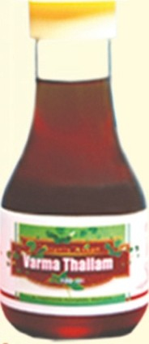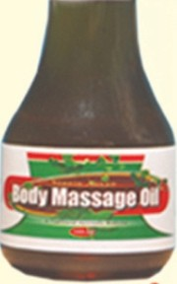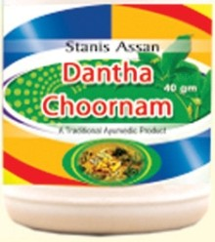

Coleuszeylanicus

Pterocarpus marsupiumAloeVera

CitruslimonPergulariadaemiaAcalyphaindica

EcliptaprastrataAzaderactaindica Ricinuscommunis

2mg

2mg

?mg8mg

5 mg

7mg

7mg

70mg

30mg

decayingteethandhalitosis(badbreath)

Solanumsurattnese lOgm

Piperlongum Bgm

Terminalia chebula SgmCinnamomumcamphoralgmSodiumChloride lgm