

Datasheet SHT3x-DIS
Humidity and Temperature Sensor
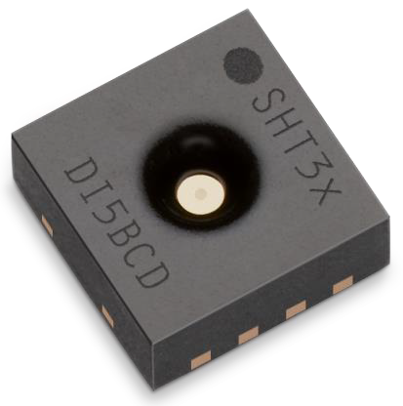


- Fully calibrated, linearized, and temperature compensated digital output
- Wide supply voltage range, from 2.4 to 5.5 V
- I2C Interface with communication speeds up to 1 MHz and two user selectable addresses
- Typical accuracy of ± 2%RH and ± 0.3°C
- Very fast start-up and measurement time
- Tiny 8-Pin DFN package

Product Summary
SHT3x-DIS is the next generation of Sensirion’s temperature and humidity sensors. It builds on a new CMOSens® sensor chip that is at the heart of Sensirion’s new humidity and temperature platform. The SHT3x-DIS has increased intelligence, reliability and improved accuracy specifications compared to its predecessor. Its functionality includes enhanced signal processing, two distinctive and user selectable I2C addresses and
communication speeds of up to 1 MHz. The DFN package has a footprint of 2.5 x 2.5 mm while keeping a height of 0.9 mm. This allows for integration of the SHT3x-DIS into a great variety of applications. Additionally, the wide supply voltage range of 2.4 to 5.5
V guarantees compatibility with diverse assembly situations. All in all, the SHT3x-DIS incorporates 15 years of knowledge of Sensirion, the leader in the humidity sensor industry.

Benefits of Sensirion’s CMOSens® Technology
- High reliability and long-term stability
- Industry-proven technology with a track record of more than 15 years
- Designed for mass production
- High process capability
- Low signal noise

Content
- Sensor Performance 2
- Specifications 5
- Pin Assignment 7
- Operation and Communication 9

RH Sensor

ADC
ADC
T Sensor
Calibration Memory

Data processing & Linearization

Digital Interface

nRESET
VDD
VSS

RESET
VSS
VDD
Power on Reset

Alert Logic

- Packaging 16
ADDR
SDA SCL
Alert

- Shipping Package 18
- Quality 19
- Ordering Information 19
- Further Information 19
Figure 1 Functional block diagram of the SHT3x-DIS. The sensor signals for humidity and temperature are factory calibrated, linearized and compensated for temperature and supply voltage dependencies.

Sensor Performance

Humidity Sensor Performance
Table 1 Humidity sensor specification
±8
�RH (%RH)
±6
maximal tolerance typical tolerance
±4
30 40 50 60 70 80 90 100
100
90
80
70
60
50
40
30
20
10
0
±4.5
±3
±2

±0
0 10 20
SHT30
Relative Humidity (%RH)
0
10
20 30
±4.5
40
50 60 70 80
SHT30 Temperature (°C)
Figure 2 Tolerance of RH at 25°C for SHT30
Figure 3 Typical tolerance of RH over T for SHT30
Relative Humidity (%RH)

Parameter | Conditions | Value | Units
SHT30 Accuracy tolerance1 | Typ. | ±3 | %RH
 | Max. | Figure 2 | %RH
SHT31 Accuracy tolerance1 | Typ. | ±2 | %RH
 | Max. | Figure 4 | %RH
Repeatability2 | Low | 0.2 | %RH
 | Medium | 0.15 | %RH
 | High | 0.07 | %RH
Resolution | Typ. | 0.01 | %RH
Hysteresis | at 25°C | ±0.8 | %RH
Specified range3 | extended4 | 0 to 100 | %RH
Response time5 | τ63% | 86 | s
Long-term drift | Typ.7 | <0.25 | %RH/yr

1 For definition of typical and maximum accuracy tolerance, please refer to the document “Sensirion Humidity Sensor Specification Statement”.
2 The stated repeatability is 3 times the standard deviation (3σ) of multiple consecutive measurements at the stated repeatability and at constant ambient conditions. It is a measure for the noise on the physical sensor output.
3 Specified range refers to the range for which the humidity or temperature sensor specification is guaranteed.
4 For details about recommended humidity and temperature operating range, please refer to section 1.3.
5 Time for achieving 63% of a humidity step function, valid at 25°C and 1m/s airflow. Humidity response time in the application depends on the design-in of the sensor.
6 With activated ART function (see section 4.7) the response time can be improved by a factor of 2.
7 Typical value for operation in normal RH/T operating range, see section 1.3. Maximum value is < 0.5 %RH/yr. Value may be higher in environments with vaporized solvents, out-gassing tapes, adhesives, packaging materials, etc. For more details please refer to Handling Instructions.

�RH (%RH)
±8
maximal tolerance typical tolerance

±6

±4

±2

±0
0 10 20 30 40 50 60 70 80 90 100
100
90
Relative Humidity (%RH)
±2

80
70
60
50
40
30
20
10
0
SHT31
Relative Humidity (%RH)
0 10 20 30 40 50 60 70 80
SHT31 Temperature (°C)
Figure 4 Tolerance of RH at 25°C for SHT31 Figure 5 Typical tolerance of RH over T for SHT31

Temperature Sensor Performance

Parameter | Condition | Value | Units
Accuracy tolerance1 | Typ. 10 to +55 | ±0.3 | °C
Repeatability2 | Low | 0.16 | °C
 | Medium | 0.07 | °C
 | High | 0.04 | °C
Resolution | Typ. | 0.015 | °C
Specified Range | - | -40 to 125 | °C
Response time 8 | τ63% | >2 | s
Long Term Drift | max | <0.03 | °C/yr
Table 2 Temperature sensor specification

�T (°C)
±2.0

±1.5

maximal tolerance typical tolerance

±1.0

±0.5

±0.0
-40 -20 0 20 40 60 80 100 120
Temperature (°C)

Figure 6 Tolerance of the temperature sensor in °C for SHT30 and SHT31

Recommended Operating Condition
The sensor shows best performance when operated within recommended normal temperature and humidity range of 5 – 60 °C and 20 – 80 %RH, respectively. Long term exposure to conditions outside normal range, especially at high humidity, may temporarily offset the RH signal (e.g.+3%RH after 60h at >80%RH). After returning into the normal temperature and humidity range the sensor will slowly come back to calibration state by itself. Prolonged exposure to extreme conditions may accelerate ageing. To ensure stable operation of the humidity sensor, the conditions described in the document “SHTxx Assembly of SMD Packages”, section “Storage and Handling Instructions” regarding exposure to volatile organic compounds have to be met. Please note as well that this does apply not only to transportation and manufacturing, but also to operation of the SHT3x-DIS.

8 Temperature response times strongly depends on the design-in of the sensor in the final application. Minimal response time can be achieved when the thermalized sensor at T1 is placed on a well conducting surface with temperature T2.

Specifications

Electrical Specifications

Table 3 Electrical specifications, Specification are valid at 25°C and typical VDD

2.2 Timing Specification for the Sensor System

Parameter | Symbol | Condition | Min. | Typ. | Max. | Units | Comments
Supply voltage | VDD |  | 2.4 | 3.3 | 5.5 | V
Power-up/down level | VPOR |  | 2.2 | 2.28 | 2.35 | V
Slew rate change of the supply voltage | VDD,slew |  |  |  | 20 | V/ms | Voltage changes on the VDD line between VDD min and VDD max should be below the maximum slew rate
Supply current | IDD | Not measuring single shot mode |  | 0.2 | 0.7 | μA | Current when sensor is not performing a measurement
 |  | Not measuring periodic data acquisition mode |  | 45 | 70 | μA | Current when sensor is not performing a measurement
 |  | Measuring |  | 800 | 1500 | μA | Current consumption while sensor is measuring,
 |  | Average |  | 2 | 5 | μA | Current consumption (operation with one measurement per second at lowest repeatability)
Alert Output driving strength | IOH |  | 0.8x VDD | 1.5x VDD | 2.1x VDD | mA | See also section 3.5
Heater power | PHeater | Heater running | 5 |  | 25 | mW | Depending on the supply voltage

Parameter | Symbol | Conditions | Min. | Typ. | Max. | Units | Comments
Power-up time | tPU | After hard reset, VDD ≥ VPOR |  | 0.5 | 1 | ms | Time between VDD reaching VPOR and sensor entering idle state
Soft reset time | tSR | After soft reset. |  | 0.5 | 1 | ms | Time between ACK of soft reset command and sensor entering idle state
Duration of reset pulse | tRESETN |  | 350 |  |  | ns | See section 3.6
Measurement duration | tMEAS,l | Low repeatability |  | 2.5 | 4 | ms | The three repeatability modes differ with respect to current consumption, measurement duration and noise level
 | tMEAS,m | Medium repeatability |  | 4.5 | 6 | ms
 | tMEAS,h | High repeatability |  | 12.5 | 15 | ms
Table 4 System Timing Specification, Specifications are valid from -40 to 125 °C and 2.4 to 5.5 V

2.3 Absolute Minimum and Maximum Ratings
Stress levels beyond those listed in Table 5 may cause permanent damage to the device or affect the reliability of the sensor. These are stress ratings only and functional operation of the device at these conditions cannot be guaranteed.

Table 5 Absolute minimum and maximum ratings; values are target specs and not confirmed by measurements yet

Parameter | Rating | Units
Supply voltage VDD | -0.3 to 6 | V
Max Voltage on pins (pin 1 (SDA); pin 2 (ADDR); pin 3 (ALERT); pin 4(SCL); pin 6(nRESET)) | -0.3 to VDD+0.3 | V
Input current on any pin | ±100 | mA
Operating temperature range | -40 to 125 | °C
Storage temperature range | -40 to 150 | °C
ESD HBM (human body model) | 4 | kV
ESD CDM (charge device model) | 750 | V

Pin Assignment
The SHT3x-DIS comes in a tiny 8-pin DFN package – see Table 6.
signal high. For dimensioning resistor sizes please take bus capacity and communication frequency into account (see for example Section 7.1 of NXPs I2C Manual for more details9). It should be noted that pull-up resistors may be included in I/O circuits of microcontrollers. It is recommended to wire the sensor according to the application circuit as shown in Figure 7.

VDD
nRESET(6) VDD(5)

ALERT(3) SCL(4)
ADDR(2)
SDA(1)
VSS(8)
die pad
R(7)

R_{P} R_{P}
100nF
Pin | Name |  |  | Comments
1 | SDA |  |  | Serial data; input / output
2 | ADDR |  |  | Address pin; input; connect to either VDD or VSS, do not leave floating
3 | ALERT |  |  | Indicates alarm condition; output; must be left floating if unused
4 | SCL |  |  | Serial clock; input / output
5 | VDD |  |  | Supply voltage; input
6 | nRESET |  |  | Reset pin active low; Input; if not used it is recommended to connect to VDD
7 | R |  |  | No electrical function; recommended to connect to VSS
8 | VSS |  |  | Ground
 |  |  | 
 |  | 1 |  |  | 8
 |  | 2 |  |  | 7
 |  | 3 |  |  | 6
 |  | 4 |  |  | 5

Figure 7 Typical application circuit. Please note that the positioning of the pins does not reflect the position on the real sensor. This is shown in Table 6.

Table 6 SHT3x-DIS pin assignment (Transparent top view). Dashed lines are only visible if viewed from below. The die pad is internally connected to VSS.

Power Pins (VDD, VSS)
The electrical specifications of the SHT3x-DIS are shown in Table 3. The power supply pins must be decoupled with a 100 nF capacitor that shall be placed as close to the sensor as possible – see Figure 7 for a typical application circuit.

Serial Clock and Serial Data (SCL, SDA)
SCL is used to synchronize the communication between microcontroller and the sensor. The clock frequency can be freely chosen between 0 to 1000 kHz. Commands with clock stretching according to I2C Standard9 are supported.
The SDA pin is used to transfer data to and from the sensor. For safe communication, the timing specifications defined in the I2C manual9 must be met.
Both SCL and SDA lines are open-drain I/Os with diodes to VDD and VSS. They should be connected to external pull-up resistors (please refer to Figure 7). A device on the I2C bus must only drive a line to ground. The external pull-up resistors (e.g. Rp=10 kΩ) are required to pull the

Die Pad (center pad)
The die pad or center pad is visible from below and located in the center of the package. It is electrically connected to VSS. Hence electrical considerations do not impose constraints on the wiring of the die pad. However, due to mechanical reasons it is recommended to solder the center pad to the PCB. For more information on design-in, please refer to the document “SHTxx Design Guide”.

ADDR Pin
Through the appropriate wiring of the ADDR Pin the I2C address can be selected (see Table 7 for the respective addresses). Aside from hard wiring the ADDR Pin to VDD or VSS, it is also possible to use it as a selector pin. This means that the address of the sensor can be changed dynamically during operation by switching the level on the ADDR Pin. The only constraint is that the level has to stay constant starting from the I2C start condition until the communication is finished. This allows to connect more than two SHT3x-DIS onto the same bus. The dynamical switching requires individual ADDR lines to the sensors.
Please note that the I2C address is represented through the 7 MSBs of the I2C read or write header. The LSB switches between read or write header. The wiring for the default address is shown in Table 7 and Figure 7. The ADDR pin must not be left floating. Please note that only the 7 MSBs of the I2C Read/Write Header constitute the I2C Address.

SHT3x-DIS | I2C Address in Hex. representation | Condition
I2C address A | 0x44 (default) | ADDR (pin 2) connected to VSS
I2C address B | 0x45 | ADDR (pin 2) connected to VDD
Table 7 I2C device address

  - ALERT Pin
The alert pin may be used to connect to the interrupt pin of a microcontroller. The output of the pin depends on the value of the RH/T reading relative to programmable limits. Its function is explained in a separate application note. If not used, this pin must be left floating. The pin switches high, when alert conditions are met. The maximum driving loads are listed Table 3. Be aware that self-heating might occur, depending on the amount of current that flows. Self-heating can be prevented if the Alert Pin is only used to switch a transistor.
3.6 nRESET Pin
The nReset pin may be used to generate a reset of the sensor. A minimum pulse duration of 350 ns is required to reliably trigger a reset of the sensor. Its function is explained in more detail in section 4. If not used it is recommended to connect to VDD.

Operation and Communication
The SHT3x-DIS supports I2C fast mode (and frequencies up to 1000 kHz). Clock stretching can be enabled and disabled through the appropriate user command. For detailed information on the I2C protocol, refer to NXP I2C-bus specification9.
All SHT3x-DIS commands and data are mapped to a 16-bit address space. Additionally, data and commands are protected with a CRC checksum. This increases communication reliability. The 16 bits commands to the sensor already include a 3 bit CRC checksum. Data send from and received by the sensor is always succeeded by an 8 bit CRC.
In write direction it is mandatory to transmit the checksum, since the SHT3x-DIS only accepts data if it is followed by the correct checksum. In read direction it is up to the master to decide if it wants to read and process the checksum.

Power-Up and Communication Start
The sensor starts powering-up after reaching the power-up threshold voltage VPOR specified in Table 3. After reaching this threshold voltage the sensor needs the time tPU to enter idle state. Once the idle state is entered it is ready to receive commands from the master (microcontroller).
Each transmission sequence begins with a START condition (S) and ends with a STOP condition (P) as described in the I2C-bus specification. The stop condition is optional. Whenever the sensor is powered up, but not performing a measurement or communicating, it automatically enters sleep state for energy saving. This sleep state cannot be controlled by the user.

Starting a Measurement
A measurement communication sequence consists of a START condition, the I2C write header (7-bit I2C device address plus 0 as the write bit) and a 16-bit measurement command. The proper reception of each byte is indicated by the sensor. It pulls the SDA pin low (ACK bit) after the falling edge of the 8th SCL clock to indicate the reception. A complete measurement cycle is depicted in Table 8.
With the acknowledgement of the measurement command, the SHT3x-DIS starts measuring humidity and temperature.

Measurement Commands for Single Shot Data Acquisition Mode
In this mode one issued measurement command triggers the acquisition of one data pair. Each data pair consists of one 16 bit temperature and one 16 bit humidity value (in this order). During transmission the data pair is always followed by a CRC checksum, see section 4.4.
In single shot mode different measurement commands can be selected. The 16 bit commands are shown in Table 8. They differ with respect to repeatability (low, medium and high) and clock stretching (enabled or disabled).
The repeatability setting influences the measurement duration and the current consumption of the sensor. This is explained in section 2.2.
During measurement the sensor generally does not respond to any I2C activity, i.e. I2C read and write headers are not acknowledged (NACK). However, when a command with clock stretching has been issued, the sensor responds to a read header with an ACK and subsequently pulls down the SCL line. The SCL line is pulled down until the measurement is complete. As soon as the measurement is complete, the sensor releases the SCL line and sends the measurement results.
If a measurement command is issued, while the sensor is busy with a measurement (Table 4 shows the measurement duration), it is recommended to issue a break command first (see section 4.8). The break command will immediately stop the ongoing measurement and the sensor will enter the single shot mode.

9 http://www.nxp.com/documents/user_manual/UM10204.pdf

Condition |  | Hex. code
Repeatability | Clock stretching | MSB | LSB
High | enabled | 0x2C | 06
Medium |  |  | 0D
Low |  |  | 10
High | disabled | 0x24 | 00
Medium |  |  | 0B
Low |  |  | 16
e.g. 0x2C06: high repeatability measurement with clock stretching enabled
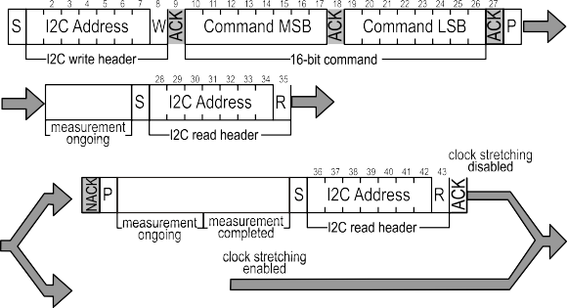
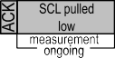
Bus free

Bus free

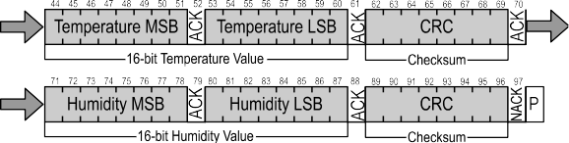
Table 8 Measurement commands in single shot mode (Clear blocks are controlled by the microcontroller, grey blocks by the sensor.)
In case the user needs humidity and temperature data but does not want to process CRC data, it is recommended to read the first two bytes of data with the CRC byte (without processing the CRC data) and abort the read transfer after reading the second two data bytes with a NACK.

Readout of Measurement Results for Single Shot Mode
After the sensor has completed the measurement, the master can read the measurement results (pair of RH& T) by sending a START condition followed by an I2C read header. The sensor will acknowledge the reception of the read header and send two bytes of data (temperature) followed by one byte CRC checksum and another two bytes of data (relative humidity) followed by one byte CRC checksum. Each byte must be acknowledged by the microcontroller with an ACK condition for the sensor to continue sending data. If the sensor does not receive an ACK from the master after any byte of data, it will not continue sending data.
The sensor will send the temperature value first and then the relative humidity value. After receiving the checksum for the humidity value a NACK and stop condition should be send (see Table 8).
The I2C master can abort the read transfer with a NACK condition after any data byte if it is not interested in subsequent data, e.g. the CRC byte or the second measurement result, in order to save time.

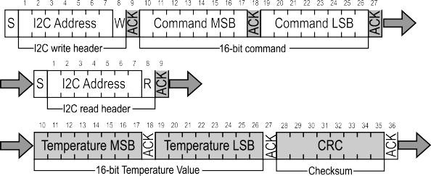
Measurement Commands for Periodic Data Acquisition Mode
In this mode one issued measurement command yields a stream of data pairs. Each data pair consists of one 16 bit temperature and one 16 bit humidity value (in this order).
In periodic mode different measurement commands can be selected. The corresponding 16 bit commands are shown in Table 9. They differ with respect to repeatability (low, medium and high) and data acquisition frequency (0.5, 1, 2, 4 & 10 measurements per second, mps). Clock stretching cannot be selected in this mode.
The data acquisition frequency and the repeatability setting influences the measurement duration and the current consumption of the sensor. This is explained in section 2.2 of this datasheet.

Condition |  | Hex. code
Repeatability | mps | MSB | LSB
High | 0.5 | 0x20 | 32
Medium |  |  | 24
Low |  |  | 2F
High | 1 | 0x21 | 30
Medium |  |  | 26
Low |  |  | 2D
High | 2 | 0x22 | 36
Medium |  |  | 20
Low |  |  | 2B
High | 4 | 0x23 | 34
Medium |  |  | 22
Low |  |  | 29
High | 10 | 0x27 | 37
Medium |  |  | 21
Low |  |  | 2A
e.g. 0x2130: 1 high repeatability mps - measurement per second
1 2 3 4 5 6 7 8 9 1 2 3 4 5 6 7 8 9 10 11 12 13 14 15 16 17 18
Table 9 Measurement commands for periodic data acquisition mode (Clear blocks are controlled by the microcontroller, grey blocks by the sensor.)
S | I2C Address | W | ACK | Command MSB | ACK | Command LSB | ACK
 | I2C write header |  |  | 16-bit | com | mand

S | I2C Address | W | ACK | Command MSB | ACK | Command LSB | ACK
 | I2C write header |  |  | 16-bit | com | mand

Table 10 Data fetch command (Clear blocks are controlled by the microcontroller, grey blocks by the sensor.)
Command | Hex code
Fetch Data | 0x E0 00
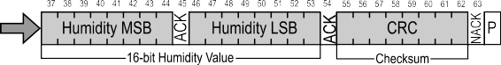

ART Command
The unique ART (accelerated response time) feature can be activated by issuing the command in Table 11. After issuing the ART command the sensor will start acquiring data with a frequency of 4Hz.
The ART command is structurally similar to any other command in Table 9. Hence section 4.5 applies for starting a measurement, section 4.6 for reading out data and section 4.8 for stopping the periodic data acquisition.
The ART feature can also be evaluated using the Evaluation Kit EK-H5 from Sensirion.

Command | Hex Code
Periodic Measurement with  ART | 0x2B32
1 2 3 4 5 6 7 8 9 1 2 3 4 5 6 7 8 9 10 11 12 13 14 15 16 17 18
Table 11 Command for a periodic data acquisition with the ART feature (Clear blocks are controlled by the microcontroller, grey blocks by the sensor.)

Readout of Measurement Results for Periodic Mode
Transmission of the measurement data can be initiated through the command shown in Table 10. If no measurement data is present the I2C read header is responded with a NACK instead of an ACK (Bit 9 in Table 10) and the communication stops.

Break command / Stop Periodic Data Acquisition Mode
The periodic data acquisition mode can be stopped using the break command shown in Table 12. It is recommended to stop the periodic data acquisition prior to sending another command using the break command. Upon reception of the break command the sensor enters the single shot mode.

Command | Hex Code
Break | 0x3093
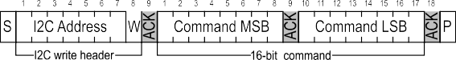
Table 12 Break command (Clear blocks are controlled by the microcontroller, grey blocks by the sensor.)

Reset
A system reset of the SHT3x-DIS can be generated externally by issuing a command (soft reset) or by sending a pulse to the dedicated reset pin (nReset pin). Additionally, a system reset is generated internally during power-up or when brownout conditions are met. During the reset procedure the sensor will not process commands.
In order to achieve a full reset of the sensor without removing the power supply, it is recommended to use the nRESET pin of the SHT3x-DIS.

Interface Reset
If communication with the device is lost, the following signal sequence will reset the serial interface: While leaving SDA high, toggle SCL nine or more times. This must be followed by a Transmission Start sequence preceding the next command. This sequence resets the interface only. The status register preserves its content.

Soft Reset / Re-Initialization
The SHT3x-DIS provides a soft reset mechanism that forces the system into a well-defined state without removing the power supply. When the system is in idle state the soft reset command can be sent to the SHT3x-DIS. This triggers the sensor to reset its system controller and reloads calibration data from the memory. In order to start the soft reset procedure the command as shown in Table 13 should be sent.
It is worth noting that the sensor reloads calibration data prior to every measurement by default.

Command | Hex Code
Soft Reset | 0x30A2
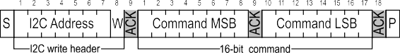
Table 13 Soft reset command (Clear blocks are controlled by the microcontroller, grey blocks by the sensor.)

Reset through General Call
Additionally, a reset of the sensor can also be generated using the “general call” mode according to I2C-bus specification9. This generates a reset which is functionally identical to using the nReset pin. It is important to understand that a reset generated in this way is not device specific. All devices on the same I2C bus that support the general call mode will perform a reset. Additionally, this command only works when the sensor is able to process I2C commands. The appropriate command consists of two bytes and is shown in Table 14.

Command | Code
Address byte | 0x00
Second byte | 0x06
Reset command using the general call address | 0x0006
1 2 3 4 5 6 7 8 9 1 2 3 4 5 6 7 8 9
Table 14 Reset through the general call address (Clear blocks are controlled by the microcontroller, grey blocks by the sensor.).
S | General Call Address | ACK | Reset Command | ACK
 | General Call 1st byte |  | General Call 2nd byte

Reset through the nReset Pin
Pulling the nReset pin low (see Table 6) generates a reset similar to a hard reset. The nReset pin is internally connected to VDD through a pull-up resistor and hence active low. The nReset pin has to be pulled low for a minimum of 350 ns to generate a reset of the sensor.

Hard Reset
A hard reset is achieved by switching the supply voltage to the VDD Pin off and then on again. In order to prevent powering the sensor over the ESD diodes, the voltage to pins 1 (SDA), 4(SCL) and 2(ADDR) also needs to be removed.

Heater
Bit | Field description | Default value
15 | Alert pending status '0': no pending alerts  '1': at least one pending alert | ‘1’
14 | Reserved | ‘0’
13 | Heater status ‘0’ : Heater OFF  ‘1’ : Heater ON | ‘0’
12 | Reserved | ‘0’
11 | RH tracking alert ‘0’ : no alert  ‘1’ . alert | ‘0
10 | T tracking alert ‘0’ : no alert  ‘1’ . alert | ‘0’
9:5 | Reserved | ‘00000’
4 | System reset detected  '0': no reset detected since last ‘clear status register’ command  '1': reset detected (hard reset, soft reset command or supply fail) | ‘1’
3:2 | Reserved | ‘00’
1 | Command status  '0': last command executed successfully '1': last command not processed. It was either invalid, failed the integrated  command checksum | ‘0’
0 | Write data checksum status  '0': checksum of last write transfer was correct  '1': checksum of last write transfer failed | ‘0’

The heater can be switched on and off by command, see table below. The status is listed in the status register. After a reset the heater is disabled (default condition).

Command | Hex Code
 | MSB | LSB
Heater Enable | 0x30 | 6D
Heater Disabled |  | 66
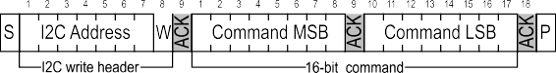
Table 15 Heater command (Clear blocks are controlled by the microcontroller, grey blocks by the sensor.)

Status Register
The status register contains information on the operational status of the heater, the alert mode and on the execution status of the last command and the last write sequence. The command to read out the status register is shown in Table 16 whereas a description of the content can be found in Table 18.
Command | Hex code
Read Out of status register | 0xF32D
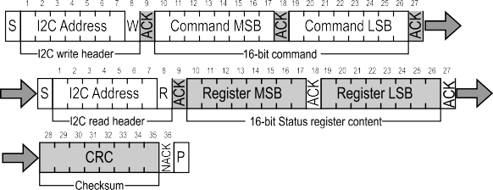

Table 18 Description of the status register

Table 16 Command to read out the status register (Clear blocks are controlled by the microcontroller, grey blocks by the sensor.)

Clear Status Register
All flags (Bit 15, 11, 10, 4) in the status register can be cleared (set to zero) by sending the command shown in Table 17.

Command | Hex Code
Clear status register | 0x 30 41
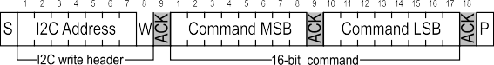
Table 17 Command to clear the status register (Clear blocks are controlled by the microcontroller, grey blocks by the sensor.)

Checksum Calculation
The 8-bit CRC checksum transmitted after each data word is generated by a CRC algorithm. Its properties are displayed in Table 19. The CRC covers the contents of the two previously transmitted data bytes. To calculate the checksum only these two previously transmitted data bytes are used.
Table 19 I2C CRC properties.
4.13 Conversion of Signal Output
Measurement data is always transferred as 16-bit values (unsigned integer). These values are already linearized and compensated for temperature and supply voltage effects. Converting those raw values into a physical scale can be achieved using the following formulas.
Relative humidity conversion formula (result in %RH):
RH = 100 ⋅
SRH 2¹⁶ − 1
Temperature conversion formula (result in °C & °F):
ST
T [°C]= − 45 +175 ⋅
T [°F]= − 49 + 315 ⋅
2¹⁶ −1
ST 2¹⁶ −1
SRH and ST denote the raw sensor output for humidity and temperature, respectively. The formulas only work
correct when representation.
SRH
and ST are used in decimal

Property | Value
Name | CRC-8
Width | 8 bit
Protected data | read and/or write data
Polynomial | 0x31 (x8 + x5 + x4 + 1)
Initialization | 0xFF
Reflect input | False
Reflect output | False
Final XOR | 0x00
Examples | CRC (0xBEEF) = 0x92

4.14 Communication Timing

Parameter | Symbol | Conditions | Min. | Typ. | Max. | Units | Comments
SCL clock frequency | fSCL |  | 0 |  | 1000 | kHz
Hold time (repeated) START condition | tHD;STA | After this period, the first clock pulse is generated | 0.24 |  |  | µs
LOW period of the SCL clock | tLOW |  | 0.65 |  |  | µs
HIGH period of the SCL clock | tHIGH |  | 0.26 |  |  | µs
SDA hold time | tHD;DAT |  | 60 |  | 250 | ns | Transmitting data
 |  |  | 0 |  |  | ns | Receiving data
SDA set-up time | tSU;DAT |  | 100 |  |  | ns
SCL/SDA rise time | tR |  |  |  | 300 | ns
SCL/SDA fall time | tF |  |  |  | 300 | ns
SDA valid time | tVD;DAT |  |  |  | 0.9 | µs
Set-up time for a repeated START condition | tSU;STA |  | 0.6 |  |  | µs
Set-up time for STOP condition | tSU;STO |  | 0.6 |  |  | µs
Capacitive load on bus line | CB |  |  |  | 400 | pF
Low level input voltage | VIL |  | -0.5 |  | 0.3xVDD | V
High level input voltage | VIH |  | 0.7xVDD |  | 1xVDD | V
Low level output voltage | VOL | 3 mA sink current |  |  | 0.66 | V
Table 20 Communication timing specifications for I2C fm (fast mode), Specification are at 25°C and typical VDD . The numbers above are values according to the I2C Specification (UM10204, Rev. 5, October 9 13, 2012)

SCL

tHIGH
1/fSCL

tLOW

tR tF

70%
30%

tSU;DAT tHD;DAT

DATA IN

SDA

70%
30%

DATA OUT

SDA

tVD;DAT tF
tR

70%
30%

Figure 8 Timing diagram for digital input/output pads. SDA directions are seen from the sensor. Bold SDA lines are controlled by the sensor, plain SDA lines are controlled by the micro-controller. Note that SDA valid read time is triggered by falling edge of preceding toggle.

Packaging
SHT3x-DIS sensors are provided in a DFN package. DFN stands for dual flat no leads. The humidity sensor opening is centered on the top side of the package.
The sensor chip is made of silicon and is mounted to a lead frame. The latter is made of Cu plated with Ni/Pd/Au. Chip and lead frame are overmolded by an epoxy-based mold compound leaving the central die pad and I/O pins exposed for mechanical and electrical connection. Please note that the side walls of the sensor are diced and therefore these diced lead frame surfaces are not covered with the respective plating.
The package (except for the humidity sensor opening) follows JEDEC publication 95, design registration 4.20, small scale plastic quad and dual inline, square and rectangular, No-LEAD packages (with optional thermal enhancements) small scale (QFN/SON), Issue D.01, September 2009.

Traceability
All SHT3x-DIS sensors are laser marked for easy identification and traceability. The marking on the sensor top side consists of a pin-1 indicator and two lines of text.
The top line consist of the pin-1 indicator which is located in the top left corner and the product name. The small letter x stands for the accuracy class.
The bottom line consists of 6 letters. The first two digits XY (=DI) describe the output mode. The third letter (A) represents the manufacturing year (4 = 2014, 5 = 2015, etc). The last three digits (BCD) represent an alphanumeric tracking code. That code can be decoded by Sensirion only and allows for tracking on batch level through production, calibration and testing – and will be provided upon justified request.
If viewed from below pin 1 is indicated by triangular shaped cut in the otherwise rectangular die pad. The dimensions of the triangular cut are shown in Figure 10 through the labels T1 & T2.

 | S | H | T | 3 | x
Figure 9 Top View of the SHT3x-DIS illustrating the laser marking.
X | Y | A | B | C | D

Package Outline

S T1 x T2

D L D2

A
E
b
e
E2




Figure 10 Dimensional drawing of SHT3x-DIS sensor package

Parameter | Symbol | Min | Nom. | Max | Units | Comments
Package height | A | 0.8 | 0.9 | 1 | mm
Leadframe height | A3 |  | 0.2 |  | mm | Not shown in the drawing
Pad width | b | 0.2 | 0.25 | 0.3 | mm
Package width | D | 2.4 | 2.5 | 2.6 | mm
Center pad length | D2 | 1 | 1.1 | 1.2 | mm
Package length | E | 2.4 | 2.5 | 2.6 | mm
Center pad width | E2 | 1.7 | 1.8 | 1.9 | mm
Pad pitch | e |  | 0.5 |  | mm
Pad length | L | 0.3 | 0.35 | 0.4 | mm
Max cavity | S |  |  | 1.5 | mm | Only as guidance. This value includes all tolerances, including displacement tolerances. Typically the opening will be smaller.
Center pad marking | T1xT2 |  | 0.3x45° |  | mm | indicates the position of pin 1
Table 21 Package outline,

Land Pattern
Figure 11 shows the land pattern. The land pattern is understood to be the metal layer on the PCB, onto which the DFN pads are soldered.
The solder mask is understood to be the insulating layer on top of the PCB covering the copper traces. It is recommended to design the solder mask as a Non-Solder Mask Defined (NSMD) type. For NSMD pads, the solder mask opening should provide a 60 μm to 75 μm design clearance between any copper pad and solder mask. As the pad pitch is only 0.5 mm we recommend to have one solder mask opening for all 4 I/O pads on one side.
For solder paste printing it is recommended to use a laser-cut, stainless steel stencil with electro-polished trapezoidal walls and with 0.1 or 0.125 mm stencil thickness. The length of the stencil apertures for the I/O pads should be the same as the PCB pads. However, the position of the stencil apertures should have an offset of 0.1 mm away from the center of the package. The die pad aperture should cover about 70 – 90 % of the die pad area –thus it should have a size of about 0.9 mm x
1.6 mm.
For information on the soldering process and further recommendation on the assembly process please consult the Application Note HT_AN_SHTxx_Assembly_of_SMD_Packages , which can be found on the Sensirion webpage.

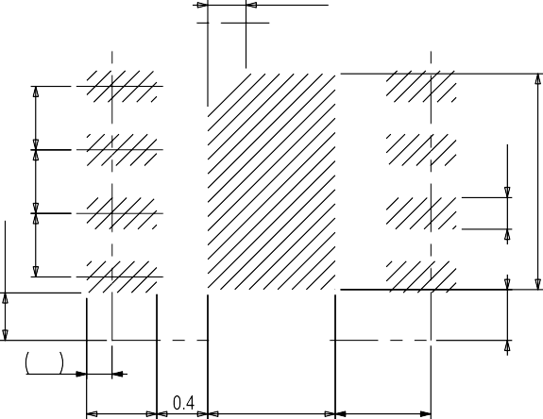

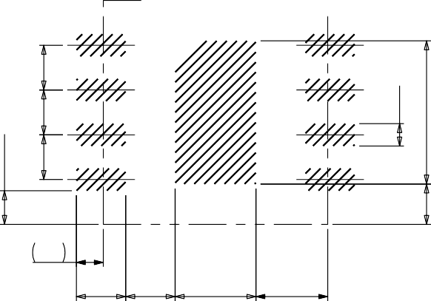
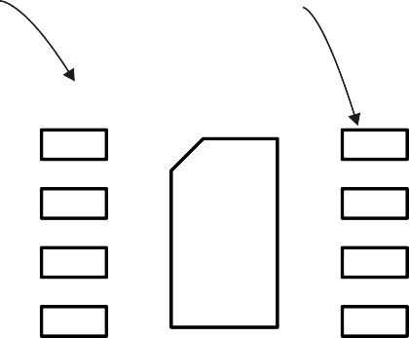
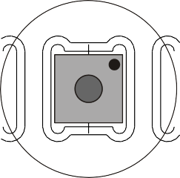
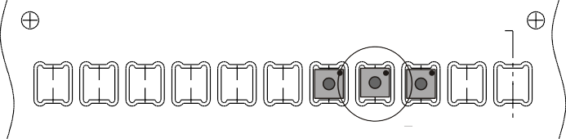
land pattern
sensor outline
stencil aperture

0.3x45°
0.5
0.25
1.7
0.5
0.5
0.25
1.6

0.2
0.375
0.5
0.5
0.4
0.375
0.5

0.55

1 0.75
0.3

0.55

0.55

0.9

0.8
0.45

Figure 11 Recommended metal land pattern and stencil apertures for the SHT3x-DIS. The dashed lines represent the outer dimension of the DFN package. The PCB pads and stencil apertures are indicated through the shaded areas.

Shipping Package

2.00 ±.05 SEE Note 2

4.00

Ø1.5 +.1 /-0.0

Ø1.00 MIN

0.30 ±.05
4.00 SEE Note 1
1.75 ±.1
A

R 0.2 MAX.

B0
5.50 ±.05
SEE NOTE 2

B 12.0 +0.3/-0.1

A
K0 R 0.25 TYP.
A0

SECTION A - A
A0 = 2.75
B0 = 2.75
K0 = 1.20

TOLERANCES - UNLESS NOTED 1PL ±.2 2PL ±.10

NOTES:
- 10 SPROCKET HOLE PITCH CUMULATIVE TOLERANCE ±0.2
- POCKET POSITION RELATIVE TO SPROCKET HOLE MEASURED AS TRUE POSITION OF POCKET, NOT POCKET HOLE
- A0 AND B0 ARE CALCULATED ON A PLANE AT A DISTANCE "R" ABOVE THE BOTTOM OF THE POCKET

DETAIL B

Figure 12 Technical drawing of the packaging tape with sensor orientation in tape. Header tape is to the right and trailer tape to the left on this drawing. Dimensions are given in millimeters.

Quality
Qualification of the SHT3x-DIS is performed based on the AEC Q 100 qualification test method.

Material Contents
The device is fully RoHS and WEEE compliant, e.g. free of Pb, Cd, and Hg.

Ordering Information
The SHT3x-DIS can be ordered in tape and reel packaging with different sizes, see Table 22. The reels are sealed into antistatic ESD bags. The document (SHT3x shipping package) that shows the packaging tape with sensor orientation is available upon request.
Name | Quantity | Order Number
SHT30-DIS-B500E | 500 | 1-101256-01
SHT30-DIS-B10kS | 10000 | 1-101173-01
SHT31-DIS-B1kS | 1000 | 1-101177-01
SHT31-DIS-B10kS | 10000 | 1-101147-01
Table 22 SHT3x-DIS ordering options.

Further Information
For more in-depth information on the SHT3x-DIS and its application please consult the following documents:

Document Name | Description | Source
SHT3x Shipping Package | Information on Tape, Reel and shipping bags (technical drawing and dimensions) | Available upon request
SHTxx Assembly of SMD Packages | Assembly Guide (Soldering Instruction,) | Available for download at the Sensirion humidity sensors download center:  www.sensirion.com/humidity-download
SHTxx Design Guide | Design guidelines for designing SHTxx humidity sensors into applications | Available for download at the Sensirion humidity sensors download center: www.sensirion.com/humidity-download
SHTxx Handling Instructions | Guidelines for proper handling of SHTxx humidity sensors (Reconditioning Procedure) | Available for download at the Sensirion humidity sensors download center: www.sensirion.com/humidity-download
Sensirion Humidity Sensor Specification Statement | Definition of sensor specifications. | Available for download at the Sensirion humidity sensors download center: www.sensirion.com/humidity-download
Table 23 Documents containing further information relevant for theSHT3x-DIS.

Revision History

Date | Version | Page(s) | Changes
November 2014 | 0.9 |  | Initial release
March 2015 | 0.91 |  | Table 1 and Table 2, added low and medium repeatability  Table 3, added current consumption for periodic data acquisition mode Table 4, extended the range for the measurement duration  Table 5, removed MM model due to change in AEC Q100 Rev H, amended absolute maximum ratings  Section 3.4, added comment on address multiplexing Table 9, changed example command  Table 11, replaced ART command Section 4.8, modified reset section  Section 4.12, amended Fahrenheit conversion Table 19, expanded the definition for SDA hold time
April 2015 | 0.92 |  | Table 1, amended resolution of the humidity sensor Table 2, amended resolution of the T-Sensor  Table 2, defined Long term drift as max Table 3, amended Power-up/down level  Table 3, amended maximum current consumption Table 4, amended typ. value of the power-up time Table 4, amended max value of the soft reset value Table 3,added driving strength of the alert out pin Section 4.8, amended nReset Pin section
May 2015 | 0.93 |  | Section 4, Added Break Command Section Table 3, Amended tSR time  Table 18, modified default values  Section 5, added section paragraph on package standard Section 8, Added ordering information

Headquarters and Subsidiaries

SENSIRION AG
Laubisruetistr. 50 CH-8712 Staefa ZH Switzerland

phone: +41 44 306 40 00
fax: +41 44 306 40 30
info@sensirion.com http://www.sensirion.com
Sensirion AG (Germany) phone: +41 44 927 11 66
Sensirion Inc., USA phone: +1 805 409 4900
info_us@sensirion.com www.sensirion.com

Sensirion Japan Co. Ltd. phone: +81 3 3444 4940
info@sensirion.co.jp www.sensirion.co.jp
Sensirion Korea Co. Ltd. phone: +82 31 337 7700 3
info@sensirion.co.kr www.sensirion.co.kr

Sensirion China Co. Ltd. phone: +86 755 8252 1501
info@sensirion.com.cn www.sensirion.com.cn

info@sensirion.com www.sensirion.com
To find your local representative, please visit http://www.sensirion.com/contact

Mouser Electronics

Authorized Distributor

Click to View Pricing, Inventory, Delivery & Lifecycle Information:

Sensirion:
SHT31-DIS-B

