# INFO8250 Assignment #1

## Name: Changho Choi

### 1. Functional Requirement:

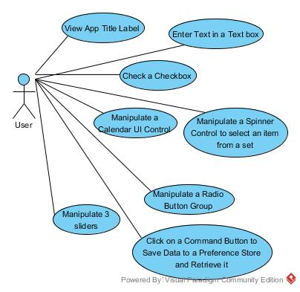

To make the app title center-align at action bar, custom action bar(*action_bar.xml*) was used. And, required widgets a editview, a checkbox, a spinner dropdown, three seekbars, six radio with radio group, text views which display label of each widget are placed at *activity_main.xml*. Additionally, text views are used for displaying birthday of person. Due to shortage of space, calendar picker is implemented as dialog. To activate calendar picker dialog when user click the birthday text view, onClick attribute is added. Furthermore, to display interactively current selected value while user moves seekbar, text views for each seekbar were used. At *onProgressChanged* callback, text view is updated. For adding menu items at spinner drop down menu, arrayAdapter was used. Finally, when user press command button, to save status of every widget, shared preference was used. To make callback when user press the button, onClick attribute was set with callback function at *activity_main.xml,* and all value of widget is read and saved at preference store within the callback function. To save the values, key is needed for each kind of values to be stored, all keys are defined at *value/strings.xml.* To practice the processing the option menu, the callback function can also be accessible through option menu. After saving values, to give feedback to user, toast message was used.

### 2. Additional Effort

To make custom app icon, I used [Android Asset Studio Site](https://romannurik.github.io/AndroidAssetStudio/icons-launcher.html). This site generates set of icon for various resolutions and to make overall layout efficiently display, relative layout was used, instead of linear layout. To make margins correct easily, constant values for margins were defined at *values/dimen.xml.* Additionally, all strings that are used throughout the code were defined at *values/strings.xml*. And, to make code readable, consistent naming rule for widget ids and object names was used, and refactored code with separate method refactoring pattern to make code clean.