SCORECARD ITEMS

Graded items for Cassandra Data Model

Each item will be “Pass/Fail”

NUMBER | RESULT | MEASUREMENT | PASSING VALUE | SIGNIFICANCE | SCREENSHOT
1 | FAIL | Pending compactions with steady “read only” load | < 15 at all times | High number of pending compactions has a negative impact on read performance because of I/ O contention between SSTables and compacting them | 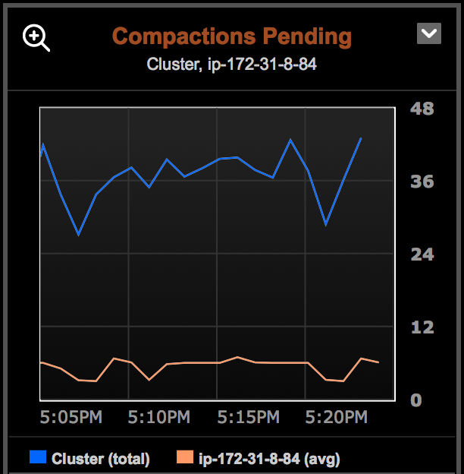
2 | PASS | Disk utilization with steady “writes only” load | < 40% most of the time. Never higher than 70% | We use writes only because reads tend to get drawn from cache | 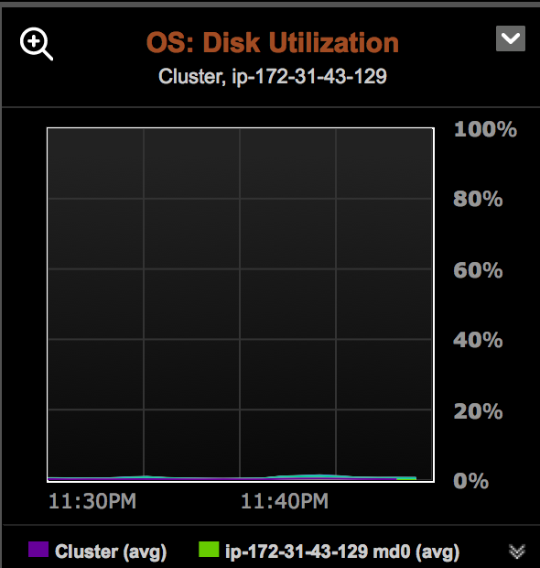
3 | PASS | Scalability  Steady state work load run against 3, 6 and 9 nodes | Throughput increases, but latency does not. | Although it is widely acknowledged that Cassandra scales in a linear fashion, this test provides concrete proof that the current project follows this pattern | 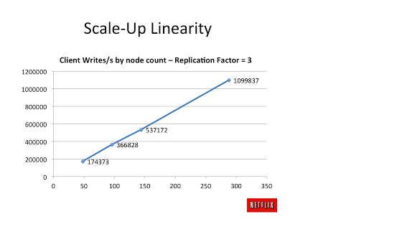
4 | PASS | TPSTATS  Steady state load | No blocked processes or dropped messages | Dropped or blocked processes indicate a bottleneck in hardware or configuration tuning | Pool Name Active Pending Completed Blocked All time blocked  ReadStage 0 0 8790069 0 0  RequestResponseStage 0 0 110774283 0 0  MutationStage 0 0 120064920 0 0  ReadRepairStage 0 0 547374 0 0  ReplicateOnWriteStage 0 0 0 0 0  GossipStage 0 0 18308956 0 0  CacheCleanupExecutor 0 0 14 0 0  MigrationStage 0 0 123 0 0  MemoryMeter 0 0 19459 0 0  FlushWriter 0 0 45811 0 11  ValidationExecutor 0 0 206469 0 0  InternalResponseStage 0 0 206647 0 0  AntiEntropyStage 0 0 1045519 0 0  MemtablePostFlusher 0 0 333805 0 0  MiscStage 0 0 206471 0 0  PendingRangeCalculator 0 0 157 0 0  commitlog_archiver 0 0 0 0 0  CompactionExecutor 3 3 879111 0 0  AntiEntropySessions 0 0 10631 0 0  HintedHandoff 0 0 65 0 0  Message type Dropped  RANGE_SLICE 0  READ_REPAIR 0  PAGED_RANGE 0  BINARY 0  READ 0  MUTATION 0  _TRACE 0  REQUEST_RESPONSE 0  COUNTER_MUTATION 0
5 | PASS | Write latency with steady state load | Flat or downward trend | Increasing latency indicates Commit log or Memtable could be overrun with write requests | 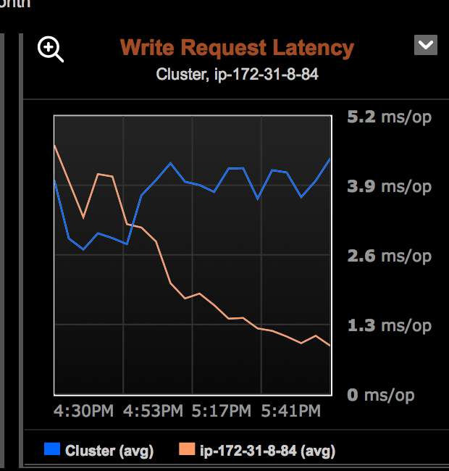
6 |  | CMS collections  (Concurrent Mark Sweep)  Steady state (any work load) | No OldGen activity lasting > 5 min | OldGen garbage collection is expensive. If heap is not released consistently, excessive CMS activity can cause OutOfMemoryExceptions in Casssandra | 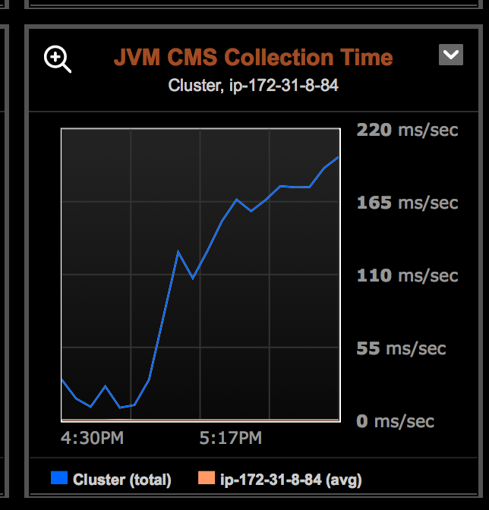
7 |  | Run Queries in cqlsh (shell) with TRACE enabled  Can be run on any node from the cluster | Query trace shows no more than 2 partitions used to get results for Read requests. | Using TRACE mode while executing a CQL query can expose inefficient query patterns and/or table designs
8 | FAIL | Row sizes in cfhistogram  Also dual hump latency is indicative of a problem | Graduated column sizes (no one partition/row greatly outsizes the others) | A single partition that is much larger than any others is a sign of problems with client application and/or data model | [kratos@ip-172-31-28-94 ~]$ nodetool -h 172.31.28.94 cfhistograms assessment_keyspace assessments_by_date  assessment_keyspace/assessments_by_date histograms  Partition Size (bytes)  3311 bytes: 9198  3973 bytes: 0  4768 bytes: 0  5722 bytes: 2794  6866 bytes: 0  8239 bytes: 0  9887 bytes: 1557  11864 bytes: 0  14237 bytes: 0  17084 bytes: 795  20501 bytes: 420  24601 bytes: 274  29521 bytes: 309  35425 bytes: 425  42510 bytes: 508  51012 bytes: 1124  61214 bytes: 967  73457 bytes: 678  88148 bytes: 188  105778 bytes: 24  126934 bytes: 0  152321 bytes: 0  182785 bytes: 0  219342 bytes: 0  263210 bytes: 0  315852 bytes: 0  379022 bytes: 0  454826 bytes: 0  545791 bytes: 0  654949 bytes: 0  785939 bytes: 0  943127 bytes: 0  1131752 bytes: 88  1358102 bytes: 334  1629722 bytes: 5  1955666 bytes: 0  2346799 bytes: 0  2816159 bytes: 0  3379391 bytes: 0  4055269 bytes: 0  4866323 bytes: 0  5839588 bytes: 1  7007506 bytes: 49
9 |  | Cassandra Anti-Patterns – Static analysis of source code, table schemas and keyspace definition | Review code to verify best usage of the Java driver, CQL3 and Cassandra featurees | AntiPatterns fall into different categories:  - Deployment  - Data model  - Access Patterns | Examples of Anti-patterns:  (there are many more)  - client side joins (using application  code to join tables on a column)  - nonUse of PreparedStatements  - nonUse of async execution for  multiple queries  - multi-partition queries  - misuse of batches (logged, unlogged)  Batches should NOT be used to  Insert large number of rows  - Distributed mutable state  - Excessive usage of Deletes / Use of  Cassandra as a queue  - Secondary Indexes on tables  (should be used with caution)  - Inappropriate read or write retry  policy
10 |  | Parnew Garbage collection | Should not last more than 1000 ms per 1 sec interval | Execessive ParNew collection indicates overload of the write paths and can lead to unresponsiveness | 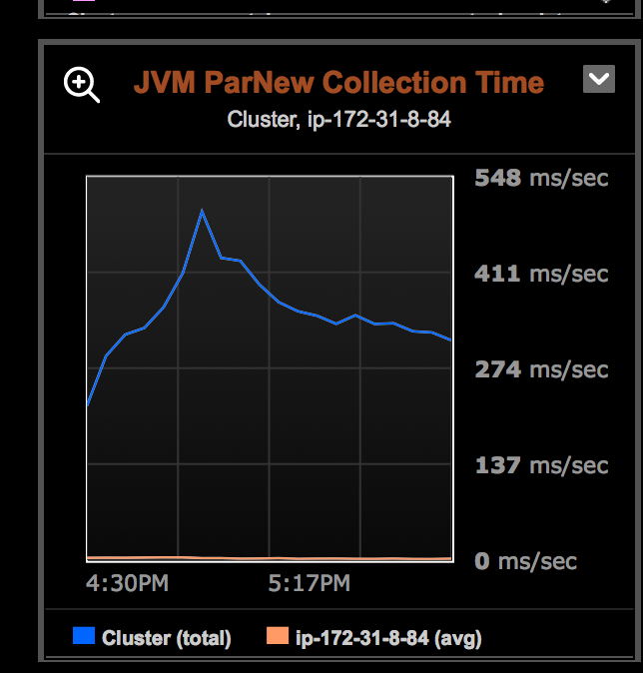

In addition to the score, report will include bullet points to address the following questions:

Does our data model scale?
Usually “scale” means we can increase number of nodes without seeing an increase in latency. Do we want this kind of definition for a data model, or do we want to target something else?

Do we meet the defined sla? → Note: we don’t have SLAs definied for the database layer. Need to find something. Perhaps we can start with expected internal latency for C* deployed on SSDs and use our SLAs from the consuming application to derive something.

What is our breaking point?

What are we bound on (i/o, cpu, network, compaction, etc)

Cards that are created to account for any discoveries

Report will have an attachment containing details and artifacts from the test session, to make the test be more repeatable.

Sample data>
1) Table DDL obtain from OpsCenter or by ssh'ing to a node and using DESCRIBE
KEYSPACE from the cqlsh prompt
2) CQL queries. Access patterns are part of the data model
2) Number of nodes
3) Deployed Machine types
4) Keyspace definition
5) Console printouts from the test tool
6) JVM arguments used for each test run
7) printout from command line utilities

