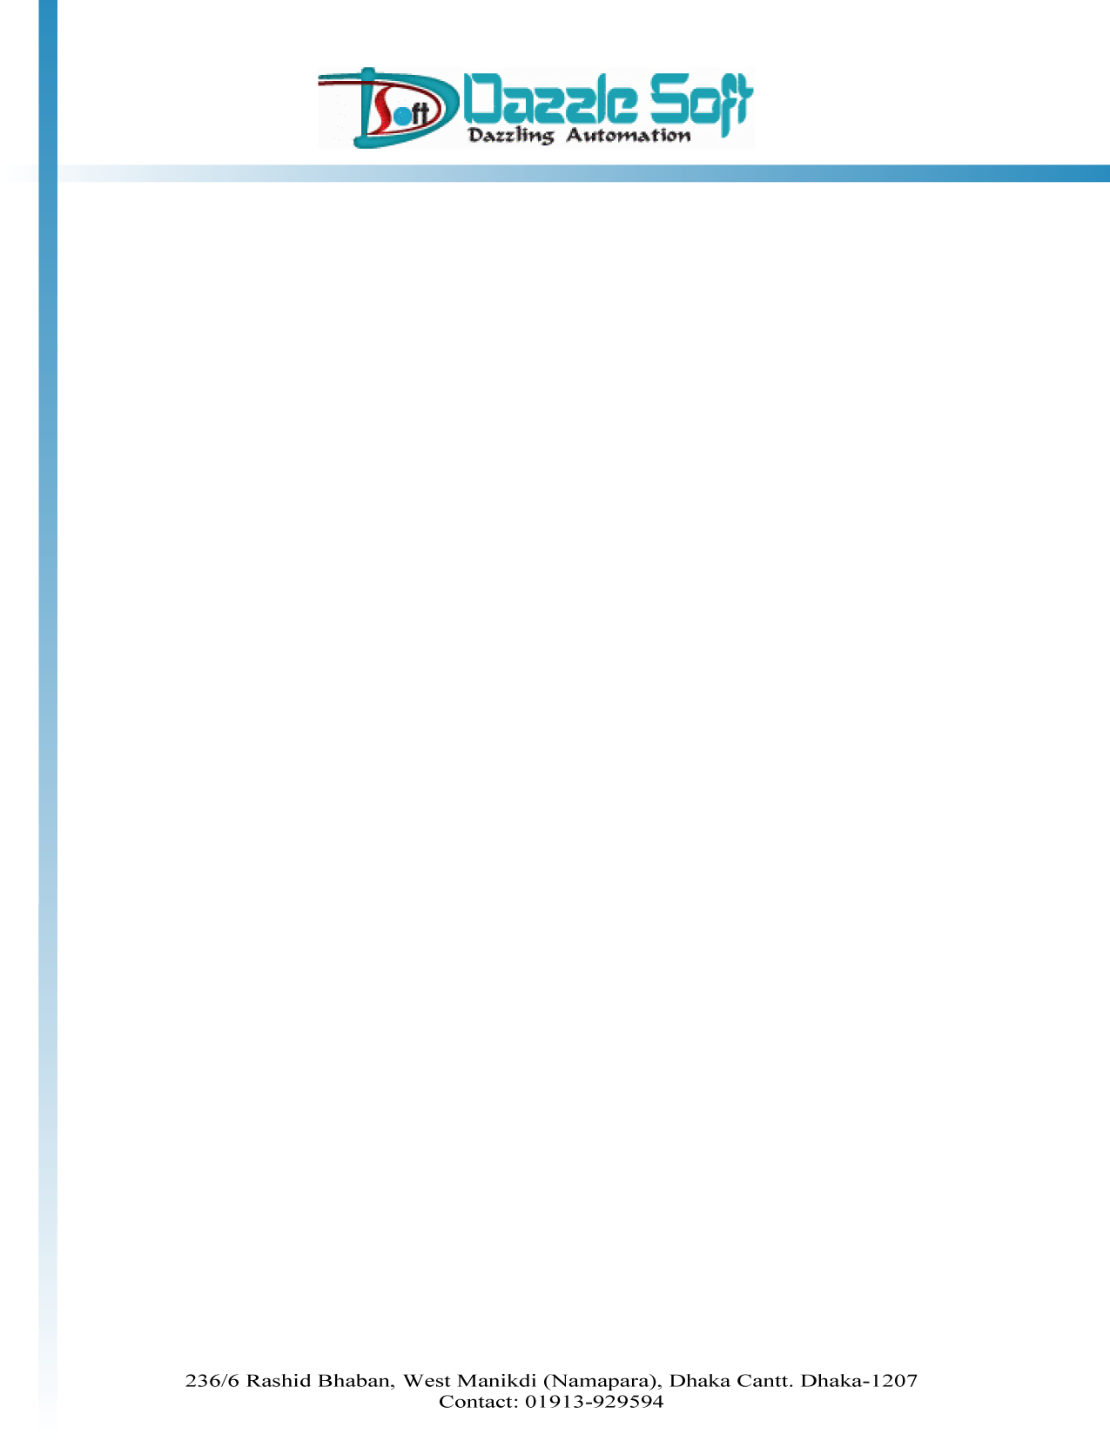

BILL

Money Receipt No : DZL0009 Date : 30 Jan 2021
Customer Name : M.M. Knitware Ltd.

SL NO | Description | Amount
1  2 | Hosting And Domain Fee (for 1 year)  Website and Mail Service | 3400/=  5000/=
Total : `8400/-

Taka In word: EIGHT THOUSAND FOUR HUNDRED ONLY

Authorized Signature

