Content Management Portal (CMP) Project
Proposed Software Architecture

Document Reference: |  | CMP/DOCS/TS.7.1
Project: |  | Content Management Portal (CMP)
Document Title: |  | Proposed Software Architecture
Version: |  | 1.0
Date: |  | 07 Aug 2009
Prepared/Revised by: |  | Ravi
Approved by :
 |  | Sui Haiyang |  | Date
 |  | Project Manager |  | 07 Aug 2009
 | © 2009  The information contained in this document is the property of ISS. The contents must not be copied in whole or in part for purposes other than which it has been supplied without the consent of ISS, or, if it has been furnished under contract to another party, as expressly authorised under that contract, then ISS shall not be liable for any errors or omissions. |  | 
Institute of Systems Science, 25 Heng Mui Keng Terrace,
Singapore 119615

Version History Record
Version | Date | Brief description of amendments and affected pages, paragraph
1.0 | 07/08/09 | Submission to ISS

Distribution:

Name | Department | Organisation
ISS Audit | ISS | ISS
Sui Haiyang | Project Manager | ISS-SE16S07
Gao Jia Si Karen | Quality Manager | ISS-SE16S07
Yap Sie Kuok, Thomas | Testing Manager | ISS-SE16S07
May Ann Sallan | Database Designer | ISS-SE16S07
Rajendran Kumaraguru | System Architect | ISS-SE16S07
Thiyagarajan Ravikumar | Technical Lead | ISS-SE16S07

Table of Contents
1. System architecture 2
2. Application Architecture 3

System architecture
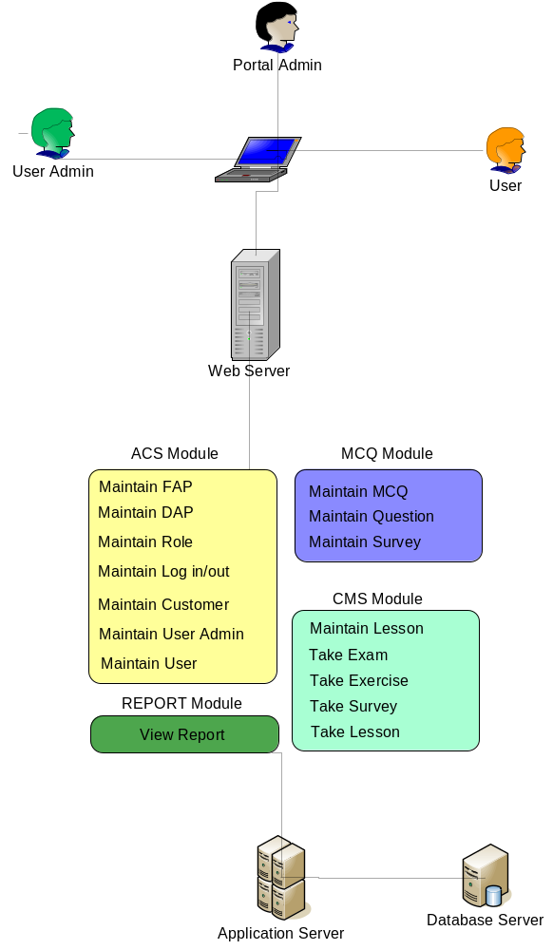

Application Architecture
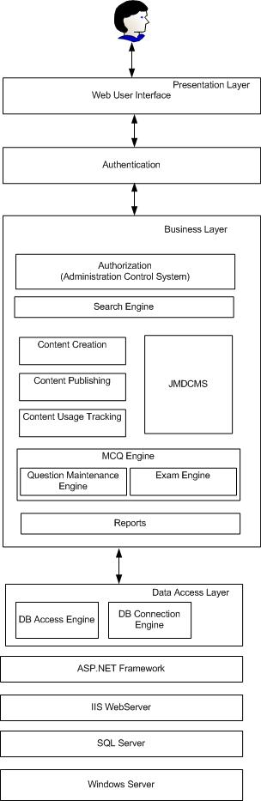
Approval Record DOCS/Forms/Approval
Project Name Content Management Portal
Document Ref CMP/DOCS/TS.7.1/1.0
Approved by Haiyang | Date 07/08/2009
Authorised by | Date
The document authorisation appears on the title page. |  | ✔
The structure of the document is logical. |  | ✔
The distribution list is correct. |  | ✔
The title page is signed |  | ✔
Calculations appear reasonable, are neatly presented and have been checked. |  | ✔
Theory and formulae are correct and properly applied. |  | ✔
Illustrations are relevant, readable and logically placed. |  | ✔
There are no typographical errors. |  | ✔
Units are consistent throughout. |  | ✔
The security classification is correct. |  | ✔
There are no obvious omissions. |  | ✔
The document complies with the Client's requirements, however specified. |  | ✔
Responsibility is accepted for all opinions, conclusions and recommendations. |  | ✔
The document does not run counter to company policy. |  | ✔

