1. Create two folders. One “Rose”, the other “Specs”
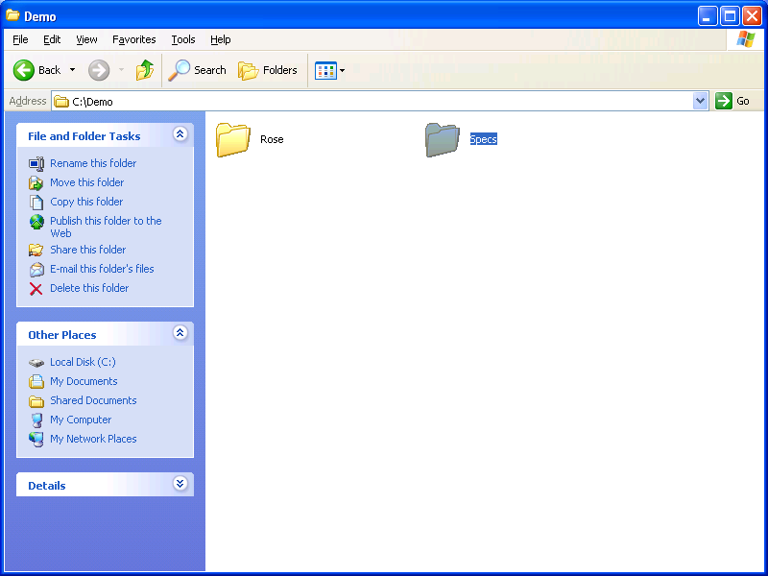

2. under specs, create four folders:

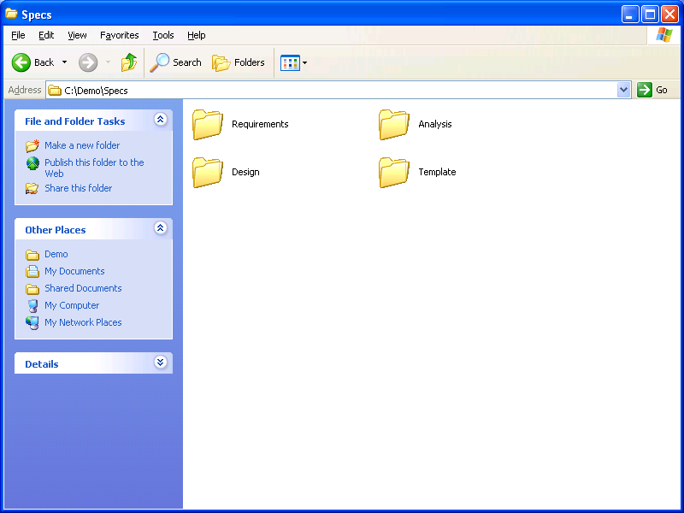
3. create new Rose document, and save into “Rose” folder. Remember choose the “Rational Unified Process”.
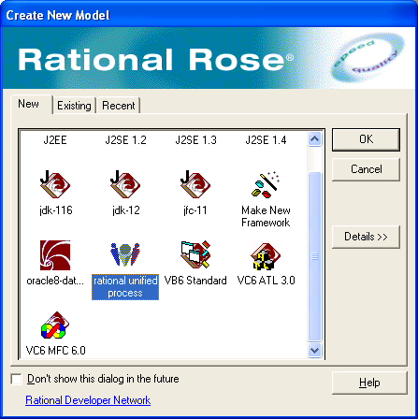

4. here to create actors: notice it’s under “Use Case View”
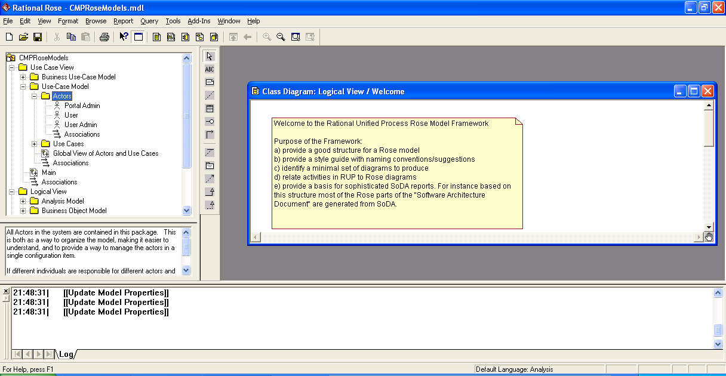

5. create class: Logical View -> Analysis Model -> rightclick -> new -> class.

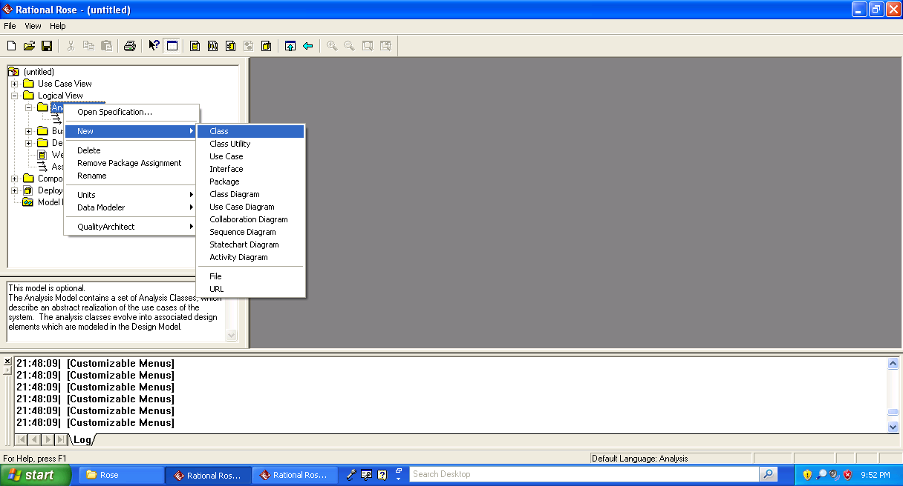
6. define class type, entity, boundary or controller.

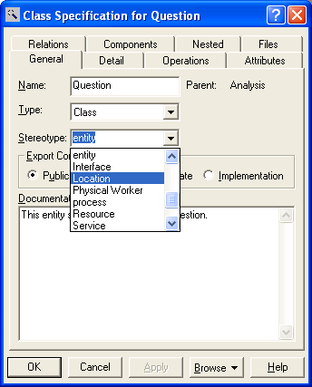

7. right click on the object, create operations and attributes.

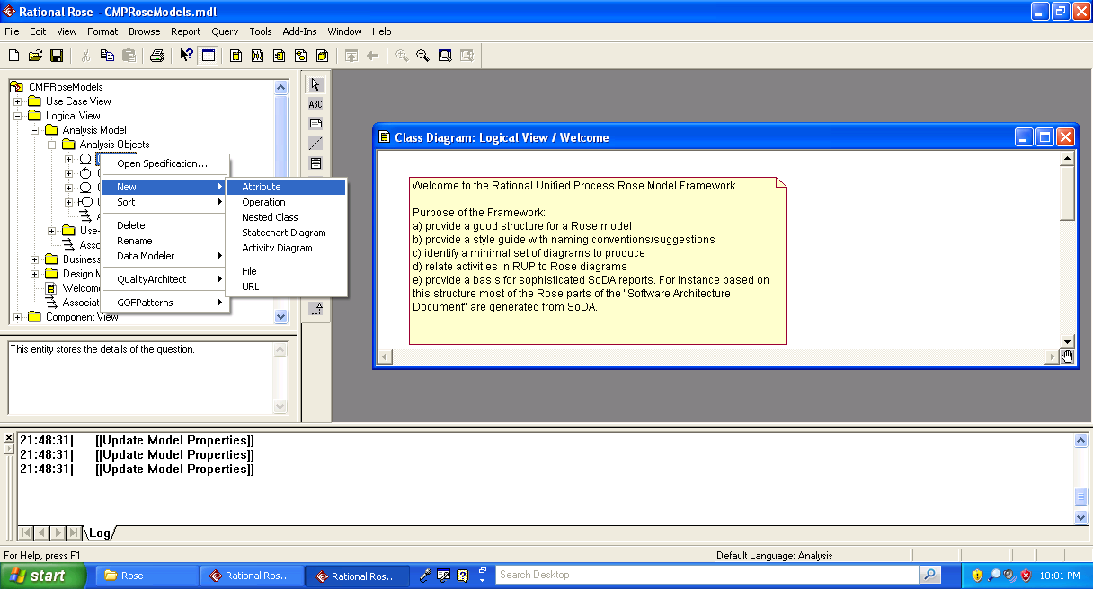
8. Under “Analysis Model”, create package “Use-Case Realizations”, then sub-package “Analysis of <Use Case Name>”, right click “Analysis of <Use Case Name>”, create new Use Case, the use case should be the same name with the package. Create only one use case under this package!
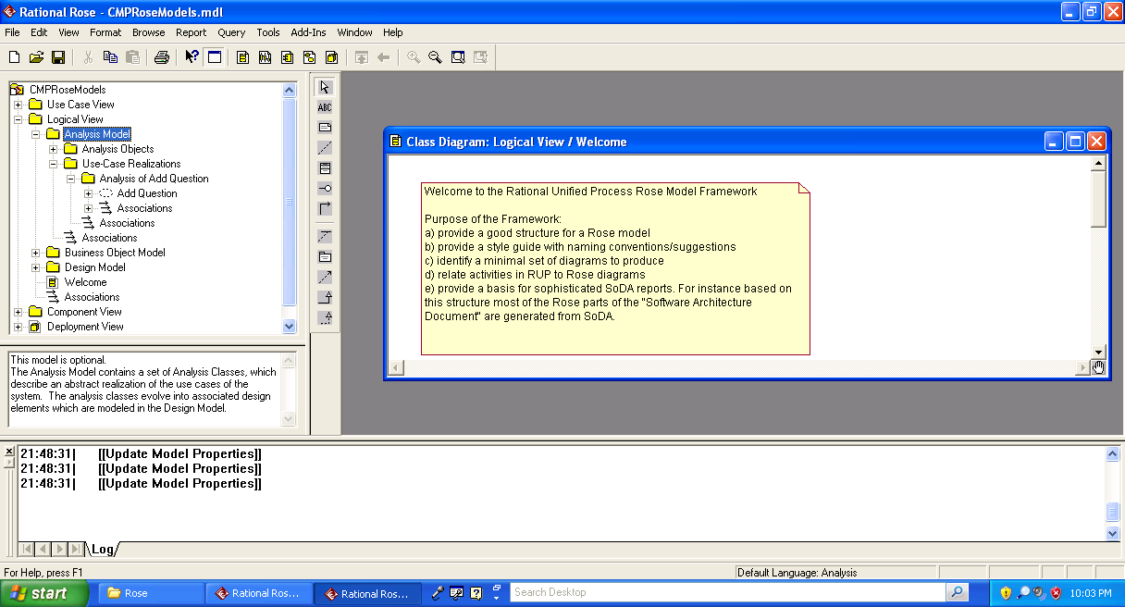
9. right click on the use case, create “Class Diagram for <Use Case Name>”, and “Collaboration Diagram for <Use Case Name>”, remember using the same name with Use Case. Drag all the actors and objects to create collaboration diagram.
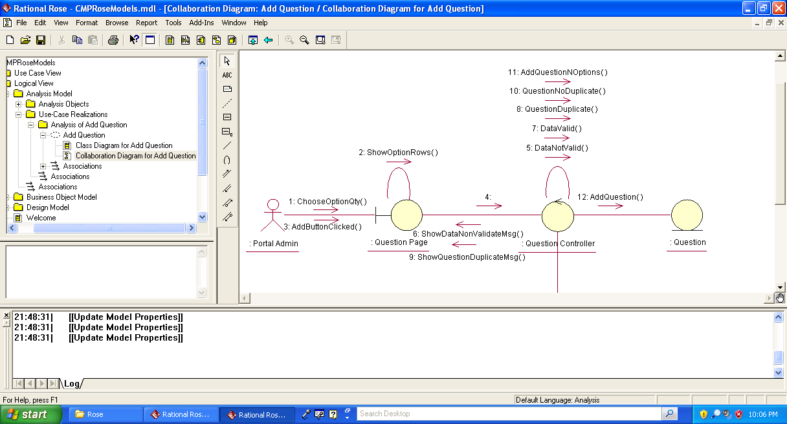
10. save it, open soda
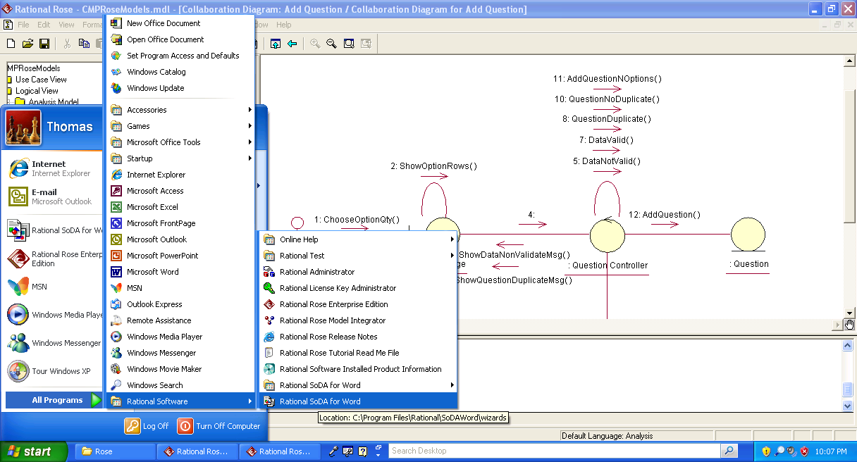
11. soda -> getting started.
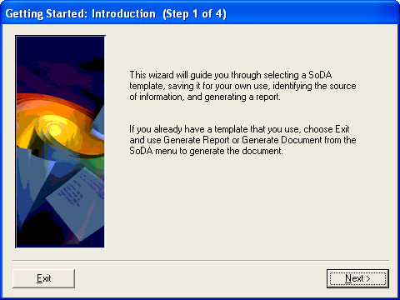

12. next, select template “Rose\rup use case realization report”, next

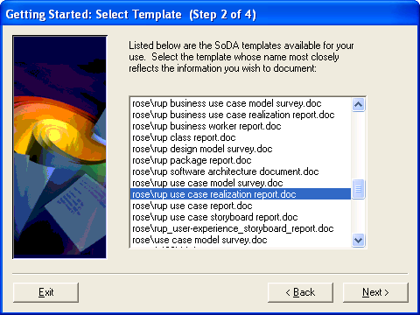

13. click “Browse”, save the template into the folder created. Then click “Exit”

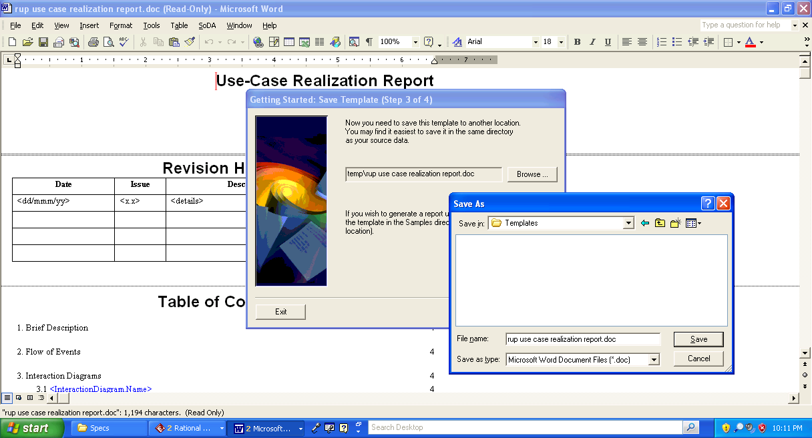

14. soda -> generate document

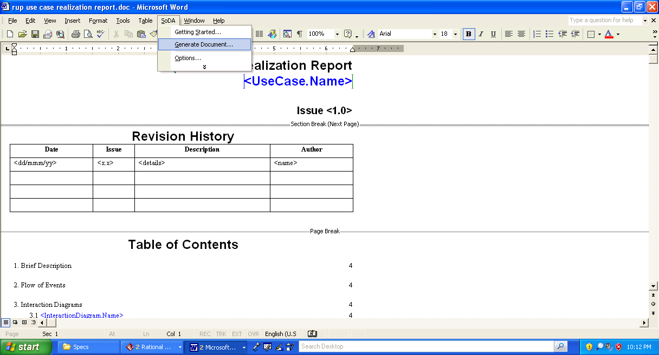
Click “OK”

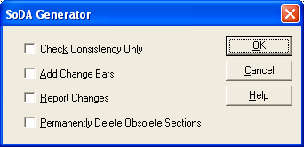

MDLFileName -> your rational rose file
PackageName -> “Analysis of <Use Case Name>”,
UseCaseName -> “Use Case Name”.
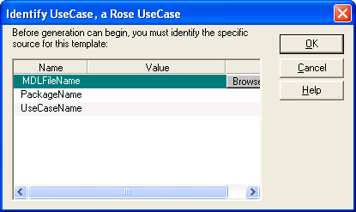
Done!

You need to do some cosmetic things though. You need to describe the workflow and “generated requirements”.

Cheers!

