Content Management Portal (CMP) Project
Prototyping Study Report

Document Reference: |  | CMP/DOCS/TS.3
Project: |  | Content Management Portal (CMP)
Document Title: |  | Prototyping Study Report
Version: |  | 1.0
Date: |  | 06 Aug 2009
Prepared/Revised by: |  | Gao Jia Si Karen
Approved by :
 |  | Sui Haiyang |  | Date
 |  | Project Manager |  | 06 Aug 2009
 | © 2009  The information contained in this document is the property of ISS. The contents must not be copied in whole or in part for purposes other than which it has been supplied without the consent of ISS, or, if it has been furnished under contract to another party, as expressly authorised under that contract, then ISS shall not be liable for any errors or omissions. |  | 
Institute of Systems Science, 25 Heng Mui Keng Terrace,
Singapore 119615

Version History Record
Version | Date | Brief description of amendments and affected pages, paragraph
0.1 | 05/08/09 | Draft Issue
0.2 | 05/08/09 | Release after Internal Review
1.0 | 06/08/09 | Submission to ISS

Distribution:

Name | Department | Organisation
ISS Audit | ISS | ISS
Sui Haiyang | Project Manager | ISS-SE16S07
Gao Jia Si Karen | Quality Manager | ISS-SE16S07
Yap Sie Kuok, Thomas | Testing Manager | ISS-SE16S07
May Ann Sallan | Database Designer | ISS-SE16S07
Rajendran Kumaraguru | System Architect | ISS-SE16S07
Thiyagarajan Ravikumar | Technical Lead | ISS-SE16S07

Table of Contents
1. INTRODUCTION 2
2. Prototype challenges & difficulties 3
3. Prototype Design Considerations 4
4. Detail Prototype Reviews 6
4.1 Architecture of Functionality Prototype 6
4.2 Functionality Prototype 7
4.3 UI Prototype 8
4.4 Integrated Prototype 9
5. Success areas achieved 11
6. gap between prototype and final product 12
7. Recommendations for further improvements 13
8. Conclusion and future work 14
Appendix A – UI PAPER pROTOTYPE 1 15
Appendix B – UI pROTOTYPE II (&iNTEGRATED prototype) 16
Appendix C – fUNTIONALITY pROTOTYPE 18

INTRODUCTION
After the user requirement specification has been accepted by Client, prototype development has been carried out and shown to sponsor after the development. This prototype shall consists of two parts; one for the User Interface (UI) prototype and the other for the functionality prototype.

The UI prototype shall be designed with intelligence to allow the user to input the necessary information and also extracting information from the system. The design shall be logical and simple to appreciate so that any user would have ease of using the UI. The UI would also be used to confirm the user requirements to avoid any unnecessary changes at any developing phase of final product.

The functionality prototype was designed to consolidate and program based on the user requirements and subsequently building the web service platform to provide the three main functionality services out of targeted six services which elicited from user requirements. These are Administration Control System (ACS), Content Management System (CMS), and Multiple Choice Question (MCQ). The successful implementation of the 3 parts shall determine the success of the product. However, the Survey Report, Membership Management were left out intentionally from the prototype as the team realized that the MCQ would have covered most of them.

Prototype challenges & difficulties
The prototype challenges and difficulties faced during development are listed below:

  - Content Management System is a complex system and it would have required many resources to have a solution.

  - Currently, many web service providers would preferred the CMS to be embedded into their existing system; at such having a successful implemented CMS would prove to have great business potential.

  - There are many Open Source CMS, however most of them are in Java language, and the customer requirement was to use the developing tool of C#.net so that it could be used into their existing platform. This had further exhausted the team as they needed to spend huge time and effort on research and feasibility study for the open source in this area in order to reduce the team developing effort.

  - Although, there are few open source CMS in C#.net, the challenges still exist as the team are required to test the other integrated functions such as the ACS and MCQ with the customized functions design by the team. The candidate open source code totally without any documentation or comments for the coding.

  - In order to have a better Web server control to achieve automatic dynamic data binding to support the XML documents, site navigation support, customizable appearance through themes, user- defined images and styles and so on, the flexible TreeView must be designed and created.

All those challenges at same time were the difficulties for the team faced during the developing. Those must be solved at end of the prototype development phase.

Prototype Design Considerations
The design consideration for the team is to construct the solution and task in the way to be representative of the features sponsor required for the web content management portal application and also be able to string together a good mental model of project for the users. As a result, three main services targeted and agreed by the sponsor to be chosen with the most complexity level for the prototype to be developed and accomplished.

The first task which also is the most challenge one is to incorporate and customize JMDCMS open source into the team’s design solution of CMS for this project according to the user’s preferences and requirements. This task is considered “hard” because it requires the most resources to research, explore, design, customize and complete it. The targeted user is the Portal Admin, User Admin and User. Portal Admin should be able to use it to create, update, delete, publish contents; User Admin and User should be able to access it to view the published contents. This task is the key to success of the project.

The second task is to design the MCQ services, which include creating, updating, and deleting questions for selected modules. This task is same as previous one which targeted on Portal Admin, User Admin and User three user groups and has similar accessibility to the services, except user could view and do the MCQ exercises or exam whichever they required and subscribed. This task requires less resource and than the first but is more of a cognitive process than the next.

The last task is to build up the ACS. This one is considered to only give the access rights Portal Admin, User Admin and User. The User Admin designated by Portal Admin to administer the users that can be given access to the customer's published contents and MCQ.

After careful consideration and analysis of the schedule and requirements, the three functionality services were locked into the functionality prototype development because it adequately covers the proposed functionality of the project. The detail architecture design for the prototype will be demonstrated in the later section of Detail Prototype Design. Creating multiple sites for multiple clients is a major function, that distinguishes our project from others content management system, in that our program is capable enough to provide multiple sites for user’s interests in large demand of clients’ requests. All the considerations will help to verify the functions requirement gathered and access the project resources allocation and planning during the project plan stage, and provide the inputs for the adjustment of project schedule and efforts arrangement.

In addition, there is two UI prototypes were produced in the team in order to have better understanding of user needs. The first one is UI prototype I, which was designed in paper format during in the functionality requirement gathering, which assembled all the functionalities required of system accomplish the goals of the CMP project and potential needs of the users. Another UI prototype II were designed, developed and integrated with functionality prototype. In overall, these prototypes are stripped of all look & feel elements and most content based on the findings developed during mind mapping and content management logical concerns from users. The UI basically designed in single skin but with mutiple control panels, functional features.

Detail Prototype Reviews

Architecture of Functionality Prototype
The architecture of Functionality Prototype has engaged the similar system architecture which may be implemented into the final product development. The only difference is that there’s no any database and server created for the fast developing purpose, every data used in prototyping were hard coded into the programming. This will easily allow the team to have the final product development based on the same architecture foundation without bothering the structure issues. The architecture of functionality prototype is shown in figure 4.1
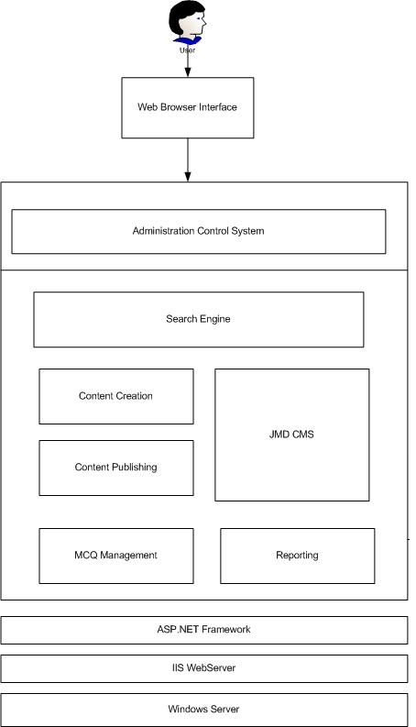
Figure 4.1 Architecture of Functionality Prototype

Functionality Prototype
Firstly, the selected three main functionalities (services) CMS, MCQ, and ACS in the prototype adequately cover the proposed functionality of the project, and produced proper representatives for the user requirements in the software development required. The MCQ and ACS have successfully developed with clear navigation instruction and workflow. The MCQ service provides the functions of creating, updating, and deleting questions to portal administrator, whilst provides the functions of exercise and exam taken to user. The functions of authorising access rights have been also successfully build up in the ACS portion of services in the prototype.

Secondly, JMDCMS open source has successful incorporated and customized into the team’s design solution of CMS for this project according to the user’s preferences and requirements. Furthermore, it shows the good compatibility with the design solution from the team. The implementation of the open source portion greatly transfers the team’s effort towards a better overall design solution for the later stage development. The customized design of JMDCMS in the team’s solution is shown as Appendix B

Lastly, the Visual Studio web development (C#.NET) package used for the development in the prototype allowed the team for a faster development by minimizing the need for handwritten code. For example, using WYSWYG feature in the package, the team were able to generate many lines of code by drag-and-dropping various AWT features such as menu bar, radio buttons and check boxes onto the Frame.

UI Prototype
The UI prototype I (shown as Appendix A) did help on understanding the user needs during the requirements elicitation stage. It is actually the paper prototype which shows the interface interaction and functions workflow, which provide team the chance to have the rapid response to users needs and clearly confirmed the user acceptability of screen layouts, formats and methods of operations (menus, function keys, etc). The most important thing is that the functionality requirements were verified based on the UI prototype I.

Based on the UI prototype I, the second UI prototype II clearly shows mind mapping and content management logical concerns from user’s view. It composed all the look & feel elements and important contents required in user requirements. It has been integrated with functionality prototype to form the integrated prototype, whose reviews were described in later section of Integrated Prototype.

Integrated Prototype
Content Management Portal starts from a page (CMP homepage) that contains header menu like shown in Figure 4.2, the interface was revised since last prototype to users for easier and faster navigations. The previous prototype for required the first time users to create profiles and it may confuse many users as some of them need services provider to perform everything for them. In addition, some users may want to proceed without creating a user profile. This updated UI design tried to pick the most suggestive and intuitive icons for the first time user.
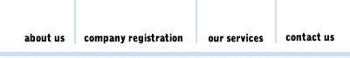

Figure 4.2 Heaher Menu

Coupled with the homepage is a global menu bar shown in Figure 4.3 that replicates all the features and capabilities of the homepage and allows users to quickly navigate through features and sections without having to return to the home page every time he/she wants to use a different section. This also has been revised since our last prototype, where each screen contained both a unique menu for that screen along with a global menu.
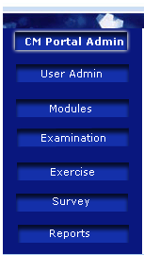

Figure 4.3 Global Menu

In this prototype, we grouped and simplified the global menu and completely removed the internal duplicated menu page to bring consistency in design from one screen to another like shown in Figure 4.4.

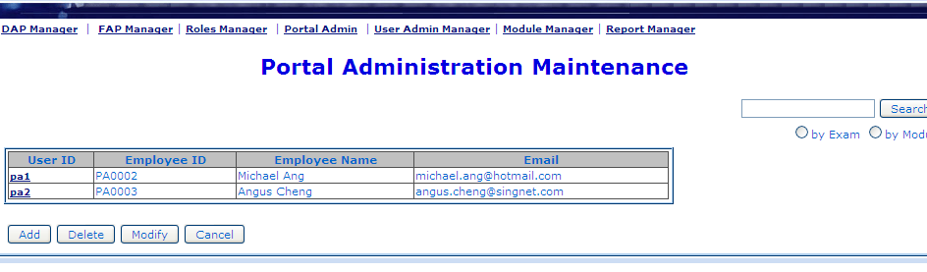
Figure 4.4 Individual Menu of Screen

Furthermore, according to the review and suggestions from the sponsor based on the UI prototype I and the Functionality prototype, the integrated prototype has improved and revised in such ways:

In general:
- Add, Delete, Modify buttons are compulsory for the screen, View and Manage buttons can be used based on screen’s purpose

For the MCQ Maintenance:
- Instead of "Delete" column, "Radio Button" were added in first column. Based on the selected "Radio Button", Modify, View, Delete, Manage (Section & Question) will be navigated.
- The question type was changed from “Easy, Medium & Hard” to “Simple, Moderate & Complex” respectively.
- One more Textbox of "Total Questions" for each section were added for validation.
- When the Exam & Section are under transaction, there will be rollback the transaction occurs if the section details are incomplete or validation fail. The direction of navigation (back, forward) will be based on the confirmation.
- Question Type title were set as "Descriptive", "Mutually Exclusive" & "Multiple Choices"

For Question Add screen:
- When the number of choice is typed, the matched number of text boxes will be generated.
- If the question type is Mutually Exclusive, “Radio button” will be generated in front of each textbox.
- If the question type is Multiple Choices, “Checkbox” will be generated in front of each textbox.
- If the question type is Descriptive, “Text Area” will be created with textboxes for the "Keys".
- To answer the question for user will just simply check on either “Checkbox” or “Radio button”.

For the Question Maintenance page:
- The records are selected based on the selection panel. The representing form of Exam Type and Question Level was changed to avoid reparative of the same value

In overall, this integrated prototype has inherent the advantages form the previous prototype and discarded those unwanted or unnecessary features, provide the most rational and practical design and successfully met the sponsor needs. The completed design is shown in Appendix C

Success areas achieved
The success areas achieved are mainly considered from below perspectives:

The implementation of JMDCMS open source greatly reduced the team developing time and effort in the later development phase. It successfully incorporated and customized into the team’s design solution. This is a key to success of the project, which build up the coefficient of project succeed as well as the team’s confidence level.

The Content Management System prototypes in such a short period has been developed and implemented with CMS ACS and MCQ functions in C#.net language, and successfully met the user requirements and needs, and achieved the customer compliment and consensus. It confirmed the design and development foundation, and provided the design template in the later development phase; the approved prototype can be used as verification point in configuration management. Once there are any changes against the prototype, the change requests should be made accordingly depends on the quality control management.

The flexible TreeView was designed and created, so that the automatic dynamic data binding are successfully created to achieve a better Web server control, which supports the XML documents and provide a better site navigation support, customizable appearance through themes, user- defined images and styles and so on, the flexible TreeView must be designed and created.

gap between prototype and final product
Through the study of the prototype, the gap between prototype and final product are analyzed and listed below:

- The required data in the design was hard coded and it might face some problems to link up with any data base or server.

- This prototype was tested against functionality and has not tested for performance to handle large information. Such as, there’s no way to simulate and calculate the percentage of contents read by user. So that, the performance issue still needed to be focused during the analysis phase.

- This prototype does not allow PDF, XLS, Video files to be uploaded, although those are not compulsory functions required but it would be a better if it could be have.

Recommendations for further improvements

Although the study of the prototype has successfully met the customer requirements, however the gap to the final product still exists, so that to have further improvement and better development in the later stages,

- Conduct Database design and design review, analysis the possible problems which we faced to link up with any data base or server.

- Ensure the coverage test plan, and set up the performance target based on the analysis and recommendation from the similar web application. Ensure the proper unit test, system test and reviews conducted for better performance. The beta test should be conducted before the deployment.

- Look for the possible solutions on the uploading PDF, XLS, Video files. In addition, the content formatting has to be established during the implementation so that the users will be able to access the contents in user friendly manner.

Conclusion and future work

As a result of prototype study, the reviews described in the preceding section shows that the Content Management Portal (CMP) fulfils the requirements specified in deliverable TS.1<< User Requirement Specification>>. However for the next phase of the project many things remain to be done.

Firstly, the performance of CMP for large percent of contents has to be considered and improved, which must be properly incorporated during the project design stage. The design specification must be reviewed, improved and executed strictly. Secondly, all the suggested improvement work must be developed into the solution, in addition, the usage tracking system should be included so that to provide a better service for user who could directly chosen to enter the last logout session. Finally, the database must be setup after the design stage according to the database design and make sure its performance meet the user requirements

Appendix A – UI PAPER pROTOTYPE 1

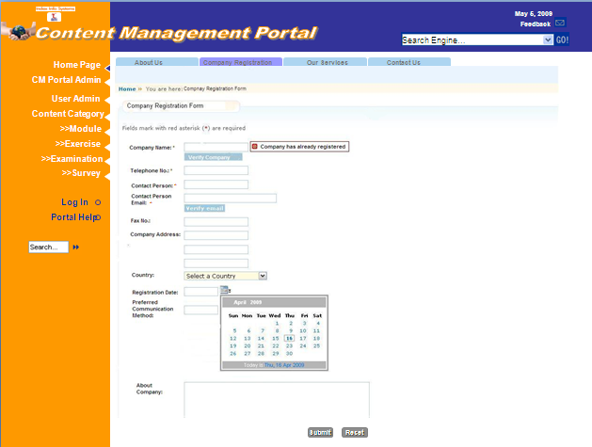
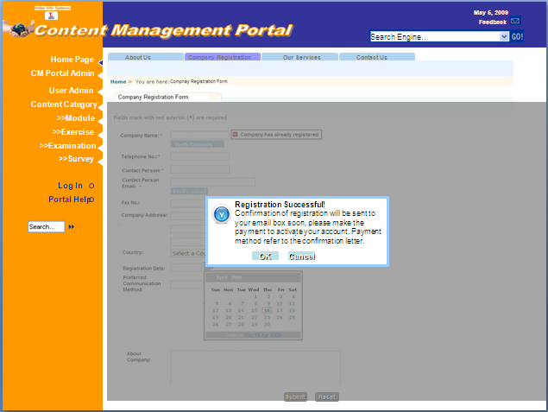
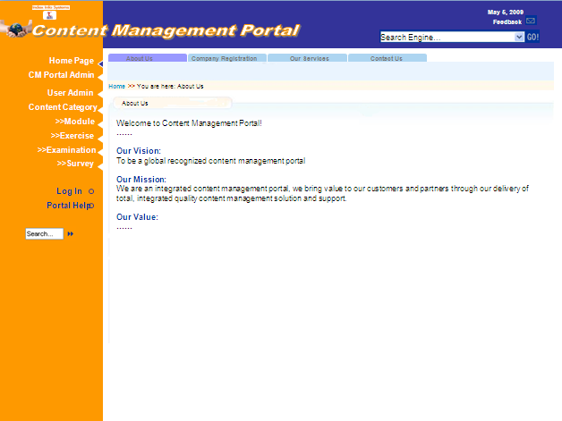
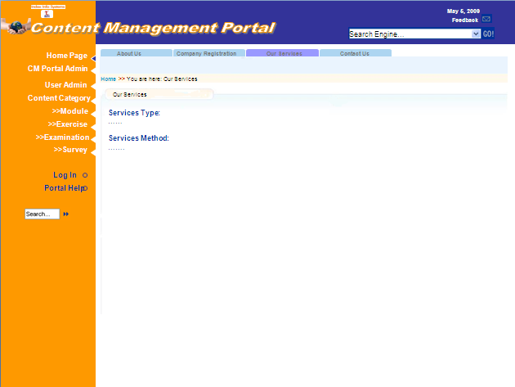
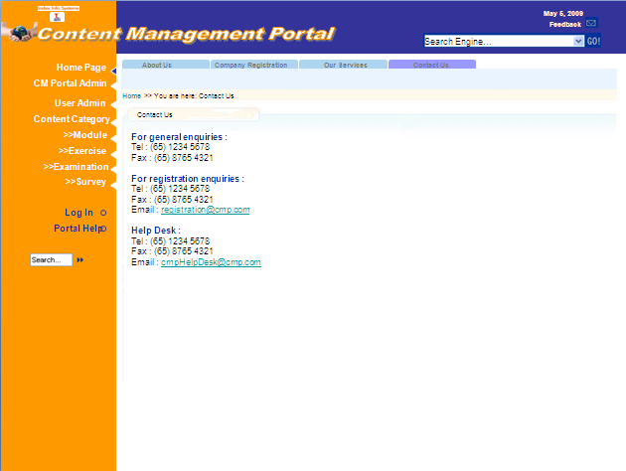
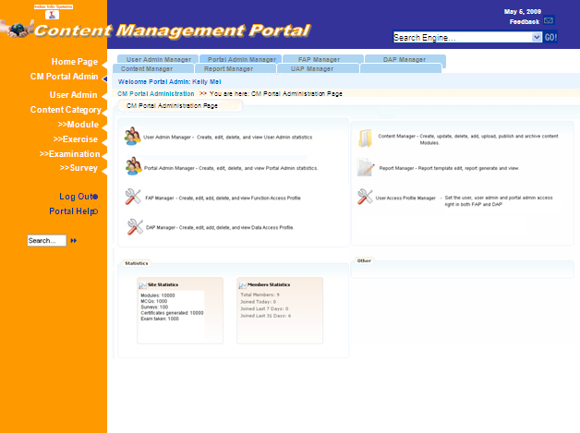
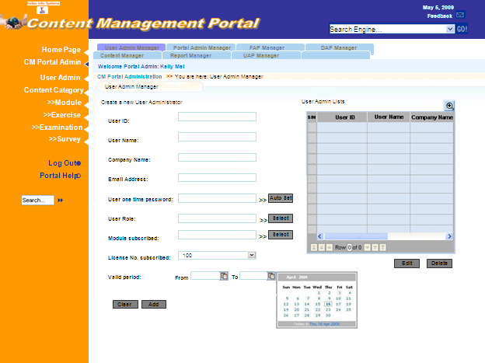
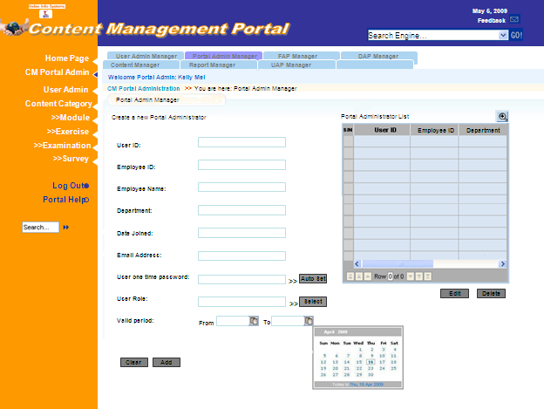
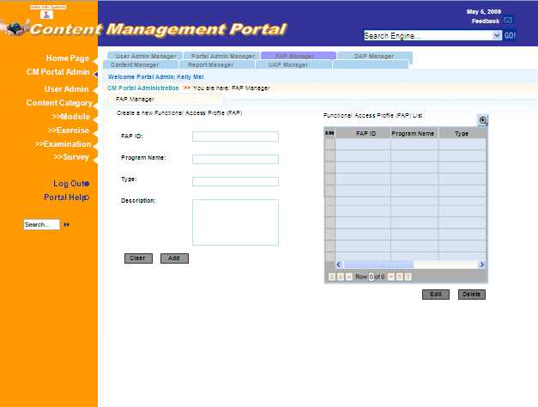
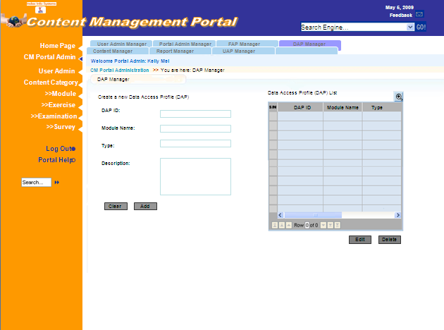
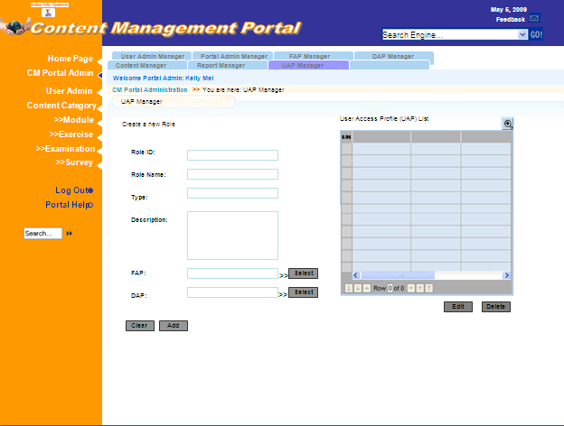
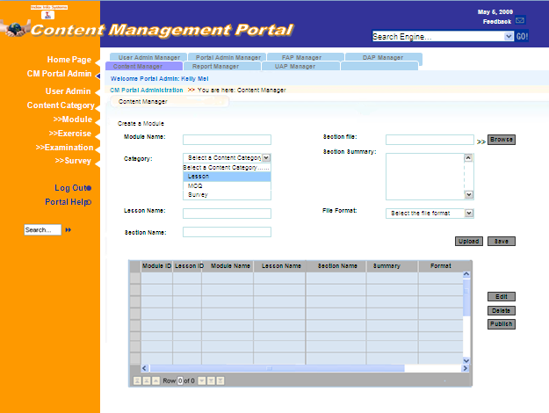
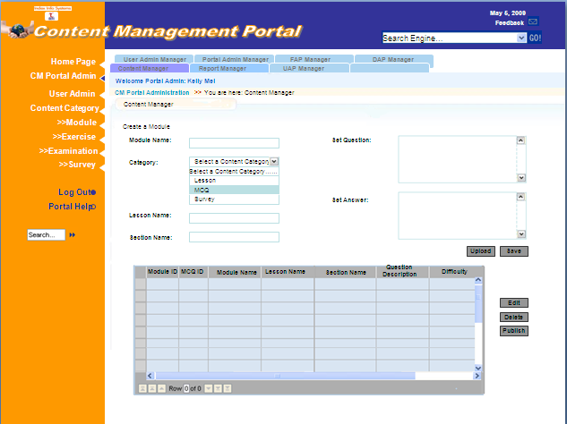
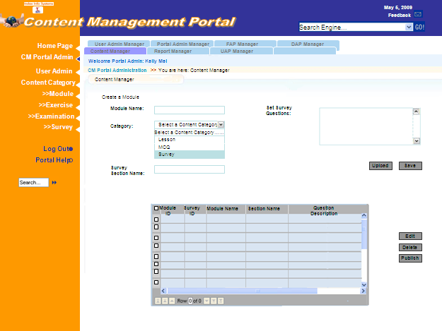
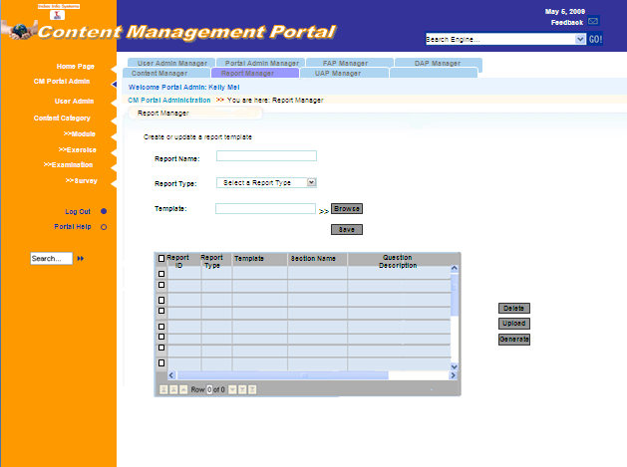
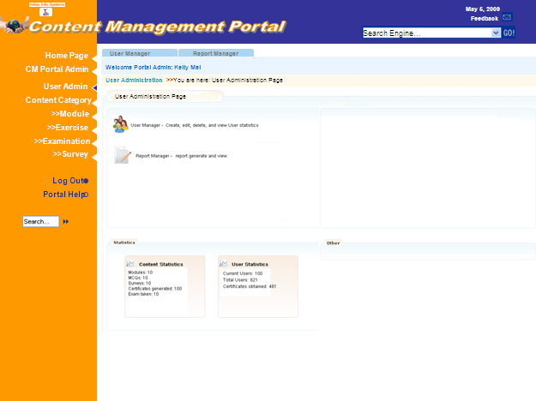
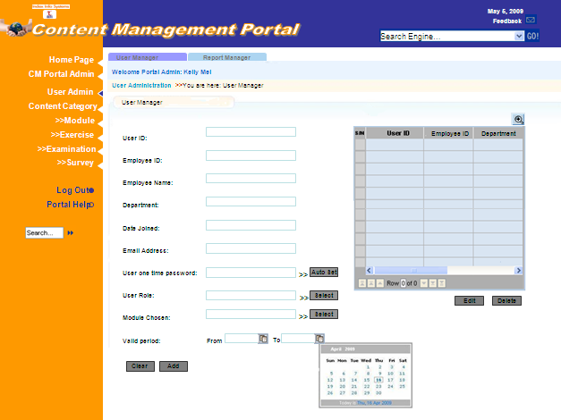
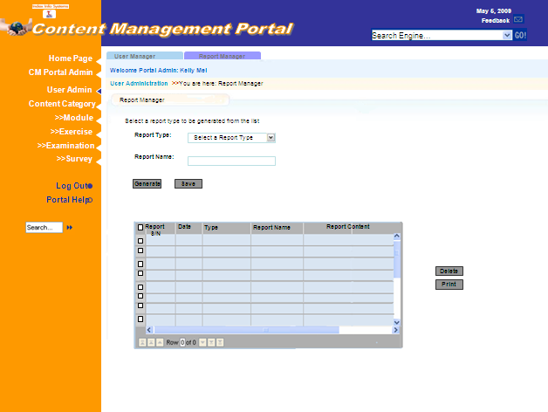
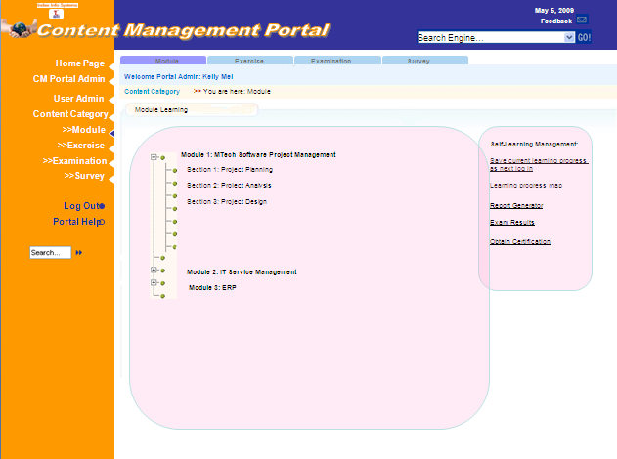
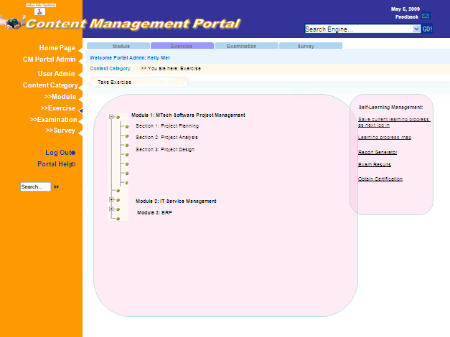
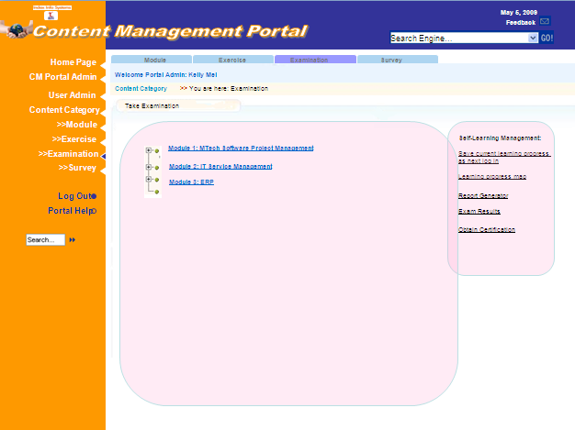
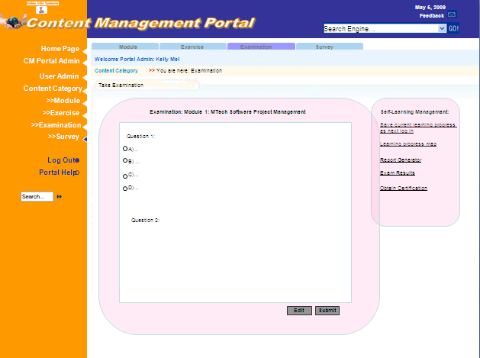
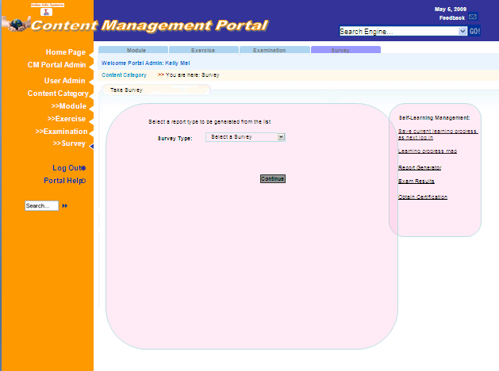
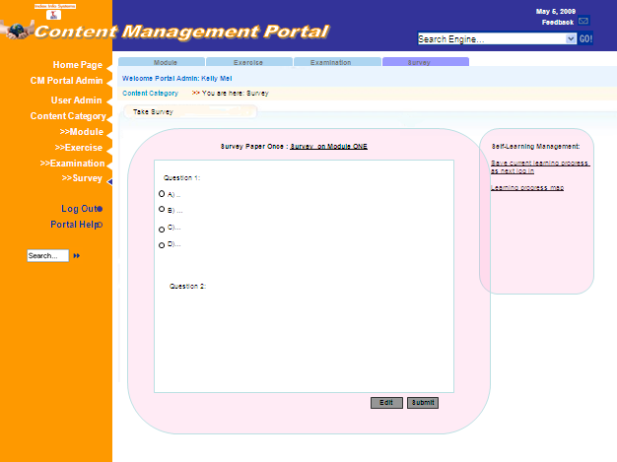
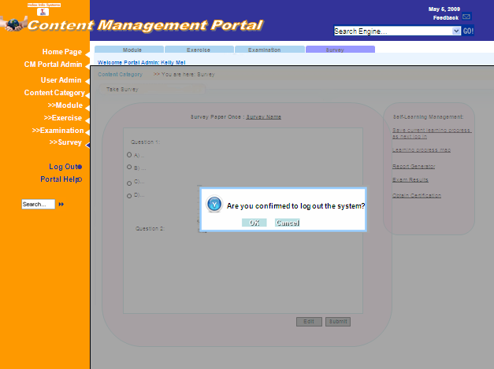


Appendix b – fUNTIONALITY pROTOTYPE
MCQ
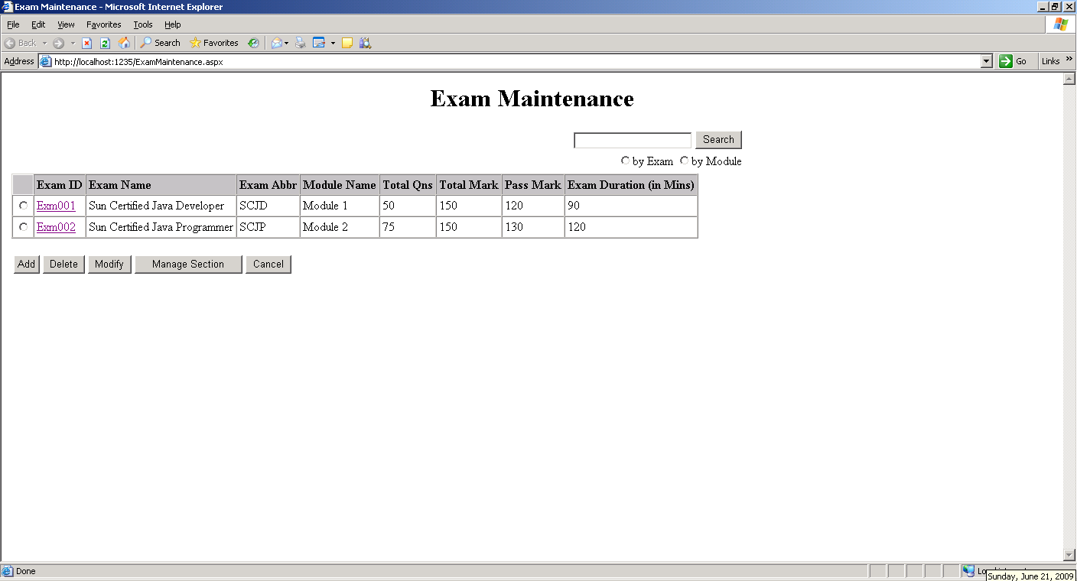

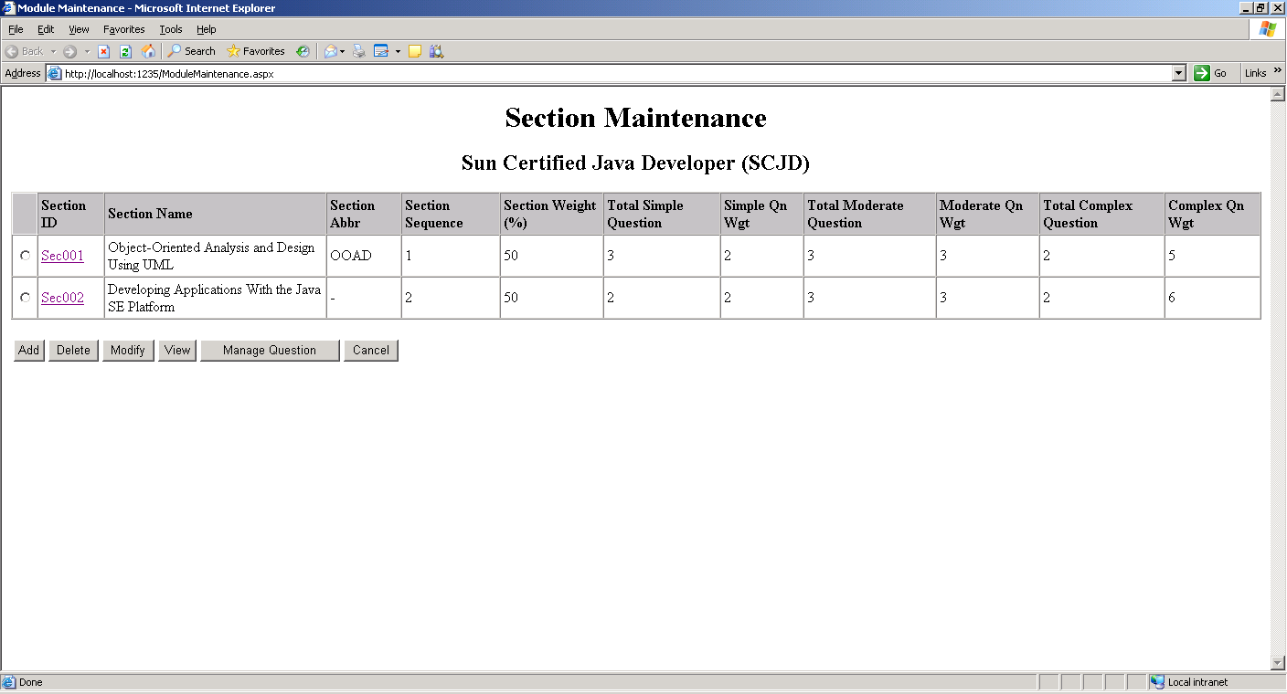

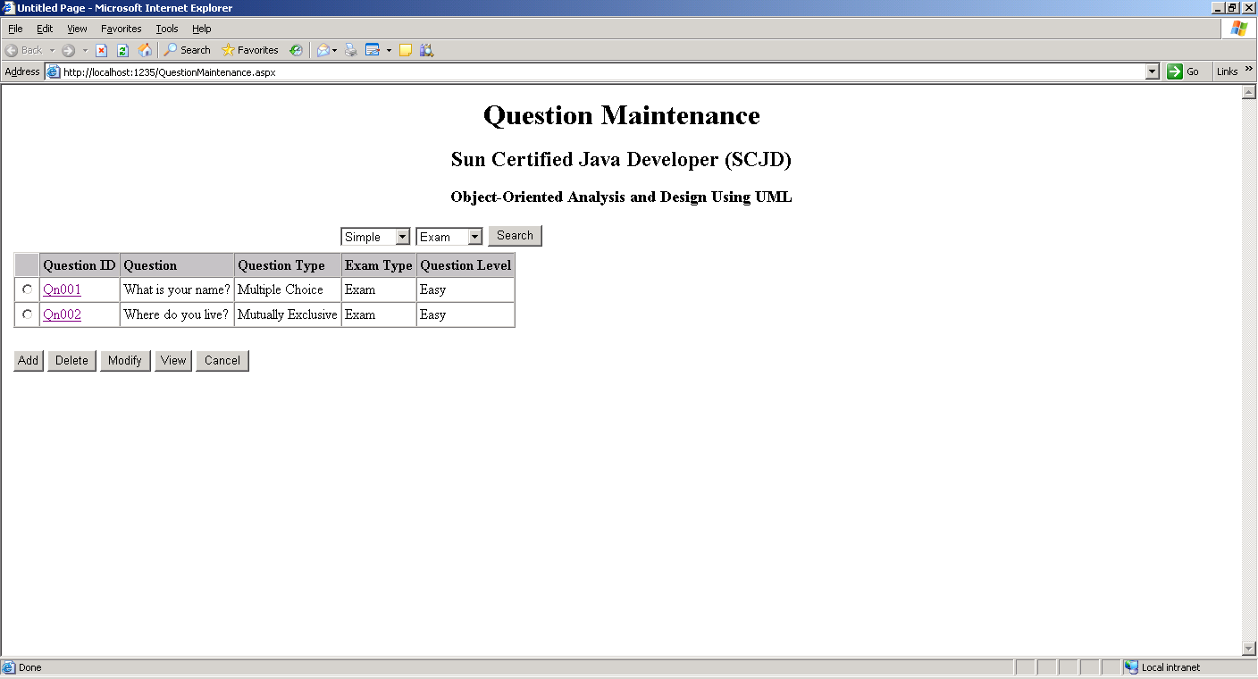

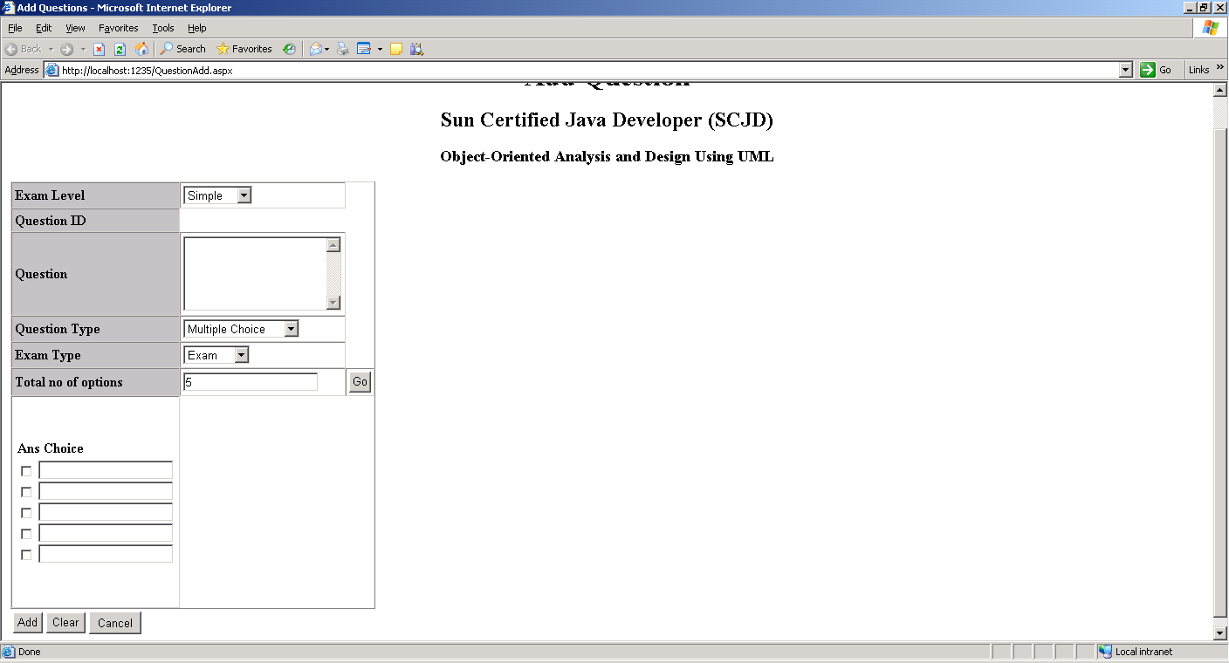

Appendix c – UI pROTOTYPE II (& iNTEGRATED prototype)

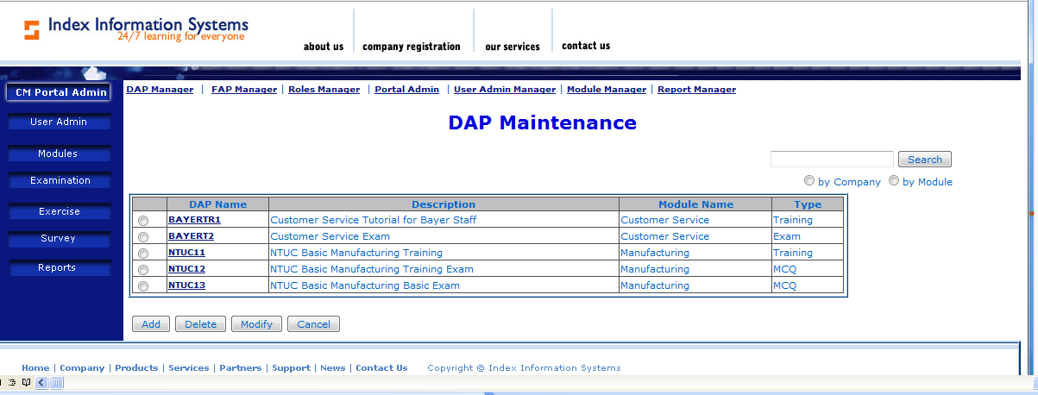
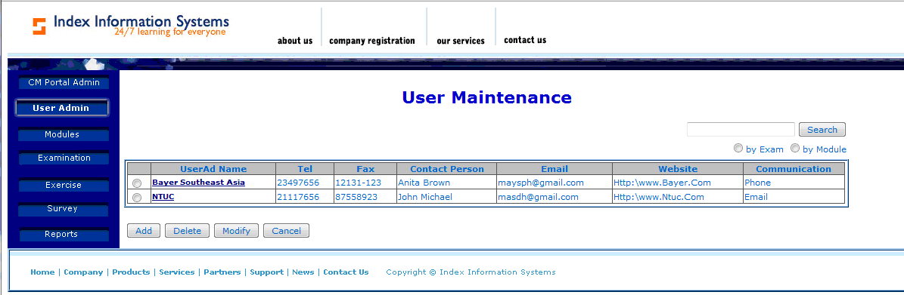
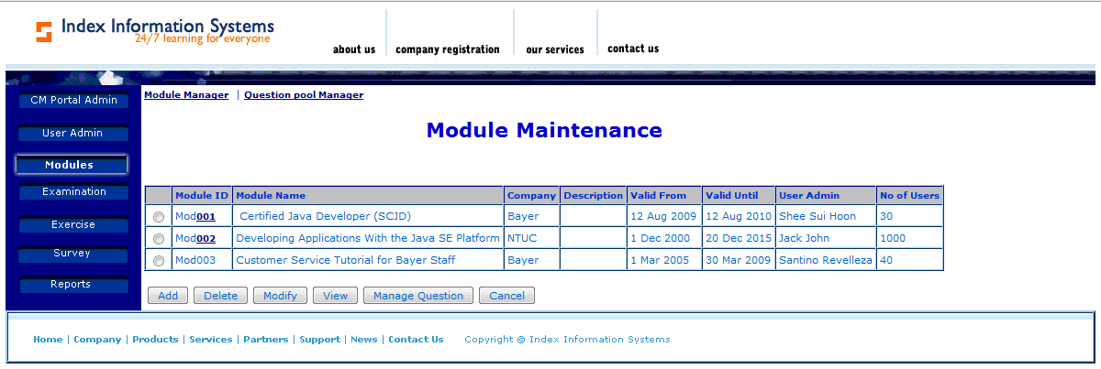
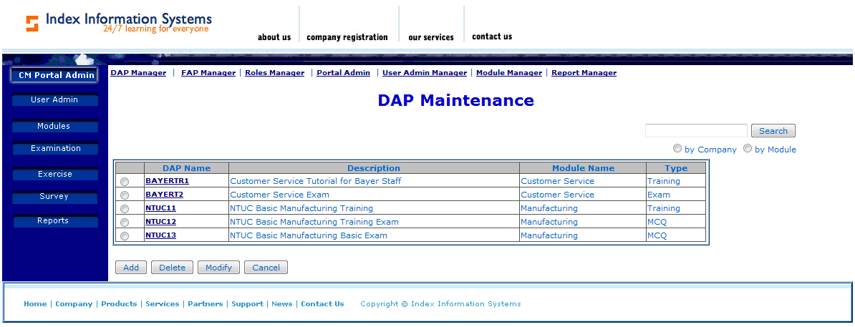
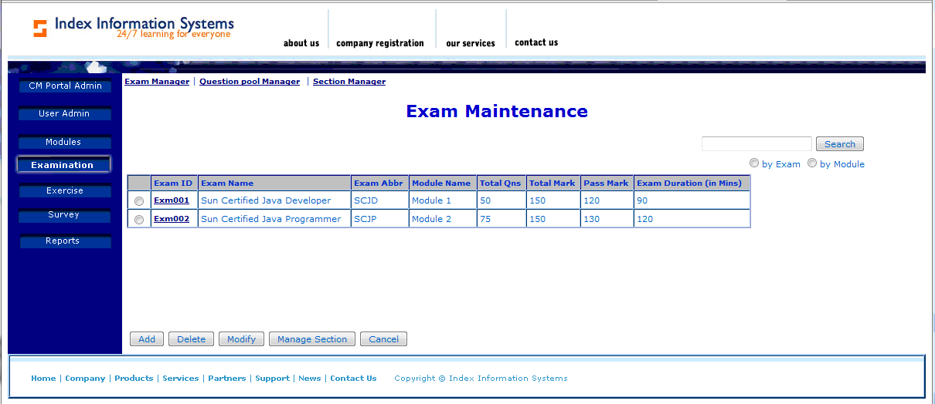
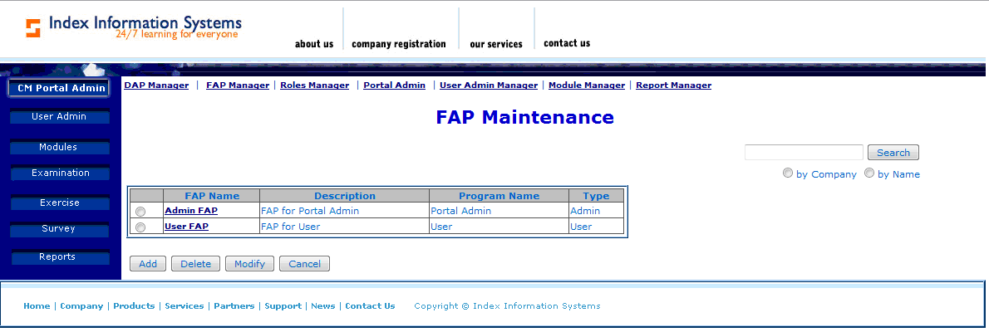
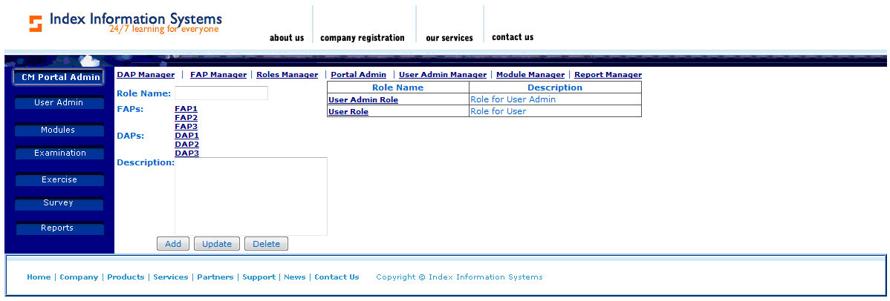
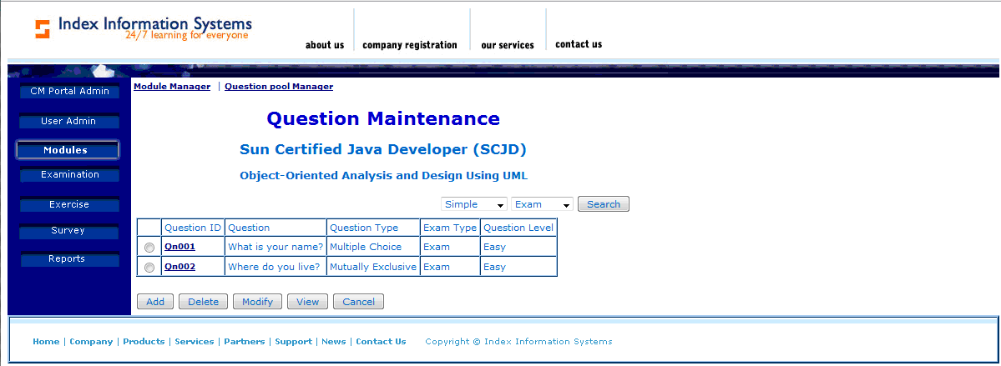
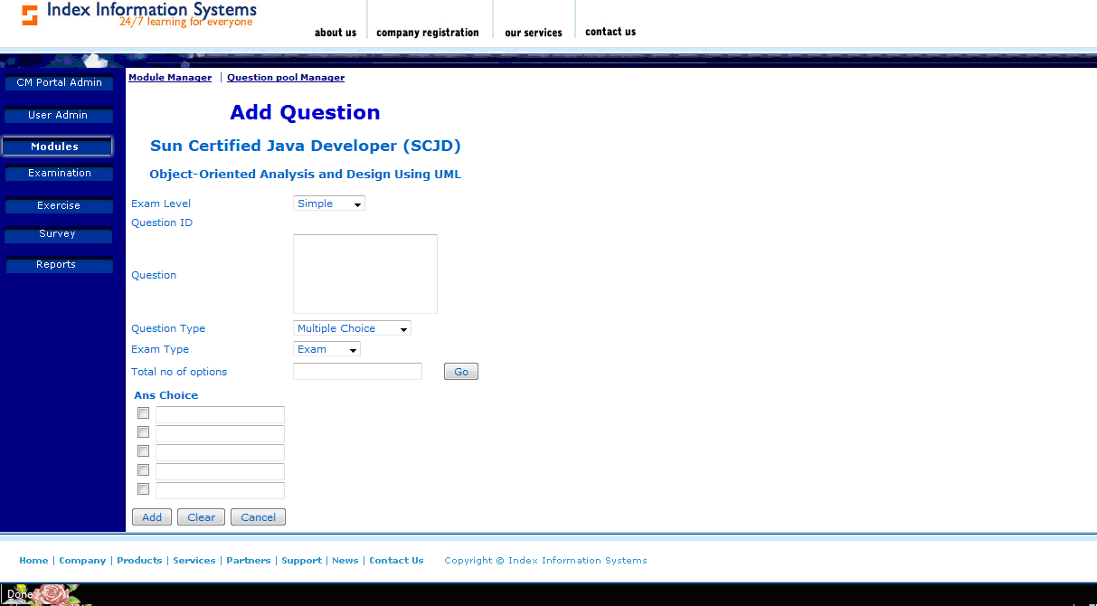
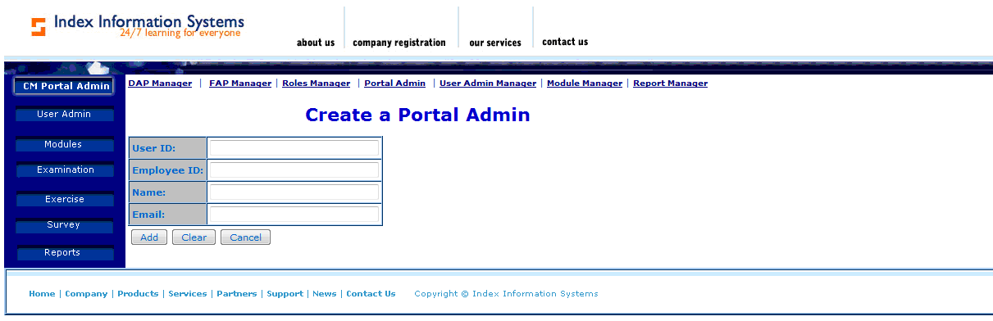

Approval Record DOCS/Forms/Approval
Project Name Content Management Portal
Document Ref CMP/DOCS/TS.3/1.0
Approved by Haiyang | Date 06/08/2009
Authorised by | Date
The document authorisation appears on the title page. |  | ✔
The structure of the document is logical. |  | ✔
The distribution list is correct. |  | ✔
The title page is signed |  | ✔
Calculations appear reasonable, are neatly presented and have been checked. |  | ✔
Theory and formulae are correct and properly applied. |  | ✔
Illustrations are relevant, readable and logically placed. |  | ✔
There are no typographical errors. |  | ✔
Units are consistent throughout. |  | ✔
The security classification is correct. |  | ✔
There are no obvious omissions. |  | ✔
The document complies with the Client's requirements, however specified. |  | ✔
Responsibility is accepted for all opinions, conclusions and recommendations. |  | ✔
The document does not run counter to company policy. |  | ✔

