Content Management Portal (CMP) Project
System Detailed Design Specification

Document Reference: |  | CMP/DOCS/TS.2
Project: |  | Content Management Portal (CMP)
Document Title: |  | System Detailed Design Specification
Version: |  | 1.0
Date: |  | 30 Nov 2009
Prepared/Revised by: |  | Gao Jia Si Karen
Approved by :
 |  | Sui Haiyang |  | Date
 |  | Project Manager |  | 30 Nov 2009
 | © 2009  The information contained in this document is the property of ISS. The contents must not be copied in whole or in part for purposes other than which it has been supplied without the consent of ISS, or, if it has been furnished under contract to another party, as expressly authorised under that contract, then ISS shall not be liable for any errors or omissions. |  | 
Institute of Systems Science, 25 Heng Mui Keng Terrace,
Singapore 119615

Version History Record
Version | Date | Brief description of amendments and affected pages, paragraph
0.1 | 30/10/09 | Draft Issue
0.2 | 26/11/09 | Issue of integration of 3 modules
1.0 | 30/11/09 | Issue after review
2.0 | 30/11/09 | ISSUE for submission

Distribution:

Name | Department | Organisation
ISS Audit | ISS | ISS
Sui Haiyang | Project Manager | ISS-SE16S07
Gao Jia Si Karen | Quality Manager | ISS-SE16S07
Yap Sie Kuok, Thomas | Testing Manager | ISS-SE16S07
May Ann Sallan | Database Designer | ISS-SE16S07
Rajendran Kumaraguru | System Architect | ISS-SE16S07
Thiyagarajan Ravikumar | Technical Lead | ISS-SE16S07

Table of Contents
1. INTRODUCTION 3
2. Transition from analysis to Design 4
2.1 New Objects 4
2.1.1 Web.config configuration file 4
2.1.2 Data Set 7
2.1.3 Master Page 8
2.2 Integration with Open-Source CMS 9
3. Sequence diagrams 10
3.1 Introduction 10
3.2 Sequence Diagrams of ACS Functions 11
3.2.1 Sequence Diagram for Add Customer 11
3.2.2 Sequence Diagram for Delete Customer 12
3.2.3 Sequence Diagram for Update Customer 13
3.2.4 Sequence Diagram for Add Dap 14
3.2.5 Sequence Diagram for Delete Dap 15
3.2.6 Sequence Diagram for Update Dap 16
3.2.7 Sequence Diagram for Add Fap 17
3.2.8 Sequence Diagram for Delete Fap 18
3.2.9 Sequence Diagram for Update Fap 19
3.2.10 Sequence Diagram for AddRole 20
3.2.11 Sequence Diagram for Delete Role 21
3.2.12 Sequence Diagram for UpdateRole 22
3.2.13 Sequence Diagram for AddUser 23
3.2.14 Sequence Diagram for DeleteUser 24
3.2.15 Sequence Diagram for UpdateUser 25
3.2.16 Sequence Diagram for Add User Administrator 26
3.2.17 Sequence Diagram for Delete User Administrator 27
3.2.18 Sequence Diagram for Update User Administrator 28
3.2.19 Sequence Diagram for Login 29
3.2.20 Sequence Diagram for Logout 30
3.3 Sequence Diagrams of MCQ Functions 31
3.3.1 Sequence Diagrams for Add Exam 31
3.3.2 Sequence Diagrams for Delete Exam 32
3.3.3 Sequence Diagrams for Update Exam 33
3.3.4 Sequence Diagrams for Add Question 34
3.3.5 Sequence Diagrams for Delete Question 35
3.3.6 Sequence Diagrams for Update Question 36
3.3.7 Sequence Diagrams for Add Section 37
3.3.8 Sequence Diagrams for Delete Section 38
3.3.9 Sequence Diagrams for Update Section 39
3.3.10 Sequence Diagrams for Add Survey 40
3.3.11 Sequence Diagrams for Delete Survey 41
3.3.12 Sequence Diagrams for Update Survey 42
3.4 Sequence Diagrams of CMS Functions 43
3.4.1 Sequence Diagrams for Add Site 43
3.4.2 Sequence Diagrams for Add Outline 44
3.4.3 Sequence Diagrams for Add Page 45
3.4.4 Sequence Diagrams for Update Site 46
3.4.5 Sequence Diagrams for Update Outline 47
3.4.6 Sequence Diagrams for Update Page 48
3.4.7 Sequence Diagrams for Delete Site 49
3.4.8 Sequence Diagrams for Delete Outline 50
3.4.9 Sequence Diagrams for Delete Page 51
3.4.10 Sequence Diagrams for View Site 52
3.4.11 Sequence Diagrams for View Outline 53
3.4.12 Sequence Diagrams for View Page 54
4. Object Specifications 55
4.1 Introduction 55
4.1.1 Package Structure 55
4.2 Object Specifications of ACS Functions 56
4.2.1 Maintain Customer 56
4.2.2 Maintain DAP 59
4.2.3 Maintain FAP 61
4.2.4 Maintain Role 65
4.2.5 Maintain User 69
4.2.6 Maintain User Administrator 73
4.2.7 Login/Logout 76
4.3 Object Specifications of MCQ Functions 78
4.3.1 Controller: MCQBL 78
4.3.2 Exam Maintenance 79
4.3.3 Question Maintenance 82
4.3.4 Section Maintenance 88
4.3.5 Survey Maintenance 91
4.4 Object Specifications of CMS Functions 95
4.4.1 CMS Site Maintenance 95
4.4.2 CMS Outline Maintenance 101
4.4.3 CMS Page Maintenance 108

INTRODUCTION
Content Management Portal (CMP) is an online learning portal, which provides an e-learning platform for various organizations. It consists of three main modules:
- Administration Control System (ACS), which manages the user access rights
- Content Management System (CMS) a platform to upload the learning content
- Multiple Choice Question (MCQ) , which include Survey and report
The main requirements for the system are defined in User Requirement Specification (reference CMP/DOCS/TS.1, version 2.0).

The main users of the system are the:
- Portal Administrator
Super user in charge of the whole system, only the staff from the organization setting up the system can be Portal Administrators. Portal Administrators are able to create User Administrator.
- User Administrator
Staff from the organization purchasing the service can be assigned with rights of User Administrator. User Administrators are able to create Users.
- User
Users are the staffs who access the system to take e-learning course and online exams.

Transition from analysis to Design
The design of CMP system is based upon the system defined in the Use Case Realization Report (reference CMP/DOCS/TS.6, version 2.0). The use case structure is defined in the Use Case Model Survey (reference CMP/DOCS/TS.5, version 2.0).
The changes that have been introduced to transition from analysis to design are discussed in the following subsections in term of:
- New objects
- Integration with open source

New Objects

Web.config configuration file
Web.config file, as it sounds like is a configuration file for the Asp .net web application. An Asp .net application has one web.config file which keeps the configurations required for the corresponding application. Web.config file is written in XML with specific tags having specific meanings.
There are number of important settings that can be stored in the configuration file. Here are some of the most frequently used configurations, stored conveniently inside Web.config file..
- Database connections
- Session States
- Error Handling
- Security
The most important configuration data that can be stored inside the web.config file is the database connection string. Storing the connection string in the web.config file makes sense, since any modifications to the database configurations can be maintained at a single location. As otherwise we'll have to keep it either as a class level variable in all the associated source files or probably keep it in another class as a public static variable.
But it this is stored in the Web.config file, it can be read and used anywhere in the program. This will certainly save us a lot of alteration in different files where we used the old connection.
The below diagram gives an example of Web.config
<configuration>
<appSettings>
<add key="ConnectionString"
value="server=localhost;uid=sa;pwd=;database=DBPerson" />
</appSettings>
</configuration>

As you can see it is really simple to store the connection string in the web.config file. The connection string is referenced by a key which in this case is "ConnectionString". The value attribute of the configuration file denotes the information about the database. Here we can see that if has database name, userid and password. You can define more options if you want.
using System.Configuration;
string connectionString = (string )ConfigurationSettings.AppSettings["ConnectionString"];

The small code snippet above is all that is needed to access the value stored inside the Web.config file.

Session States:
Session in Asp .net web application is very important. As we know that HTTP is a stateless protocol and we needs session to keep the state alive. Asp .net stores the sessions in different ways. By default the session is stored in the asp .net process. You can always configure the application so that the session will be stored in one of the following ways.
There are two main advantages of using the State Service. First the state service is not running in the same process as the asp .net application. So even if the asp .net application crashes the sessions will not be destroyed. Any advantage is sharing the state information across a Web garden (Multiple processors for the same computer).
Lets see a small example of the Session State Service.
<sessionState mode="StateServer" stateConnectionString="tcpip=127.0.0.1:55455" sqlConnectionString="data source=127.0.0.1;user id=sa;password='' cookieless="false" timeout="20"/>
The attributes are self explanatory but I will go over them.
mode:
This can be StateServer or SqlServer. Since we are using StateServer we set the mode to StateServer.

Error Handling:

Error handling is one of the most important part of any web application. Each error has to be caught and suitable action has to be taken to resolve that problem. Asp.net web.config file lets us configure, what to do when an error occurs in our application.

Check the following xml tag in the web.config file that deals with errors:
<customErrors mode = "On">
<error statusCode = "404" redirect = "errorPage.aspx" />
</customErrors>
This tells the Asp.net to display custom errors from a remote client or a local client and to display a page named errorPage.aspx. Error "404" is "Page not found" error.
If custom error mode is turned "off" than you will see Asp.net default error message. This error messages are good for debugging purposes but should never be exposed to the users. The users should always be presented with friendly errors if any.

Security:
The most critical aspect of any application is the security. Asp.net offers many different types of security method which can be used depending upon the condition and type of security you need.

Forms Authentication:
Forms Authentication uses HTML forms to collect the user information and than it takes required actions on those HTML collected values.

Data Set
Dataset will be used in designing phase. What is a Dataset in .NET?
A Dataset is a in memory representation of a collection of Database objects including tables of a relational database scheme. The dataset contains a collection of Tables, Relations, constraints etc.,
It can be used for manipulating the data remotely and finally updating the database with the modified data. This way it enables disconnected means of working with data. This improves performance in terms of reducing the number of times a database is accessed for data manipulations.
The dataset contains all the objects as a Collection of objects. For example it contains the Database Tables as DataTable objects. The data from the database is filled into the dataset by using the DataAdapter.
All the related classes like DataSet, DataAdapter, DataTable, DataRow etc are available inside the System.Data namespace. This namespace can be used as follows:
--Inside an asp.net page
<%@ Import Namespace="System.Data" %>
--Inside a C# page
using System.Data;
All Data Access related classes and namespaces come under this System.Data namespace. There are some more Database specific namespaces under System.Data such as System.Data.SqlClient,System.Data.XML etc., The SqlClient contains the classes required to work with the Sql Server database and XML namespaces gives classes tailored to suit the needs of XML data access.

Master Page
ASP.NET master pages allow you to create a consistent layout for the pages in your application. A single master page defines the look and feel and standard behavior that you want for all of the pages (or a group of pages) in your application. You can then create individual content pages that contain the content you want to display. When users request the content pages, they merge with the master page to produce output that combines the layout of the master page with the content from the content page.

In addition to static text and controls that will appear on all pages, the master page also includes one or more ContentPlaceHolder controls. These placeholder controls define regions where replaceable content will appear. In turn, the replaceable content is defined in content pages. After you have defined the ContentPlaceHolder controls, a master page might look like the following.

<% @ Master Language="VB" %>

<!DOCTYPE html PUBLIC "-//W3C//DTD XHTML
1.1//EN" "http://www.w3.org/TR/xhtml11/DTD/xhtml11.dtd">

<html >
<head runat="server" >
<title>Master page title</title>
</head>
<body>
<form id="form1" runat="server">
<table>
<tr>
<td><asp:contentplaceholder id="Main" runat="server" /></td>
<td><asp:contentplaceholder id="Footer" runat="server" /></td>
</tr>
</table>
</form>
</body>
</html>

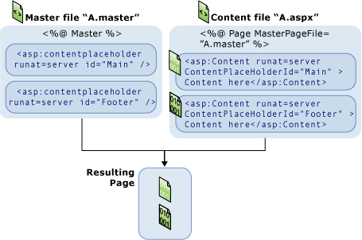

Integration with Open-Source CMS
Open-source CMS module is a complete production of Content Management tool. We will use this module in our system. Instead of changing the database, we will decide to use Web Service to communicate with this module database, and update the tables as well. the database structure of the open-source CMS should then be intact.

The design should be like followings:

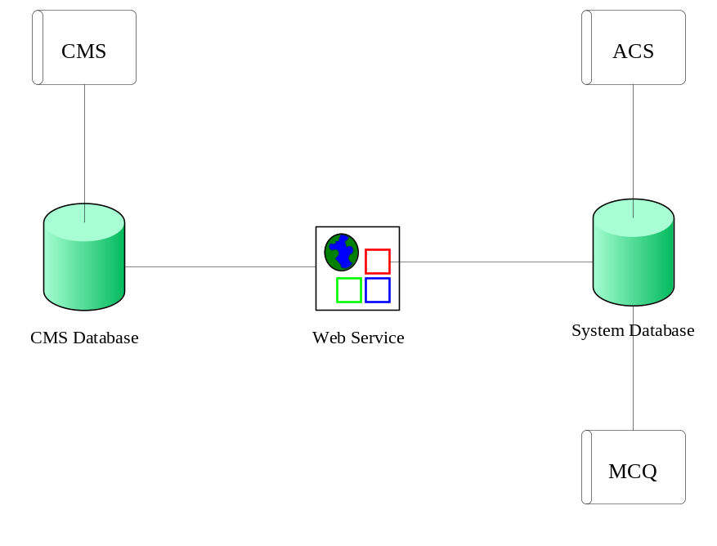

Sequence diagrams

Introduction
The Sequence diagrams representing the dynamic behaviour of the objects of the system are presented in the following subsections. They are organized according to the use cases of the system defined, which presented into three packages according to the requirements
3.2 | ACS | 3.3 | MCQ | 3.4 | CMS
1 | Add Customer | 1 | Add Exam | 1
2 | Delete Customer | 2 | Delete Exam | 2
3 | Update Customer | 3 | Update Exam | 3
4 | Add DAP | 4 | Add Question | 4
5 | Delete DAP | 5 | Delete Question | 5
6 | Update DAP | 6 | Update Question | 6
7 | Add FAP | 7 | Add Section | 7
8 | Delete FAP | 8 | Delete Section | 8
9 | Update FAP | 9 | Update Section | 9
10 | Add Role | 10 | Add Survey | 10
11 | Delete Role | 11 | Delete Survey | 11
12 | Update Role | 12 | Update Survey | 12
13 | Add User |  |  | 13
14 | Delete User |  |  | 14
15 | Update User |  |  | 15
16 | Add User Administrator |  |  | 16
17 | Delete User Administrator |  |  | 17
18 | Update User Administrator |  |  | 18
19 | Login |  |  | 19
20 | Logout |  |  | 20

Sequence Diagrams of ACS Functions

Sequence Diagram for Add Customer
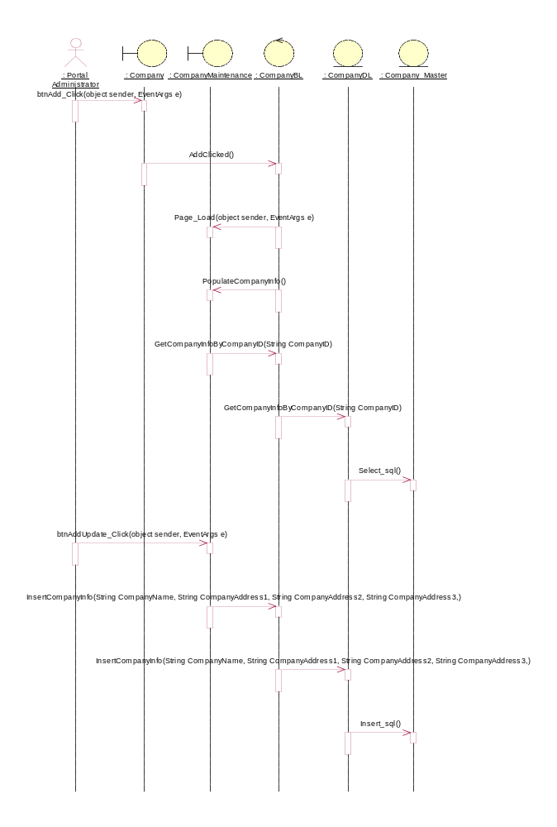

Sequence Diagram for Delete Customer
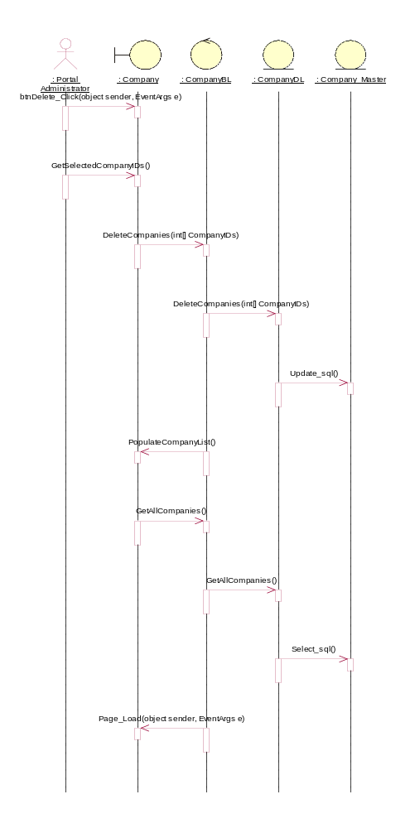

Sequence Diagram for Update Customer
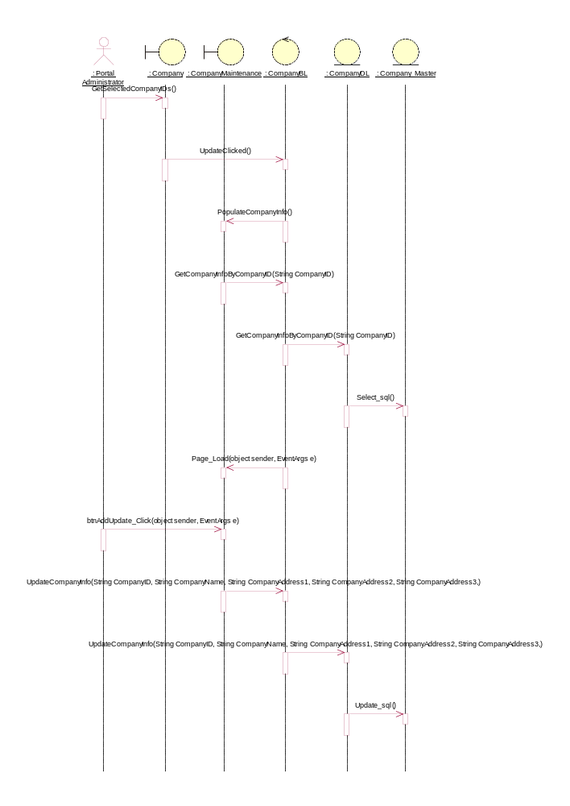

Sequence Diagram for Add Dap
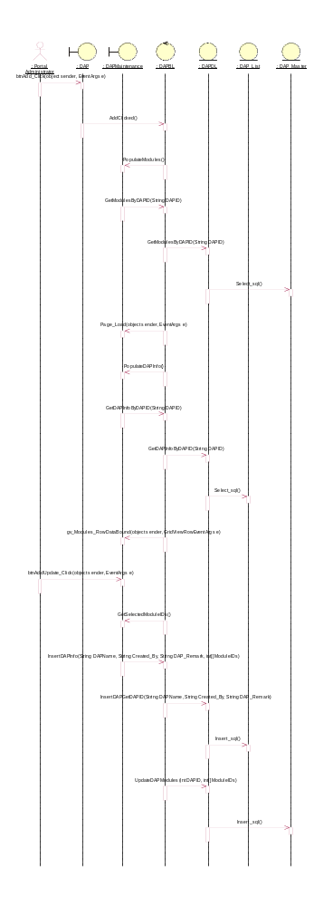

Sequence Diagram for Delete Dap
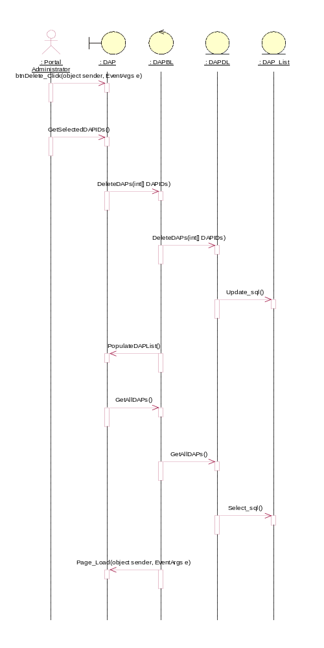

Sequence Diagram for Update Dap
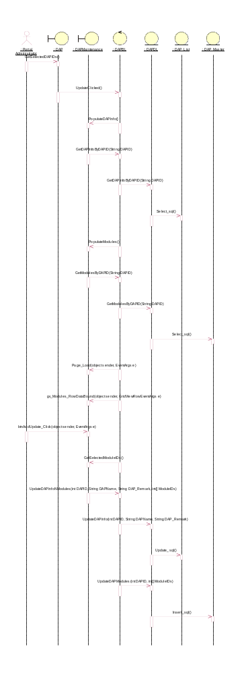

Sequence Diagram for Add Fap
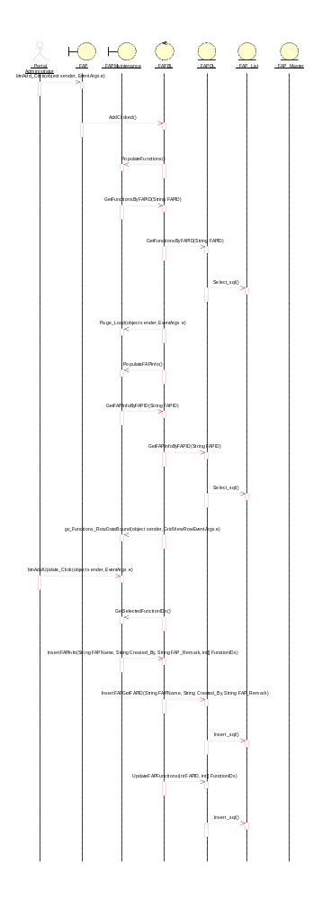

Sequence Diagram for Delete Fap
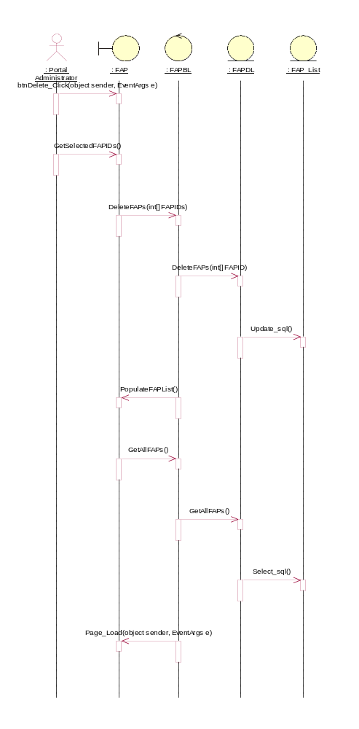

Sequence Diagram for Update Fap
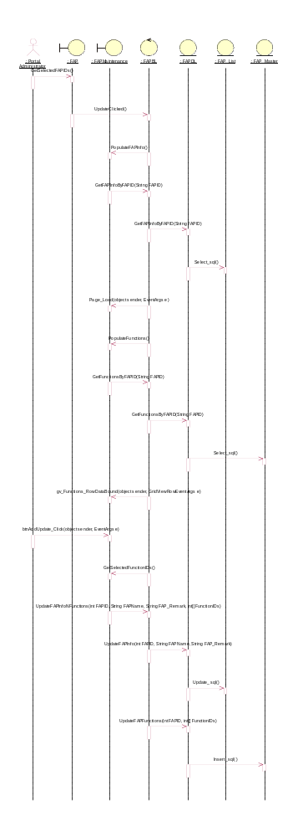

Sequence Diagram for AddRole
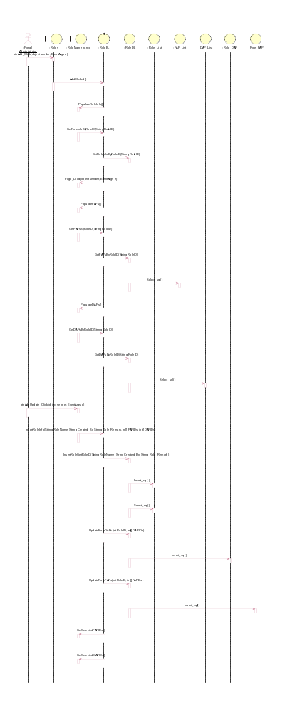

Sequence Diagram for Delete Role
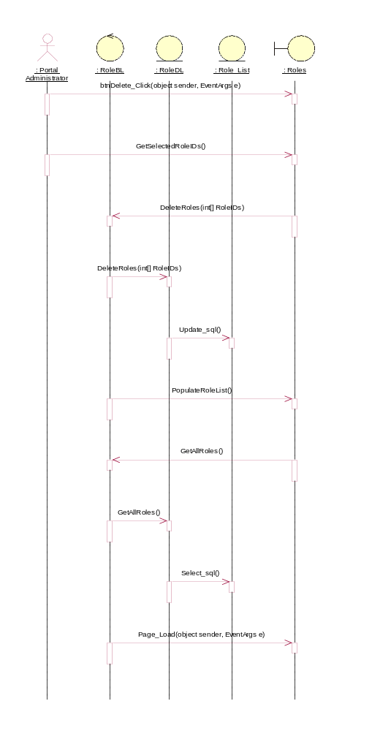

Sequence Diagram for UpdateRole
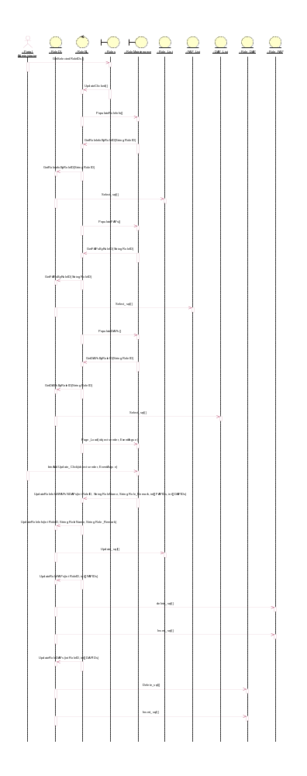

Sequence Diagram for AddUser
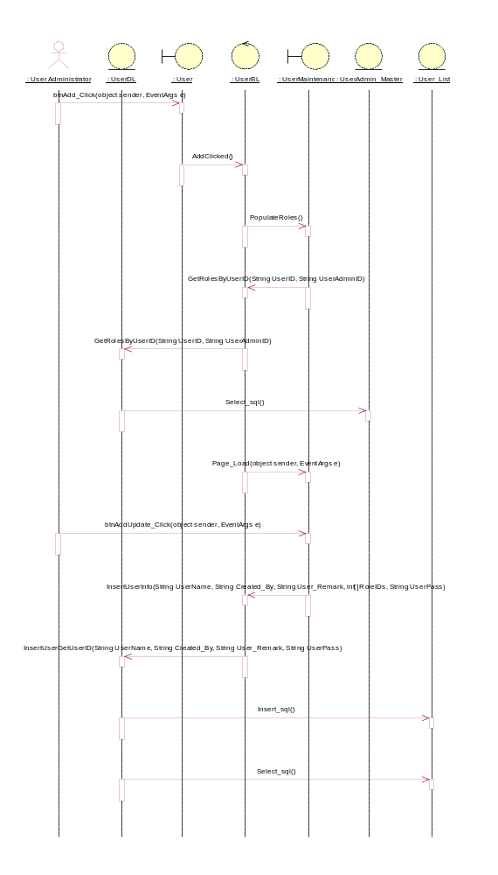

Sequence Diagram for DeleteUser
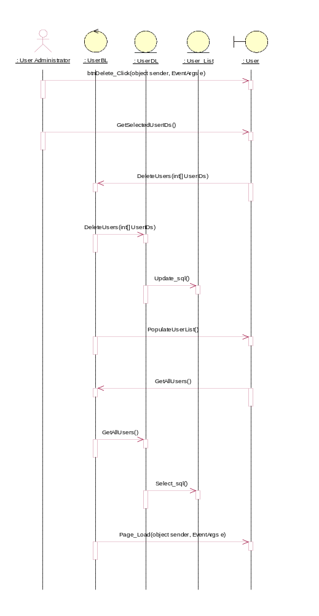

Sequence Diagram for UpdateUser
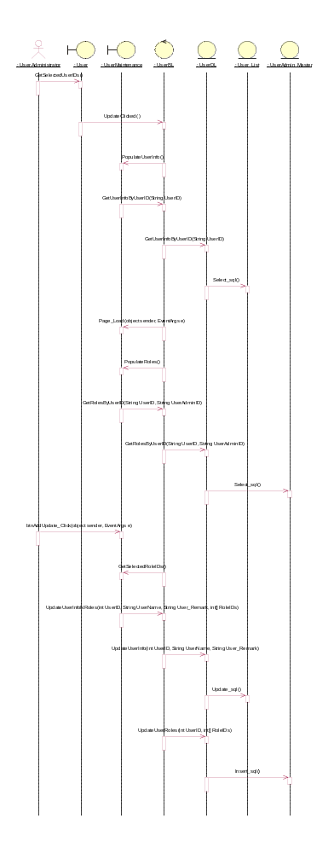

Sequence Diagram for Add User Administrator
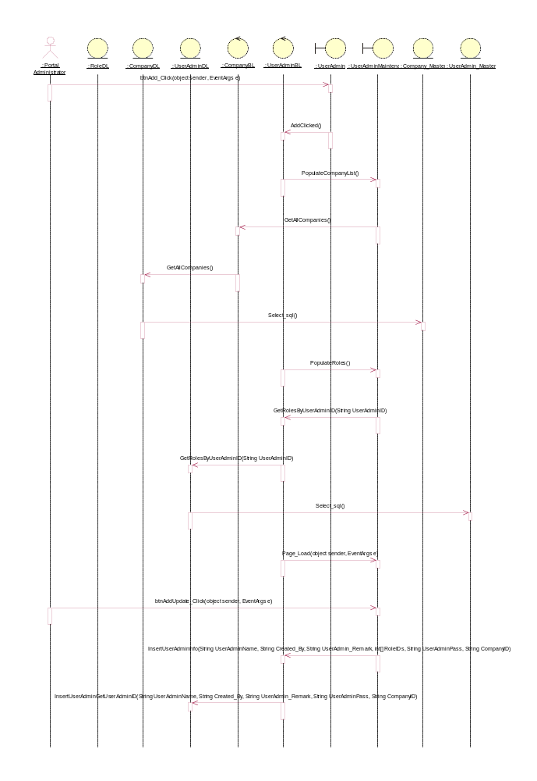

Sequence Diagram for Delete User Administrator
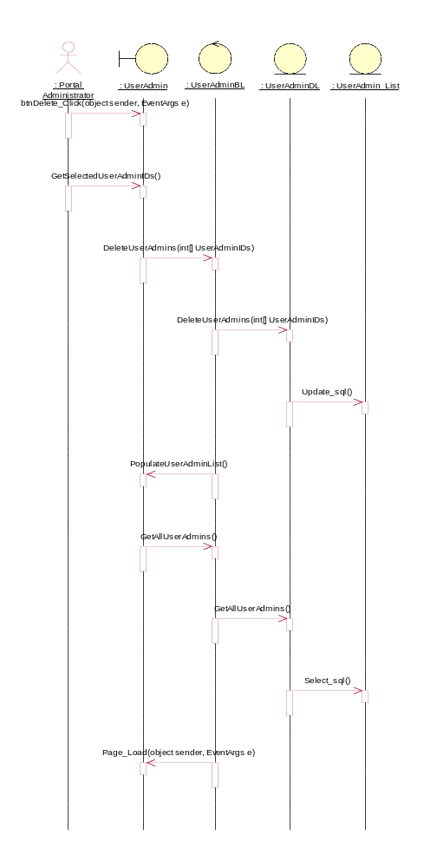

Sequence Diagram for Update User Administrator
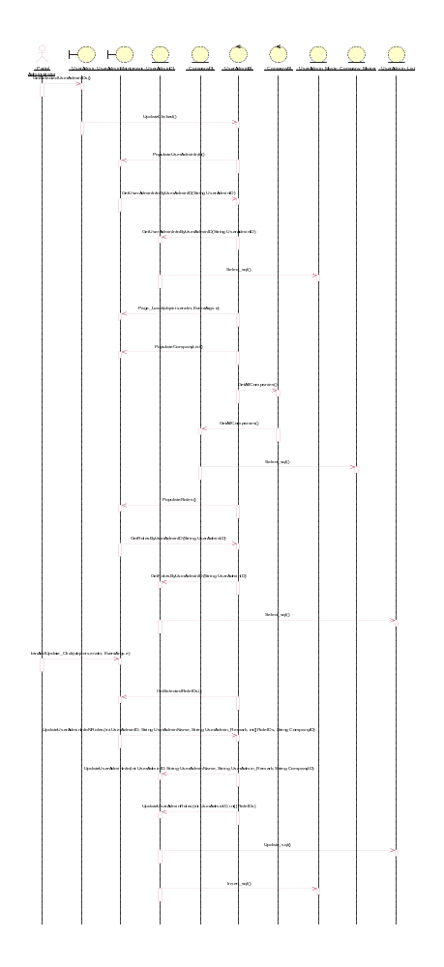

Sequence Diagram for Login

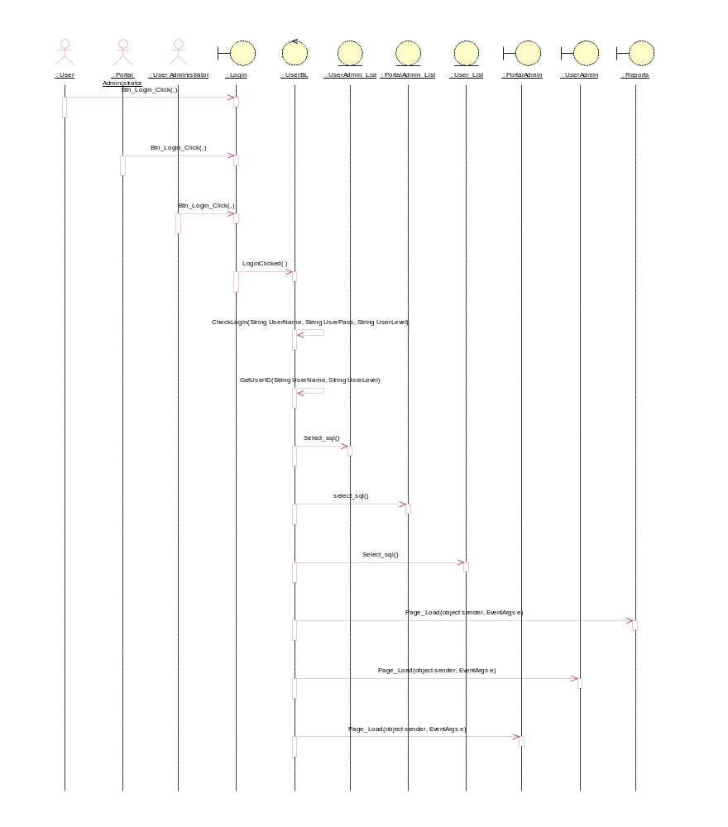

Sequence Diagram for Logout

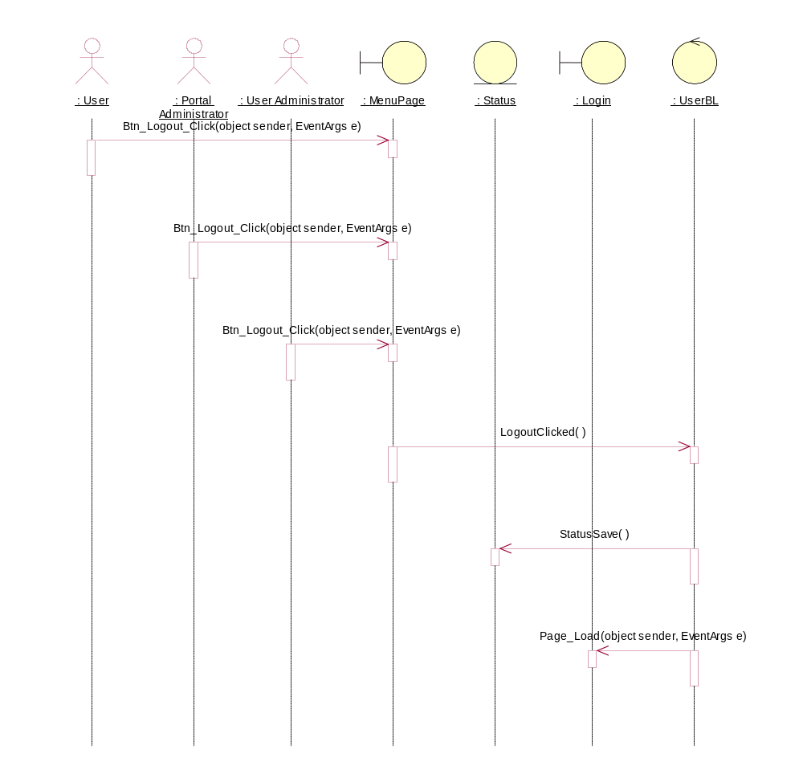

Sequence Diagrams of MCQ Functions

Sequence Diagrams for Add Exam
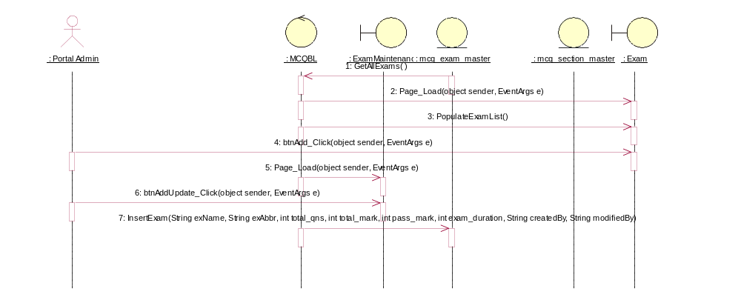

Sequence Diagrams for Delete Exam
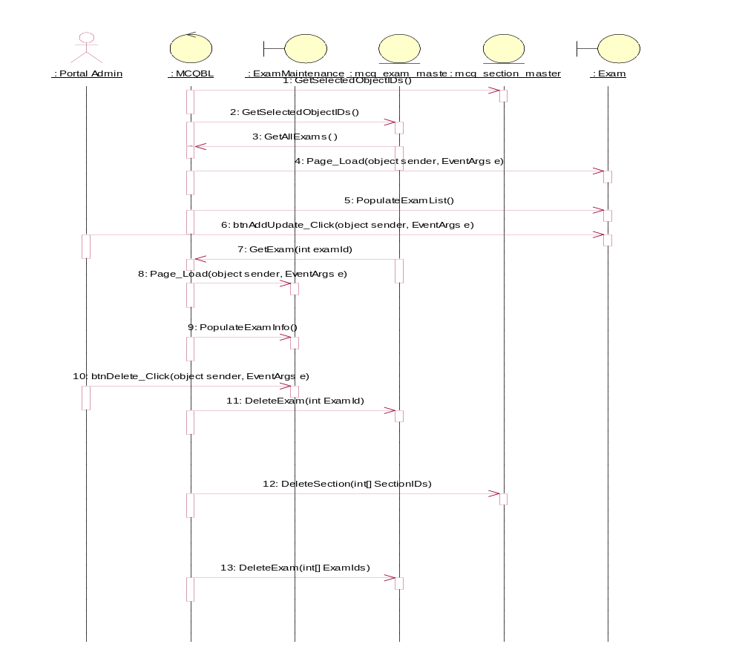

Sequence Diagrams for Update Exam

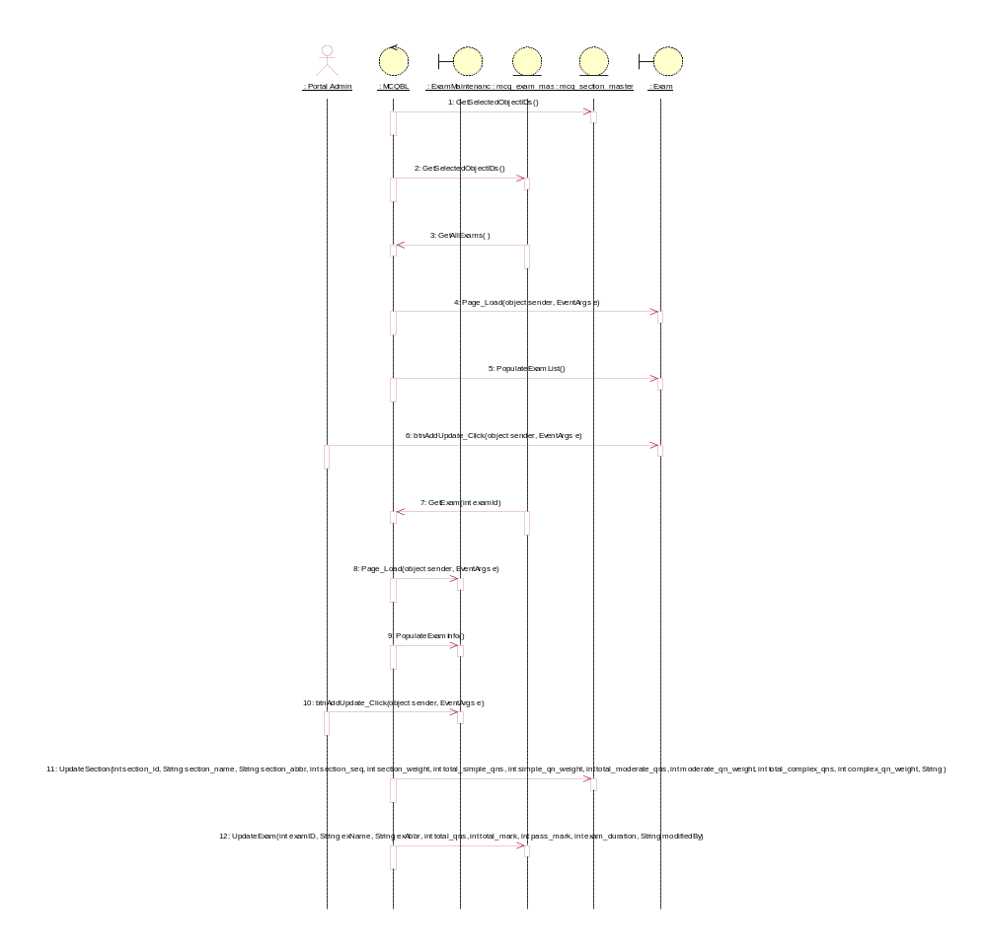

Sequence Diagrams for Add Question

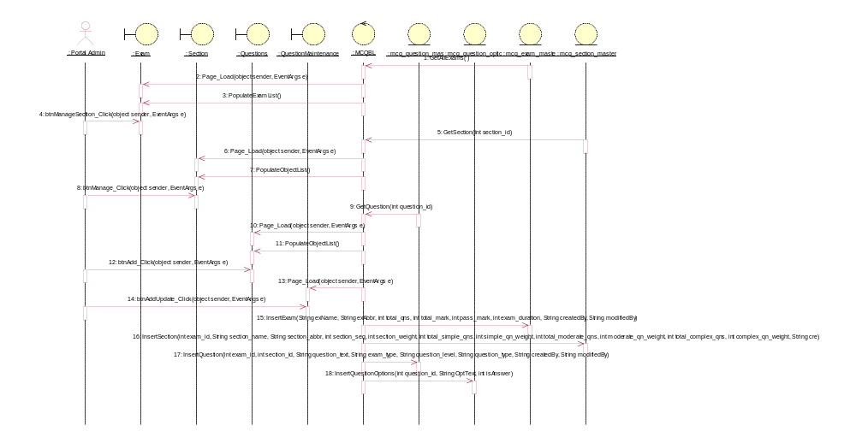

Sequence Diagrams for Delete Question
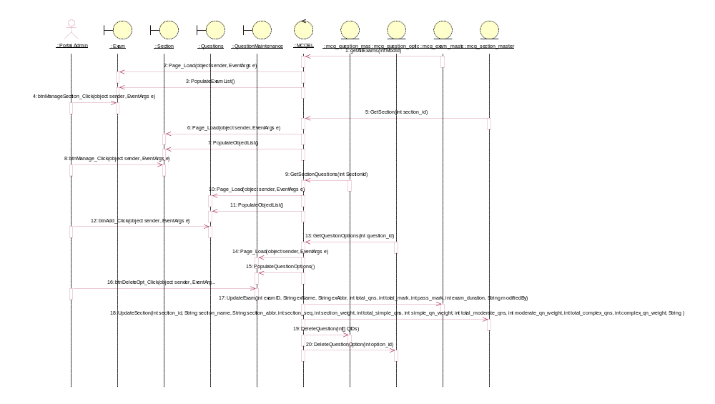

Sequence Diagrams for Update Question
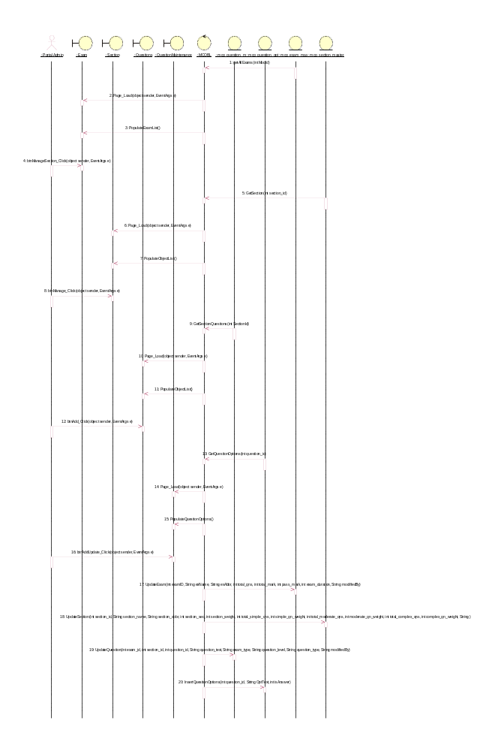

Sequence Diagrams for Add Section

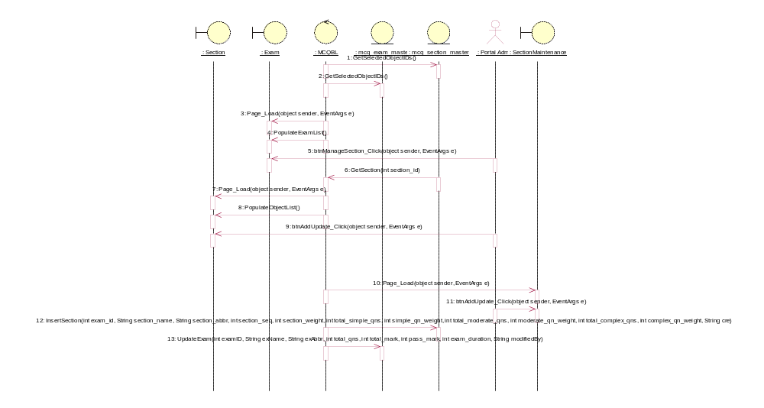

Sequence Diagrams for Delete Section
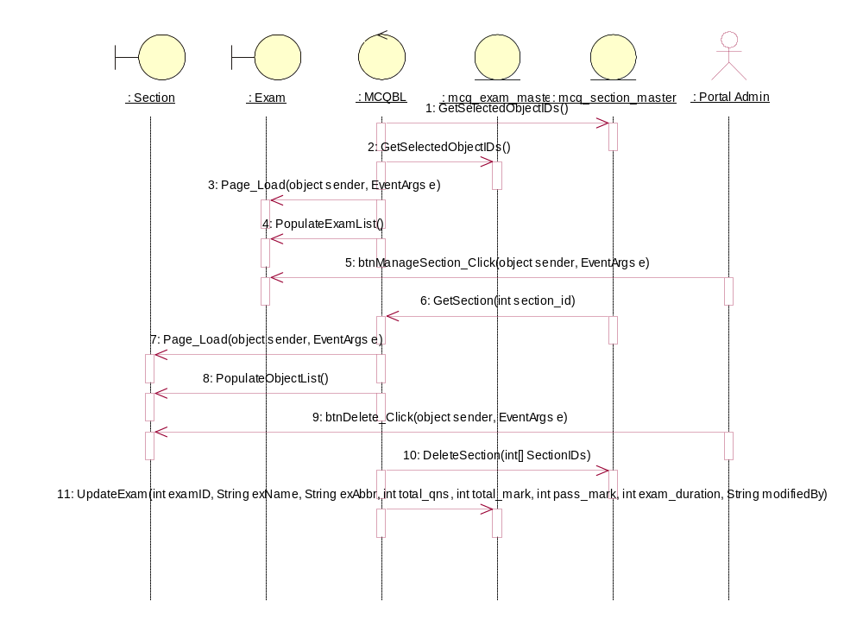

Sequence Diagrams for Update Section

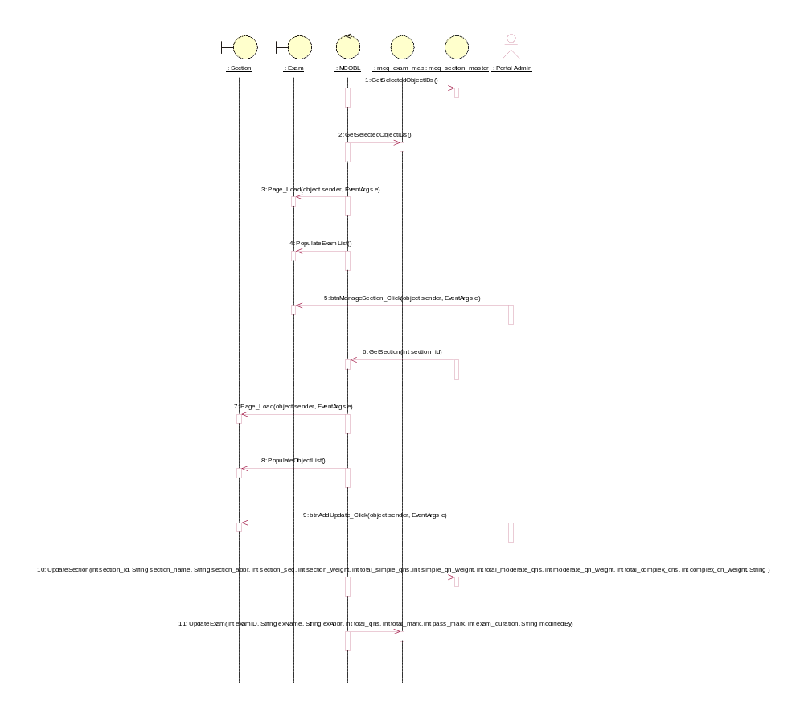

Sequence Diagrams for Add Survey
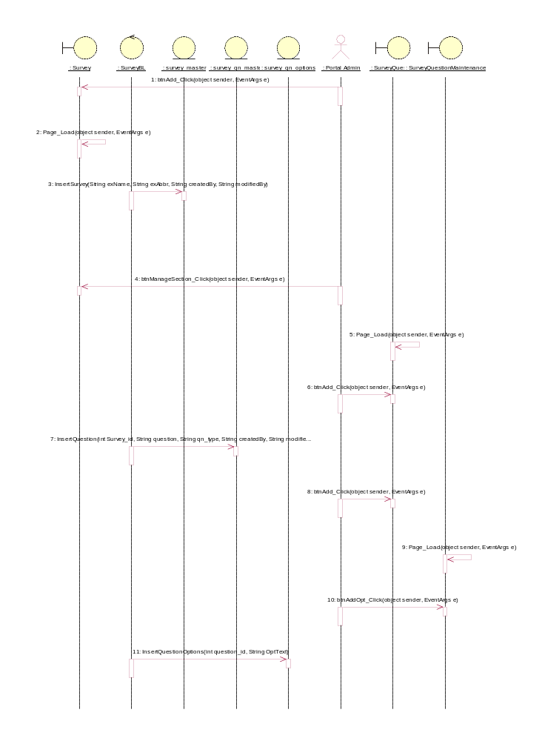

Sequence Diagrams for Delete Survey

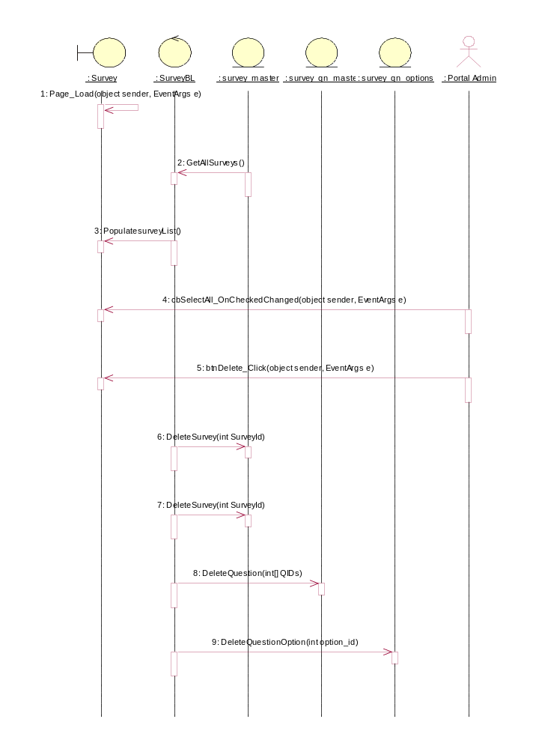

Sequence Diagrams for Update Survey

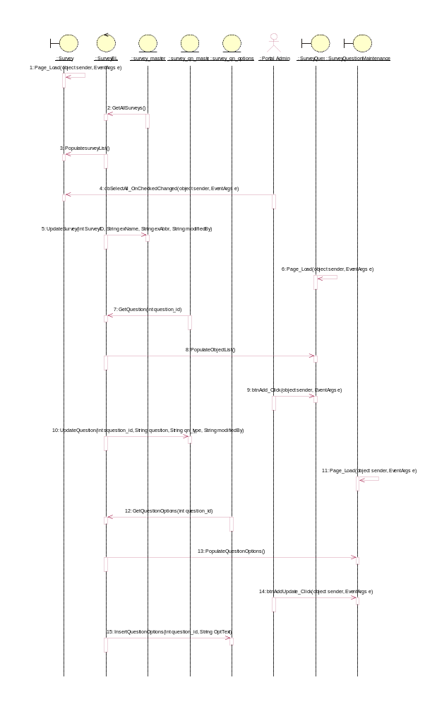

Sequence Diagrams of CMS Functions

Sequence Diagrams for Add Site
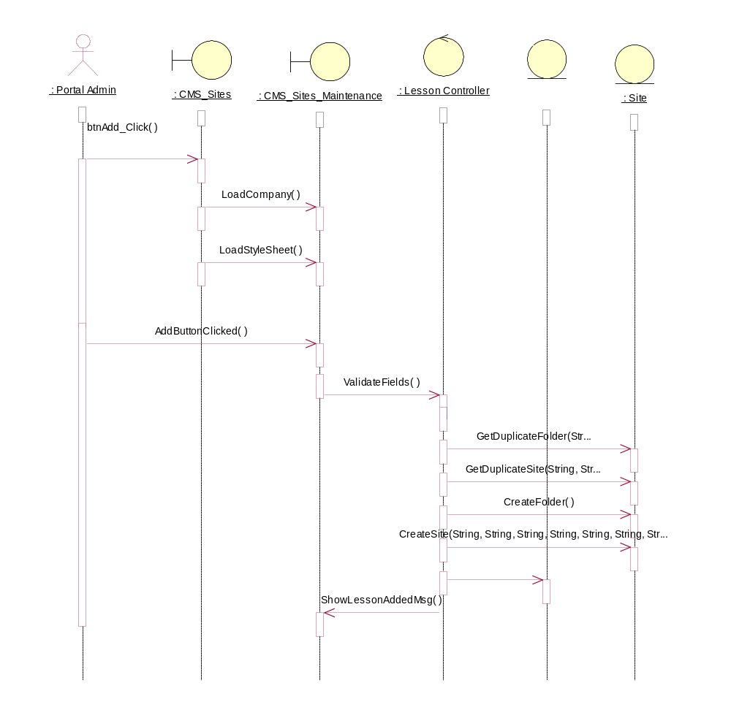

Sequence Diagrams for Add Outline
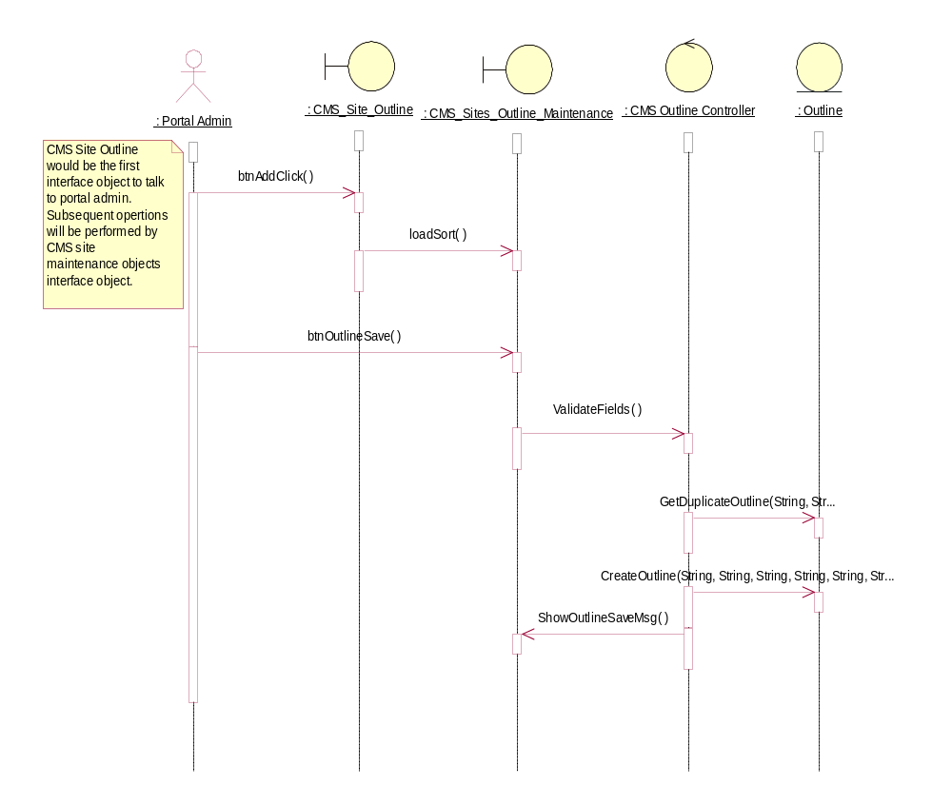

Sequence Diagrams for Add Page
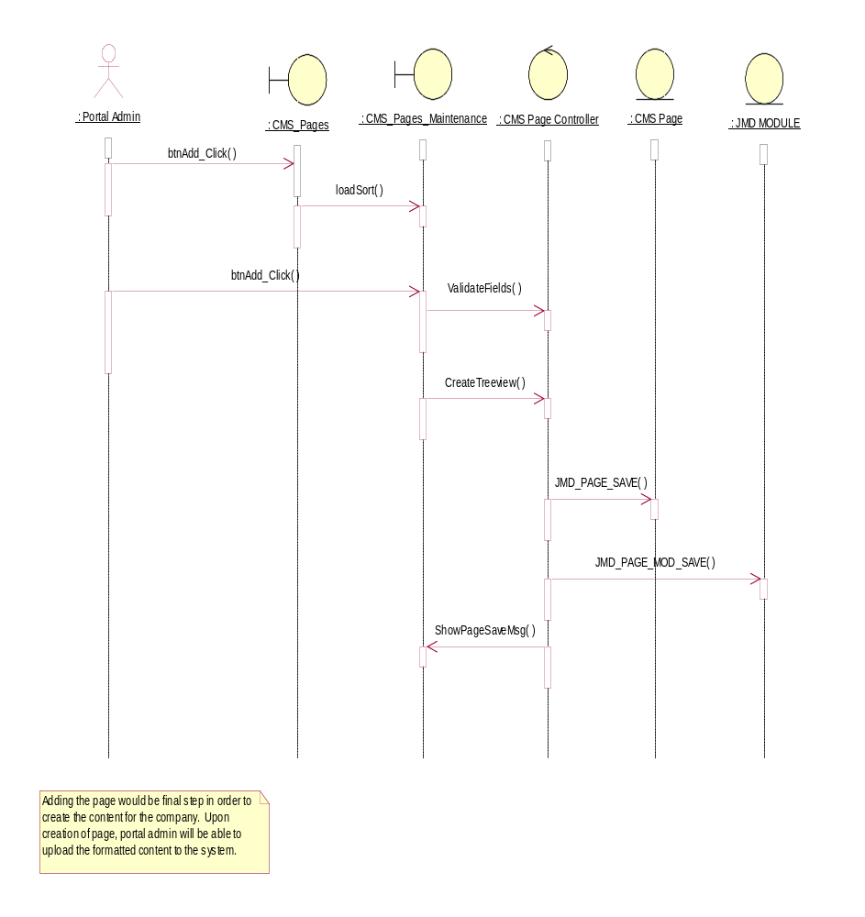

Sequence Diagrams for Update Site
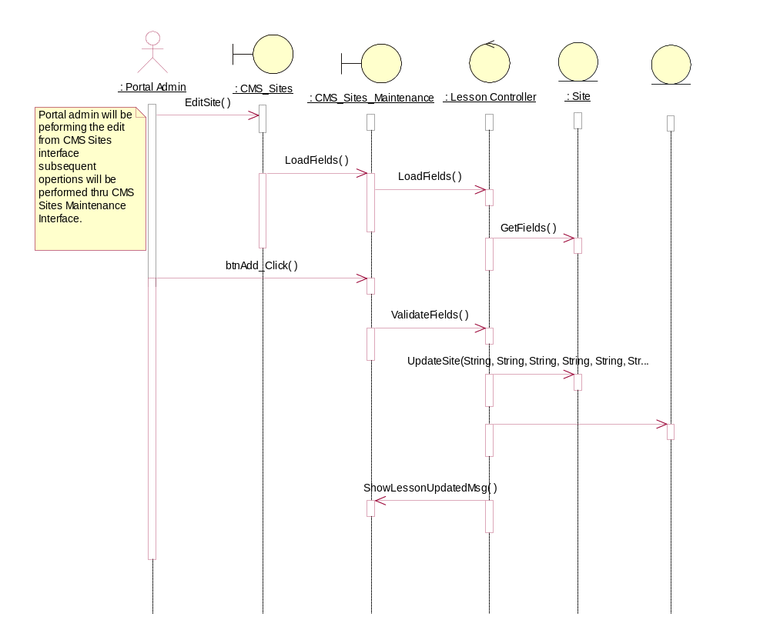

Sequence Diagrams for Update Outline
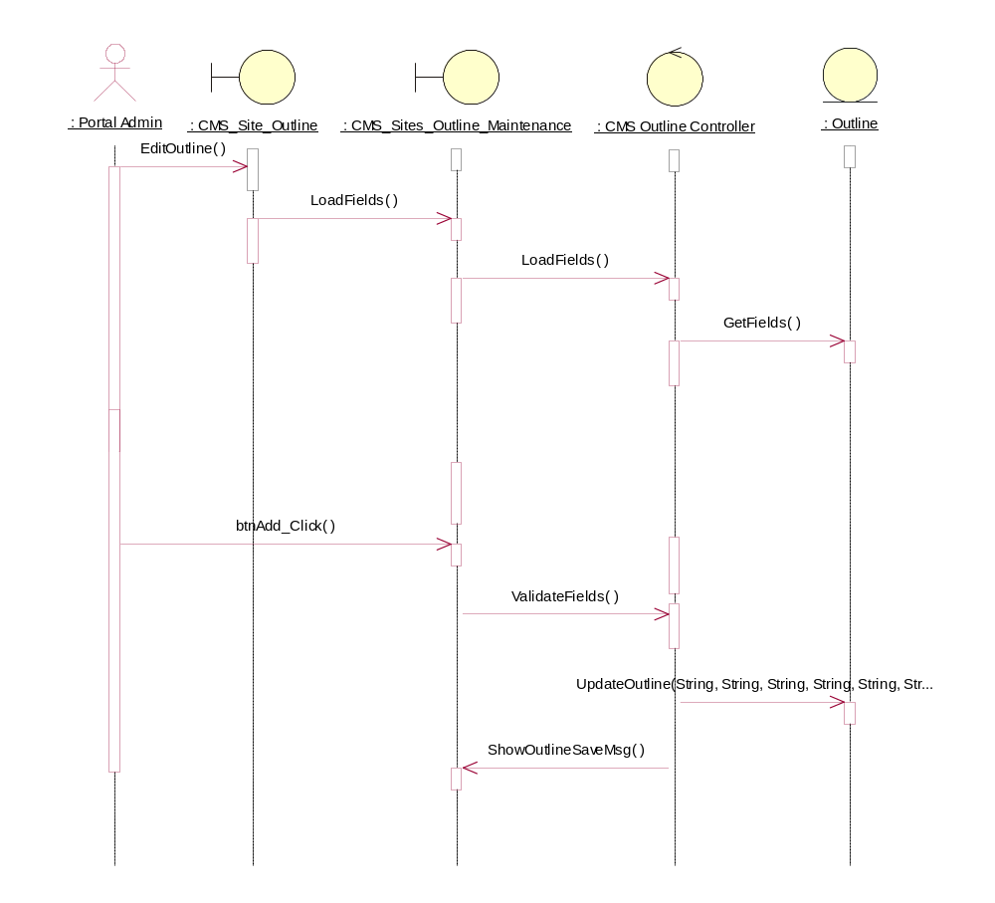

Sequence Diagrams for Update Page
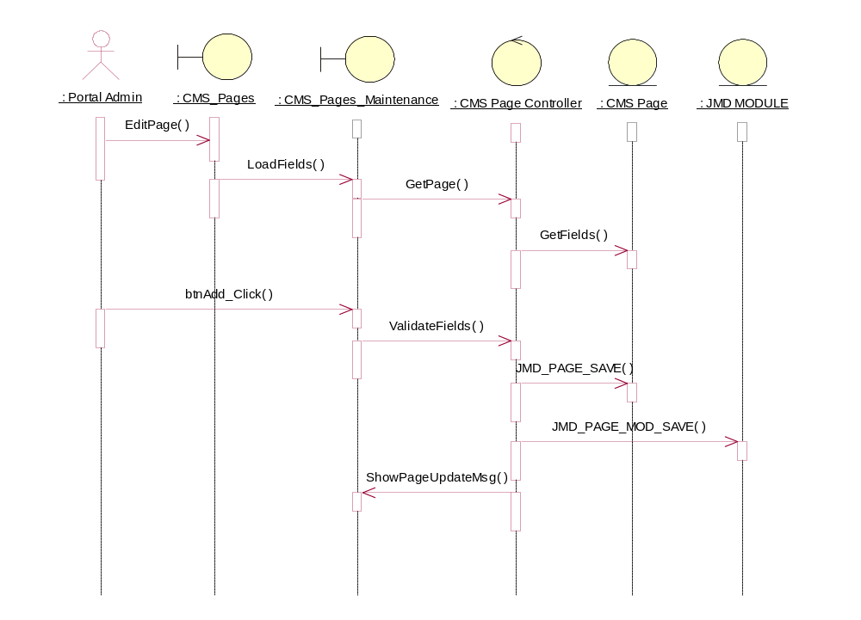

Sequence Diagrams for Delete Site
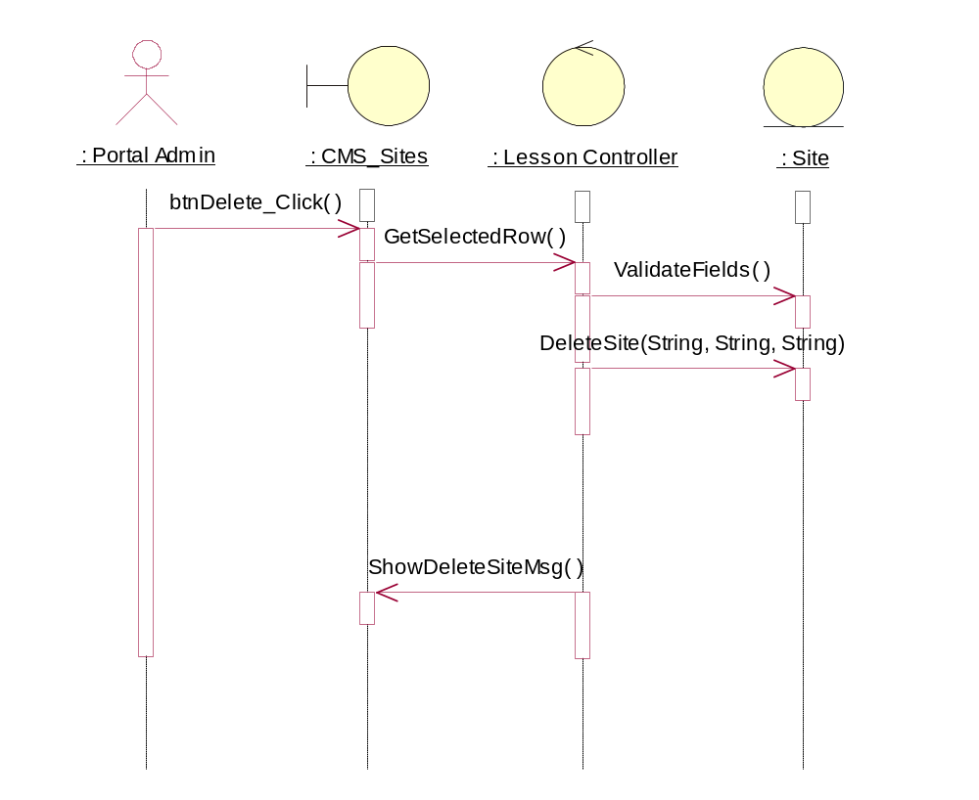

Sequence Diagrams for Delete Outline
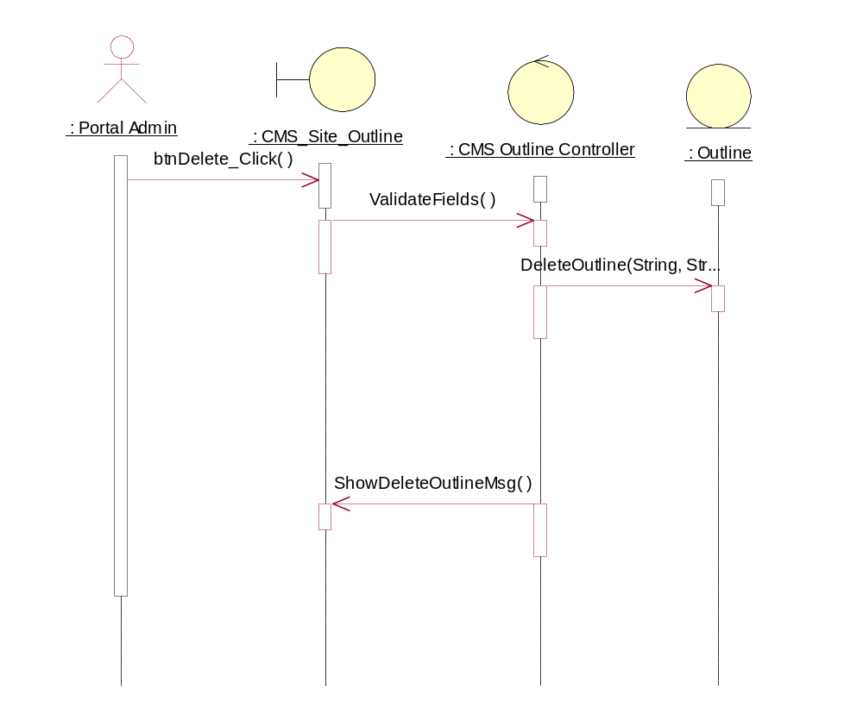

Sequence Diagrams for Delete Page
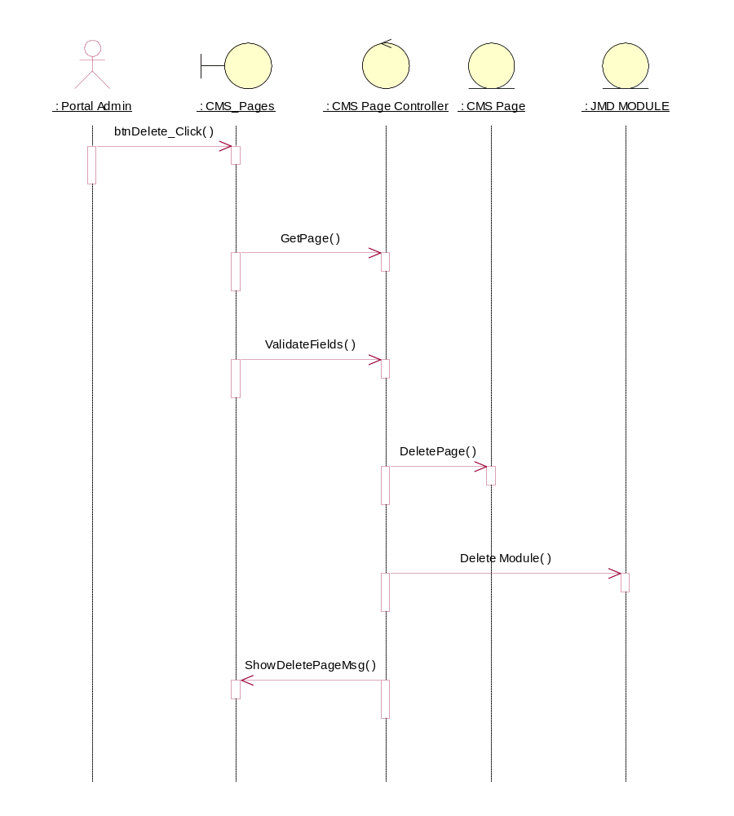

Sequence Diagrams for View Site
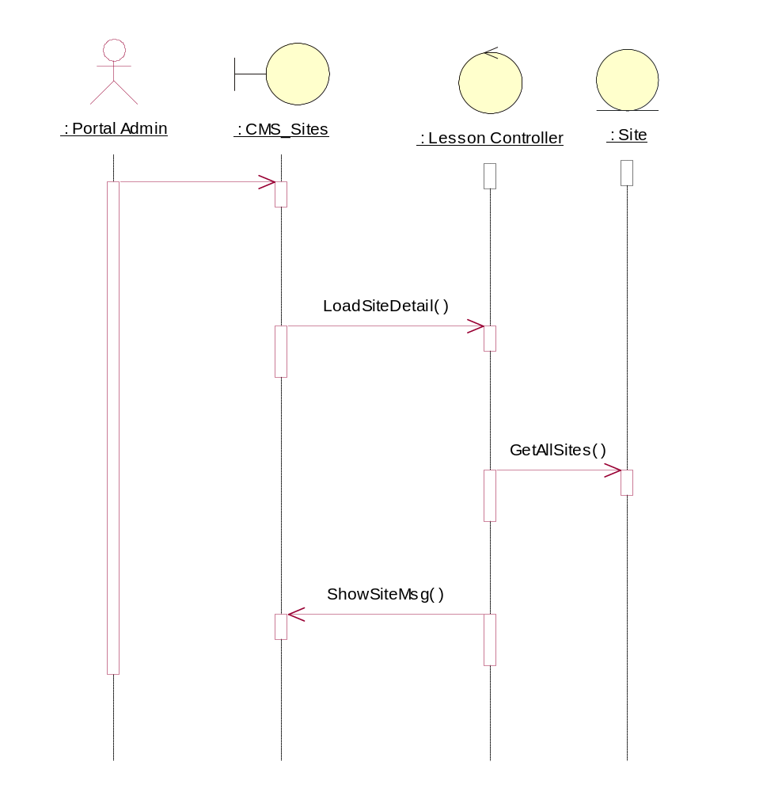

Sequence Diagrams for View Outline
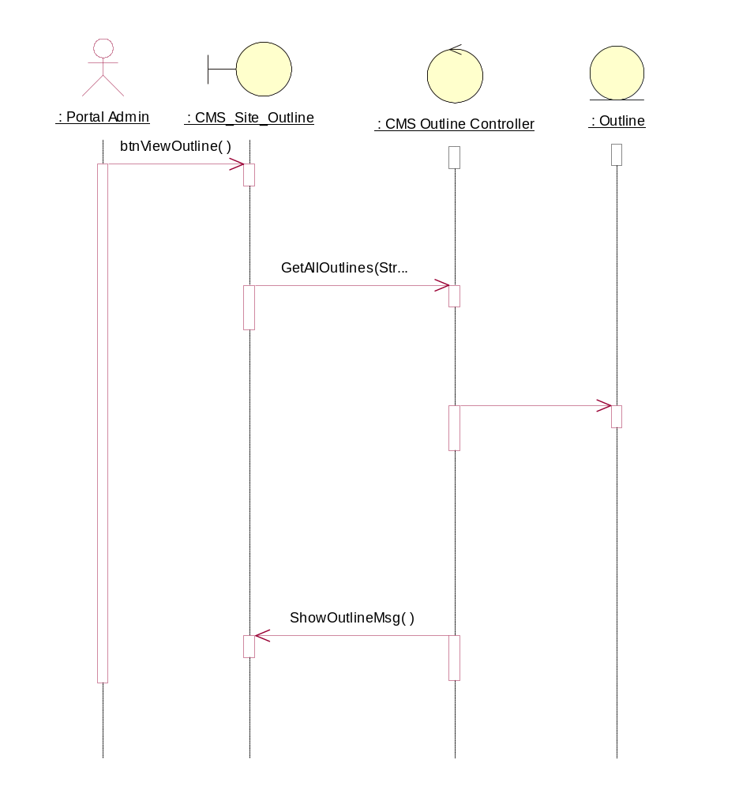

Sequence Diagrams for View Page
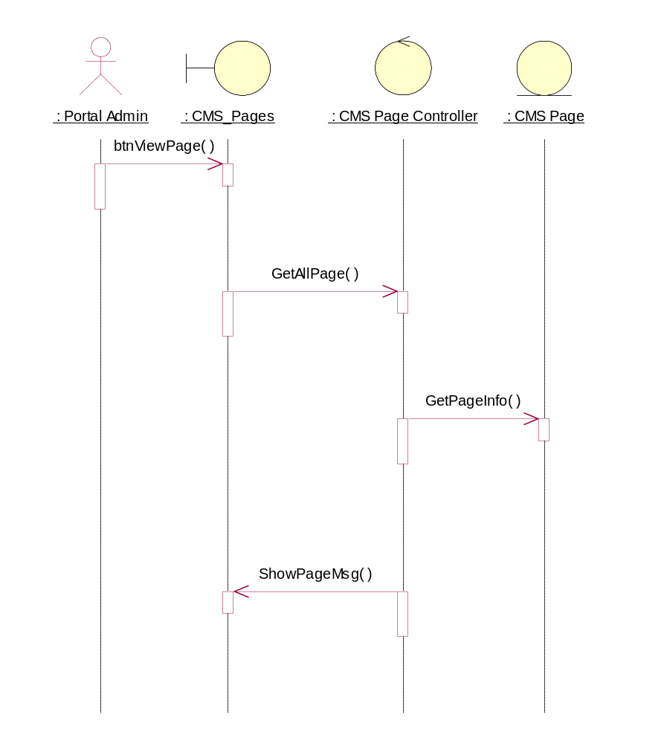

Object Specifications

Introduction
The Section describes each object of the system in terms of attributes, operations and associations. The objects are structured into 3 main packages, supported by Open source, MS SQL Server 2005 and .NET Class Library.

Package Structure
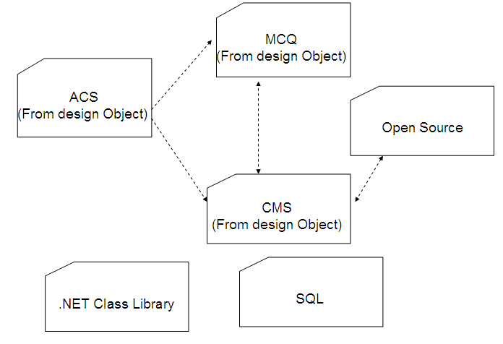

Object Specifications of ACS Functions

Maintain Customer

Static structure of Maintain Customer
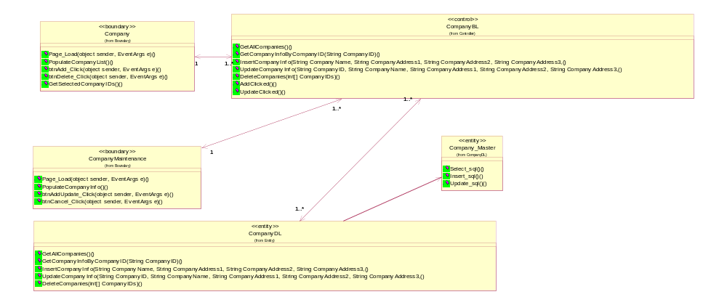

Company
Boundary object of Company

Relationships:

Object Name: CompanyBL (Logical View::Design Model::Design Objects::Controller::CompanyBL )
Kind of Relationship: Associations

Object Name: CompanyMaintenance (Logical View::Design Model::Design Objects::Boundary::CompanyMaintenance )

Kind of Relationship: Associations

Operations:

btnAdd_Click(object sender, EventArgs e) : void
Documentation: button to add company

btnDelete_Click(object sender, EventArgs e) () : void
Documentation: button to delete company

GetSelectedCompanyIDs() () : int[]
Documentation: to get the company ID return as integer array type

Page_Load(object sender, EventArgs e) () : void
Documentation: load and display page

PopulateCompanyList() () : void
Documentation: request and display the company list

Company Maintenance
Relationships:

Object Name: CompanyBL (Logical View::Design Model::Design Objects::Controller::CompanyBL )

Kind of Relationship: Associations

Object Name: Company (Logical View::Design Model::Design Objects::Boundary::Company )

Kind of Relationship: Associations

Operations:

btnAdd_Click(object sender, EventArgs e) : void
Documentation: button to add company

btnDelete_Click(object sender, EventArgs e) () : void
Documentation: button to delete company

GetSelectedCompanyIDs() () : int[]
Documentation: to get the company ID return as integer array type

Page_Load(object sender, EventArgs e) () : void
Documentation: load and display page

PopulateCompanyList() () : void
Documentation: request and display the company list

CompanyBL
Relationships:

Object Name: UserAdminBL (Logical View::Design Model::Design Objects::Controller::UserAdminBL )

Kind of Relationship: Associations

Object Name: CompanyMaintenance (Logical View::Design Model::Design Objects::Boundary::CompanyMaintenance )

Kind of Relationship: Associations
Object Name: Company (Logical View::Design Model::Design Objects::Boundary::Company )

Kind of Relationship: Associations
Object Name: CompanyDL (Logical View::Design Model::Design Objects::Entity::CompanyDL )

Operations:

AddClicked() () : void
Documentation:

DeleteCompanies(int[] CompanyIDs) () : void
Documentation:

GetAllCompanies() () : DataTable
Documentation:

GetCompanyInfoByCompanyID(String CompanyID) () : DataTable
Documentation:

InsertCompanyInfo(String CompanyName, String CompanyAddress1, String CompanyAddress2, String CompanyAddress3, () : void
Documentation:

UpdateClicked() () : void
Documentation:

UpdateCompanyInfo(String CompanyID, String CompanyName, String CompanyAddress1, String CompanyAddress2, String CompanyAddress3, () : void
Documentation:

CompanyDL

Relationships:

Object Name: CompanyBL (Logical View::Design Model::Design Objects::Controller::CompanyBL )

Kind of Relationship: Associations

Operations:

DeleteCompanies(int[] CompanyIDs) : void
Documentation: This function will mark the Delete_Flag=1

GetAllCompanies() : DataTable
Documentation: The function will get all company in list

GetCompanyInfoByCompanyID(String CompanyID) : DataTable
Documentation: This function will retrieve the company information via CompanyID

InsertCompanyInfo(String CompanyName, String CompanyAddress1, String CompanyAddress2, String CompanyAddress3, : void
Documentation: This function will insert new Company

UpdateCompanyInfo(String CompanyID, String CompanyName, String CompanyAddress1, String CompanyAddress2, String CompanyAddress3, ) : void
Documentation: This function will update the company information after the update executed

Maintain DAP

Static structure of Maintain Customer
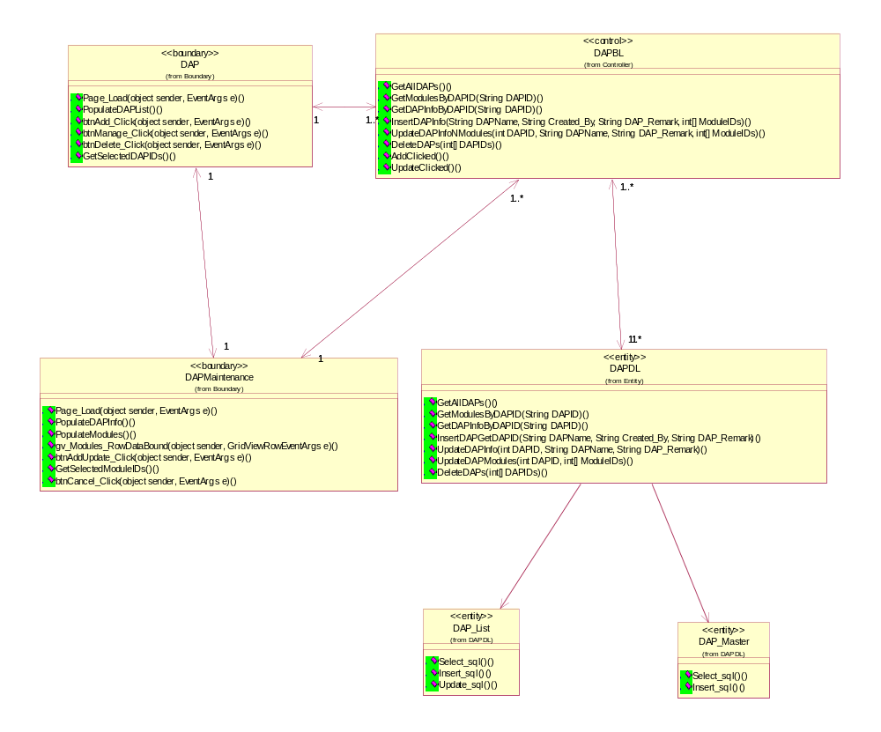

DAP
Boundary object of DAP

Relationships:

Object Name: DAPBL (Logical View::Design Model::Design Objects::Controller::DAPBL )
Kind of Relationship: Associations

Object Name: DAPMaintenance (Logical View::Design Model::Design Objects::Boundary::DAPMaintenance )
Kind of Relationship: Associations
Operations:

btnAdd_Click(object sender, EventArgs e) () : void
Documentation: button action for add functions

btnDelete_Click(object sender, EventArgs e) () : void
Documentation: button action for delete functions

btnManage_Click(object sender, EventArgs e) () : void
Documentation: to manage the functions

GetSelectedDAPIDs() () : int[]
Documentation: function to get the selected DAP id

Page_Load(object sender, EventArgs e) () : void
Documentation: function to load and display the DAP page

PopulateDAPList() () : void
Documentation: function the request and display the DAP list.

DAP Maintenance

Boundary object of DAP Maintenance

Relationships:

Object Name: DAP (Logical View::Design Model::Design Objects::Boundary::DAP )
Kind of Relationship: Associations

Object Name: DAPBL (Logical View::Design Model::Design Objects::Controller::DAPBL )
Kind of Relationship: Associations

Operations:

btnAddUpdate_Click(object sender, EventArgs e) () : void
Documentation: to add or update the functions into database

btnCancel_Click(object sender, EventArgs e) () : void
Documentation: to cancel and back to DAP interface

GetSelectedModuleIDs() () : int[]
Documentation: to get the selected module id

gv_Modules_RowDataBound(object sender, GridViewRowEventArgs e) () : void
Documentation: to get the action for commit the update function

Page_Load(object sender, EventArgs e) () : void
Documentation: to load and display DAP Maintenance interface

PopulateDAPInfo() () : void
Documentation: to request and display the DAP information

PopulateModules() () : void
Documentation: to request and display the module list

DAPBL
DAP Controller

Relationships:

Object Name: DAPMaintenance (Logical View::Design Model::Design Objects::Boundary::DAPMaintenance )
Kind of Relationship: Associations

Object Name: DAPDL (Logical View::Design Model::Design Objects::Entity::DAPDL )Kind of Relationship: Associations

Object Name: DAP (Logical View::Design Model::Design Objects::Boundary::DAP )
Kind of Relationship: Associations

Operations:

AddClicked() () : void
Documentation: to receive the add action from DAP interface

DeleteDAPs(int[] DAPIDs) () : void
Documentation: to delete the Modules

GetAllDAPs() () : DataTable
Documentation: to get all modules

GetDAPInfoByDAPID(String DAPID) () : DataTable
Documentation: to get the DAP information by DAP id

GetModulesByDAPID(String DAPID) () : DataTable
Documentation: to the the modules by DAP id

InsertDAPInfo(String DAPName, String Created_By, String DAP_Remark, int[] ModuleIDs) () : void
Documentation: to insert the DAP information after the update function executed

UpdateClicked() () : void
Documentation: updated action received by DAPBL

UpdateDAPInfoNModules(int DAPID, String DAPName, String DAP_Remark, int[] ModuleIDs) () : void
Documentation: function to update the DAP information and modules after the update or delete function executed

DAPDL
Entity of DAP

Relationships:

Object Name: DAPBL (Logical View::Design Model::Design Objects::Controller::DAPBL )
Kind of Relationship: Associations

Operations:

DeleteDAPs(int[] DAPIDs) () : void
Documentation: This function will mark the Delete_Flag=1

GetAllDAPs() () : DataTable
Documentation: This function will get all the DAPs.

GetDAPInfoByDAPID(String DAPID) () : DataTable
Documentation: This function will retrieve the DAP information via DAPID

GetModulesByDAPID(String DAPID) () : DataTable
Documentation: This function will get all the modules, as well marks which modules does the DAP has, according to the DAPID.

InsertDAPGetDAPID(String DAPName, String Created_By, String DAP_Remark) () : Integer
Documentation: This function will insert new DAP and get ID of this DAP.

UpdateDAPInfo(int DAPID, String DAPName, String DAP_Remark) () : void
Documentation: This function will update the existing DAP.

UpdateDAPModules(int DAPID, int[] ModuleIDs) () : void
Documentation: This function will delete all the old modules a DAP has, then add in new modules.

Maintain FAP

Static structure of Maintain Customer
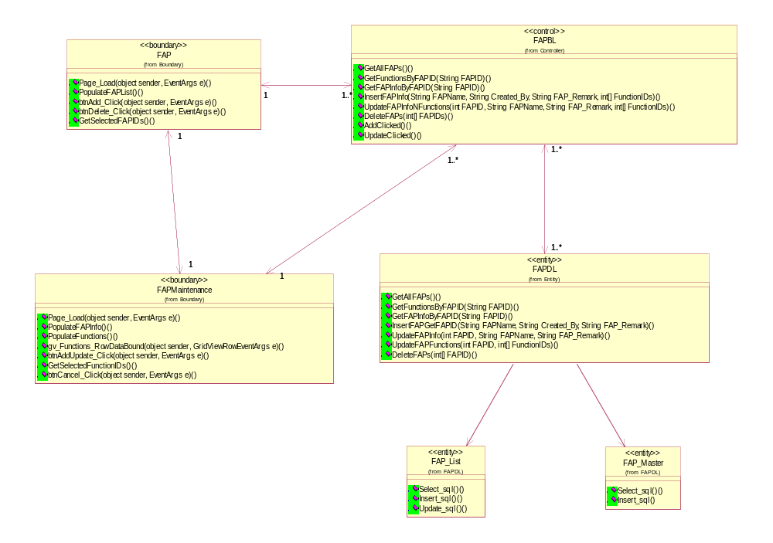

FAP
Boundary class of FAP

Relationships:

Object Name: FAPBL (Logical View::Design Model::Design Objects::Controller::FAPBL )
Kind of Relationship: Associations

Object Name: FAPMaintenance (Logical View::Design Model::Design Objects::Boundary::FAPMaintenance )
Kind of Relationship: Associations

Operations:

btnAdd_Click(object sender, EventArgs e) () : void
Documentation: button action to add Functions

btnDelete_Click(object sender, EventArgs e) () : void
Documentation: Button action to delete functions

GetSelectedFAPIDs() () : int[]
Documentation: function to get the selected FAP ID

Page_Load(object sender, EventArgs e) () : void
Documentation: to load and display the FAP interface

PopulateFAPList() () : void
Documentation: to request and display FAP list

FAP Maintenance
Boundary class of FAP Maintenance

Relationships:
Object Name: FAPBL (Logical View::Design Model::Design Objects::Controller::FAPBL )
Kind of Relationship: Associations

Object Name: FAP (Logical View::Design Model::Design Objects::Boundary::FAP )
Kind of Relationship: Associations

Operations:
btnAddUpdate_Click(object sender, EventArgs e) : void
Documentation: button action to add or update Functions

btnCancel_Click(object sender, EventArgs e) : void
Documentation: Button action to return back to FAP interface

GetSelectedFunctionIDs() : int[]
Documentation: function to get the selected FAP ID

gv_Functions_RowDataBound(object sender, GridViewRowEventArgs e) : void
Documentation: to get the action for commit the update function

Page_Load(object sender, EventArgs e) : void
Documentation: to load and display the FAP Maitenance interface

PopulateFAPInfo() : void
Documentation: to request and display FAP information

PopulateFunctions() : void
Documentation: to request and display functions

FAPBL
FAP Controller

Relationships:
Object Name: FAPMaintenance (Logical View::Design Model::Design Objects::Boundary::FAPMaintenance )
Kind of Relationship: Associations

Object Name: FAP (Logical View::Design Model::Design Objects::Boundary::FAP )
Kind of Relationship: Associations

Object Name: FAPDL (Logical View::Design Model::Design Objects::Entity::FAPDL )
Kind of Relationship: Associations

Operations:

AddClicked() () : void
Documentation: button action to add or update Functions

DeleteFAPs(int[] FAPIDs) () : void
Documentation: Button action to delete functions

GetAllFAPs() () : DataTable
Documentation: function to get all function list

GetFAPInfoByFAPID(String FAPID) () : DataTable
Documentation: function to get FAP information by FAP ID

GetFunctionsByFAPID(String FAPID) () : DataTable
Documentation: to the functions by FAP id

InsertFAPInfo(String FAPName, String Created_By, String FAP_Remark, int[] FunctionIDs) () : void
Documentation: to insert the FAP information after the update function executed

UpdateClicked() () : void
Documentation: FAPBL received the update action

UpdateFAPInfoNFunctions(int FAPID, String FAPName, String FAP_Remark, int[] FunctionIDs) () : void
Documentation: update FAP information and functions

FAPDL
Entity of FAP

Relationships:
Object Name: FAPBL (Logical View::Design Model::Design Objects::Controller::FAPBL )
Kind of Relationship: Associations

Operations:

DeleteFAPs(int[] FAPID) () : void
Documentation: This function will mark the Delete_Flag=1

GetAllFAPs() () : DataTable
Documentation: This function will get all the FAPs.

GetFAPInfoByFAPID(String FAPID) () : DataTable
Documentation: This function will retrieve the FAP information via FAPID

GetFunctionsByFAPID(String FAPID) () : DataTable
Documentation: This function will get all the functions, as well marks which functions does the FAP has, according to the FAPID.

InsertFAPGetFAPID(String FAPName, String Created_By, String FAP_Remark) () : Integer
Documentation: This function will insert new FAP and get ID of this FAP.

UpdateFAPFunctions(int FAPID, int[] FunctionIDs) () : void
Documentation: This function will delete all the old functions a FAP has, then add in new functions.

UpdateFAPInfo(int FAPID, String FAPName, String FAP_Remark) () : void
Documentation: to update FAP information through FAP ID , Name and remarks

Maintain Role

Static structure of Maintain Customer
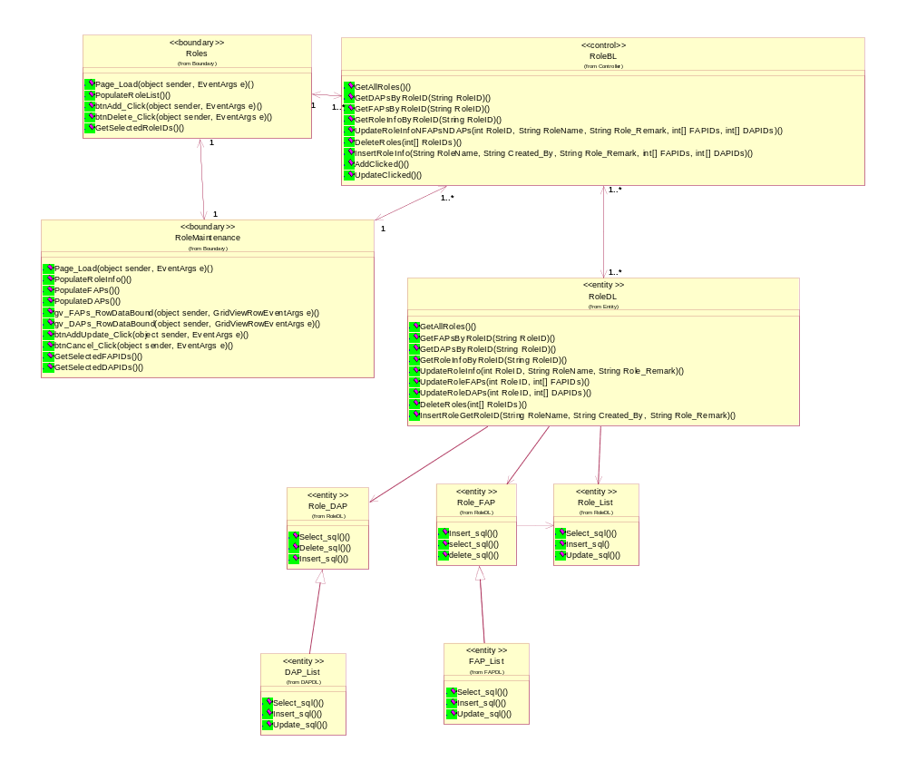

Role
Boundary class of Roles

Relationships:
Object Name: RoleBL (Logical View::Design Model::Design Objects::Controller::RoleBL )
Kind of Relationship: Associations

Object Name: RoleMaintenance (Logical View::Design Model::Design Objects::Boundary::RoleMaintenance )
Kind of Relationship: Associations

Operations:

btnAdd_Click(object sender, EventArgs e) () : void
Documentation: Button action to add roles

btnDelete_Click(object sender, EventArgs e) () : void
Documentation: button action to delete roles

GetSelectedRoleIDs() () : int[]
Documentation: function to get the selected role id

Page_Load(object sender, EventArgs e) () : void
Documentation: to load and display the role interface

PopulateRoleList() () : void
Documentation: to request and display the Role list

Role Maintenance
Boundary class of Role Maintenance

Relationships:
Object Name: Roles (Logical View::Design Model::Design Objects::Boundary::Roles )
Kind of Relationship: Associations

Object Name: RoleBL (Logical View::Design Model::Design Objects::Controller::RoleBL )
Kind of Relationship: Associations

Operations:

btnAddUpdate_Click(object sender, EventArgs e) () : void
Documentation: Button action to add or update the Roles

btnCancel_Click(object sender, EventArgs e) () : void
Documentation: Button action to cancel and back to Role interface

GetSelectedDAPIDs() () : int[]
Documentation: function the get the selected DAP id

GetSelectedFAPIDs() () : int[]
Documentation: function the get the selected FAP id

gv_DAPs_RowDataBound(object sender, GridViewRowEventArgs e) () : void
Documentation: action listener to update the DAP

gv_FAPs_RowDataBound(object sender, GridViewRowEventArgs e) () : void
Documentation: action listener to update the FAP

Page_Load(object sender, EventArgs e) () : void
Documentation: to load and display the role maintenance interface

PopulateDAPs() () : void
Documentation: to request and display DAP

PopulateFAPs() () : void
Documentation: to request and display FAP

PopulateRoleInfo() () : void
Documentation: to request and display the role information

RoleBL
Role Controller

Relationships:
Object Name: Roles (Logical View::Design Model::Design Objects::Boundary::Roles )
Kind of Relationship: Associations

Object Name: RoleDL (Logical View::Design Model::Design Objects::Entity::RoleDL )
Kind of Relationship: Associations

Object Name: RoleMaintenance (Logical View::Design Model::Design Objects::Boundary::RoleMaintenance )
Kind of Relationship: Associations
Operations:

AddClicked() () : void
Documentation: Button action to add the Roles

DeleteRoles(int[] RoleIDs) () : void
Documentation: Button action to delete Role interface

GetAllRoles() () : DataTable
Documentation: function to get all role list

GetDAPsByRoleID(String RoleID) () : DataTable
Documentation: to get the DAP by role id

GetFAPsByRoleID(String RoleID) () : DataTable
Documentation: to get the FAP by role id

GetRoleInfoByRoleID(String RoleID) () : DataTable
Documentation: to get the role information by role id

InsertRoleInfo(String RoleName, String Created_By, String Role_Remark, int[] FAPIDs, int[] DAPIDs) () : void
Documentation: to insert the role information through role name, created_by, role remark, fap id, and dap id.

UpdateClicked() () : void
Documentation: to received the update action

UpdateRoleInfoNFAPsNDAPs(int RoleID, String RoleName, String Role_Remark, int[] FAPIDs, int[] DAPIDs) () : void
Documentation: to update the role information, FAP and DAP

RoleDL

Entity of Role

Relationships:
Object Name: UserAdminBL (Logical View::Design Model::Design Objects::Controller::UserAdminBL )
Kind of Relationship: Associations

Object Name: RoleBL (Logical View::Design Model::Design Objects::Controller::RoleBL )
Kind of Relationship: Associations

Operations:

DeleteRoles(int[] RoleIDs) () : void
Documentation: This function will mark the Delete_Flag=1

GetAllRoles() () : DataTable
Documentation: This function will get all the Roles.

GetDAPsByRoleID(String RoleID) () : DataTable
Documentation: This function will get all the DAPs, as well marks which DAPs does the Role has, according to the RoleID.

GetFAPsByRoleID(String RoleID) () : DataTable
Documentation: This function will get all the FAPs, as well marks which FAPs does the Role has, according to the RoleID.

GetRoleInfoByRoleID(String RoleID) () : DataTable
Documentation: This function will retrieve the Role information via RoleID

InsertRoleGetRoleID(String RoleName, String Created_By, String Role_Remark) () : Integer
Documentation: This function will insert new Role and get ID of this Role.

UpdateRoleDAPs(int RoleID, int[] DAPIDs) () : void
Documentation: This function will delete all the old DAPs a Role has, then add in new DAPs.

UpdateRoleFAPs(int RoleID, int[] FAPIDs) () : void
Documentation: This function will delete all the old FAPs a Role has, then add in new FAPs.

UpdateRoleInfo(int RoleID, String RoleName, String Role_Remark) () : void
Documentation: This function will update the role informations

Maintain User

Static structure of Maintain Customer
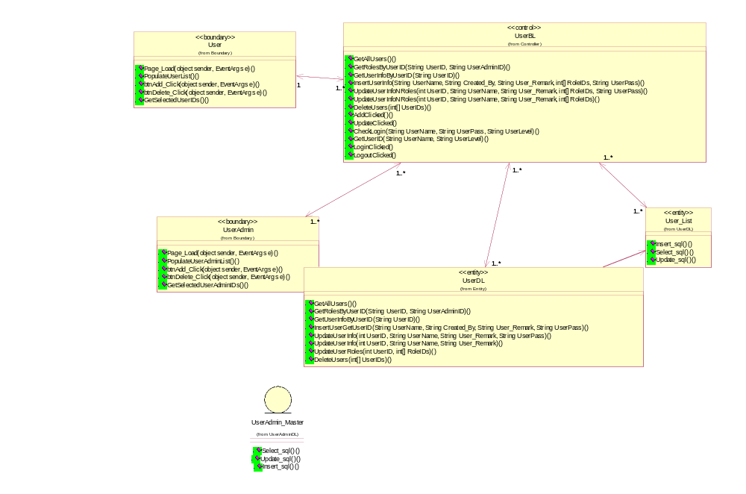

User
Boundary class of User

Relationships:
Object Name: UserBL (Logical View::Design Model::Design Objects::Controller::UserBL )
Kind of Relationship: Associations

Operations:

btnAdd_Click(object sender, EventArgs e) () : void
Documentation: button action to add user

btnDelete_Click(object sender, EventArgs e) () : void
Documentation: Button action to delete user

GetSelectedUserIDs() () : int[]
Documentation: Method to get selected user IDs

Page_Load(object sender, EventArgs e) () : void
Documentation: Method to page load

PopulateUserList() () : void
Documentation: Method to Populate User list

User Maintenance
Boundary class of User Maintenance

Relationships:
Operations:

btnAddUpdate_Click(object sender, EventArgs e) () : void
Documentation: Button action to add or update User interface

btnCancel_Click(object sender, EventArgs e) () : void
Documentation: Button action to cancel and back to user interface

chkChangePass_OnCheckedChanged(object sender, EventArgs e) () : void
Documentation: method to check change pass on checked changed

GetSelectedRoleIDs() () : int[]
Documentation: Method to get selected role IDs

gv_Roles_RowDataBound(object sender, GridViewRowEventArgs e) () : void
Documentation: Method to give Roles row Data bound

Page_Load(object sender, EventArgs e) () : void
Documentation: Method to page load

PopulateRoles() () : void
Documentation: Method to request and display roles

PopulateUserInfo() () : void
Documentation: Method to request and display user info

UserBL
User Controller which also manage the login authorization check

Relationships:
Object Name: User_List (Logical View::Design Model::Design Objects::Entity::UserDL::User_List )
Kind of Relationship: Associations

Object Name: UserAdmin_List (Logical View::Design Model::Design Objects::Entity::UserAdminDL::UserAdmin_List )
Kind of Relationship: Associations

Object Name: PortalAdmin_List (Logical View::Design Model::Design Objects::Entity::PortalAdmin_List )
Kind of Relationship: Associations

Object Name: Reports (Logical View::Design Model::Design Objects::Boundary::Reports )
Kind of Relationship: Associations

Object Name: PortalAdmin (Logical View::Design Model::Design Objects::Boundary::PortalAdmin )
Kind of Relationship: Associations

Object Name: UserAdmin (Logical View::Design Model::Design Objects::Boundary::UserAdmin )
Kind of Relationship: Associations

Object Name: MenuPage (Logical View::Design Model::Design Objects::Boundary::MenuPage )
Kind of Relationship: Associations

Object Name: MenuPage (Logical View::Design Model::Design Objects::Boundary::MenuPage )

Kind of Relationship: Associations

Object Name: Login (Logical View::Design Model::Design Objects::Boundary::Login )
Kind of Relationship: Associations

Object Name: class UserDL (Logical View::Design Model::Design Objects::Entity::UserDL )
Kind of Relationship: Associations

Object Name: User (Logical View::Design Model::Design Objects::Boundary::User )
Kind of Relationship: Associations

Operations:
AddClicked() () : void
Documentation: method to add click

CheckLogin(String UserName, String UserPass, String UserLevel) () : Boolean
Documentation: CheckLogin to check whether the user exists in the database (checkLogin will check three tables: User_List, UserAdmin_List, PortalAdmin_List)

DeleteUsers(int[] UserIDs) () : void
Documentation: method to delete Users

GetAllUsers() () : DataTable
Documentation: Method to get all users

GetRolesByUserID(String UserID, String UserAdminID) () : DataTable
Documentation: Method to get roles by user

GetUserID(String UserName, String UserLevel) () : Integer
Documentation: To get the user Id through the user name and level

GetUserInfoByUserID(String UserID) () : DataTable
Documentation: Method to get user info by userID

InsertUserInfo(String UserName, String Created_By, String User_Remark, int[] RoleIDs, String UserPass) () : void
Documentation: Method to insert user info

LoginClicked () : void
Documentation: Method to login clicked

LogoutClicked () : void
Documentation: Method to logout clicked

UpdateClicked () : void
Documentation: Method to update clicked

UpdateUserInfoNRoles(int UserID, String UserName, String User_Remark, int[] RoleIDs) () : void
Documentation: Method to update user info & roles

UpdateUserInfoNRoles(int UserID, String UserName, String User_Remark, int[] RoleIDs, String UserPass) () : void
Documentation: Method to update user info & Roles

UserDL

Relationships:
Object Name: User_List (Logical View::Design Model::Design Objects::Entity::UserDL::User_List )
Kind of Relationship: Associations

Object Name: UserAdmin_List (Logical View::Design Model::Design Objects::Entity::UserAdminDL::UserAdmin_List )
Kind of Relationship: Associations

Object Name: PortalAdmin_List (Logical View::Design Model::Design Objects::Entity::PortalAdmin_List )
Kind of Relationship: Associations

Object Name: Reports (Logical View::Design Model::Design Objects::Boundary::Reports )
Kind of Relationship: Associations

Object Name: PortalAdmin (Logical View::Design Model::Design Objects::Boundary::PortalAdmin )
Kind of Relationship: Associations

Object Name: UserAdmin (Logical View::Design Model::Design Objects::Boundary::UserAdmin )
Kind of Relationship: Associations

Object Name: class UserBL (Logical View::Design Model::Design Objects::Entity::UserDL )
Kind of Relationship: Associations

Object Name: User (Logical View::Design Model::Design Objects::Boundary::User )
Kind of Relationship: Associations

Operations:
GetAllUsers():DataTable
Documentation: This function will get all the Users.

GetRolesByUserID(String UserID, String UserAdminID): DataTable
Documentation: This function will get all the Users, as well marks which roles does the User has, according to the UserID.

GetUserInfoByUserID(String UserID): DataTable
Documentation: This function will retrieve the User information via UserID

InsertUserGetUserID(String UserName, String Created_By, String User_Remark, String UserPass) : Integer
Documentation: This function will insert new User and get ID of this User.

UpdateUserInfo(int UserID, String UserName, String User_Remark, String UserPass): void
Documentation: This function will update the existing User.

UpdateUserInfo(int UserID, String UserName, String User_Remark): void
Documentation: This function will update the existing User, except the password

UpdateUserRoles(int UserID, int[] RoleIDs): void
Documentation: This function will delete all the old roles a User has, then add in new roles.

DeleteUsers(int[] UserIDs): void
Documentation: This function will mark the Delete_Flag=1

Maintain User Administrator

Static structure of Maintain Customer
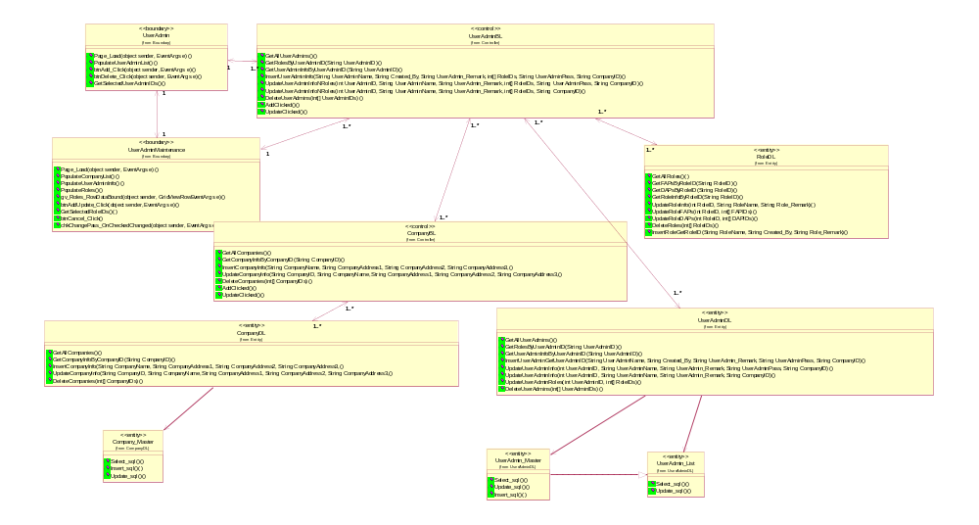

User Administrator
Boundary class of User Adinistrator

Relationships:
Object Name: UserAdminBL (Logical View::Design Model::Design Objects::Controller::UserAdminBL )
Kind of Relationship: Associations

Object Name: UserAdminMaintenance (Logical View::Design Model::Design Objects::Boundary::UserAdminMaintenance )
Kind of Relationship: Associations

Object Name: UserBL (Logical View::Design Model::Design Objects::Controller::UserBL )
Kind of Relationship: Associations

Operations:

btnAdd_Click(object sender, EventArgs e) () : void
Documentation: Button to add

btnDelete_Click(object sender, EventArgs e) () : void
Documentation: Button to delete

GetSelectedUserAdminIDs() () : int[]
Documentation: Method to get selected user admin

Page_Load(object sender, EventArgs e) () : void
Documentation: Method to page load

PopulateUserAdminList() () : void
Documentation: Method to populate user admin list

User Administrator Maintenance
Boundary class of User Administrator Maintenance

Relationships:
Object Name: UserAdminBL (Logical View::Design Model::Design Objects::Controller::UserAdminBL )
Kind of Relationship: Associations

Object Name: UserAdmin (Logical View::Design Model::Design Objects::Boundary::UserAdmin )
Kind of Relationship: Associations

Operations:

btnAddUpdate_Click(object sender, EventArgs e) () : void
Documentation: Button to add update

btnCancel_Click (object sender, EventArgs e) : void
Documentation: Button to cancel

chkChangePass_OnCheckedChanged(object sender, EventArgs e) () : void
Documentation: method to check Change pass on checked changed

GetSelectedRoleIDs() () : int[]
Documentation: Method to get selected role IDs

gv_Roles_RowDataBound(object sender, GridViewRowEventArgs e) () : void
Documentation: method to give Roles row databound

Page_Load(object sender, EventArgs e) () : void
Documentation: Method to page load

PopulateCompanyList() () : void
Documentation: Method to populate company list

PopulateRoles() () : void
Documentation: Method to populate roles

PopulateUserAdminInfo() () : void
Documentation: Method to populate user admin info

User AdministratorBL
Entity of User Administrator

Relationships:
Object Name: UserAdminBL (Logical View::Design Model::Design Objects::Controller::UserAdminBL )
Kind of Relationship: Associations

Operations:
DeleteUserAdmins(int[] UserAdminIDs) () : void
Documentation: This function will mark the Delete_Flag=1

GetAllUserAdmins() () : DataTable
Documentation: This function will get all the User Admin.

GetRolesByUserAdminID(String UserAdminID) () : DataTable
Documentation: This function will get all the User Admins, as well marks which roles does the User Admin has, according to the UserAdminID.

GetUserAdminInfoByUserAdminID(String UserAdminID) () : DataTable
Documentation: This function will retrieve the User Admin information via UserAdminID

InsertUserAdminGetUserAdminID(String UserAdminName, String Created_By, String UserAdmin_Remark, String UserAdminPass, String CompanyID) () : Integer
Documentation: This function will insert new User Admin and get ID of this User Admin.

UpdateUserAdminInfo(int UserAdminID, String UserAdminName, String UserAdmin_Remark, String CompanyID) () : void
Documentation: This function will update the existing User Admin, except the password

UpdateUserAdminInfo(int UserAdminID, String UserAdminName, String UserAdmin_Remark, String UserAdminPass, String CompanyID) () : void
Documentation: This function will update the existing User Admin.

UpdateUserAdminRoles(int UserAdminID, int[] RoleIDs) () : void
Documentation: This function will delete all the old roles a User Admin has, then add in new roles.

User AdministratorDL
User Administrator Controller

Relationships:
Object Name: UserAdmin (Logical View::Design Model::Design Objects::Boundary::UserAdmin )
Kind of Relationship: Associations

Object Name: UserAdminMaintenance (Logical View::Design Model::Design Objects::Boundary::UserAdminMaintenance )
Kind of Relationship: Associations

Object Name: CompanyBL (Logical View::Design Model::Design Objects::Controller::CompanyBL )
Kind of Relationship: Associations

Object Name: RoleDL (Logical View::Design Model::Design Objects::Entity::RoleDL )
Kind of Relationship: Associations

Object Name: UserAdminDL (Logical View::Design Model::Design Objects::Entity::UserAdminDL )

Kind of Relationship: Associations

Operations:
AddClicked() () : void
Documentation: Add button clicked

DeleteUserAdmins(int[] UserAdminIDs) () : void
Documentation: Method to delete user admins

GetAllUserAdmins() () : DataTable
Documentation: Method to get all user admins

GetRolesByUserAdminID(String UserAdminID) () : DataTable
Documentation: Method to get roles by user admin ID

GetUserAdminInfoByUserAdminID(String UserAdminID) () : DataTable
Documentation: Method to get user admin info by user admin ID

InsertUserAdminInfo(String UserAdminName, String Created_By, String UserAdmin_Remark, int[] RoleIDs, String UserAdminPass, String CompanyID) () : void
Documentation: Method to insert user admin info

UpdateClicked() () : void
Documentation: Method to Update clicked

UpdateUserAdminInfoNRoles(int UserAdminID, String UserAdminName, String UserAdmin_Remark, int[] RoleIDs, String CompanyID) () : void
Documentation: Method to update useradmin info & roles

UpdateUserAdminInfoNRoles(int UserAdminID, String UserAdminName, String UserAdmin_Remark, int[] RoleIDs, String UserAdminPass, String CompanyID) () : void
Documentation: Methods to update User admin info & Roles

Login/Logout

Static structure of Maintain Customer
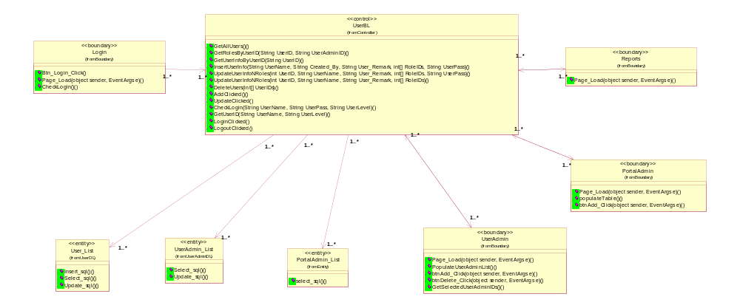

Login
Boundary class of Login

Relationships:
Object Name: UserBL (Logical View::Design Model::Design Objects::Controller::UserBL )
Kind of Relationship: Associations

Operations:
Btn_Login_Click (object sender, EventArgs e) : void
Documentation: Button to login

CheckLogin() () : Boolean
Documentation: Method to check login

Page_Load(object sender, EventArgs e) () : void
Documentation: Method to page load

Portal Administrator

Boundary class of Portal Admin

Relationships:
Object Name: UserBL (Logical View::Design Model::Design Objects::Controller::UserBL )
Kind of Relationship: Associations

Operations:
btnAdd_Click(object sender, EventArgs e) () : void
Documentation: Button to add

Page_Load(object sender, EventArgs e) () : void
Documentation: Method to Page load

populateTable() () : void
Documentation: Method to populate table

Reports
Boundary Class of Reports for CMS user

Relationships:
Object Name: UserBL (Logical View::Design Model::Design Objects::Controller::UserBL )
Kind of Relationship: Associations

Operations:
Page_Load(object sender, EventArgs e) () : void
Documentation: Method to load and display CMS report page for user level user.

Object Specifications of MCQ Functions

Controller: MCQBL

Class: mcq_exam_master (Logical View::Design Model::Design Objects::Exam::mcq_exam_master )
Documentation: This is mcq_exam_master datatable to store exam details.
Cardinality [1 ]
Associated class mcq_exam_master documentation:
This is an entity for exam (datatable).

Class: mcq_section_master (Logical View::Design Model::Design Objects::Section::mcq_section_master )
Documentation: This is mcq_section_master datatable to store exam section details.
Cardinality [1 ]
Associated class mcq_section_master documentation:
This is the datatable for section details.

Class: mcq_question_master (Logical View::Design Model::Design Objects::Questions::mcq_question_master )
Documentation: This is mcq_question_master datatable to store exam question details.
Cardinality [1 ]
Associated class mcq_question_master documentation:
This is the main datatable for question pool module.

Class: mcq_question_option (Logical View::Design Model::Design Objects::Questions::mcq_question_option )
Documentation: This is mcq_question_option datatable to store exam question option details.
Cardinality [ Undefined ]
Associated class mcq_question_option documentation:
This is the answer datatable for question pool datatable.

Exam Maintenance

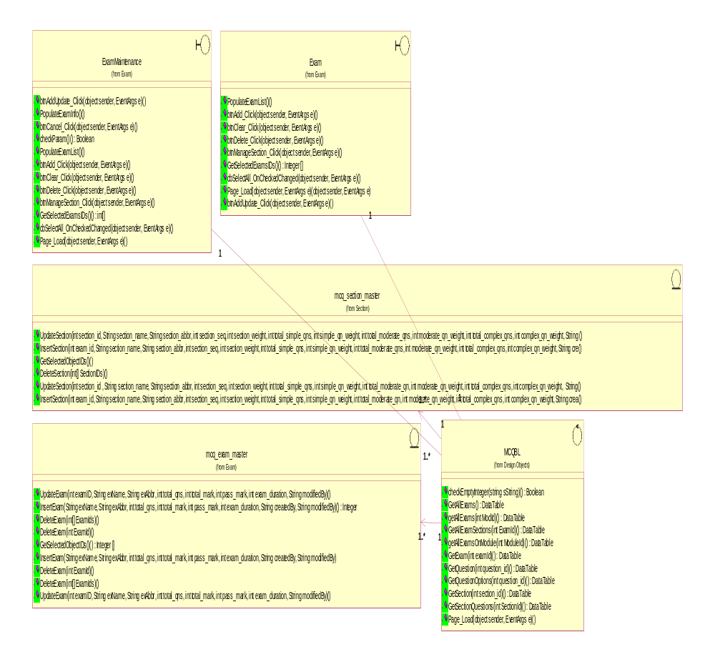

Class: MCQBL

checkEmptyInteger(string sString) () : Boolean
Documentation:

GetAllExams () : DataTable
Documentation:

getAllExams(int ModId) () : DataTable
Documentation:

GetAllExamSections(int ExamId) () : DataTable
Documentation:

getAllExamsOnModule(int ModuleId) () : DataTable
Documentation:

GetExam(int examId) () : DataTable
Documentation:

GetQuestion(int question_id) () : DataTable
Documentation:

GetQuestionOptions(int question_id) () : DataTable
Documentation:

GetSection(int section_id) () : DataTable
Documentation:

GetSectionQuestions(int SectionId) () : DataTable
Documentation:

Page_Load(object sender, EventArgs e) () : void
Documentation:

Class: Exam

btnAdd_Click(object sender, EventArgs e) () : void
Documentation: This method allow portal admin to click on Add button on the interface.

btnAddUpdate_Click(object sender, EventArgs e) () : void
Documentation: This method is to allow portal admin to click on a button to update the exam data.

btnClear_Click(object sender, EventArgs e) () : void
Documentation: This method is to allow portal admin to clear/cancel the existing data entry.

btnDelete_Click(object sender, EventArgs e) () : void
Documentation: This method is to delete an exam from mcq_exam_master datatabe.

btnManageSection_Click(object sender, EventArgs e) () : void
Documentation: This method allows portal admin to create sections of an exam.

cbSelectAll_OnCheckedChanged(object sender, EventArgs e) () : void
Documentation: This method is to allow portal admin to select all the has been ticked to be removed.

GetSelectedExamsIDs() () : Integer []
Documentation: This method is to allow portal admin to select an exam to be modified/removed or to create sections.

Page_Load(object sender, EventArgs e) (object sender, EventArgs e) : void
Documentation: This method is to load the first page of the respective module.

PopulateExamList() () : void
Documentation: This method will extract the exam list from mcq_exam_master datatable.

Class: ExamMaintenance

btnAdd_Click(object sender, EventArgs e) () : void
Documentation: This method is to allow portal admin to click on button to add or update exam properties.

btnAddUpdate_Click(object sender, EventArgs e) () : void
Documentation: This method is to allow portal admin to click on button to add or update exam properties.

btnCancel_Click(object sender, EventArgs e) () : void
Documentation: This method allows portal admin to click on a button to cancel the exam maintenance operation.

btnClear_Click(object sender, EventArgs e) () : void
Documentation: This method will clear the data input on the interface to allow portal admin to key in new exam details.

btnDelete_Click(object sender, EventArgs e) () : void
Documentation: This method will allow portal admin to delete an exam or list of exams.

btnManageSection_Click(object sender, EventArgs e) () : void
Documentation: This method will allow portal admin to select the section maintenance module and transfer to section maintenance interface.

cbSelectAll_OnCheckedChanged(object sender, EventArgs e) () : void
Documentation: This method allows other method to extract/remove exam list based on the selection.

checkParam() () : Boolean
Documentation: This method is to check whether portal admin inputed the exam name / exam abbreviation.

GetSelectedExamsIDs() () : int[]
Documentation: This method is the buffer that stores the selection of exams from exam interface.

Page_Load(object sender, EventArgs e) () : void
Documentation: This method will display the exam / exam maintenance interface to portal admin.

PopulateExamInfo() () : void
Documentation: This method will extract the exam info from mcq_exam_master datatable.

PopulateExamList() () : void
Documentation: This method will extract exam list from mcq_exam_master datatable.

Class: mcq_exam_master

DeleteExam(int ExamId) () : void
Documentation: This method will remove an exam from mcq_exam_master datatable.

DeleteExam(int ExamId) () : void
Documentation:

DeleteExam(int[] ExamIds) () : void
Documentation: This method will remove exams from mcq_exam_datatable.

DeleteExam(int[] ExamIds) () : void
Documentation:

GetSelectedObjectIDs() () : Integer []
Documentation: This method will extract info based on criteria in this array.

InsertExam (String exName, String exAbbr, int total_qns, int total_mark, int pass_mark, int exam_duration, String createdBy, String modifiedBy) : void
Documentation:

InsertExam(String exName, String exAbbr, int total_qns, int total_mark, int pass_mark, int exam_duration, String createdBy, String modifiedBy) () : Integer
Documentation: This method will insert exam details into mcq_exam_master datatable.

UpdateExam(int examID, String exName, String exAbbr, int total_qns, int total_mark, int pass_mark, int exam_duration, String modifiedBy) () : void
Documentation: This method will update the exam details to mcq_exam_master datatable.

UpdateExam(int examID, String exName, String exAbbr, int total_qns, int total_mark, int pass_mark, int exam_duration, String modifiedBy) () : void
Documentation:

Class: mcq_section_master

DeleteSection(int[] SectionIDs) () : void
Documentation:

GetSelectedObjectIDs() () : Integer[]
Documentation: This method will extract the section details based on portal admin's selection.

InsertSection(int exam_id, String section_name, String section_abbr, int section_seq, int section_weight, int total_simple_qns, int simple_qn_weight, int total_moderate_qn, int moderate_qn_weight, int total_complex_qns, int complex_qn_weight, String crea () : Integer
Documentation:

InsertSection(int exam_id, String section_name, String section_abbr, int section_seq, int section_weight, int total_simple_qns, int simple_qn_weight, int total_moderate_qns, int moderate_qn_weight, int total_complex_qns, int complex_qn_weight, String cre () : void
Documentation: This method will insert the section details of an exam.

UpdateSection(int section_id , String section_name, String section_abbr, int section_seq, int section_weight, int total_simple_qns, int simple_qn_weight, int total_moderate_qn, int moderate_qn_weight, int total_complex_qns, int complex_qn_weight, String () : void
Documentation:

UpdateSection(int section_id, String section_name, String section_abbr, int section_seq, int section_weight, int total_simple_qns, int simple_qn_weight, int total_moderate_qns, int moderate_qn_weight, int total_complex_qns, int complex_qn_weight, String () : void
Documentation: This method will update the section details of an exam.

Question Maintenance
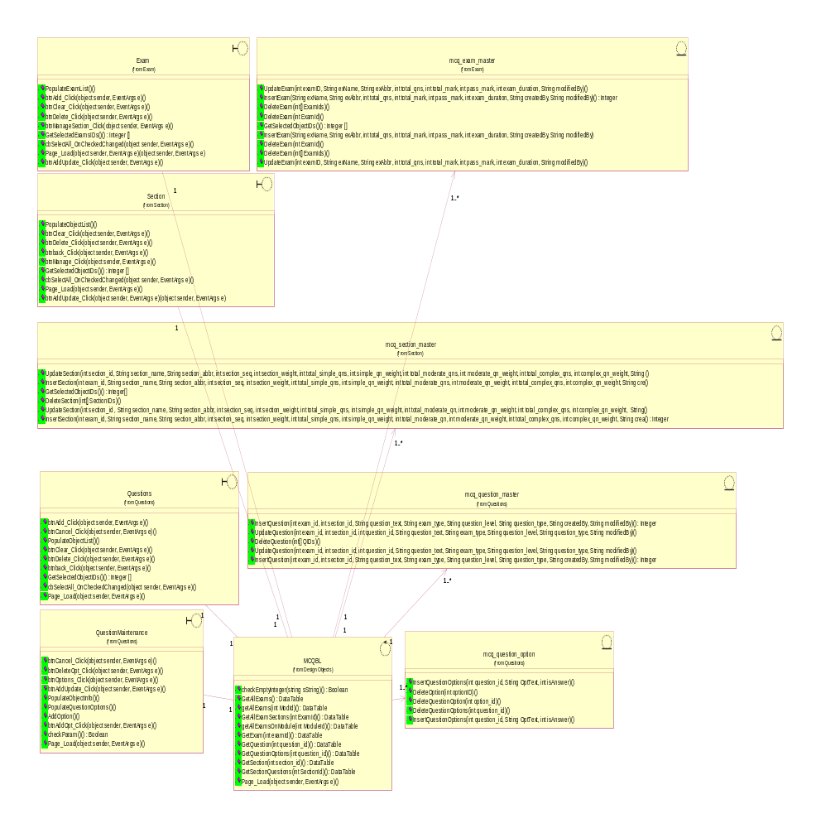

Class: Exam

btnAdd_Click(object sender, EventArgs e) () : void
Documentation: This method allow portal admin to click on Add button on the interface.

btnAddUpdate_Click(object sender, EventArgs e) () : void
Documentation: This method is to allow portal admin to click on a button to update the exam data.

btnClear_Click(object sender, EventArgs e) () : void
Documentation: This method is to allow portal admin to clear/cancel the existing data entry.

btnDelete_Click(object sender, EventArgs e) () : void
Documentation: This method is to delete an exam from mcq_exam_master datatabe.

btnManageSection_Click(object sender, EventArgs e) () : void
Documentation: This method allows portal admin to create sections of an exam.

cbSelectAll_OnCheckedChanged(object sender, EventArgs e) () : void
Documentation: This method is to allow portal admin to select all the has been ticked to be removed.

GetSelectedExamsIDs() () : Integer []
Documentation: This method is to allow portal admin to select an exam to be modified/removed or to create sections.

Page_Load(object sender, EventArgs e) (object sender, EventArgs e) : void
Documentation: This method is to load the first page of the respective module.

PopulateExamList() () : void
Documentation: This method will extract the exam list from mcq_exam_master datatable.

Class: ExamMaintenance

btnAdd_Click(object sender, EventArgs e) () : void
Documentation: This method is to allow portal admin to click on button to add or update exam properties.

btnAddUpdate_Click(object sender, EventArgs e) () : void
Documentation: This method is to allow portal admin to click on button to add or update exam properties.

btnCancel_Click(object sender, EventArgs e) () : void
Documentation: This method allows portal admin to click on a button to cancel the exam maintenance operation.

btnClear_Click(object sender, EventArgs e) () : void
Documentation: This method will clear the data input on the interface to allow portal admin to key in new exam details.

btnDelete_Click(object sender, EventArgs e) () : void
Documentation: This method will allow portal admin to delete an exam or list of exams.

btnManageSection_Click(object sender, EventArgs e) () : void
Documentation: This method will allow portal admin to select the section maintenance module and transfer to section maintenance interface.

cbSelectAll_OnCheckedChanged(object sender, EventArgs e) () : void
Documentation: This method allows other method to extract/remove exam list based on the selection.

checkParam() () : Boolean
Documentation: This method is to check whether portal admin inputed the exam name / exam abbreviation.

GetSelectedExamsIDs() () : int[]
Documentation: This method is the buffer that stores the selection of exams from exam interface.

Page_Load(object sender, EventArgs e) () : void
Documentation: This method will display the exam / exam maintenance interface to portal admin.

PopulateExamInfo() () : void
Documentation: This method will extract the exam info from mcq_exam_master datatable.

PopulateExamList() () : void
Documentation: This method will extract exam list from mcq_exam_master datatable.

Class: mcq_exam_master

DeleteExam(int ExamId) () : void
Documentation: This method will remove an exam from mcq_exam_master datatable.

DeleteExam(int ExamId) () : void
Documentation:

DeleteExam(int[] ExamIds) () : void
Documentation: This method will remove exams from mcq_exam_datatable.

DeleteExam(int[] ExamIds) () : void
Documentation:

GetSelectedObjectIDs() () : Integer []
Documentation: This method will extract info based on criteria in this array.

InsertExam (String exName, String exAbbr, int total_qns, int total_mark, int pass_mark, int exam_duration, String createdBy, String modifiedBy) : void
Documentation:

InsertExam(String exName, String exAbbr, int total_qns, int total_mark, int pass_mark, int exam_duration, String createdBy, String modifiedBy) () : Integer
Documentation: This method will insert exam details into mcq_exam_master datatable.

UpdateExam(int examID, String exName, String exAbbr, int total_qns, int total_mark, int pass_mark, int exam_duration, String modifiedBy) () : void
Documentation: This method will update the exam details to mcq_exam_master datatable.

UpdateExam(int examID, String exName, String exAbbr, int total_qns, int total_mark, int pass_mark, int exam_duration, String modifiedBy) () : void
Documentation:

Class: mcq_section_master

DeleteSection(int[] SectionIDs) () : void
Documentation:

GetSelectedObjectIDs() () : Integer[]
Documentation: This method will extract the section details based on portal admin's selection.

InsertSection(int exam_id, String section_name, String section_abbr, int section_seq, int section_weight, int total_simple_qns, int simple_qn_weight, int total_moderate_qn, int moderate_qn_weight, int total_complex_qns, int complex_qn_weight, String crea () : Integer
Documentation:

InsertSection(int exam_id, String section_name, String section_abbr, int section_seq, int section_weight, int total_simple_qns, int simple_qn_weight, int total_moderate_qns, int moderate_qn_weight, int total_complex_qns, int complex_qn_weight, String cre () : void
Documentation: This method will insert the section details of an exam.

UpdateSection(int section_id , String section_name, String section_abbr, int section_seq, int section_weight, int total_simple_qns, int simple_qn_weight, int total_moderate_qn, int moderate_qn_weight, int total_complex_qns, int complex_qn_weight, String () : void
Documentation:

UpdateSection(int section_id, String section_name, String section_abbr, int section_seq, int section_weight, int total_simple_qns, int simple_qn_weight, int total_moderate_qns, int moderate_qn_weight, int total_complex_qns, int complex_qn_weight, String () : void
Documentation: This method will update the section details of an exam.

Class: Section

btnAddUpdate_Click(object sender, EventArgs e) (object sender, EventArgs e) : void
Documentation: This method will add new section into exam.

btnback_Click(object sender, EventArgs e) () : void
Documentation: This method will go back to previous screen.

btnClear_Click(object sender, EventArgs e) () : void
Documentation: This method will allow portal admin to click on clear button to renew the interface for further operation.

btnDelete_Click(object sender, EventArgs e) () : void
Documentation: This method will allow portal admin to click on delete button to delete a section of an exam.

btnManage_Click(object sender, EventArgs e) () : void
Documentation: This method will allow portal admin to click on button to manage section interface.

cbSelectAll_OnCheckedChanged(object sender, EventArgs e) () : void
Documentation: This method select all items on records.

GetSelectedObjectIDs() () : Integer []
Documentation: This method will buffer the selection from portal admin and extract details from the mcq_section_master datatable.

Page_Load(object sender, EventArgs e) () : void
Documentation: This method will load the section interface.

PopulateObjectList() () : void
Documentation: This method will extract a list of section.

Class: Question

btnAdd_Click(object sender, EventArgs e) () : void
Documentation: This method will allow portal admin to click a button to activate add question operation.

btnback_Click(object sender, EventArgs e) () : void
Documentation: This method will allow portal admin to click a button to go back question operation.

btnCancel_Click(object sender, EventArgs e) () : void
Documentation: This method will allow portal admin to click a button to cancel add/remove question operation.

btnClear_Click(object sender, EventArgs e) () : void
Documentation: This method will allow portal admin to click a button to clear question details.

btnDelete_Click(object sender, EventArgs e) () : void
Documentation: This method will allow portal admin to click a button to delete a question.

cbSelectAll_OnCheckedChanged(object sender, EventArgs e) () : void
Documentation: This method will buffer all the selections of portal admin on quetions.

GetSelectedObjectIDs() () : Integer []
Documentation: This method will buffer the portal admin's selections.

Page_Load(object sender, EventArgs e) () : void
Documentation: This method will load the interface on question.

PopulateObjectList() () : void
Documentation:

Class: QuestionMaintenance

AddOption() () : void
Documentation: This method will add additional options into a question.

btnAddOpt_Click(object sender, EventArgs e) () : void
Documentation: This method allows portal admin to click on a button to add an option.

btnAddUpdate_Click(object sender, EventArgs e) () : void
Documentation: This method will update a question details into mcq_question_master.

btnCancel_Click(object sender, EventArgs e) () : void
Documentation: This method will allow portal admin to click the cancel button to cancel the maintenance operation.

btnDeleteOpt_Click(object sender, EventArgs e) () : void
Documentation: This method will allow portal admin to click the delete button to delete a question from datatable mcq_question_master.

btnOptions_Click(object sender, EventArgs e) () : void
Documentation: This method will allow portal admin to click the button to add additional options for a question.

checkParam() () : Boolean
Documentation: This method will validate a question parameters.

Page_Load(object sender, EventArgs e) () : void
Documentation: This method will load the interface for question maintenance.

PopulateObjectInfo() () : void
Documentation: This method will extract the question list and its options from datatable mcq_question_master and mcq_question_option.

PopulateQuestionOptions() () : void
Documentation: This method will extract the question option from mcq_question_option datatable.

Class: mcq_question_master

DeleteQuestion(int[] QIDs) () : void
Documentation:

InsertQuestion(int exam_id, int section_id, String question_text, String exam_type, String question_level, String question_type, String createdBy, String modifiedBy) () : Integer
Documentation: This method will insert the question details into mcq_question_master datatable.

InsertQuestion(int exam_id, int section_id, String question_text, String exam_type, String question_level, String question_type, String createdBy, String modifiedBy) () : Integer
Documentation:

UpdateQuestion(int exam_id, int section_id, int question_id, String question_text, String exam_type, String question_level, String question_type, String modifiedBy) () : void
Documentation: This method will update the question details into mcq_question_master datatable.

UpdateQuestion(int exam_id, int section_id, int question_id, String question_text, String exam_type, String question_level, String question_type, String modifiedBy) () : void
Documentation:

Class: mcq_question_option

DeleteOption(int optionID) () : void
Documentation: This method will delete an option from a question.

DeleteQuestionOption(int option_id) () : void
Documentation:

DeleteQuestionOptions(int question_id) () : void
Documentation:

InsertQuestionOptions(int question_id, String OptText, int isAnswer) () : void
Documentation: This method will insert the question options details into mcq_question_option datatable.

InsertQuestionOptions(int question_id, String OptText, int isAnswer) () : void
Documentation:

Section Maintenance

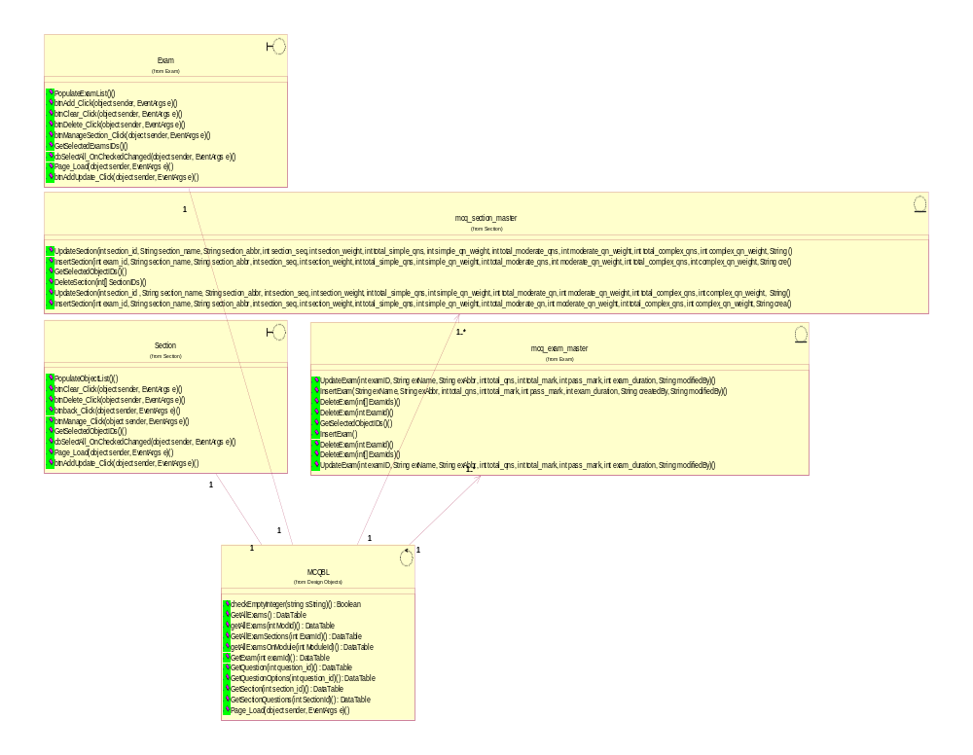

Class: MCQBL

checkEmptyInteger(string sString) () : Boolean
Documentation:

GetAllExams () : DataTable
Documentation:

getAllExams(int ModId) () : DataTable
Documentation:

GetAllExamSections(int ExamId) () : DataTable
Documentation:

getAllExamsOnModule(int ModuleId) () : DataTable
Documentation:

GetExam(int examId) () : DataTable
Documentation:

GetQuestion(int question_id) () : DataTable
Documentation:

GetQuestionOptions(int question_id) () : DataTable
Documentation:

GetSection(int section_id) () : DataTable
Documentation:

GetSectionQuestions(int SectionId) () : DataTable
Documentation:

Page_Load(object sender, EventArgs e) () : void
Documentation:

Class: Exam

btnAdd_Click(object sender, EventArgs e) () : void
Documentation: This method allow portal admin to click on Add button on the interface.

btnAddUpdate_Click(object sender, EventArgs e) () : void
Documentation: This method is to allow portal admin to click on a button to update the exam data.

btnClear_Click(object sender, EventArgs e) () : void
Documentation: This method is to allow portal admin to clear/cancel the existing data entry.

btnDelete_Click(object sender, EventArgs e) () : void
Documentation: This method is to delete an exam from mcq_exam_master datatabe.

btnManageSection_Click(object sender, EventArgs e) () : void
Documentation: This method allows portal admin to create sections of an exam.

cbSelectAll_OnCheckedChanged(object sender, EventArgs e) () : void
Documentation: This method is to allow portal admin to select all the has been ticked to be removed.

GetSelectedExamsIDs() () : Integer []
Documentation: This method is to allow portal admin to select an exam to be modified/removed or to create sections.

Page_Load(object sender, EventArgs e) (object sender, EventArgs e) : void
Documentation: This method is to load the first page of the respective module.

PopulateExamList() () : void
Documentation: This method will extract the exam list from mcq_exam_master datatable.

Class: mcq_exam_master

DeleteExam(int ExamId) () : void
Documentation: This method will remove an exam from mcq_exam_master datatable.

DeleteExam(int ExamId) () : void
Documentation:

DeleteExam(int[] ExamIds) () : void
Documentation: This method will remove exams from mcq_exam_datatable.

DeleteExam(int[] ExamIds) () : void
Documentation:

GetSelectedObjectIDs() () : Integer []
Documentation: This method will extract info based on criteria in this array.

InsertExam (String exName, String exAbbr, int total_qns, int total_mark, int pass_mark, int exam_duration, String createdBy, String modifiedBy) : void
Documentation:

InsertExam(String exName, String exAbbr, int total_qns, int total_mark, int pass_mark, int exam_duration, String createdBy, String modifiedBy) () : Integer
Documentation: This method will insert exam details into mcq_exam_master datatable.

UpdateExam(int examID, String exName, String exAbbr, int total_qns, int total_mark, int pass_mark, int exam_duration, String modifiedBy) () : void
Documentation: This method will update the exam details to mcq_exam_master datatable.

UpdateExam(int examID, String exName, String exAbbr, int total_qns, int total_mark, int pass_mark, int exam_duration, String modifiedBy) () : void
Documentation:

Class: mcq_section_master

DeleteSection(int[] SectionIDs) () : void
Documentation:

GetSelectedObjectIDs() () : Integer[]
Documentation: This method will extract the section details based on portal admin's selection.

InsertSection(int exam_id, String section_name, String section_abbr, int section_seq, int section_weight, int total_simple_qns, int simple_qn_weight, int total_moderate_qn, int moderate_qn_weight, int total_complex_qns, int complex_qn_weight, String crea () : Integer
Documentation:

InsertSection(int exam_id, String section_name, String section_abbr, int section_seq, int section_weight, int total_simple_qns, int simple_qn_weight, int total_moderate_qns, int moderate_qn_weight, int total_complex_qns, int complex_qn_weight, String cre () : void
Documentation: This method will insert the section details of an exam.

UpdateSection(int section_id , String section_name, String section_abbr, int section_seq, int section_weight, int total_simple_qns, int simple_qn_weight, int total_moderate_qn, int moderate_qn_weight, int total_complex_qns, int complex_qn_weight, String () : void
Documentation:

UpdateSection(int section_id, String section_name, String section_abbr, int section_seq, int section_weight, int total_simple_qns, int simple_qn_weight, int total_moderate_qns, int moderate_qn_weight, int total_complex_qns, int complex_qn_weight, String () : void
Documentation: This method will update the section details of an exam.

Class: Section

btnAddUpdate_Click(object sender, EventArgs e) (object sender, EventArgs e) : void
Documentation: This method will add new section into exam.

btnback_Click(object sender, EventArgs e) () : void
Documentation: This method will go back to previous screen.

btnClear_Click(object sender, EventArgs e) () : void
Documentation: This method will allow portal admin to click on clear button to renew the interface for further operation.

btnDelete_Click(object sender, EventArgs e) () : void
Documentation: This method will allow portal admin to click on delete button to delete a section of an exam.

btnManage_Click(object sender, EventArgs e) () : void
Documentation: This method will allow portal admin to click on button to manage section interface.

cbSelectAll_OnCheckedChanged(object sender, EventArgs e) () : void
Documentation: This method select all items on records.

GetSelectedObjectIDs() () : Integer []
Documentation: This method will buffer the selection from portal admin and extract details from the mcq_section_master datatable.

Page_Load(object sender, EventArgs e) () : void
Documentation: This method will load the section interface.

PopulateObjectList() () : void
Documentation: This method will extract a list of section.

Survey Maintenance

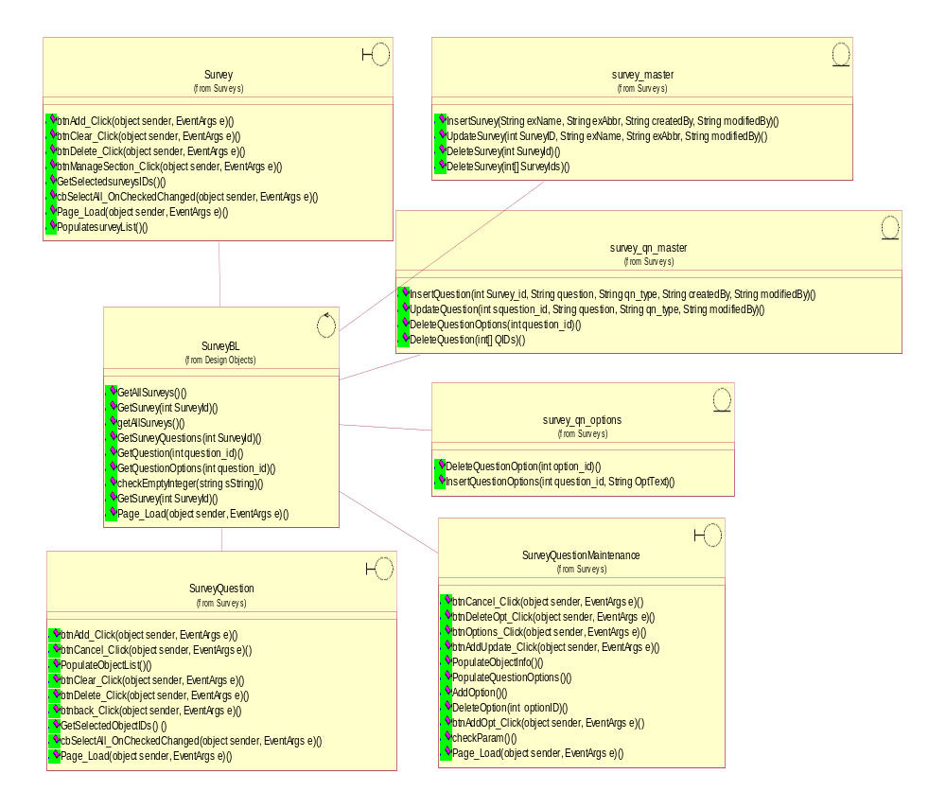

Class: SurveyBL

checkEmptyInteger(string sString) () : Boolean
Documentation: This method will do validation check.

GetAllSurveys() () : DataTable
Documentation: This method will get all surveys.

getAllSurveys() () : DataTable
Documentation: This method will get all surveys.

GetQuestion(int question_id) () : DataTable
Documentation: This method will get survey question.

GetQuestionOptions(int question_id) () : DataTable
Documentation: This method will get survey question options.

GetSurvey(int SurveyId) () : DataTable
Documentation: This method will get a survey.

GetSurvey(int SurveyId) () : void
Documentation: This method will get survey details.

GetSurveyQuestions(int SurveyId) () : DataTable
Documentation: This method will get survey question.

Page_Load(object sender, EventArgs e) () : void
Documentation: This method will load the interface.

Class: survey

btnAdd_Click(object sender, EventArgs e) () : void
Documentation: This method allows portal admin to click on Add button.

btnClear_Click(object sender, EventArgs e) () : void
Documentation: This method allows portal admin to click on Clear button.

btnDelete_Click(object sender, EventArgs e) () : void
Documentation: This method allows portal admin to click on Delete button.

btnManageSection_Click(object sender, EventArgs e) () : void
Documentation: This method allows portal admin to click on manage question button.

cbSelectAll_OnCheckedChanged(object sender, EventArgs e) () : void
Documentation: This method allows portal admin to pick multiple selections.

GetSelectedsurveysIDs() () : Integer []
Documentation: This method will extract selected surveys from datatable.

Page_Load(object sender, EventArgs e) () : void
Documentation: This method will load the interface.

PopulatesurveyList() () : void
Documentation: This method will extract survey list from datatable.

Class: survey_master

DeleteSurvey(int SurveyId) () : void
Documentation: This method will remove 1 survey.

DeleteSurvey(int[] SurveyIds) () : void
Documentation: This method will remove 1 or more surveys.

InsertSurvey(String exName, String exAbbr, String createdBy, String modifiedBy) (String exName, String exAbbr, String createdBy, String modifiedBy) : void
Documentation: This method allows portal admin to insert new survey into datatable.

UpdateSurvey(int SurveyID, String exName, String exAbbr, String modifiedBy) () : void
Documentation: This method allows portal admin to update survey details into datatable.

Class: survey_qn_master

DeleteQuestion(int[] QIDs) () : void
Documentation: This method will delete survey question from datatable.

DeleteQuestionOptions(int question_id) () : void
Documentation: This method will delete survey question option from datatable.

InsertQuestion(int Survey_id, String question, String qn_type, String createdBy, String modifiedBy) () : void
Documentation: This method will insert new survey question into datatable.

UpdateQuestion(int squestion_id, String question, String qn_type, String modifiedBy) () : void
Documentation: This method will update survey question details into datatable.

Class: survey_qn_option

DeleteQuestionOption(int option_id) () : void
Documentation: This method will delete survey question options.

InsertQuestionOptions(int question_id, String OptText) () : void
Documentation: This method will insert survey question options.

Class: SurveyQuestion

btnAdd_Click(object sender, EventArgs e) () : void
Documentation: This method allows portal admin to click on Add button.

btnback_Click(object sender, EventArgs e) () : void
Documentation: This method allows portal admin to click on back button.

btnCancel_Click(object sender, EventArgs e) () : void
Documentation: This method allows portal admin to click on cancel button.

btnClear_Click(object sender, EventArgs e) () : void
Documentation: This method allows portal admin to click on clear button.

btnDelete_Click(object sender, EventArgs e) () : void
Documentation: This method allows portal admin to click on delete button.

cbSelectAll_OnCheckedChanged(object sender, EventArgs e) () : void
Documentation: This method will pick multiple selection.

GetSelectedObjectIDs() () : Integer []
Documentation: This method will extract list of survey question from datatable.

Page_Load(object sender, EventArgs e) () : void
Documentation: This method will load the interface.

PopulateObjectList() () : void
Documentation: This method will populate the extracted list on interface.

Class: SurveyQuestionMaintenance

AddOption() () : void
Documentation: This method will add additional option.

btnAddOpt_Click(object sender, EventArgs e) () : Boolean
Documentation: This method allow portal admin to click on add option button.

btnAddUpdate_Click(object sender, EventArgs e) () : void
Documentation: This method allows portal admin to click on update button.

btnCancel_Click(object sender, EventArgs e) () : void
Documentation: This method allows portal admin to click on cancel button.

btnDeleteOpt_Click(object sender, EventArgs e) () : void
Documentation: This method allows portal admin to click on delete button.

btnOptions_Click(object sender, EventArgs e) () : void
Documentation: This method allows portal admin to click on manage survey question button.

checkParam() () : void
Documentation: This method will do validation check.

DeleteOption(int optionID) () : void
Documentation: This method will delete an option.

Page_Load(object sender, EventArgs e) () : void
Documentation: This method will load the interface.

PopulateObjectInfo() () : void
Documentation: This method will populate the extracted list into interface.

PopulateQuestionOptions() () : void
Documentation: This method will populate the question option on interface.

Object Specifications of CMS Functions

CMS Site Maintenance

Static structure of CMS Site Maintenance Add Site

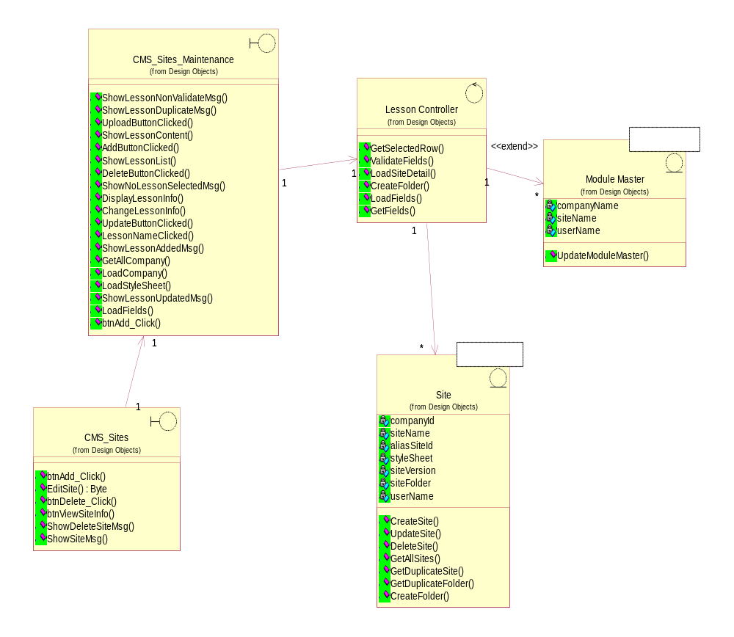

Static structure of CMS Site Maintenance Update Site

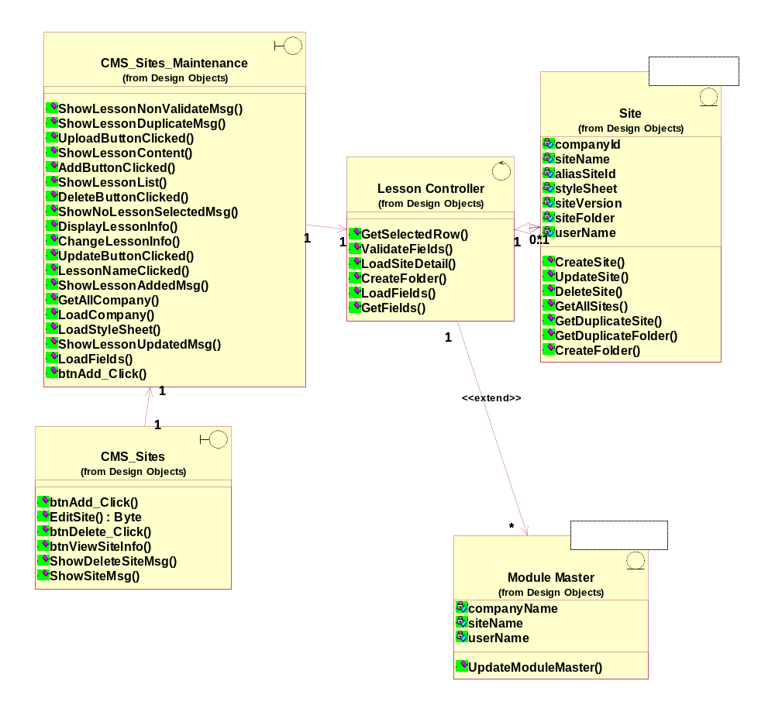

Static structure of CMS Site Maintenance Delete Site
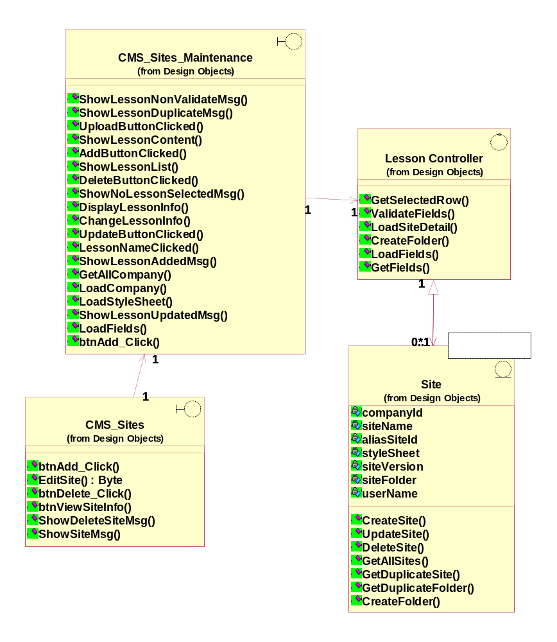

Static structure of CMS Site Maintenance View Site

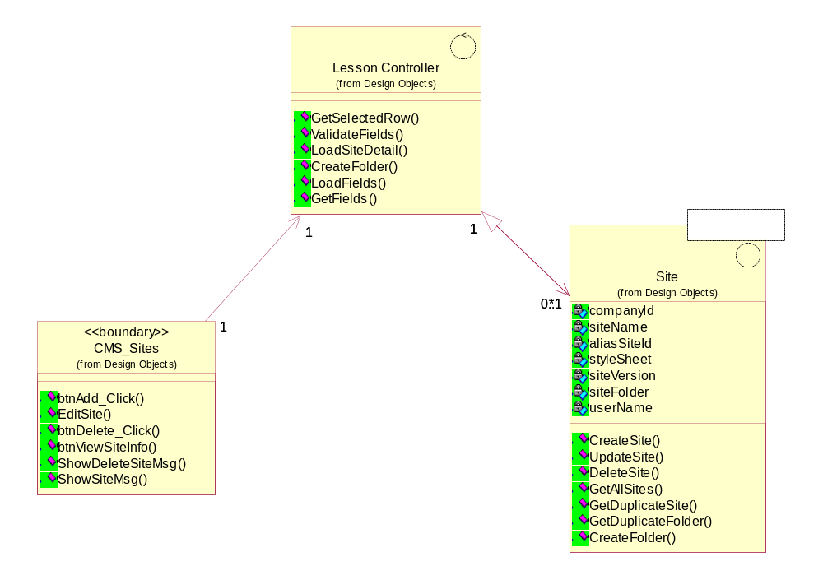

Static structure of CMS Site Maintenance Add/Update/Delete & View Site

Object Name: Lesson Controller (Logical View::Design Model::Design Objects::Controller::LessonController )

Kind of Relationship: Associations

Object Name: CMS_Sites (Logical View::Design Model::Design Objects::Boundary::CMS_Sites )

Kind of Relationship: Associations

Object Name: CMS_Sites_Maintenance (Logical View::Design Model::Design Objects::Boundary::CMS_Sites_Maintenance )

Kind of Relationship: Associations

Object Name: CMS_Site (Logical View::Design Model::Design Objects::Entity::Site )

Kind of Relationship: Associations

CMS Sites Maintenance

Operations:
CMS Sites Maintenance handles the requests from portal admin, this class is used to handle the requests for adding and updating the sites.

btnAdd_Click (object sender, EventArgs e) : void
Documentation: Add click invokes the Save to save the content of the page.
Parameters: object sender, EventArgs e

GetAllCompany () : void
Documentation: Data will be fetched from the ACS module. Once the company is created GetAllCompany() will fetch all data from the company master entity.

LoadCompany () : void
Documentation: Loading details of the company, company is created in ACS module and data will be fetched from the GetAllCompany().

LoadFields (string companyID, string siteID) : void
Documentation: Loading the details for the selected company

Parameters: string companyID, string siteID

LoadStyleSheet () : void
Documentation: Loading the selected style sheets in order to create the outline.

ShowLessonAddedMsg () : void
Documentation: When the module is added the response message will be shown to the portal admin.

ShowLessonUpdatedMsg () : void
Documentation: When the module is updated the response message will be shown to the portal admin.

ShowNoLessonSelectedMsg () : void
Documentation: When the module is deleted the response message will be shown to the portal admin.

CMS Sites

Operations:
Upon successful creation of the company CMS Site is used to handle the requests for Adding, Updating, Deleting and Viewing the site for the portal admin.

btnAdd_Click (object sender, EventArgs e) : void
Documentation: Performs the add opertion for the sites which is being created.

Parameters: object sender, EventArgs e

btnDelete_Click (object sender, EventArgs e) : void
Documentation: Performs the deletion operation for the sites which is arleady created.

Parameters: object sender, EventArgs e

EditSite (object sender, EventArgs e) : Byte
Documentation: Performs the edit operation for the site which is already created.

Parameters: object sender, EventArgs e
Return Type: Byte

ShowDeleteSiteMsg () : void
Documentation: Upon deletion of the site the status message will be displayed accordingly.

ShowSiteMsg () : void
Documentation: When site is being saved then the message will be shown accordingly.

CMS Site

Operations
Entity class which handles the requests from the controller for the operations Adding, Deleting, Updating and Viewing the site information.

CreateFolder (string siteFolder) : void
Documentation: Folder is being created for the given name.

Parameters: string siteFolder

CreateSite
Documentation: This method is creating the site thru portal admin and all the argument values will be stored as a record into the entity.

Parameters: companyId : String, siteName : String, aliasSiteId : String, styleSheet : String, siteVersion : String, siteFolder : String, userName : String
Return Type : Integer

DeleteSite (companyId : String, siteId : String, userName : String) : Integer
Documentation: When the subscription of the service is ended, the site information for the subscribed company will be delted. Hence the arguments will be passed to the entity object in order to delete the site.

Parameters: companyId : String, siteId : String, userName : String
Return Type : Integer

GetAllSites () : Byte
Documentation: While viewing the site information get all sites will be invoked to get the details about site.

GetDuplicateFolder (folderName : String) : Integer
Documentation: This clas is used to check whether this folder is duplicate folder or not.

Parameters: folderName : String
Return Type : Integer

GetDuplicateSite (siteName : String, companyID : String) : Integer
Documentation: This is used to check whether the site is already exist or not.

Parameters: siteName : String, companyID : String
Return Type : Integer

UpdateSite (companyId : String, siteId : String, aliasSiteId : String, styleSheet : String, siteVersion : String, siteFolder : String) : Integer
Documentation: While performing the update operation for the each site which is already created, this class will be updating the some of the key information for updating the site.

Parameters: companyId : String, siteId : String, aliasSiteId : String, styleSheet : String, siteVersion : String, siteFolder : String
Return Type : Integer

Lesson Controller:

Operations:
Performs various operations for Adding, Updating, Deleting and Viewing the site information
CreateFolder (string siteFolder) : void
Documentation: Creates the folder based on the sitefolder name.

Parameters: string siteFolder

GetFields () : void
Documentation: Get all the filed values for update operation.

GetSelectedRow () : void
Documentation:

LoadFields (string companyID, string siteID) : void
Documentation: Loading the details for the selected company

Parameters: string companyID, string siteID

LoadSiteDetail () : void
Documentation: Once the particular site is selected for update operation then the details will be fetched from the entity.

ValidateFields () : void
Documentation: Java script which performs the validation on the input values.

CMS Outline Maintenance

Static structure of CMS Site Maintenance Add Outline
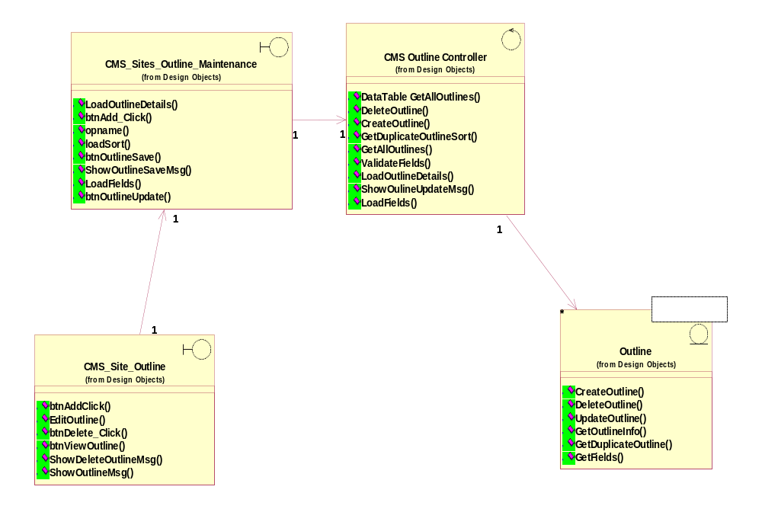

Static structure of CMS Site Maintenance Update Outline
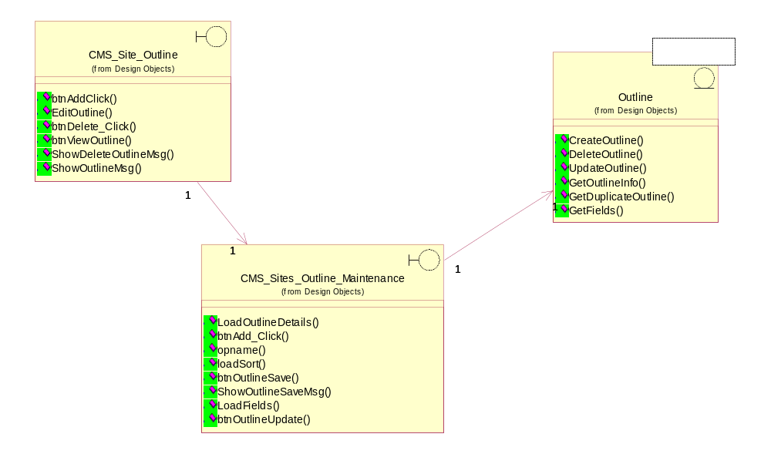

Static structure of CMS Site Maintenance Delete Outline
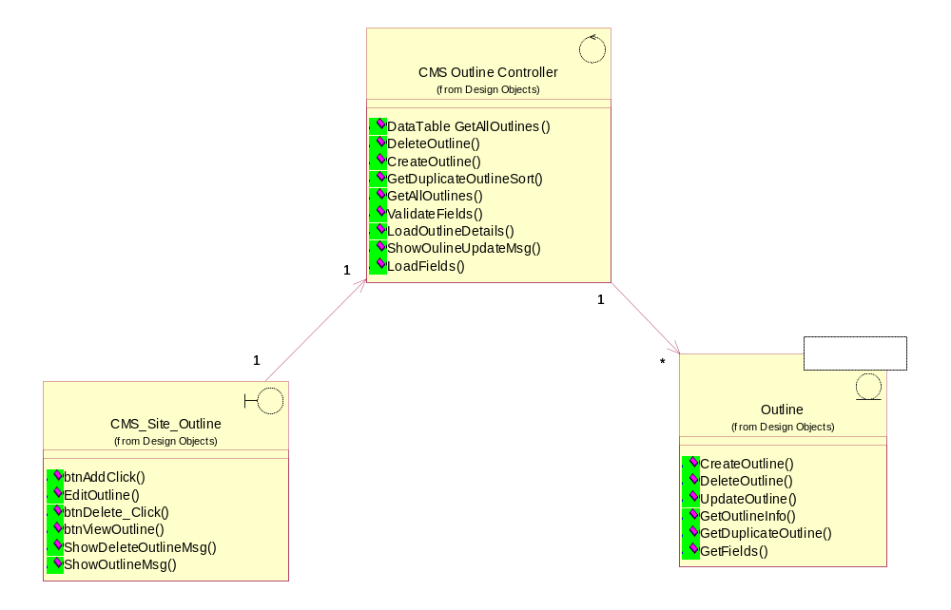

Static structure of CMS Site Maintenance View Outline

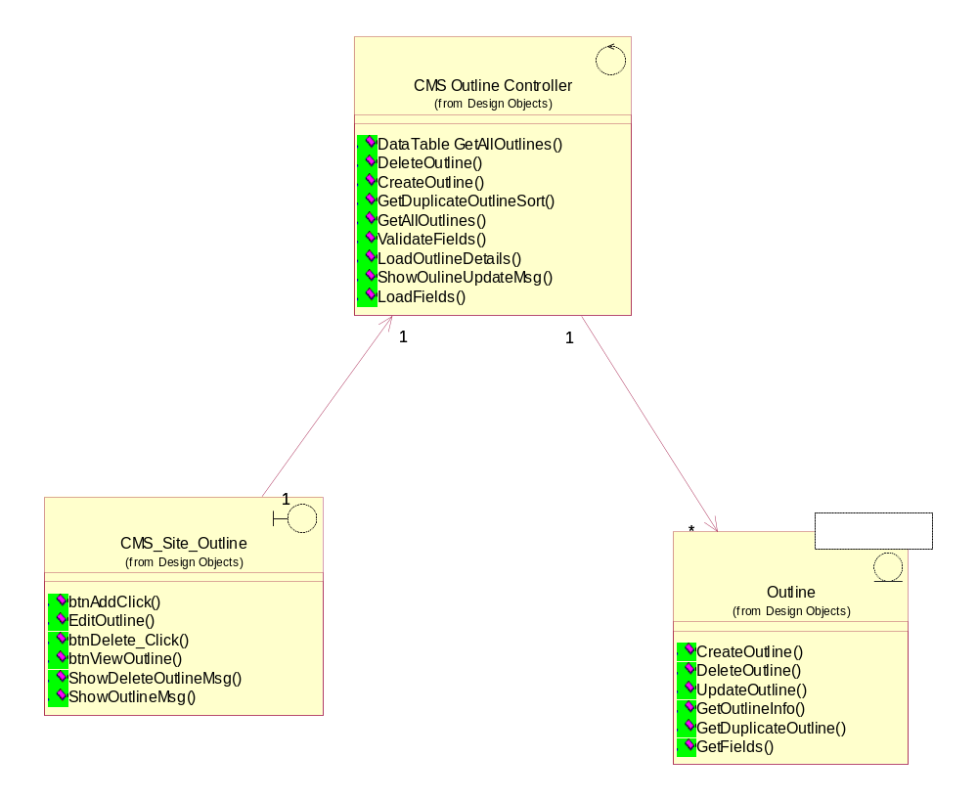

Static structure of CMS Site Outline Maintenance Add/Update/Delete & View Outline
Relationships:

Object Name: CMS_Site_Outline (Logical View::Design Model::Design Objects::Boundary::CMS_Site_Outline )

Kind of Relationship: Associations

Object Name: CMS_Sites_Outline_Maintenance (Logical View::Design Model::Design Objects::Boundary::CMS_Sites_Outline_Maintenance )

Kind of Relationship: Associations

Object Name: CMS_Outline_Controller (Logical View::Design Model::Design Objects::Controller::CMS_Outline_Controller )

Kind of Relationship: Associations

Object Name: Outline (Logical View::Design Model::Design Objects::Entity::Outline )

CMS_Site_Outline
Interfacing class where it handles the requests from the portal admin. Whenever the add outline, delete outline, update outline and view the outline operations initiated from portal admin will be handled in this class. Only for the update and creation of outline will be initiated first time the subsequent operations which are related to add and update outlines will be handled in different class. View and delete operations will be handled in CMS Site outline class.

Operations:
btnAddClick (object sender, EventArgs e) : void
Documentation: Button add click will re-directing the request to CMS Outline Maintenance interface object, all the mandatory fields information will be passed into CMS Outline Maintenance for creating the outline.

Parameters: object sender, EventArgs e

btnDelete_Click (object sender, EventArgs e) : void
Documentation: Button delete click will re-directing the request to CMS Outline Maintenance interface object, all the mandatory fields information will be passed into CMS Outline Maintenance for deleting the outline.

Parameters: object sender, EventArgs e

btnViewOutline (object sender, EventArgs e) : void
Documentation: Interface object which will be used to view the particular outline which is already created.

Parameters: object sender, EventArgs e

EditOutline (object sender, EventArgs e) : void
Documentation: Object will be re-directing the request to CMS Interfaces object once the portal admin clicks the Edit Outline. All the subsequent operations will be performed under CMS Sites Maintenance interface object.

Parameters: object sender, EventArgs e

ShowDeleteOutlineMsg (object sender, EventArgs e) : void
Documentation: When the outlines is getting deleted it shows the success or failure message to the interface object.

Parameters: object sender, EventArgs e

ShowOutlineMsg (): void
Documentation: Upon successful creation of the outline the success or failure message will be shown to interface object.

CMS_Site_Outline_Maintenance
Interfacing class where it directly communicates to the portal admin actor, for create outline and update outline after first operation subsequent operations will be performed in CMS Sites Outline Maintenance class.

btnAdd_Click (object sender, EventArgs e) : void
Documentation: Once the request come from CMS Site Outline the operation add or update of outline will be performed.

Parameters: object sender, EventArgs e

btnOutlineSave (object sender, EventArgs e) : void
Documentation: Once the request come from CMS Site Outline the operation add or update of outline will be performed.

Parameters: object sender, EventArgs e

btnOutlineUpdate object sender, EventArgs e () : void
Documentation: Once the request come from CMS Site Outline the operation add or update of outline will be performed.

Parameters: object sender, EventArgs e

LoadFields (string companyID, string siteID) : void
Documentation: Loading the details for the selected company

LoadOutlineDetails () : void
Documentation: Loading the outline details by calling GetAllOutlines().

loadSort () : void
Documentation: Sorting the outlines based on the sequence nos.

ShowOutlineSaveMsg () : void
Documentation: Upon successful creation of the outline the success message will be shown to the portal admin.

CMS_Site_Outline_Controller
CMS Site outline controller this class performing all the requests from interface objects and validating the outline inputs and based on the operation activity the outline details will be saved into the entity objects.

Operations:
DataTable GetAllOutlines (string siteID) : void
Documentation: All selected outline details will be fetched.

DeleteOutline (string siteID, string pageID) : void
Documentation: Deletes the outlines which are already created based on the parameter values.

Parameters: string siteID, string pageID

GetAllOutlines (siteID : String) : Byte
Documentation: Get All outlines will be used to get the details of the outline by passing the company id.

Parameters: siteID : String
Return Type : Byte

GetDuplicateOutlineSort (siteID : String, sortNum : String) : Byte
Documentation: This class return with all the duplicate outlines which is created for the particular site and page. The return value for the outline is data table and will be a sorted output.

Parameters: siteID : String, sortNum : String
Return Type : Byte

LoadFields (string companyID, string siteID) : void
Documentation: Loading the details for the selected company

Parameters: string companyID, string siteID

LoadOutlineDetails () : void
Documentation: This class is used to get all the outline details and will be loaded in the CMS Site Interface. Loading the outline details by calling GetAllOutlines().

ShowOulineUpdateMsg () : Byte
Documentation: Shows the success or failure message when the outline is getting updated successfully or deleted successfully.

Return Type : Byte

ValidateFields () : Boolean
Documentation: Java script which is being used across all the modules under cms, this is to perform the validation against input data.

CMS_Outline
This class is used to create the outline all the argument values will be passed to entity object.

Operations:
CreateOutline () : Integer
Documentation: This class is used to create the outline all the arugment values will be passed to entity object.

Parameters: siteID : String, pageName : String, remark : String, sortNum : String, isOutline : String, userName : String
Return Type : Integer

DeleteOutline (siteID : String, pageID : String) : Byte
Documentation: Delete outline will be performing the deletion operation of the outlines which is already created.

Parameters: siteID : String, pageID : String
Return Type : Byte

GetDuplicateOutline (siteID : String, pageName : String) : Integer
Documentation: This validates the if there is any duplicate outline exist for the given site id and page name

Parameters: siteID : String, pageName : String
Return Type : Integer
.

GetFields () : void
Documentation: Get all the fields values for the update operation for the selected site.

UpdateOutline (siteID : String, pageID : String, pageName : String, remark : String, sortNum : String, userName : String) : Integer
Documentation: Update outline will be used to update existing out lines which are already created

Parameters: siteID : String, pageID : String, pageName : String, remark : String, sortNum : String, userName : String
Return Type : Integer

CMS Page Maintenance

Static structure of CMS Site Maintenance Add Page

Static structure of CMS Site Maintenance Update Page

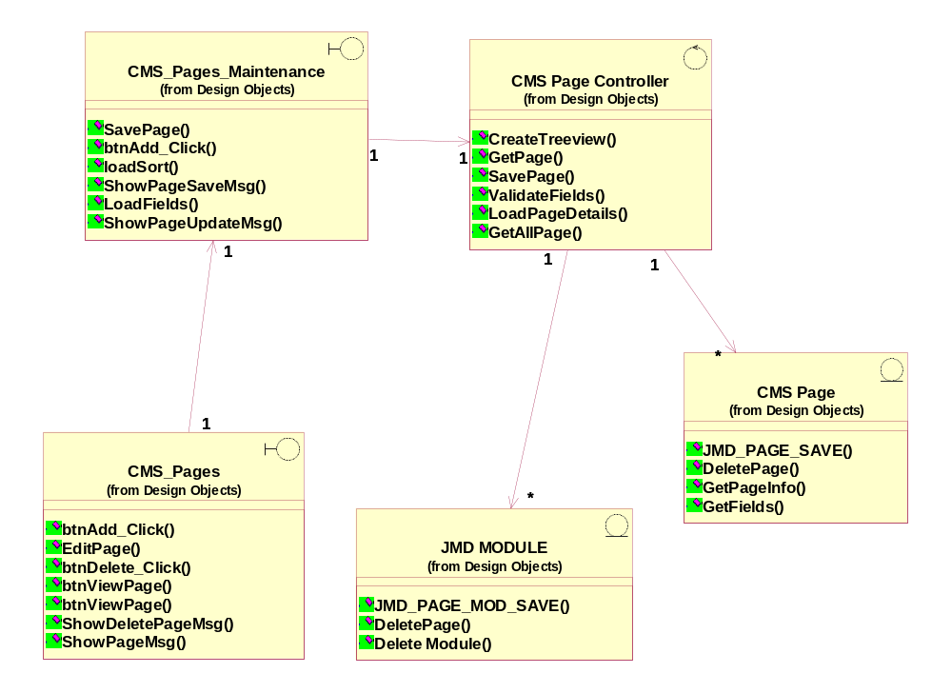

Static structure of CMS Site Maintenance Delete Page
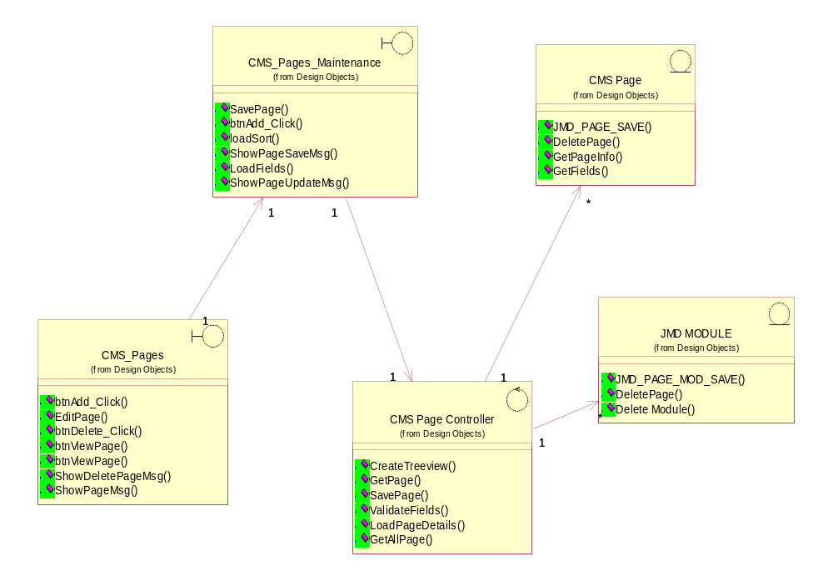

Static structure of CMS Site Maintenance View Page

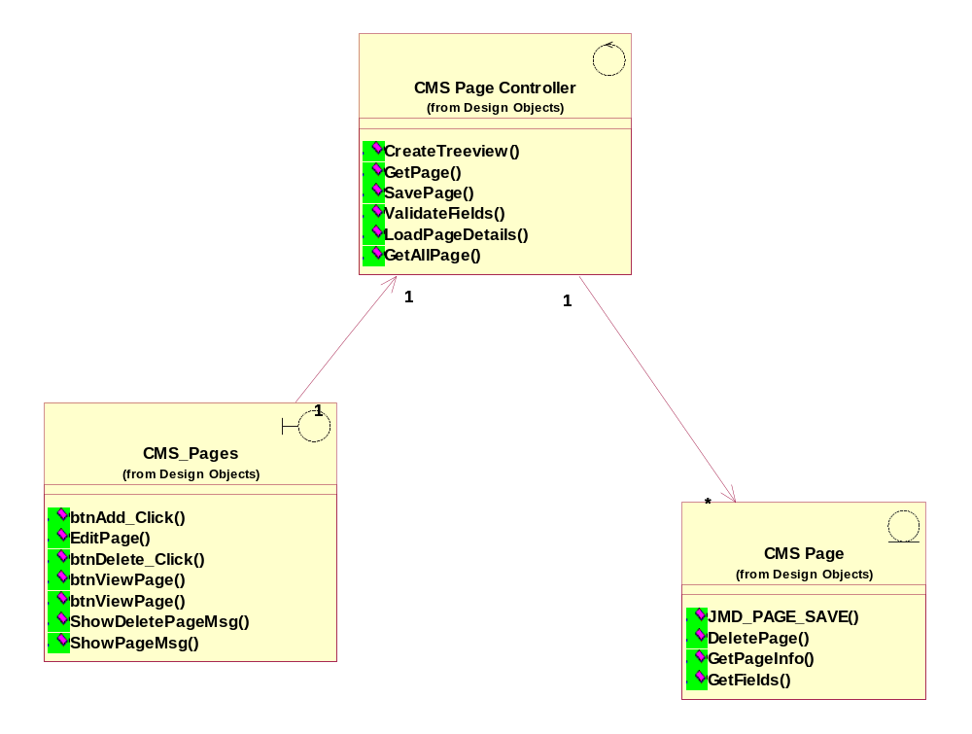

Static structure of CMS Site Page Maintenance Add/Update/Delete & View Page

Relationships:

Object Name: CMS_Site_Page (Logical View::Design Model::Design Objects::Boundary::CMS_Pages)

Kind of Relationship: Associations

Object Name: CMS_Sites_Pages_Maintenance (Logical View::Design Model::Design Objects::Boundary::CMS_Site_Pages_Maintenance )

Kind of Relationship: Associations

Object Name: CMS_Page_Controller (Logical View::Design Model::Design Objects::Controller::CMS_Page_Controller )

Kind of Relationship: Associations

Object Name: Outline (Logical View::Design Model::Design Objects::Entity::CMS_Page )
Kind of Relationship: Associations

Object Name: Outline (Logical View::Design Model::Design Objects::Entity::JMD_MODULE )
Kind of Relationship: Associations

CMS_Site_Page
CMS pages handles the request for Add, Update, Delete and View Pages. Delete and View operations will be initiated in this CMS Pages class

Operations:
btnAdd_Click (object sender, EventArgs e) : void
Documentation: Button add click will be redirecting the request to CMS Page Maintenance for Add or Update operation. All the subsequent operations which belong to interface will be performed thru CMS Page Maintenance.

Parameters: object sender, EventArgs e

btnDelete_Click (object sender, EventArgs e) : void
Documentation: Delete click performs the deletion operation based on the site id, page id and child page id value.

Parameters: object sender, EventArgs e

btnViewPage (object sender, EventArgs e) : void
Documentation: Peforms to show the page which is already created.

Parameters: object sender, EventArgs e

btnViewPage (object sender, EventArgs e) : void
Documentation: Peforms to show the page which is already created.

Parameters: object sender, EventArgs e

EditPage () : void
Documentation: Button EditPage will be redirecting the request to CMS Page Maintenance for Add or Update operation. All the subsequent operations which belong to interface will be performed thru CMS Page Maintenance.

ShowDeletePageMsg () : void
Documentation: Upon deleting the particular page the success or failure message will be shown to portal admin.

ShowPageMsg () : void
Documentation: Upon successful saving of the page information the success or failure message will be shown.

CMS_Site_Pages_Maintenance
Class which handles the request form CMS Pages for creating the page and updating the page and this operation can be performed upon creation of site, outline. All the subsequent operations for CMS Page maintenance will be handled in this class.

Operations:
btnAdd_Click (object sender, EventArgs e) : void
Documentation: Performs the add operation for the pages which is being created.

Parameters: object sender, EventArgs e

LoadFields (string companyID, string siteID) : void
Documentation: Loading the details for the selected company

loadSort () : void
Documentation: Performs the sorting of the pages which is being created.

SavePage () : void
Documentation: Invokes the business layer functions to save the page detail for the particular outline

ShowPageSaveMsg () : void
Documentation: Upon successful saving the message this class shows the status of the page save.

ShowPageUpdateMsg () : void
Documentation: Upon editing the particular page the status message will be shown.

CMS_Page_Controller
This controller class handles the requests from CMS page maintenance class for creating, updating, deleting and viewing the pages.

Operations:
CreateTreeview (siteID : String, pageID : String, childPageID : String, childSortNum : String, userName : String) : Integer
Documentation: Pefroms tree view creation for the pages which is being created for the particular site.

Parameters: siteID : String, pageID : String, childPageID : String, childSortNum : String, userName : String
Return Type : Integer

DuplicatePageName (siteID : String, pageName : String) : void
Documentation: Duplicate page to get the details while adding the page. This will be called internally.

GetAllPage (siteID : String, pageID : String) : Integer
Documentation: Selects the page information based on site id and page id.

Parameters: siteID : String, pageID : String
Return Type : Integer

GetPage (siteID : String, childPageID : String) : Byte
Documentation: This class will be retriving the page information for the given site id and child page id.

Parameters: siteID : String, childPageID : String
Return Type : Byte

LoadPageDetails () : void
Documentation: Loading the page detail which is already created in the system. Loading based on company name, site name, outline name, site id and page id.

SavePage () : void
Documentation: Saves the page detail.

UpdateTreeview (siteID : String, pageID : String, childPageID : String, childSortNum : String, userName : String) : Integer
Documentation: While performing the update of page update tree view called internally in order to update the tree.

Parameters: siteID : String, pageID : String, childPageID : String, childSortNum : String, userName : String
Return Type: Integer

ValidateFields () : void
Documentation: Java script which is being used across all the modules under cms, this is to perform the validation against input data.

CMS_Page
Class handles the requests from the controller in order to save or update or delete the pages.

Operations:
DeletePage (siteId : String, pageID : String, childPageID : String) : Integer
Documentation: This class will be performing the deletion operation for the given page.

GetFields () : void
Documentation:

JMD_PAGE_SAVE (pageId : String, siteURL : String, pageName : String, pageCaption : String, metaTitle : String, metaDesc : String, metaKeywords : String, parentPageName : String, isPublished : String, isRoot : String, isMenuItem : String, viewRoles : String, addRoles : String, editRoles : String, deleteRoles : String, moveRoles : String, addModuleRoles : String, isInternal : String, loadShared_Modules : String, pageSort : String, isViewStateEnabled : String) : Integer
Documentation: This class is used to save the page information into entity.

Parameters: pageId : String, siteURL : String, pageName : String, pageCaption : String, metaTitle : String, metaDesc : String, metaKeywords : String, parentPageName : String, isPublished : String, isRoot : String, isMenuItem : String, viewRoles : String, addRoles : String, editRoles : String, deleteRoles : String, moveRoles : String, addModuleRoles : String, isInternal : String, loadShared_Modules : String, pageSort : String, isViewStateEnabled : String
Return Type : Integer

JMD_MODULE

Operations:
Delete Module () : void
Documentation:

DeletePage () : void
Documentation:

JMD_PAGE_MOD_SAVE (Page_Mod_Id : String, Site_URL : String, Page_Name : String, Mod_Id : String, Mod_Title : String, Div_Id : String, Is_Published : String, Show_On_All_Pages : String, View_Role : String, Edit_Role : String, Delete_Role : String, Move_Role : String, Edit_Contents_Role : String, Mod_Sort : String) : void

Documentation: Class will be used to create the modules into entity object.

Parameters: Page_Mod_Id : String, Site_URL : String, Page_Name : String, Mod_Id : String, Mod_Title : String, Div_Id : String, Is_Published : String, Show_On_All_Pages : String, View_Role : String, Edit_Role : String, Delete_Role : String, Move_Role : String, Edit_Contents_Role : String, Mod_Sort : String
Approval Record DOCS/Forms/Approval
Project Name Content Management Portal
Document Ref CMP/DOCS/TS.2/1.0
Approved by Haiyang | Date
Authorised by | Date
The document authorisation appears on the title page. |  | ✔
The structure of the document is logical. |  | ✔
The distribution list is correct. |  | ✔
The title page is signed |  | ✔
Calculations appear reasonable, are neatly presented and have been checked. |  | ✔
Theory and formulae are correct and properly applied. |  | ✔
Illustrations are relevant, readable and logically placed. |  | ✔
There are no typographical errors. |  | ✔
Units are consistent throughout. |  | ✔
The security classification is correct. |  | ✔
There are no obvious omissions. |  | ✔
The document complies with the Client's requirements, however specified. |  | ✔
Responsibility is accepted for all opinions, conclusions and recommendations. |  | ✔
The document does not run counter to company policy. |  | ✔

