Content Management Portal (CMP) Project
User Manual

Document Reference: |  | CMP/DOCS/TU.1/
Project: |  | Content Management Portal (CMP)
Document Title: |  | User Manual
Version: |  | 2.0
Date: |  | 04 January 2010
Prepared/Revised by: |  | Haiyang Sui
Approved by :
 |  | Sui Haiyang |  | Date
 |  | Project Manager
 | © 2009  The information contained in this document is the property of ISS. The contents must not be copied in whole or in part for purposes other than which it has been supplied without the consent of ISS, or, if it has been furnished under contract to another party, as expressly authorised under that contract, then ISS shall not be liable for any errors or omissions. |  | 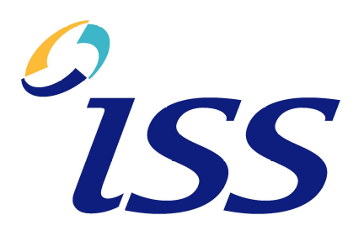
Institute of Systems Science, 25 Heng Mui Keng Terrace,
Singapore 119615

Version History Record
Version | Date | Brief description of amendments and affected pages, paragraph
1.0 | 01/01/10 | Draft Issue
1.1 | 02/01/10 | Changes done based on the review.
2.0 | 04/01/10 | Issue for submission

Distribution:
Name | Department | Organisation
ISS Audit | ISS | ISS
Sui Haiyang | Project Manager | ISS-SE16S07
Gao Jia Si Karen | Quality Manager | ISS-SE16S07
Yap Sie Kuok, Thomas | Testing Manager | ISS-SE16S07
May Ann Sallan | Database Designer | ISS-SE16S07
Rajendran Kumaraguru | System Architect | ISS-SE16S07
Thiyagarajan Ravikumar | Technical Lead | ISS-SE16S07

Contents
1. Introduction 6
2. ACS Module (Administration Control System) 7
2.1 Login Page 7
2.2 DAP (Data Access Profile) Manager 8
2.2.1 Introduction 8
2.2.2 DAP List 8
2.2.3 Add new DAP 8
2.2.4 Delete DAP 10
2.2.5 Update DAP 11
2.3 FAP Manager 12
2.3.1 Introduction 12
2.3.2 FAP List 13
2.3.3 Add new FAP 13
2.3.4 Delete FAP 15
2.3.5 Update FAP 16
2.4 Role Manager 17
2.4.1 Introduction 17
2.4.2 Role List 17
2.4.3 Add New Role 18
2.4.4 Delete Role 19
2.4.5 Update Role 20
2.5 User Admin Manager 21
2.5.1 Introduction 21
2.5.2 User Admin List 22
2.5.3 Add User Admin 22
2.5.4 Delete User Admin 24
2.5.5 Update User Admin 25
2.6 Company Manager 26
3.6.1 Introduction 26
3.6.2 Company List 27
3.6.3 Add New Company 27
3.6.4 Delete Company 29
3.6.5 Update Company 30
2.7 User Manager 31
2.7.1 Introduction 31
2.7.2 User List 31
2.7.3 Add New User 32
2.7.4 Delete User 33
2.7.5 Update User 34
3. CMS Module (Content Management System) 36
3.1 E-learning module maintenance 36
3.1.1 Introduction 36
3.1.2 Add e-learning module 36
3.1.3 Add e-learning Sections 37
3.1.4 Add E-Learning Page. 39
3.2 Update E-Learning Module 42
3.2.1 Update E-Learning Site 42
3.2.2 Update E-Learning Section 43
3.2.3 Update E-Learning Page 44
3.3 Delete E-Learning Module 46
3.3.1 Delete E-Learning Site 46
3.3.2 Delete E-Learning Section 47
3.3.3 Delete E-Learning Page 48
4. MCQ Module (Multiple Choice Question) 49
4.1 Introduction 49
4.2 Add Exam Module 50
4.2.1 Add Exam 50
4.2.2 Add Exam Section 51
4.2.3 Add Exam Question 52
4.3 Delete Exam Module 55
4.3.1 Delete Exam 55
4.3.2 Delete Exam Section 55
4.3.3 Delete Exam Question 57
4.4 Update Exam Module 58
4.4.1 Update Exam Module 58
4.4.2 Update Exam Section 59
4.4.3 Update Exam Question 60
4.5 Take Exam 62

Introduction
CMP (Content Management Portal) is an online learning portal, which provides an e-learning platform for various organizations. It consists of three main modules:
- ACS (Administration Control System), which manages the company profiles, user access rights, user profiles, administrator profiles of the system and
- CMS (Content Management System), a platform to manage the learning content process, and
- MCQ (Multiple Content Question), manage multiple question exams for the uploaded content
Three user levels are:
- Portal Administrator (Super user is in charge of the whole system. Only the staff from the organization setting up the system can be Portal Administrators. Portal Administrators are able to create User Administrator Profiles for each company.)
- User Administrator (Staff from the organization purchasing the service can be assigned with rights of User Administrator. User Administrators are able to create Users.)
- User (Users are the staff who access the system to take e-learning course and online exams.)
The diagram below summarizes the relationships among these three user levels:
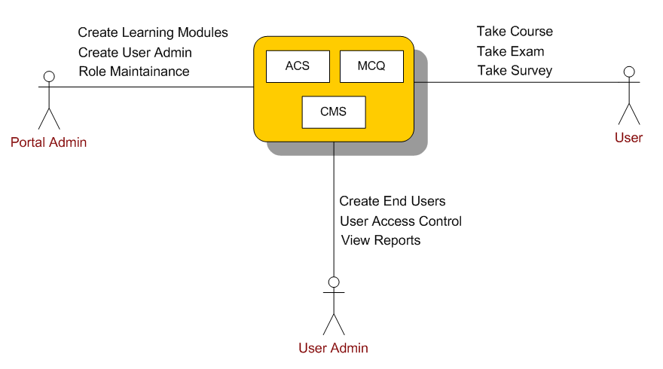

ACS Module (Administration Control System)

Login Page
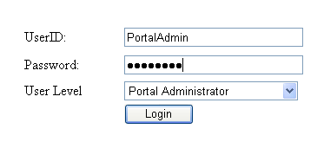
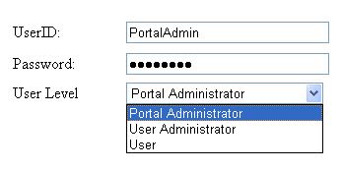
Description | User provides user id and password to log into the system.
Details | When launching the system, user needs to provide User ID, password, and select the user level to log into the system. Users need to choose one from three user levels: Portal Administrator, User Administrator, and User.

DAP (Data Access Profile) Manager

Introduction
Portal Administrator can add, delete, and update DAP (Data Access Profile), to control the access rights of User Administrators, i.e., to control how many modules (including e-learning modules and MCQ modules) a user administrator can access.

DAP List
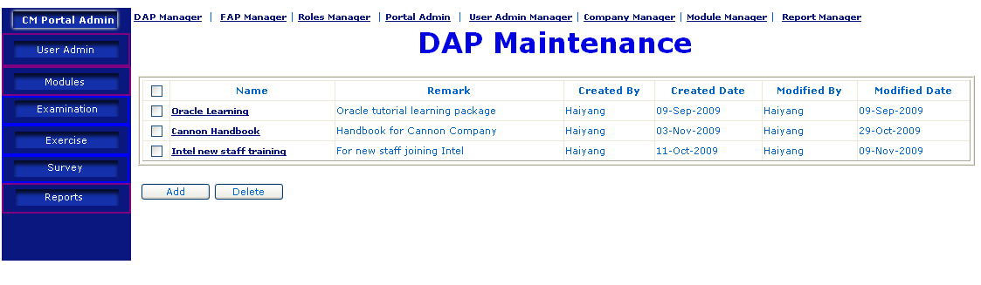
Description | List of DAP
Details | Show list of DAP available in the system. User can add, delete, update and view these DAPs.
Remark | Only Portal Administrator has access right to this feature.

Add new DAP
Clicking “Add” button, user will be able to add new DAP.
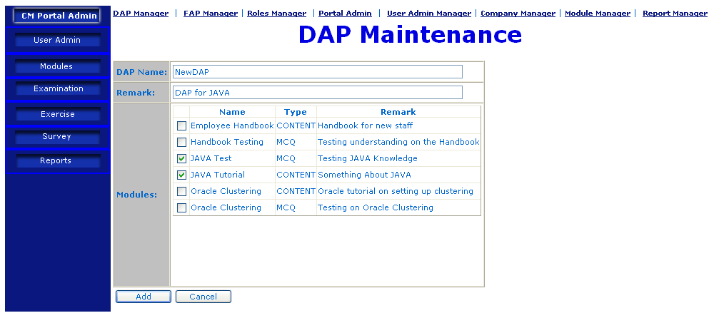
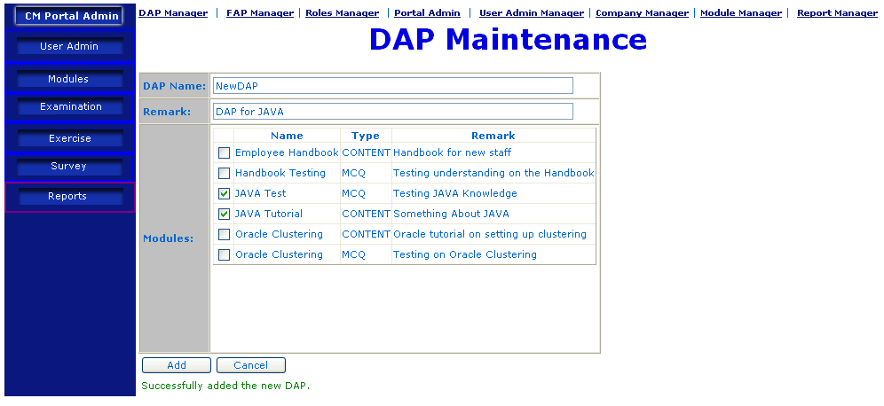
Description | Add new DAP
Details | - Clicking “Add” button in DAP List Page  - Before proceed for DAP Maintenance, portal admin should have created the content under CMS module in order to assign the Data Access Profiles to particular User Administrator. Once User Administrator has the DAP then it will be inherited to the users. “DAP Maintenance” page will be displayed, where user can add new DAP. User needs to provide DAP Name, Remark, and choose the modules to be included in this DAP.  - System will show the result of DAP addition.
Remark | Only Portal Administrator has access right to this feature.  The module type can be either “Content”, the e-learning modules; or “MCQ”, the multiple-choice exam modules.

Delete DAP
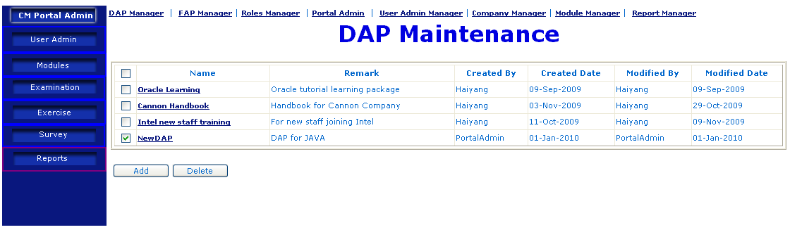
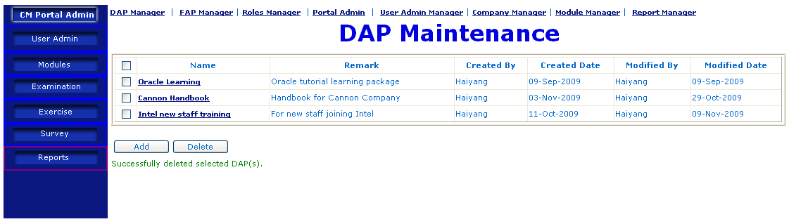
Description | Delete existing DAP
Details | - In “DAP List” page, choose the DAP(s) to be deleted by checking the checkbox(s) before DAP(s)  - Click “Delete” button.  - The chosen DAP(s) will be deleted. System will show the result of DAP deletion.
Remark | Only Portal Administrator has access right to this feature.

Update DAP
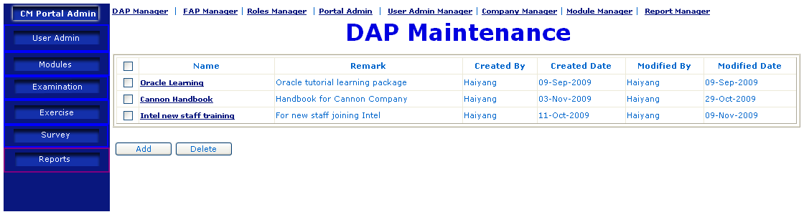
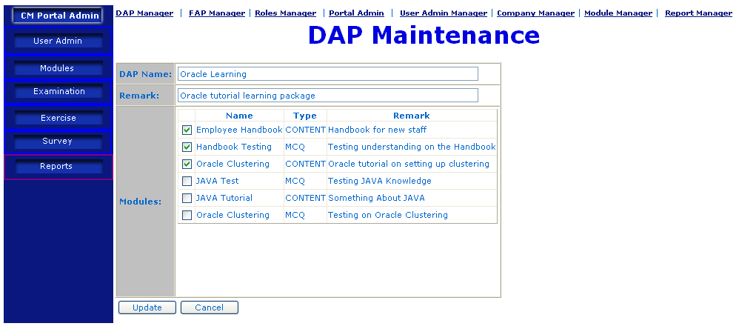
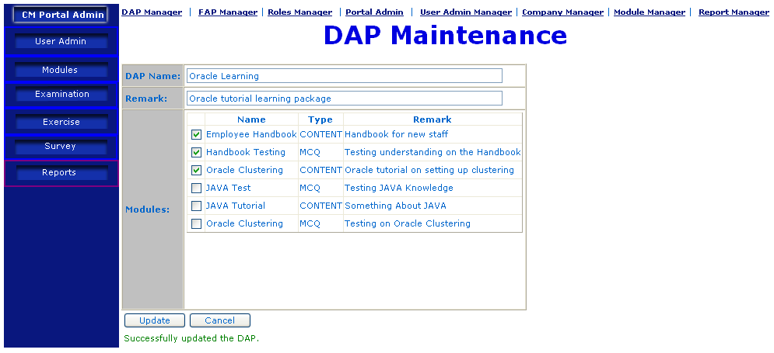
Description | Update existing DAP
Details | - In “DAP List” page, mouse over the DAP to be updated.  - “DAP Maintenance” page will be displayed. User can change the name, description, and the modules included in this DAP.  - User clicks the “Update” button, the DAP will be updated, and a message will be displayed to show the result of updating DAP.
Remark | Only Portal Administrator has access right to this feature.

FAP Manager

Introduction
Portal Administrator can add, delete, and update FAP (Functions Access Profile). FAP is to control the functions that users can utilize on the modules assigned to them. Functions are limited to:
- Take Exam
- Take Exercise
- Print Certification
- Create User Admin
- Create User
- Create Module

FAP List
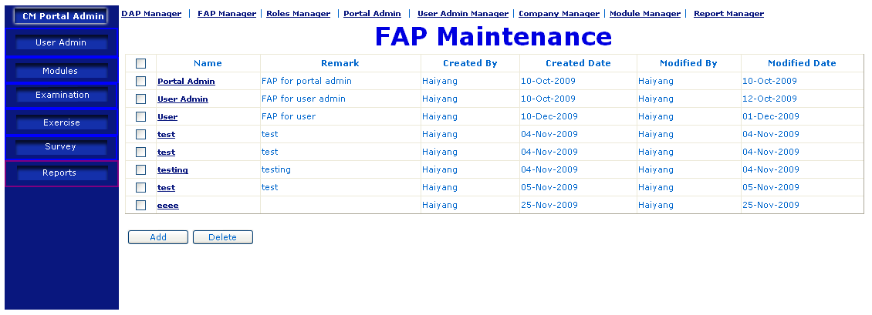
Description | FAP List
Details | - Clicking “FAP Manager”  - FAP List Page will be displayed, where users can Add, Delete, and Update FAP.
Remark | Only Portal Administrator has access right to this feature.

Add new FAP
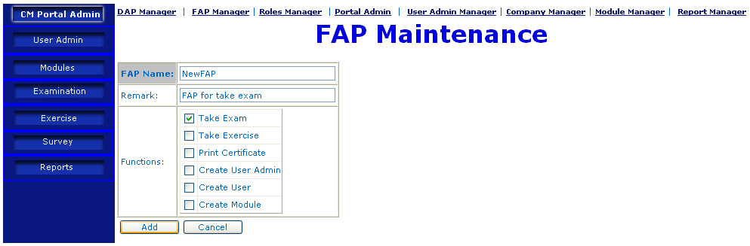
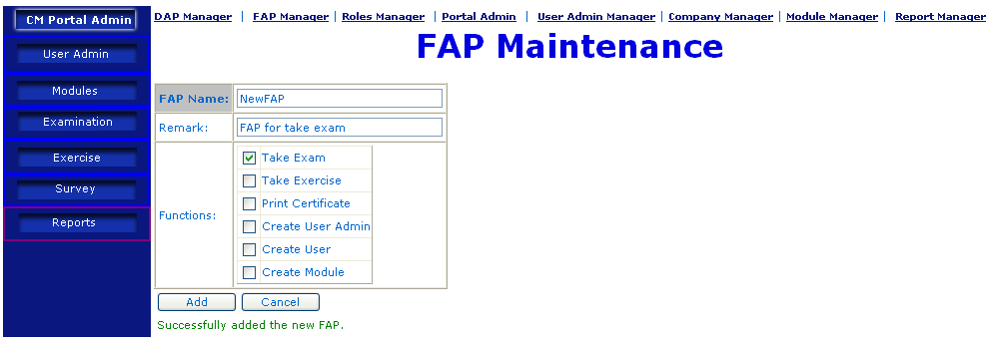
Description | Add new FAP
Details | - In FAP List Page, click “Add” button.  - “FAP Maintenance” page will be displayed, where user provides FAP Name, Remark, and choose the functions.  - After user clicking “Add” button, the new FAP will be added. A message will be shown to indicate the result of FAP addition.
Remark | Only Portal Administrator has access right to this feature.

Delete FAP
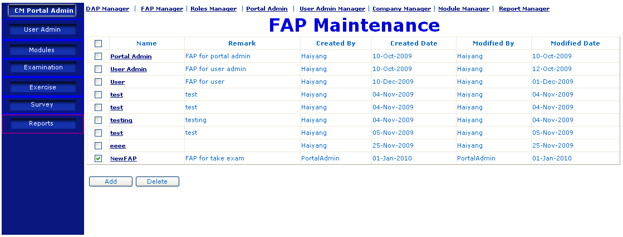
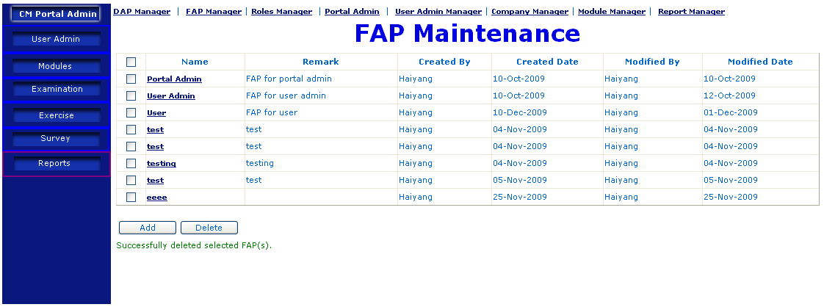
Description | Delete existing FAP
Details | - In FAP List Page, choose the FAP(s) to be deleted by checking the checkbox before FAP(s).  - After user clicks “Delete” button, system will delete selected FAP(s).  - A message will be displayed to show the outcome of FAP Deletion.
Remark | Only Portal Administrator has access right to this feature.

Update FAP
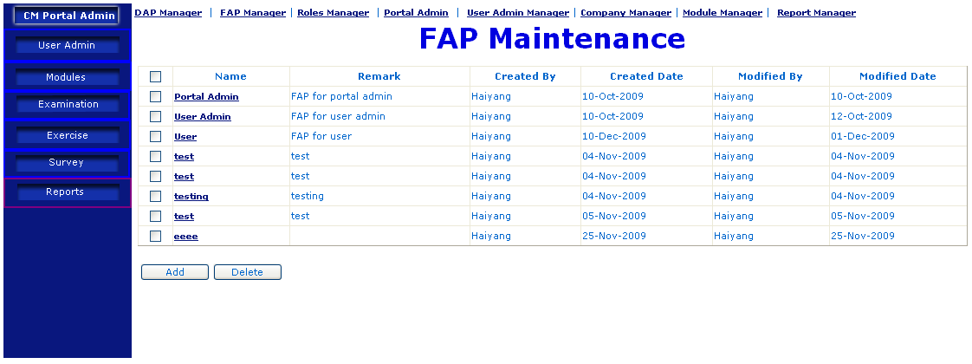
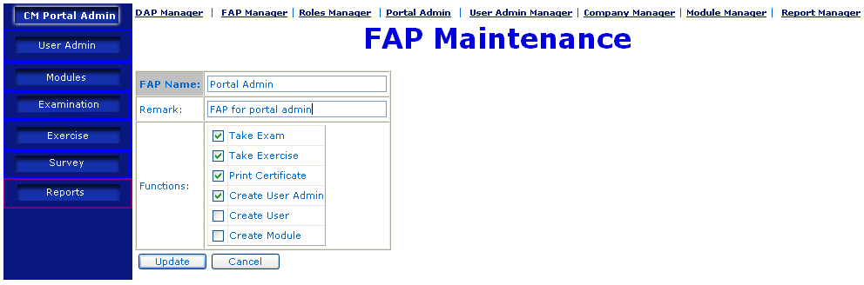
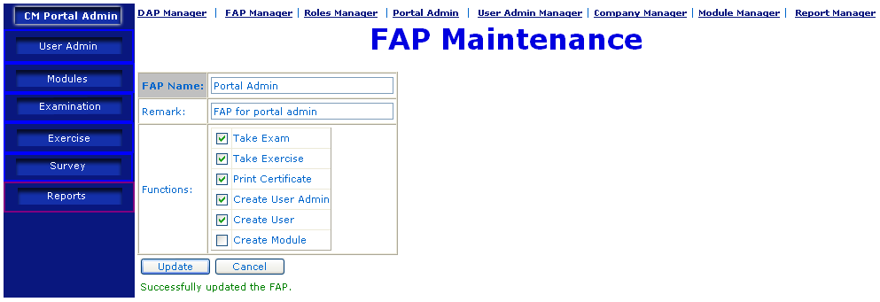
Description | Update existing FAP
Details | - In FAP List Page, mouse-over the FAP to be updated, click on the link.  - “FAP Maintenance” will be displayed, where users can update the FAP.  - After user clicks “Update” button, system will update the FAP, and a message will be displayed to show the outcome of FAP Updating.
Remark | Only Portal Administrator has access right to this feature.

Role Manager

Introduction
Role combines FAP and DAP, controls the modules user can access, and what functions the user can perform on these modules. Roles can be assigned to users and user administrators.

Role List
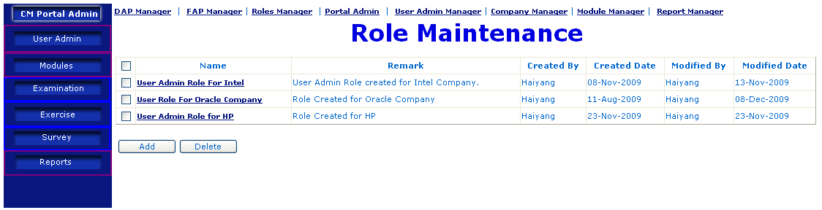
Description | Role List
Details | - By clicking “Roles Manager”, user will be able to view the list of existing Roles.  - User can create, delete, or update Roles.
Remark | Only Portal Administrator has access right to this feature.

Add New Role
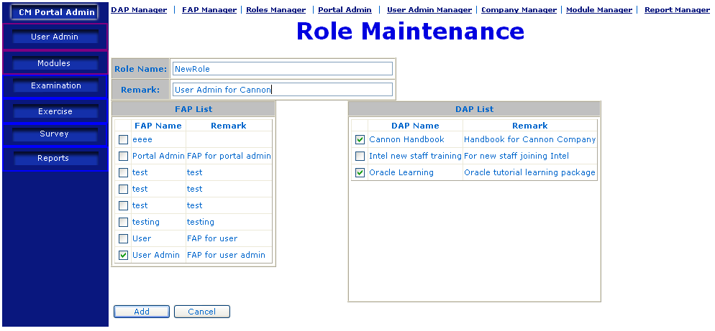
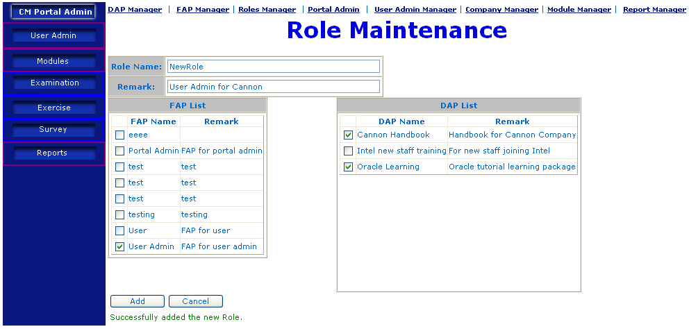
Description | Add New Role
Details | - User clicks “Add” button in Roles List Page.  - “Role Maintenance” page will be displayed, where user can add new role by providing Name, Remark, and choose appropriate FAP and DAP from respective list.  - User clicks “Add” button, a message will be displayed to show the output of Role Addition.
Remark | Only Portal Administrator has access right to this feature.

Delete Role
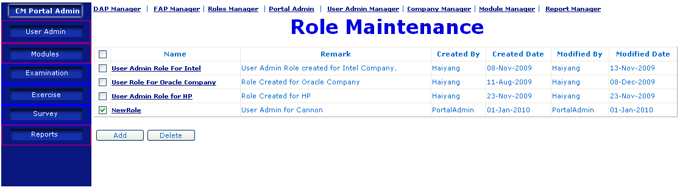
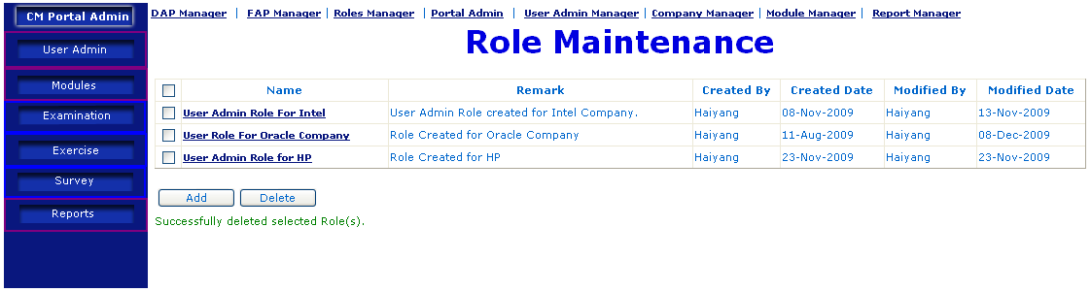
Description | Delete Existing Role
Details | - User chooses the Role(s) to be deleted by checking the checkbox(s) beside the Role(s).  - User clicks the “Delete” button, system will delete selected Role(s), and a message will be displayed to show the outcome of the Role Deletion.
Remark | Only Portal Administrator has access right to this feature.

Update Role
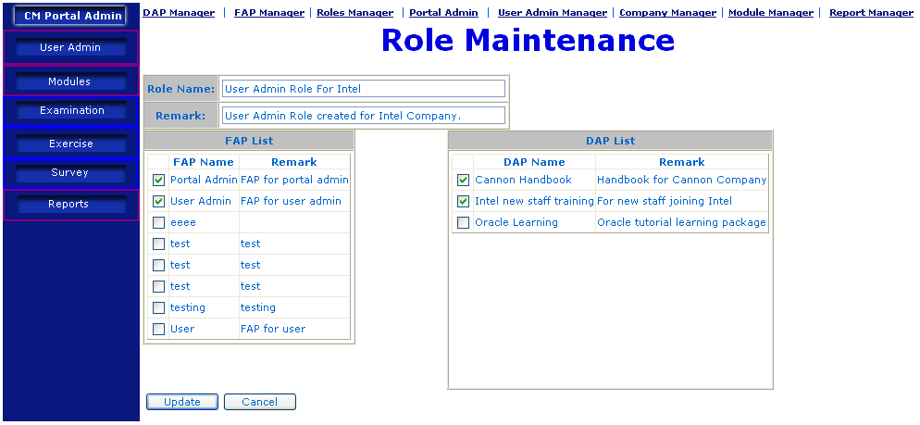
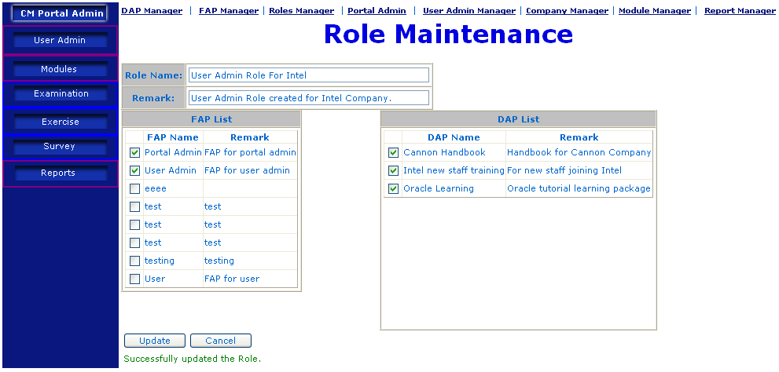
Description | Update Role
Details | - In Role List Page, User mouse-over the Role to be updated, and clicks the link.  - “Role Maintenance” page will be displayed, where user can change the name, remark, and the corresponding DAP and FAP.  - User clicks “Update” button, the role will be updated, and a message will be displayed to show the output of role updating.
Remark | Only Portal Administrator has access right to this feature.

User Admin Manager

Introduction
User Admin (User Administrator) is the staff from the organization that purchases the system for e-learning. “User Admin Manager” is used by Portal Admin to add, delete and update Users. All the users and user administrator will have the access until the expiry of subscription.

User Admin List
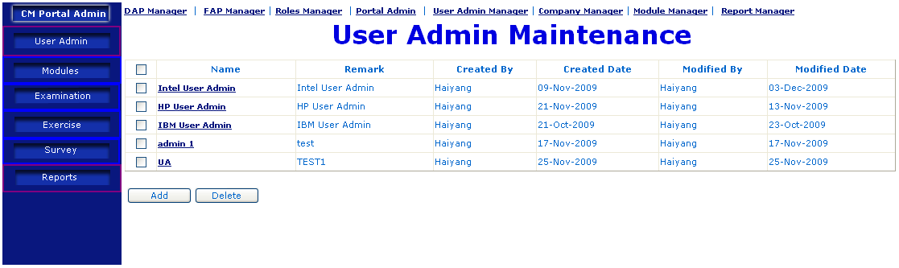
Description | User Admin List
Details | - User clicks the “User Admin Manager”, a list of User Admin will be displayed.
Remark | Only Portal Administrator has access right to this feature.

Add User Admin
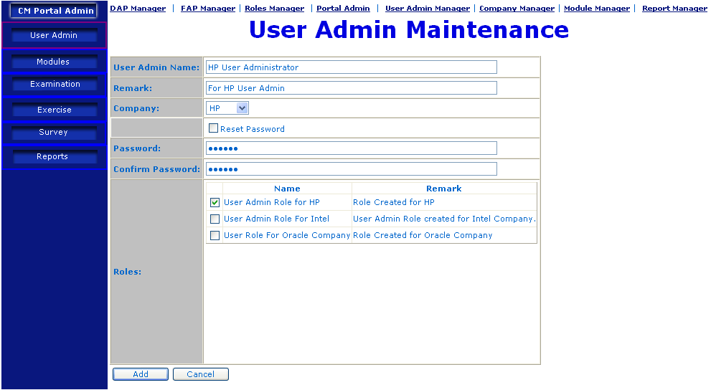
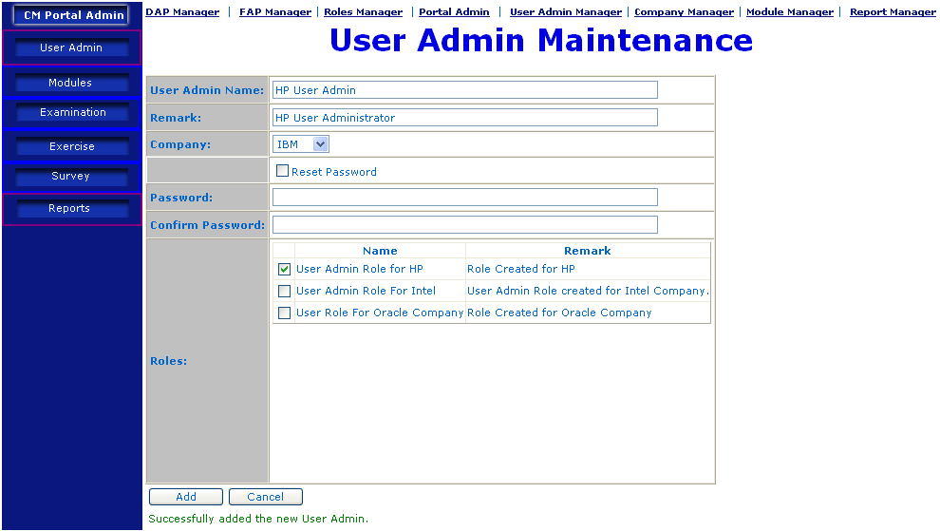

Description | Add New User Admin
Details | - From “User Admin List” page, user clicks “Add” button  - “Add User Admin” will be displayed, where user provides name, remark, company and select roles to assign to this user admin.  - After user clicks “Add” button, a new user admin will be created, and a message will be displayed to show the outcome of adding new user admin.  - Upon successful creation of User Admin, then the respective roles will have to be assigned to User Admin in order to access the system.
Remark | Only Portal Administrator has access right to this feature.

Delete User Admin
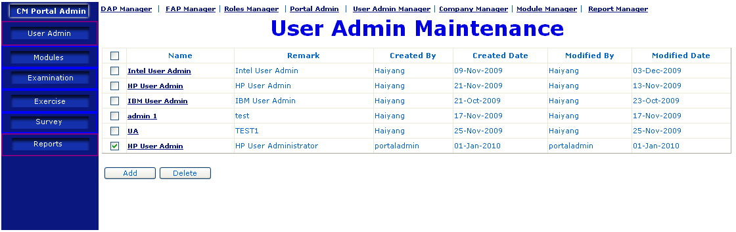
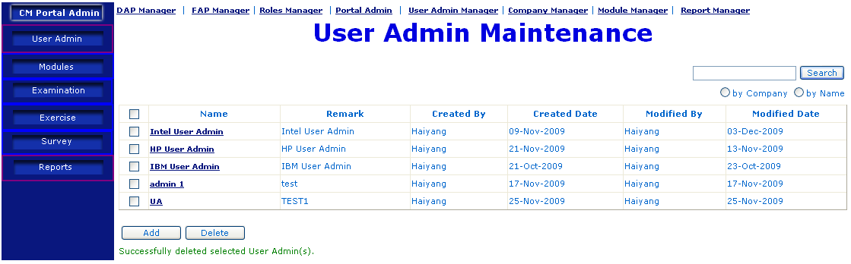
Description | Delete Existing User Admin
Details | - In “User Admin List” page, user can select the user admin(s) to be deleted by checking the checkbox besides the user admin(s).  - After user clicks “Delete” button, selected user admin(s) will be deleted, and a message will be displayed to show the outcome of user admin deletion.  - Once the user admin for the particular company is being deleted then users under User admin will be deleted automatically.
Remark | Only Portal Administrator has access right to this feature.

Update User Admin
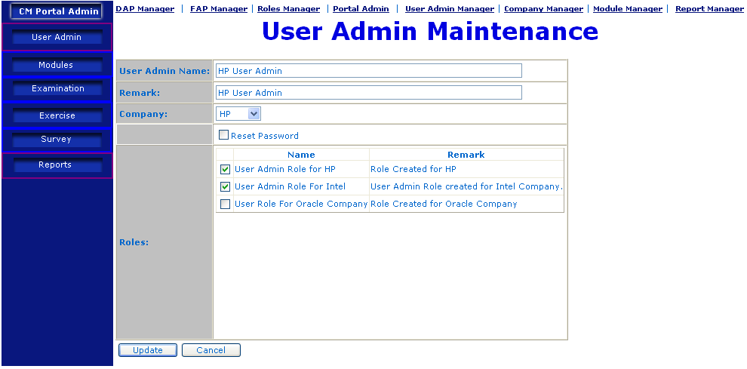
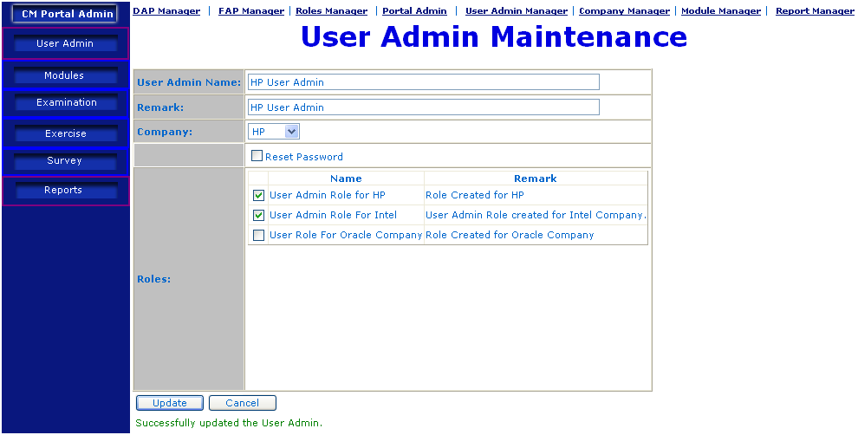
Description | Update User Admin
Details | - In “User Admin List” page, user mouse-over the user admin to be updated, and clicks the link.  - System will display the detail information of the user admin, where user can change the company, name, remark, and re-assign roles to it.  - After user clicks “Update” button, system will update the user admin, and a message will be displayed to show the outcome of user admin updating.
Remark | Only Portal Administrator has access right to this feature.

Company Manager

Introduction
Company Manager is to maintain the company purchasing the service. User can add, delete, and update company information in this feature. Only Portal Administrator has access right to this feature.

Company List
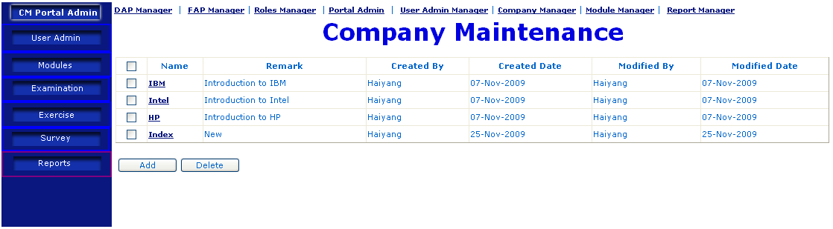
Description | Company List
Details | - User clicks the “Company Manager” link, a list of existing companies will be displayed, where user can add, delete, and update company information.
Remark | Only Portal Administrator has access right to this feature.

Add New Company
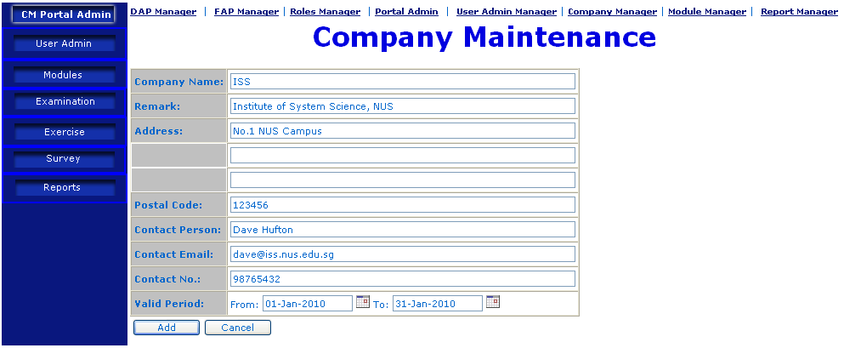
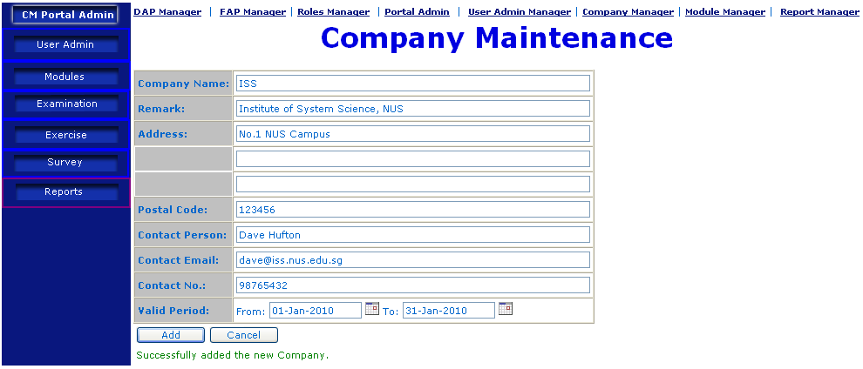
Description | Add New Company
Details | - In “Company List” page, user clicks the “Add“ button  - User needs to provide necessary information of the new company to be added, like name, remark, address, etc.  - A message will be displayed to show the outcome of adding company.
Remark | Only Portal Administrator has access right to this feature.

Delete Company
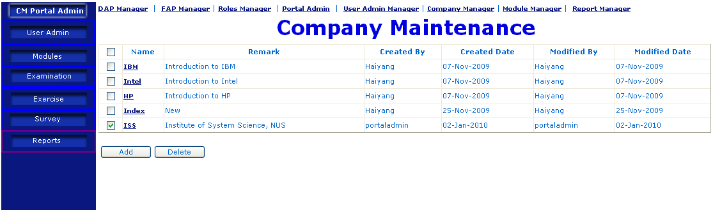
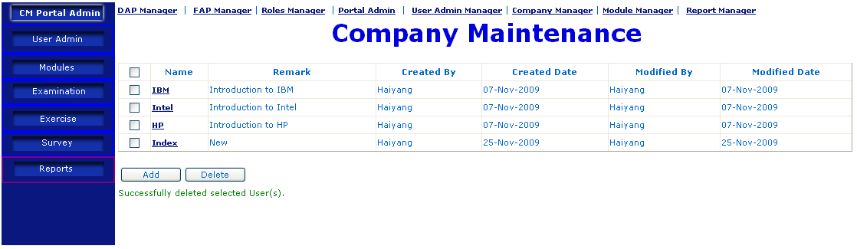
Description | Delete Company
Details | - In “Company List” page, user can select the Company(s) to be deleted by checking the checkbox besides the company(s).  - After user clicks “Delete” button, selected company(s) will be deleted, and a message will be displayed to show the outcome of company deletion.
Remark | Only Portal Administrator has access right to this feature.

Update Company
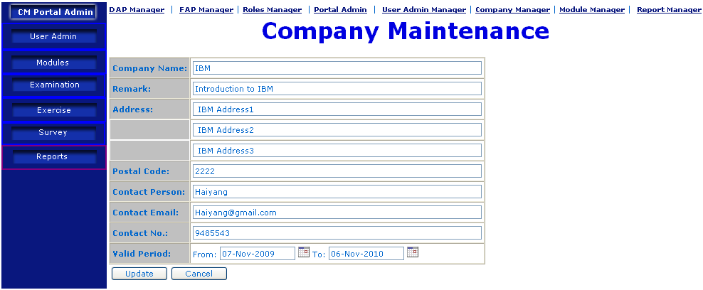
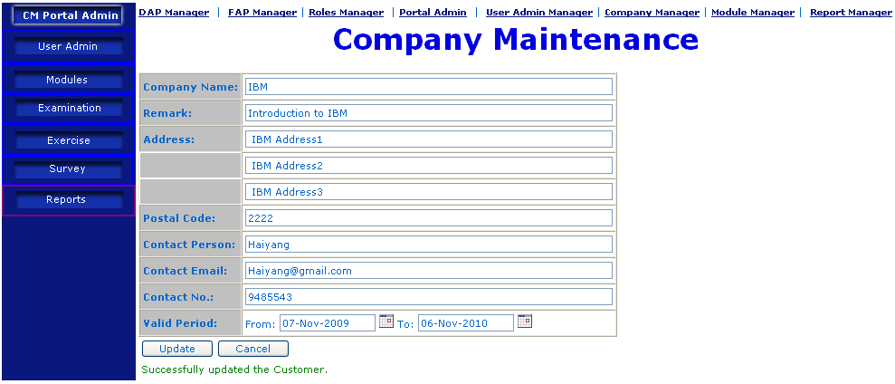
Description | Update Company
Details | - In “Company List” page, user mouse-over the company to be updated, and clicks the link.  - System will display the detail information of the company, where user can change the address, contact person, contact no, etc.  - After user clicks “Update” button, system will update the company, and a message will be displayed to show the outcome of company updating.
Remark | Only Portal Administrator has access right to this feature.

User Manager

Introduction
This feature is to maintain the users, who are the staff from organization that purchases the service. User admin can create, delete and update user information. Only user administrator has access right to this feature.

User List
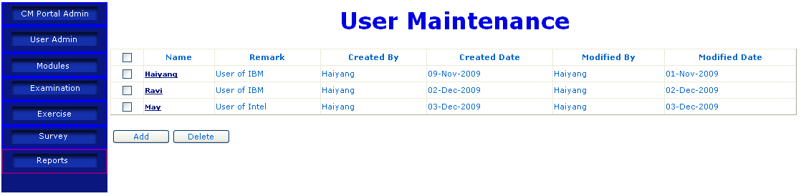
Description | User List
Details | - After logging into the system, user administrator will see a list of current users.
Remark | Only User Administrator has access right to this feature.

Add New User
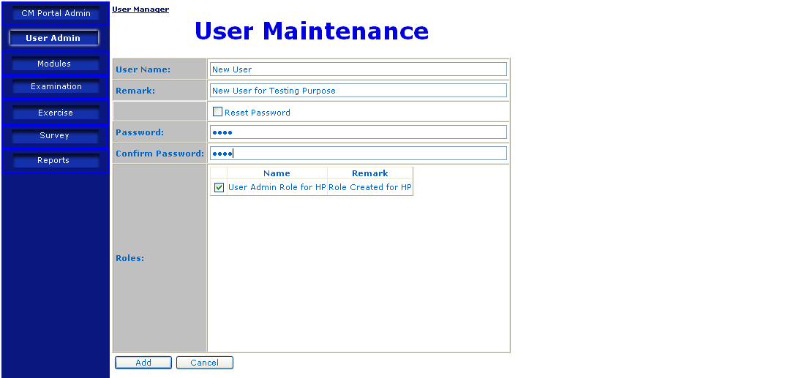
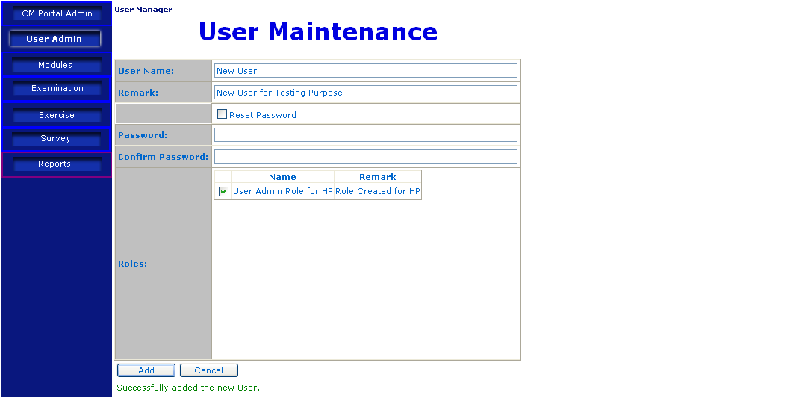
Description | Add New User
Details | - From “User List” page, user clicks “Add” button  - “Add User” will be displayed, where user provides name, remark, Password, and assign the roles to this new user. Note user admin can only assign those roles owned by him/her.  - After user clicks “Add” button, a new user will be created, and a message will be displayed to show the outcome of adding new user.
Remark | Only User Administrator has access right to this feature.

Delete User
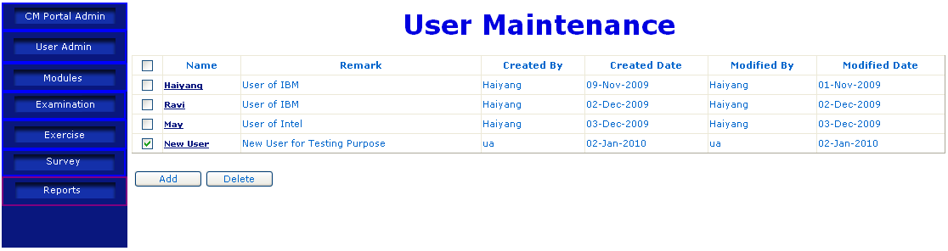
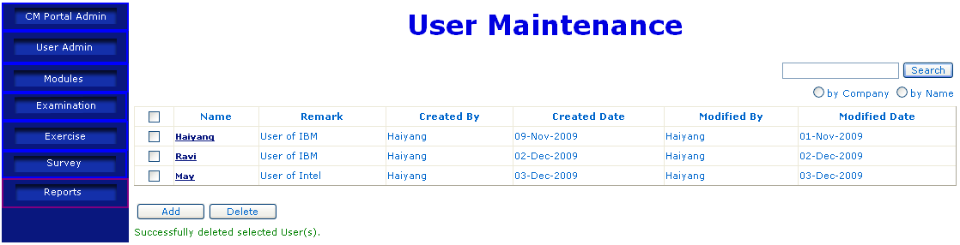
Description | Delete Existing User
Details | - In “User List” page, user can select the user(s) to be deleted by checking the checkbox besides the user(s).  - After user clicks “Delete” button, selected user(s) will be deleted, and a message will be displayed to show the outcome of user deletion.
Remark | Only User Administrator has access right to this feature.

Update User
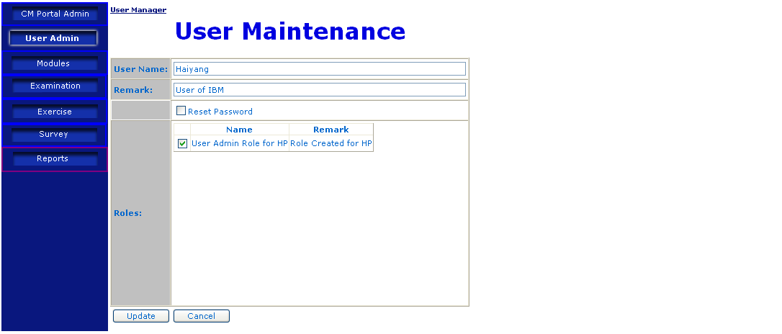
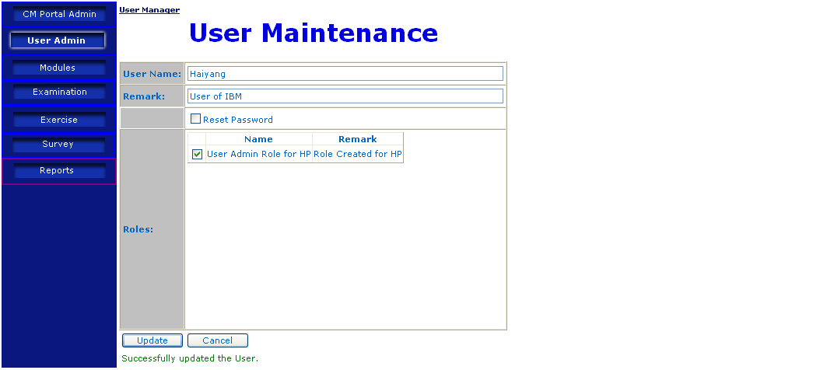
Description | Update User
Details | - In “User List” page, user mouse-over the user to be updated, and clicks the link.  - System will display the detail information of the user, where user can change the name, password and re-assign roles to it.  - After user clicks “Update” button, system will update the user, and a message will be displayed to show the outcome of user updating.
Remark | Only User Administrator has access right to this feature.

CMS Module (Content Management System)

E-learning module maintenance

Introduction
Maintaining an e-learning module is equivalent to maintaining a website, which is specially designed for each organization purchasing the service. Such a website consists of a series of content pages, which are used by portal admin to upload the learning content. Only Portal Administrator has the access right to this module.

Add e-learning module
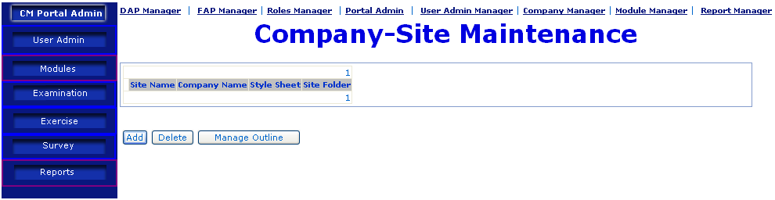
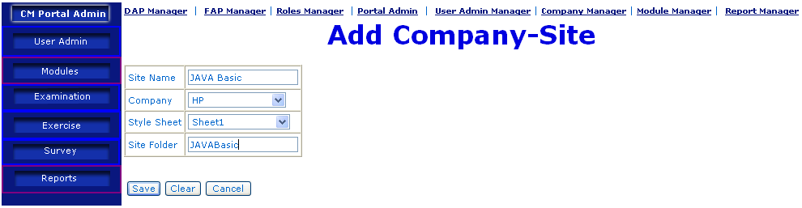
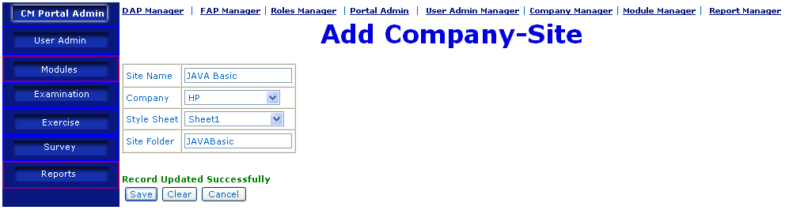
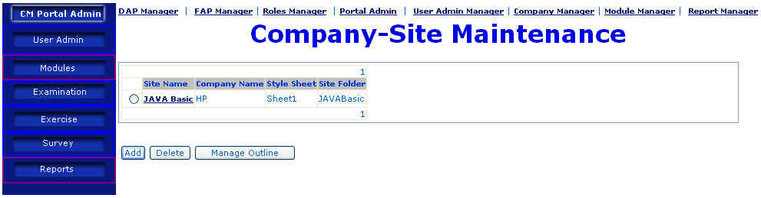
Description | Add E-Learning Module
Details | - User clicks the menu “Modules” on the left, a list of modules are displayed.  - User clicks the “Add” button, page “Add Company-Site” will be displayed, where user provides name, company, stylesheet and folder name. One company site is one learning module, and one learning module consists of many sections.  - After providing all the required information, user clicks the “Save” button, the new module will be created, with a message showing the outcome of module addition.  - “Company-Site Maintenance” page will be displayed, with the new module in the list.
Remark | Only Portal Administrator has access right to this feature.

Add e-learning Sections
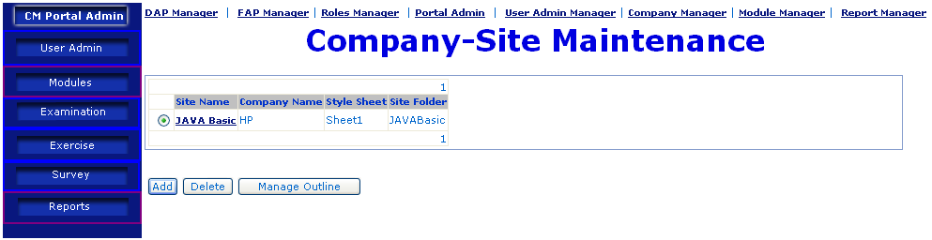
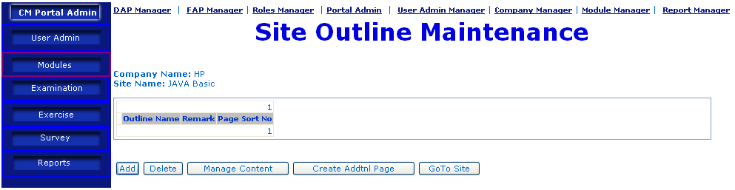
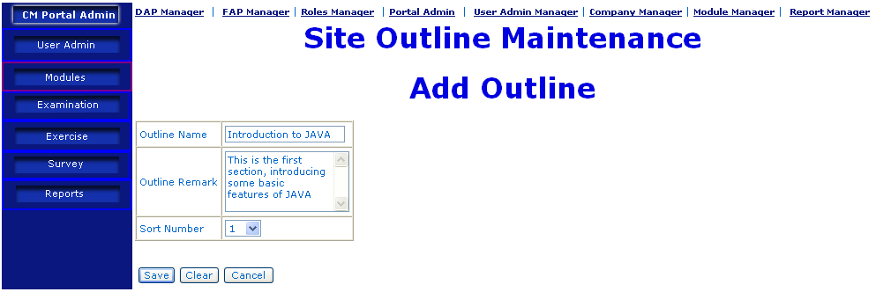
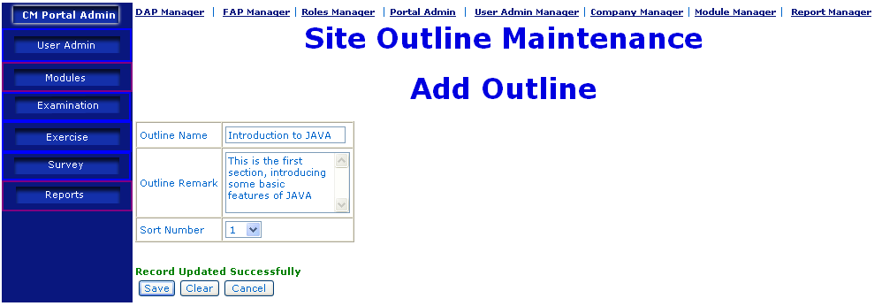
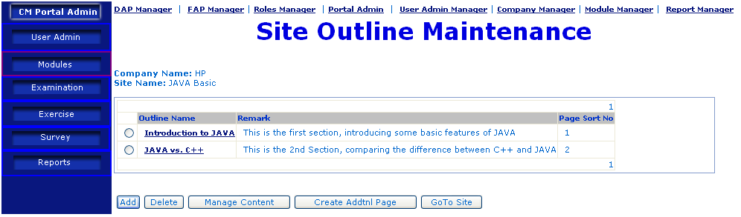
Description | Add E-Learning Section
Details | - Firstly, user needs to select the e-learning module site by checking the radio button besides the site. User clicks the “Manage Outline” button to go to next page.  - In “Site Outline Maintenance”, user clicks “Add” button, a detail page will be displayed, where user provides name, remark, and define the order of the section, i.e. the 1st, 2nd, 3rd….  - After providing all the required information, user clicks the “Save” button, the new section will be created, with a message showing the outcome of section addition.  - Repeating steps 1 to 3, add other sections accordingly.
Remark | Only Portal Administrator has access right to this feature.

Add E-Learning Page.
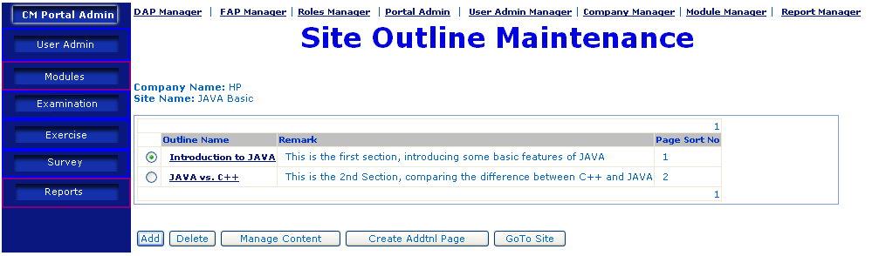
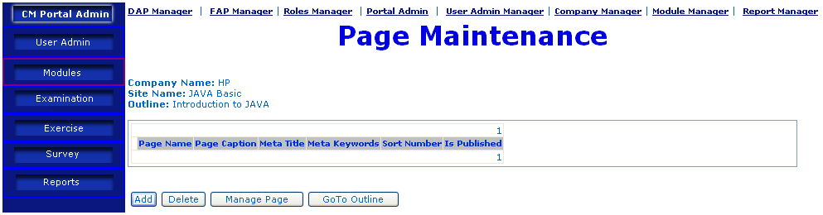
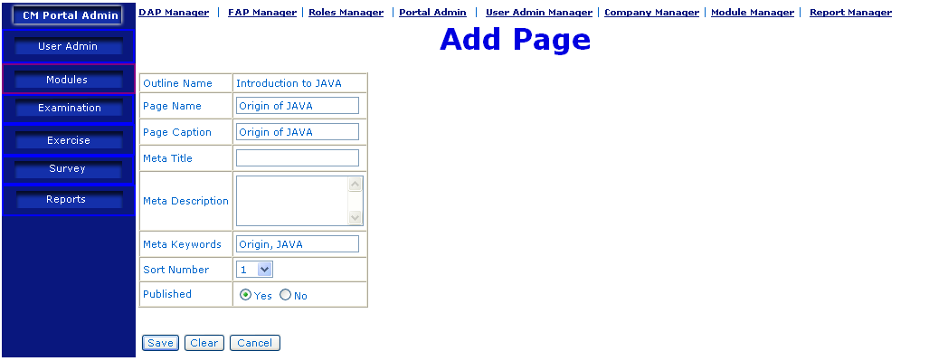
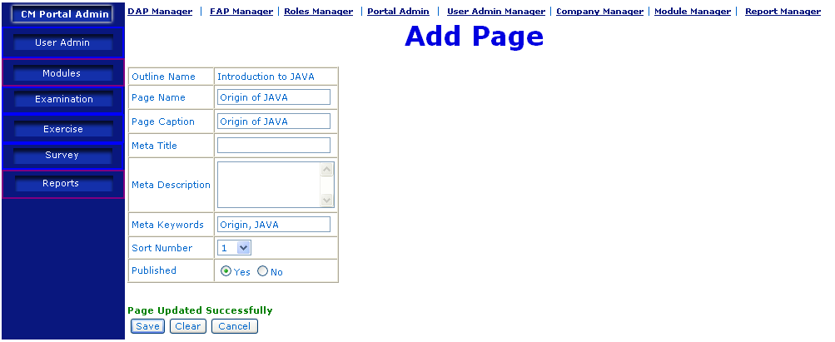
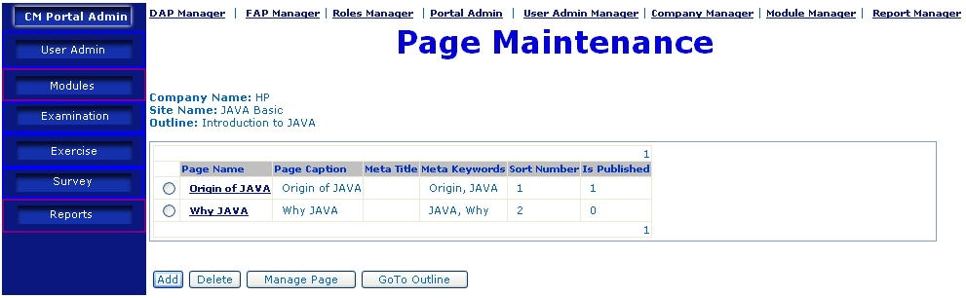
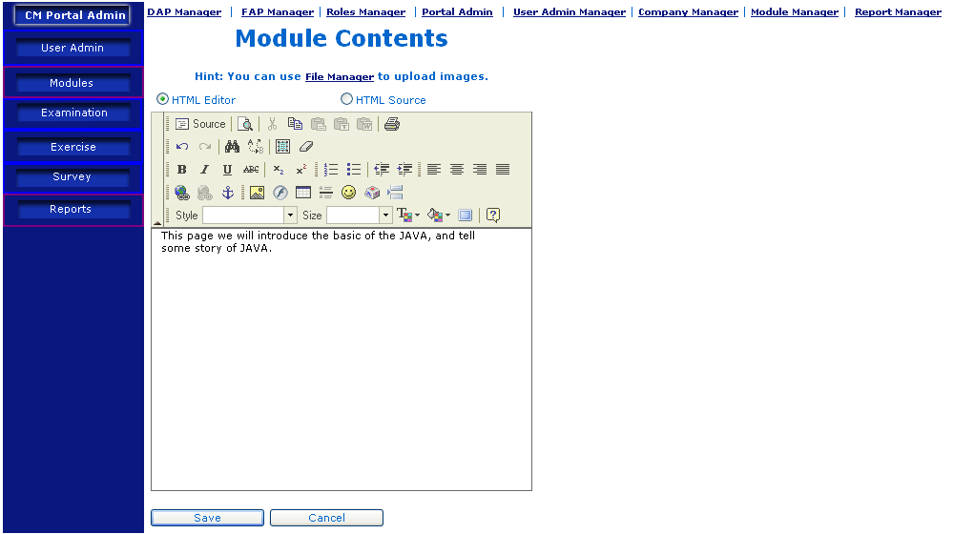
Description | Add E-Learning Page
Details | - User checks the checkbox before the section, then clicks “Manage Content” button.  - A list of pages will be displayed. User clicks “Add” button to create new page.  - User provides necessary information for the new page, like name, caption, Meta, and the order of the page, like 1st,2nd, 3rd….. Meta information will be used for searching.  - User clicks “Save” button, the new page will be created, and a message will show the outcome of the page addition.  - User can either type in, copy & paste, or upload the content of the page.  - User clicks the “Save” button to save the page content.
Remark | Only Portal Administrator has access right to this feature.

Update E-Learning Module

Update E-Learning Site
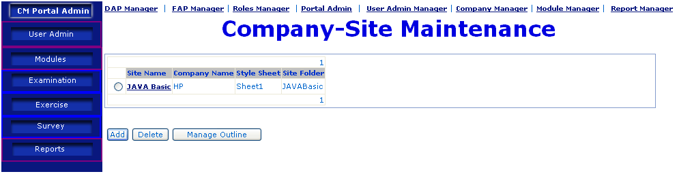
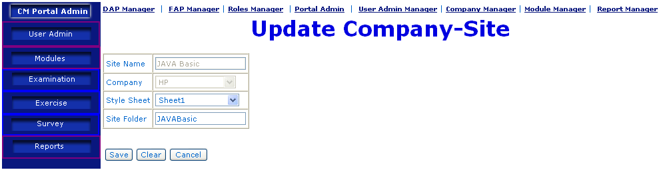
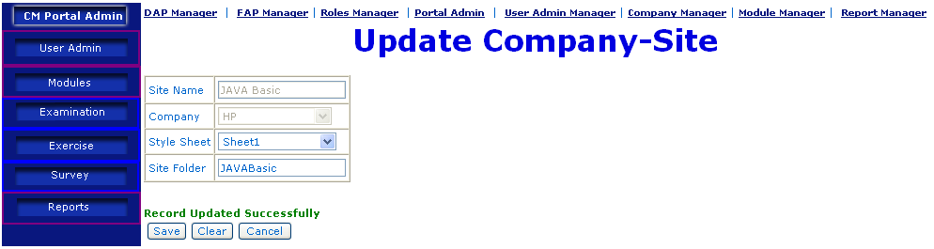
Description | Update E-Learning Site
Details | - In E-Learning Site List, user mouse-over the Site to be updated, and clicks the link.  - System will display the detail information of the site, where user can change the stylesheet and the folder name.  - After user clicks “Save” button, system will update the site, and a message will be displayed to show the outcome of site updating.
Remark | Only Portal Administrator has access right to this feature.

Update E-Learning Section
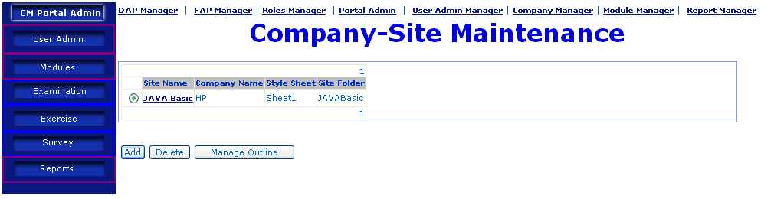
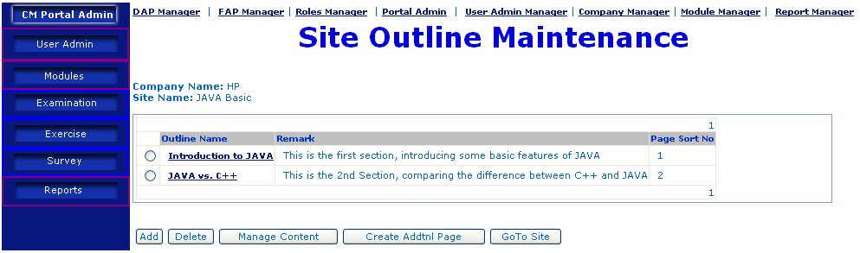
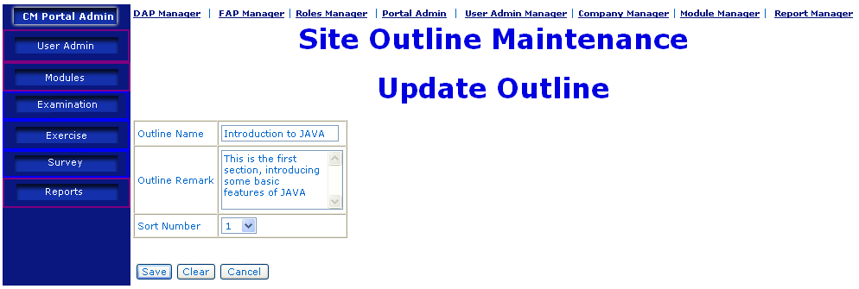
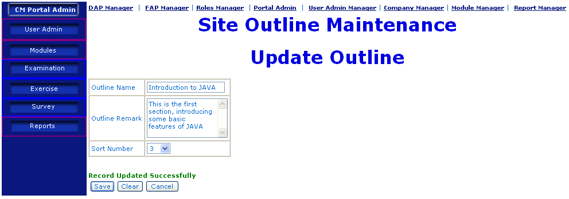
Description | Update E-Learning Section
Details | - In “E-Learning Site List” page, user choose the site to be modified by checking the radio button besides the site, and clicks “Manage Outline” button.  - A list of sections will be displayed. User needs to mouse-over the name of the section to be modified, then clicks the link.  - System will display the information of the section, where user can update the name, remark, and the sort order.  - After user clicking the “Save” button, the section will be updated, and a message will be displayed to show the outcome of section updating.
Remark | Only Portal Administrator has access right to this feature.

Update E-Learning Page
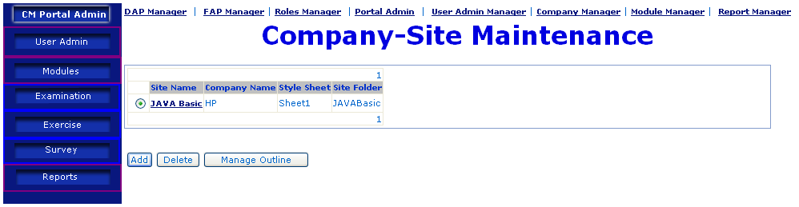
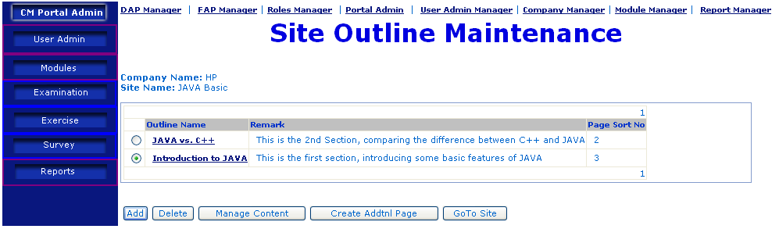
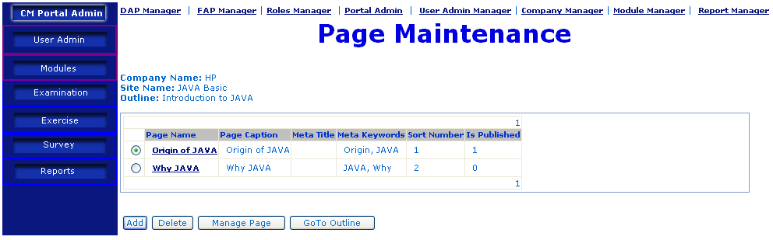
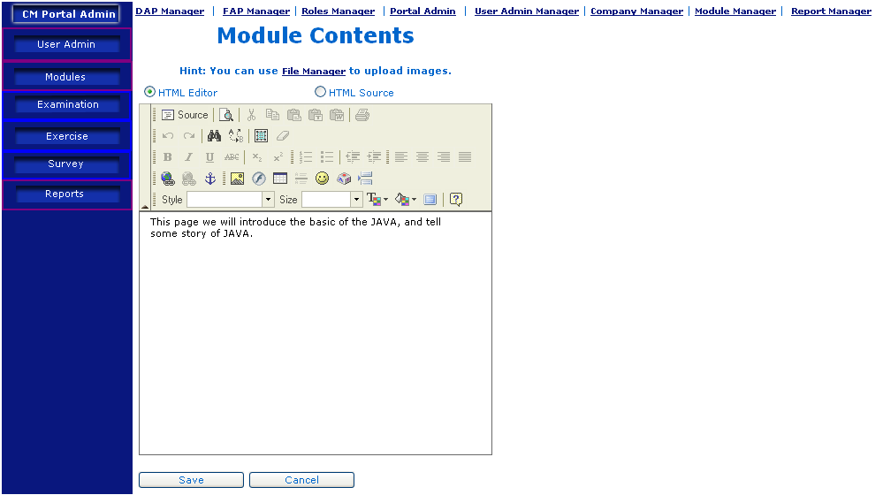
Description | Update E-Learning Page
Details | - In “E-Learning Site List” page, user choose the site to be modified by checking the radio button besides the site, and clicks “Manage Outline” button.  - A list of sections will be displayed. User selects the section to be modified by checking the radio button besides the section, then clicks “Manage Content” button.  - A list of E-Learning pages will be displayed. User selects the page to be modified by checking the radio button besides the page, then clicks “Manage page” button.  - The content of the page will be displayed; user can modify the content, and then clicks “Save” button to save the content.
Remark | Only Portal Administrator has access right to this feature.

Delete E-Learning Module

Delete E-Learning Site
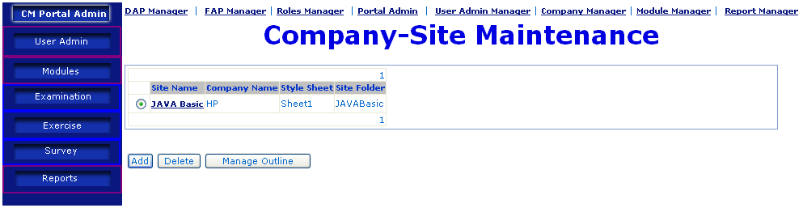
Description | Update E-Learning Site
Details | - In “E-Learning Site List” page, user choose the site to be deleted by checking the radio button besides the site, and clicks “Delete” button.  - The E-Learning Site will be deleted, and a message will be displayed to show the outcome of the site deletion.
Remark | Only Portal Administrator has access right to this feature.

Delete E-Learning Section
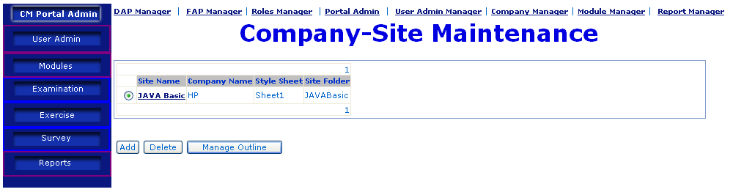
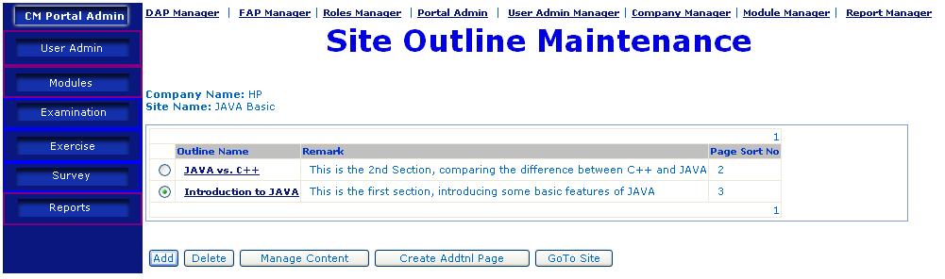
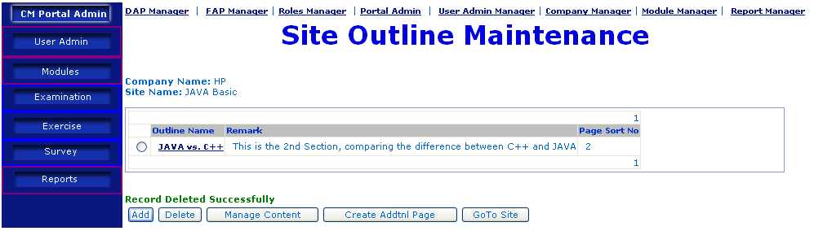
Description | Delete E-Learning Section
Details | - In “E-Learning Site List” page, user choose the site containing the section to be deleted by checking the radio button besides the site, and clicks “Manage Outline” button.  - A list of sections will be displayed. User selects the section to be deleted by checking the radio button besides the section, then clicks “delete” button.  - The section will be deleted, and a message will be displayed to show the outcome of the section deletion.
Remark | Only Portal Administrator has access right to this feature.

Delete E-Learning Page

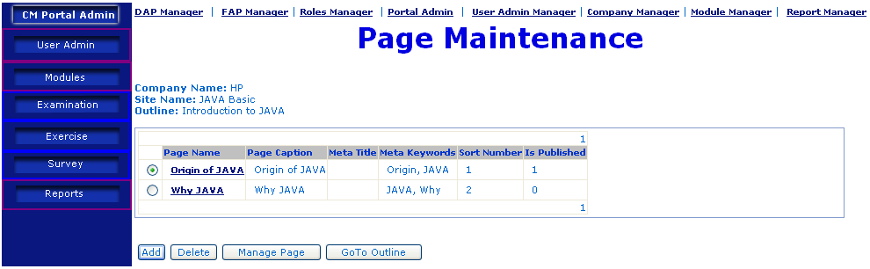
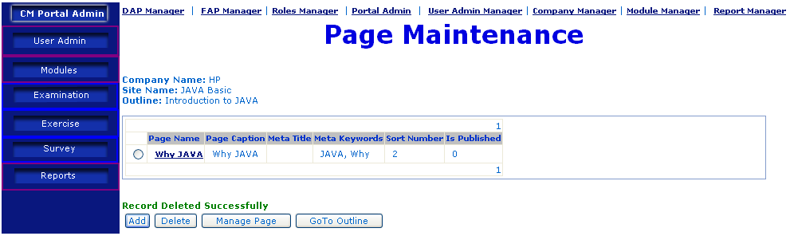
Description | Delete E-Learning Page
Details | - In “E-Learning Site List” page, user choose the site containing the page to be deleted by checking the radio button besides the site, and clicks “Manage Outline” button.  - A list of sections will be displayed. User selects the section containing the page to be deleted by checking the radio button besides the section, then clicks “Manage Content” button.  - A list of E-Learning pages will be displayed. User selects the page to be deleted by checking the radio button besides the page, then clicks “Delete” button.  - The page will be deleted, and a message will be displayed to show the outcome of the page deletion.
Remark | Only Portal Administrator has access right to this feature.

MCQ Module (Multiple Choice Question)

Introduction
One Exam Module consists of one or more Exam Sections, which consist of one or more Exam Questions. When user takes exam, the system will randomly pick questions from a pool of exam questions, according to some pre-defined criteria, like the question level (easy or hard), No. of the questions etc.

Add Exam Module

Add Exam
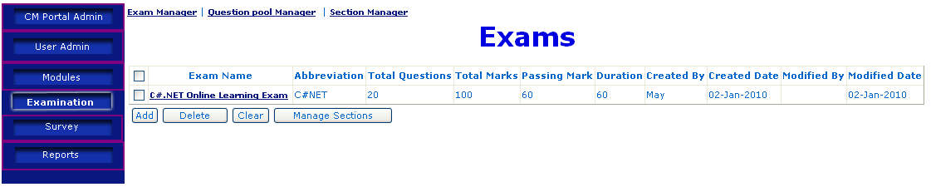
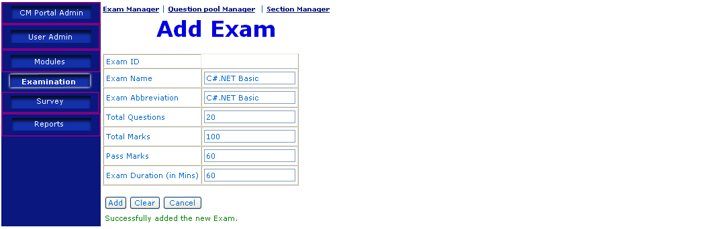
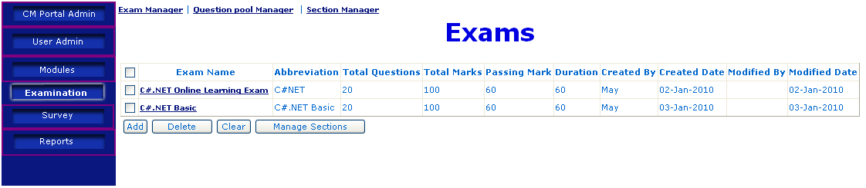
Description | Add Exam
Details | - User clicks the menu “Examination” on the left, a list of existing exams are displayed.  - User clicks the “Add” button, page “Add Exam” will be displayed, where user provides Name, total questions, total marks etc.  - After providing all the required information, user clicks the “Add” button, the new Exam will be created, with a message showing the outcome of Exam addition.  - User clicks “Cancel” button, “Exam List” page will be displayed, with the new exam in the list.
Remark | Only Portal Administrator has access right to this feature.

Add Exam Section
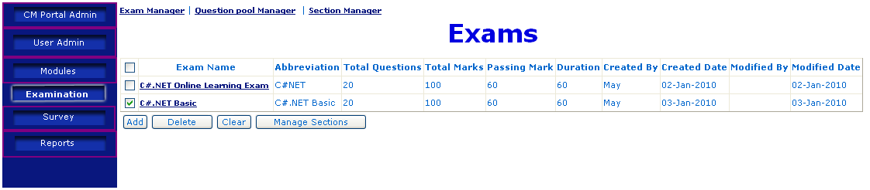
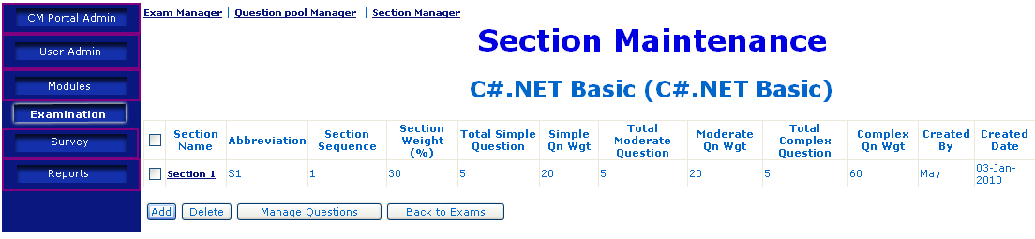
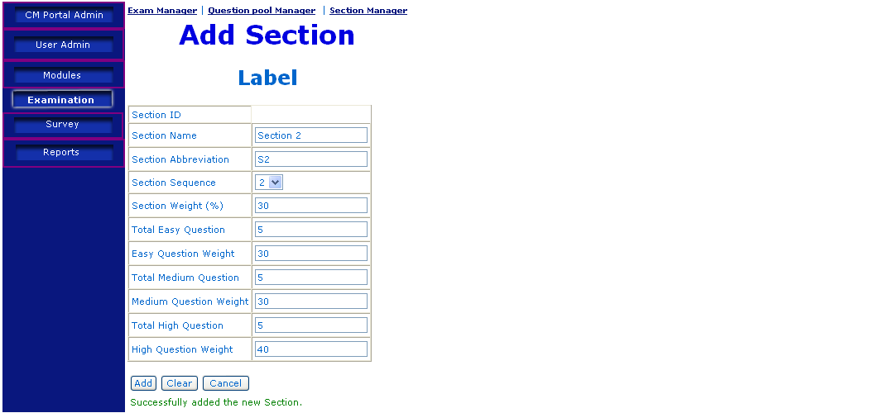
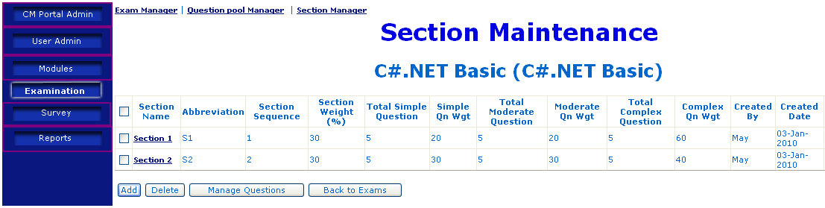
Description | Add Exam Section
Details | - User clicks the menu “Examination” on the left, a list of existing exams are displayed.  - Use checks the checkbox before the exam that to add new section to, then clicks “Manage Section” button.  - A list of existing sections will be displayed. User clicks “Add” button to go to “Add Section” page.  - User provides all the necessary information of the exam section, like the question level and number of questions, and the weight of each level.  - User clicks “Add” button, the new section will be added, and a message will be displayed to show the outcome of the section addition.  - User clicks “Cancel” button, “Exam Section List“ page will be displayed, with the new section in the list.
Remark | Only Portal Administrator has access right to this feature.

Add Exam Question
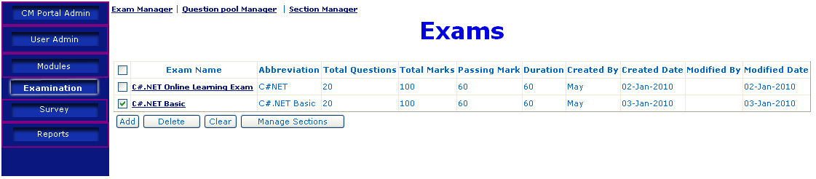
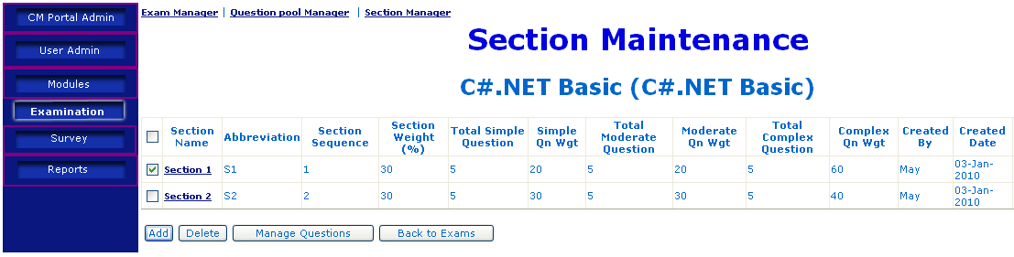
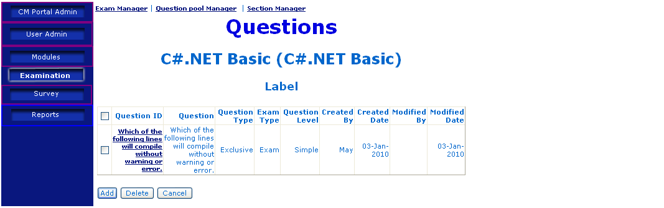
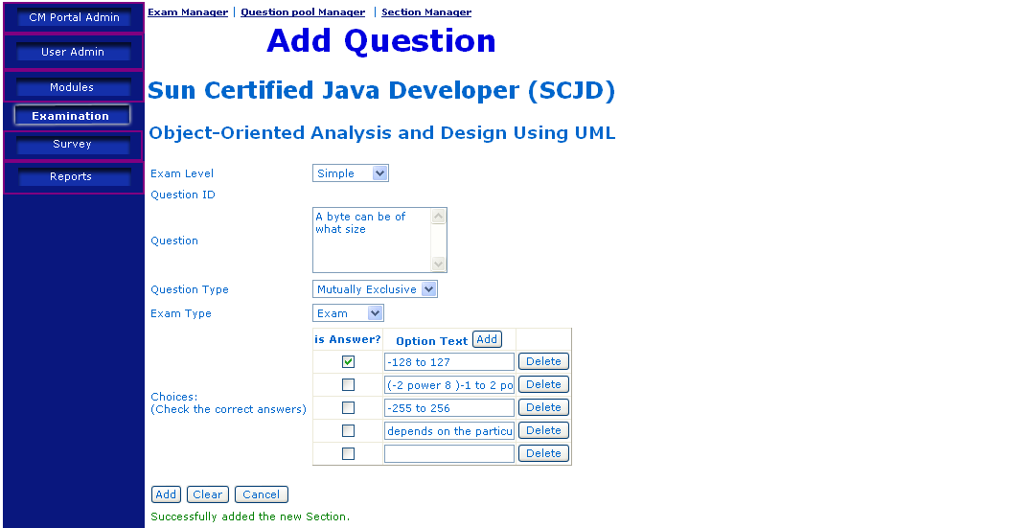
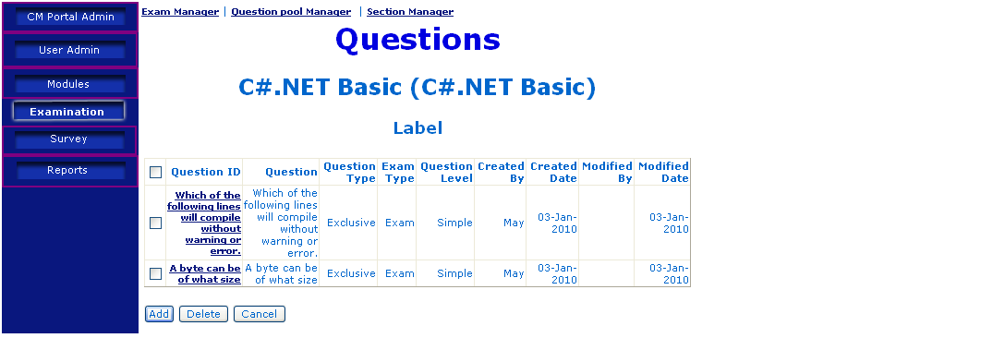
Description | Add Exam Question
Details | - User clicks the menu “Examination” on the left, a list of existing exams are displayed.  - Use checks the checkbox before the exam to add new question to, then clicks “Manage Section” button.  - A list of existing sections will be displayed. Use checks the checkbox before the section to add new question to, then clicks “Manage Question” button.  - User provides all the necessary information of the exam question, like the question level, the text, the options and correct answers.  - User clicks “Add” button, the new question will be added, and a message will be displayed to show the outcome of the question addition.  - User clicks “Cancel” button, “Exam Question List“ page will be displayed, with the new question in the list.
Remark | Only Portal Administrator has access right to this feature.

Delete Exam Module

Delete Exam
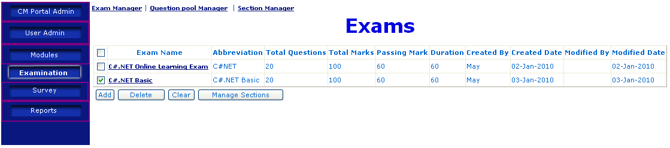
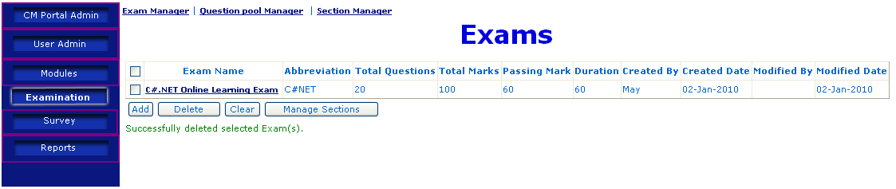
Description | Delete Exam
Details | - User clicks the menu “Examination” on the left, a list of existing exams are displayed.  - Use checks the checkbox before the exam to be deleted, then clicks “delete” button.  - Selected exam(s) will be deleted, and a message is displayed to show the outcome of the exam deletion.
Remark | Only Portal Administrator has access right to this feature.

Delete Exam Section
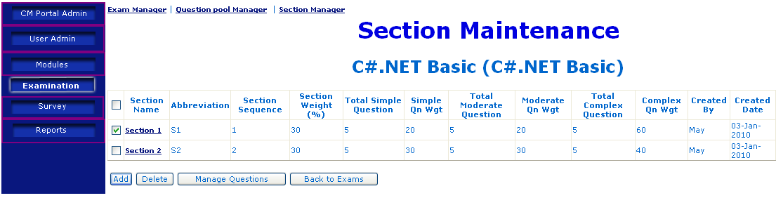
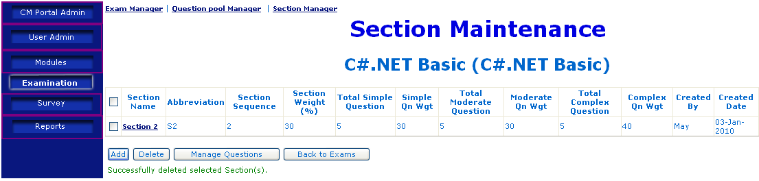
Description | Delete Exam Section
Details | - User clicks the menu “Examination” on the left, a list of existing exams are displayed.  - Use checks the checkbox before the exam that to add new section to, then clicks “Manage Section” button.  - A list of existing sections will be displayed. User selects the section(s) to be deleted by checking the checkbox before the section(s).  - User clicks “Delete” button, the selected section(s) will be deleted, and a message will be displayed to show the outcome of the section deletion.
Remark | Only Portal Administrator has access right to this feature.

Delete Exam Question
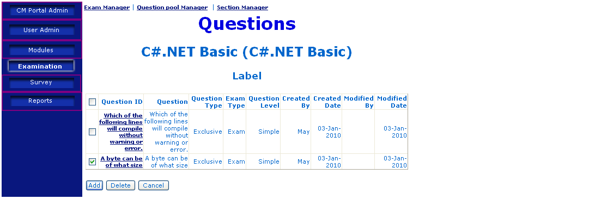
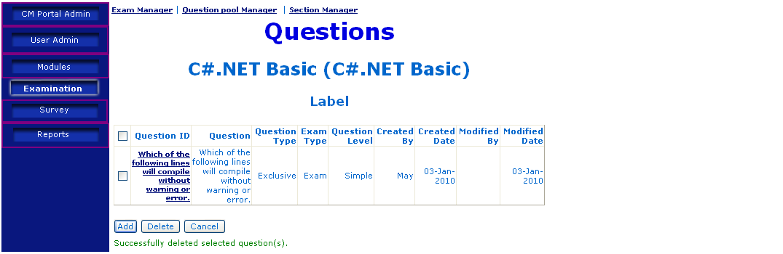
Description | Delete Exam Question
Details | - User clicks the menu “Examination” on the left, a list of existing exams are displayed.  - Use checks the checkbox before the exam to add new question to, then clicks “Manage Section” button.  - A list of existing sections will be displayed. Use checks the checkbox before the section to add new question to, then clicks “Manage Question” button.  - A list of questions in the section will be displayed. User selects the question to delete by checking the checkbox before the question.  - User clicks “Delete” button, the question will be deleted, and a message will be displayed to show the outcome of question deletion.
Remark | Only Portal Administrator has access right to this feature.

Update Exam Module

Update Exam Module
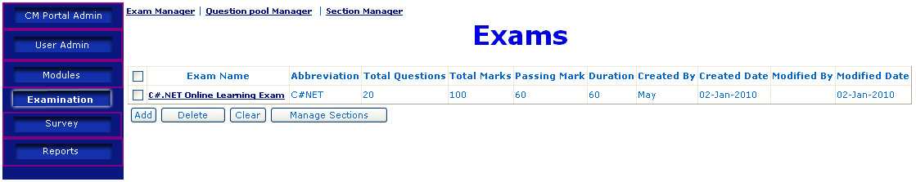
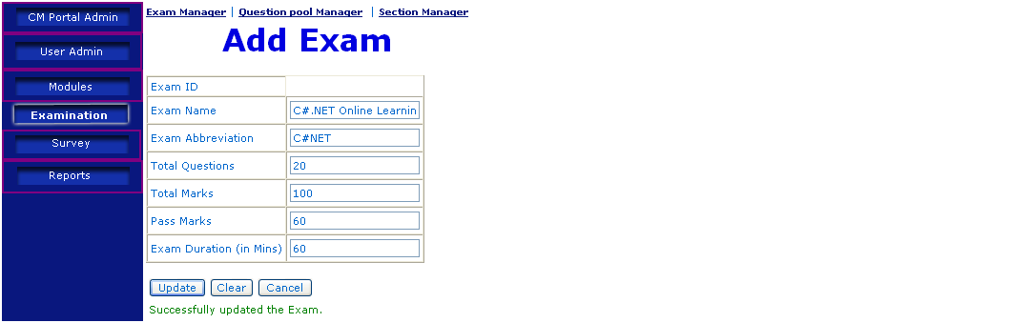
Description | Update Exam
Details | - In “Exam List” page, user mouse-over the exam to be updated, and clicks the link.  - The detail information of the exam will be displayed, where user can make changes.  - User clicks “Update” button, the exam will be updated, and a message will be displayed to show the outcome of exam updating.
Remark | Only Portal Administrator has access right to this feature.

Update Exam Section
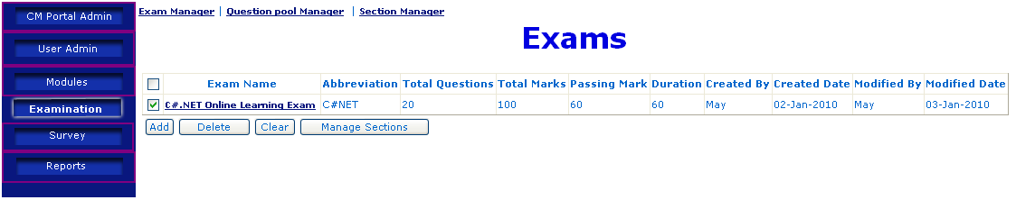
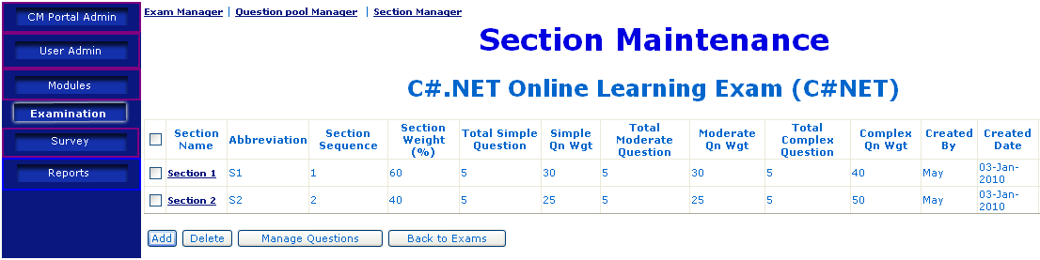
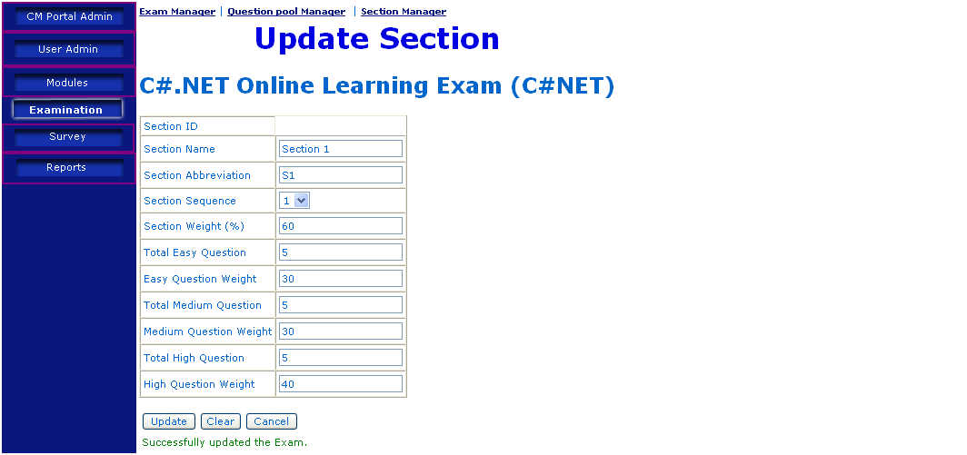
Description | Update Exam Section
Details | - In “Exam List” page, user checks the checkbox besides the exam containing the section to be updated, then clicks “Manage Sections” button.  - The detail information of the exam section will be displayed, where user can make changes.  - User clicks “Update” button, the exam section will be updated, and a message will be displayed to show the outcome of exam section updating.
Remark | Only Portal Administrator has access right to this feature.

Update Exam Question
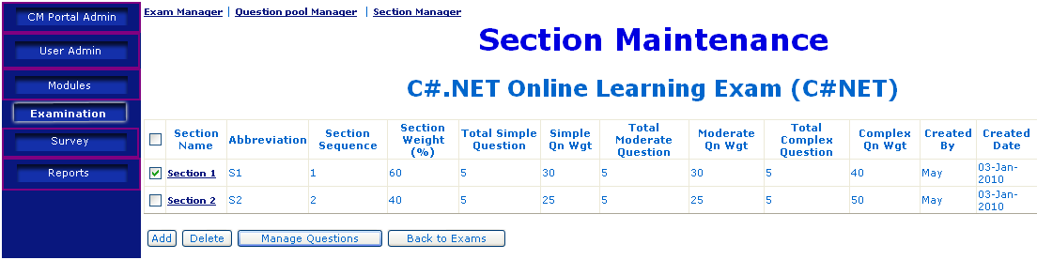
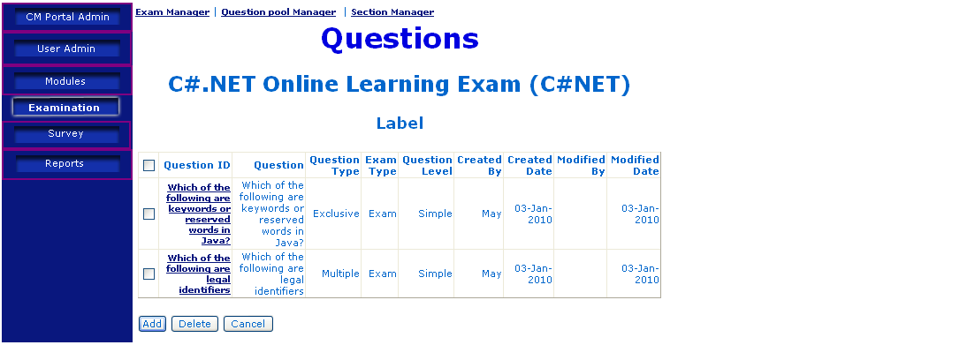
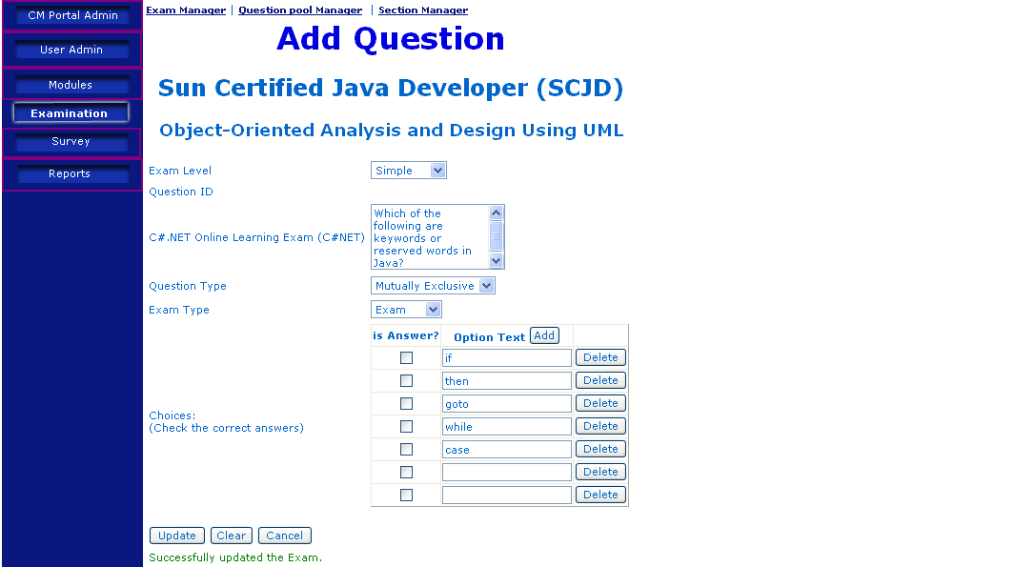
Description | Update Exam Question
Details | - In “Exam List” page, user checks the checkbox besides the exam containing the section to be updated, then clicks “Manage Sections” button.  - A list of sections will be displayed, user checks the checkbox besides the section containing the question to be updated, then clicks “Manage Questions” button.  - The detail information of the exam question will be displayed, where user can make changes.  - User clicks “Update” button, the exam question will be updated, and a message will be displayed to show the outcome of exam question updating.
Remark | Only Portal Administrator has access right to this feature.

Take Exam
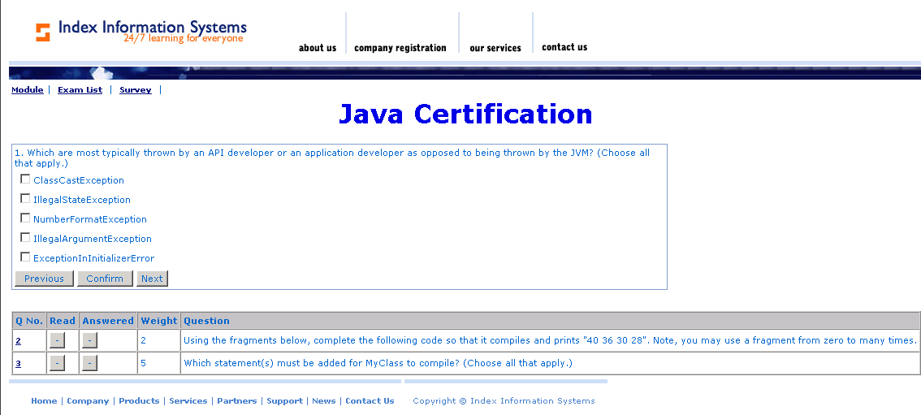
Description | Take Exam
Details | Once the user chooses the exam, the 1st question will be displayed with the choice.  The rest of the question will be displayed in the bottom. This allows the user to choose the questions which he/she wants to answer.  “-“ Symbol below “Read” column informs that question was not read by the user  “+” Symbol below “Read” column informs that question was read by the user  “-“ Symbol below “Answered” column informs that question was not Answered by the user  “+” Symbol below “Answered” column informs that question was Answered by the user

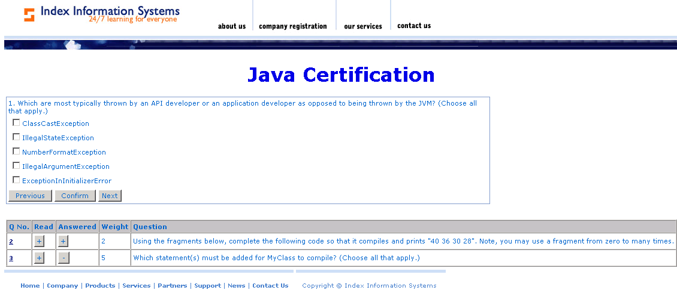

Description | Take Exam
Details | Above question page informs  Question 2: User has Read & Answered  Question 3: User has Read & Not Answered

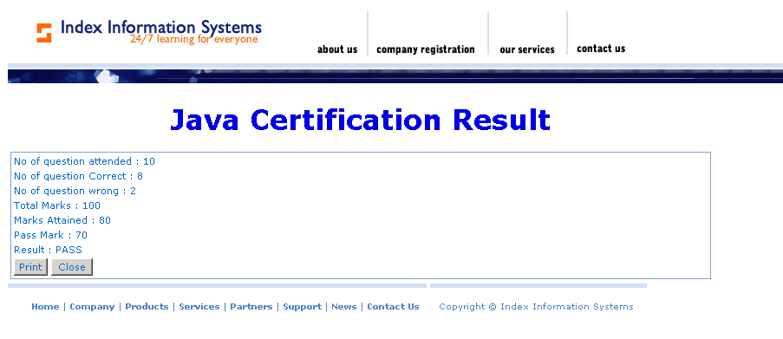

Approval Record DOCS/Forms/Approval
Project Name Content Management Portal
Document Ref CMP/DOCS/TU.1/2.0
Approved by Haiyang | Date
Authorised by | Date
The document authorisation appears on the title page. |  | ✔
The structure of the document is logical. |  | ✔
The distribution list is correct. |  | ✔
The title page is signed |  | ✔
Calculations appear reasonable, are neatly presented and have been checked. |  | ✔
Theory and formulae are correct and properly applied. |  | ✔
Illustrations are relevant, readable and logically placed. |  | ✔
There are no typographical errors. |  | ✔
Units are consistent throughout. |  | ✔
The security classification is correct. |  | ✔
There are no obvious omissions. |  | ✔
The document complies with the Client's requirements, however specified. |  | ✔
Responsibility is accepted for all opinions, conclusions and recommendations. |  | ✔
The document does not run counter to company policy. |  | ✔

