Content Management Portal (CMP) Project
Transition Strategy

Document Reference: |  | CMP/DOCS/TS.8
Project: |  | Content Management Portal (CMP)
Document Title: |  | Transition Strategy
Version: |  | 1.0
Date: |  | 01 Aug 2009
Prepared/Revised by: |  | Sui Haiyang
Approved by :
 |  | Sui Haiyang |  | Date
 |  | Project Manager |  | 01 Aug 2009
 | © 2009  The information contained in this document is the property of ISS. The contents must not be copied in whole or in part for purposes other than which it has been supplied without the consent of ISS, or, if it has been furnished under contract to another party, as expressly authorised under that contract, then ISS shall not be liable for any errors or omissions. |  | 
Institute of Systems Science, 25 Heng Mui Keng Terrace,
Singapore 119615

Version History Record
Version | Date | Brief description of amendments and affected pages, paragraph
1.0 | 01/08/09 | Submission to ISS

Distribution:

Name | Department | Organisation
ISS Audit | ISS | ISS
Sui Haiyang | Project Manager | ISS-SE16S07
Gao Jia Si Karen | Quality Manager | ISS-SE16S07
Yap Sie Kuok, Thomas | Testing Manager | ISS-SE16S07
May Ann Sallan | Database Designer | ISS-SE16S07
Rajendran Kumaraguru | System Architect | ISS-SE16S07
Thiyagarajan Ravikumar | Technical Lead | ISS-SE16S07

Table of Contents
1. INTRODUCTION 1
2. Design Architecture 2
3. New Objects 3
3.1 Web.config configuration file 3
3.2 Data Set 1
3.3 Master Page 2
4. Integration with Open-Source CMS 4

INTRODUCTION
This document describes when transiting from analysis to design, what should be changes, and how to facilitate this process, to make the transition smoothly. The platform will be C#.NET, so when planning the transition, we also take C#.NET Specialty into consideration. E.g. the dataset feature in C#.NET will be utilized to ease the process of data objects creation.

This transition covers following parts:

Design Architecture
Three-layer will be used in design phase, as illustrated in the diagram below:

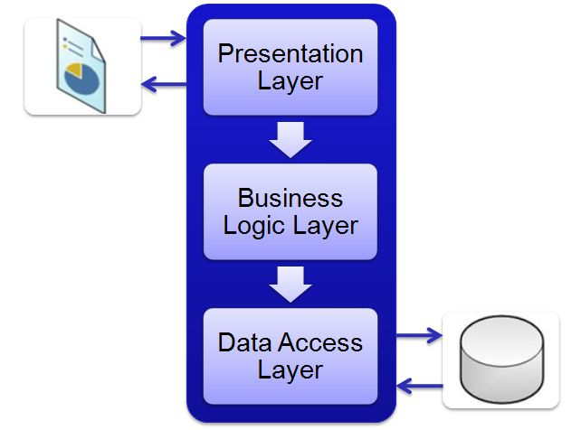

- Data Tier is basically the server which stores all the application’s data. Data tier contents Database Tables, XML Files and other means of storing Application Data.
- Business Tier is mainly working as the bridge between Data Tier and Presentation Tier. All the Data passes through the Business Tier before passing to the presentation Tier. Business Tier is the sum of Business Logic Layer, Data Access Layer and Value Object and other components used to add business logic.
- Presentation Tier is the tier in which the users interact with an application. Presentation Tier contents Shared UI code, Code Behind and Designers used to represent information to user.

New Objects

Web.config configuration file
Web.config file, as it sounds like is a configuration file for the Asp .net web application. An Asp .net application has one web.config file which keeps the configurations required for the corresponding application. Web.config file is written in XML with specific tags having specific meanings.
There are number of important settings that can be stored in the configuration file. Here are some of the most frequently used configurations, stored conveniently inside Web.config file..
- Database connections
- Session States
- Error Handling
- Security
The most important configuration data that can be stored inside the web.config file is the database connection string. Storing the connection string in the web.config file makes sense, since any modifications to the database configurations can be maintained at a single location. As otherwise we'll have to keep it either as a class level variable in all the associated source files or probably keep it in another class as a public static variable.
But it this is stored in the Web.config file, it can be read and used anywhere in the program. This will certainly save us a lot of alteration in different files where we used the old connection.
The below diagram gives an example of Web.config
<configuration>
<appSettings>
<add key="ConnectionString"
value="server=localhost;uid=sa;pwd=;database=DBPerson" />
</appSettings>
</configuration>

As you can see it is really simple to store the connection string in the web.config file. The connection string is referenced by a key which in this case is "ConnectionString". The value attribute of the configuration file denotes the information about the database. Here we can see that if has database name, userid and password. You can define more options if you want.
using System.Configuration;
string connectionString = (string )ConfigurationSettings.AppSettings["ConnectionString"];

The small code snippet above is all that is needed to access the value stored inside the Web.config file.

Session States:
Session in Asp .net web application is very important. As we know that HTTP is a stateless protocol and we needs session to keep the state alive. Asp .net stores the sessions in different ways. By default the session is stored in the asp .net process. You can always configure the application so that the session will be stored in one of the following ways.
There are two main advantages of using the State Service. First the state service is not running in the same process as the asp .net application. So even if the asp .net application crashes the sessions will not be destroyed. Any advantage is sharing the state information across a Web garden (Multiple processors for the same computer).
Lets see a small example of the Session State Service.
<sessionState mode="StateServer" stateConnectionString="tcpip=127.0.0.1:55455" sqlConnectionString="data source=127.0.0.1;user id=sa;password='' cookieless="false" timeout="20"/>
The attributes are self explanatory but I will go over them.
mode:
This can be StateServer or SqlServer. Since we are using StateServer we set the mode to StateServer.

Error Handling:

Error handling is one of the most important part of any web application. Each error has to be caught and suitable action has to be taken to resolve that problem. Asp.net web.config file lets us configure, what to do when an error occurs in our application.

Check the following xml tag in the web.config file that deals with errors:
<customErrors mode = "On">
<error statusCode = "404" redirect = "errorPage.aspx" />
</customErrors>
This tells the Asp.net to display custom errors from a remote client or a local client and to display a page named errorPage.aspx. Error "404" is "Page not found" error.
If custom error mode is turned "off" than you will see Asp.net default error message. This error messages are good for debugging purposes but should never be exposed to the users. The users should always be presented with friendly errors if any.

Security:
The most critical aspect of any application is the security. Asp.net offers many different types of security method which can be used depending upon the condition and type of security you need.

Forms Authentication:
Forms Authentication uses HTML forms to collect the user information and than it takes required actions on those HTML collected values.

Data Set
Dataset will be used in designing phase. What is a Dataset in .NET?
A Dataset is a in memory representation of a collection of Database objects including tables of a relational database scheme. The dataset contains a collection of Tables, Relations, constraints etc.,
It can be used for manipulating the data remotely and finally updating the database with the modified data. This way it enables disconnected means of working with data. This improves performance in terms of reducing the number of times a database is accessed for data manipulations.
The dataset contains all the objects as a Collection of objects. For example it contains the Database Tables as DataTable objects. The data from the database is filled into the dataset by using the DataAdapter.
All the related classes like DataSet, DataAdapter, DataTable, DataRow etc are available inside the System.Data namespace. This namespace can be used as follows:
--Inside an asp.net page
<%@ Import Namespace="System.Data" %>
--Inside a C# page
using System.Data;
All Data Access related classes and namespaces come under this System.Data namespace. There are some more Database specific namespaces under System.Data such as System.Data.SqlClient,System.Data.XML etc., The SqlClient contains the classes required to work with the Sql Server database and XML namespaces gives classes tailored to suit the needs of XML data access.

Master Page
ASP.NET master pages allow you to create a consistent layout for the pages in your application. A single master page defines the look and feel and standard behavior that you want for all of the pages (or a group of pages) in your application. You can then create individual content pages that contain the content you want to display. When users request the content pages, they merge with the master page to produce output that combines the layout of the master page with the content from the content page.

In addition to static text and controls that will appear on all pages, the master page also includes one or more ContentPlaceHolder controls. These placeholder controls define regions where replaceable content will appear. In turn, the replaceable content is defined in content pages. After you have defined the ContentPlaceHolder controls, a master page might look like the following.

<% @ Master Language="VB" %>

<!DOCTYPE html PUBLIC "-//W3C//DTD XHTML
1.1//EN" "http://www.w3.org/TR/xhtml11/DTD/xhtml11.dtd">

<html >
<head runat="server" >
<title>Master page title</title>
</head>
<body>
<form id="form1" runat="server">
<table>
<tr>
<td><asp:contentplaceholder id="Main" runat="server" /></td>
<td><asp:contentplaceholder id="Footer" runat="server" /></td>
</tr>
</table>
</form>
</body>
</html>

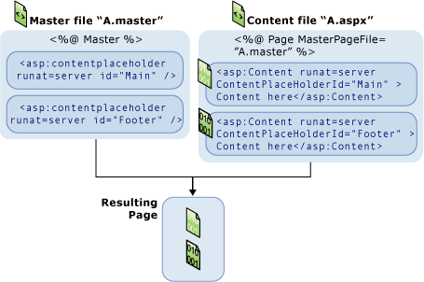

Integration with Open-Source CMS
Open-source CMS module is a complete production of Content Management tool. We will use this module in our system. Instead of changing the database, we will decide to use Web Service to communicate with this module database, and update the tables as well. the database structure of the open-source CMS should then be intact.

The design should be like followings:

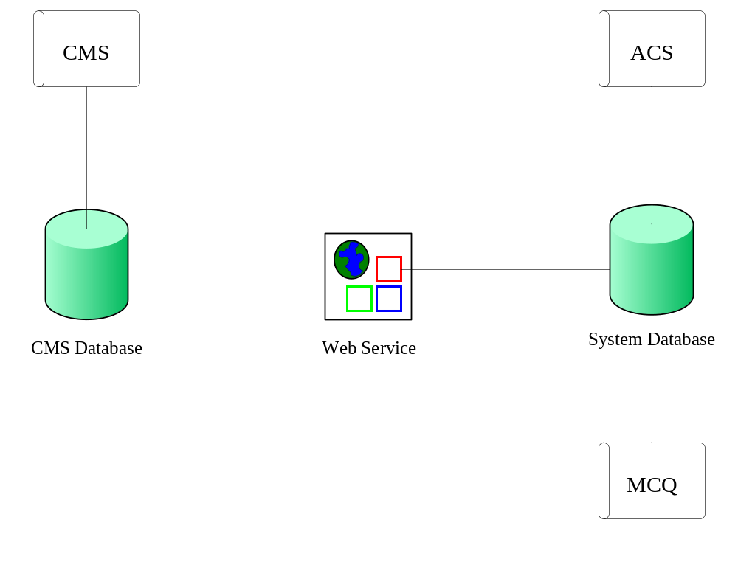
Approval Record DOCS/Forms/Approval
Project Name Content Management Portal
Document Ref CMP/DOCS/TS.8/1.0
Approved by Haiyang | Date 01/08/2009
Authorised by | Date
The document authorisation appears on the title page. |  | ✔
The structure of the document is logical. |  | ✔
The distribution list is correct. |  | ✔
The title page is signed |  | ✔
Calculations appear reasonable, are neatly presented and have been checked. |  | ✔
Theory and formulae are correct and properly applied. |  | ✔
Illustrations are relevant, readable and logically placed. |  | ✔
There are no typographical errors. |  | ✔
Units are consistent throughout. |  | ✔
The security classification is correct. |  | ✔
There are no obvious omissions. |  | ✔
The document complies with the Client's requirements, however specified. |  | ✔
Responsibility is accepted for all opinions, conclusions and recommendations. |  | ✔
The document does not run counter to company policy. |  | ✔

