Work Instruction Form DOCS/Forms/WIF
Project Name | B2B Information Exchange Portal
Task Title | Draft Project plan
Generated by | Haiyang |  |  | Signature
For use by | Haiyang |  |  | Date | 08-Mar-2009
Project Plan | B2B-IEP/DOCS/MP.1 |  |  | QA Plan | B2B-IEP/DOCS/MQ.1
Related documents
Standards
Follow the template provided by ISS

Instructions

Deliverables from this task
A draft project plan

Acceptance criteria
Should be complete version.

Remark
Finished on time.

Target Start Date |  | 08-Mar-2009 | Target Finish Date |  |  | 12-Mar-2009
Actual Start Date |  | 12-Mar-2009 | Actual Finish Date |  |  | 12-Mar-2009
Completed By |  | Haiyang | Reviewed By |  |  | Haiyang
Signature |  |  | Signature
Review Date |  | 14-Mar-2009

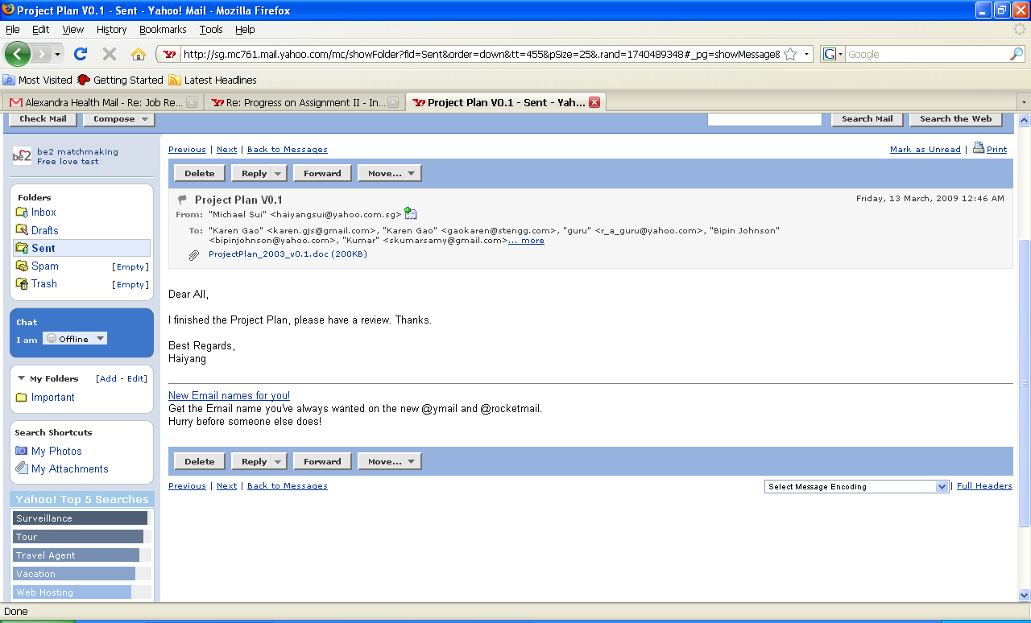

Work Instruction Form DOCS/Forms/WIF
Project Name | B2B Information Exchange Portal
Task Title | Performance and Report Module for URS
Generated by | Haiyang |  |  | Signature
For use by | Haiyang |  |  | Date | 08-Mar-2009
Project Plan | B2B-IEP/DOCS/MP.1 |  |  | QA Plan | B2B-IEP/DOCS/MQ.1
Related documents
Standards
Make a workable and marketing standard one.

Instructions

Deliverables from this task
Finish the part of performance and report requirements of URS

Acceptance criteria

Remark
Finished before the deadline.

Target Start Date |  | 08-Mar-2009 | Target Finish Date |  |  | 12-Mar-2009
Actual Start Date |  | 08-Mar-2009 | Actual Finish Date |  |  | 10-Mar-2009
Completed By |  | Haiyang | Reviewed By |  |  | Haiyang
Signature |  |  | Signature
Review Date |  | 14Mar-2009

