Content Management Portal (CMP) Project
System Test Plan (STP)

Document Reference: |  | CMP/DOCS/MP.2/
Project: |  | Content Management Portal (CMP)
Document Title: |  | System Test Pan (STP)
Version: |  | 0.1
Date: |  | 30 Nov 2009
Prepared/Revised by: |  | Gao Jia Si Karen
Approved by :
 |  | Sui Haiyang |  | Date
 |  | Project Manager |  | 24 Dec 2009
 | © 2009  The information contained in this document is the property of ISS. The contents must not be copied in whole or in part for purposes other than which it has been supplied without the consent of ISS, or, if it has been furnished under contract to another party, as expressly authorised under that contract, then ISS shall not be liable for any errors or omissions. |  | 
Institute of Systems Science, 25 Heng Mui Keng Terrace,
Singapore 119615

Version History Record
Version | Date | Brief description of amendments and affected pages, paragraph
0.1 | 30/11/09 | Draft Issue

Distribution:

Name | Department | Organisation
ISS Audit | ISS | ISS
Sui Haiyang | Project Manager | ISS-SE16S07
Gao Jia Si Karen | Quality Manager | ISS-SE16S07
Yap Sie Kuok, Thomas | Testing Manager | ISS-SE16S07
May Ann Sallan | Database Designer | ISS-SE16S07
Rajendran Kumaraguru | System Architect | ISS-SE16S07
Thiyagarajan Ravikumar | Technical Lead | ISS-SE16S07

Table of Contents
1. INTRODUCTION 1
1.1 Objective 1
1.2 Audience 2
1.3 Organisation 2
1.4 References 2
2. TEST PROCEDURE 3
2.1 Scope 3
2.2 Approach 3
2.3 Bug Handling 5
2.4 Pass/Fail Criteria 6
2.5 Test completion Criteria 6
2.6 Procedure 7
3. TEST DATA 9
3.1 Portal Administration Maintenance 9
3.2 DAP Maintenance 9
3.3 FAP Maintenance 9
3.4 Role Maintenance 9
3.5 User Administration Maintenance 9
3.6 Company Maintenance 9
3.7 Module Maintenance 9
3.8 Question Maintenance 9
3.9 Exam Maintenance 9
3.10 Section Maintenance 9
4. TEST SPECIFICATION 12
4.1 Maintenance of Portal Administration 12
4.2 Maintenance of DAP 12
4.3 Maintenance of FAP 12
4.4 Maintenance of Role 12
4.5 Maintenance of User Administration 12
4.6 Maintenance of Company 12
4.7 Maintenance of Module 12
4.8 Maintenance of Question 12
4.9 Maintenance of Exam 12
4.10 Maintenance of Section 12
5. Test DELIVERABLES 13
6. Test schedule 1
7. resource & ENVIRONMNENTAL requirements 1
7.1 Testing Environment 1
7.2 Bug Severity and Priority Definition 1
8. Change management procedures 3
9. PLAN Appovals 4

INTRODUCTION
The Index Info Systems Pte Ltd requires the development of a Content Management Portal (CMP). Basically it will involve the three major service functions:
  - Administration Control System
  - Content Management System
  - Multiple Choice Question (include Survey and report)

The System Test Plan (STP) is designed to prescribe the scope, approach, resources, and schedule of all testing activities. The plan will identify the items to be tested, the features to be tested, the types of testing to be performed, the personnel responsible for testing, the resources and schedule required to complete testing, and the risks associated with the plan.

Objective
The purpose of this document is to provide a plan for the testing work to be done during the development of CMP.

Primary Objective
It must assure that the system meets the full requirements, including quality requirements (i.e.: Non-functional requirements) and fit metrics for each quality requirement and satisfies the use case scenarios and maintain the quality of the product. At the end of the project development cycle, the user should find that the project has met or exceeded all of their expectations as detailed in the requirements.

Any changes, additions, or deletions to the requirements document, Functional Specification, or Design Specification will be documented and tested at the highest level of quality allowed within the remaining time of the project and within the ability of the test team.

Secondary Objective
It also assure to identify and expose all issues and associated risks, communicate all known issues to the project team, and ensure that all issues are addressed in an appropriate matter before release. As an objective, this requires careful and methodical testing of the application to first ensure all areas of the system are scrutinized and, consequently, all issues (bugs) found are dealt with appropriately.

Audience
The intended readers of this plan are all development team members, who are responsible for carrying out the testing of the system. All the necessary instructions should be provided in this test plan.

Organisation
The testing approach and procedure is summarised in Section 2. The test data set is defined in Section 3. Finally, Section 4 specifies each of the system tests to be performed.

References
To fully understand the background to this project, the reader should also be familiar with:
1. CMP Project Plan, reference CMP/DOCS/MP.1/, version 3.0, dated July 2009.
2. CMP Quality Plan, reference CMP/DOCS/MQ.1/, version 2.1, dated 12 Sep 2009.
3. CMP User Requirement Specification, reference CMP/DOCS/TS.1, version 2.0, dated July 2009.
4. CMP System Detailed Design Specification, reference CMP/DOCS/TS.2, version 2.0, dated 7 Aug 2009
5. CMP User Interface Specification, reference CMP/DOCS/TS.4, version 2.0, dated July 2009
6. CMP Prototyping Study Report, reference CMP/DOCS/TS.3, version 2.0, dated 7 Aug 2009
7. CMP Use Case Model Survey, reference CMP/DOCS/TS.5, version 2.0, dated 7 Aug 2009
8. CMP Use Case Realization Report, reference CMP/DOCS/TS.6, version 2.0, dated 7 Aug 2009
9. CMP Proposed Software Architecture, reference CMP/DOCS/TS.7.1, version 1.0, dated 7 Aug 2009
10. CMP Transition Strategy, reference CMP/DOCS/TS.8, version 1.0, dated 7 Aug 2009
11. CMP Database Design Specification, reference CMP/DOCS/TS.7.2, version 1.0, dated 7 Aug 2009

TEST PROCEDURE
The aim of understanding system testing is to enable the project to demonstrate, with an acceptable degree of confidence, that the ACS, MCQ and CMS modules of the CMP satisfy the requirements as defined in the Detail System Design Specification (reference CMP/DOCS/TS.2, version 2.0, dated 7 Aug 2009).

Scope
The tests defined in Section 4 will attempt to demonstrate that the features and functions specified in User Requirement Specification (reference CMP/DOCS/TS.1, version 2.0, dated July 2009) operate correctly. However it should be noted that features that have no specific user requirement, have no tests identified to verify that the facilities operate correctly.

Testing will be performed at several points in the project development life cycle as the product is constructed. Testing is a very 'dependent' activity. As a result, test planning is a continuing activity performed throughout the system development life cycle. Test plans must be developed for each level of product testing.

In Scope
The CMP System Test Plan defines and demonstrates the unit, integration, system, regression, and User Acceptance testing approach. The test scope includes the following:
- Testing of all functional, application performance, security and use cases requirements listed in the Use Case documents and Detail System Design Specifications.
- Quality requirements
- Testing of interfaces of whole systems and users those satisfy with User Interface Specification.

Out of Scope
The following are considered out of scope for CMP system Test Plan and testing scope:
- Functional requirements testing for systems outside CMP applications

Approach
The basic method to be adopted will be to use a test data set, as defined in Section 3, to exercise and demonstrate the functions and features of the system. This will be done through a series of defines tests given below.

Usability Testing
To ensure the components and features function in a manner that is acceptable to the customer, a functioning prototype of the UI components was created to evaluate the proposed design for the development. Testing will review the findings and provide the project team with its evaluation of the impact these changes will have on the testing process and to the project as a whole.

Unit Testing
The purpose of Unit testing is to ensure that the program logic is completed and correct and ensuring that the component works as designed and code coverage have been achieved. It was conducted by the Developer during code development process.

Interface Testing
The purpose of Interface testing is to ensure the application operates efficiently and effectively outside the application boundary with all interface systems

Security Testing
The purpose of Security testing is to ensure that the application system control and auditability features of the application are functional.

Recovery Testing
The purpose of Recovery Testing is to ensure that application restart and backup and recovery facilities operate as designed.

Integration Testing
The purpose of Integration Testing is to ensure that all components/units or modules that can be combined and tested functional properly.

Regression Testing
During the repeated cycles of identifying bugs and taking receipt of new builds (containing bug fix code changes), there are several processes which are common to this phase across all projects. These include the various types of tests: functionality, performance, stress, configuration, etc. There is also the process of communicating results from testing and ensuring that new code contains stable fixes (regression). The project will plan at least 2 cycles of testing (drops/iterations of new builds).

At each regression test, a debriefing should be held. Specifically, the report must show that to the best degree achievable during the iteration testing phase, all identified severity 1 and severity 2 bugs have been communicated and addressed. At a minimum, all priority 1 and priority 2 bugs should be resolved prior to entering the beta phase.

User Acceptance Testing
The UAT will be done by testing team together with the customer. It’s conducted to determine whether or not a system satisfies the acceptance criteria and to enable the customer to determine whether or not to accept the system. Acceptance testing ensures that customer requirements’ objectives are met and that all components are correctly included in a customer package.

Bug Handling

Bug Regression
All bugs that are resolved as “Fixed, Needs Re-Testing” will be regressed when testing team is notified of the new drop containing the fixes. When a bug passes regression it will be considered “Closed, Fixed”. If a bug fails regression, testing team will notify development team. When a Severity 1 bug fails regression, testing team should also put out an immediate inform development team. The Test manager will be responsible for tracking and reporting to development and product management the status of regression testing.

Bug Triage
The Test Manager, Product Manager, and Development Lead should all be involved in these bug triage. The test manager will provide required documentation and reports on bugs for all attendees. The purpose of the triage is to determine the type of resolution for each bug and to prioritize and determine a schedule for all “To Be Fixed Bugs’. Development will then assign the bugs to the appropriate person for fixing and report the resolution. The test manager will be responsible for tracking and reporting on the status of all bug resolutions.

Bug Reporting & Triage Conditions:
The standard conditions for the bug reporting and evaluation are defined as below:
- Bug find rate remains at 0 new bugs found (Severity 1/2/3) despite a constant test effort across 3 or more working days.
- Bug severity distribution has changed to a steady decrease in Severity 1 and 2 bugs discovered.
- No ‘Must Fix’ bugs remaining prior despite sustained testing.

Pass/Fail Criteria
The pass or fail criteria are defined below, the purpose of it is to ensure the certain degree and pre-defined levels of test objectives and goals are met.

Suspension Criteria
These criteria apply to suspend all or a portion of the testing activity on test items associated with the plan.
- Testing will be suspended on the affected software module when the test case bugs are discovered after the 3rd iteration of regression testing.
- Testing will be suspended if there is critical scope change that impacts the Critical Path

Resumption Criteria
A bug list should be filed by Development team. After fixing the bug, Development team will follow the test criteria to provide its latest drop for additional Testing. At that time, tester will regress the bug, and if passes, continue testing the module.

Test completion Criteria
Release version can occur only after the successful completion of the application under test throughout all of the phases and milestones previously discussed above.

The milestone target is to place the release/app (build) into production for the release version after it has been shown that the application has reached a level of stability that meets or exceeds the customer’s expectations as defined in the User Requirements Specification, System Detailed Design Specification, and User Interface Specification.

In general, testing will be considered complete when the following conditions have been met:

Standard Conditions:
- When Testers and Developers, both agree that testing is complete, the application is stable, and agree that the application meets functional requirements.
- Script execution of all test cases in all areas has passed.
- Automated test cases have in all areas have passed.
- All priority 1 and 2 bugs have been resolved and closed.
- PM approves the test completion

Procedure
The system tests to be performed are defined in Section 4. System testing will be deemed complete when all the defined tests have been performed, documented, and approved by the Project Manager. For each test defined in Section 4, the following step shall be performed:
- Determine the involved test cases depending on the System Detailed Design Specification for the test;
- Determine the expected results of the test;
2. Carry out the test instructions and create any required hardcopy print-outs;
3. Compare the expected with the actual results. If the required results have not been achieved then define the required corrective action;
4. Fill out a test log form which defined in Testing Log (reference CMP/DOCS/TC.3), and also as shown in Figure 2.1. Attach to the form with all the required print-outs, and file in the System Testing Workfile (reference CMP/DOCS/TW.8).
5. If the required results were not achieved then:
a. implement the corrective action, as specified on the testing log form;
b. perform steps 2, 3 and 4 above. Create a NEW testing log form for each repeated test;
c. repeat (a) and (b) above until the test is successful.

When the tests have been completed, the System Testing Workfile (reference CMP/DOCS/TW.8) should be submitted to the Project Manager for approval.
Figure 2.1 : Testing Log Form.

Testing Log Form CMP/DOCS/Forms/Testing
Project Name Content Management Portal Project
Test Case Identifier | File Ref CMP/DOCS/TW.X/
Tested by | Date
Approved by | Date
Test Description (give brief description)
Expected Results (refer to attached documents if necessary)
Actual Results (refer to attached documents if necessary)
Test Status (either SUCCESSFUL or ERROR)
Corrective Action or Remarks (refer to attached documents if necessary)

TEST DATA
The aim of this section is to define the basic data set to be used in the system tests defined in Section 4.

Portal Administration Maintenance
Figure 3.1 defines the test data of Portal Administration Maintenance to be used in the system tests.

DAP Maintenance
Figure 3.2 defines the test data of DAP Maintenance to be used in the system tests.

FAP Maintenance
Figure 3.3 defines the test data of FAP Maintenance to be used in the system tests.

Role Maintenance
Figure 3.4 defines the test data of Role Maintenance to be used in the system tests.

User Administration Maintenance
Figure 3.5 defines the test data of User Administration Maintenance to be used in the system tests.

Company Maintenance
Figure 3.6 the test data of Company Maintenance to be used in the system tests.

Module Maintenance
Figure 3.7 defines the test data of Module Maintenance to be used in the system tests.

Question Maintenance
Figure 3.8 defines the test data of Question Maintenance to be used in the system tests.

Exam Maintenance
Figure 3.9 defines the test data of Question Maintenance to be used in the system tests.

Section Maintenance
Figure 3.10 defines the test data of Section Maintenance to be used in the system tests.
Figure 3.1: Portal Administration Maintenance to be used in the System Testing
User ID | Employee ID | Employee Name | Email
pa1 | PA0002 | Michael Ang | michael.ang@hotmail.com
pa2 | PA0003 | Angus Cheng | angus.cheng@singnet.com

Figure 3.2: DAP Maintenance to be used in the System Testing
Name | Remark
Oracle Learning | Oracle tutorial learning package
Cannon Handbook | Handbook for Cannon Company
Intel new staff training | For new staff joining Intel

Figure 3.3: FAP Maintenance to be used in the System Testing
Name | Remark
FAP1 | For portal admin
FAP2 | For user admin
FAP3 | For user
FAP4 | for testing

Figure 3.4: Role Maintenance to be used in the System Testing
Name | Remark
User Admin Role For Intel | User Admin Role Created For Intel
User Admin Role For Oracle Company | User Admin Role Created For Oracle Company
User Admin Role for HP | User Admin Role Created for HP

Figure 3.5: User Administration Maintenance to be used in the System Testing
Name | Remark
Intel User Admin | For Intel User Admin
HP User Admin | For HP User Admin
IBM User Admin | For IBM User Admin

Figure 3.6: Company Maintenance to be used in the System Testing
Name | Remark
IBM | Introduction to IBM
Intel | Introduction to Intel
HP | Introduction to HP

Figure 3.7: Module Maintenance to be used in the System Testing
Module ID | Module Name | Company | Validation data | User Admin | No of User
Mod001 | Certified java Developer (SCJD) | Bayer | 12 Aug 2009 to 12 Aug 2010 | Shee Sui Hoon | 30
Mod002 | Developing Application with the Java SE Platform | NTUC | 1 Dec 2000 to 20 Dec 2015 | Jack John | 1000
Mod003 | Customer Service Tutorial for Bayer Staff | Bayer | 1 Mar 2005 to 30 Mar 2009 | Santino Revelleza | 40
Figure 3.8: Question Maintenance to be used in the System Testing
Question ID | Question | Question Type | Exam Type | Question Level
Qn001 | What is your name | Multiple Choice | Exam | Simple
Qn002 | Where do you live? | Mutually Exclusive | Exam | Simple
Qn003 | How many use case for the module? | Mutually Exclusive | Exam | Complex
Qn004 | how many defects you observed? | Mutually Exclusive | Exercise | Moderate
Figure 3.9: Exam Maintenance to be used in the System Testing
Exam ID | Exam Name | Exam Abbr | Module Name | Total Qns | Total Marks | Pass Marks | Exam Duration (mins)
Exm001 | Sun Certified Java Developer | SCJD | Module 1 | 50 | 150 | 120 | 90
Exm002 | Sun Certified Java Programmer | SCJP | Module 2 | 75 | 150 | 130 | 120
Figure 3.10: Section Maintenance to be used in the System Testing
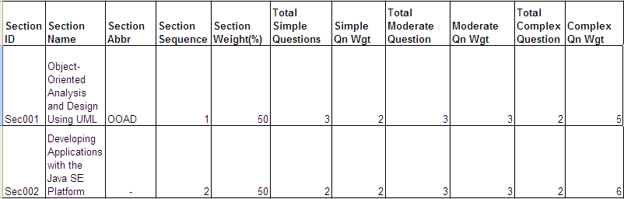

TEST SPECIFICATION
The system tests to be performed, using the procedure defined in Section 2 and the test data given in Section 3. The testing coverage of test cases is listed in Unit test Plan. It provides specifications for the construction of Test Cases and includes list(s) of test case areas and test objectives for each of the components to be tested.
Note that unless otherwise stated, all tests assume that:
- The tester has access privileges set such that read, write, edit and delete operations are permissible for all record types; and
- The system is operating in single user mode.

Maintenance of Portal Administration
The functions of add, delete and modify will tested for Portal Administration Maintenance.

Maintenance of DAP
The functions of add and delete will be tested for DAP Maintenance.

Maintenance of FAP
The functions of add and delete will be tested for FAP Maintenance.

Maintenance of Role
The function of add and delete will be tested for Role Maintenance.

Maintenance of User Administration
The function of add and delete will be tested for User Administration Maintenance.

Maintenance of Company
The functions of add and delete will be tested for Company Maintenance.

Maintenance of Module
The functions of add, delete, modify, view and manage question will be tested for Module Maintenance.

Maintenance of Question
The functions of add, delete, modify and view, will be tested for Question Maintenance.

Maintenance of Exam
The functions of add, delete, modify, view and manage section will be tested for Module Maintenance.

Maintenance of Section
The functions of add, delete, modify, view and manage question will be tested for Section Maintenance.

Test DELIVERABLES
Testing will provide specific deliverables during the project. These deliverables fall into three basic categories: Documents, Test Cases / Bug list/ testing/changes logs, and test results report. Here is a diagram indicating the dependencies of the various deliverables:
Figure 5.1: Dependencies of the Various Deliverables
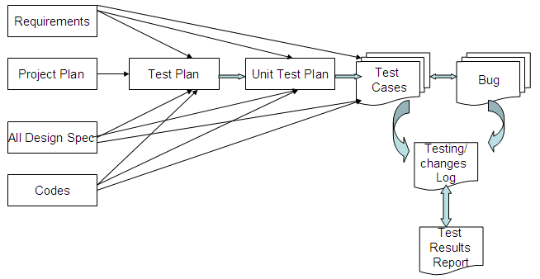

As the diagram above shows, there is a progression from one deliverable to the next. Each deliverable has its own dependencies, without which it is not possible to fully complete the deliverable. The final test results report should be sign off by PM.

Test schedule
The Test Schedule is the responsibility of the Test Manager and will be based on information from the Project plan (reference CMP/DOCS/MP.1/, version 3.0, dated July 2009). The project specific Test Schedule is shown as below.

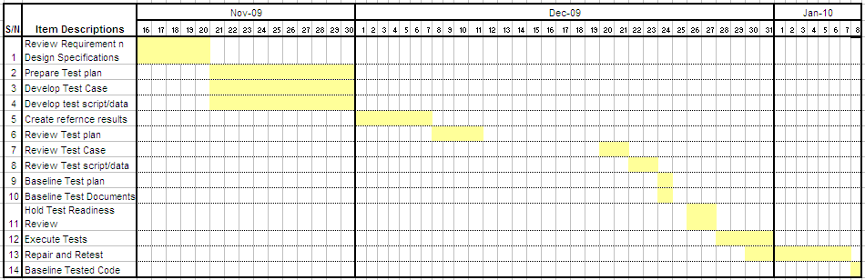

resource & ENVIRONMNENTAL requirements

Testing Environment

Hardware
The Normal PC/Laptop and desktops installed in ISS will be used for the testing environment set up.

Software
The below software will be used for the testing environment setup
        - Windows XP Professional
        - Microsoft Office 2003
        - Microsoft Project 2003
        - Microsoft Visio 2003
        - IIS
        - Visual Studio 2008
        - MS SQL Server 2005
        - .NET Framework 3.5
        - AJAX

Bug Severity and Priority Definition
Bug Severity and Priority fields are both very important for categorizing bugs and prioritizing if and when the bugs will be fixed. The bug Severity and Priority levels will be defined as outlined in the following tables below. Testing will assign a severity level to all bugs. The Test Manager will be responsible to see that a correct severity level is assigned to each bug.

Severity List
The tester is also responsible for entering the bug Severity.

Severity ID | Severity Level | Severity Description
1 | Critical | The module/product crashes or the bug causes non-recoverable conditions. System crashes, Faults, or database or file corruption, or potential data loss, program hangs requiring reboot are all examples of a Severity 1 bug.
2 | Major | Major system component unusable due to failure or incorrect functionality. Severity 2 bugs cause serious problems such as a lack of functionality, or insufficient or unclear error messages that can have a major impact to the user, prevents other areas of the app from being tested, etc. Severity 2 bugs can have a work around, but the work around is inconvenient or difficult.
3 | Medium | Incorrect functionality of component or process. There is a simple work around for the bug if it is Severity 3.
4 | Minor | Documentation errors or signed off severity 3 bugs.

Priority List
Priority ID | Priority Level | Priority Description
5 | Must Fix | This bug must be fixed immediately; the product cannot ship with this bug.
4 | Should Fix | These are important problems that should be fixed as soon as possible. It would be an embarrassment to the company if this bug shipped.
3 | Fix When Have Time | The problem should be fixed within the time available. If the bug does not delay shipping date, then fix it.
2 | Low Priority | It is not important (at this time) that these bugs be addressed. Fix these bugs after all other bugs have been fixed.
1 | Trivial | Enhancements/ Good to have features incorporated- just are out of the current scope.

Bug Reporting
The Test Manager will be responsible for managing the bug reporting process. Testing log, bug list and change log will be used. The tracking system SVN defined in Quality plan will be used. Testing and development will enter their data into the SVN system.

Change management procedures
The below workflow illustrates the change management procedures during the testing process.
Figure 8.1: dependencies of the various deliverables

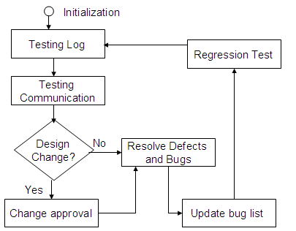

PLAN Appovals
The test plan must be approved and authorised by PM. The approval record form was attached in the test plan.
Approval Record DOCS/Forms/Approval
Project Name Content Management Portal
Document Ref CMP/DOCS/MP.2/
Approved by Haiyang | Date 24/12/2009
Authorised by Haiyang | Date 24/12/2009
The document authorisation appears on the title page. |  | ✔
The structure of the document is logical. |  | ✔
The distribution list is correct. |  | ✔
The title page is signed |  | ✔
Calculations appear reasonable, are neatly presented and have been checked. |  | ✔
Theory and formulae are correct and properly applied. |  | ✔
Illustrations are relevant, readable and logically placed. |  | ✔
There are no typographical errors. |  | ✔
Units are consistent throughout. |  | ✔
The security classification is correct. |  | ✔
There are no obvious omissions. |  | ✔
The document complies with the Client's requirements, however specified. |  | ✔
Responsibility is accepted for all opinions, conclusions and recommendations. |  | ✔
The document does not run counter to company policy. |  | ✔

