Academia Humanities Review Volume 1 (1), July 2026

The Hydrosocial Cycle: Water as Culture, Not Just Resource; Reimagining Smallholder Irrigation Development in Zimbabwe

Vimbai Pachawo
Vimbs Irrigation Consultancy, Zimbabwe
id8129@alunos.uminho.pt
Lorraine Rukarwa
Total Farm Solutions, Zimbabwe
lorarux@gmail.com
Shingirirai Zano
Department of Irrigation, Zimbabwe
shingiezano@gmail.com
Tendai Chimunhu
Department of Irrigation, Zimbabwe
tindochim@gmail.com

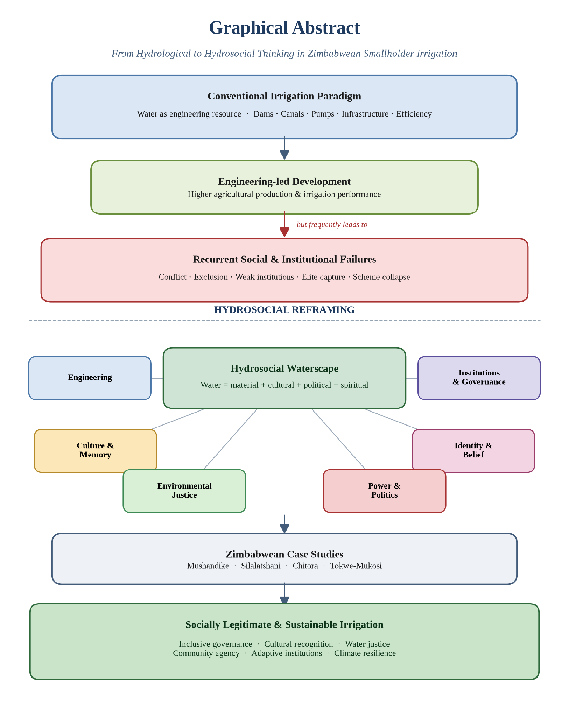
Graphical Abstract. Visual synthesis of the paper’s argument: conventional engineering-led irrigation development in Zimbabwe delivers hydraulic performance but recurrent social failures; a hydrosocial reframing re-centres water as a socio-natural hybrid and yields socially legitimate, culturally meaningful and climate-resilient irrigation.

Published: July 2026

Abstract
Conventional irrigation development has historically conceptualized water as a measurable and controllable physical resource whose efficient allocation can be secured through engineering design, institutional regulation, and economic optimization. While such approaches have improved agricultural productivity in many contexts, they have repeatedly failed to produce durable outcomes in Zimbabwe’s smallholder irrigation schemes. Existing scholarship on Zimbabwean smallholder irrigation has concentrated overwhelmingly on technical performance, engineering design, institutional governance and economic efficiency, giving comparatively little sustained attention to the cultural, political, historical and social dimensions through which water is experienced and governed. This conceptual research article addresses that gap by mobilizing the hydrosocial cycle to reframe water as simultaneously material, cultural, political and social, a hybrid that both shapes and is shaped by relations of power, memory, identity and everyday practice. Through a critical literature review supported by four illustrative Zimbabwean irrigation schemes, Mushandike, Silalatshani, Chitora and Tokwe-Mukosi, the paper demonstrates how engineering interventions have frequently overlooked local water cultures, customary governance systems and community meanings attached to rivers, wetlands and sacred pools, contributing to institutional conflict, weak local ownership and long-term scheme decline. The paper argues that sustainable smallholder irrigation requires integrating hydraulic expertise with social memory, customary institutions and participatory governance, and it advances hydrosocial theory into the context of post-colonial smallholder irrigation in Southern Africa. In doing so, it contributes to contemporary debates in Environmental Humanities, Human Geography, Political Ecology, Water Governance and African Development Studies.
Keywords: hydrosocial cycle; smallholder irrigation; political ecology; water governance; environmental humanities; Zimbabwe.

1. Introduction
Water is routinely described through the language of engineering: flows, reservoirs, canals, storage capacity, abstraction rates, irrigation efficiency. This vocabulary portrays water as a neutral, quantifiable substance whose movement can be predicted, measured and controlled. Such abstraction is indispensable for hydraulic design, but it captures only part of what water is and does in society. As Linton (2010) argues, what we call “modern water”, H₂O abstracted from its social and ecological context, is itself a historically specific cultural production, not a self-evident fact.
Across rural Zimbabwe, water is simultaneously livelihood, heritage, spirituality, memory and political authority. Rivers demarcate administrative and community boundaries; wetlands (dambos) sustain dry-season cultivation and medicinal practices; springs and pools such as those associated with mermaid (njuzu) water spirits carry ancestral significance (Bourdillon 1987; Mawere 2013); and irrigation canals become both cooperative and contested infrastructures. Decisions about water are therefore never merely technical: they are social negotiations embedded in histories of dispossession, race, gender and belonging (Derman and Ferguson 2003; Manzungu 2002).
The hydrosocial cycle provides a conceptual framework for holding these dimensions together. Rather than separating “nature” from “society”, it treats water and social relations as mutually constitutive: institutions shape water flows through dams, canals, policies and technologies, while water simultaneously produces subjectivities, economies and forms of political authority (Swyngedouw 2009; Linton and Budds 2014; Boelens et al. 2016). Bakker’s (2012) closely related notion of the “hydrosocial contract” underscores that every waterscape encodes a distribution of rights, responsibilities and risks.

1.1 Research Gap
Despite an extensive Zimbabwean literature on smallholder irrigation, four scholarly emphases dominate the field: (i) technical performance and hydraulic efficiency (Rukuni 1988; FAO 2016); (ii) engineering design, rehabilitation and command-area optimization (Manzungu and van der Zaag 1996; Moyo et al. 2017); (iii) institutional governance and cost-recovery arrangements after the 1998 Water Act (Kujinga and Manzungu 2004; Derman and Hellum 2007); and (iv) economic efficiency and productivity barriers (Mutambara, Darkoh and Atlhopheng 2016). Cultural, political, historical and social dimensions of water, the meanings attached to rivers, sacred pools and wetlands; the memory of dispossession; gendered and generational hierarchies of allocation; the moral economies of everyday reciprocity, have remained comparatively under-theorized, and are rarely treated as constitutive of irrigation sustainability rather than as background context.
This paper addresses that gap by positioning the hydrosocial cycle as its principal theoretical contribution. It reframes Zimbabwean smallholder irrigation not as a hydraulic system with a social periphery, but as a hydrosocial assemblage in which engineering and meaning co-produce one another. In doing so, it extends hydrosocial theory, developed largely in Andean, European and South Asian contexts (Swyngedouw 1999; Boelens 2014; Mehta 2005), into the post-colonial smallholder irrigation setting of Southern Africa.
This perspective is particularly generative for Zimbabwe’s smallholder irrigation schemes. Since independence, substantial state and donor investment has expanded irrigation infrastructure to enhance food security, reduce poverty and buffer climatic variability (FAO 2016; Moyo et al. 2017). Many schemes were engineered with sound hydraulic principles, adequate water resources and modern infrastructure. Yet performance data reveal a striking pattern of governance disputes, infrastructure decay and partial collapse (Chazovachii 2012; Mutambara et al. 2016). The paper argues that these failures arose not despite good engineering but because planning privileged hydraulic efficiency while neglecting the hydrosocial realities through which communities experience and govern water.

2. Methodology
This paper is a conceptual research article informed by a critical literature review and supported by illustrative case studies. It does not report primary empirical fieldwork; rather, it advances theory by synthesising existing scholarship on Zimbabwean smallholder irrigation and interpreting documented cases through the lens of the hydrosocial cycle (Linton and Budds 2014; Boelens et al. 2016). The methodological stance follows established traditions of conceptual and interpretive scholarship in Environmental Humanities, Political Ecology and Human Geography, in which theoretical innovation is generated through the systematic re-reading of secondary material rather than the collection of new observational data.
The critical literature review proceeded in three iterative phases. Firstly, foundational hydrosocial and political-ecology texts (Swyngedouw 1999, 2004, 2009, 2015; Linton 2010; Linton and Budds 2014; Bakker 2003, 2012; Boelens 2014; Boelens et al. 2016; Mehta 2005; Zwarteveen and Boelens 2014) were read against work on cultural and relational dimensions of water (Strang 2004; Krause and Strang 2016). Secondly, the Zimbabwean and Southern African literature on smallholder irrigation, land reform, water reform and displacement was reviewed (Rukuni 1988; Manzungu 1999, 2002; Manzungu and van der Zaag 1996; Kujinga and Manzungu 2004; Derman and Ferguson 2003; Derman and Hellum 2007; Derman, Hellum and Sithole 2007; Scoones et al. 2010; Chazovachii 2012; Bolding, Mutimba and van der Zaag 2010; Mutambara, Darkoh and Atlhopheng 2016; Moyo et al. 2017; Mavhura 2020; Chirisa, Mutambisi and Bandauko 2015; Muchadenyika 2015). Thirdly, ethnographic and cultural sources on Shona water cosmologies and customary institutions (Bourdillon 1987; Mawere 2013; Cleaver 2012; Ostrom 1990) were used to triangulate the interpretation of the cases.
The four schemes examined; Mushandike, Silalatshani, Chitora and Tokwe-Mukosi, were selected purposely as illustrative examples of distinct hydrosocial dynamics in Zimbabwe, not as a statistically representative sample. Mushandike is a colonial-era gravity scheme that illuminates the long shadow of paternalistic native agricultural policy and contested post-rehabilitation ownership. Silalatshani, in Matabeleland South, foregrounds the friction between formal irrigation committees and lineage-based authority. Chitora, in Mashonaland East, is widely cited as a comparatively successful smallholder-managed scheme in which informal reciprocity underpins performance. Tokwe-Mukosi, Zimbabwe’s largest inland reservoir, exemplifies the hydrosocial rupture produced by large-scale hydraulic modernity, dam-induced displacement and the submergence of culturally significant landscapes. Together the four cases span colonial and post-colonial infrastructures; small and large hydraulic systems; state-led and community-led governance; and functioning, contested and ruptured hydrosocial relations. This deliberate variation supports analytic generalisation to the hydrosocial dynamics of Zimbabwean irrigation rather than statistical generalisation to a defined population of schemes (see Ostrom 1990; Cleaver 2012 for cognate analytic strategies).
Case material is drawn exclusively from peer-reviewed studies, monographs, policy reports and previously published ethnographies. The interpretive strategy proceeds by (i) reconstructing the engineering and governance history of each scheme from the secondary record; (ii) identifying the cultural, political and historical dimensions rendered visible or invisible by that record; and (iii) re-reading the scheme through the hydrosocial cycle to surface implications for irrigation planning. The article’s contribution is therefore theoretical synthesis, interdisciplinary interpretation and conceptual innovation rather than empirical measurement; its claims should be read as conceptual propositions that invite, and are amenable to, subsequent empirical testing.

3. From Hydrological to Hydrosocial: A Conceptual Framework
The geographical hydrological cycle, evaporation, precipitation, infiltration, runoff and storage, is scientifically indispensable, but as Linton (2010) has shown, it emerged historically as a device that abstracts water from social life, positioning humans as external “users” or “managers” of an ostensibly natural flow. This abstraction underwrites what Bakker (2003, 2012) calls the techno-managerial imaginary of water governance.
Hydrosocial theory challenges this separation on three fronts. First, following Swyngedouw’s (1999, 2009) political-ecological reading of the Spanish waterscape, it insists that dams, canals and reservoirs are socio-natural hybrids: their material form is inseparable from the political projects, colonial, developmentalist and neoliberal, that produced them. Second, Linton and Budds (2014) formalize the hydrosocial cycle as a dialectical process in which H₂O and society continually make and remake one another; water is thus both an outcome and an agent of social relations. Third, Boelens and colleagues (Boelens 2014; Boelens et al. 2016) extend this into a territorial register, showing how irrigation waterscapes, “hydrosocial territories”, are sites where competing knowledge, rights systems and cultural meanings collide.
Within this framing:
- Water shapes society through agriculture, health, settlement, livelihoods and identity;
- Society reshapes water through engineering works, legislation, markets and rituals;
- The interchanges continually reproduce landscapes of inclusion and exclusion (Perreault 2014; Loftus 2009).
Irrigation infrastructure is therefore never a purely technical intervention. It is a social project that redistributes opportunity, authority, labor and environmental risk, which Mehta, Veldwisch and Franco (2012) term “water grabbing” when the redistribution is coercive. Figure 1 summarizes the conceptual transition proposed here: from a hydrological imaginary anchored in engineering, institutional regulation and economic efficiency, to a hydrosocial imaginary in which engineering, culture, identity, power, institutions, governance and environmental justice interact to produce irrigation sustainability.
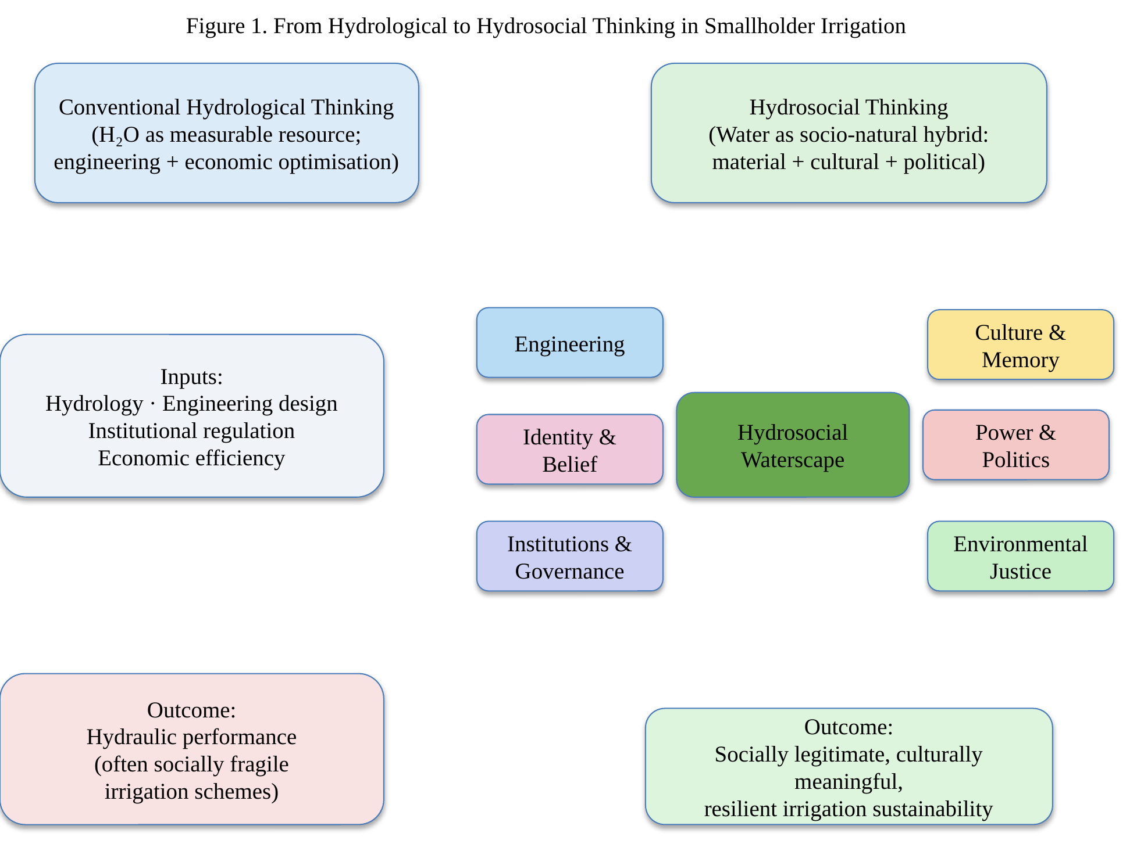
Figure 1. Conceptual framework illustrating the transition from conventional hydrological thinking to hydrosocial thinking in smallholder irrigation planning.

4. Zimbabwe’s Irrigation Development: Engineering Success, Social Failure?
Zimbabwe’s smallholder irrigation history is long and layered. Colonial-era schemes such as Mushandike (established in the 1930s in Masvingo Province) were designed as instruments of native agricultural policy, resettling African farmers under paternalistic technical supervision (Rukuni 1988; Manzungu and Van der Zaag 1996). Post-independence rehabilitation retained much of the original engineering logic, reliable water supply, hydraulic efficiency and command-area optimisation, together with economic return, but grafted new institutions onto it: Irrigation Management Committees, cost-recovery regimes and, after the 1998 Water Act, catchment-based governance (Derman and Hellum 2007; Kujinga and Manzungu 2004).
While technically defensible, this trajectory consistently underestimated the plural legal and cultural orders through which rural Zimbabweans govern water. Statutory rules coexist, often uneasily, with customary authority vested in chiefs, spirit mediums and kinship networks (Bourdillon 1987; Derman, Hellum and Sithole 2007). At Silalatshani in Matabeleland South, for example, Manzungu (1999) documented how formally elected water committees became sites of contestation between agronomic rationalities imposed by extension officers and locally legitimate authority structures rooted in lineage and seniority. Similar dynamics have been reported at Mushandike, where post-rehabilitation governance eroded as farmers, chiefs and the state contested the meaning of “ownership” of infrastructure they had neither designed nor financed (Chazovachii 2012; Mutambara et al. 2016).
Engineering designs frequently assumed communities would simply adopt new institutional arrangements. Instead, formal management structures coexisted uneasily with customary institutions, producing overlapping authorities, ambiguous accountability and, often, the fragmentation of maintenance responsibility. As Cleaver’s (2012) concept of institutional bricolage helps clarify, rural water users do not choose between “modern” and “traditional” institutions; they improvise hybrids from whatever normative materials are at hand. Rehabilitation programmes that ignore this bricolage tend to reproduce, rather than resolve, the governance frictions they claim to fix.

5. Water as Memory and Identity: The Case of Tokwe-Mukosi
Hydrosocial theory insists that communities develop collective memories around water (Krause and Strang 2016; Strang 2004). Rivers mark settlement histories; wetlands supply medicinal plants and dry-season grazing; sacred pools host ancestral ceremonies; seasonal floods calibrate agricultural calendars passed across generations.
Few Zimbabwean cases illustrate this more starkly than Tokwe-Mukosi Dam, the country’s largest inland reservoir, whose construction in Masvingo Province culminated in the catastrophic flooding of 2014 and the displacement of over 20,000 people to Chingwizi transit camp (Mavhura 2020; Chirisa et al. 2015). Beyond the well-documented humanitarian failures, Tokwe-Mukosi enacted a hydrosocial rupture: ancestral graves, sacred groves and ritual sites tied to the Tokwe and Mukosi rivers were submerged, severing communities from the material anchors of lineage identity (Mavhura 2020; Muchadenyika 2015). Displaced households were resettled onto land without hydrological or cultural continuity with the drowned valley, and the promised downstream irrigation development has advanced only partially and unevenly.
Reading through Swyngedouw’s (2015) analysis of large dams as monuments to hydraulic modernity, Tokwe-Mukosi exemplifies how techno-political ambition can produce not only engineering artefacts but also new geographies of loss. Analysing Linton and Budds (2014), it shows how the “same” water, now impounded, renamed, redistributed, becomes a different social object, entangled with grievance, compensation politics and contested futures.
Similar, if less dramatic, hydrosocial ruptures have been documented at Mushandike, where the drying of the Mushandike River during drought years is interpreted by some elders as ancestral displeasure at the disruption of customary water etiquette (Mawere 2013; Chazovachii 2012). When irrigation projects redirect rivers, drain wetlands or impose unfamiliar management systems, they alter not only hydrology but also cultural landscapes. Community resistance in such contexts is rarely opposition to development per se; it is a defense of established relationships with water. Ignoring this, projects reduce participation to a procedural ritual, and maintenance obligations quietly dissolve.

6. Informal Water Practices and Everyday Governance: Lessons from Chitora
One of the most overlooked dimensions of Zimbabwean irrigation is the dense fabric of informal water practice. At the smallholder-managed Chitora irrigation scheme in Mashonaland East Province, often cited as a comparatively successful case, farmers have sustained the scheme largely through locally negotiated arrangements rather than the formal by-laws prescribed at rehabilitation (Bolding, Mutimba and van der Zaag 2010; Mutambara et al. 2016). These include:
- reciprocal labour exchanges (jangano / nhimbe) for canal cleaning;
- negotiated water sharing between head- and tail-enders;
- rotational irrigation timings adjusted seasonally;
- drought-time reallocation mediated by respected elders;
- conflict resolution through hybrid forums combining committee members and traditional authorities.
Such arrangements maintain cohesion under conditions of infrastructural imperfection and climatic variability. Yet externally designed projects frequently replace these adaptive arrangements with rigid schedules, standard operating procedures and bureaucratic accountability chains. Rather than raising efficiency, such institutional overwriting can undermine cooperation by eroding local flexibility, a dynamic Cleaver (2012) and Ostrom (1990) both anticipate.
A hydrosocial reading recasts informal practices not as governance deficits but as adaptive institutions forged through long histories of interaction with variable water availability (Mehta 2005; Boelens et al. 2016). The policy implication is significant: rehabilitation should build from these institutions, not around them.

7. Comparative Synthesis of the Four Cases
Table 1 summarizes the four schemes along dimensions salient to a hydrosocial reading: engineering focus, principal hydrosocial challenge, and the lesson each case yields for irrigation planning. The table is intended as an interpretive synthesis of the illustrative material, not as a statistical comparison.
Table 1. Comparative synthesis of the four illustrative Zimbabwean irrigation schemes.
Irrigation Scheme | Engineering Focus | Hydrosocial Challenge | Principal Lesson for Planning
Mushandike (Masvingo, 1930s) | Colonial gravity-fed command area; post-independence rehabilitation for hydraulic efficiency. | Contested ownership; erosion of customary authority; drying river interpreted as ancestral displeasure. | Rehabilitation must negotiate colonial legacies and integrate customary meanings of water.
Silalatshani (Matabeleland South) | Formal irrigation committees and cost-recovery rules layered onto existing lineage authority. | Friction between agronomic rationalities of extension officers and lineage-based seniority; head/tail-end inequity. | Governance design must recognize plural legal orders and address intra-scheme spatial hierarchies.
Chitora (Mashonaland East) | Smallholder-managed scheme with modest formal infrastructure; hybrid formal/informal by-laws. | Success rests on informal reciprocity (jangano/nhimbe), elder-mediated allocation, adaptive rotations. | Planning should build from adaptive informal institutions rather than overwriting them.
Tokwe-Mukosi (Masvingo) | Large multipurpose dam; downstream irrigation command; techno-political hydraulic modernity. | Displacement to Chingwizi; submergence of sacred sites and graves; hydrosocially dispossessed households. | Large infrastructure must account for cultural continuity, grievance, and post-displacement justice.

8. Water, Power and Social Inequality
Water infrastructure inevitably redistributes power (Swyngedouw 2004; Loftus 2009; Bakker 2012). In Zimbabwean schemes this plays out along several axes:
- Spatial hierarchy. Head-end farmers at Silalatshani and Mushandike consistently receive more reliable supply than tail-enders, producing entrenched intra-scheme inequalities (Manzungu 1999; Mutambara et al. 2016).
- Gender. Women contribute the majority of irrigation labour yet remain under-represented in formal committees, echoing patterns documented across Southern Africa (Zwarteveen 1997; Derman, Hellum and Sithole 2007).
- Generation. Youth, despite depending on irrigation for livelihoods, wield limited influence over allocation decisions dominated by senior male household heads (Scoones et al. 2010).
- Displacement. At Tokwe-Mukosi, dam-induced resettlement produced a new category of hydrosocially dispossessed households whose entitlements remain formally unresolved (Mavhura 2020).
These inequalities are not accidental by-products of infrastructure; following Swyngedouw (2004) and Perreault (2014), they are produced through the hydrosocial assemblage that links pipes, policies and power. Irrigation performance, therefore, cannot be separated from questions of water justice (Zwarteveen and Boelens 2014). Hydraulic efficiency without social equity rarely produces long-term sustainability.

9. Towards Hydrosocial Irrigation Planning
Recognising water as a hydrosocial entity demands substantive changes in how irrigation is planned, financed and evaluated. Engineering expertise remains essential, but it must operate alongside serious social inquiry. Building on Boelens et al. (2016), Zwarteveen and Boelens (2014) and Mehta (2005), a hydrosocial planning agenda for Zimbabwe should integrate:
- participatory mapping of community water values and sacred sites;
- documentation and formal recognition of customary water institutions;
- incorporation of local ecological knowledge into scheme design;
- gender- and youth-sensitive governance arrangements;
- conflict-sensitive institutional design attentive to historical grievance (especially at post-displacement sites like Chingwizi);
- protection of culturally significant water landscapes (sacred pools, wetlands, riverine groves).
Hydrological modelling should be complemented by ethnographic and historical understanding. Beyond the standard question of whether sufficient water exists, planners should ask, with Boelens (2014) and Linton and Budds (2014):
- Who defines legitimate water use?
- Whose knowledge counts in infrastructure design?
- Which cultural relationships with water are strengthened or weakened?
- Who benefits, and who bears the risks?
These questions extend irrigation planning beyond infrastructure towards social sustainability.

10. Theoretical Contribution and Scope of the Study
The paper’s contribution is theoretical rather than empirical. It extends hydrosocial theory, developed principally in Andean (Boelens 2014; Boelens et al. 2016), European (Swyngedouw 1999, 2015) and South Asian (Mehta 2005) contexts, into the specific setting of post-colonial smallholder irrigation in Southern Africa. In this setting, colonial hydraulic legacies, statutory water reform, customary institutions, spirit-based cosmologies and dam-induced displacement combine in ways that existing hydrosocial scholarship has not fully addressed. By reading Mushandike, Silalatshani, Chitora and Tokwe-Mukosi through this lens, the paper offers a conceptual vocabulary through which African irrigation performance can be theorized as an outcome of co-produced hydraulic and cultural systems.
The article makes a deliberately interdisciplinary contribution. For Environmental Humanities, it foregrounds the cultural, ritual and memorial life of water in a region often written about in strictly developmentalist terms. For Political Ecology, it demonstrates how colonial and post-colonial hydraulic projects redistribute power along spatial, gendered and generational lines. For Human Geography, it treats irrigation schemes as hydrosocial territories in which knowledge, rights and meanings collide. For Water Governance scholarship, it reframes the persistent “implementation gap” in Zimbabwean water reform as a hydrosocial mismatch rather than a technical or institutional deficit. For African Development Studies, it argues that socially legitimate irrigation cannot be engineered without engaging African epistemologies of water.

10.1 Limitations
Consistent with its conceptual character, the paper acknowledges three self-imposed limits. Firstly, the four case studies are illustrative rather than statistically representative; they are mobilized to surface distinct hydrosocial dynamics, not to support generalization to a defined population of schemes. Secondly, the article is conceptual and does not rely on primary empirical data; its claims are conceptual propositions grounded in a critical reading of the secondary literature, and they invite subsequent empirical testing through ethnography, oral history, hydrological modelling and comparative survey work. Thirdly, the paper’s contribution lies in theoretical synthesis, interdisciplinary interpretation and conceptual innovation rather than in the measurement of scheme performance. These positions are stated explicitly here so that the article’s claims are read within their intended register.

11. Conclusion
The persistent challenges facing Zimbabwe’s smallholder irrigation schemes cannot be fully explained through engineering limitations, financial constraints or climatic variability. They reflect deeper mismatches between technical interventions and the lived realities of water in rural communities, mismatches made visible by the hydrosocial lens.
The cases of Mushandike, Silalatshani, Chitora and Tokwe-Mukosi show that water is at once ecological, technological, cultural, political and historical. Schemes endure not merely when canals deliver water efficiently, but when institutions reflect local practice, when governance acknowledges existing social relationships and when infrastructure strengthens rather than erases community understandings of water. To view water solely as a resource is to reduce development to hydraulic optimization; to view water as culture is to expand irrigation into a project of social collaboration, historical continuity and environmental justice.
The implications of this argument extend well beyond Zimbabwe. Across sub-Saharan Africa, smallholder irrigation is being scaled up as a central instrument of food security, poverty reduction and climate adaptation, often through the same techno-managerial templates that underpinned earlier Zimbabwean interventions. A hydrosocial approach offers a diagnostic and design vocabulary for this wider region: it prompts planners to treat customary institutions, sacred landscapes and gendered labor regimes as constitutive elements of irrigation sustainability rather than as social “add-ons”.
For climate adaptation, hydrosocial thinking is particularly generative. Adaptation strategies that concentrate on infrastructural hardening, larger dams, expanded canals, additional boreholes, risk reproducing the very hydrosocial ruptures documented at Tokwe-Mukosi, unless they are matched by attention to the cultural and institutional systems through which communities absorb hydrological shocks. Adaptive capacity is not only a function of storage and abstraction; it is also a function of memory, reciprocity and legitimacy.
Hydrosocial thinking also speaks directly to Sustainable Development Goal 6 (Clean Water and Sanitation) and to the broader 2030 Agenda (UN 2015). SDG 6 targets on integrated water resources management, water-use efficiency and participation of local communities cannot be met by hydraulic and administrative reforms alone: they require the socially inclusive water governance that a hydrosocial approach makes possible, governance attentive to plural legal orders, to gendered and generational inequalities and to the cultural meanings that underwrite compliance and cooperation.
Future research should therefore extend the conceptual work developed here in at least four directions. First, comparative empirical studies of Zimbabwean schemes should test the propositions advanced in this paper through mixed-method fieldwork combining hydrological monitoring, ethnography and oral history. Second, cross-country comparisons across Southern and Eastern Africa should examine how hydrosocial dynamics vary with colonial legacy, land tenure and hydro-climatic regime. Third, gender- and youth-focused studies should trace how hydrosocial hierarchies are reproduced and contested in the everyday life of schemes. Fourth, methodological work is needed on how participatory mapping, ethnographic diagnostics and cultural-landscape assessments can be embedded in the standard feasibility and rehabilitation cycles of irrigation planning. Pursued together, these agendas would consolidate hydrosocial thinking not as a supplement to engineering but as its indispensable complement, and would offer irrigation systems that are technically functional, socially legitimate, culturally meaningful and resilient to climatic and institutional change.

References
Bakker, K. 2003. An Uncooperative Commodity: Privatizing Water in England and Wales. Oxford: Oxford University Press.
Bakker, K. 2012. “Water: Political, Biopolitical, Material.” Social Studies of Science 42 (4): 616-623.
Boelens, R. 2014. “Cultural Politics and the Hydrosocial Cycle: Water, Power and Identity in the Andean Highlands.” Geoforum 57: 234-247.
Boelens, R., J. Hoogesteger, E. Swyngedouw, J. Vos, and P. Wester. 2016. “Hydrosocial Territories: A Political Ecology Perspective.” Water International 41 (1): 1-14.
Bolding, A., J. Mutimba, and P. van der Zaag. 2010. “Interventions in Smallholder Agriculture: Implications for Extension in Zimbabwe.” Wageningen: Wageningen University.
Bourdillon, M. F. C. 1987. The Shona Peoples. Gweru: Mambo Press.
Chazovachii, B. 2012. “The Impact of Small Scale Irrigation Schemes on Rural Livelihoods: The Case of Panganai Irrigation Scheme, Bikita District, Zimbabwe.” Journal of Sustainable Development in Africa 14 (4): 217-231.
Chirisa, I., E. Mutambisi, and E. Bandauko. 2015. “Post-Disaster Rehabilitation and Reconstruction: A Study of the Tokwe-Mukosi Disaster in Zimbabwe.” Jàmbá: Journal of Disaster Risk Studies 7 (1): 1-7.
Cleaver, F. 2012. Development through Bricolage: Rethinking Institutions for Natural Resource Management. London: Routledge.
Derman, B., and A. Ferguson. 2003. “Value of Water: Political Ecology and Water Reform in Southern Africa.” Human Organization 62 (3): 277-288.
Derman, B., and A. Hellum. 2007. “Livelihood Rights Perspective on Water Reform: Reflections from Zimbabwe.” Land Use Policy 24 (4): 664-673.
Derman, B., A. Hellum, and P. Sithole. 2007. “Intersections of Human Rights and Customs: A Livelihood Perspective on Water Laws.” In Community-Based Water Law and Water Resource Management Reform in Developing Countries, edited by B. van Koppen, M. Giordano, and J. Butterworth, 177-191. Wallingford: CABI.FAO. 2016. AQUASTAT Country Profile, Zimbabwe. Rome: Food and Agriculture Organization.
Krause, F., and V. Strang. 2016. “Thinking Relationships Through Water.” Society & Natural Resources 29 (6): 633-638.
Kujinga, K., and E. Manzungu. 2004. “Enduring Contestations: Stakeholder Strategies in Water Resources Management in the Save Catchment, Zimbabwe.” Eastern Africa Social Science Research Review 20 (1): 67-91.
Linton, J. 2010. What Is Water? The History of a Modern Abstraction. Vancouver: UBC Press.
Linton, J., and J. Budds. 2014. “The Hydrosocial Cycle: Defining and Mobilizing a Relational-Dialectical Approach to Water.” Geoforum 57: 170-180.
Loftus, A. 2009. “Rethinking Political Ecologies of Water.” Third World Quarterly 30 (5): 953-968.
Manzungu, E. 1999. Strategies of Smallholder Irrigation Management in Zimbabwe. Wageningen: Wageningen University (PhD thesis).
Manzungu, E. 2002. “The Processes and Dynamics of Catchment Management in Zimbabwe.” Harare: Save Africa Trust Publications.
Manzungu, E., and P. van der Zaag, eds. 1996. The Practice of Smallholder Irrigation: Case Studies from Zimbabwe. Harare: University of Zimbabwe Publications.
Mavhura, E. 2020. “Learning from the Tokwe-Mukosi Dam-Induced Displacement in Zimbabwe.” International Journal of Disaster Risk Reduction 44: 101439.
Mawere, M. 2013. “Traditional Environment Conservation Strategies in Pre-Colonial Africa: Lessons for Zimbabwe to Forget or to Carry Forward into the Future?” Afro Asian Journal of Social Sciences 4 (4.2): 1-23.
Mehta, L. 2005. The Politics and Poetics of Water: Naturalising Scarcity in Western India. New Delhi: Orient Longman.
Mehta, L., G. J. Veldwisch, and J. Franco. 2012. “Introduction to the Special Issue: Water Grabbing? Focus on the (Re)appropriation of Finite Water Resources.” Water Alternatives 5 (2): 193-207.
Moyo, M., A. van Rooyen, M. Moyo, P. Chivenge, and S. Bjornlund. 2017. “Irrigation Development in Zimbabwe: Understanding Productivity Barriers and Opportunities at Mkoba and Silalatshani Irrigation Schemes.” International Journal of Water Resources Development 33 (5): 740-754.
Muchadenyika, D. 2015. “Land for Housing: A Political Resource, Reflections from Zimbabwe’s Urban Areas.” Journal of Southern African Studies 41 (6): 1219-1238.
Mutambara, S., M. F. C. Darkoh, and J. R. Atlhopheng. 2016. “A Comparative Review of Water Management Sustainability Challenges in Smallholder Irrigation Schemes in Africa and Asia.” Agricultural Water Management 171: 63-72.
Ostrom, E. 1990. Governing the Commons: The Evolution of Institutions for Collective Action. Cambridge: Cambridge University Press.
Perreault, T. 2014. “What Kind of Governance for What Kind of Equity? Towards a Theorization of Justice in Water Governance.” Water International 39 (2): 233-245.
Rukuni, M. 1988. “The Evolution of Smallholder Irrigation Policy in Zimbabwe: 1928–1986.” Irrigation and Drainage Systems 2 (2): 199-210.
Scoones, I., N. Marongwe, B. Mavedzenge, J. Mahenehene, F. Murimbarimba, and C. Sukume. 2010. Zimbabwe’s Land Reform: Myths and Realities. Woodbridge: James Currey.
Strang, V. 2004. The Meaning of Water. Oxford: Berg.
Swyngedouw, E. 1999. “Modernity and Hybridity: Nature, Regeneracionismo, and the Production of the Spanish Waterscape, 1890-1930.” Annals of the Association of American Geographers 89 (3): 443-465.
Swyngedouw, E. 2004. Social Power and the Urbanization of Water: Flows of Power. Oxford: Oxford University Press.
Swyngedouw, E. 2009. “The Political Economy and Political Ecology of the Hydro-Social Cycle.” Journal of Contemporary Water Research & Education 142 (1): 56-60.
Swyngedouw, E. 2015. Liquid Power: Contested Hydro-Modernities in Twentieth-Century Spain. Cambridge, MA: MIT Press.
UN. 2015. Transforming Our World: The 2030 Agenda for Sustainable Development. New York: United Nations.
Zwarteveen, M. 1997. “Water: From Basic Need to Commodity, A Discussion on Gender and Water Rights in the Context of Irrigation.” World Development 25 (8): 1335-1349.
Zwarteveen, M., and R. Boelens. 2014. “Defining, Researching and Struggling for Water Justice: Some Conceptual Building Blocks for Research and Action.” Water International 39 (2): 143-158.

