Running the Image Checker

1. Copy a tab-delimited text version of the Excel spreadsheet to be checked into the parser_input/ folder. Rename this file input.txt. Also, copy the listings.txt file into this folder.

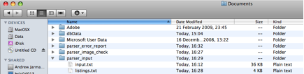

2. Open up a terminal shell (on toolbar). Navigate to the folder Documents/parser_image_check/ and press Enter.

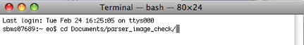

3. Type the following on the command line and press Enter:

java -jar checkimages.jar -f /Users/eo/Documents/parser_image_check/input.properties

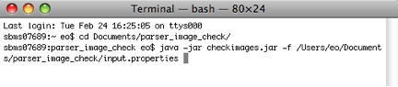

4. By pressing Enter, you will run the image checker program.

You will see something like the following:
DO YOU WISH TO PROCEED? Y/N

5. Press y.

You will see a list of filenames, which will end with something like this.

********* FINISHED **********
Number of Rows transformed: 8
sbms07689:parser_image_check eo$

Ensure that the number of rows transformed is equivalent to the number of submissions in the spreadsheet.

An error report entitled ‘image_error_report.txt’ will have been generated in the ‘parser_error_report’ folder.

