Running the Probe Checker
1. Navigate to the folder which contains both the perl script ‘primer_coordinates’ and Blast applications.
sbms07689:~ eo$ cd Desktop/test/
Press enter
_______________________________________________________________________
2. Define the path.
sbms07689:~/Desktop/test eo$ export PATH=.:$PATH
Press enter
_______________________________________________________________________
3. Type ‘primer_coordinates’ followed by the input file (text windows format).
sbms07689:~/Desktop/test eo$ primer_coordinates ArchiveXXX.txt
Press enter
_______________________________________________________________________
4. You will see something like the following:
Processing NM_013523.2 ...
Processing NM_007857.2 ...
Processing NM_007809.2 ...
Coordinates are stored in ArchiveXXX_processed.txt

This exe file was created with the evaluation version of Perl2Exe.
For more information visit http://www.indigostar.com
(The full version does not display this message with a 2 second delay.)
...
_______________________________________________________________________
A probe report will have been generated in the ‘test’ folder.
The filename of this report appears in the Unix shell.
(in the example above, the filename is ‘ArchiveXXX_processed.txt’)

_______________________________________________________________________
IMPORTANT - The input file should contains only 3 columns. these are:
- Accession_Number
- Probe_5’
- Probe_3’
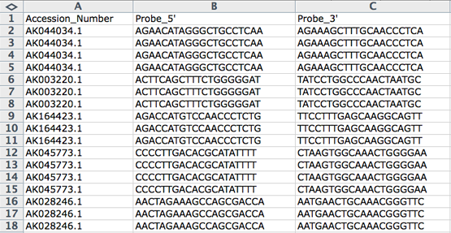

The input file must be saved as a text windows format.
