Running the Spreadsheet Checker
1. Copy a tab-delimited text version of the Excel spreadsheet to be checked into the ‘parser_input’ folder.
Rename this file ‘input.txt’.
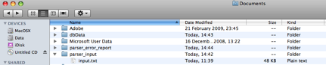
_______________________________________________________________________
2. Open up the 'input.properties' files. The parameters in this file must match the type of Excel spreadsheet the submitter is using.
For a high resolution spreadsheet, ensure you have set the following parameters:
- stage=hires
- format=hires
For a TS23 low resolution spreadsheet, ensure you have set the following parameters:
- stage=23
- format=23
_______________________________________________________________________
3. Open up a terminal shell (on toolbar). Navigate to the folder ‘Documents/dbData/’ and press enter.
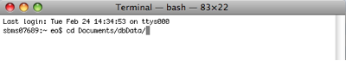
_______________________________________________________________________
4. Type the following on the command line and press enter.
jar -xf submitparser.jar

_______________________________________________________________________
5. Type the following on the command line and press enter.
java -cp .:/Users/Chris/Documents/dbData/mysql_3.1.12.jar hgu.submitparser.bin.Submit_Parser -f ./input.properties
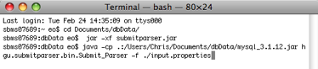
_______________________________________________________________________
6. By pressing enter, you will run the spreadsheet checker program.
You will see something like the following:
DO YOU WISH TO PROCEED? Y/N
_______________________________________________________________________
7. Press ‘y’.
You will see a list of filenames, which will end with something like this.
********* FINISHED **********
Number of Rows transformed: 8
sbms07689:dbData eo$
Ensure that the number of rows transformed is equivalent to the number of submissions in the spreadsheet.
_______________________________________________________________________
An error report will have been generated in the ‘parser_error_report’ folder.
