Isolation of transgene-expressing (e.g. GFP+) sensory neuron progenitors from fetal and postnatal DRG by flow sorting

Source: Michelle Southard-Smith Laboratory

Buehler, D. P., Wiese, C. B., Skelton, S. B., Southard-Smith, E. M. An Optimized Procedure for Fluorescence-activated Cell Sorting (FACS) Isolation of Autonomic Neural Progenitors from Visceral Organs of Fetal Mice. J. Vis. Exp. (66), e4188, doi:10.3791/4188 (2012).

Last update: November 25, 2015

This protocol was developed after consultation with Sean Morrison’s group (formerly at University of Michigan, particularly Jack Mosher) and the staff of the Vanderbilt Flow Core Facility (particularly Kevin Weller and Dave Flaherty). Methods were optimized by Stephanie Byers-Skelton and Dennis Buehler in the Michelle Southard-Smith Lab.

Reagents used for this procedure:

Tissue Culture Grade Water, Lonza (Cat#17-724Q)
10x PBS pH 7.4, Gibco (Cat# 70011-044)
-Make up to 1x with tissue culture grade water then sterile filter
10x HBSS w/o Ca or Mg, Gibco (Cat# 14185-052)
-Make up to 1x with tissue culture grade water then sterile filter
Accumax, Sigma (Cat# A7089)
DNAse I, Sigma (Cat# D4527)
-5mg/ml in 1xHBSS, Store aliquoted at -20ºC
L-15 media, Gibco (Cat# 21083-027)
Penicillin /Streptomycin 100X, Gibco (Cat# 15140-122)
BSA, Sigma (Cat# A3912)
-100mg/ml in TC H2O, Store aliquoted at -20ºC
1M HEPES, Lonza (Cat# 17-737E)
Nitex Nylon Mesh - 38 Micron - Open Area %: 22 - Width: 40 in, ELKO Filtering (Cat# 3-38/22)
- Cut into ~3 cm squares. UV treat overnight to sterilize in tissue culture hood.
7-AAD, Invitrogen (Cat# A-1310)
5 ml polystyrene tubes, Falcon (Cat# 352058)

Prepare L15 staining media the morning of the isolation:

- L15 staining media: (for 50 ml of solution)
43.5 ml - L15 media
0.5 ml - Penicillin /Streptomycin
0.5 ml - BSA (for 1mg/ml)
0.5 ml - HEPES (for 10mM)
5 ml - TC Water
- Mix well and filter final media through 0.2 micron filter to sterilize. Keep on ice
- Use L-15 staining Media from step 1 to make up Quencing solutions:
  - Quench- 45 μl DNase I , 6 ml L-15 Media
  - Quench 1:5- 45 μl DNase I , 30 ml L-15 Media

Dissociation Procedure:

- Dissect embryonic tissues in ice cold 1xPBS, collecting tissues from wild-type and GFP+ embryos separately
- Transfer dissected tissues (GFP+ and wild-type separately) to 15ml conical tubes containing ice-cold 1xHBSS.
- Pellet tissues by centrifugation for 5 minutes at 210 RCF, 4°C.
- Aspirate off as much HBSS as possible
- Resuspend tissue in 1 ml of Accumax. (Scale amount up/down for large/small amounts of tissue)
- Incubate suspension in 37°C water bath until tissue begins to fall apart with gentle mixing (usually 20-40 minutes but depends on tissue type).
  - Flick tube down to help manually dissociate halfway through the incubation time
- Remove samples to ice and immediately add 1ml of Quench, triturating to dissociate residual pieces.
- Filter cell suspension through Nylon Mesh positioned atop a new 15ml conical tube.
  - Wash sides of Tube with 1 ml Quench 1.5 and filter to get any remaining tissue pieces
- Pellet cells by centrifugation for 5 minutes at 210 RCF, 4°C.
- Aspirate off supernatant being careful not to disturb the cell pellet. Resuspend in 1ml Quench 1:5
- Filter a second time through the nylon mesh into 5 ml polystyrene tubes for Flow Cytometry
  - Wash sides of Tube with 1 ml Quench 1.5 and filter to get any remaining cells
- Divide the wild-type cells into 2 tubes, and set aside 1/10-1/20 of volume of the GFP+ cells in a separate tube for compensation controls. For viable GFP+ neural crest cells you will need the following controls:
  - Unstained wild-type cells
  - 7AAD stained wild-type cells
  - GFP only cells (this is your 1/10-1/20 aliquot)
- Fill all tubes with Quench 1:5.
- Pellet cells by centrifugation for 5 minutes at 210 RCF, 4°C.
- Aspirate off supernatant, leaving approximately 200 µl of supernatant over the cell pellet.
- Add 150-200 µl 7AAD (Diluted 1:1000 in Quench 1:5) to 7AAD stained WT control and GFP+ sample to be sorted (larger portion of GFP+ cells)
- Keep tubes on ice and covered until arrival at the Flow Cytometry Facility.

FACS Procedures:

Setup of sorts requires use of compensation controls to correct for spectral overlap of fluorochromes so that fluorescence detected in a particular detector (eg GFP) derives solely from the fluorochrome that is being measured such as
- unstained cells
- wildtype cells that contain only 7AAD
- GFP+ cells that do not contain any 7AAD
- Finally – the experimental isolate of 7AAD+, GFP+ cells

Southard-Smith Lab gating hierarchy applied during flow sort isolations using FACS Diva software for acquisition on BDFACS AriaII:

- Gate for single cells such that cell debris and multiplets are excluded based on forward (FSC) and side (SSC) scatter area.
- Gate to exclude any residual doublets by geometry gating for width and height measurement of FSC and SSC
- Gate to exclude non-viable cells that are 7AAD+ so that only the 7AAD- population is retained. % viability will be indicated by No. 7AAD- events / total single cell events
- Gate to select for presence of GFP or other cell surface marker

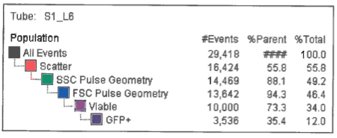

Viability of %Parent = 10,000 / 13,642 = 73%
Viability of %Total = 10,000 / 29,418 = 34%

In the example above 35% of viable cells sorted are GFP+ and 12% of total events through the sorter are GFP+.

Typical Compensation Sort Profile of “Unstained” sample
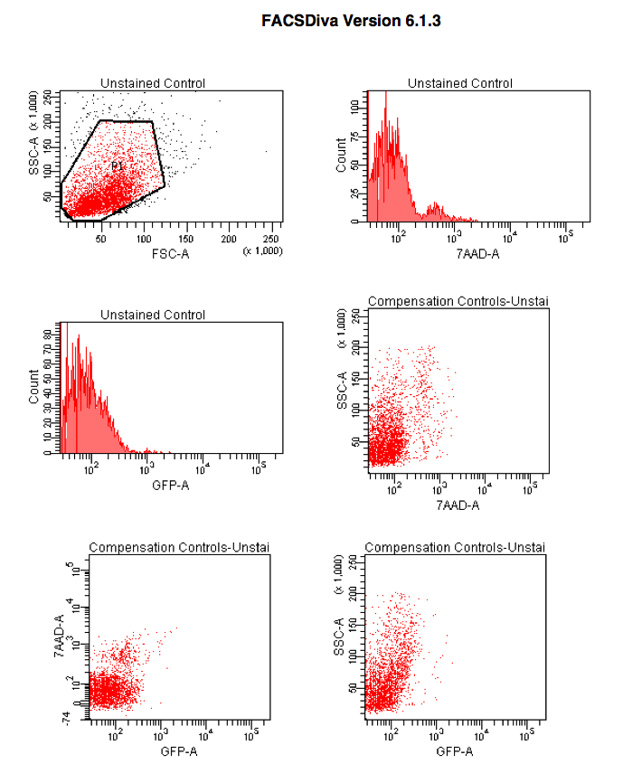
Typical Compensation Sort Profile of “7AAD only” sample
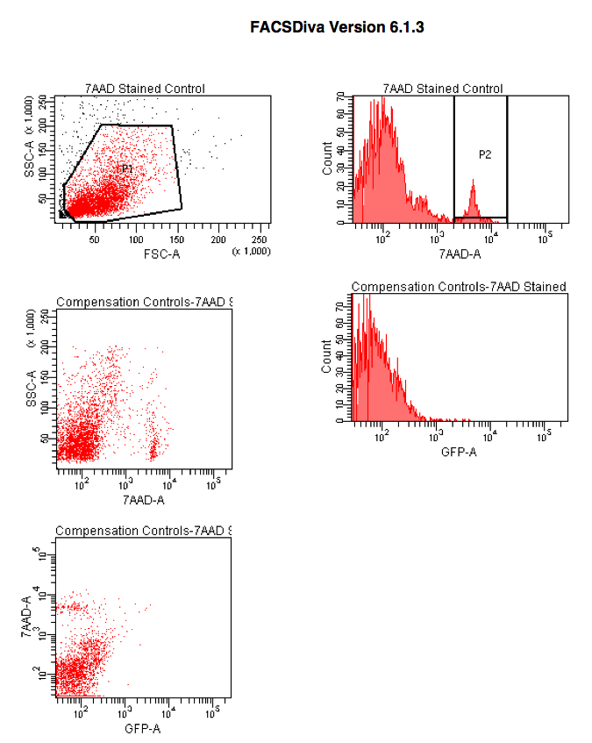
Typical Compensation Sort Profile of “GFP only” sample
NOTE: this GFP only sample derived from fetal gut, which contains GFP+cells, but at lower intensity than fetal DRG. Optimal GFP only control should be at comparable level so either use DRG cells without 7AAD added or if DRG cells are limiting pick a tissue source with comparable GFP level such as fetal brain
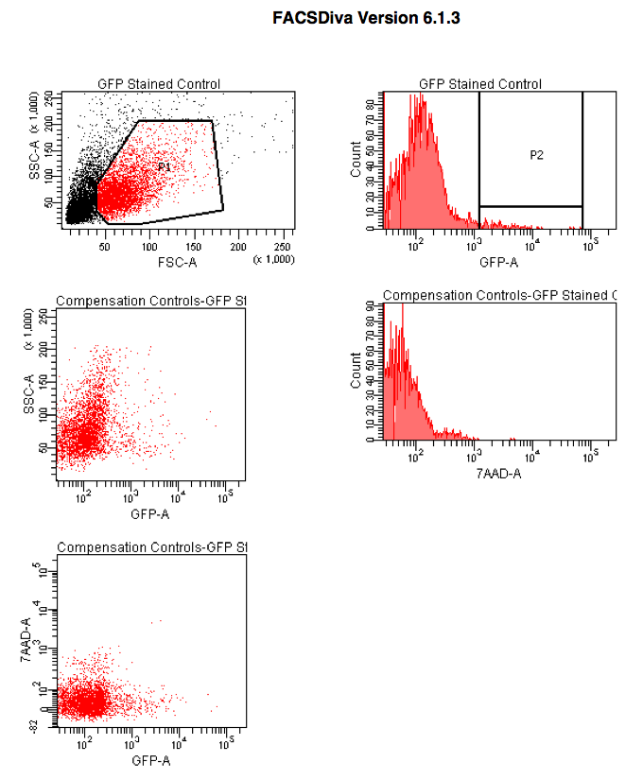

Run of samples after compensation has been applied. “Unstained” sample.
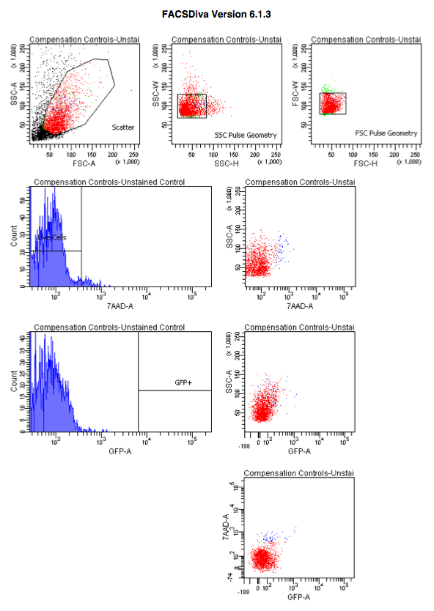

Run of samples after compensation has been applied. “7AAD+” control sample.
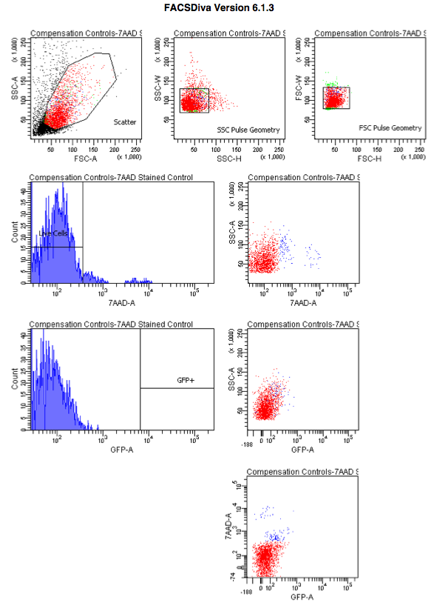

Run of samples after compensation has been applied. “GFP only” sample.
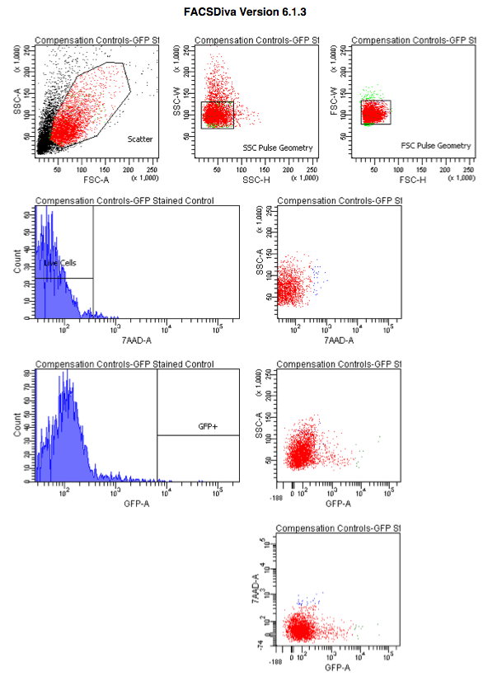
Run of experimental sample after compensation has been applied. “7AAD+, GFP+”.
