Normalisation of cDNA microarray CHP files
CHP files are normalised by averaging values for each cDNA probe across entire datasets. Binary logarithms (log2) of these normalised values are published as heatmaps on the GUDMAP website.

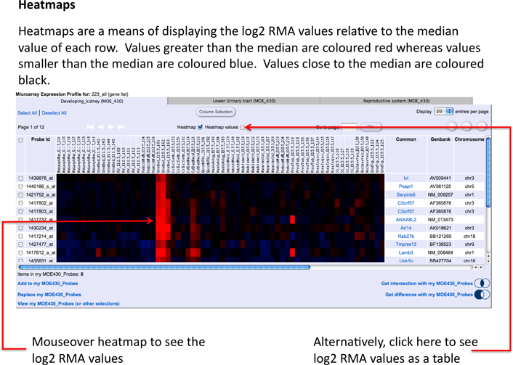

Heatmaps are currently available for the following datasets.

- Developing Kidney (MOE_430)
- Lower Urinary Tract (MOE_430)
- Reproductive Gonadal (MOE_430)
- Developing Kidney (ST1)
- Developing Gonadal FACS (ST1)
- Developing Pelvic Ganglia FACS (ST1)
- JGS Single Cell (ST1)

To display heatmaps we use the following formula:

- M (of a probeset in sample i) = RMA (of probeset in sample i) - RMA (median of its value across all samples)

More details on the Affymetrix platforms (MOE430, ST1) can be found here.

