How to perform searches in GPCR data explorer:

1. Go to this URL: <https://data.gpcrconsortium.org/>

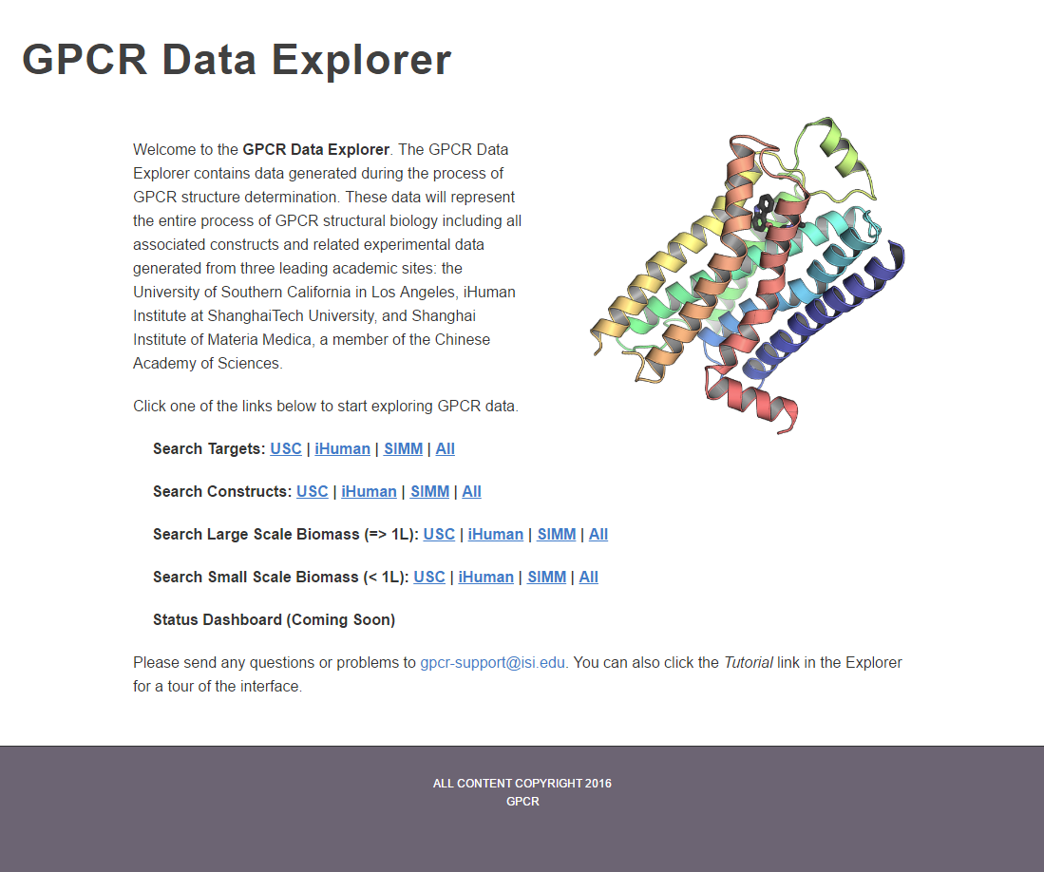

1. Pick USC as an example.

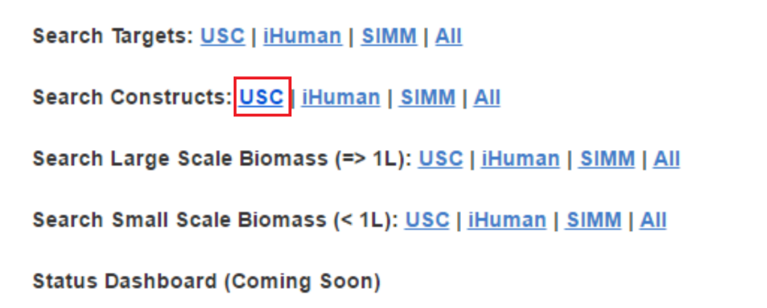

3. Here is the Target search page

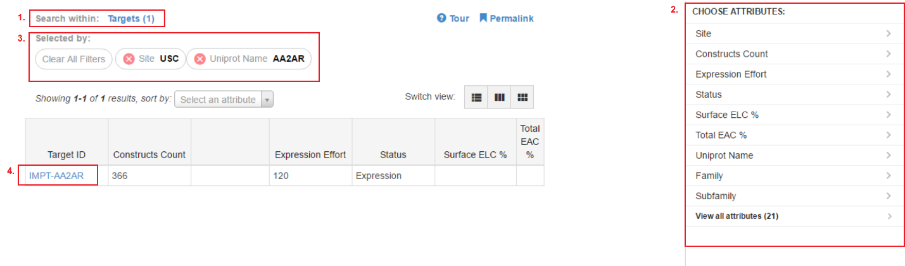

1. This area shows you what you are currently searching, next to it is the number of results return by the system.
2. This area is your search options. As an example, click on the [Uniprot Name] and select AA2AR (click on the [Uniprot Name] again to go back). The browser will refresh every time when you applied a new filter.
3. This area show you the current search condition.
4. This is the result window. The hyperlink is highlighted in blue, click on the link and will take you to the next details page. Here you will see a short summary of the Target. In addition, you can compare the sequence alignment against the wild type and other constructs. Click on the hyperlink IMPT-AA2AR to continue.

4. Here is the construct search page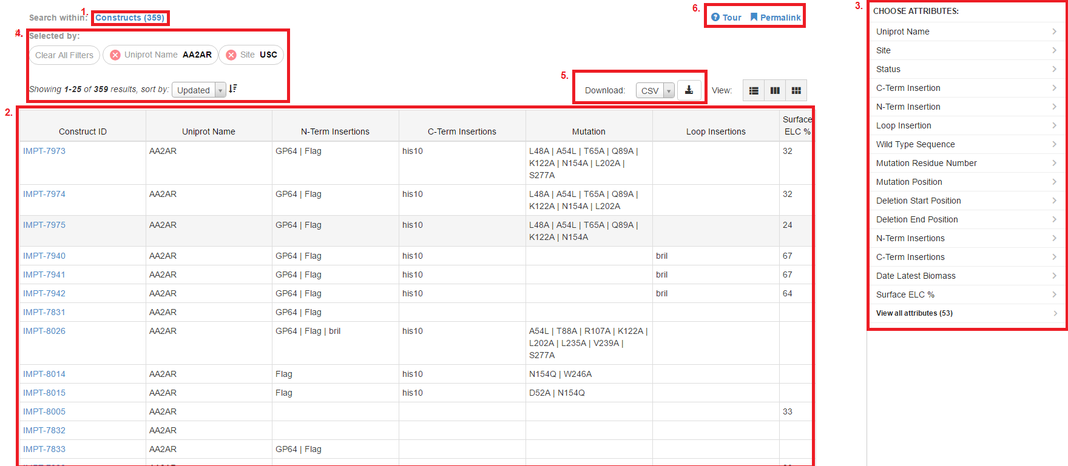

1. This area shows you what you are currently searching, next to it is the number of results returned by the system.
2. This area display the output and details.
3. This area is your search option for the current page. Noticed the search filter is already applied from your previous steps.
4. This area shows you the selected filters from your previous step. The sorting menu is at the bottom. As an example, pick ‘updated’ in the dropdown menu. Next, click the arrow next to it to the dropdown (to sort from the most recent to the oldest).
5. This is the download option of the browser. User can select the download format here from the dropdown. Based on the filters we used, this download will output all the 359 records. The result will contain all the fields in the database for each record.
6. There is a Tour function for each page. The Permalink give you the URL to save or share with other users.
7. Click on one of the any of the constructs to continue:

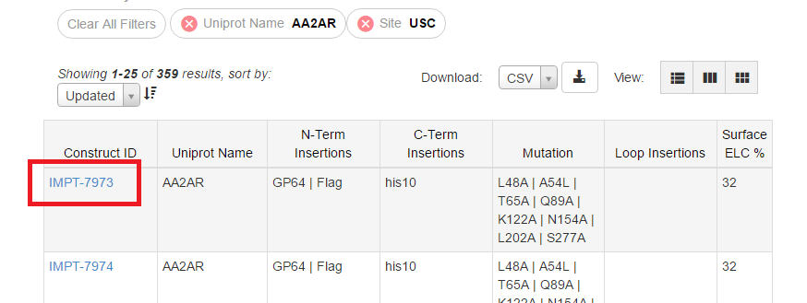

Select any construct from the page will take you to the details construct page, here you will see all the information available for this construct. In addition, you can go back to the Target information to compare the sequence alignment against the wild type and other constructs. You can also browse the related biomass for this construct and its details. Click on the hyperlink next to the View Biomasses and go to the biomass page.

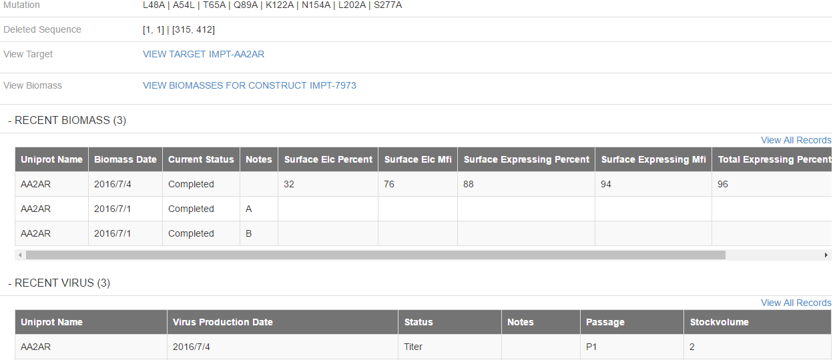

In the next page, you will notice the current search is linked to Biomass Expressions (black box). Similar to searching in the construct page, you can filter information based on the right pane. The search condition for this page is any biomass with a construct ID equal to **IMPT-7973**. Select one of the recent biomass to continue:

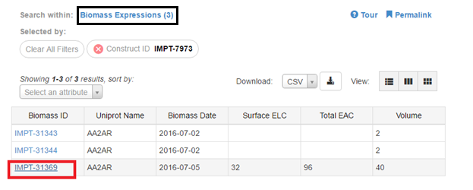

In the biomass details page, you will see all the information related to this biomass. Including the FCS plots downloadable from the browser:

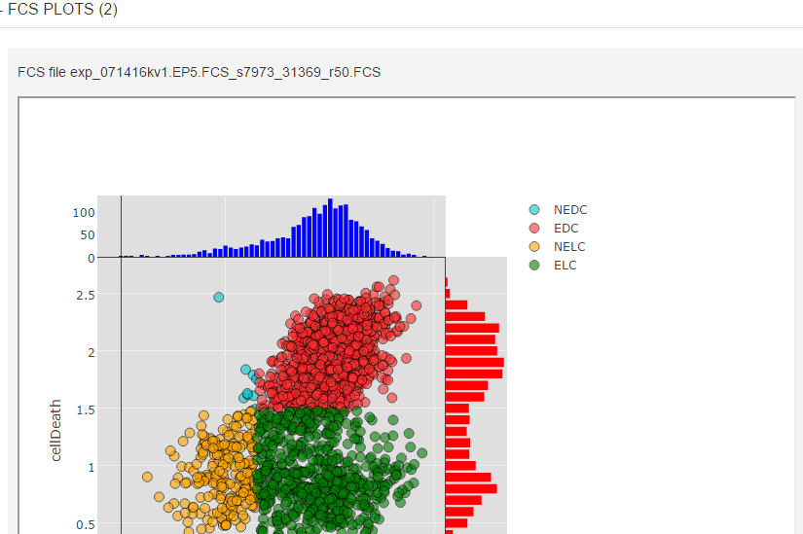

Information entered into NetTrack will sync to data explorer within 24 hours. The data explorer is a tool to do analysis and search for existing information from NetTrack among 3 sites. Feel free to explore and give us your feedback to improve this project in the future.