Informatics Research and Development
Engagement Request Form
<Insert engagement Name>

Informatics Innovation Unit (IIU)
Center for Surveillance, Epidemiology and Laboratory Services (CSELS)
Centers for Disease Control and Prevention

Version 1.9.3


10/24/2013

This request form contains the following four (4) sections as indicated below:

- Primary Contact Information
- Engagement Request Overview
- Project Summary
- Technology Requirements

Please complete all applicable sections to the best of your ability to facilitate your R&D project success. Send the completed form to InformaticsLab@cdc.gov. Most forms are reviewed and processed within 2-5 days.

The activities of the program team requesting an R&D project and the Lab Team are briefly displayed in Figure 1. This is not a rigid structure, but serves as a guide for how a typical R&D project should progress.

Figure 1 Lab Engagement Process
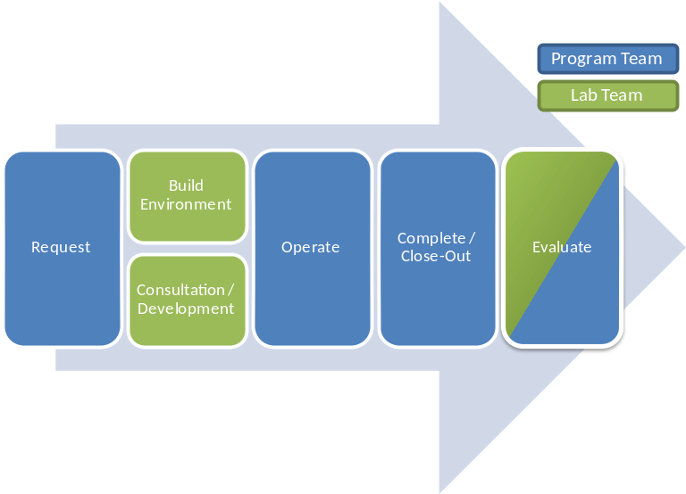

Please note that at no time are projects in the R&D Laboratory to use data that contains information about health status, provision of health care, or payment for health care that can be linked to a specific individual.

In addition, projects are not to create production systems, nor connect to production systems (with the exception of, for example, low impact informational web services, to be determined on a case by case basis). Please refer to the R & D Lab Security Policy for further detail on security procedures and rules of behavior.
The lab does not provide a specific service level agreement (SLA) for support of lab engagements. However, our team is responsive and will work to resolve incidents within core CDC hours.

The lab maintains an Outlook calendar for InformaticsLab@cdc.gov that will contain information on scheduled maintenance and down times. Notices of unexpected maintenance will be sent to the primary point of contact’s email address. Should your engagement have an important activity that you would like the lab to be aware of, please send a calendar invite to InformaticsLab@cdc.gov with the name of the event, date, time, engagement name and your point of contact information.

Lab engagements are designed to answer specific informatics questions and to perform experiments within a short duration. Typical engagements last from 3-6 months and can be extended further if necessary. If an engagement needs to continue longer past the extension, please complete a new engagement form noting the results of the previous engagement. Resources (virtual machines, web sites, etc.) can be transferred to the new engagement without any interruption in service.

Near the end of the engagement, IIU will schedule a brief interview with you to record the outcomes of your engagement and collect feedback for how to improve the research and development lab.

Primary Contact Information

Name:
Organization (i.e., C/I/O):
Email:
Phone#:
Backup point of contact:

Engagement Request Overview

- Project name:
- Start date (estimated):
- Duration (estimated):
- Do you request a consultation meeting with our Research and Innovation Team?
- Do you request developer resources from our Prototype Development Team?
- Do you request on-site use of the Informatics R&D Laboratory in Century Center Building 2500?
- If available, would you like to remotely access your R&D Laboratory resources?
- How many of your team will be using lab resources at any one time?
- Please list names and email addresses for team members who will require access to the lab:
Name | Email

Project Summary

- Please describe a concise but detailed overview of your project; including: goals, challenges, opportunities, overall project vision, data, technologies, and any existing work processes or use cases that may be impacted by this project. Please include why your project requires use of the lab?

- Who are your project stakeholders? List all applicable, key technology users, data suppliers, report recipients, and governing guidelines.

Stakeholder (organization, C/I/O, user group, individual, etc.) | Role (e.g., user, data supplier, report recipient, governing body).

- How do you define project success? What are some measures or metrics you will use to determine project success (e.g., user acceptance, efficiency measures, completed transaction)? What is the potential impact to public health?

Technology Requirements

The Lab has defined a set of core technology standards which are installed as a default (i.e., not otherwise specified). Please modify as needed for your specific project requirements. Please describe how you will each desktop or server.

Desktop / Client Requirements

# | Operating System* | Mem | Disk | VM? | Software** | Description
0 | Windows XP / 7 | 2GB | 10GB | Y | Default | (Describe purpose)

*Examples of Desktop OS platforms available: Windows XP, Windows 7 (32 bit / 64 bit), and Ubuntu Desktop Edition. Other platforms (Linux, Unix, Mac, Vista) may be possible based on availability and need.
**Examples of Desktop Software packages available: Visual Studio. Other software packages may be possible based on availability and need.

Server Requirements

# | Operating System* | Mem | Disk | VM? | Software** | Description
0 | Windows 2008 Server | 2GB | 16GB | Y | Default | (Describe purpose)

* Examples of Server OS platforms available: Windows 2008 Server (32 bit / 64 bit), and Ubuntu Server Edition. Other platforms (Linux, Unix, Mac, Vista) may be possible based on availability and need.
**Examples of Server Software packages available: Microsoft IIS, Oracle WebLogic, Red Hat JBoss, SQL Server 2005/2008, Oracle 11g Standard Edition, MySQL, PostgreSQL. Other software packages may be possible based on availability and need.

Technology – Configuration & Networking

- Will you need access to your prototype from outside the R&D Lab network?

- Do you expect custom network configurations to be required?

- Will your prototype connect to non-production systems / databases OUTSIDE the agency?

- Will your prototype connect to non-production systems / databases INSIDE the agency?

- Does your project require access to any third-party website and/or applications (TPWA) that may require completion of a TPWA privacy impact assessment? If so, please coordinate with your Information System Security Officer to complete the guidance provided by OCISO regarding use of TPWA. Please list below the planned TPWA used by this engagement. Prior to use of any TPWA, please forward confirmation by email to InformaticsLab@cdc.gov that the site has been reviewed by the appropriate security personnel and is appropriate for use by your engagement.
Website and/or application name | Description

- Please feel free to provide any additional information regarding your technology needs below:

