**User story 1:**

1. ***To maintain Doctor’s information***

db.doctorInformation.insert(

{

   "doctorId" : "d3",

   "name" : "Dr. Maria Thomas",

   "qualification" : "MD - Skin,VD & Leprosy, MBBS",

   "experience" : "11years",

   "specialization" : "Dermatology",

   "publications" : [

       "Israel Medical Association Journal",

       "JAMA Dermatology"

   ],

   "awards" : [

       "Dr. Sardari Lal Memorial Award",

       "Aronson Prize"

   ],

       "researchPaper" : [

       "American Journal of Translational Research",

       "Research and Humanities in Medical Education"

   ],

   "start" : "2018-05-05T13:00:00",

   "timeZone" : "Europe/Germany",

   "doctorTimeSlots" : {

       "2019-03-01T13:00:00" : 0.0,

       "2019-02-01T13:00:00" : 1.0,

       "2019-06-25T13:00:00" : 0.0,

       "2019-08-12T13:00:00" : 1.0,

       "2019-10-19T13:00:00" : 0.0,

       "2019-07-05T13:00:00" : 1.0

   }

}

)

**OUTPUT -**

WriteResult({ "nInserted" : 1 })

1. ***To fetch doctor’s availability on 12-08-2019 with doctor Id, name and specialization***.

**QUERY -**

db.doctorInformation.find**({**"doctorTimeSlots.2019-08-12T13:00:00" **:** 1**},{**"doctorId" **:** 1**,** "name" **:** 1**,**"specialization" **:** 1**})**.pretty()

**OUTPUT –**

{

"_id" : ObjectId("5ccaa52d1547188f81a36f1d"),

"doctorId" : "d1",

"name" : "Dr. Ramesh Reddy",

"specialization" : "Surgery"

}

{

"_id" : ObjectId("5ccc157d787e925ca53a341b"),

"doctorId" : "d3",

"name" : "Dr. Maria Thomas",

"specialization" : "Dermatology"

}

1. ***To fetch which doctor is treating which patient.***

**QUERY -**

db.patientInformation.aggregate([

   { $lookup:

      {

        from: 'doctorInformation',

        localField: 'doctorId',

        foreignField: 'doctorId',

        as: 'join'

      }

    },

    {$unwind:'$join'},

    {

       "$project": {

         "doctorId": 1,

         "firstName": 1,

         "lastName":1,

         "occupation": 1,

         "doctorName": '$join.name',

         "doctorSpecialization":'$join.specialization'

       }

     }

])

**OUTPUT –**

{

"_id" : ObjectId("5cc198850e56351dadc25dc6"),

"doctorId" : "d1",

"firstName" : "Paul",

"lastName" : "Walter",

"occupation" : "civilEngineer",

"doctorName" : "Dr. Ramesh Reddy",

"doctorSpecialization" : "Surgery"

}

{

"_id" : ObjectId("5cc199340e56351dadc25dc7"),

"doctorId" : "d2",

"firstName" : "John",

"lastName" : "Gerhard",

"occupation" : "painter",

"doctorName" : "Dr. Alexander Graf",

"doctorSpecialization" : "Neurology"

}

{

"_id" : ObjectId("5cc6df510847954df01037e6"),

"doctorId" : "d1",

"firstName" : "Paul",

"lastName" : "Walter",

"occupation" : "civilEngineer",

"doctorName" : "Dr. Ramesh Reddy",

"doctorSpecialization" : "Surgery"

}

{

"_id" : ObjectId("5cc6fa1d0847954df01037e8"),

"doctorId" : "d1",

"firstName" : "Emma",

"lastName" : "Lina",

"occupation" : "electricalEngineer",

"doctorName" : "Dr. Ramesh Reddy",

"doctorSpecialization" : "Surgery"

}

1. ***To fetch the emergency case of type accident.***

**QUERY -**

db.patientInformation.aggregate([

{$match: {"emergencyCase.typeOfIncident": "accident" }},

{$group: {_id: { FirstName: "$firstName",

   LastName: "$lastName",

   Age: "$age",

   Gender: "$gender",

   Occupation: "$occupation",

   emergency: "$emergencyCase"

    }} }

]).pretty()

**OUTPUT –**

{

"_id" : {

"FirstName" : "Sam",

"LastName" : "Wilson",

"Age" : "27",

"Gender" : "male",

"Occupation" : "civilEngineer",

"emergency" : {

"typeOfIncident" : "accident"

}

}

}

**User story 2:**

***a. To fetch the patient’s current disease with their lab reports***

**QUERY –**

db.patientInformation.aggregate([

   {$match: {"firstName" : "Paul"}},

   {$group: {_id: {patientInformation : { firstName: "$firstName",

       LastName: "$lastName",

       Age: "$age",

       Gender: "$gender",

       Occupation: "$occupation",

       currentDisease : "$currentDisease",

       currentLabReports : "$currentLabReports"

       }} } }

   ]).pretty()

**OUTPUT –**

{

"_id" : {

"patientInformation" : {

"firstName" : "Paul",

"LastName" : "Walter",

"Age" : "27",

"Gender" : "male",

"Occupation" : "civilEngineer",

"currentDisease" : {

"disease" : "malaria-chronic",

"typeOfDisease" : "plasmodium malariae",

"symptoms" : "fever, vomiting",

"dietPlanSuggested" : "eat carrot, beetroots, papaya, berries",

"medicinesPrescribed" : "mefloquine, quinine"

},

"currentLabReports" : {

"bloodTest" : {

"haemoglobin" : "positive, 14.5 gm/dl",

"malaria antigen blood test" : "positive, non falciparum plasmodium species",

"bilirubin" : "negative, 6/4.7 mg/dl"

},

"thyroidTest" : {

"throglobin" : "positive, 5 IU/ml",

"throxine" : "negative, 7.0 DNR mg/dl",

"tsh" : "negative, 1.5 mIU/ml"

},

"diagnosticTest" : {

"latex culture" : "negative, 66(10.3)%",

"rt PCR" : "negative, 74(94.0)%"

}

}

}

}

}

***b. To fetch the number of people with same disease type.***

**QUERY –**

db.patientInformation.aggregate([

   {$match: {"currentDisease.disease" : "malaria-chronic","medicalHistory.disease": "malaria" }},

   {$group: {_id: { firstName: "$firstName",

       LastName: "$lastName",

       Age: "$age",

       Gender: "$gender",

       Occupation: "$occupation",

                       pastDisease: "$medicalHistory",

                       currentDisease: "$currentDisease",

       currentLabReports : "$currentLabReports"

       }} }

   ]

   ).pretty()

**OUTPUT –**

{

   "_id" : {

       "firstName" : "John",

       "LastName" : "Gerhard",

       "Age" : "32",

       "Gender" : "male",

       "Occupation" : "painter",

       "pastDisease" : {

           "_id" : ObjectId("5ccae5fb12a1fe1754218155"),

           "disease" : "malaria",

           "medicinesPrescribed" : "acetaminophen",

           "dietPlan" : "drink coconut water, avoid spicy foods",

           "dateWhenDiseaseOccurred" : "27.02.2019",

           "labReports" : "bloodTest"

       },

       "currentDisease" : {

           "disease" : "malaria-chronic",

           "typeOfDisease" : "typhoid-O",

           "symptoms" : "abdominal pain, severe headache",

           "dietPlan" : "eat fruits, glucose water, soft rice and more water",

           "medicinesPrescribed" : "ceftriaxone, ciprofloxacin"

       },

       "currentLabReports" : {

           "bloodCultureTest" : {

               "_id" : ObjectId("5ccae55412a1fe1754218150"),

               "test group blood culture" : "positive 104 Igm",

               "control group III" : "negative 22 IgM"

           },

           "haemotologicalTest" : {

               "_id" : ObjectId("5ccae66912a1fe1754218165"),

               "WBC Count" : "postive, 8(10.6) /ul",

               "haemoglobin" : "negative, 46(61.3) gm/dl",

               "platelet count" : "negative, 45(60) /ul"

           }

       }

   }

}

// ----------------------------------------------

{

   "_id" : {

       "firstName" : "Paul",

       "LastName" : "Walter",

       "Age" : "27",

       "Gender" : "male",

       "Occupation" : "civilEngineer",

       "pastDisease" : {

           "_id" : ObjectId("5ccae63b12a1fe175421815c"),

           "disease" : "malaria",

           "medicinesPrescribed" : "malarone",

           "dietPlan" : "eat fruits, avoid junk and processed foods",

           "dateWhenDiseaseOccurred" : "20.02.2019",

           "labReports" : "PCR"

       },

       "currentDisease" : {

           "disease" : "malaria-chronic",

           "typeOfDisease" : "plasmodium malariae",

           "symptoms" : "fever, vomiting",

           "dietPlan" : "eat carrot, beetroots, papaya, berries",

           "medicinesPrescribed" : "mefloquine, quinine"

       },

       "currentLabReports" : {

           "bloodTest" : {

               "_id" : ObjectId("5ccae5fb12a1fe1754218155"),

               "haemoglobin" : "positive, 14.5 gm/dl",

               "malaria antigen blood test" : "positive, non falciparum plasmodium species",

               "bilirubin" : "negative, 6/4.7 mg/dl"

           },

           "thyroidTest" : {

               "_id" : ObjectId("5ccae65a12a1fe1754218162"),

               "throglobin" : "positive, 5 IU/ml",

               "throxine" : "negative, 7.0 DNR mg/dl",

               "tsh" : "negative, 1.5 mIU/ml"

           }

       }

   }

}

**User story 3:**

***Product insert query:***

hmset product1 name "cottonRoll" manufacturing_date 20.03.2019 expiry_date 27.03.2019 quantity 2000 manufacturer "Apollo"

***Pushing products into list:***

lpush productsInformation product1

lpush productsInformation product2

lpush productsInformation product3

lpush productsInformation product4

lpush productsInformation product5

lpush productsInformation product6

**OUTPUT –**

 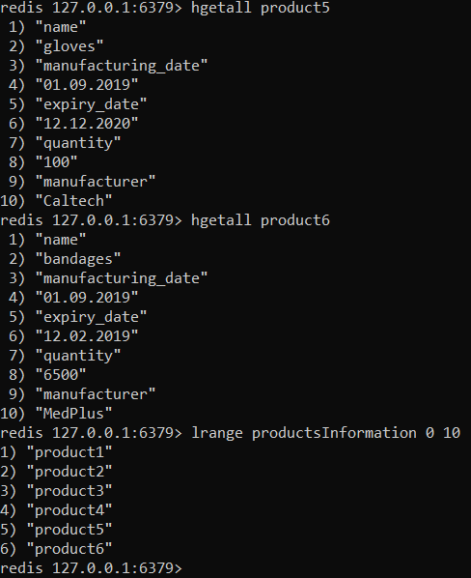

**User story 4:**

1. ***To fetch ward availability***

**QUERY –**

MATCH (n:ward),(o:floor),(p:hospital)

WHERE('available' IN labels(n))

RETURN *

**OUTPUT -**

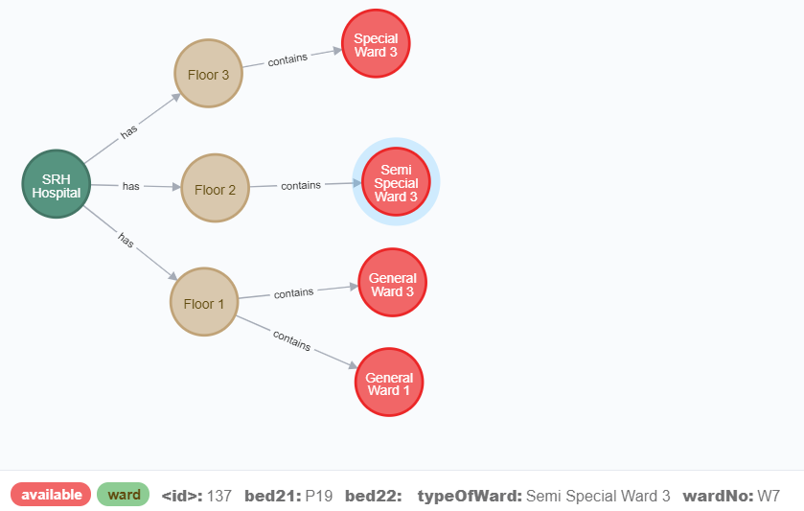

1. ***To allocate bed to a patient***

**QUERY –**

Match (n:ward) where n.wardNo="W7" Remove n:available set n.bed22="new ptn 2" set n:full

return (n)

**OUTPUT -**

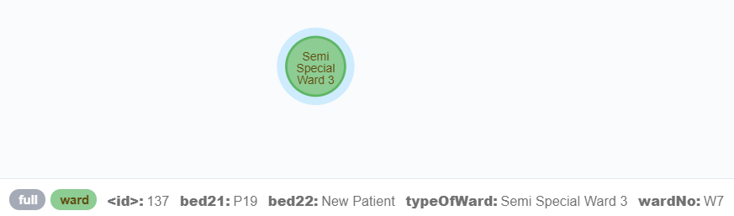

1. ***To fetch number beds in the ward.***

**QUERY –**

Match (n:floor)-[r:contains]->(m:ward) Where n.number = "Floor 3" Return m.wardNo,r.noOfbeds As NO_OF_BEDS

**OUTPUT -**

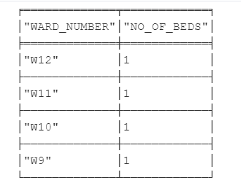

**User story 5:**

1. ***To fetch staff information with their staff Id, name and work type***

**QUERY -**

db.staffInformation.aggregate([

{$project: {staffId : 1, firstName : 1, workType : 1, _id:0, }}

])

**OUTPUT –**

{

   "staffId" : "s1",

   "firstName" : "Harry",

   "workType" : "technical"

}

// ----------------------------------------------

{

   "staffId" : "s1",

   "firstName" : "Jacob",

   "workType" : "technical"

}

// ----------------------------------------------

{

   "staffId" : "s1",

   "firstName" : "Mila",

   "workType" : "technical"

}

// ----------------------------------------------

{

   "staffId" : "s2",

   "firstName" : "Jack",

   "workType" : "nonTechnical"

}

// ----------------------------------------------

{

   "staffId" : "s2",

   "firstName" : "Moritz",

   "workType" : "nonTechnical"

}

// ----------------------------------------------

{

   "staffId" : "s2",

   "firstName" : "Henry",

   "workType" : "nonTechnical"

}

1. ***To fetch the count of both technical and non-technical staff members***

**QUERY –**

db.staffInformation.aggregate([

{$match: {workType:"technical"}},

{$group: {

    _id:"$staffId",

    numberOfTechnicalStaff: {$sum : 1 }

}

}

])

db.staffInformation.aggregate([

{$match: {workType:"nonTechnical"}},

{$group: {

    _id:"$staffId",

    numberOfNonTechnicalStaff: {$sum : 1 }

}

}

])

**OUTPUT –**

{

   "_id" : "s1",

   "numberOfTechnicalStaff" : 3.0

}

{

   "_id" : "s2",

   "numberOfNonTechnicalStaff" : 3.0

}

1. ***To fetch the staff availability using calendar data structure for 2019-03-28T12:00:00***

**QUERY –**

db.staffInformation.find({"staffAvailability.2019-03-28T12:00:00" : 1},{"staffId" : 1, "firstName" : 1, "workType" : 1, "_id" : 0})

**OUTPUT –**

{

   "staffId" : "s1",

   "firstName" : "Harry",

   "workType" : "technical"

}

// ----------------------------------------------

{

   "staffId" : "s1",

   "firstName" : "Jacob",

   "workType" : "technical"

}

// ----------------------------------------------

{

   "staffId" : "s2",

   "firstName" : "Jack",

   "workType" : "nonTechnical"

}

1. ***To fetch the staff information using their name***

**QUERY –**

db.staffInformation.aggregate([

{$match: {firstName : "Harry"}},

{$project: {"staffId" : 1, "workType" : 1, "staffAvailability" : 1, "_id" : 0}}

])

**OUTPUT –**

{

   "staffId" : "s1",

   "workType" : "technical",

   "staffAvailability" : {

       "2019-02-01T14:00:00" : 0.0,

       "2019-02-02T08:00:00" : 1.0,

       "2019-03-01T10:00:00" : 1.0,

       "2019-03-03T08:00:00" : 1.0,

       "2019-03-28T12:00:00" : 1.0

   }

}