WERKSNORM 1 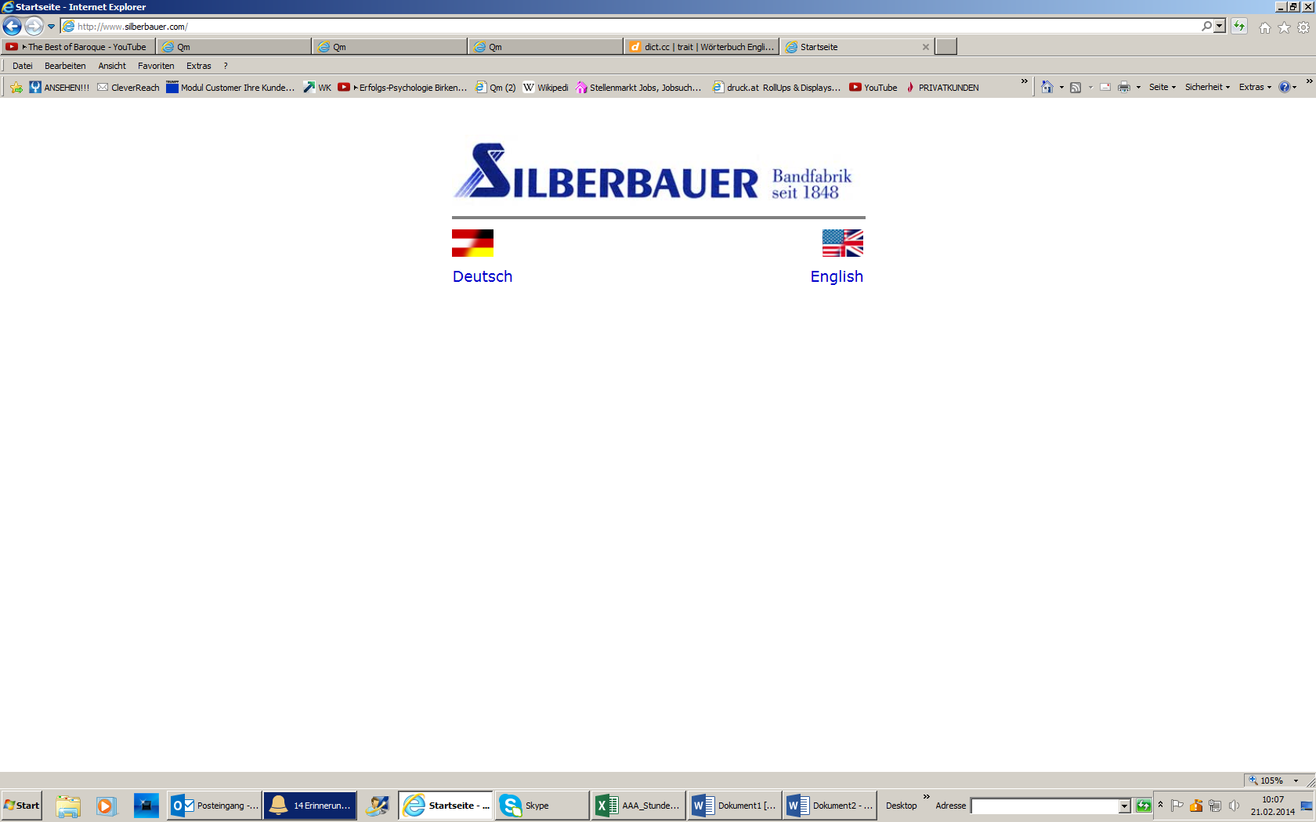

Dnvadfkl-vbjkl-adfbjkl-sdfnbsdf

Asdfbn xcvjk.bnfcv

ASDFÖkbbfjkl-bnsdfnbklbsfkl-

|  |  |
| --- | --- |
|  | Eeslöjdftjkl  ASKÖfbkl-sdbgf  Efdfjkl-bddnklfskl |