DOCX Test Template

Context tags
Operator name: Operator 1
Sector: Energy → Electricity
Reference year: 2026
Publication date: 23 March 2026
Threshold for high risk: 8
Top ranking: 3

Chart tags
Security objectives by level
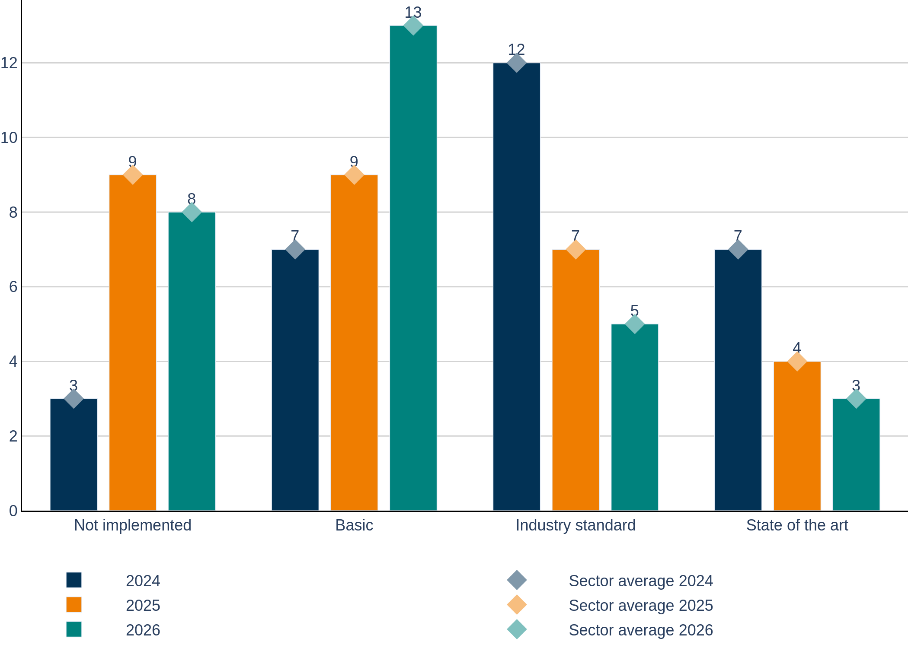
Evolution security objectives by domain
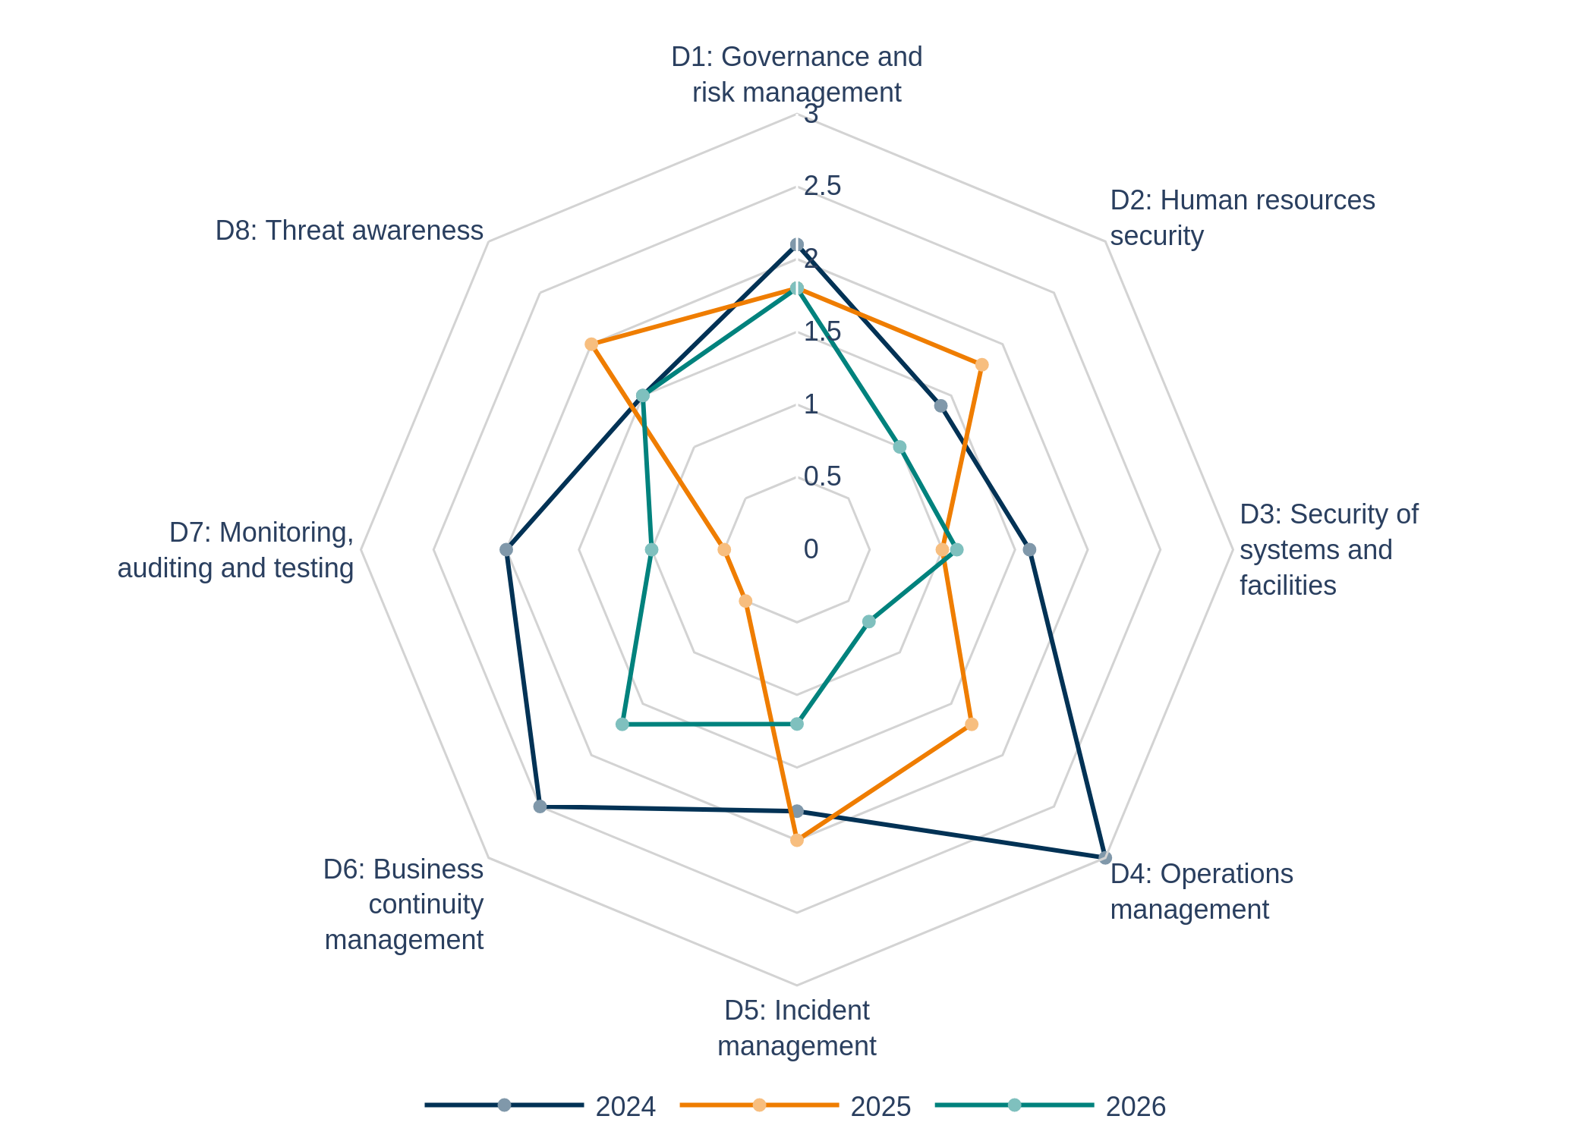
Evolution security objectives by domain with sector avg
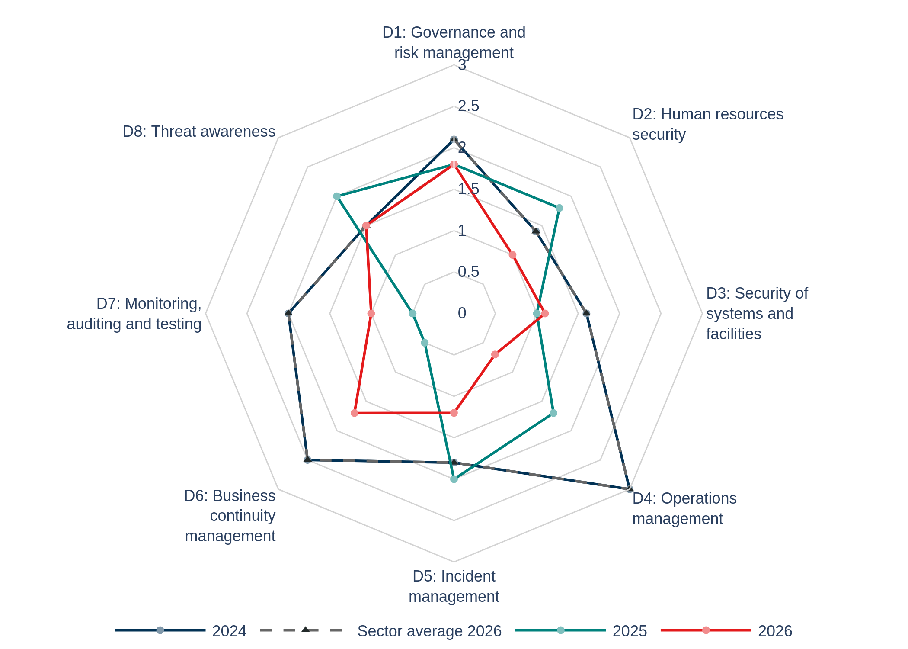
Evolution security objectives
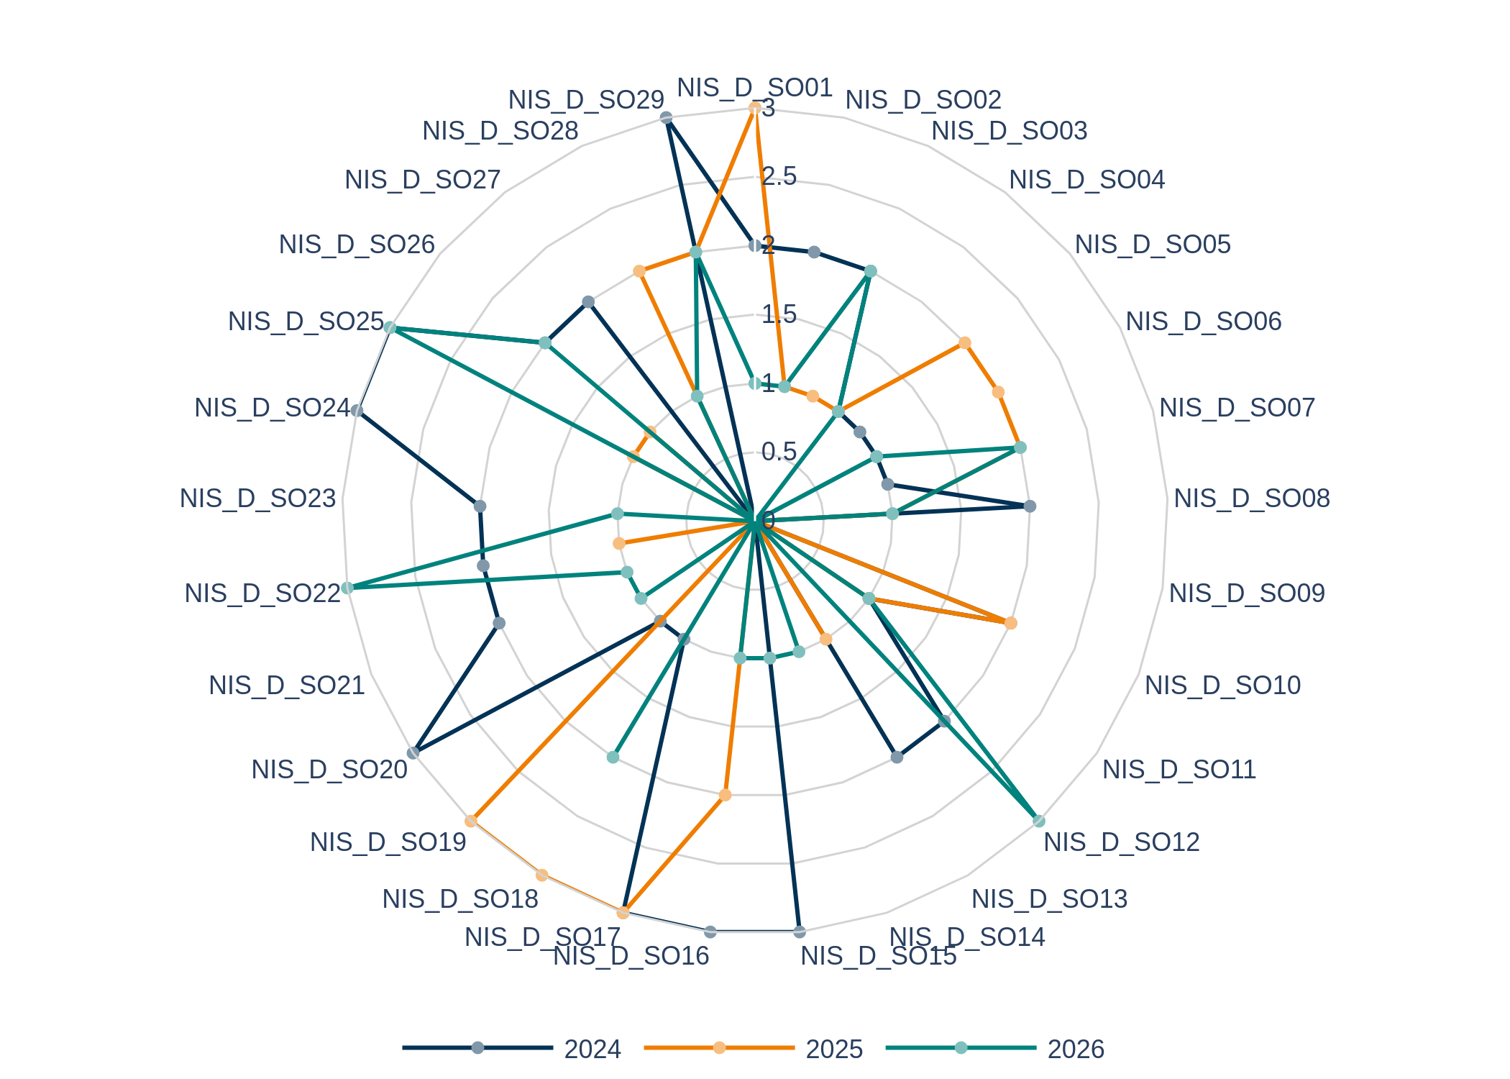
Average risk level
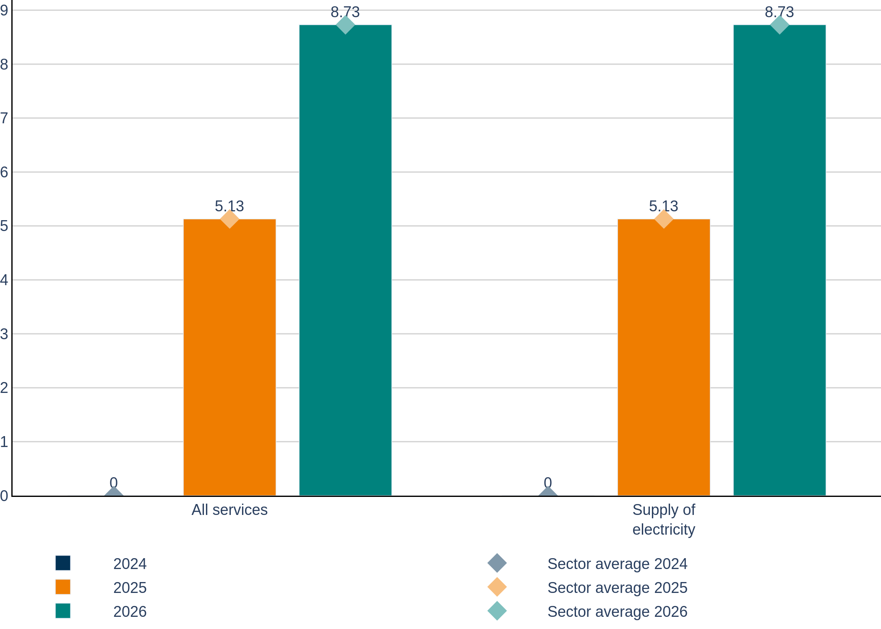
High risk rate
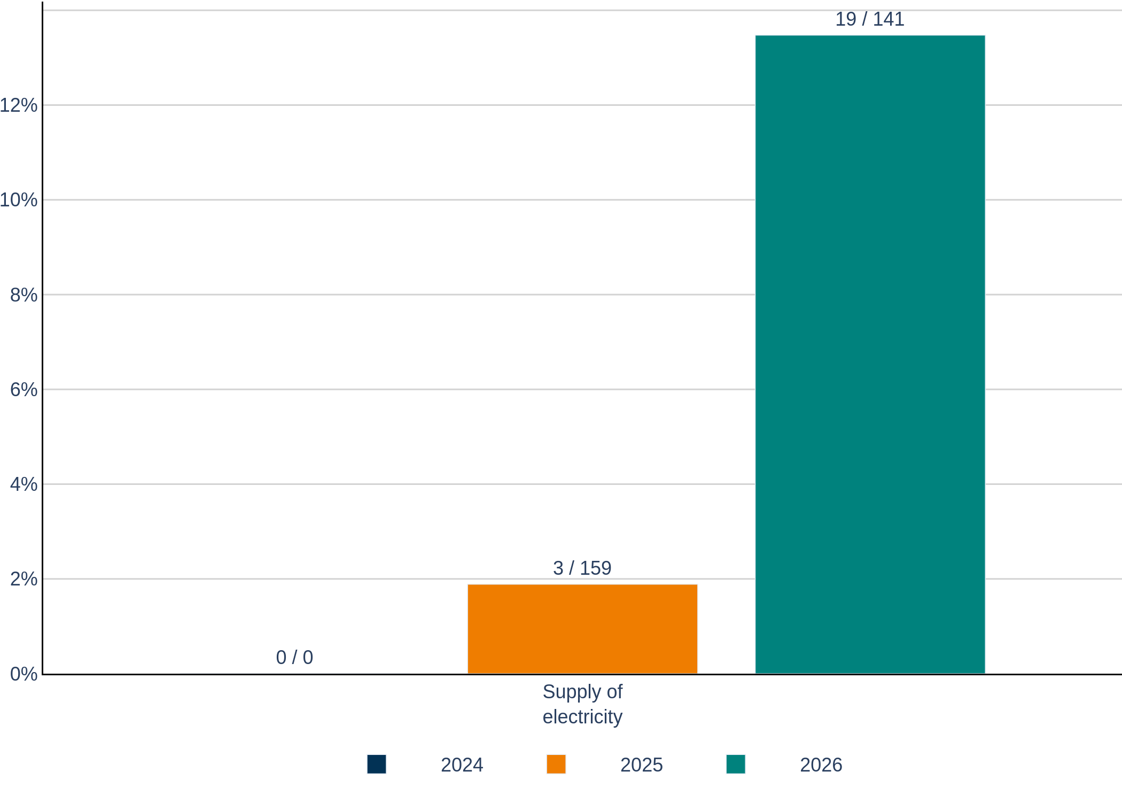
Average high risk level
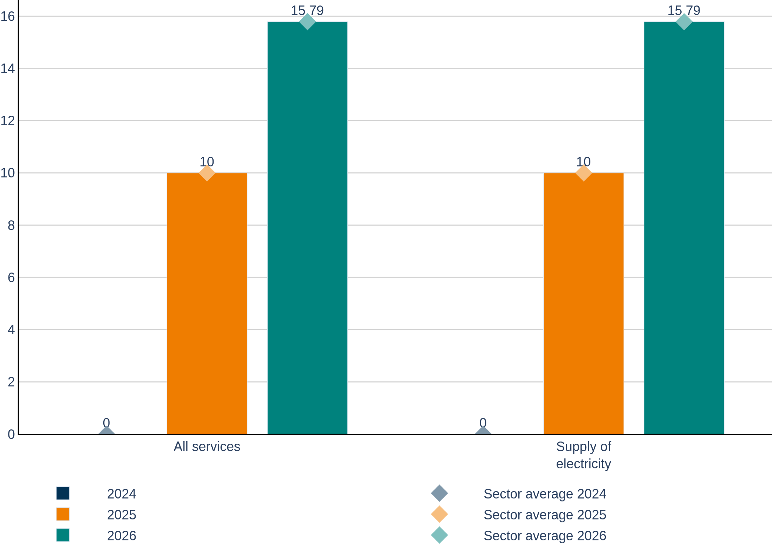
Evolution highest risks
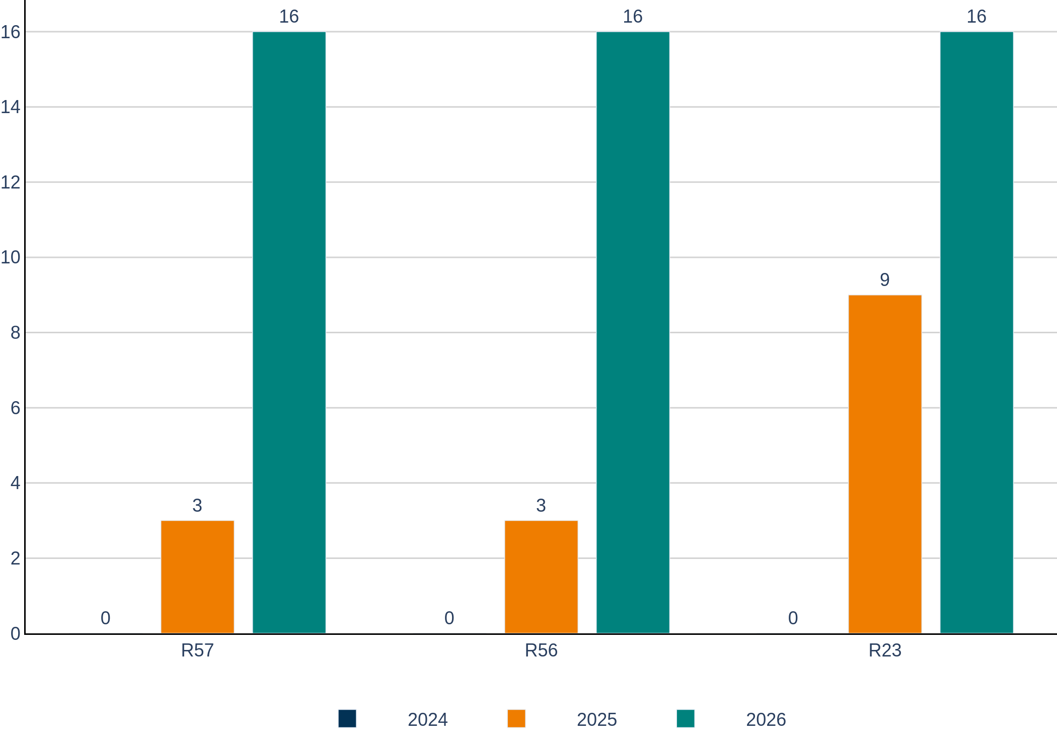

Table tags
Evolution security objectives
OBJECTIVE | 2024 | 2025 | 2026 | EVOLUTION
NIS_D_SO01:Information security policy | 2 | 3 | 1 | ↗ ↘
NIS_D_SO02:Governance and risk management | 2 | 1 | 1 | ↘ →
NIS_D_SO03:Security roles and responsibilities | 2 | 1 | 2 | ↘ ↗
NIS_D_SO04:Security of third-party dependencies | 1 | 1 | 1 | → →
NIS_D_SO05:Background checks | 1 | 2 | 0 | ↗ ↘
NIS_D_SO06:Security knowledge and training | 1 | 2 | 1 | ↗ ↘
NIS_D_SO07:Personnel changes | 1 | 2 | 2 | ↗ →
NIS_D_SO08:Handling violations | 2 | 1 | 1 | ↘ →
NIS_D_SO09:Physical and environmental security | 0 | 0 | 0 | → →
NIS_D_SO10:Security of supplies | 2 | 2 | 0 | → ↘
NIS_D_SO11:Access control to network and information systems | 1 | 1 | 1 | → →
NIS_D_SO12:Integrity of network and information systems | 2 | 0 | 3 | ↘ ↗
NIS_D_SO13:Use of encryption | 2 | 1 | 0 | ↘ ↘
NIS_D_SO14:Protection of security critical data | 0 | 0 | 1 | → ↗
NIS_D_SO15:Operational procedures | 3 | 0 | 1 | ↘ ↗
NIS_D_SO16:Change management | 3 | 2 | 1 | ↘ ↘
NIS_D_SO17:Asset management | 3 | 3 | 0 | → ↘
NIS_D_SO18:Incident management procedures | 1 | 3 | 2 | ↗ ↘
NIS_D_SO19:Incident detection capability | 1 | 3 | 0 | ↗ ↘
NIS_D_SO20:Incident reporting and communication | 3 | 0 | 1 | ↘ ↗
NIS_D_SO21:Service continuity strategy and contingency plans | 2 | 0 | 1 | ↘ ↗
NIS_D_SO22:Disaster recovery capabilities | 2 | 1 | 3 | ↘ ↗
NIS_D_SO23:Monitoring and logging policies | 2 | 0 | 1 | ↘ ↗
NIS_D_SO24:Exercise contingency plans | 3 | 0 | 0 | ↘ →
NIS_D_SO25:Network and information systems testing | 3 | 1 | 3 | ↘ ↗
NIS_D_SO26:Security assessments | 2 | 1 | 2 | ↘ ↗
NIS_D_SO27:Compliance monitoring | 2 | 0 | 0 | ↘ →
NIS_D_SO28:Threat intelligence | 0 | 2 | 1 | ↗ ↘
NIS_D_SO29:Informing users about threats | 3 | 2 | 2 | ↘ →

Evolution security objectives by domain
DOMAIN | 2024 | 2025 | 2026 | EVOLUTION | SECTOR AVERAGE 2026
D1: Governance and risk management | 2.1 | 1.8 | 1.8 | ↘ → | 1.8
D2: Human resources security | 1.4 | 1.8 | 1.0 | ↗ ↘ | 1.0
D3: Security of systems and facilities | 1.6 | 1.0 | 1.1 | ↘ ↗ | 1.1
D4: Operations management | 3.0 | 1.7 | 0.7 | ↘ ↘ | 0.7
D5: Incident management | 1.8 | 2.0 | 1.2 | ↗ ↘ | 1.2
D6: Business continuity management | 2.5 | 0.5 | 1.7 | ↘ ↗ | 1.7
D7: Monitoring, auditing and testing | 2.0 | 0.5 | 1.0 | ↘ ↗ | 1.0
D8: Threat awareness | 1.5 | 2.0 | 1.5 | ↗ ↘ | 1.5

Highest security objectives in the sector
 | SECTOR RANKING 2026 | SECTOR SCORES | OPERATOR SCORES
1 | NIS_D_SO12:Integrity of network and information systems  NIS_D_SO22:Disaster recovery capabilities  NIS_D_SO25:Network and information systems testing | 3.0  3.0  3.0 | 3.0  3.0  3.0
2 | NIS_D_SO03:Security roles and responsibilities  NIS_D_SO07:Personnel changes  NIS_D_SO18:Incident management procedures  NIS_D_SO26:Security assessments  NIS_D_SO29:Informing users about threats | 2.0  2.0  2.0  2.0  2.0 | 2.0  2.0  2.0  2.0  2.0
3 | NIS_D_SO01:Information security policy  NIS_D_SO02:Governance and risk management  NIS_D_SO04:Security of third-party dependencies  NIS_D_SO06:Security knowledge and training  NIS_D_SO08:Handling violations  NIS_D_SO11:Access control to network and information systems  NIS_D_SO14:Protection of security critical data  NIS_D_SO15:Operational procedures  NIS_D_SO16:Change management  NIS_D_SO20:Incident reporting and communication  NIS_D_SO21:Service continuity strategy and contingency plans  NIS_D_SO23:Monitoring and logging policies  NIS_D_SO28:Threat intelligence | 1.0  1.0  1.0  1.0  1.0  1.0  1.0  1.0  1.0  1.0  1.0  1.0  1.0 | 1.0  1.0  1.0  1.0  1.0  1.0  1.0  1.0  1.0  1.0  1.0  1.0  1.0

Lowest security objectives in the sector
 | SECTOR RANKING 2026 | SECTOR SCORES | OPERATOR SCORES
1 | NIS_D_SO05:Background checks  NIS_D_SO09:Physical and environmental security  NIS_D_SO10:Security of supplies  NIS_D_SO13:Use of encryption  NIS_D_SO17:Asset management  NIS_D_SO19:Incident detection capability  NIS_D_SO24:Exercise contingency plans  NIS_D_SO27:Compliance monitoring | 0.0  0.0  0.0  0.0  0.0  0.0  0.0  0.0 | 0.0  0.0  0.0  0.0  0.0  0.0  0.0  0.0
2 | NIS_D_SO01:Information security policy  NIS_D_SO02:Governance and risk management  NIS_D_SO04:Security of third-party dependencies  NIS_D_SO06:Security knowledge and training  NIS_D_SO08:Handling violations  NIS_D_SO11:Access control to network and information systems  NIS_D_SO14:Protection of security critical data  NIS_D_SO15:Operational procedures  NIS_D_SO16:Change management  NIS_D_SO20:Incident reporting and communication  NIS_D_SO21:Service continuity strategy and contingency plans  NIS_D_SO23:Monitoring and logging policies  NIS_D_SO28:Threat intelligence | 1.0  1.0  1.0  1.0  1.0  1.0  1.0  1.0  1.0  1.0  1.0  1.0  1.0 | 1.0  1.0  1.0  1.0  1.0  1.0  1.0  1.0  1.0  1.0  1.0  1.0  1.0
3 | NIS_D_SO03:Security roles and responsibilities  NIS_D_SO07:Personnel changes  NIS_D_SO18:Incident management procedures  NIS_D_SO26:Security assessments  NIS_D_SO29:Informing users about threats | 2.0  2.0  2.0  2.0  2.0 | 2.0  2.0  2.0  2.0  2.0

Evolution of the weakest security objectives
OBJECTIVE | 2024 | 2025 | 2026 | EVOLUTION
NIS_D_SO09:Physical and environmental security | 0 | 0 | 0 | → →
NIS_D_SO28:Threat intelligence | 0 | 2 | 1 | ↗ ↘
NIS_D_SO14:Protection of security critical data | 0 | 0 | 1 | → ↗
NIS_D_SO05:Background checks | 1 | 2 | 0 | ↗ ↘
NIS_D_SO07:Personnel changes | 1 | 2 | 2 | ↗ →

Security objectives by maturity level
0 (NOT IMPLEMENTED) | 1 (BASIC) | 2 (INDUSTRY STANDARD) | 3 (STATE OF THE ART)
NIS_D_SO05:Background checks | NIS_D_SO01:Information security policy | NIS_D_SO03:Security roles and responsibilities | NIS_D_SO12:Integrity of network and information systems
NIS_D_SO09:Physical and environmental security | NIS_D_SO02:Governance and risk management | NIS_D_SO07:Personnel changes | NIS_D_SO22:Disaster recovery capabilities
NIS_D_SO10:Security of supplies | NIS_D_SO04:Security of third-party dependencies | NIS_D_SO18:Incident management procedures | NIS_D_SO25:Network and information systems testing
NIS_D_SO13:Use of encryption | NIS_D_SO06:Security knowledge and training | NIS_D_SO26:Security assessments
NIS_D_SO17:Asset management | NIS_D_SO08:Handling violations | NIS_D_SO29:Informing users about threats
NIS_D_SO19:Incident detection capability | NIS_D_SO11:Access control to network and information systems
NIS_D_SO24:Exercise contingency plans | NIS_D_SO14:Protection of security critical data
NIS_D_SO27:Compliance monitoring | NIS_D_SO15:Operational procedures
 | NIS_D_SO16:Change management
 | NIS_D_SO20:Incident reporting and communication
 | NIS_D_SO21:Service continuity strategy and contingency plans
 | NIS_D_SO23:Monitoring and logging policies
 | NIS_D_SO28:Threat intelligence

Maturity level legend
0 | Not implemented
1 | Basic
2 | Industry standard
3 | State of the art
↘ Downward
→ Stable
↗ Upward

Evolution of the highest risks
ID | ASSET | THREAT | VULNERABILITY | CURRENT RISK (MAX)
 |  |  |  | 2024 | 2025 | 2026
R57 | Supply of electricity > CRM - Customer Relationship Management | Abuse of rights | Wrong allocation of access rights | - | 3 | 16
R56 | Supply of electricity > CRM - Customer Relationship Management | Abuse of rights | Software not adequately tested before acceptance (test data set does not cover all the operating conditions - intense demand on the system, input of non-conforming data, input of data corresponding to operating limits) | - | 3 | 16
R23 | Supply of electricity > Decision maker | Error in use | Insufficient security training | - | 9 | 16

Treatment of the highest risks
ID | ASSET | THREAT | VULNERABILITY | CURRENT RISK (MAX) | TREATMENT | RESIDUAL RISK
R57 | Supply of electricity > CRM - Customer Relationship Management | Abuse of rights | Wrong allocation of access rights | 16 | Reduction | 8
R56 | Supply of electricity > CRM - Customer Relationship Management | Abuse of rights | Software not adequately tested before acceptance (test data set does not cover all the operating conditions - intense demand on the system, input of non-conforming data, input of data corresponding to operating limits) | 16 | Reduction | 8
R23 | Supply of electricity > Decision maker | Error in use | Insufficient security training | 16 | Reduction | 8

Risk summary
YEAR | 2024 | 2025 | 2026
TREATED RISKS | 307 | 263 | 141
UNTREATED RISKS | 5 | 0 | 18
AVERAGE TREATED CURRENT RISKS | 3.24 | 3.58 | 8.73
HIGH RISKS | 14 | 4 | 19
AVERAGE HIGH RISKS | 13.71 | 10.5 | 15.79
AVERAGE RESIDUAL RISKS | 2.57 | 3.31 | 5.29
REDUCED RISKS | 36 | 18 | 84
REJECTED RISKS | 0 | 0 | 0
ACCEPTED RISKS | 271 | 245 | 53
SHARED RISKS | 0 | 0 | 4

Top threats by occurrence
1 | - Error in use
2 | - Abuse of rights
3 | - Breach of information system maintainability

Top vulnerabilities by occurrence
1 | - Insufficient maintenance/faulty installation of storage media  - Problems in change management or software maintenance
2 | - Lack of care at disposal
3 | - Incorrect parameter set up  - Software not adequately tested before acceptance (test data set does not cover all the operating conditions - intense demand on the system, input of non-conforming data, input of data corresponding to operating limits)  - Wrong allocation of access rights

Recommendations
RECOMMENDATION | DEADLINE | STATUS
ISO 27002 - 2022 - 5.29  Planning information security continuity - Implementing information security continuity - Verify, review and evaluate information security continuity | 31/12/2024 | New
ISO 27002 - 2022 - 5.26  Response to information security incidents | 31/12/2023 | New
ISO 27002 - 2022 - 5.37  Documented operating procedures | 31/12/2023 | New
ISO 27002 - 2022 - 8.29  System security testing - System acceptance testing | 31/12/2023 | New
ISO 27002 - 2022 - 6.3  Information security awareness, education and training | 31/12/2023 | New
ISO 27002 - 2022 - 8.15  Event logging - Protection of log information - Administrator and operator logs | 31/12/2023 | New
ISO 27002 - 2022 - 5.15  Access control policy - Access to networks and network services | 30/06/2024 | New
ISO 27002 - 2022 - 8.2  Management of privileged access rights - Network controls | 31/12/2023 | New
ISO 27002 - 2022 - 5.18  User access provisioning - Review of user access rights - Removal or adjustment of access rights | 30/06/2024 | New
ISO 27002 - 2022 - 5.16  User registration and de-registration | 30/06/2024 | New
ISO 27002 - 2022 - 6.8  Reporting information security events - Reporting information security weaknesses | 30/06/2024 | New
ISO 27002 - 2022 - 5.4  Management responsibilities | 31/12/2023 | New
ISO 27002 - 2022 - 7.14  Secure disposal or reuse of equipment | 31/12/2023 | New
ISO 27002 - 2022 - 5.10  Acceptable use of assets - Handling of assets | 31/12/2023 | New

