FHH Interoperability Partner Information
Family Health History

Last Revised: | 10/1/2008
Produced By: | FHH Development Team
Version: | 0.3

Table of Contents
1. Introduction 3
1.1. Purpose 3
2. Architectural Goals and Constraints 3
2.1. Standards-Based 3
2.2. Open Source 3
2.3. Privacy Ensured 3
3. Implementation View 4
3.1. HL7 Family History (Pedigree) Model 4
3.2. HL7 Family History (Pedigree) Schema 4
3.3. Additional definition of supported nodes and attributes 4
3.3.1. FamilyHistory node 5
3.3.2. Subject node 5
3.3.3. Patient node 6
3.3.4. PatientPerson node 7
3.3.5. SubjectOf1 node 10
3.3.6. DeceasedEstimatedAge node 11
3.3.7. SubjectOf2 node 12
3.3.8. ClinicalObservation node 13
3.3.9. Relative node 16
3.3.10. RelationshipHolder node 17
3.4. Codes used by FHH 22
3.5. Appendix A: Sample Family Health History XML File 23
3.6. Appendix B: HL7 Family History (Pedigree) XSD 30

Introduction

Purpose
This document provides a comprehensive overview of the components of the Family Health History (FHH) system that are most relevant to our interoperability partners. It is intended to capture and convey the significant architectural decisions which have been made on the system, and to provide useful information to clients of FHH that want to use its output information to populate their own system and better serve their own clients and patients.
Stakeholders who require a technical understanding of FHH are encouraged to start by reading this document, then review the FHH UML model. Please note that all diagrams represented in this document are taken from the FHH UML model; for more detail about the elements in these diagrams, please consult the source model.
Our project timeframe includes an interoperability demonstration on about November 21, 2008. This document is meant to provide information to our partners so that they can begin developing their own systems that translate the FHH output into their own systems, in parallel with the development of the FHH tool. Thus, the beauty of standards. This document should clearly outline the interoperability interface, and partners are encouraged to contact the FHH development team if new information is required or if you have any questions, comments, or concerns.

Architectural Goals and Constraints
The following factors are key considerations behind the functional requirements that are guiding the design of FHH.

Standards-Based
FHH must be capable of exporting a machine-readable (presumably xml) file containing the family health history entered by users of the system. The expected transport mechanism is the HL7 Family History model. The expected coding standard to be employed is SNOMED. Details are included in this document.

Open Source
FHH is expected to be written using either open source tools or tenets (tbd).

Privacy Ensured
To ensure that FHH users’ privacy and health information is protected, the system will not store user data locally. User data may be stored as a downloadable file to the user’s personal storage device.

Implementation View

HL7 Family History (Pedigree) Model
The FHH tool will export information in conformance with the HL7 Family History (Pedigree) model.
The rich HL7 Family History model includes information outside the scope of the FHH tool; therefore, FHH will use only certain components of the HL7 Family History model (those that are relevant to the information collected by the FHH tool). The diagram below indicates the components of the HL7 Family History tool that FHH will use.
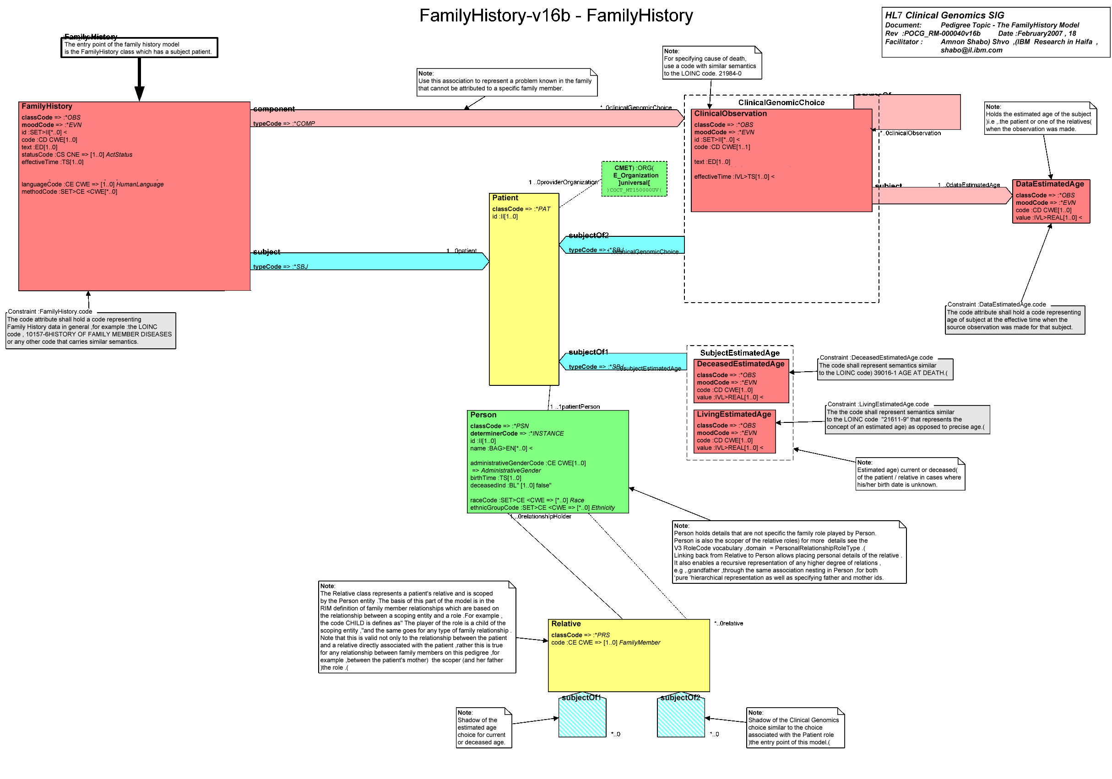
Figure 1. Classes of HL7 Family History model used by FHH.

HL7 Family History (Pedigree) Schema
Please see Appendix A: Sample Family Health History XML File, below, for an example of the Family Health History output file, and Appendix B: HL7 Family History (Pedigree) XSD, for details on the HL7 Family History schema and a copy of the XSD.

Additional definition of supported nodes and attributes
This section indicates details of the form of the XML file to be output by the FHH tool.
It may be helpful to refer to Appendix A: Sample Family Health History XML File as you read this section.

FamilyHistory node
Node Name | Interior Nodes (multiplicity) | Attribute | Attribute Value
FamilyHistory | id (1)  effectiveTime (1)  methodCode (1)  subject (1) | classCode | OBS
 |  | moodCode | EVN
 |  | xsi:schemaLocation | (TBD)
id |  | extension | gov.hhs.fhh:(number)
effectiveTime |  | value | (date, format TBD)
methodCode |  | displayName | Surgeon General’s Family Health History Tool
example:
<FamilyHistory classCode="OBS" moodCode="EVN">
<id extension="gov.hhs.fhh:718163810183" />
<effectiveTime value="09/26/2008" />
<methodCode displayName="Surgeon General's Family Health History Tool" />
. . .

Subject node
Node Name | Interior Nodes (multiplicity) | Attribute | Attribute Value
subject | patient (1) | typeCode | SBJ
example:
<FamilyHistory classCode="OBS" moodCode="EVN">
. . .
<methodCode displayName="Surgeon General's Family Health History Tool" />
<subject typeCode=”SBJ”>
. . .

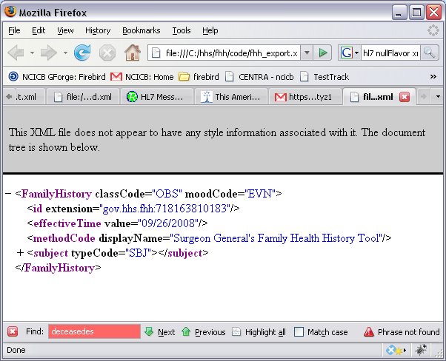
Figure 2. FamilyHistory and subject nodes

Patient node
Node Name | Interior Nodes (multiplicity) | Attribute | Attribute Value
patient | patientPerson (1)  relative (0..*)  subjectOf1 (0..*) | classCode | PAT
example:
<FamilyHistory classCode="OBS" moodCode="EVN">
. . .
<subject typeCode=”SBJ”>
<patient classCode=”PAT”>
. . .

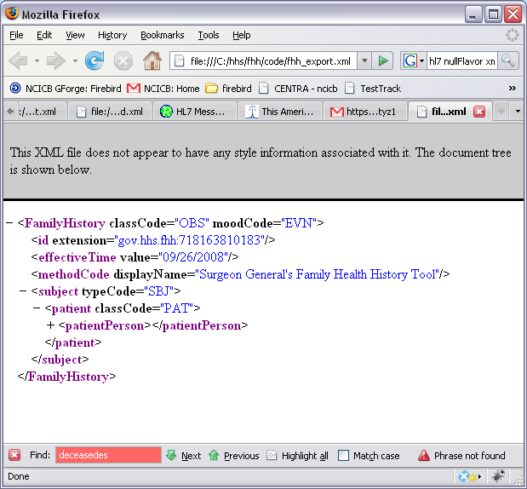
Figure 3. FamilyHistory, subject, and patient nodes.

PatientPerson node
Node Name | Interior Nodes (multiplicity) | Attribute | Attribute Value
patientPerson | id (1)  name (1)  administrativeGenderCode (1)  raceCode(0..*)  ethnicGroupCode(0..*)  birthTime (1)  deceasedIndCode (1)  multipleBirthIndicator (0..1)  subjectOf1 (0..*)  subjectOf2 (0..*)  relative (0..*)
example:
<FamilyHistory classCode="OBS" moodCode="EVN">
. . .
<subject typeCode=”SBJ”>
<patient classCode=”PAT”>
. . .
<patientPerson>
. . .
id |  | extension | (number)
name |  | formatted | (string)
administrativeGenderCode  * displays orginalText OR code, codeSystemName, and displayName attributes |  | code | (see Gender values below)
 |  | codeSystemName | (TBD)
 |  | displayName | (see Gender values below)
 |  | originalText* | (when no code is available, only orginalText attribute will be included, with value “unknown”)
raceCode |  | code | (see Race values below)
 |  | codeSystemName | (TBD)
 |  | displayName | (see Gender values below)
 |  | originalText* | (when no code is available, only orginalText attribute will be included, with value “unknown”)
ethnicCode |  | code | (see Ethnic values below)
 |  | codeSystemName | (TBD)
 |  | displayName | (see Gender values below)
 |  | originalText* | (when no code is available, only orginalText attribute will be included, with value “unknown”)
birthTime |  | value | TBD
deceasedIndCode |  | value | (boolean: “true” or “false”)
multipleBirthIndicator |  | value | “true” or “false”
example:
<FamilyHistory classCode="OBS" moodCode="EVN">
. . .
<subject typeCode=”SBJ”>
<patient classCode=”PAT”>
. . .
<patientPerson>
<id extension=”1234” />
<name formatted=”Marta Marquez” />
<administrativeGenderCode code=”F” codeSystemName=”[TBD]” displayName=”female” />
<birthTime value=”07/11/1974” />
<deceasedIndCode value=”false” />
<multipleBirthIndicator value=”true” />
<raceCode code=”413582008” codeSystemName=”SNOMED_CT” displayName=”Asian” />
<ethnicGroupCode code=”414408004” codeSystemName=”SNOMED_CT” displayName=”Hispanic or Latino” />
. . .
example of person with unknown gender and race:
<FamilyHistory classCode="OBS" moodCode="EVN">
. . .
<subject typeCode=”SBJ”>
<patient classCode=”PAT”>
. . .
<patientPerson>
<id extension=”1234” />
<name formatted=”Marta Marquez” />
<administrativeGenderCode originalText=”unknown” />
<birthTime value=”07/11/1974” />
<deceasedIndCode value=”false” />
<raceCode originalText=”unknown” />
. . .

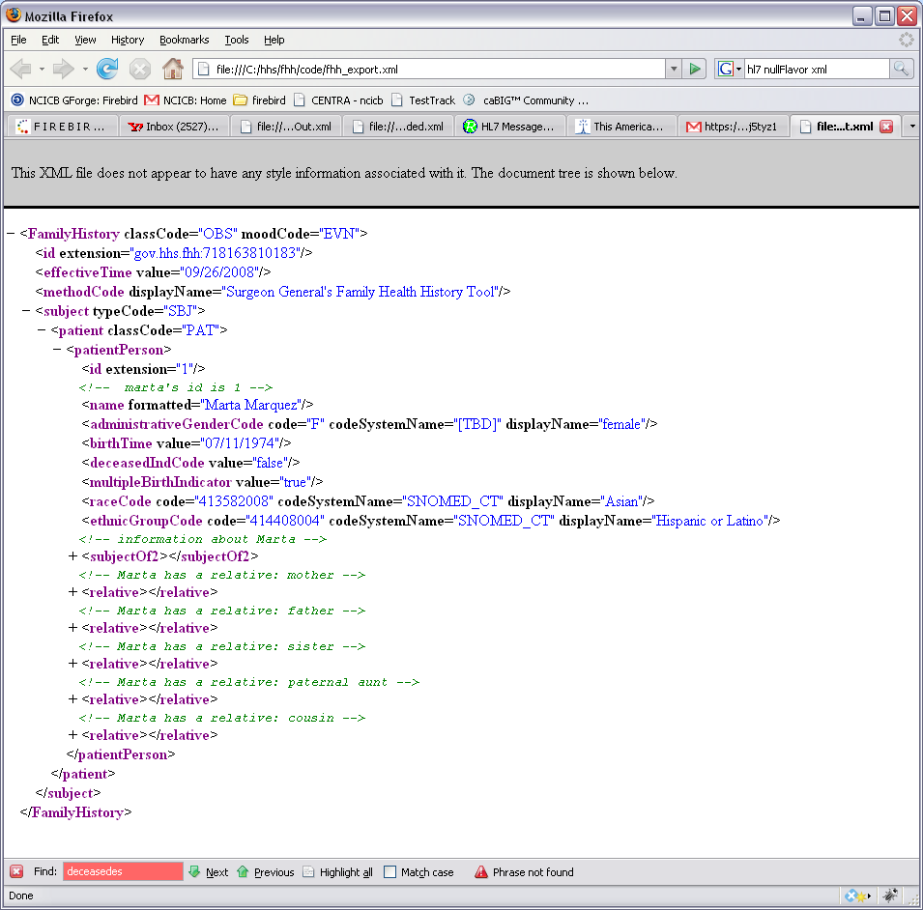
Figure 4. FamilyHistory, subject, patient, and patientPerson nodes. See additional nodes hanging from patientPerson, including subjectOf2 and relative.

SubjectOf1 node
Holds the deceasedEstimatedAge node.
Node Name | Interior Nodes (multiplicity) | Attribute | Attribute Value
subjectOf1 | deceasedEstimatedAge (1)
example:
<FamilyHistory classCode="OBS" moodCode="EVN">
. . .
<subject typeCode=”SBJ”>
<patient classCode=”PAT”>
. . .
<patientPerson>
. . .
<subjectOf1>
<deceasedEstimatedAge>
<code code=”39016-1” codeSystemName=”LOINC” displayName=”Age at Death”>
<value value=”96” unit=”year” />
</deceasedEstimatedAge>
</subjectOf1>
. . .

DeceasedEstimatedAge node
Indicates estimated age at which person was deceased.
Node Name | Interior Nodes (multiplicity) | Attribute | Attribute Value
deceasedEstimatedAge | code  value | nullFlavor (used only if unknown is selected) | ASKU
code |  | code | 39016-1
 |  | codeSystemName | LOINC
 |  | displayName | Age at Death
 |  | originalText | (not included)
value  will typically have either value or both low value and high value (indicating a range) and not both |  | value | (number)
 |  | unit | year, month, or day
 |  | low value | (number)
 |  | high value | (number)
example with exact (estimated) age:
<FamilyHistory classCode="OBS" moodCode="EVN">
. . .
<subject typeCode=”SBJ”>
<patient classCode=”PAT”>
. . .
<patientPerson>
. . .
<subjectOf1>
<deceasedEstimatedAge>
<code code=”39016-1” codeSystemName=”LOINC” displayName=”Age at Death”>
<value value=”96” unit=”year” />
</deceasedEstimatedAge>
</subjectOf1>
. . .
example with age range:
<FamilyHistory classCode="OBS" moodCode="EVN">
. . .
<subject typeCode=”SBJ”>
<patient classCode=”PAT”>
. . .
<patientPerson>
. . .
<subjectOf1>
<deceasedEstimatedAge>
<code code=”39016-1” codeSystemName=”LOINC” displayName=”Age at Death”>
<value unit=”year”>
<low value=”90”/>
<high value=”99”/>
</value>
</deceasedEstimatedAge>
</subjectOf1>
. . .
example with age range indicated as unknown:
<FamilyHistory classCode="OBS" moodCode="EVN">
. . .
<subject typeCode=”SBJ”>
<patient classCode=”PAT”>
. . .
<patientPerson>
. . .
<subjectOf1>
<deceasedEstimatedAge nullFlavor=”ASKU” />
</subjectOf1>
. . .

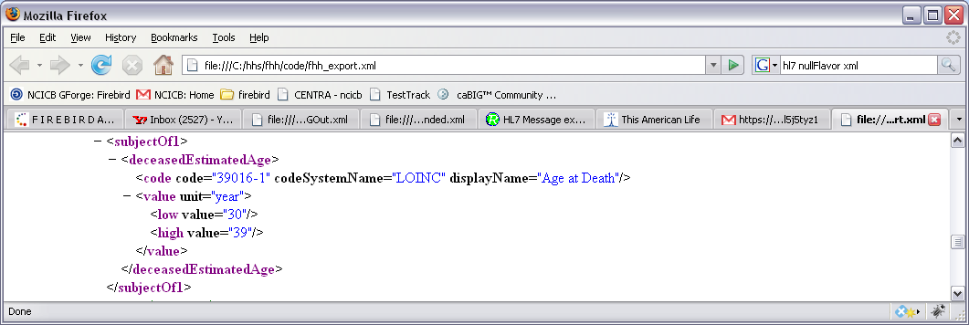
Figure 5. subjectOf1 and deceasedEstimatedAge nodes.

SubjectOf2 node
Holds the clinicalObservation node.
Node Name | Interior Nodes (multiplicity) | Attribute | Attribute Value
subjectOf2 | clinicalObservation (0..*)
example:
<FamilyHistory classCode="OBS" moodCode="EVN">
. . .
<subject typeCode=”SBJ”>
<patient classCode=”PAT”>
. . .
<patientPerson>
. . .
<subjectOf2>
. . .

ClinicalObservation node
Indicates the diseases, cause of death, and other codeable concerns for a person.
Node Name | Interior Nodes (multiplicity) | Attribute | Attribute Value
clinicalObservation  in most cases, subject multiplicity is 1  sourceOf is used to indicate cause of death | code (1)  subject (0..1)  sourceOf(0..1)
code |  | code | See diseases
 |  | codeSystemName | See diseases
 |  | displayName | See diseases
 |  | originalText* | (when user enters information, only orginalText attribute will be included, with user-entered value)
subject | dataEstimatedAge (1)
dataEstimatedAge  will typically have either value or both low value and high value (indicating a range) and not both. if unknown, nullFlavor attribute is shown | code | nullFlavor (used only if unknown is selected) | ASKU
code (for dataEstimatedAge) |  | value | (number)
 |  | unit | year, month, or day
 |  | low value | (number)
 |  | high value | (number)
sourceOf  (this is used to indicate cause of death – typically no subject is used if sourceOf is involved) | code
code (for sourceOf, cause of death) |  | code | 419620001
 |  | codeSystemName | SNOMED_CT
 |  | displayDeath | death
example with exact (estimated) age:
<FamilyHistory classCode="OBS" moodCode="EVN">
. . .
<subject typeCode=”SBJ”>
<patient classCode=”PAT”>
. . .
<patientPerson>
. . .
<subjectOf2>
<clinicalObservation>
<code code=”38341003” codeSystemName=”SNOMED_CT” displayName=”Hypertension” />
<subject>
<dataEstimatedAge
<code code=” 21611-9” codeSystemName=”LOINC” displayName=”Estimated Age”/>
<value value=”26” unit=”year” />
</dataEstimatedAge>
</subject>
</clinicalObservation>
</subjectOf2>
. . .
example with age range:
<FamilyHistory classCode="OBS" moodCode="EVN">
. . .
<subject typeCode=”SBJ”>
<patient classCode=”PAT”>
. . .
<patientPerson>
. . .
<subjectOf2>
<clinicalObservation>
<code code=”38341003” codeSystemName=”SNOMED_CT” displayName=”Hypertension” />
<subject>
<dataEstimatedAge>
<code code=”21611-9” codeSystemName=”LOINC” displayName=”Estimated Age”>
<value unit=”year”>
<low value=”20”/>
<high value=”29”/>
</value>
</dataEstimatedAge>
</subject>
</clinicalObservation>
</subjectOf2>
. . .
example with unknown diagnosis age:
<FamilyHistory classCode="OBS" moodCode="EVN">
. . .
<subject typeCode=”SBJ”>
<patient classCode=”PAT”>
. . .
<patientPerson>
. . .
<subjectOf2>
<clinicalObservation>
<code code=”38341003” codeSystemName=”SNOMED_CT” displayName=”Hypertension” />
<subject>
<dataEstimatedAge nullFlavor=”ASKU” />
</subject>
</clinicalObservation>
</subjectOf2>
. . .
example with user-entered disease:
<FamilyHistory classCode="OBS" moodCode="EVN">
. . .
<subject typeCode=”SBJ”>
<patient classCode=”PAT”>
. . .
<patientPerson>
. . .
<subjectOf2>
<clinicalObservation>
<code originalText=”High blood presssure” />
<subject>
<dataEstimatedAge>
<code code=”21611-9” codeSystemName=”LOINC” displayName=”Estimated Age”>
<value unit=”year”>
<low value=”20”/>
<high value=”29”/>
</value>
</dataEstimatedAge>
</subject>
</clinicalObservation>
</subjectOf2>
. . .

example with cause of death:
<FamilyHistory classCode="OBS" moodCode="EVN">
. . .
<subject typeCode=”SBJ”>
<patient classCode=”PAT”>
. . .
<patientPerson>
. . .
<subjectOf2>
<clinicalObservation>
<code code=”90708001” codeSystemName=”SNOMED_CT” displayName=”Kidney disease - other” />
<sourceOf>
<code code=”419620001” codeSystemName=”SNOMED_CIT” displayName=”death” />
</sourceOf>
</subjectOf2>
. . .
example of height, weight, and BMI, applicable for the proband only:
<FamilyHistory classCode="OBS" moodCode="EVN">
. . .
<subject typeCode=”SBJ”>
<patient classCode=”PAT”>
. . .
<patientPerson>
. . .
<subjectOf2>
<clinicalObservation>
<code code="271603002" codeSystemName="SNOMED_CT" displayName="height"/>
<value unit="inch" value="64" />
</clinicalObservation>
<clinicalObservation>
<code code="107647005" codeSystemName="SNOMED_CT" displayName="weight"/>
<value unit="pound" value="120" />
</clinicalObservation>
<clinicalObservation>
<code code="301331008" codeSystemName="SNOMED_CT" displayName="bmi"/>
<value unit="percentage" value="20.5" />
</clinicalObservation>
. . .
example of how the system will handle those who indicate adoption:
<FamilyHistory classCode="OBS" moodCode="EVN">
. . .
<subject typeCode=”SBJ”>
<patient classCode=”PAT”>
. . .
<subjectOf2>
<clinicalObservation>
<code code="160496001" codeSystemName="SNOMED_CT" displayName="adopted"/>
</clinicalObservation>
. . .

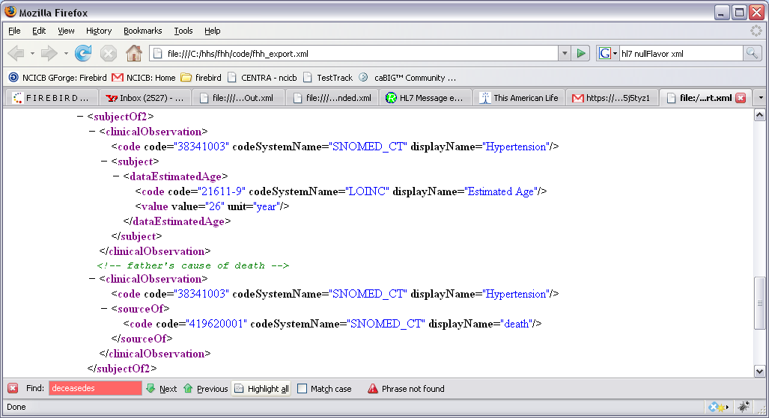
Figure 6. subjectOf2, clinicalObservation, dataEstimatedAge, and sourceOf nodes. sourceOf is included only to indicate that a disease caused death.

Relative node
Node Name | Interior Nodes (multiplicity) | Attribute | Attribute Value
relative | code (1)  relationshipHolder (1)
code |  | code | see Relative information, below
 |  | codeSystemName | HL7 Family History Model
 |  | displayName | see Relative information, below
 |  | originalText | (not included)
example:
<FamilyHistory classCode="OBS" moodCode="EVN">
. . .
<subject typeCode=”SBJ”>
<patient classCode=”PAT”>
. . .
<patientPerson>
. . .
<relative>
<code code=”MTH” codeSystemName=”HL7 Family History Model” displayName=”mother” />
. . .

RelationshipHolder node
A relationshipHolder is essentially a Person wrapper. It indicates the person attributes of the person holding the typed relationship.
Node Name | Interior Nodes (multiplicity) | Attribute | Attribute Value
relationshipHolder | id (1)  name (1)  administrativeGenderCode (1)  raceCode (0..*)  ethnicGroupCode (0..*)  birthTime (1)  deceasedIndCode (1)  multipleBirthIndicator (0..1)  subjectOf1 (0..*)  subjectOf2 (0..*)  relative (0..*)
id |  | extension | (number)
name |  | formatted | (string)
administrativeGenderCode  * displays orginalText OR code, codeSystemName, and displayName attributes |  | code | (see Gender values below)
 |  | codeSystemName | (TBD)
 |  | displayName | (see Gender values below)
 |  | originalText* | (when no code is available, only orginalText attribute will be included, with value “unknown”)
raceCode |  | code | (see Race values below)
 |  | codeSystemName | (TBD)
 |  | displayName | (see Gender values below)
 |  | originalText* | (when no code is available, only orginalText attribute will be included, with value “unknown”)
ethnicCode |  | code | (see Ethnic values below)
 |  | codeSystemName | (TBD)
 |  | displayName | (see Gender values below)
 |  | originalText* | (when no code is available, only orginalText attribute will be included, with value “unknown”)
birthTime |  | value | TBD
deceasedIndCode |  | value | (boolean: “true” or “false”)
multipleBirthIndicator |  | value | “true” or “false”
example:
<FamilyHistory classCode="OBS" moodCode="EVN">
. . .
<subject typeCode=”SBJ”>
<patient classCode=”PAT”>
. . .
<patientPerson>
. . .
<!-- the patientPerson has a relative -->
<relative>
<!-- the relative is a mother - ->
<code code=”MTH” codeSystemName=”HL7 Family History Model” displayName=”mother” />
<relationshipHolder>
<!-- information about the person having the “mother” relationship -->
<id extension=”5” />
<name formatted=”Ellen Marquez” />
<administrativeGenderCode code=”F” codeSystemName=”[TBD]” displayName=”female” />
<birthTime value=”07/18/1948” />
<deceasedIndCode value=”false” />
<raceCode code=”413582008” codeSystemName=”SNOMED_CT” displayName=”Asian” />
. . .
example of a relationshipHolder with a relative: When a relative node is within a relationshipHolder, it typical is to indicate the mother or father of the relationshipHolder. For example, a relationshipHolder of type PCOUSN, paternal cousin, would indicate a mother or father to establish the connective relationship to the proband, as exampled below. FHH will never include a subjectOf2 node within a relative inside of a relationshipHolder.
<FamilyHistory classCode="OBS" moodCode="EVN">
. . .
<subject typeCode=”SBJ”>
<patient classCode=”PAT”>
. . .
<patientPerson>
. . .
<!-- the patientPerson has a relative -->
<relative>
<!-- the relative is a paternal aunt -->
<code code=”PAUNT” codeSystemName=”HL7 Family History Model” displayName=”paternal aunt” />
<!-- information about the person holding the “cousin” relationship - - >
<relationshipHolder>
<id extension=”6” />
<name formatted=”Aunt Bettina” />
<administrativeGenderCode code=”F” codeSystemName=”[TBD]” displayName=”female” />
<birthTime value=”012/12/1946” />
<deceasedIndCode value=”false” />
<raceCode code=”413582008” codeSystemName=”SNOMED_CT” displayName=”Asian” />
. . .
</relative>
<!-- the patientPerson has another relative -->
<relative>
<!-- the relative is a paternal cousin -->
<code code=”PCOUSN” codeSystemName=”HL7 Family History Model” displayName=”paternal cousin” />
<!-- information about the person holding the “cousin” relationship - - >
<relationshipHolder>
<id extension=”66” />
<name formatted=”Cousin Betty” />
<administrativeGenderCode code=”F” codeSystemName=”[TBD]” displayName=”female” />
<birthTime value=”04/1/1967” />
<deceasedIndCode value=”false” />
<raceCode code=”413582008” codeSystemName=”SNOMED_CT” displayName=”Asian” />
<!-- this cousin has a relative -->
<relative>
<!-- the cousin’s relative is a a mother -->
<code code=”NMTH” codeSystemName=”HL7 Family History Model” displayName=”mother” />
<!-- information about the person holding the “mother” relationship (to the cousin) -->
<relationshipHolder>
<!-- the id of the person who is the (cousin’s) “mother” (Aunt Betty, above) -->
<id extension=”6” />
</relationshipHolder>
</relative>
<!-- end the contained relation and relationshipHolder -->
. . .
example of a relationshipHolder with an indicated medical condition:
<FamilyHistory classCode="OBS" moodCode="EVN">
. . .
<subject typeCode=”SBJ”>
<patient classCode=”PAT”>
. . .
<patientPerson>
. . .
<!-- the patientPerson has a relative -->
<relative>
<!-- the relative is a sister - ->
<code code=”NSIS” codeSystemName=”HL7 Family History Model” displayName=”natural sister” />
<relationshipHolder>
<!-- information about the person having the “sister” relationship -->
<id extension=”8” />
<name formatted=”Mayra Marquez” />
<administrativeGenderCode code=”F” codeSystemName=”[TBD]” displayName=”female” />
<birthTime value=”07/11/1974” />
<deceasedIndCode value=”false” />
<multipleBirthIndicator value=”true” />
<ethnicGroupCode code=”414408004” codeSystemName=”SNOMED_CT” displayName=”Hispanic or Latino” />
<subjectOf2>
<subjectOf2>
<!-- indicating the sister’s medical condition -->
<clinicalObservation>
<code code=”38341003” codeSystemName=”SNOMED_CT” displayName=”Hypertension” />
<subject>
<dataEstimatedAge>
<code code=”21611-9” codeSystemName=”LOINC” displayName=”Estimated Age”>
<value value=”26” unit=”year” />
</dataEstimatedAge>
</subject>
</clinicalObservation>
</subjectOf2>
<!-- indicating that the sister is an identical twin (see multipleBirthIndicator above) -->
<clinicalObservation>
<code code=”313415001” codeSystemName=”SNOMED_CT” displayName=”Identical Twin” /> </clinicalObservation>
</subjectOf2>
</relationshipHolder>
</relative
<!-- end of sister information -->
. . .

example of a relationshipHolder who is deceased:
<FamilyHistory classCode="OBS" moodCode="EVN">
. . .
<subject typeCode=”SBJ”>
<patient classCode=”PAT”>
. . .
<patientPerson>
. . .
<!-- the patientPerson has a relative -->
<relative>
<!-- the relative is a father - ->
<code code=”NFTH” codeSystemName=”HL7 Family History Model” displayName=”natural father” />
<relationshipHolder>
<!-- information about the person having the “father” relationship -->
<id extension=”4” />
<name formatted=”David Marquez” />
<administrativeGenderCode code=”M” codeSystemName=”[TBD]” displayName=”female” />
<birthTime value=”07/18/1948” />
<deceasedIndCode value=”true” />
<ethnicGroupCode code=”414408004” codeSystemName=”SNOMED_CT” displayName=”Hispanic or Latino” />
<subjectOf1>
<deceasedEstimatedAge>
<code code=”39016-1” codeSystemName=”LOINC” displayName=”Age at Death”>
<value value=”96” unit=”year” />
</deceasedEstimatedAge>
</subjectOf1>
</relationshipHolder>
</relative
<!-- end of father information -->
. . .
example of a relationshipHolder who is deceased, with indicated medical condition and cause of death:
<FamilyHistory classCode="OBS" moodCode="EVN">
. . .
<subject typeCode=”SBJ”>
<patient classCode=”PAT”>
. . .
<patientPerson>
. . .
<!-- the patientPerson has a relative -->
<relative>
<!-- the relative is a father - ->
<code code=”NFTH” codeSystemName=”HL7 Family History Model” displayName=”natural father” />
<relationshipHolder>
<!-- information about the person having the “father” relationship -->
<id extension=”4” />
<name formatted=”David Marquez” />
<administrativeGenderCode code=”M” codeSystemName=”[TBD]” displayName=”female” />
<birthTime value=”07/18/1948” />
<deceasedIndCode value=”true” />
<ethnicGroupCode code=”414408004” codeSystemName=”SNOMED_CT” displayName=”Hispanic or Latino” />
<!-- father is dead, so indicate age at death -->
<subjectOf1>
<deceasedEstimatedAge>
<code code=”39016-1” codeSystemName=”LOINC” displayName=”Age at Death”>
<value value=”96” unit=”year” />
</deceasedEstimatedAge>
</subjectOf1>
<!-- father’s diseases -->
<subjectOf2>
<clinicalObservation>
<code code=”38341003” codeSystemName=”SNOMED_CT” displayName=”Hypertension” />
<subject>
<dataEstimatedAge>
<code code=”21611-9” codeSystemName=”LOINC” displayName=”Estimated Age”>
<value value=”26” unit=”year” />
</dataEstimatedAge>
</subject>
</clinicalObservation>
</subjectOf2>
</relationshipHolder>
</relative
<!-- end of father information -->
. . .
</patientPerson>
</patient>
</subject>
</FamilyHistory>

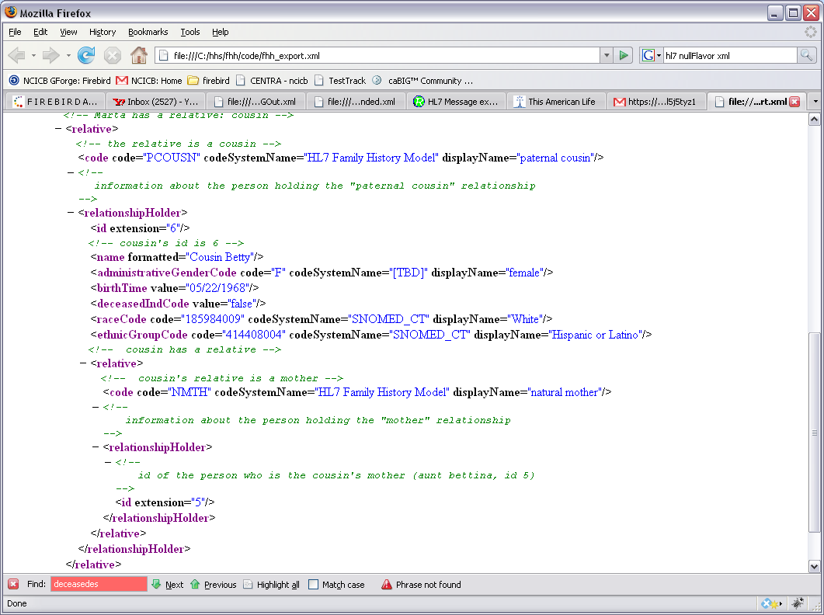
Figure 7. relative node, with relationshipHolder node that contains another relative. In this example, the relationshipHolder indicates a relative in order to establish the blood relationship with the proband (a cousin’s parent(s) must be known to establish the relationship).

Codes used by FHH
The charts below indicate the disease, race, ethnicity, and other codes used by the FHH tool. The predominant coding system used by the tool is SNOMED.
Charts to be added shortly.

Appendix A: Sample Family Health History XML File
The below file is an example of the format, information, and structure transmitted by the FHH tool.
<FamilyHistory classCode="OBS" moodCode="EVN">
<id extension="gov.hhs.fhh:718163810183" />
<effectiveTime value="09/26/2008" />
<methodCode displayName="Surgeon General's Family Health History Tool" />
<subject typeCode="SBJ">
<patient classCode="PAT">
<patientPerson>
<id extension="1" /> <!-- marta's id is 1 -->
<name formatted="Marta Marquez" />
<administrativeGenderCode code="F" codeSystemName="[TBD]" displayName="female" />
<birthTime value="07/11/1974" />
<deceasedIndCode value="false" />
<multipleBirthIndicator value="true" />
<raceCode code="413582008" codeSystemName="SNOMED_CT" displayName="Asian" />
<ethnicGroupCode code="414408004" codeSystemName="SNOMED_CT" displayName="Hispanic or Latino" />
<!-- information about Marta -->
<subjectOf2>
<!-- Martha disease information -->
<clinicalObservation>
<code code="38341003" codeSystemName="SNOMED_CT" displayName="Hypertension" />
<subject>
<dataEstimatedAge>
<code code="21611-9" codeSystemName="LOINC" displayName="Estimated Age" />
<value value="26" unit="year" />
</dataEstimatedAge>
</subject>
</clinicalObservation>
<!-- Marta has a user-entered medical condition to indicate -->
<clinicalObservation>
<code originalText="underactive thyroid" />
<subject>
<dataEstimatedAge>
<code code="21611-9" codeSystemName="LOINC" displayName="Estimated Age" />
<value unit="year">
<low value="20" />
<high value="29" />
</value>
</dataEstimatedAge>
</subject>
</clinicalObservation>
<!-- Marta entered her height and weight into the fhh tool; the tool calculated her bmi -->
<clinicalObservation>
<code code="271603002" codeSystemName="SNOMED_CT" displayName="height" />
<value unit="inch" value="64" />
</clinicalObservation>
<clinicalObservation>
<code code="107647005" codeSystemName="SNOMED_CT" displayName="weight" />
<value unit="pound" value="120" />
</clinicalObservation>
<clinicalObservation>
<code code="301331008" codeSystemName="SNOMED_CT" displayName="bmi" />
<value unit="percentage" value="20.5" />
</clinicalObservation>
<!-- Marta is an identical twin (see multiple birth indicator above) -->
<clinicalObservation>
<code code="313415001" codeSystemName="SNOMED_CT" displayName="Identical Twin" />
</clinicalObservation>
</subjectOf2>
<!-- Marta has a relative: mother -->
<relative>
<!-- the relative is a mother -->
<code code="NMTH" codeSystemName="HL7 Family History Model" displayName="matural mother" />
<!-- information about the person holding the "mother" relationship -->
<relationshipHolder>
<id extension="2" /><!-- mom's id is 2 -->
<name formatted="Ma" />
<administrativeGenderCode code="F" codeSystemName="[TBD]" displayName="female" />
<birthTime value="09/10/1941" />
<deceasedIndCode value="false" />
<raceCode code="413582008" codeSystemName="SNOMED_CT" displayName="Asian" />
</relationshipHolder>
</relative>
<!-- Marta has a relative: father -->
<relative>
<!-- the relative is a father -->
<code code="NFTH" codeSystemName="HL7 Family History Model" displayName="natural father" />
<!-- information about the person holding the "father" relationship -->
<relationshipHolder>
<id extension="3" /><!-- dad's id is 3 -->
<name formatted="Pa" />
<administrativeGenderCode code="M" codeSystemName="[TBD]" displayName="male" />
<birthTime value="09/26/1940" />
<deceasedIndCode value="true" />
<raceCode code="185984009" codeSystemName="SNOMED_CT" displayName="White" />
<ethnicGroupCode code="414408004" codeSystemName="SNOMED_CT" displayName="Hispanic or Latino" />
<!-- father is dead (true deceasedIndCode), so subjectOf1 indicates age of death -->
<subjectOf1>
<deceasedEstimatedAge>
<code code="39016-1" codeSystemName="LOINC" displayName="Age at Death" />
<value unit="year">
<low value="40" />
<high value="49" />
</value>
</deceasedEstimatedAge>
</subjectOf1>
<!-- information on father -->
<subjectOf2>
<clinicalObservation>
<code code="38341003" codeSystemName="SNOMED_CT" displayName="Hypertension" />
<subject>
<dataEstimatedAge>
<code code="21611-9" codeSystemName="LOINC" displayName="Estimated Age" />
<value value="26" unit="year" />
</dataEstimatedAge>
</subject>
</clinicalObservation>
<!-- father's cause of death -->
<clinicalObservation>
<code code="38341003" codeSystemName="SNOMED_CT" displayName="Hypertension" />
<sourceOf>
<code code="419620001" codeSystemName="SNOMED_CT" displayName="death" />
</sourceOf>
</clinicalObservation>
</subjectOf2>
</relationshipHolder>
</relative>
<!-- Marta has a relative: sister -->
<relative>
<!-- the relative is a sister -->
<code code="NSIS" codeSystemName="HL7 Family History Model" displayName="natural sister" />
<!-- information about the person holding the "natural sister" relationship (relationshipHolder) -->
<relationshipHolder>
<id extension="4" /><!-- sister's id is 4 -->
<name formatted="Sissy" />
<administrativeGenderCode code="F" codeSystemName="[TBD]" displayName="female" />
<birthTime value="07/11/1974" />
<deceasedIndCode value="false" />
<multipleBirthIndicator value="true" />
<raceCode code="185984009" codeSystemName="SNOMED_CT" displayName="White" />
<ethnicGroupCode code="414408004" codeSystemName="SNOMED_CT" displayName="Hispanic or Latino" />
<!-- information on sister -->
<subjectOf2>
<!-- sister is an identical twin (see multiple birth indicator above) -->
<clinicalObservation>
<code code="313415001" codeSystemName="SNOMED_CT" displayName="Identical Twin" />
</clinicalObservation>
</subjectOf2>
</relationshipHolder>
</relative>
<!-- Marta has a relative: paternal aunt -->
<relative>
<!-- the relative is a paternal aunt -->
<code code="PAUNT" codeSystemName="HL7 Family History Model" displayName="paternal aunt" />
<!-- information about the person holding the "paternal aunt" relationship (relationshipHolder) -->
<relationshipHolder>
<id extension="5" /><!-- aunt's id is 5 -->
<name formatted="Aunt Bettina" />
<administrativeGenderCode code="F" codeSystemName="[TBD]" displayName="female" />
<birthTime value="09/26/1943" />
<deceasedIndCode value="true" />
<raceCode code="185984009" codeSystemName="SNOMED_CT" displayName="White" />
<ethnicGroupCode code="414408004" codeSystemName="SNOMED_CT" displayName="Hispanic or Latino" />
<!-- aunt is dead (true deceasedIndCode), so subjectOf1 indicates age of death -->
<subjectOf1>
<deceasedEstimatedAge>
<code code="39016-1" codeSystemName="LOINC" displayName="Age at Death" />
<value unit="year">
<low value="30" />
<high value="39" />
</value>
</deceasedEstimatedAge>
</subjectOf1>
<!-- information about aunt -->
<subjectOf2>
<!-- aunt's disease information -->
<clinicalObservation>
<!-- hypertension -->
<code code="38341003" codeSystemName="SNOMED_CT" displayName="Hypertension" />
<subject>
<!-- age of diagnosis -->
<dataEstimatedAge>
<code code="21611-9" codeSystemName="LOINC" displayName="Estimated Age" />
<value unit="year">
<low value="20" />
<high value="29" />
</value>
</dataEstimatedAge>
</subject>
</clinicalObservation>
<!-- aunt was adopted -->
<clinicalObservation>
<code code="160496001" codeSystemName="SNOMED_CT" displayName="adopted" />
</clinicalObservation>
<!-- aunt's cause of death -->
<clinicalObservation>
<code code="38341003" codeSystemName="SNOMED_CT" displayName="Hypertension" />
<sourceOf>
<code code="419620001" codeSystemName="SNOMED_CT" displayName="death" />
</sourceOf>
</clinicalObservation>
</subjectOf2>
</relationshipHolder>
</relative>
<!-- Marta has a relative: cousin -->
<relative>
<!-- the relative is a cousin -->
<code code="PCOUSN" codeSystemName="HL7 Family History Model" displayName="paternal cousin" />
<!-- information about the person holding the "paternal cousin" relationship -->
<relationshipHolder>
<id extension="6" /><!-- cousin's id is 6 -->
<name formatted="Cousin Betty" />
<administrativeGenderCode code="F" codeSystemName="[TBD]" displayName="female" />
<birthTime value="05/22/1968" />
<deceasedIndCode value="false" />
<raceCode code="185984009" codeSystemName="SNOMED_CT" displayName="White" />
<ethnicGroupCode code="414408004" codeSystemName="SNOMED_CT" displayName="Hispanic or Latino" />
<!-- cousin has a relative -->
<relative>
<!-- cousin's relative is a mother -->
<code code="NMTH" codeSystemName="HL7 Family History Model" displayName="natural mother" />
<!-- information about the person holding the "mother" relationship -->
<relationshipHolder>
<!-- id of the person who is the cousin's mother (aunt bettina, id 5) -->
<id extension="5" />
</relationshipHolder>
</relative>
</relationshipHolder>
</relative>
</patientPerson>
</patient>
</subject>
</FamilyHistory>

Appendix B: HL7 Family History (Pedigree) XSD
The table below shows the HL7 Family History (Pedigree) Model XSD. FHH will export information in conformance with this XSD. Because FHH does not concern itself with all of the information covered by the model, its files will represent a conformant subset.
POCG_MT000040.xsd

<?xml version="1.0" encoding="UTF-8" standalone="no"?>
<xs:schema xmlns:xs="http://www.w3.org/2001/XMLSchema" xmlns="urn:hl7-org:v3" xmlns:mif="urn:hl7-org:v3/mif" targetNamespace="urn:hl7-org:v3" elementFormDefault="qualified">
<!--
*****************************************************************************************************************
* XML schema for message type POCG_MT000040.
* Source information:
* Rendered by: RoseTree 4.0.2
* Rendered on:
* HMD was rendered into XML using software provided to HL7 by Beeler Consulting LLC.
HMD to MIF Transform: $Id: RoseTreeHmdToMIFStaticModel.xsl,v 1.12 2005/07/19 04:27:26 lmckenzi Exp $
Base transform: $Id: ConvertBase.xsl,v 1.2 2005/04/17 03:20:15 lmckenzi Exp $
Package Id Conversion: $Id: TransformPackageIds.xsl,v 1.3 2005/07/31 05:19:52 lmckenzi Exp $
HTML To MIF markup: $Id: HtmlToMIFMarkup.xsl,v 1.2 2005/04/17 03:20:15 lmckenzi Exp $
Flat to Serialization Transform: $Id: MIFStaticModelFlatToSerialization.xsl,v 1.3 2005/04/17 03:20:15 lmckenzi Exp $
Fix Names Transform: $Id: FixMifNames.xsl,v 1.6 2005/04/17 03:20:15 lmckenzi Exp $
Base transform: $Id: ConvertBase.xsl,v 1.2 2005/04/17 03:20:15 lmckenzi Exp $
Package Id Conversion: $Id: TransformPackageIds.xsl,v 1.3 2005/07/31 05:19:52 lmckenzi Exp $
*
* Generated by XMLITS version 2.0
* MIF to XSD Transform $Id: StaticMifToXsd.xsl,v 1.25 2005/07/09 20:20:15 lmckenzi Exp $
* Package Id Conversion: $Id: TransformPackageIds.xsl,v 1.3 2005/07/31 05:19:52 lmckenzi Exp $
*
* Copyright (c) 2002, 2003, 2004, 2005 Health Level Seven. All rights reserved.
* Redistribution and use in source and binary forms, with or without
* modification, are permitted provided that the following conditions
* are met:
* 1. Redistributions of source code must retain the above copyright
* notice, this list of conditions and the following disclaimer.
* 2. Redistributions in binary form must reproduce the above copyright
* notice, this list of conditions and the following disclaimer in the
* documentation and/or other materials provided with the distribution.
* 3. All advertising materials mentioning features or use of this software
* must display the following acknowledgement:
* This product includes software developed by Health Level Seven.
* THIS SOFTWARE IS PROVIDED BY HEALTH LEVEL SEVEN, INC. AND CONTRIBUTORS "AS IS" AND
* ANY EXPRESS OR IMPLIED WARRANTIES, INCLUDING, BUT NOT LIMITED TO, THE
* IMPLIED WARRANTIES OF MERCHANTABILITY AND FITNESS FOR A PARTICULAR PURPOSE
* ARE DISCLAIMED. IN NO EVENT SHALL THE REGENTS OR CONTRIBUTORS BE LIABLE
* FOR ANY DIRECT, INDIRECT, INCIDENTAL, SPECIAL, EXEMPLARY, OR CONSEQUENTIAL
* DAMAGES (INCLUDING, BUT NOT LIMITED TO, PROCUREMENT OF SUBSTITUTE GOODS
* OR SERVICES; LOSS OF USE, DATA, OR PROFITS; OR BUSINESS INTERRUPTION)
* HOWEVER CAUSED AND ON ANY THEORY OF LIABILITY, WHETHER IN CONTRACT, STRICT
* LIABILITY, OR TORT (INCLUDING NEGLIGENCE OR OTHERWISE) ARISING IN ANY WAY
* OUT OF THE USE OF THIS SOFTWARE, EVEN IF ADVISED OF THE POSSIBILITY OF
* SUCH DAMAGE.
*
********************************************************************************************************************
-->
<xs:annotation>
<xs:documentation>Generated using schema builder version 2.0. Stylesheets:was rendered into XML using software provided to HL7 by Beeler Consulting LLC.
HMD to MIF Transform: $Id: RoseTreeHmdToMIFStaticModel.xsl,v 1.12 2005/07/19 04:27:26 lmckenzi Exp $
Base transform: $Id: ConvertBase.xsl,v 1.2 2005/04/17 03:20:15 lmckenzi Exp $
Package Id Conversion: $Id: TransformPackageIds.xsl,v 1.3 2005/07/31 05:19:52 lmckenzi Exp $
HTML To MIF markup: $Id: HtmlToMIFMarkup.xsl,v 1.2 2005/04/17 03:20:15 lmckenzi Exp $
Flat to Serialization Transform: $Id: MIFStaticModelFlatToSerialization.xsl,v 1.3 2005/04/17 03:20:15 lmckenzi Exp $
Fix Names Transform: $Id: FixMifNames.xsl,v 1.6 2005/04/17 03:20:15 lmckenzi Exp $
Base transform: $Id: ConvertBase.xsl,v 1.2 2005/04/17 03:20:15 lmckenzi Exp $
Package Id Conversion: $Id: TransformPackageIds.xsl,v 1.3 2005/07/31 05:19:52 lmckenzi Exp $.xsl version 2.0</xs:documentation>
</xs:annotation>
<xs:include schemaLocation="../coreschemas/infrastructureRoot.xsd"/>
<xs:include schemaLocation="../coreschemas/NarrativeBlock.xsd"/>
<xs:include schemaLocation="COCT_MT930000.xsd"/>
<xs:complexType name="POCG_MT000040.Age">
<xs:sequence>
<xs:group ref="InfrastructureRootElements"/>
<xs:element name="code" type="CD" minOccurs="0"/>
<xs:element name="value" type="IVL_PQ" minOccurs="0"/>
<xs:element name="pertinentInformation" type="POCG_MT000040.PertinentInformation" nillable="true"/>
</xs:sequence>
<xs:attributeGroup ref="InfrastructureRootAttributes"/>
<xs:attribute name="classCode" type="ActClassObservation" use="optional" default="OBS"/>
<xs:attribute name="moodCode" type="ActMood" use="optional" fixed="EVN"/>
</xs:complexType>
<xs:complexType name="POCG_MT000040.AnalysisResult">
<xs:sequence>
<xs:group ref="InfrastructureRootElements"/>
<xs:element name="code" type="CD" minOccurs="0"/>
<xs:element name="value" type="ANY" minOccurs="0"/>
</xs:sequence>
<xs:attributeGroup ref="InfrastructureRootAttributes"/>
<xs:attribute name="classCode" type="ActClassObservation" use="optional" default="OBS"/>
<xs:attribute name="moodCode" type="ActMood" use="optional" fixed="EVN"/>
</xs:complexType>
<xs:complexType name="POCG_MT000040.ClinicalObservation">
<xs:sequence>
<xs:group ref="InfrastructureRootElements"/>
<xs:element name="code" type="CD"/>
<xs:element name="text" type="ED" minOccurs="0"/>
<xs:element name="effectiveTime" type="IVL_TS" minOccurs="0"/>
<xs:element name="confidentialityCode" type="CE" minOccurs="0" maxOccurs="unbounded"/>
<xs:element name="uncertaintyCode" type="CE" minOccurs="0"/>
<xs:element name="value" type="ANY" minOccurs="0"/>
<xs:element name="methodCode" type="CE" minOccurs="0" maxOccurs="unbounded"/>
<xs:element name="subject" type="POCG_MT000040.Subject4" nillable="true" minOccurs="0"/>
<xs:element name="sourceOf" type="POCG_MT000040.SourceOf" nillable="true" minOccurs="0" maxOccurs="unbounded"/>
</xs:sequence>
<xs:attributeGroup ref="InfrastructureRootAttributes"/>
<xs:attribute name="classCode" type="ActClassObservation" use="optional" default="OBS"/>
<xs:attribute name="moodCode" type="ActMood" use="optional" fixed="EVN"/>
<xs:attribute name="negationInd" type="bl" use="optional"/>
</xs:complexType>
<xs:complexType name="POCG_MT000040.Component">
<xs:sequence>
<xs:group ref="InfrastructureRootElements"/>
<xs:choice>
<xs:element name="age" type="POCG_MT000040.Age" nillable="true"/>
<xs:element name="analysisResult" type="POCG_MT000040.AnalysisResult" nillable="true"/>
<xs:element name="percentageRisk" type="POCG_MT000040.PercentageRisk" nillable="true"/>
<xs:element name="probability" type="POCG_MT000040.Probability" nillable="true"/>
<xs:element name="relativeRisk" type="POCG_MT000040.RelativeRisk" nillable="true"/>
</xs:choice>
</xs:sequence>
<xs:attributeGroup ref="InfrastructureRootAttributes"/>
<xs:attribute name="typeCode" type="ActRelationshipHasComponent" use="optional" default="COMP"/>
</xs:complexType>
<xs:complexType name="POCG_MT000040.Component2">
<xs:sequence>
<xs:group ref="InfrastructureRootElements"/>
<xs:choice>
<xs:element name="geneticLocus" type="COCT_MT930000.GeneticLocus" nillable="true"/>
<xs:element name="clinicalObservation" type="POCG_MT000040.ClinicalObservation" nillable="true"/>
</xs:choice>
</xs:sequence>
<xs:attributeGroup ref="InfrastructureRootAttributes"/>
<xs:attribute name="typeCode" type="ActRelationshipHasComponent" use="optional" default="COMP"/>
</xs:complexType>
<xs:complexType name="POCG_MT000040.Component3">
<xs:sequence>
<xs:group ref="InfrastructureRootElements"/>
<xs:element name="pedigreeAnalysisResults" type="POCG_MT000040.PedigreeAnalysisResults" nillable="true"/>
</xs:sequence>
<xs:attributeGroup ref="InfrastructureRootAttributes"/>
<xs:attribute name="typeCode" type="ActRelationshipHasComponent" use="optional" default="COMP"/>
</xs:complexType>
<xs:complexType name="POCG_MT000040.ControlVariable">
<xs:sequence>
<xs:group ref="InfrastructureRootElements"/>
<xs:element name="inputParameters" type="POCG_MT000040.InputParameters" nillable="true"/>
</xs:sequence>
<xs:attributeGroup ref="InfrastructureRootAttributes"/>
<xs:attribute name="typeCode" type="ActRelationshipType" use="optional" fixed="CTRLV"/>
</xs:complexType>
<xs:complexType name="POCG_MT000040.DataEstimatedAge">
<xs:sequence>
<xs:group ref="InfrastructureRootElements"/>
<xs:element name="code" type="CD" minOccurs="0"/>
<xs:element name="value" type="IVL_PQ" minOccurs="0"/>
</xs:sequence>
<xs:attributeGroup ref="InfrastructureRootAttributes"/>
<xs:attribute name="classCode" type="ActClassObservation" use="optional" default="OBS"/>
<xs:attribute name="moodCode" type="ActMood" use="optional" fixed="EVN"/>
</xs:complexType>
<xs:complexType name="POCG_MT000040.DeceasedEstimatedAge">
<xs:sequence>
<xs:group ref="InfrastructureRootElements"/>
<xs:element name="code" type="CD" minOccurs="0"/>
<xs:element name="value" type="IVL_PQ" minOccurs="0"/>
</xs:sequence>
<xs:attributeGroup ref="InfrastructureRootAttributes"/>
<xs:attribute name="classCode" type="ActClassObservation" use="optional" default="OBS"/>
<xs:attribute name="moodCode" type="ActMood" use="optional" fixed="EVN"/>
</xs:complexType>
<xs:complexType name="POCG_MT000040.FamilyHistory">
<xs:sequence>
<xs:group ref="InfrastructureRootElements"/>
<xs:element name="id" type="II" minOccurs="0" maxOccurs="unbounded"/>
<xs:element name="code" type="CD" minOccurs="0"/>
<xs:element name="text" type="ED" minOccurs="0"/>
<xs:element name="effectiveTime" type="TS" minOccurs="0"/>
<xs:element name="confidentialityCode" type="CE" minOccurs="0" maxOccurs="unbounded"/>
<xs:element name="uncertaintyCode" type="CE" minOccurs="0"/>
<xs:element name="languageCode" type="CE" minOccurs="0"/>
<xs:element name="methodCode" type="CE" minOccurs="0" maxOccurs="unbounded"/>
<xs:element name="subject" type="POCG_MT000040.Subject5" nillable="true" minOccurs="0"/>
<xs:element name="component1" type="POCG_MT000040.Component2" nillable="true" minOccurs="0" maxOccurs="unbounded"/>
<xs:element name="component2" type="POCG_MT000040.Component3" nillable="true" minOccurs="0" maxOccurs="unbounded"/>
</xs:sequence>
<xs:attributeGroup ref="InfrastructureRootAttributes"/>
<xs:attribute name="classCode" type="ActClassObservation" use="optional" default="OBS"/>
<xs:attribute name="moodCode" type="ActMood" use="optional" fixed="EVN"/>
</xs:complexType>
<xs:complexType name="POCG_MT000040.InputParameters">
<xs:sequence>
<xs:group ref="InfrastructureRootElements"/>
<xs:element name="code" type="CD" minOccurs="0"/>
<xs:element name="text" type="ED" minOccurs="0"/>
<xs:element name="value" type="ANY" minOccurs="0"/>
</xs:sequence>
<xs:attributeGroup ref="InfrastructureRootAttributes"/>
<xs:attribute name="classCode" type="ActClassObservation" use="optional" default="OBS"/>
<xs:attribute name="moodCode" type="ActMood" use="optional" fixed="EVN.CRT"/>
</xs:complexType>
<xs:complexType name="POCG_MT000040.LivingEstimatedAge">
<xs:sequence>
<xs:group ref="InfrastructureRootElements"/>
<xs:element name="code" type="CD" minOccurs="0"/>
<xs:element name="value" type="IVL_PQ" minOccurs="0"/>
</xs:sequence>
<xs:attributeGroup ref="InfrastructureRootAttributes"/>
<xs:attribute name="classCode" type="ActClassObservation" use="optional" default="OBS"/>
<xs:attribute name="moodCode" type="ActMood" use="optional" fixed="EVN"/>
</xs:complexType>
<xs:complexType name="POCG_MT000040.Patient">
<xs:sequence>
<xs:group ref="InfrastructureRootElements"/>
<xs:element name="id" type="II" minOccurs="0"/>
<xs:element name="patientPerson" type="POCG_MT000040.Person" nillable="true"/>
<xs:element name="provider" type="POCG_MT000040.Provider" nillable="true" minOccurs="0"/>
<xs:element name="subjectOf1" type="POCG_MT000040.Subject3" nillable="true" minOccurs="0" maxOccurs="unbounded"/>
<xs:element name="subjectOf2" type="POCG_MT000040.Subject" nillable="true" minOccurs="0" maxOccurs="unbounded"/>
</xs:sequence>
<xs:attributeGroup ref="InfrastructureRootAttributes"/>
<xs:attribute name="classCode" type="RoleClass" use="optional" fixed="PAT"/>
</xs:complexType>
<xs:complexType name="POCG_MT000040.PedigreeAnalysisResults">
<xs:sequence>
<xs:group ref="InfrastructureRootElements"/>
<xs:element name="id" type="II" minOccurs="0" maxOccurs="unbounded"/>
<xs:element name="code" type="CD" minOccurs="0"/>
<xs:element name="derivationExpr" type="ST" minOccurs="0"/>
<xs:element name="text" type="ED" minOccurs="0"/>
<xs:element name="effectiveTime" type="IVL_TS" minOccurs="0"/>
<xs:element name="methodCode" type="CE" minOccurs="0" maxOccurs="unbounded"/>
<xs:element name="component" type="POCG_MT000040.Component" nillable="true" minOccurs="0" maxOccurs="unbounded"/>
<xs:element name="controlVariable" type="POCG_MT000040.ControlVariable" nillable="true" minOccurs="0" maxOccurs="unbounded"/>
</xs:sequence>
<xs:attributeGroup ref="InfrastructureRootAttributes"/>
<xs:attribute name="classCode" type="ActClassObservation" use="optional" default="OBS"/>
<xs:attribute name="moodCode" type="ActMood" use="optional" fixed="EVN"/>
<xs:attribute name="negationInd" type="bl" use="optional"/>
</xs:complexType>
<xs:complexType name="POCG_MT000040.PercentageRisk">
<xs:sequence>
<xs:group ref="InfrastructureRootElements"/>
<xs:element name="code" type="CD" minOccurs="0"/>
<xs:element name="value" type="INT" minOccurs="0"/>
</xs:sequence>
<xs:attributeGroup ref="InfrastructureRootAttributes"/>
<xs:attribute name="classCode" type="ActClassObservation" use="optional" default="OBS"/>
<xs:attribute name="moodCode" type="ActMood" use="optional" fixed="EVN"/>
</xs:complexType>
<xs:complexType name="POCG_MT000040.Person">
<xs:sequence>
<xs:group ref="InfrastructureRootElements"/>
<xs:element name="id" type="II" minOccurs="0"/>
<xs:element name="name" type="EN" minOccurs="0" maxOccurs="unbounded"/>
<xs:element name="telecom" type="TEL" minOccurs="0" maxOccurs="unbounded"/>
<xs:element name="administrativeGenderCode" type="CE" minOccurs="0"/>
<xs:element name="birthTime" type="TS" minOccurs="0"/>
<xs:element name="deceasedInd" type="BL" minOccurs="0"/>
<xs:element name="deceasedTime" type="TS" minOccurs="0"/>
<xs:element name="raceCode" type="CE" minOccurs="0" maxOccurs="unbounded"/>
<xs:element name="ethnicGroupCode" type="CE" minOccurs="0" maxOccurs="unbounded"/>
<xs:element name="relative" type="POCG_MT000040.Relative" nillable="true" minOccurs="0" maxOccurs="unbounded"/>
</xs:sequence>
<xs:attributeGroup ref="InfrastructureRootAttributes"/>
<xs:attribute name="classCode" type="EntityClass" use="optional" fixed="PSN"/>
<xs:attribute name="determinerCode" type="EntityDeterminer" use="optional" fixed="INSTANCE"/>
</xs:complexType>
<xs:complexType name="POCG_MT000040.PertinentInformation">
<xs:sequence>
<xs:group ref="InfrastructureRootElements"/>
<xs:element name="probability" type="POCG_MT000040.Probability" nillable="true"/>
</xs:sequence>
<xs:attributeGroup ref="InfrastructureRootAttributes"/>
<xs:attribute name="typeCode" type="ActRelationshipPertains" use="optional" default="PERT"/>
</xs:complexType>
<xs:complexType name="POCG_MT000040.Probability">
<xs:sequence>
<xs:group ref="InfrastructureRootElements"/>
<xs:element name="code" type="CD" minOccurs="0"/>
<xs:element name="value" type="PQ" minOccurs="0"/>
</xs:sequence>
<xs:attributeGroup ref="InfrastructureRootAttributes"/>
<xs:attribute name="classCode" type="ActClassObservation" use="optional" default="OBS"/>
<xs:attribute name="moodCode" type="ActMood" use="optional" fixed="EVN"/>
</xs:complexType>
<xs:complexType name="POCG_MT000040.Provider">
<xs:sequence>
<xs:group ref="InfrastructureRootElements"/>
<xs:element name="id" type="II" minOccurs="0" maxOccurs="unbounded"/>
<xs:element name="name" type="EN" minOccurs="0" maxOccurs="unbounded"/>
</xs:sequence>
<xs:attributeGroup ref="InfrastructureRootAttributes"/>
<xs:attribute name="classCode" type="EntityClassOrganization" use="optional" default="ORG"/>
<xs:attribute name="determinerCode" type="EntityDeterminer" use="optional" fixed="INSTANCE"/>
</xs:complexType>
<xs:complexType name="POCG_MT000040.Relative">
<xs:sequence>
<xs:group ref="InfrastructureRootElements"/>
<xs:element name="code" type="CE" minOccurs="0"/>
<xs:element name="relationshipHolder" type="POCG_MT000040.Person" nillable="true" minOccurs="0"/>
<xs:element name="subjectOf1" type="POCG_MT000040.Subject3" nillable="true" minOccurs="0" maxOccurs="unbounded"/>
<xs:element name="subjectOf2" type="POCG_MT000040.Subject" nillable="true" minOccurs="0" maxOccurs="unbounded"/>
</xs:sequence>
<xs:attributeGroup ref="InfrastructureRootAttributes"/>
<xs:attribute name="classCode" type="RoleClass" use="optional" fixed="PRS"/>
</xs:complexType>
<xs:complexType name="POCG_MT000040.RelativeRisk">
<xs:sequence>
<xs:group ref="InfrastructureRootElements"/>
<xs:element name="code" type="CD" minOccurs="0"/>
<xs:element name="value" type="PQ" minOccurs="0"/>
</xs:sequence>
<xs:attributeGroup ref="InfrastructureRootAttributes"/>
<xs:attribute name="classCode" type="ActClassObservation" use="optional" default="OBS"/>
<xs:attribute name="moodCode" type="ActMood" use="optional" fixed="EVN"/>
</xs:complexType>
<xs:complexType name="POCG_MT000040.SourceOf">
<xs:sequence>
<xs:group ref="InfrastructureRootElements"/>
<xs:element name="clinicalObservation" type="POCG_MT000040.ClinicalObservation" nillable="true"/>
</xs:sequence>
<xs:attributeGroup ref="InfrastructureRootAttributes"/>
<xs:attribute name="typeCode" type="ActRelationshipType" use="required"/>
</xs:complexType>
<xs:complexType name="POCG_MT000040.Subject">
<xs:sequence>
<xs:group ref="InfrastructureRootElements"/>
<xs:choice>
<xs:element name="geneticLocus" type="COCT_MT930000.GeneticLocus" nillable="true"/>
<xs:element name="clinicalObservation" type="POCG_MT000040.ClinicalObservation" nillable="true"/>
</xs:choice>
</xs:sequence>
<xs:attributeGroup ref="InfrastructureRootAttributes"/>
<xs:attribute name="typeCode" type="ParticipationTargetSubject" use="optional" default="SBJ"/>
</xs:complexType>
<xs:complexType name="POCG_MT000040.Subject3">
<xs:sequence>
<xs:group ref="InfrastructureRootElements"/>
<xs:choice>
<xs:element name="deceasedEstimatedAge" type="POCG_MT000040.DeceasedEstimatedAge" nillable="true"/>
<xs:element name="livingEstimatedAge" type="POCG_MT000040.LivingEstimatedAge" nillable="true"/>
</xs:choice>
</xs:sequence>
<xs:attributeGroup ref="InfrastructureRootAttributes"/>
<xs:attribute name="typeCode" type="ParticipationTargetSubject" use="optional" default="SBJ"/>
</xs:complexType>
<xs:complexType name="POCG_MT000040.Subject4">
<xs:sequence>
<xs:group ref="InfrastructureRootElements"/>
<xs:element name="dataEstimatedAge" type="POCG_MT000040.DataEstimatedAge" nillable="true"/>
</xs:sequence>
<xs:attributeGroup ref="InfrastructureRootAttributes"/>
<xs:attribute name="typeCode" type="ActRelationshipType" use="optional" fixed="SUBJ"/>
</xs:complexType>
<xs:complexType name="POCG_MT000040.Subject5">
<xs:sequence>
<xs:group ref="InfrastructureRootElements"/>
<xs:element name="patient" type="POCG_MT000040.Patient" nillable="true"/>
</xs:sequence>
<xs:attributeGroup ref="InfrastructureRootAttributes"/>
<xs:attribute name="typeCode" type="ParticipationTargetSubject" use="optional" default="SBJ"/>
</xs:complexType>
</xs:schema>

Figure 8. HL7 Family History (Pedigree) XSD Format

