Architectural Review Checklist

Family Health History
2.0

Revision Document History
Date | Version | Description | Author
10/03/08 | 0.1 | Initial draft | Leslie Power  5AM Solutions  202-359-0990  lpower@5amsolutions.com  powerless@mail.nih.gov

Table of Contents

1. Introduction 6
Purpose 6
Guidelines for Completing the ARC 6
2. Project Details (To be answered by development team) 6
General Information 6
Project Description 6
Contact Information 6
Major Deployment Milestones 6
Architectural Details 7
High level architectural description: 7
High Level Design Diagram (If available): 7
Implementation language(s) used? 7
Will connections/requests to the application be session based (i.e. statefull versus stateless)? If so, is there any reason why application would not support “sticky session” load balancing? 7
Will the application be caching data? If so, what is being cached and how much data will be cached? 7
What data files will be created (if any)? How much data will be saved on an on going basis? 7
Will this application need a database schema(s) created on the NCICB infrastructure? If so, what is the maximum number of objects to be stored? 7
Are there any external/non-NCICB data sources that will be accessed by the application? 7
If this is a web-based application, what are the preferred virtual hosts names to be registered? 7
Any additional architectural details that may be of significance to the needed deployment environment. 7
Performance Requirements 8
Total number of users for this application? 8
Peak number of concurrent users? 8
Peak number of requests/minute? 8
Up time requirements? 8
Acceptable down time when recovering from major systems disaster? 8
NCICB Project Dependencies 8
Configuration Management Details 8
Version Control 8
Change Control 8
Migration to CVS 8
Users 8
Build Process 8
Other CM Needs 8
Additional Notes 8
3. System Requirements (To be answered by both development & systems team) 9
Operating System 9
<<Solaris/LINUX/Windows 2000/…>> 9
Software (Technology Stack) 9
Web Server: <<Apache/Tomcat/ZOPE/…>> 9
App Server: <<Tomcat/JBoss/Oracle 9iAS/…>> 9
Database Server: <<Oracle[with JVM component]/MySQL/PostgreSQL/…>> 9
Other software components: <<PERL x.x, Python x.x, …>> 9
Server Hardware 9
Server: <<type, model, …>> 9
Minimum processor speed: 9
Minimum memory: 9
Minimum local drive space: 9
Storage 9
Expected file server disk storage (in MB): 9
Expected database storage (in MB): 9
Expected ftp storage (in MB): 9
Expected media/image storage (in MB): 9
Load Balancing/Fault Tolerance 9
Does the application support load balancing? 9
Implement load balancing – YES/NO 9
Networking 9
Any application specific port assignments? 9
Any additional configuration? 9
Additional Notes 9
4. Proposed NCICB Deployment Environment (To be answered by systems team) 9
Hardware 9
Technology Stack 10
File Server 10
Database 10
Networking 10
Other Resources 10
5. Impact Assessment (To be answered by systems team) 10
Overview 10
Cost 10
Timeline to implement 10
Additional Notes 10
6. Acceptance 10
7. Appendix 1 - Future Systems Requirements 11
New Architecture Diagram 11
Notes on the design change 11
Hardware 11
Servers 11
Processor speed 11
Memory 11
Drive Space 11
Software (Technology Stack) 11
Web Server 11
App Server 11
Other components 11
Fault Tolerance (Redundancy) 11
Does the application support load balancing? 11
Implement load balancing – YES/NO 11
Load balancing requirements 11
Fault tolerance solution suggested 11
Additional requirements (if any) 11
Performance Enhancements 11
Processing Power 11
Memory 11
I/O 11
Other needs 11

Introduction

Purpose
The purpose of the Architectural Review Checklist (ARC) is to help identify the deployment environment (both hardware and software components) necessary for an application to execute optimally within the NCICB IT infrastructure. The ARC is considered to be a dynamic artifact for any NCICB project and should be maintained in the configuration library (i.e. CVS) for each project. For new projects, this document template will be automatically checked into the projects repository by the SCM team upon project initiation. The ARC should be reviewed on at least a quarterly basis to capture any application design changes that may effect the deployment environment necessary for optimal performance.

Guidelines for Completing the ARC
The ARC is divided into 4 main sections. The first section (Project Details) is meant to capture general information about the project. The project development team should fill out the Project Details section and return it to the systems team. The second section (Systems Requirements) is meant to capture details of specific system requirements for the project. Both the development and system teams will preferably answer the Systems Requirement section jointly. However, depending on the development teams familiarity with the NCICB infrastructure, they may choose to answer either all or parts of this section on their own. The third section (Planned Deployment Environment) specifies the proposed deployment environment for the application and is to be answered by the systems team based on the response to section 1 & 2. Finally, the last section (Impact Assessment) describes the impact (additional hardware/software costs, staffing resources…) to the existing NCICB IT infrastructure in order to support this application. Upon completion of the Deployment Environment and Impact Assessment sections, the systems team will return the ARC to the development team for final review and comments.

Project Details (To be answered by development team)

General Information

Project Description
The Surgeon General’s Family Health History tool enables users to create an electronic records of the diseases and conditions of members of their families. The tool outputs a standards-based file which can then be uploaded into other systems, such as electronic health records, hospital systems, etc.

Contact Information
Title | Name | Phone | Email
Project Manager | Dan Weikart | 703-915-6476 | Dan.Weikart@hhs.gov
Team Lead/Architect | Leslie Power | 202-359-0990 | lpower@5amsolutions.com
SCM Coordinator | 5AM Solutions | 202-359-0990 | lpower@5amsolutions.com

Major Deployment Milestones
Milestone | Date
Planned Release to QA | N/A
Planned Release to Staging | 10/27
Planned Release to Production | 12/19 or 12/30

Architectural Details

High level architectural description:
FHH is a MVC web-based application. Written in Java, it will be deployed on JBOSS 4.0.5 and requires a MySQL 5.0 database as well as EH cacheing. It does not currently have a web service but may in a future release.

High Level Design Diagram (If available):
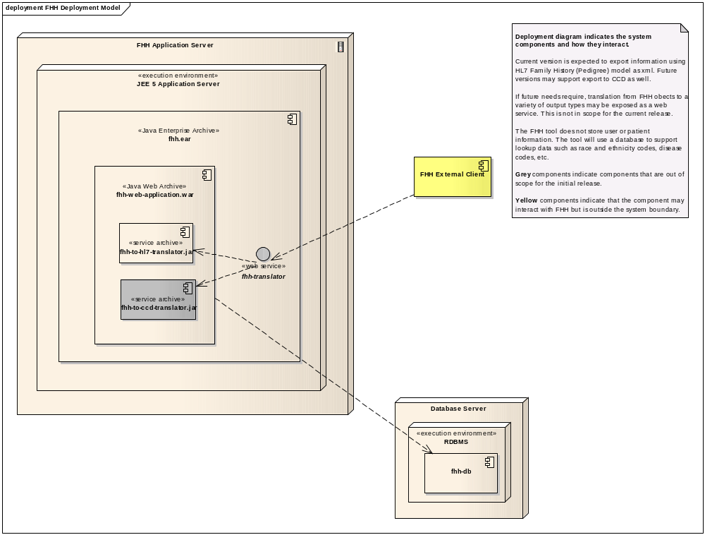

Implementation language(s) used?
Java 1.5

Will connections/requests to the application be session based (i.e. statefull versus stateless)? If so, is there any reason why application would not support “sticky session” load balancing?
Yes. HTTP request for the web UI rely on statefull sessions for processing. The load balancer should use the jsessionid parameter and cookie to bind requests from the client to the servers that are hosting the session.

Will the application be caching data? If so, what is being cached and how much data will be cached?
FHH will use Hibernate's 2nd level cache to improve performance and reduce hits to the database. The amount of data cached is relatively small - under 50MB - and will be stored in memory. Hibernate's caching mechanism will need no more that 1GB of disk space for swapping (or spillover) in the directory identified by the System Property java.io.tmpdir.

What data files will be created (if any)? How much data will be saved on an on going basis?
<<e.g. ftp uploads, log files, temporary work files, cache storage…>>
No data files will be created that require storage.

Will this application need a database schema(s) created on the NCICB infrastructure? If so, what is the maximum number of objects to be stored?
Yes, the FHH application uses a MySQL database for its data storage. We can provide a data schema when we’re further along in the development cycle.

Are there any external/non-NCICB data sources that will be accessed by the application?
<<e.g. USCS DAS, SKY/M-FISH, Mittelman DB, Pubmed, …>>
No.

If this is a web-based application, what are the preferred virtual hosts names to be registered?
This project requires a dns transfer from the existing 1.0 version of the app - https://familyhistory.hhs.gov/

Any additional architectural details that may be of significance to the needed deployment environment.

Performance Requirements

Total number of users for this application?
There are thousands of users of the application’s current production version, Average monthly visitor number fo the first six months of 2008 was 25,000.

Peak number of concurrent users?
Unknown; we will calculate for you.

Peak number of requests/minute?
See above.

Up time requirements?
SLA is in negotiation. FHH application does not required uptime beyond NCI’s current hosting capabilities.

Acceptable down time when recovering from major systems disaster?
Well, presumably this depends on the type of system disaster. If the disaster can be recovered from by a server reboot/app server redeployment, then we would appreciate recovery within 2 hours of an outage. We welcome suggestions and a conversation based on your current capabilities.

NCICB Project Dependencies
None.

Configuration Management Details
Briefly describe your current configuration management practices here.
Code is checked in daily into developer’s branch. After code is reviewed, the code is merged to the proper tag.
All project artifacts are stored in the Subversion repository. Updates are made by project team members on the documents in the repository and committed when completed.

Version Control
Current system uses Subversion 1.5 hosted by the development team’s company.

Change Control
Our change control board is comprised of a subset of stakeholders across commercial, academic, and government. This board makes decisions regarding change requests. At this point, support for future versions beyond 2.0 has not been determined, so future releases, even patch releases, are unknown.

Migration to CVS
No.

Users
Source control hosted outside of NCI. We will need to meet with your team to determine how to handle source control handoff for deployment; we can provide access to our svn repository to your deployment team if that is helpful, or some other solution.

Build Process
System uses Maven for its build.

Other CM Needs
Describe any other CM needs?

Additional Notes

System Requirements (To be answered by both development & systems team)

Operating System
The expectation is that FHH will be installed in multiple locations outside of NCI as well as within NCI. For those installations outside NCI, FHH should be installable on the following Operating Systems:
RedHat Linux Enterprise (EL3O04)
Windows 2003 Server (not Vista)

Software (Technology Stack)

Web Server: <<Apache/Tomcat/ZOPE/…>>

App Server: <<Tomcat/JBoss/Oracle 9iAS/…>>
JBoss 4.0.5

Database Server: <<Oracle[with JVM component]/MySQL/PostgreSQL/…>>
MySql 5.x

Other software components: <<PERL x.x, Python x.x, …>>

Server Hardware

Server: <<type, model, …>>

Minimum processor speed:

Minimum memory:

Minimum local drive space:

Storage

Expected file server disk storage (in MB):

Expected database storage (in MB):

Expected ftp storage (in MB):

Expected media/image storage (in MB):

Load Balancing/Fault Tolerance

Does the application support load balancing?

Implement load balancing – YES/NO

Networking

Any application specific port assignments?

Any additional configuration?

Additional Notes

Proposed NCICB Deployment Environment (To be answered by systems team)

Hardware
<<dev, qa, staging, production servers to be used>>

Technology Stack
<<specific technology stack to be used>>

File Server
<<space allocation on big IP, NFS mount points, initial size allocation…>>

Database
<<database server to used, schema names to be created, initial size, maximum size…>>

Networking
<<e.g. any BigIP configuration necessary, …>>

Other Resources
<<e.g. ftp server access, media server access, …>>

Impact Assessment (To be answered by systems team)

Overview

Cost

Timeline to implement

Additional Notes

Acceptance
Project Lead ( ) | Project Coordinator – NCICB ( )
Systems Team | SCM Administrator

Appendix 1 - Future Systems Requirements
In this section, describe any projected future anticipated requirements for your system.

New Architecture Diagram

Notes on the design change

Hardware

Servers

Processor speed

Memory

Drive Space

Software (Technology Stack)

Web Server

App Server

Other components

Fault Tolerance (Redundancy)

Does the application support load balancing?

Implement load balancing – YES/NO

Load balancing requirements

Fault tolerance solution suggested

Additional requirements (if any)

Performance Enhancements

Processing Power

Memory

I/O

Other needs

