Family Health History
Use Case Survey Model and Specification

Version: 2.0
Latest Revision Date: July 15, 2009

Document Approvals
The list contains the name and contact information for the core project team and any key stakeholders who have an interest in the success of the project. An “S” identifies persons responsible for approval from the stakeholder groups. Sign off of the document would be required when a decision is made not to take action for defined gaps.

S | Name | Role
 | Terry Cullen | Indian Health Service
 | Greg Downing | Program Director, Personalized Health Care, Office of the Secretary, HHS
 | Greg Feero | National Human Genome Research Institute (NHGRI)
 | George Komatsoulis | National Cancer Institute
 | Kathie Kendrick | Agency for Healthcare Research and Quality
 | Vish Sankaran | Program Director, Federal Health Architecture, ONC
 | Mollie Ullman | Harvard Partners
 | Grant Wood | Intermountain Health

Revision History

Because requirements may change during the course of the project, frequent additions and corrections to this document will occur. The following table lists the change history for this document.

Date | Version | Description | Author
09/15/2008 | 0.9 | Initial Draft | Pawan Chadha
09/16/2008 | 0.9.1 | General edits | L. Power
09/17/2008 | 1.0 | Baseline with updates to use case model | Pawan Chadha
01/05/2009 | 1.1 | Final Edits | Pawan Chadha
07/15/2009 | 2.0 | Revision to reflect functionality to export/import family health history data to/from HealthVault | Peter Gordon

Table of Contents
1. Introduction 4
1.1 Purpose 4
1.2 Background 4
2. Use Case Model Survey 4
3. Actors 5
3.1 Clinician 5
3.2 Patient 5
3.3 Patient Family Member 5
3.4 Third-Party Application 5
3.5 User 6
4. Use Case Specifications 6
4.1 Get Help 6
4.2 Get File 6
4.3 Process File 6
4.4 Re-Index Profile 6
4.4.1 User Story – Change Proband 6
4.5 Create or Edit FHH Profile 6
4.5.1 User Story - Upload Family Health History File 7
4.5.2 User Story – Save and Download Family Health History File 8
4.5.3 User Story - Add an undefined disease 8
4.5.4 User Story - Create Personal Profile 8
4.5.5 User Story - Create/Edit Family Member Health History 8
4.5.6 User Story - Associate Disease with Family Member 9
4.6 View Pedigree Chart 9
4.6.1 User Story – Define Chart/Table – 10
4.6.2 User Story – Download Chart/Table 10
4.6.3 User Story – Print Chart/Table 10
4.6.4 User Story – View Chart/Table 10
4.7 Export Family Health History to HealthVault 11
4.7.1 Pre-conditions 11
4.7.2 Basic Flow 11
4.7.3 Post-conditions 11
4.7.4 Alternative Flows 12
4.7.5 Special Requirements 12
4.8 User Imports Family History Data from HealthVault 12
4.8.1 Pre-conditions 12
4.8.2 Basic Flow 13
4.8.3 Post-conditions 13
4.8.4 Alternative Flows 13
4.8.5 Special Requirements 14

Introduction
This document captures the functional requirements for the Family Health History (FHH) Project using a combination of use cases and user stories. This document contains the Use Case Survey which is a model that provides a high-level overview of who all will interact with the system (actors) and the capabilities that the system will provide them (use cases). The use cases in this document are captured at a high level, with the detailed requirements being captured within the use cases in the form of user stories. User stories are more of a narrative, depicting how a particular user would interact with the system.

Purpose
This Use Case Survey document for FHH supports the following objectives:
- Establishes the users of the system.
- Defines the functional scope of the system.
- Captures detailed requirements for the system.

Background
The Family Health History application is the next generation of the existing Surgeon General’s My Family Health Portrait, which allows users to input health information about themselves and their biological family members. The goal is to be able to create an electronic record of both personal health history and family health history. This information can then be shared among family members and medical health professionals or clinicians, with either being able to augment or edit information. Additionally, clinicians would then be able to take the electronic record provided by the patient and input that data into their own systems, such as electronic health record or hospital charting systems. In order to provide meaningful information, this project follows the HL-7 Pedigree Model, which provides a mechanism for the exchange of family history genomic and clinical information. It also utilizes SNOMED coding for the common classification of diseases and disorders.
This application strives to create an interface that is easy to use and one that codifies data entry so that meaningful information is captured using a common vocabulary and definitions that can be used by the disparate user community that this application will serve.

Use Case Model Survey
The following diagram depicts the use cases, actors, and their relationships as they pertain to the Family Health History project. It also defines the system boundary, delineating what the system is responsible for and the functions it will provide from those that are outside the scope or control of the system.

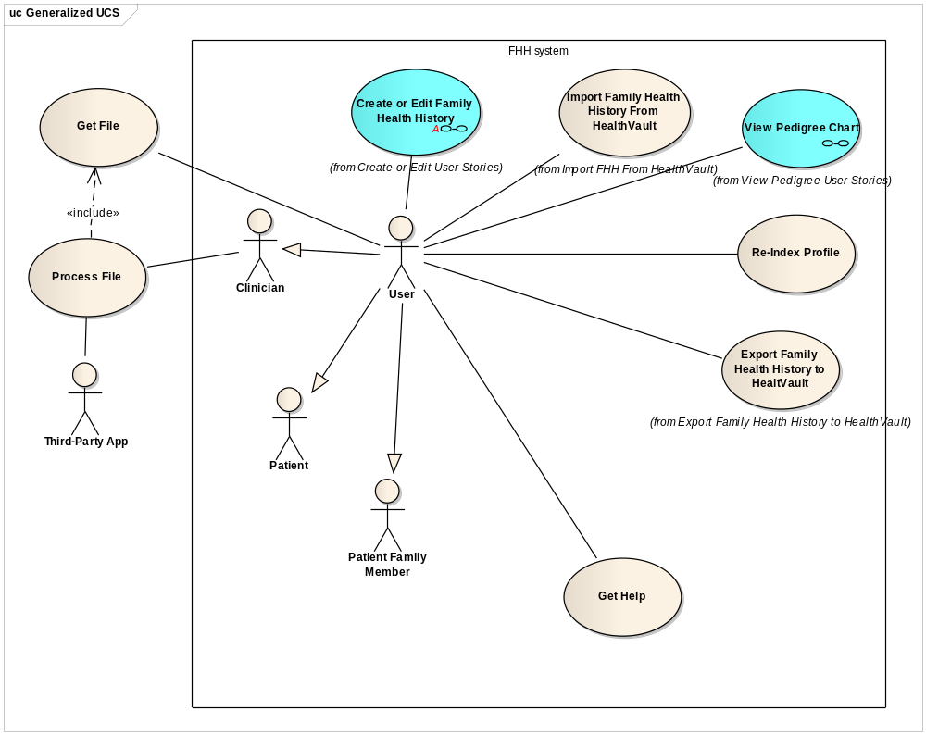
Figure 1- Complete Use Case Model Survey

Actors
The following are the actors that will use and interact with the Family Health History system.

Clinician
This actor represents any health care provider that is granted access to a patient's health profile.

Patient
This is the core actor within the system, who is the proband for the family health history profile.

Patient Family Member
This actor represents any member of a patient's family that may be given the profile to review or edit.

Third-Party Application
This actor represents any system external to the application that needs to be able to receive and process the XML file generated by the application.

Note: The responsibility for building the capability to digest the file is incumbent on the owner of the Third Party App.

User
This actor is a generalized actor representing the user that is creating or editing the Family Health History Profile. The Clinician, Patient, and Patient Family Member actors inherit the capabilities of the generalized User actor.

Use Case Specifications
The following are the use cases that the system will support.

Get Help
This use case allows any actor to get assistance on how to use the system. Each page within the site will have a help link that displays page specific content.

Get File
This is an external use case that deals with the physical movement of the Family Health History file so that it can be accessed and processed by third party applications or uploaded by another actor.

Process File
This is an external use case which allows a clinician to import and process the Family Health History file from the FHH system through any third party application (Risk assessment, EHR, PHR, etc).

Re-Index Profile
This use case allows a user to take a previously created health profile record and change the proband to another family member. The user will select an existing family member and the system will re-calculate the familial relationships with the chosen member as the new index for the Family Health History. The system will only preserve the family members that are biologically related.

User Story – Change Proband
In this user story a family member wants to take an existing profile and edit it so that they become the proband and the system automatically adjusts the relationships to reflect the change.

When the user first changes the proband, the system checks to see if the relationship is a sibling. If it is, the system utilizes the existing data for all relationships.

Create or Edit FHH Profile
This use case enables a user to create a new FHH profile by entering medical health history for his- or herself and relevant family members. A user may also edit an existing profile by first uploading an existing profile that was created by the application back into the application

Once completed, the Patient can extend this use case to view a pedigree diagram of the health history, download a graphical representation of the model, or download an XML version of the profile to local media.

It should be noted that the system does not store or persist any data, all data is downloaded and stored in the user's environment.

The diagram below shows the user stories contained within this use case.
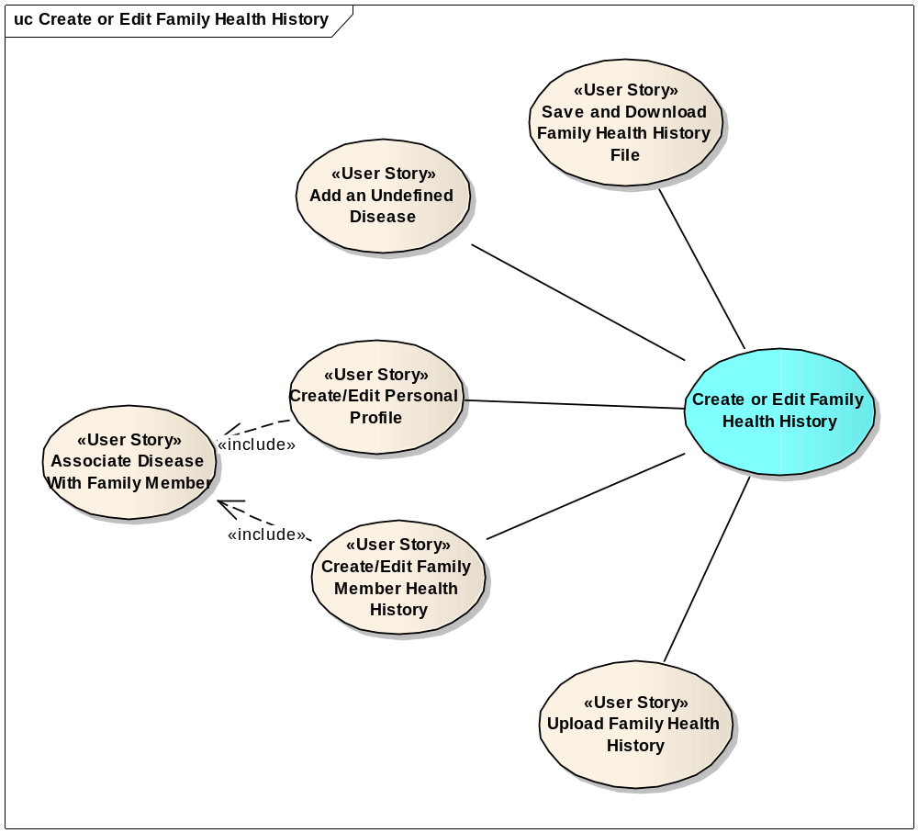
Figure 2 - Create/Edit Family History User Stories

User Story - Upload Family Health History File
In order to edit a profile, the user must first find a Family Health History (XML file) in their local environment and upload it to the application. The system then opens the profile and allows the user to edit it.

If the user loads a Family Health History that has a different structure than that generated by the system, the system will try and read as much of the data as possible, but if it is unable to, it will notify the user and prompt to choose another file.

User Story – Save and Download Family Health History File
In this user story, the user elects to save the Family Health History file to a local drive. This is a system generated XML file, using the Hl7 Family History model XSD that the user can download to local media. Each time the user elects to save the family health history, the system regenerates this file. The system does not store the file, or persist any user information, internally.

User Story - Add an undefined disease
The user story allows a user to manually input one or more diseases that were not predefined by the FHH tool. If a disease is added, it becomes available in the disease selection for this user's session so that duplicate entry is not necessary.

User Story - Create Personal Profile
This user story allows a user to input personal data and health history for the proband. This is required before a family history can be created. The following personal information is requested for the proband, followed by the personal health history:
- Name (Text Field)
- Date of Birth (Numeric Text Field, dd/mm/yyyy)
- Biological Gender (M or F)
- Weight in lbs. (Numeric Text )
- Height (2 Numeric Text fields for feet and inches)
- Ethnicity (user will select from pre-defined values, can select multiple values)
- Race (user will select from pre-defined values, can select multiple values)
- Consanguinity
- Multiple Birth (Y or N Flag)
- Identical or Fraternal (Flag, Only if Multiple-Birth is Y)

NOTE: The Living Flag, though not displayed, needs to be set as "Y"
NOTE: Only the DoB and Gender are required

The user can then associate a disease with this family member. (See Associate Disease with Family Member user story.)

User Story - Create/Edit Family Member Health History
This user story allows a user to enter for one or more family members, by filling in the following for each entry created:
- Name of Individual or Family Member
- Biological Sex
- Relationship (User should choose from a pre-determined list. If relationship is cousin, need to be able to assign the appropriate aunt/uncle as the parent; if half bro/sis, need to assign the appropriate parent)
- Living Flag (y or N)
- Age (Only if Living Flag is Y; the system will prompt for the DoB or an approximate age (3 digit numeric value). The system will translate this to the year of birth)
- Age at Death (only valid if Living Flag N; user will select a range of ages)
- Cause of Death (only valid if Living Flag N, user will select from a pre-defined values and have the option of selecting other or unknown. If other, the user may input a free-text entry)
- Multiple Birth (Y or N Flag)
- Identical or Fraternal (Flag, Only if Multiple-Birth is Y)

NOTE: Relationship and gender are the only required fields.

The user can then associate a disease with this family member. (See Associate Disease with Family Member user story.)

User Story - Associate Disease with Family Member
The user story allows a user to manually input one or more diseases that were not predefined by the FHH tool. If a disease is added, it becomes available in the disease selection for this user's session so that duplicate entry is not necessary.
The system should display a list of all default diseases that are tracked in the system, as defined by the enumerated Disease type table in the Domain Model. If the user marks as suffering from a disease, and the disease has branches, the sub-disease(s) will be shown. By selecting a diseases the user is saying that it is an affliction, so there is no need to ask if afflicted or not.
The following are the data fields that needed to be completed for each applicable disease/sub-disease:
- Age at Onset (If afflicted, need to select from a set of age ranges as specified in the enumerated Age Range table in the Domain Model).

User Story – Auto-complete Data Entry
This user story allows the user to select from a list of pre-determined diseases that are available in the system, when one of the standard displayed diseases does not meet their needs. As the user types a value in the text field to add, the application will display a list of values matching the entered string for the user to select from. The system will look to match the input value against any portion of the pre-existing diseases, not just a beginning text search.

View Pedigree Chart
This is a system use case which creates a pedigree chart of the family health history based on the selected profile. The user can select to limit the profile to select disease(s), or view all. The chart includes a diagram (pedigree chart) and information in tabular format.

The diagram below shows the user stories associated with this use case.
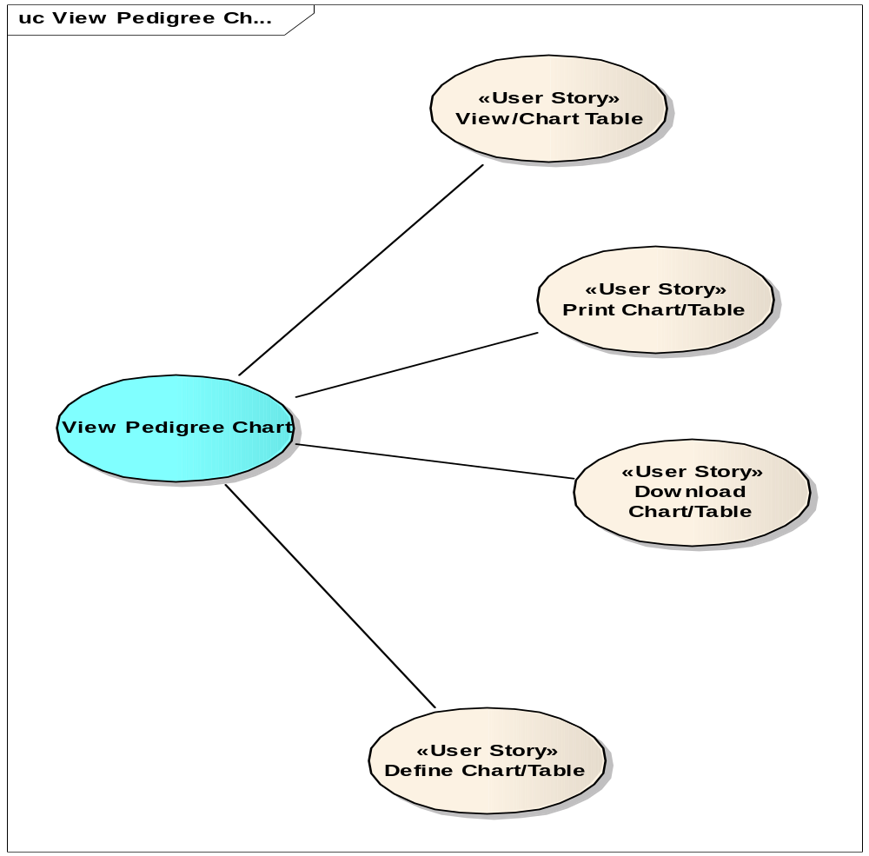

User Story – Define Chart/Table –
This user story allows a user to customize the chart/table by selecting which diseases and/or family members to display and include. The user will have the option to create a chart, diagram, or a chart and diagram. Within the diagram, the user will be able to choose which diseases to highlight, and can assign abbreviations to the non-standard diseases that have been added.

User Story – Download Chart/Table
This user story allows a user to download a read-only version of the chart and/or table to their local media so that it can be shared with others for viewing purposes. Any person viewing the data should be able to copy the data to be used in another application.

User Story – Print Chart/Table
This user story allows the user wants to print the pedigree chart and/or the table on a local printer. The user must be able to print the entire chart.

User Story – View Chart/Table
In this user story the user wants to view a graphical representation of the pedigree chart and/or a table on the computer screen they are working on. If the chart is large, the user must be able to scroll vertically or horizontally to see the entire chart.

Export Family Health History to HealthVault
An user in MFHP exports family health history data from his/her MFHP file to his/her HealthVault Account/Record.

Pre-conditions
- The User has created a family history in MFHP
- The User has MFHP application opened in an internet browser
- The User is at the Save Family History screen

Basic Flow
- The user opts to export his/her MFHP information to HealthVault

- MFHPV prompts the user to save a file to his or her computer before proceeding. (See “Save Family History” user story.)
3. MFHP presents information about HealthVault and asks the user if he/she wants to proceed to export data
4. The user opts to proceed to export data
5. MFHP connects to HealthVault and presents the HealthVault user authentication screen. MFHP also notifies the user that she or he is leaving the government web site.

6. The user enters his/her HealthVault credentials into HealthVault
7. HealthVault accepts the credentials and logs the user into HealthVault.

8. HealthVault identifies the matching record in the chosen HealthVault Account, and informs the user it is ready to accept the MFHP data to the presented HealthVault record

9. The user opts to export the MFHP information to the presented HealthVault record

10. MFHP exports family health history data to the HealthVault account holder’s account

11. MFHP confirms to the user that the data has been saved to HealthVault; asks the MFHP User to check within HealthVault that the data is in the intended location.

12. Use case ends.

Post-conditions
- MFHP User has exported the family history data of the MFHP proband to the record of a HealthVault account holder.

Alternative Flows
1a. User cancels action

3a. User cancels action

4a. MFHP fails to establish an “application session” with HealthVault
- MFHP informs User that: a) a connection could not be established; b) the problem may be that HealthVault is unavailable; c) try again at a later time and d) if the problem persists, contact Microsoft Health Vault to resolve the problem (URL for contact information is: https://support.healthvault.com/eform.aspx?productKey=healthvault2&ct=eformts&scrx=1)
- Use case ends

4b. The user is timed out by MFHP before providing credentials
- The user must resume at Step 1

5a. The user does not have a HealthVault account
- The user clicks the HealthVault “Get Started” link and registers an account with HealthVault
- Resume Step 6

6a. The user provides invalid credentials
- HealthVault tells the user that he/she has submitted invalid credentials
- Resume at end of Step 4

8a. MFHP decides to change the MFHP proband (“Self”) data to export
- User changes the proband (“Self”) on which the MFHP data orients itself (See “save family history as” user story.)
- User resumes export at Step 1

9a. MFHP did not export the data from the HealthVault
- MFHP informs MFHP User that: a) the data could not be exported; b) the problem may be that HealthVault is unavailable; c) try again at a later time and d) if the problem persists, contact Microsoft Health Vault to resolve the problem (URL for contact information is: https://support.healthvault.com/eform.aspx?productKey=healthvault2&ct=eformts&scrx=1
- Use case ends

Special Requirements

- MFHP data stored in HealthVault shall maintain a unique identifier so that it can be imported back into MFHP to the identical MFHP fields from which it came – e.g. a condition exported to HealthVault and changed in HealthVault can be imported back into MFHP and MFHP will “understand” it to be a changed condition and store it as a changed value in its original attribute.

User Imports Family History Data from HealthVault
A user in MFHP imports family health history data from his/her HealthVault Account/Record into his/her MFHP file.

Pre-conditions
- The User is at the My Family Health History screen

Basic Flow
- The user opts to import HealthVault data into his/her MFHP file

2. MFHP presents information about HealthVault and pre-conditions to import data, and asks the MFHP user if he/she wants to proceed
3. The user opts to proceed.
4. MFHP establishes an application session” with HealthVault, and HealthVault, via MFHP, presents its user authentication screen

5. The user enters his/her HealthVault credentials into HealthVault
6. HealthVault accepts the credentials and logs the user into HealthVault.

7. MFHP informs the user that it is ready to import data from the presented HealthVault account.

8. The user opts to import the HealthVault data into MFHP

9. MFHP imports the HealthVault account holder’s data into MFHP

10. MFHP confirms to the user that the HealthVault information has been imported

Post-conditions
- The user has imported the family history data of the account holder of one HealthVault account into the MFHP application.

Alternative Flows
1a. The user cancels action

3a. The user opts not to proceed
- MFHP returns the user to My Family History page
- Use case ends

4a. MFHP is not able to establish a connection with HealthVault
- MFHP informs MFHP User that: a) a connection could not be established; b) the problem may be that HealthVault is unavailable; c) try again at a later time and d) if the problem persists, contact Microsoft Health Vault to resolve the problem (URL for contact information is: https://support.healthvault.com/eform.aspx?productKey=healthvault2&ct=eformts&scrx=1
- Use case ends

5a. The user is timed out before providing credentials
- The user must resume at Step 6

6a. The user provides invalid credentials
- HealthVault tells the user that he/she has submitted invalid credentials
- Resume at Step 5

9a. MFHP did not import the data from the HealthVault
- MFHP informs MFHP User that: a) the data could not be imported; b) the problem may be that HealthVault is unavailable; c) try again at a later time and d) if the problem persists, contact Microsoft Health Vault to resolve the problem (URL for contact information is: https://support.healthvault.com/eform.aspx?productKey=healthvault2&ct=eformts&scrx=1
- Use case ends

Special Requirements
- Standardized data imported from HealthVault by MFHP shall be maintained according to standard in MFHP
- HealthVault family history attributes/fields which do not have a corresponding attribute/field in MFHP shall not be imported into MFHP.
- MFHP data stored in HealthVault shall maintain a unique identifier so that it can be exported back to HealthVault to the identical HealthVault fields from which it came – e.g. a condition imported from HealthVault, changed in MFHP, can be exported back to HealthVault and Healthvault will “understand” it to be a changed condition and store it as a changed value in its original attribute.

