Model Summary
Family Health History

Last Revised: | 10/24/2008
Produced By: | FHH Development Team
Version: | 1.0

Document Approvals
The list contains the name and contact information for the core project team and any key stakeholders who have an interest in the success of the project. An “S” identifies persons responsible for approval from the stakeholder groups. Sign off of the document would be required when a decision is made not to take action for defined gaps.

S | Name | Role
 | Terry Cullen | Indian Health Service
 | Greg Downing | Program Director, Personalized Health Care, Office of the Secretary, HHS
 | Greg Feero | National Human Genome Research Institute (NHGRI)
 | George Komatsoulis | National Cancer Institute
 | Kathie Kendrick | Agency for Healthcare Research and Quality
 | Vish Sankaran | Program Director, Federal Health Architecture, ONC
 | Mollie Ullman | Harvard Partners
 | Grant Wood | Intermountain Health

Revision History
When you make a change to a document, you must add an entry to this Revision History table and you must manually type the Last Revised Date on the front cover.

Date | Version | Description | Revised by
09/08/2008 | 0.1 | Initial version | Leslie Power
10/12/2008 | 0.2 | Updated with latest model | L. Power
10/24/2008 | 1.0 | Initial elaboration baseline | L. Power
Copyrights and Trademarks
© Copyright 2008 by United States Department of Health and Human Services. All rights reserved.
Table of Contents
1. Introduction 3
1.1. Purpose 3
1.2. References 3
2. Architectural Goals and Constraints 3
2.1. Standards-Based 3
3. Information Model 3
3.1. HL7 Family History (Pedigree) Model 3
3.2. HL7 Family History (Pedigree) Schema 4
3.3. Interfacing with FHH 4
3.4. Codes 4
4. Domain Model 5
4.1. Appendix A: HL7 Family History (Pedigree) XSD 7

Introduction

Purpose
This document provides a summary of the information and domain models for the Family Health History (FHH) system. It is intended to capture and convey the interface the system will present through the information it outputs in the HL7 Family History XML schema, and the domain model that underlies the interface.

References
- FHH UML Model
- FHH Use Case Summary
- FHH Requirements Documents
- FHH Interoperability Partner Document
- FHH Example XML Output

Architectural Goals and Constraints
The following factors are key considerations beyond the functional requirements that are guiding the information and semantic design of FHH.

Standards-Based
FHH must be capable of exporting a machine-readable (presumably xml) file containing the family health history entered by users of the system. The expected transport mechanism is the HL7 Family History model (www.hl7.org). The expected coding standard to be employed is SNOMED_CT (www.snomed.org).

Information Model

HL7 Family History (Pedigree) Model
The FHH tool will export information in conformance with the HL7 Family History (Pedigree) model.
The rich HL7 Family History model includes information outside the scope of the FHH tool; therefore, FHH will use only certain components of the HL7 Family History model (those that are relevant to the information collected by the FHH tool). The diagram below indicates the components of the HL7 Family History tool that FHH will use. The HL7 Family History Model is property of HL7 and includes a larger set of information.
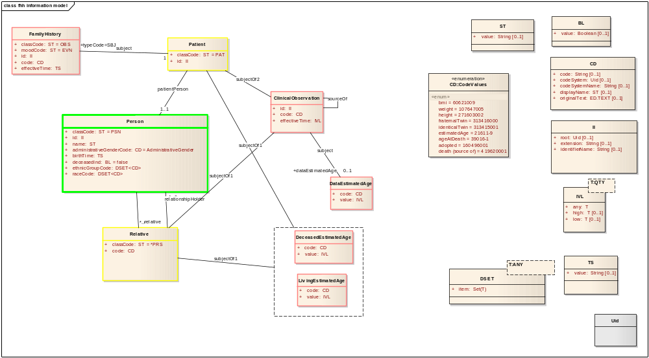
Figure 1. FHH information model, based on HL7 Family History model.

HL7 Family History (Pedigree) Schema
Please see Appendix A: HL7 Family History (Pedigree) XSD, below for details on the HL7 Family History schema and a copy of the XSD.

Interfacing with FHH
Please see the FHH Interoperability partner document and its accompanying example XML file for deeper information on the details of the model.

Codes
The chart below indicates the disease, race, ethnicity, and other codes used by the FHH tool. The primary coding system used by the tool is SNOMED. The relative codes used by the system come from HL7, and the HL7 model dictates the use of a few LOINC codes.
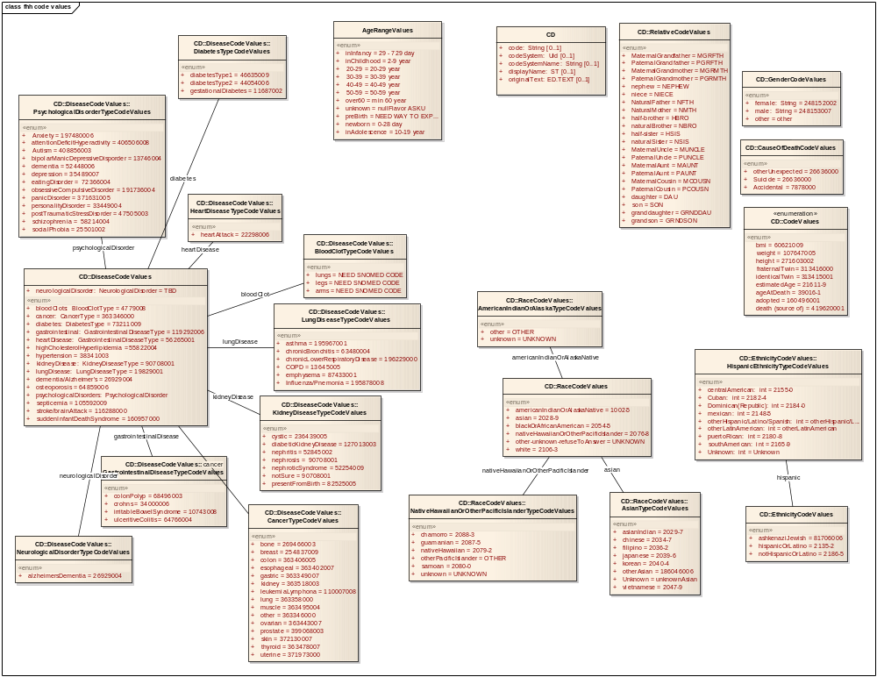
Figure 2. Information to be captured by FHH, and related SNOMED and HL7 codes.

Domain Model
The domain model represents the key concepts and underlying classes to support the FHH requirements, including the interface described in the information model. The domain model represents what is implemented by the code the team will write.
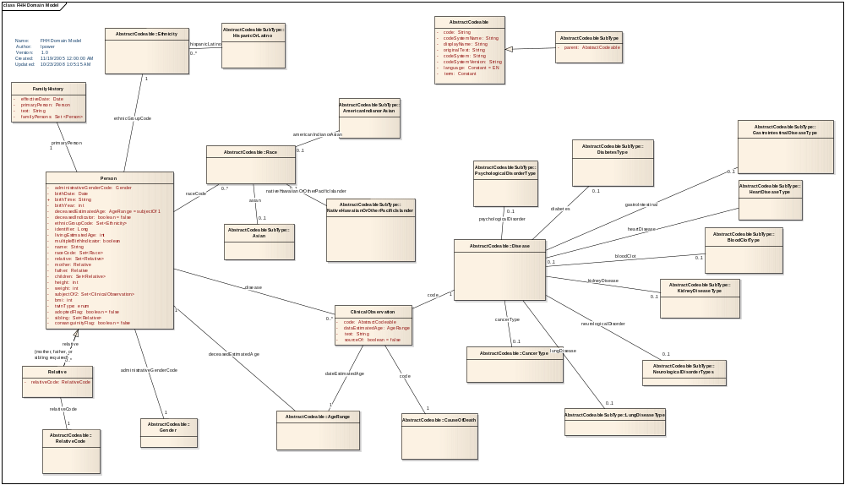
Figure 3. FHH Domain Model

Appendix A: HL7 Family History (Pedigree) XSD
The table below shows the HL7 Family History (Pedigree) Model XSD. FHH will export information in conformance with this XSD. Because FHH does not concern itself with all of the information covered by the model, its files will represent a conformant subset.
POCG_MT000040.xsd

<?xml version="1.0" encoding="UTF-8" standalone="no"?>
<xs:schema xmlns:xs="http://www.w3.org/2001/XMLSchema" xmlns="urn:hl7-org:v3" xmlns:mif="urn:hl7-org:v3/mif" targetNamespace="urn:hl7-org:v3" elementFormDefault="qualified">
<!--
*****************************************************************************************************************
* XML schema for message type POCG_MT000040.
* Source information:
* Rendered by: RoseTree 4.0.2
* Rendered on:
* HMD was rendered into XML using software provided to HL7 by Beeler Consulting LLC.
HMD to MIF Transform: $Id: RoseTreeHmdToMIFStaticModel.xsl,v 1.12 2005/07/19 04:27:26 lmckenzi Exp $
Base transform: $Id: ConvertBase.xsl,v 1.2 2005/04/17 03:20:15 lmckenzi Exp $
Package Id Conversion: $Id: TransformPackageIds.xsl,v 1.3 2005/07/31 05:19:52 lmckenzi Exp $
HTML To MIF markup: $Id: HtmlToMIFMarkup.xsl,v 1.2 2005/04/17 03:20:15 lmckenzi Exp $
Flat to Serialization Transform: $Id: MIFStaticModelFlatToSerialization.xsl,v 1.3 2005/04/17 03:20:15 lmckenzi Exp $
Fix Names Transform: $Id: FixMifNames.xsl,v 1.6 2005/04/17 03:20:15 lmckenzi Exp $
Base transform: $Id: ConvertBase.xsl,v 1.2 2005/04/17 03:20:15 lmckenzi Exp $
Package Id Conversion: $Id: TransformPackageIds.xsl,v 1.3 2005/07/31 05:19:52 lmckenzi Exp $
*
* Generated by XMLITS version 2.0
* MIF to XSD Transform $Id: StaticMifToXsd.xsl,v 1.25 2005/07/09 20:20:15 lmckenzi Exp $
* Package Id Conversion: $Id: TransformPackageIds.xsl,v 1.3 2005/07/31 05:19:52 lmckenzi Exp $
*
* Copyright (c) 2002, 2003, 2004, 2005 Health Level Seven. All rights reserved.
* Redistribution and use in source and binary forms, with or without
* modification, are permitted provided that the following conditions
* are met:
* 1. Redistributions of source code must retain the above copyright
* notice, this list of conditions and the following disclaimer.
* 2. Redistributions in binary form must reproduce the above copyright
* notice, this list of conditions and the following disclaimer in the
* documentation and/or other materials provided with the distribution.
* 3. All advertising materials mentioning features or use of this software
* must display the following acknowledgement:
* This product includes software developed by Health Level Seven.
* THIS SOFTWARE IS PROVIDED BY HEALTH LEVEL SEVEN, INC. AND CONTRIBUTORS "AS IS" AND
* ANY EXPRESS OR IMPLIED WARRANTIES, INCLUDING, BUT NOT LIMITED TO, THE
* IMPLIED WARRANTIES OF MERCHANTABILITY AND FITNESS FOR A PARTICULAR PURPOSE
* ARE DISCLAIMED. IN NO EVENT SHALL THE REGENTS OR CONTRIBUTORS BE LIABLE
* FOR ANY DIRECT, INDIRECT, INCIDENTAL, SPECIAL, EXEMPLARY, OR CONSEQUENTIAL
* DAMAGES (INCLUDING, BUT NOT LIMITED TO, PROCUREMENT OF SUBSTITUTE GOODS
* OR SERVICES; LOSS OF USE, DATA, OR PROFITS; OR BUSINESS INTERRUPTION)
* HOWEVER CAUSED AND ON ANY THEORY OF LIABILITY, WHETHER IN CONTRACT, STRICT
* LIABILITY, OR TORT (INCLUDING NEGLIGENCE OR OTHERWISE) ARISING IN ANY WAY
* OUT OF THE USE OF THIS SOFTWARE, EVEN IF ADVISED OF THE POSSIBILITY OF
* SUCH DAMAGE.
*
********************************************************************************************************************
-->
<xs:annotation>
<xs:documentation>Generated using schema builder version 2.0. Stylesheets:was rendered into XML using software provided to HL7 by Beeler Consulting LLC.
HMD to MIF Transform: $Id: RoseTreeHmdToMIFStaticModel.xsl,v 1.12 2005/07/19 04:27:26 lmckenzi Exp $
Base transform: $Id: ConvertBase.xsl,v 1.2 2005/04/17 03:20:15 lmckenzi Exp $
Package Id Conversion: $Id: TransformPackageIds.xsl,v 1.3 2005/07/31 05:19:52 lmckenzi Exp $
HTML To MIF markup: $Id: HtmlToMIFMarkup.xsl,v 1.2 2005/04/17 03:20:15 lmckenzi Exp $
Flat to Serialization Transform: $Id: MIFStaticModelFlatToSerialization.xsl,v 1.3 2005/04/17 03:20:15 lmckenzi Exp $
Fix Names Transform: $Id: FixMifNames.xsl,v 1.6 2005/04/17 03:20:15 lmckenzi Exp $
Base transform: $Id: ConvertBase.xsl,v 1.2 2005/04/17 03:20:15 lmckenzi Exp $
Package Id Conversion: $Id: TransformPackageIds.xsl,v 1.3 2005/07/31 05:19:52 lmckenzi Exp $.xsl version 2.0</xs:documentation>
</xs:annotation>
<xs:include schemaLocation="../coreschemas/infrastructureRoot.xsd"/>
<xs:include schemaLocation="../coreschemas/NarrativeBlock.xsd"/>
<xs:include schemaLocation="COCT_MT930000.xsd"/>
<xs:complexType name="POCG_MT000040.Age">
<xs:sequence>
<xs:group ref="InfrastructureRootElements"/>
<xs:element name="code" type="CD" minOccurs="0"/>
<xs:element name="value" type="IVL_PQ" minOccurs="0"/>
<xs:element name="pertinentInformation" type="POCG_MT000040.PertinentInformation" nillable="true"/>
</xs:sequence>
<xs:attributeGroup ref="InfrastructureRootAttributes"/>
<xs:attribute name="classCode" type="ActClassObservation" use="optional" default="OBS"/>
<xs:attribute name="moodCode" type="ActMood" use="optional" fixed="EVN"/>
</xs:complexType>
<xs:complexType name="POCG_MT000040.AnalysisResult">
<xs:sequence>
<xs:group ref="InfrastructureRootElements"/>
<xs:element name="code" type="CD" minOccurs="0"/>
<xs:element name="value" type="ANY" minOccurs="0"/>
</xs:sequence>
<xs:attributeGroup ref="InfrastructureRootAttributes"/>
<xs:attribute name="classCode" type="ActClassObservation" use="optional" default="OBS"/>
<xs:attribute name="moodCode" type="ActMood" use="optional" fixed="EVN"/>
</xs:complexType>
<xs:complexType name="POCG_MT000040.ClinicalObservation">
<xs:sequence>
<xs:group ref="InfrastructureRootElements"/>
<xs:element name="code" type="CD"/>
<xs:element name="text" type="ED" minOccurs="0"/>
<xs:element name="effectiveTime" type="IVL_TS" minOccurs="0"/>
<xs:element name="confidentialityCode" type="CE" minOccurs="0" maxOccurs="unbounded"/>
<xs:element name="uncertaintyCode" type="CE" minOccurs="0"/>
<xs:element name="value" type="ANY" minOccurs="0"/>
<xs:element name="methodCode" type="CE" minOccurs="0" maxOccurs="unbounded"/>
<xs:element name="subject" type="POCG_MT000040.Subject4" nillable="true" minOccurs="0"/>
<xs:element name="sourceOf" type="POCG_MT000040.SourceOf" nillable="true" minOccurs="0" maxOccurs="unbounded"/>
</xs:sequence>
<xs:attributeGroup ref="InfrastructureRootAttributes"/>
<xs:attribute name="classCode" type="ActClassObservation" use="optional" default="OBS"/>
<xs:attribute name="moodCode" type="ActMood" use="optional" fixed="EVN"/>
<xs:attribute name="negationInd" type="bl" use="optional"/>
</xs:complexType>
<xs:complexType name="POCG_MT000040.Component">
<xs:sequence>
<xs:group ref="InfrastructureRootElements"/>
<xs:choice>
<xs:element name="age" type="POCG_MT000040.Age" nillable="true"/>
<xs:element name="analysisResult" type="POCG_MT000040.AnalysisResult" nillable="true"/>
<xs:element name="percentageRisk" type="POCG_MT000040.PercentageRisk" nillable="true"/>
<xs:element name="probability" type="POCG_MT000040.Probability" nillable="true"/>
<xs:element name="relativeRisk" type="POCG_MT000040.RelativeRisk" nillable="true"/>
</xs:choice>
</xs:sequence>
<xs:attributeGroup ref="InfrastructureRootAttributes"/>
<xs:attribute name="typeCode" type="ActRelationshipHasComponent" use="optional" default="COMP"/>
</xs:complexType>
<xs:complexType name="POCG_MT000040.Component2">
<xs:sequence>
<xs:group ref="InfrastructureRootElements"/>
<xs:choice>
<xs:element name="geneticLocus" type="COCT_MT930000.GeneticLocus" nillable="true"/>
<xs:element name="clinicalObservation" type="POCG_MT000040.ClinicalObservation" nillable="true"/>
</xs:choice>
</xs:sequence>
<xs:attributeGroup ref="InfrastructureRootAttributes"/>
<xs:attribute name="typeCode" type="ActRelationshipHasComponent" use="optional" default="COMP"/>
</xs:complexType>
<xs:complexType name="POCG_MT000040.Component3">
<xs:sequence>
<xs:group ref="InfrastructureRootElements"/>
<xs:element name="pedigreeAnalysisResults" type="POCG_MT000040.PedigreeAnalysisResults" nillable="true"/>
</xs:sequence>
<xs:attributeGroup ref="InfrastructureRootAttributes"/>
<xs:attribute name="typeCode" type="ActRelationshipHasComponent" use="optional" default="COMP"/>
</xs:complexType>
<xs:complexType name="POCG_MT000040.ControlVariable">
<xs:sequence>
<xs:group ref="InfrastructureRootElements"/>
<xs:element name="inputParameters" type="POCG_MT000040.InputParameters" nillable="true"/>
</xs:sequence>
<xs:attributeGroup ref="InfrastructureRootAttributes"/>
<xs:attribute name="typeCode" type="ActRelationshipType" use="optional" fixed="CTRLV"/>
</xs:complexType>
<xs:complexType name="POCG_MT000040.DataEstimatedAge">
<xs:sequence>
<xs:group ref="InfrastructureRootElements"/>
<xs:element name="code" type="CD" minOccurs="0"/>
<xs:element name="value" type="IVL_PQ" minOccurs="0"/>
</xs:sequence>
<xs:attributeGroup ref="InfrastructureRootAttributes"/>
<xs:attribute name="classCode" type="ActClassObservation" use="optional" default="OBS"/>
<xs:attribute name="moodCode" type="ActMood" use="optional" fixed="EVN"/>
</xs:complexType>
<xs:complexType name="POCG_MT000040.DeceasedEstimatedAge">
<xs:sequence>
<xs:group ref="InfrastructureRootElements"/>
<xs:element name="code" type="CD" minOccurs="0"/>
<xs:element name="value" type="IVL_PQ" minOccurs="0"/>
</xs:sequence>
<xs:attributeGroup ref="InfrastructureRootAttributes"/>
<xs:attribute name="classCode" type="ActClassObservation" use="optional" default="OBS"/>
<xs:attribute name="moodCode" type="ActMood" use="optional" fixed="EVN"/>
</xs:complexType>
<xs:complexType name="POCG_MT000040.FamilyHistory">
<xs:sequence>
<xs:group ref="InfrastructureRootElements"/>
<xs:element name="id" type="II" minOccurs="0" maxOccurs="unbounded"/>
<xs:element name="code" type="CD" minOccurs="0"/>
<xs:element name="text" type="ED" minOccurs="0"/>
<xs:element name="effectiveTime" type="TS" minOccurs="0"/>
<xs:element name="confidentialityCode" type="CE" minOccurs="0" maxOccurs="unbounded"/>
<xs:element name="uncertaintyCode" type="CE" minOccurs="0"/>
<xs:element name="languageCode" type="CE" minOccurs="0"/>
<xs:element name="methodCode" type="CE" minOccurs="0" maxOccurs="unbounded"/>
<xs:element name="subject" type="POCG_MT000040.Subject5" nillable="true" minOccurs="0"/>
<xs:element name="component1" type="POCG_MT000040.Component2" nillable="true" minOccurs="0" maxOccurs="unbounded"/>
<xs:element name="component2" type="POCG_MT000040.Component3" nillable="true" minOccurs="0" maxOccurs="unbounded"/>
</xs:sequence>
<xs:attributeGroup ref="InfrastructureRootAttributes"/>
<xs:attribute name="classCode" type="ActClassObservation" use="optional" default="OBS"/>
<xs:attribute name="moodCode" type="ActMood" use="optional" fixed="EVN"/>
</xs:complexType>
<xs:complexType name="POCG_MT000040.InputParameters">
<xs:sequence>
<xs:group ref="InfrastructureRootElements"/>
<xs:element name="code" type="CD" minOccurs="0"/>
<xs:element name="text" type="ED" minOccurs="0"/>
<xs:element name="value" type="ANY" minOccurs="0"/>
</xs:sequence>
<xs:attributeGroup ref="InfrastructureRootAttributes"/>
<xs:attribute name="classCode" type="ActClassObservation" use="optional" default="OBS"/>
<xs:attribute name="moodCode" type="ActMood" use="optional" fixed="EVN.CRT"/>
</xs:complexType>
<xs:complexType name="POCG_MT000040.LivingEstimatedAge">
<xs:sequence>
<xs:group ref="InfrastructureRootElements"/>
<xs:element name="code" type="CD" minOccurs="0"/>
<xs:element name="value" type="IVL_PQ" minOccurs="0"/>
</xs:sequence>
<xs:attributeGroup ref="InfrastructureRootAttributes"/>
<xs:attribute name="classCode" type="ActClassObservation" use="optional" default="OBS"/>
<xs:attribute name="moodCode" type="ActMood" use="optional" fixed="EVN"/>
</xs:complexType>
<xs:complexType name="POCG_MT000040.Patient">
<xs:sequence>
<xs:group ref="InfrastructureRootElements"/>
<xs:element name="id" type="II" minOccurs="0"/>
<xs:element name="patientPerson" type="POCG_MT000040.Person" nillable="true"/>
<xs:element name="provider" type="POCG_MT000040.Provider" nillable="true" minOccurs="0"/>
<xs:element name="subjectOf1" type="POCG_MT000040.Subject3" nillable="true" minOccurs="0" maxOccurs="unbounded"/>
<xs:element name="subjectOf2" type="POCG_MT000040.Subject" nillable="true" minOccurs="0" maxOccurs="unbounded"/>
</xs:sequence>
<xs:attributeGroup ref="InfrastructureRootAttributes"/>
<xs:attribute name="classCode" type="RoleClass" use="optional" fixed="PAT"/>
</xs:complexType>
<xs:complexType name="POCG_MT000040.PedigreeAnalysisResults">
<xs:sequence>
<xs:group ref="InfrastructureRootElements"/>
<xs:element name="id" type="II" minOccurs="0" maxOccurs="unbounded"/>
<xs:element name="code" type="CD" minOccurs="0"/>
<xs:element name="derivationExpr" type="ST" minOccurs="0"/>
<xs:element name="text" type="ED" minOccurs="0"/>
<xs:element name="effectiveTime" type="IVL_TS" minOccurs="0"/>
<xs:element name="methodCode" type="CE" minOccurs="0" maxOccurs="unbounded"/>
<xs:element name="component" type="POCG_MT000040.Component" nillable="true" minOccurs="0" maxOccurs="unbounded"/>
<xs:element name="controlVariable" type="POCG_MT000040.ControlVariable" nillable="true" minOccurs="0" maxOccurs="unbounded"/>
</xs:sequence>
<xs:attributeGroup ref="InfrastructureRootAttributes"/>
<xs:attribute name="classCode" type="ActClassObservation" use="optional" default="OBS"/>
<xs:attribute name="moodCode" type="ActMood" use="optional" fixed="EVN"/>
<xs:attribute name="negationInd" type="bl" use="optional"/>
</xs:complexType>
<xs:complexType name="POCG_MT000040.PercentageRisk">
<xs:sequence>
<xs:group ref="InfrastructureRootElements"/>
<xs:element name="code" type="CD" minOccurs="0"/>
<xs:element name="value" type="INT" minOccurs="0"/>
</xs:sequence>
<xs:attributeGroup ref="InfrastructureRootAttributes"/>
<xs:attribute name="classCode" type="ActClassObservation" use="optional" default="OBS"/>
<xs:attribute name="moodCode" type="ActMood" use="optional" fixed="EVN"/>
</xs:complexType>
<xs:complexType name="POCG_MT000040.Person">
<xs:sequence>
<xs:group ref="InfrastructureRootElements"/>
<xs:element name="id" type="II" minOccurs="0"/>
<xs:element name="name" type="EN" minOccurs="0" maxOccurs="unbounded"/>
<xs:element name="telecom" type="TEL" minOccurs="0" maxOccurs="unbounded"/>
<xs:element name="administrativeGenderCode" type="CE" minOccurs="0"/>
<xs:element name="birthTime" type="TS" minOccurs="0"/>
<xs:element name="deceasedInd" type="BL" minOccurs="0"/>
<xs:element name="deceasedTime" type="TS" minOccurs="0"/>
<xs:element name="raceCode" type="CE" minOccurs="0" maxOccurs="unbounded"/>
<xs:element name="ethnicGroupCode" type="CE" minOccurs="0" maxOccurs="unbounded"/>
<xs:element name="relative" type="POCG_MT000040.Relative" nillable="true" minOccurs="0" maxOccurs="unbounded"/>
</xs:sequence>
<xs:attributeGroup ref="InfrastructureRootAttributes"/>
<xs:attribute name="classCode" type="EntityClass" use="optional" fixed="PSN"/>
<xs:attribute name="determinerCode" type="EntityDeterminer" use="optional" fixed="INSTANCE"/>
</xs:complexType>
<xs:complexType name="POCG_MT000040.PertinentInformation">
<xs:sequence>
<xs:group ref="InfrastructureRootElements"/>
<xs:element name="probability" type="POCG_MT000040.Probability" nillable="true"/>
</xs:sequence>
<xs:attributeGroup ref="InfrastructureRootAttributes"/>
<xs:attribute name="typeCode" type="ActRelationshipPertains" use="optional" default="PERT"/>
</xs:complexType>
<xs:complexType name="POCG_MT000040.Probability">
<xs:sequence>
<xs:group ref="InfrastructureRootElements"/>
<xs:element name="code" type="CD" minOccurs="0"/>
<xs:element name="value" type="PQ" minOccurs="0"/>
</xs:sequence>
<xs:attributeGroup ref="InfrastructureRootAttributes"/>
<xs:attribute name="classCode" type="ActClassObservation" use="optional" default="OBS"/>
<xs:attribute name="moodCode" type="ActMood" use="optional" fixed="EVN"/>
</xs:complexType>
<xs:complexType name="POCG_MT000040.Provider">
<xs:sequence>
<xs:group ref="InfrastructureRootElements"/>
<xs:element name="id" type="II" minOccurs="0" maxOccurs="unbounded"/>
<xs:element name="name" type="EN" minOccurs="0" maxOccurs="unbounded"/>
</xs:sequence>
<xs:attributeGroup ref="InfrastructureRootAttributes"/>
<xs:attribute name="classCode" type="EntityClassOrganization" use="optional" default="ORG"/>
<xs:attribute name="determinerCode" type="EntityDeterminer" use="optional" fixed="INSTANCE"/>
</xs:complexType>
<xs:complexType name="POCG_MT000040.Relative">
<xs:sequence>
<xs:group ref="InfrastructureRootElements"/>
<xs:element name="code" type="CE" minOccurs="0"/>
<xs:element name="relationshipHolder" type="POCG_MT000040.Person" nillable="true" minOccurs="0"/>
<xs:element name="subjectOf1" type="POCG_MT000040.Subject3" nillable="true" minOccurs="0" maxOccurs="unbounded"/>
<xs:element name="subjectOf2" type="POCG_MT000040.Subject" nillable="true" minOccurs="0" maxOccurs="unbounded"/>
</xs:sequence>
<xs:attributeGroup ref="InfrastructureRootAttributes"/>
<xs:attribute name="classCode" type="RoleClass" use="optional" fixed="PRS"/>
</xs:complexType>
<xs:complexType name="POCG_MT000040.RelativeRisk">
<xs:sequence>
<xs:group ref="InfrastructureRootElements"/>
<xs:element name="code" type="CD" minOccurs="0"/>
<xs:element name="value" type="PQ" minOccurs="0"/>
</xs:sequence>
<xs:attributeGroup ref="InfrastructureRootAttributes"/>
<xs:attribute name="classCode" type="ActClassObservation" use="optional" default="OBS"/>
<xs:attribute name="moodCode" type="ActMood" use="optional" fixed="EVN"/>
</xs:complexType>
<xs:complexType name="POCG_MT000040.SourceOf">
<xs:sequence>
<xs:group ref="InfrastructureRootElements"/>
<xs:element name="clinicalObservation" type="POCG_MT000040.ClinicalObservation" nillable="true"/>
</xs:sequence>
<xs:attributeGroup ref="InfrastructureRootAttributes"/>
<xs:attribute name="typeCode" type="ActRelationshipType" use="required"/>
</xs:complexType>
<xs:complexType name="POCG_MT000040.Subject">
<xs:sequence>
<xs:group ref="InfrastructureRootElements"/>
<xs:choice>
<xs:element name="geneticLocus" type="COCT_MT930000.GeneticLocus" nillable="true"/>
<xs:element name="clinicalObservation" type="POCG_MT000040.ClinicalObservation" nillable="true"/>
</xs:choice>
</xs:sequence>
<xs:attributeGroup ref="InfrastructureRootAttributes"/>
<xs:attribute name="typeCode" type="ParticipationTargetSubject" use="optional" default="SBJ"/>
</xs:complexType>
<xs:complexType name="POCG_MT000040.Subject3">
<xs:sequence>
<xs:group ref="InfrastructureRootElements"/>
<xs:choice>
<xs:element name="deceasedEstimatedAge" type="POCG_MT000040.DeceasedEstimatedAge" nillable="true"/>
<xs:element name="livingEstimatedAge" type="POCG_MT000040.LivingEstimatedAge" nillable="true"/>
</xs:choice>
</xs:sequence>
<xs:attributeGroup ref="InfrastructureRootAttributes"/>
<xs:attribute name="typeCode" type="ParticipationTargetSubject" use="optional" default="SBJ"/>
</xs:complexType>
<xs:complexType name="POCG_MT000040.Subject4">
<xs:sequence>
<xs:group ref="InfrastructureRootElements"/>
<xs:element name="dataEstimatedAge" type="POCG_MT000040.DataEstimatedAge" nillable="true"/>
</xs:sequence>
<xs:attributeGroup ref="InfrastructureRootAttributes"/>
<xs:attribute name="typeCode" type="ActRelationshipType" use="optional" fixed="SUBJ"/>
</xs:complexType>
<xs:complexType name="POCG_MT000040.Subject5">
<xs:sequence>
<xs:group ref="InfrastructureRootElements"/>
<xs:element name="patient" type="POCG_MT000040.Patient" nillable="true"/>
</xs:sequence>
<xs:attributeGroup ref="InfrastructureRootAttributes"/>
<xs:attribute name="typeCode" type="ParticipationTargetSubject" use="optional" default="SBJ"/>
</xs:complexType>
</xs:schema>

Figure 4. HL7 Family History (Pedigree) XSD Format

