Using version controlled packages in the FHH model
This document provides information on how to use the version-controlled packages that comprise the FHH model. To allow colleagues to work on the model at the same time while avoiding lock and merge issues, the team decided to use version control at the package level. The FHH model does not exist as a single .EAP file, but rather as components that can be viewed and edited independently and individually.
Contents
Check-out Source 2
Create a new model to hold version controlled packages 2
Configure version control 3
Using version controlled packages from the FHH model 7
How to update (get latest from subversion) 8
Editing a package 9
Commit a package 9
Add Package To Version Control 10
No version control? 12

Check-out Source
Before configuring EA with subversion, you need to checkout out the source tree containing the packages you wish to use or where you plan on placing your new packages. In addition, if you plan on doing writing changes back to the subversion via EA, EA needs your credentials cached. So, you need to provide them when checking out the source tree. The following command line will do it:
svn co –username <username> --password <password> https://svn.5amsolutions.com/client/hhs/fhh/trunk
Otherwise, using TortoiseSVN, you can do an “update” or a “checkout” of the source or just the model directory:
Entire source: checkout https://svn.5amsolutions.com/client/hhs/fhh/trunk
Model directory: checkout https://svn.5amsolutions.com/client/hhs/fhh/trunk/documents/architecture/model
Once credentials are cached, you should not have to do this again unless they change.

Create a new model to hold version controlled packages
In this step, you’ll be creating a local model, to be used just by you, in which you can view and manipulate the FHH model packages.
- Create a new model. Best to store it in your local FHH model directory (the local directory in which you store the FHH model artifacts that you download from Subversion.).
- You can select an empty default model, because you’ll be populating your model with the FHH model packages – right now, you’re creating a holding place.
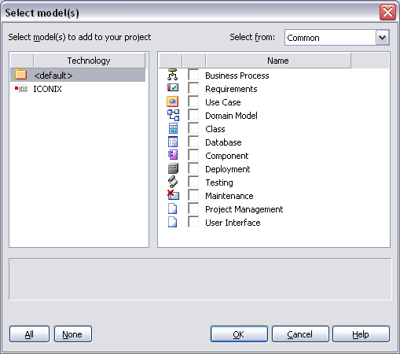
Figure 1. Model type irrelevant. Select <default> and click OK.

Configure version control
Now, we’ll configure version control on your system. Since version control settings are managed by EA, you can configure the settings from any model, but we’ll do so from the empty model you’ve just created.
- Within your model, right-click on the root of the model. Select Package Control…Version Control Settings.
- Complete the dialog box as described below; see screen shot for details.
  - Model Settings –
    - Uncheck This model is private. This is VERY IMPORTANT as this will make sure that changes do not get overwritten by others. Here is an explanation from the EA help text:
Specify Private or Shared Models
In the Version Control Settings dialog, the This model is private option affects the availability of the Get Latest / Get All Latest menu options. These options cannot be used with shared models. This is to prevent the possibility of overwriting any new modifications to a package with out-of-date versions of the package that are retrieved from version control.
Consider the following scenario, with two users both working on a shared model at the same time.
If user1 checks-out and modifies a package within Enterprise Architect, user2, who also has this shared model open in Enterprise Architect, can see the changes to the model immediately.
If, at this point, user2 performs a Get Latest or Get All Latest on the package, they retrieve from Version Control a package that is now out of date. (User1 has it checked-out and has made changes that are yet to be checked-in.) The out-of-date package would be imported into the model loaded on user2's machine, immediately updating the model database (either the shared .EAP file or the DB repository) and overwriting the modifications that user1 has just made.
Similarly, if a user checked-out and modified a package and then performed a Get Latest on that package, the modifications would be overwritten by the version of the package retrieved from version control.
The Get Latest option is consequently disabled for packages that you have checked out.

    - select Save nested version controlled packages to stubs only (recommended) and This model is private.
  - Configuration Details…
    - Unique ID – VERY IMPORTANT!!! We’ve discovered that sharing model packages works best when everyone sharing the packages uses the same configuration unique id. So, for this project, the unique id is fhh.
    - Type – Select subversion – this is the source control software that manages our repository.
    - Working Copy Path – This is the location on your own drive of your local FHH repository – the local directory in which you store the FHH model artifacts that you download from Subversion.
  - Workstation Settings…
    - Subversion exe path – This is the location on your local drive of the subversion executable (svn.exe)
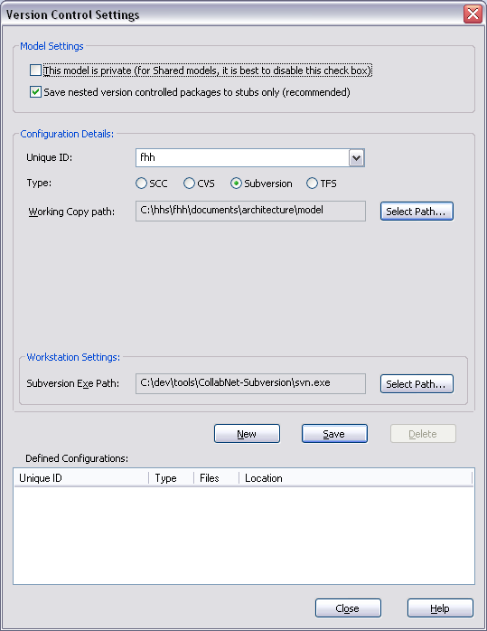
Figure 2. Configure version control.

- Select Save. The configuration you just created will show up in the Defined Configurations section of the dialog, as below.
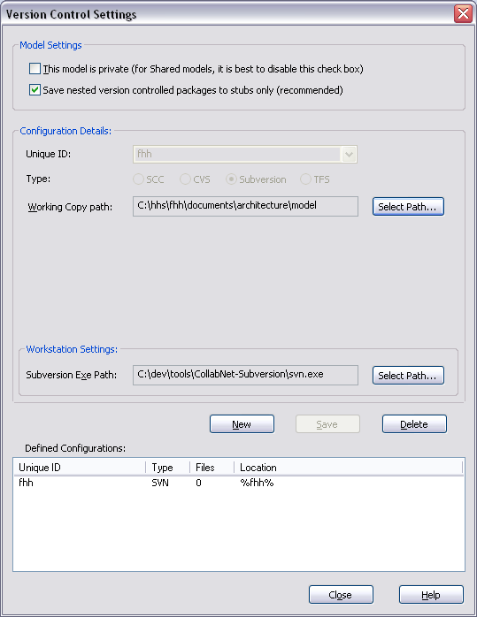
Figure 3. Version control configuration saved in EA.
- Click Close.
- You’re now ready to use version controlled packages from the FHH model.

Using version controlled packages from the FHH model
- On the root of your model, right-click and select Package Control…Get Package. Select the fhh version control configuration. When you do this, the packages under version control will appear.
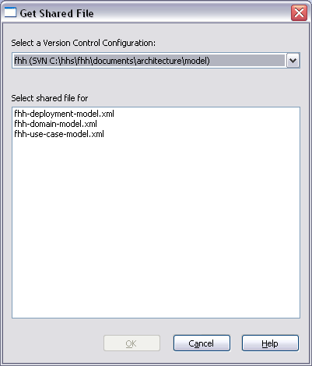
Figure 4. Select a version-controlled package to store in your local model.
- If you receive this kind of a message, best to select No and allow packages to be below the root of the model, rather than on the same level.
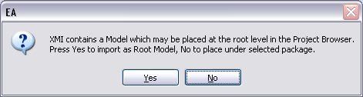
Figure 5. Just say No.
- EA will import your package. You’ll notice a little icon next to the controlled package to indicate that it’s under version control. You’ll also notice a key to indicate that it’s locked in version control. You will not be able to edit this package until you check it out.
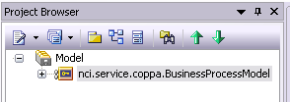
Figure 6. Source controlled package.
- Now, you can add the other packages in the same way, beginning at Step 1 above and right-clicking from the root of your model. When you’re done, you should have all source-controlled packages (or at least those that you’re interested in) within your local model.
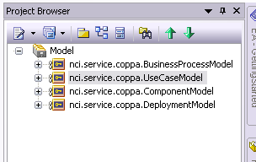
Figure 7. Local model containing all source controlled packages (as of this writing).
- You’re now ready to work.

How to update (get latest from subversion)
Unfortunately Sparx EA does not automatically retrieve the latest and greatest changes regularly. It is incumbent on the user to make sure they keep their packages up to date. This is done as follows:
- Right click on the package you wish to update
- Select Package Control -> File History...
- Select the latest revision
- Click Retrieve

If updates have been made it will import them for you. If not, it will ask you if you wish to refresh the model view from current package or forced reload of XMI.

Editing a package
This section describes how to make changes to a package.
- When you would like to work within a package, right-click on the package and select Package Control…Check Out. Only one person is allowed to check out a package at a time.
- You’ll see that the key icon on your package directory diagram has changed to indicate you can edit it.
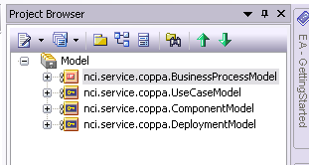
Figure 8. Package is writeable.
- Make the required changes. Note that if any entities cross package boundaries, you will need to check out both affected packages. An example of this is using an actor from the Use Case Model in a sequence diagram in an Analysis Model (as an example).

Commit a package
Whatever changes you have made exist only locally, until you commit the changes back to the repository.
- When you’ve completed your edits, right-click on the package and select Package Control…Check In. (You also can select Undo Checkout if you want to revert your changes).
- The Add Comment window will show. Add your comment and click OK.
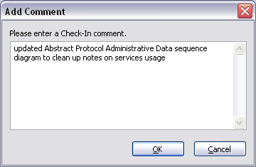
Figure 9. Always comment when you commit.
- The commit removes your lock. Your package icon will return to the locked state.
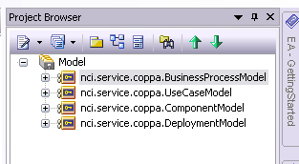
Figure 10. After commit, package returns to locked (read-only) state.
- Now, colleagues will see your change in their own local model.

Add Package To Version Control
To add a new package to version control do the following:
- Make sure Version Control is configured for root or current node. (See above)
- Right click on the package you wish to add to version control, select Package Control -> Configure
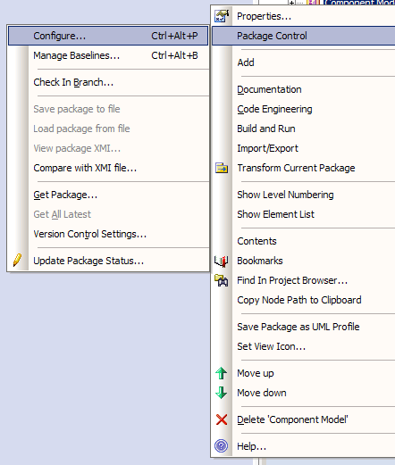
- Check Control Package, select the Version Control to which you wish to add this package, and click OK.
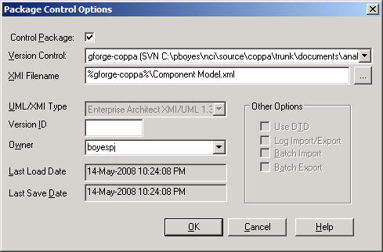
- You will then be asked if you would like to keep the package checked out. Answer as desired and click OK.
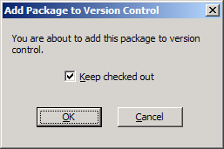

The package is now part of version control.

No version control?
If a colleague outside of the team would like to view parts or all of the FHH model, this can be done without bothering with the version control stuff. Anyone can simply import a package into any other model to view it.

