Family Health History Test Coverage Report
October 24, 2008

Development Process
When a FHH developer writes code, the build process run locally, on the developer’s machine, runs tools against the code to test for quality. Code is validated against a template of rules covering topics such as code format, line length, complexity, duplication, etc. Code is validated against a defined test coverage goal, and the code will not be built until the code coverage reaches the 80% defined for this project. Finally, the tests are run automatically when the developer runs the simple command to build the project. The constraints of our build process ensure that each developer follows the rules, or he or she won’t be able to see the code in action.
When the developer commits code to the repository, a continuous integration (CI) system that monitors the repository kicks into action. The CI box gets an update of the latest repository code, build it, runs tests, deploys it, and runs any additional tests (such as browser-based automated functional testing). If the CI build has an error, it sends an email to the development team, and the developers work immediately to resolve the integration problem. This workflow ensures that code integration occurs constantly, and is automated. Our developers will never need to say they’re having problems integration their code with that of another developer – the systems and workflow raise any issues immediately, so they can be handled and work can proceed.
This document includes the latest test information and results from the code developed during the FHH elaboration phase. This information is always accessible by our developers locally and via web browser on the CI machine. We’ve excerpted the test-relevant components here to expose the code coverage and test results.

Code Coverage
Code coverage refers to the amount of code in the system that is subjected to tests – the amount of code “covered” by tests. The FHH project aims for 80% test coverage, and achieves greater than 95%.
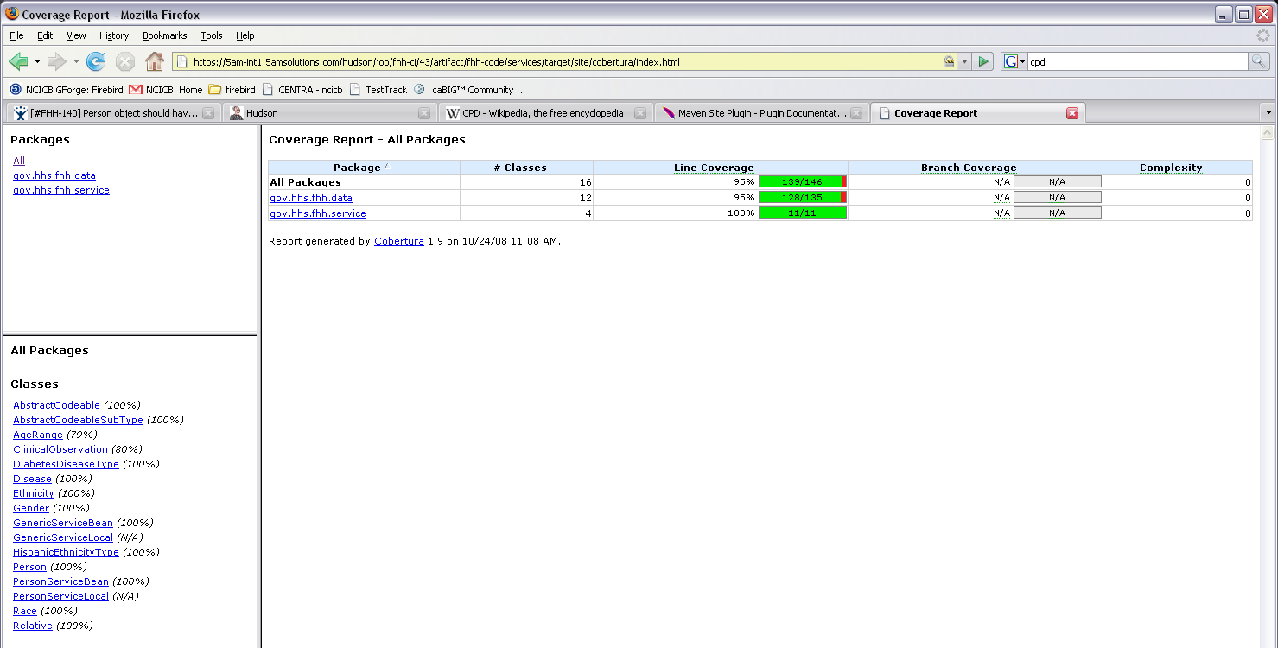
Figure 1. General Code coverage information.

Specific Code Coverage Metrics
Packages |  |  |  | 100%
Files |  |  | 100%
Classes | 100%
Methods |  |  |  |  |  | 95%
Lines |  | 97%
Conditionals |  |  |  |  | 82%

Total Test Summary
Tests | Errors | Failures | Skipped | Success Rate | Time
19 | 0 | 0 | 0 | 100% | 7.774
Note: failures are anticipated and checked for with assertions while errors are unanticipated.

Package List
Package | Tests | Errors | Failures | Skipped | Success Rate | Time
gov.hhs.fhh.data | 1 | 0 | 0 | 0 | 100% | 0.099
gov.hhs.fhh.service | 18 | 0 | 0 | 0 | 100% | 7.675
Note: package statistics are not computed recursively, they only sum up all of its test suites numbers.

gov.hhs.fhh.data
 | Class | Tests | Errors | Failures | Skipped | Success Rate | Time
 | PersonTest | 1 | 0 | 0 | 0 | 100% | 0.099

gov.hhs.fhh.service
 | Class | Tests | Errors | Failures | Skipped | Success Rate | Time
 | GenericServiceBeanTest | 14 | 0 | 0 | 0 | 100% | 7.203
 | PersonServiceBeanTest | 4 | 0 | 0 | 0 | 100% | 0.472

Test Cases

GenericServiceBeanTest
 | testCreateAndRetrieveGender | 4.983
 | testCreateCopyConstructorAndRetrieveGender | 0.101
 | testCreateAndRetrieveRelative | 0.073
 | testCreateCopyConstructorAndRetrieveRelative | 0.085
 | testCreateAndRetrieveRace | 0.811
 | testCreateCopyConstructorAndRetrieveRace | 0.102
 | testCreateAndRetrieveEthnicity | 0.208
 | testCreateCopyConstructorAndRetrieveEthnicity | 0.143
 | testCreateAndRetrieveDisease | 0.163
 | testCreateCopyConstructorAndRetrieveDisease | 0.1
 | testCreateAndRetrieveDiabetesType | 0.071
 | testCreateCopyConstructorAndRetrieveDiabetesType | 0.074
 | testCreateAndRetrieveHispanicType | 0.065
 | testCreateCopyConstructorAndRetrieveHispanicType | 0.132

PersonServiceBeanTest
 | testGetGenders | 0.012
 | testGetRaces | 0.202
 | testGetEthnicities | 0.12
 | testGetDiseases | 0.133

PersonTest
 | testCreatePerson | 0.097

